A compact modularized power-supply system for stable flow generation in microfluidic devices
Weihao Li^{1,2}, Wuyang Zhuge^{1,3}, Youwei Jiang¹, Kyle Jiang^{3,4}, Jun Ding³ and Xing Cheng^{1*}
- The Greater Bay Area University Joint Laboratory of Micro- and Nanofabrication, Department of Materials Science and Engineering, Southern University of Science and Technology, Shenzhen, Guangdong, P.R. China
- Department of Materials Science and Engineering, National University of Singapore, 9 Engineering Drive 1, 117576, Singapore
- Department of Mechanical Engineering, University of Birmingham, Edgbaston, Birmingham, B152TT, United Kingdom
- Yangtze Delta Region Institute of Tsinghua University，705 Yatai Road, Jiaxing, Zhejiang, China
*Correspondence: Xing Cheng (chengx@sustech.edu.cn)
These authors contributed equally: Weihao Li, Wuyang Zhuge

S1. Material choice
To identifying the Stability of the output signal, the droplets generation system based on the pump system is established. Containing a control board, two microfluidic pumps, three modularized stabilizer units and one generation channel, the system provides a new way of forming microreactor or microsphere.

Clear V4 resin (Asiga, USA) is used as the structural material for the samples because of its low cost and good mechanical property. As for the membrane material, two properties are considered when choosing it. The first one is the elastic Young’s modulus which would determine the RC constant of the overall system; The second property is the maximum elongation the material could reach, which is to ensure the membrane deflection could function normally even under large pressure range. Fig. S1 provides the comparison of the mentioned properties among a range of materials.
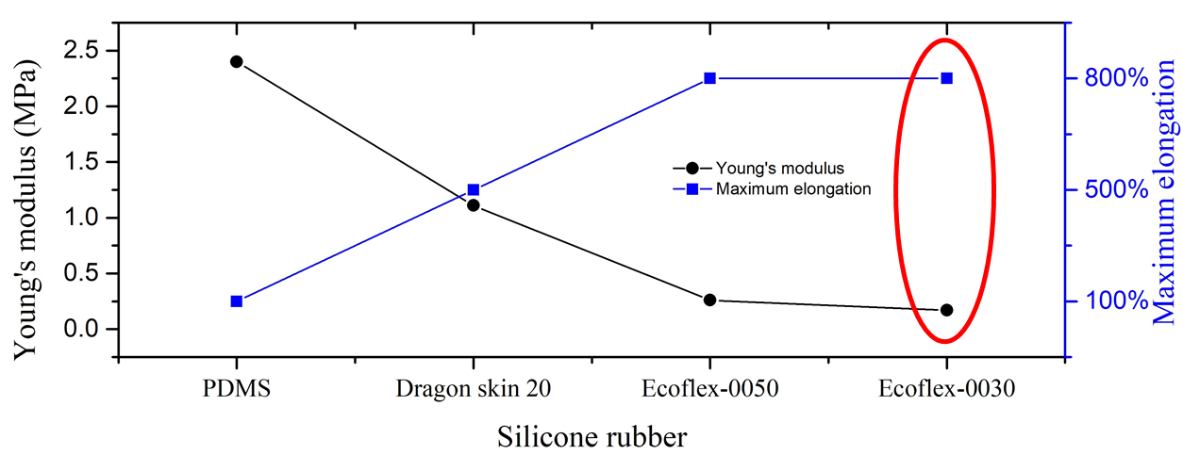
Figure S1 Comparison among four materials.

As shown in Fig. S1, Ecoflex 0030(Smooth On, Inc.) exhibits the lowest Young’s modulus and the highest maximum elongation, which therefore makes us use it as the membrane material in our experiments.

S2. Derivation of the simplified model
Previous work that employed microfluidic circuit analogy mostly focused on explaining phenomena (and generating preliminary ideas in the lab) rather than building specific applications in the actual world. When creating a practical system, it is preferable to have a simple model that preserves the main qualities and accuracy. The model we offer here is intended to assist in focusing on the most significant qualities while discarding less important terms. The following is a mathematical derivation.
The complete microfluidic circuit in our experiments should be like:
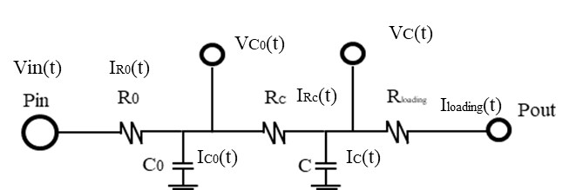
Figure S2 The complete circuit based on the experimental setup.

The equations for describing the above circuit are:
$\frac{P_{in}-P_{c0}\left(t\right)}{R_{0}}=C_{0}\frac{dP_{c0}\left(t\right)}{dt}+\frac{P_{c0}\left(t\right)-P_{c}\left(t\right)}{R_{c}}$ (1)
$\frac{P_{c0}\left(t\right)-P_{c}\left(t\right)}{R_{c}}=C\frac{dP_{c}\left(t\right)}{dt}+\frac{P_{c}\left(t\right)}{R_{loading}}$ (2)
$P_{c0}\left(t\right)=R_{c}C\frac{dP_{c}\left(t\right)}{dt}+\frac{{R_{c}P}_{c}\left(t\right)}{R_{loading}}{+P}_{c}\left(t\right)$ (3)
However, the simplified model has the following equation:
$\frac{P_{in}-P_{c}\left(t\right)}{R_{1}}=C_{overall}\frac{dP_{c}\left(t\right)}{dt}+\frac{P_{c}\left(t\right)}{R_{2}}$ (4)
In order to justify the correctness of the simplification, combine equations 1, 2, 3 and transform them into the following forms:
$\frac{P_{in}-R_{c}C\frac{dP_{c}\left(t\right)}{dt}-\frac{{R_{c}P}_{c}\left(t\right)}{R_{loading}} {-P}_{c}\left(t\right)}{R_{0}}=C_{0}\frac{d(R_{c}C\frac{dP_{c}\left(t\right)}{dt}+\frac{{R_{c}P}_{c}\left(t\right)}{R_{loading}} {+P}_{c}\left(t\right))}{dt}+C\frac{dP_{c}\left(t\right)}{dt}+\frac{P_{c}\left(t\right)}{R_{loading}}$ (5)
$\frac{P_{in}{-P}_{c}\left(t\right)}{R_{0}}=\left(\frac{R_{c}}{R_{0}}C+C_{0}\frac{R_{c}}{R_{loading}}+C_{0}+C\right)\frac{dP_{c}\left(t\right)}{dt}+P_{c}\left(t\right)\left(\frac{1}{R_{loading}}+\frac{R_{c}}{R_{loading}R_{0}}\right)+R_{c}CC_{0}\frac{d^{2}P_{c}\left(t\right)}{dt^{2}}$ (6)
Subsequently, the corresponding parameters under the two models were obtained by comparing equations (6) and (4). In contrast to (4), the last term in (5) is an additional term, and it is presumed that this second-order term is negligible in this study.
The model simplification is justified using the equations presented above, and subsequently, Thevenin's theorem is applied to the three-element model, converting it to a series RC circuit. In this study, the characteristics of a series RC circuit are employed to predict experimental outcomes, and the experimental results align with the equations, affirming the soundness of our logic to simplify the original model.

S3. Low-pass-filter effect and RC constant extraction
- Figure S3 (a) and (d) illustrates the low pass filter working on a periodic flow input. After the rising time, the output flow would have modulated amplitude. (c) shows the transient decay of the flowrate. (d) demonstrates the extraction of RC constant from flowrate decay, RC=16.7s and linear fitting R square is 0.997 is obtained in this example.

Fig. S3(c) and (d) show a specific example of RC constant extraction. The RC constant of the whole system could be obtained from the flowrate decay data. This method was first reported in Kang et al.’s work in ref¹⁰. Q_{H} and Q_{L} represent the high value and the small value of the steady state of the flowrate respectively. Besides, the RC constant $τ$ in a three-element circuit represents $C_{overall}\frac{{R_{1}R}_{2}}{R_{1}+R_{2}}$ , the τ is given more attention, and the values of R₁ and R₂ are not discussed in this study. Fig. S3(d) provides an example of using flowrate decay data to obtain the corresponding RC constant. As it suggests, the slope of the fitting line is negatively inverse to the RC constant. The slope is -0.06 in the example shown in Fig. S3(d), so the calculated RC constant is approximately 16.7 s, and the R square value is 0.997, confirming the high fitting quality.

S4. Dynamic behavior
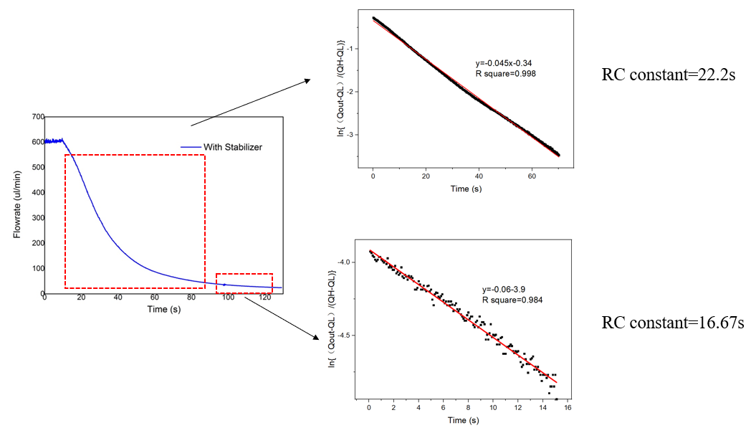
Fig. S4 Flow decay method for RC constant estimation of the cascaded connected microfluidic capacitors.

In the experiments described previously, two modular capacitors were cascaded to increase the RC constant. In general, the resistance of a modular device would be affected by its cross-sectional variation. The degree of change depends on the ratio of device resistance to total resistance, which includes the resistance of the tubing.
The overall RC constant of the proposed system was estimated using the flow decay method. As shown in Fig. S4, the linear fitting of the RC constant exhibited some variation in two distinct regions. In the first decay region, highlighted by the dashed square from 16s to 22s in Fig. S4, the RC constant was determined to be 22.2s, whereas in the second dashed square region, the RC constant decreased to 16.67s. Both fittings yielded a high R-squared value, exceeding 0.98, indicating a satisfactory degree of fit. The phenomenon may be attributed to the smaller effective area of the membrane. As the flowrate decreased, the condition of the membrane changed accordingly, leading to a reduction in the interaction area between the fluid and the membrane and resulting in a decrease in capacitance.

S5. Photo of experimental setup for droplet generation
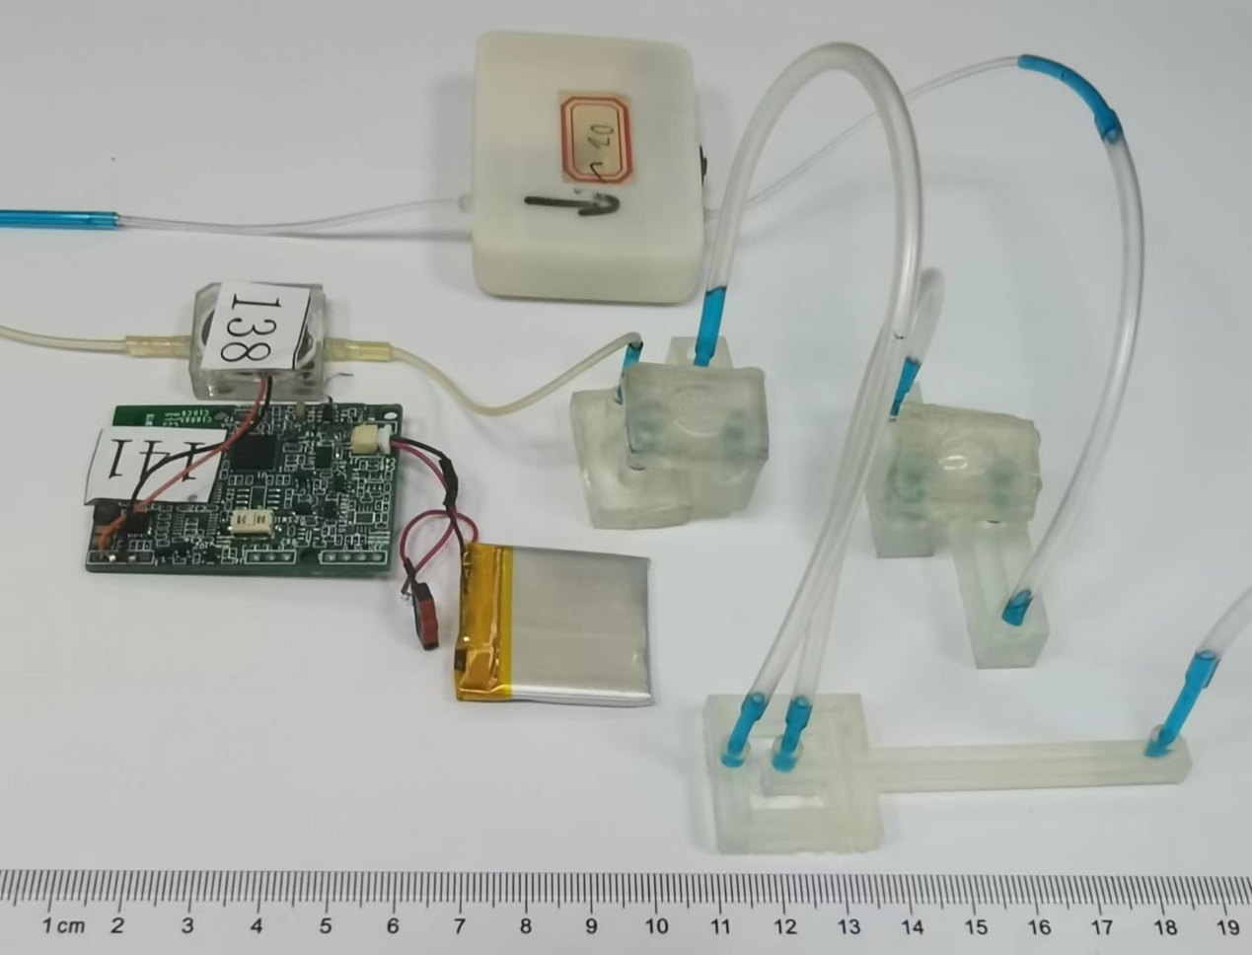
Fig. S5 The Whole droplet generation system established by a micro-pump system, two modularized fluidic capacitor unit and a cross-junction droplet generation channel.

Fig. S5 depicts the configuration used to generate micro-droplets in our experiments.
According to the illustration, two micropumps were connected to the respective inlets of the cross-junction generator. And the fluidic capacitors were cascaded to stabilize the flow to the greatest extent possible. As the dispersed and continuous phases, respectively, ink water and oil were utilized.

S6. Working curve for micropump

Fig. S6 Relationship between frequency the flow rate of single and double face micropump.

As shown in Fig. S6, the flowrate characterization of the micropump used in the experiment is demonstrated. When the working frequency of the micropump is smaller than 10 Hz, the flow rate increases linearly with the increasing of the working frequency of the piezoelectric pump.

S7. Droplet identification
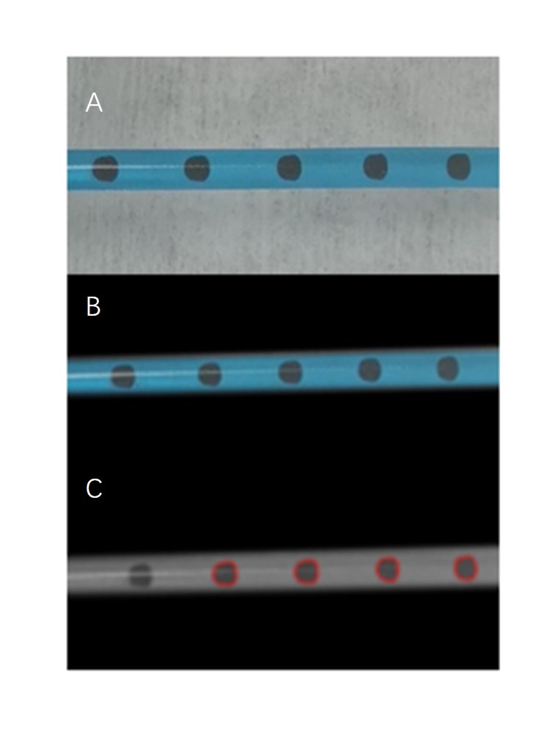
Fig. S7 The counting progress of the droplets.

In the experiments, a computer-based method is utilized for measuring and calculating the droplets' equivalent diameter. The original image is depicted in Fig. S7(A), and after a binary process, the edge of the background color is found and set to black, as shown in Fig. S7(B), along with the boundary of the pipe. As shown in Fig. S7(C), a droplet was detected and counted by locating its edge.

