Supplementary Appendix
Table of contents
1.- Table S1.- Catalogue of validated 3D-printed medical devices............................2
2.- Table S2.- Number, type, and material of items manufactured by 3D printing ...11

1.- Table S1.- Catalogue of validated 3D-printed medical devices
Category | Virtual Model | 3D-printed unit
Airway connectors and replacements | 3DPT001
Airway connectors and replacements | 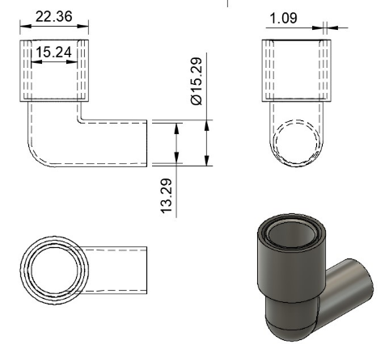 | 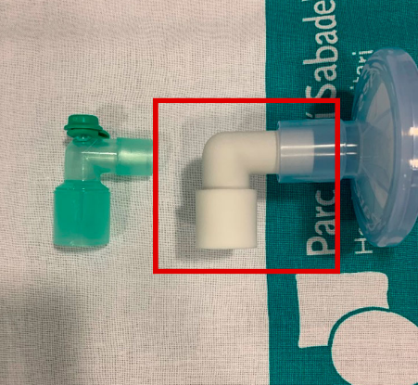
Airway connectors and replacements | 3DPT005
Airway connectors and replacements | 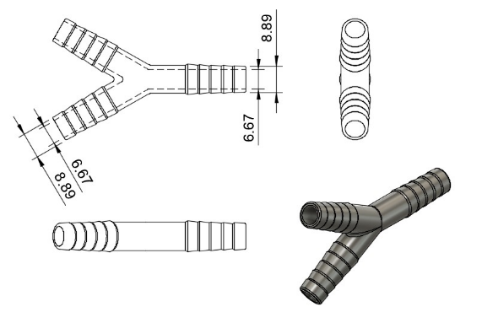 | 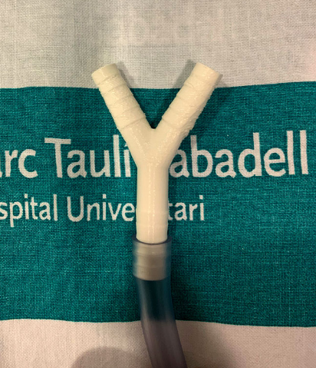
Airway connectors and replacements | 3DPT006
Airway connectors and replacements | 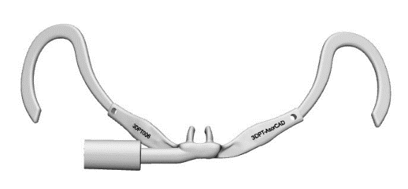 | 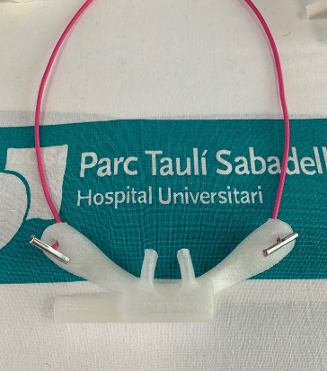
Airway connectors and replacements | 3DPT007
Airway connectors and replacements | 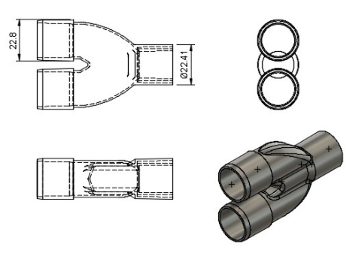 | 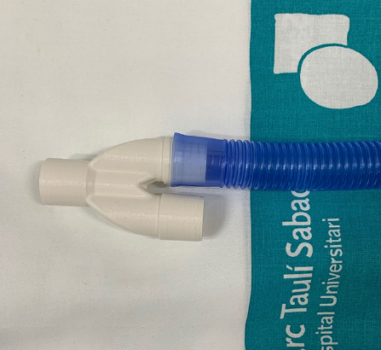

Airway connectors and replacements | 3DPT008
Airway connectors and replacements | 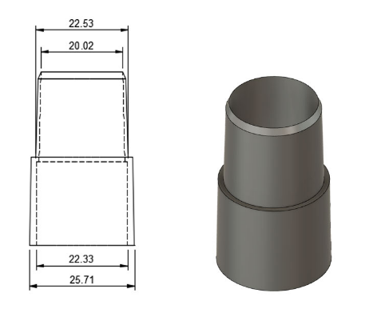 | 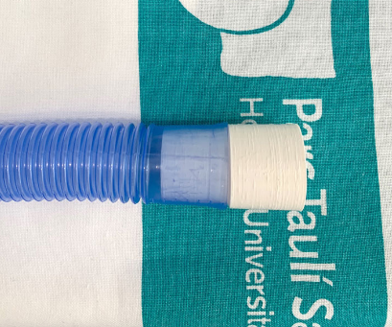
Airway connectors and replacements | 3DPT009
Airway connectors and replacements | 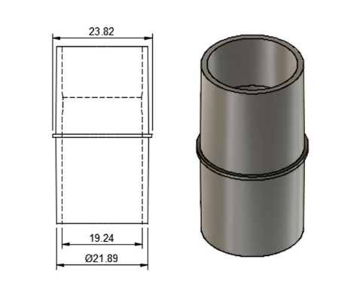 | 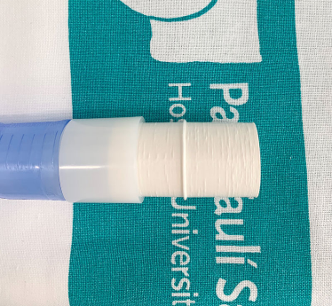
Airway connectors and replacements | 3DPT010
Airway connectors and replacements | 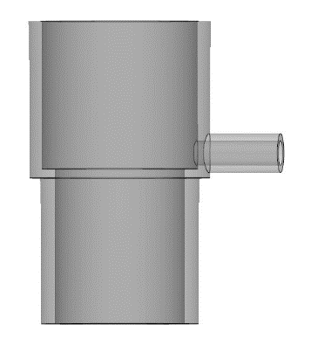 | 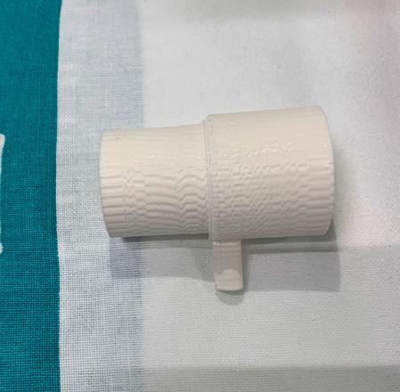
Airway connectors and replacements | 3DPT011
Airway connectors and replacements | 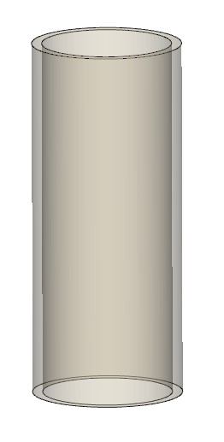 | 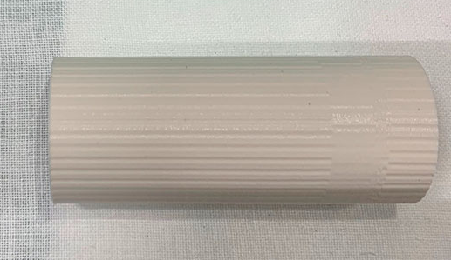

Airway connectors and replacements | 3DPT012
Airway connectors and replacements | 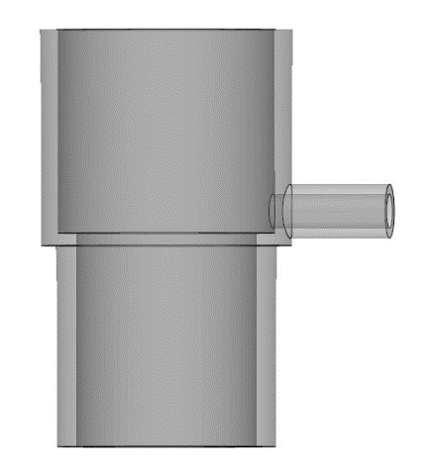 | 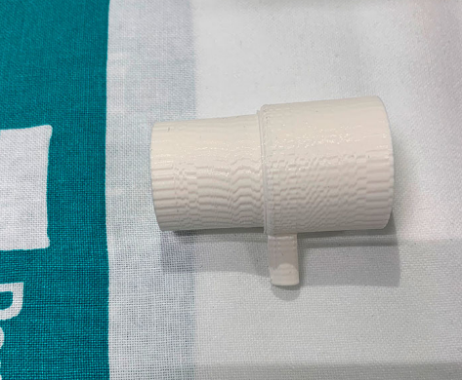
Airway connectors and replacements | 3DPT013
Airway connectors and replacements | 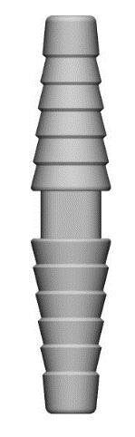 | 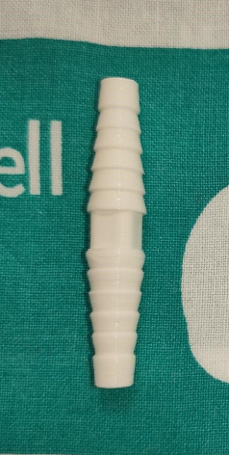
Airway connectors and replacements | 3DPT014
Airway connectors and replacements | 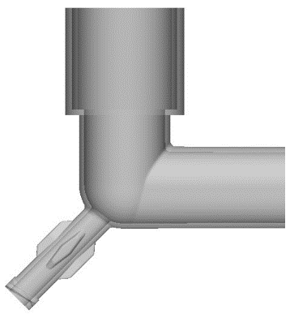 | 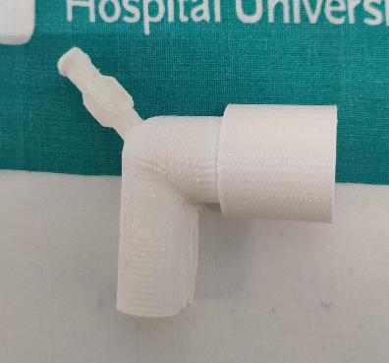
Airway connectors and replacements | 3DPT015
Airway connectors and replacements | 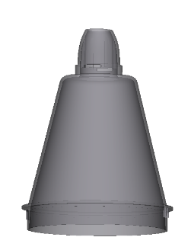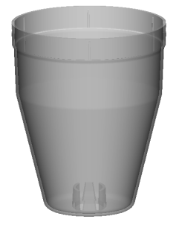 | 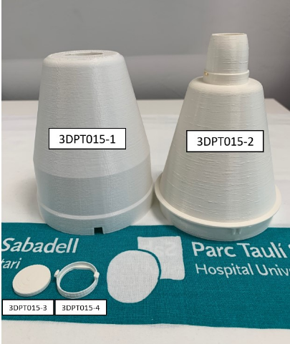

Airway connectors and replacements | 3DPT016
Airway connectors and replacements | 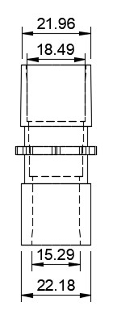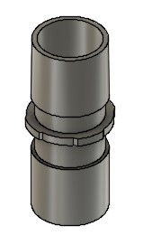 | 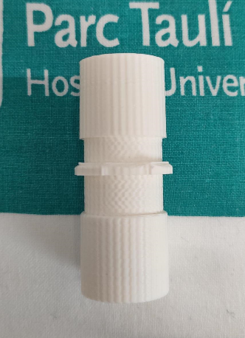
Airway connectors and replacements | 3DPT018
Airway connectors and replacements | 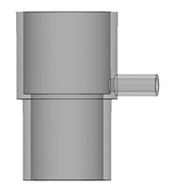 | 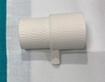
Airway connectors and replacements | 3DP019
Airway connectors and replacements | 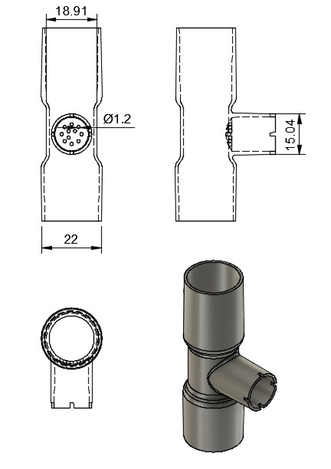 | 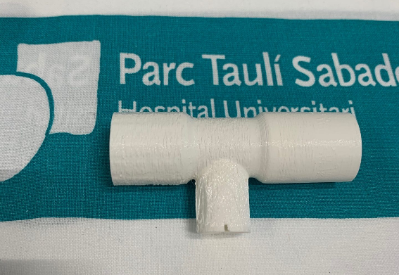

Airway connectors and replacements | 3DPT022
Airway connectors and replacements | 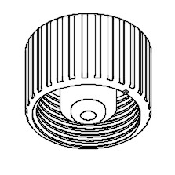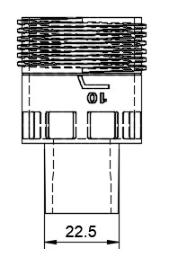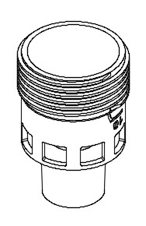 | 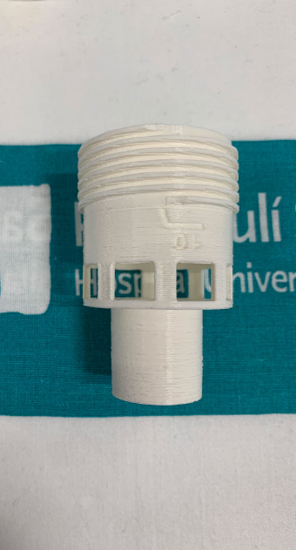
Airway connectors and replacements | 3DPT024
Airway connectors and replacements | 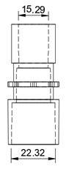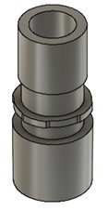 | 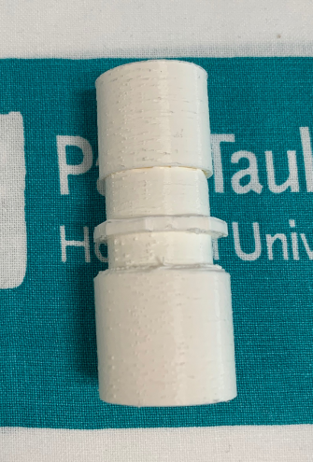
Airway connectors and replacements | 3DPT025
Airway connectors and replacements | 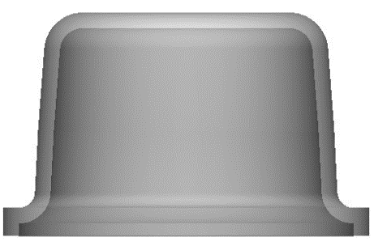 | 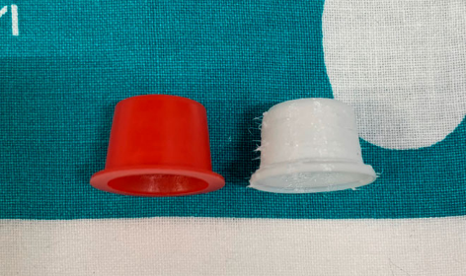
Airway connectors and replacements | 3DPT026
Airway connectors and replacements | 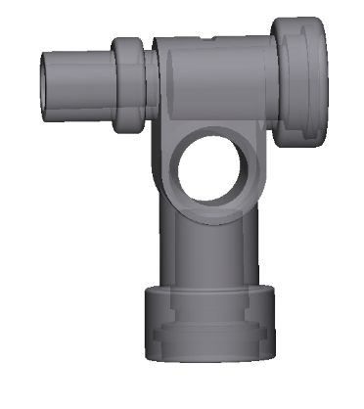 | 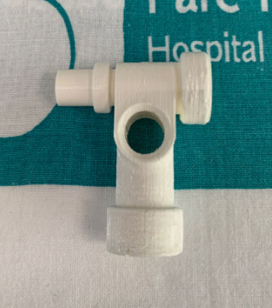
Airway connectors and replacements | 3DPT027
Airway connectors and replacements | 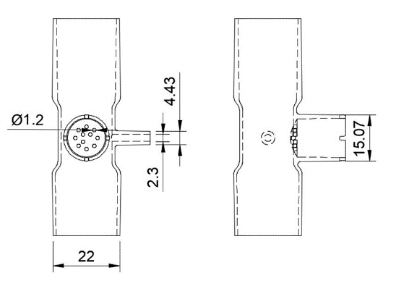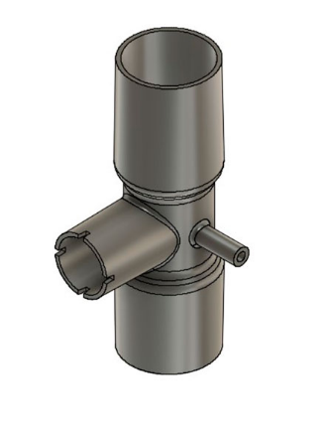 | 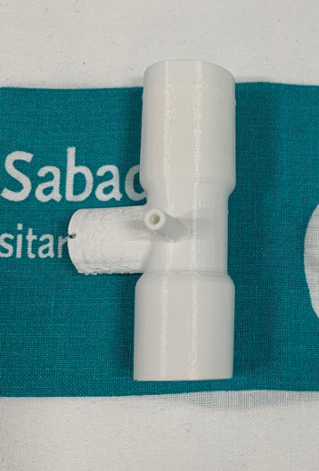
Protection and Prevention Systems | 3DPT002
Protection and Prevention Systems | 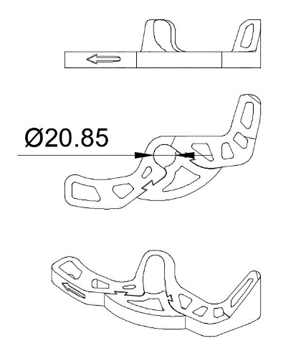 | 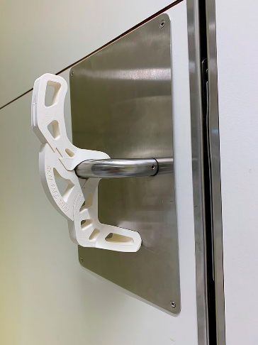
Protection and Prevention Systems | 3DPT020-HSJ
Protection and Prevention Systems | 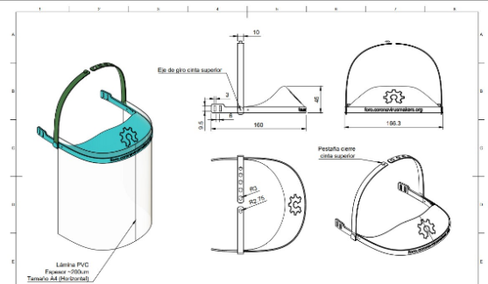 | 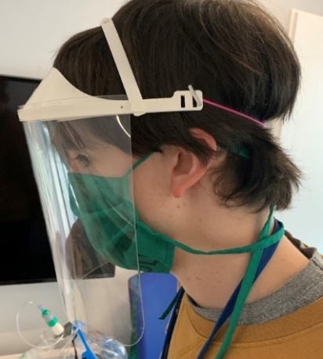

 | 3DPT031
 | 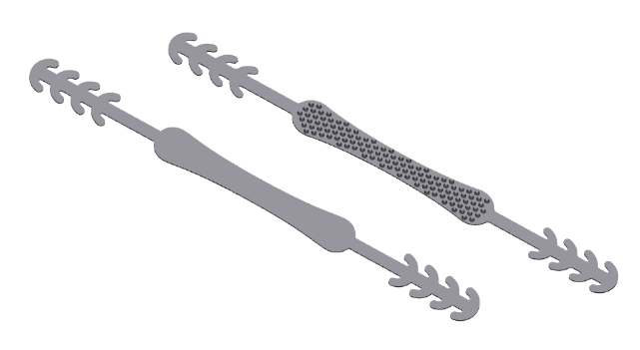 | 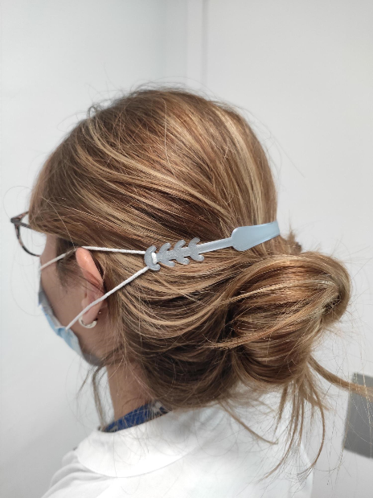
Non-invasive Ventilation | 3DPT021 (including 3DPT021-1 and 3DPT021-2)
Non-invasive Ventilation | 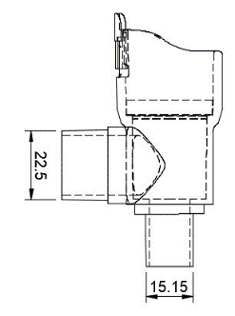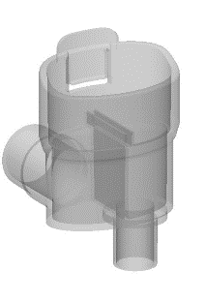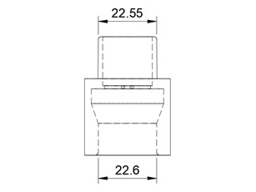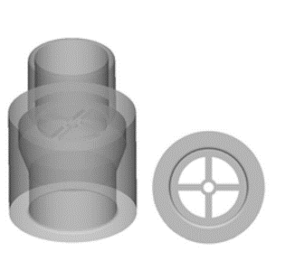 |  | 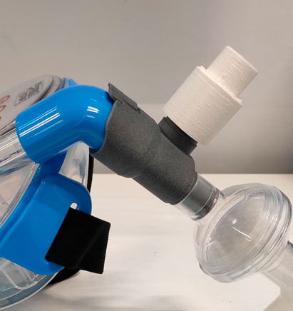
Non-invasive Ventilation | 3DPT023 (including 3DPT023-1 and 3DPT023-2)
Non-invasive Ventilation | 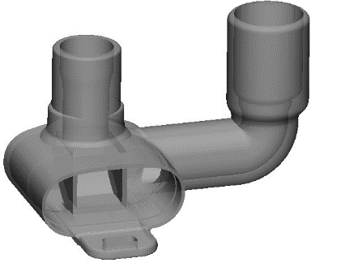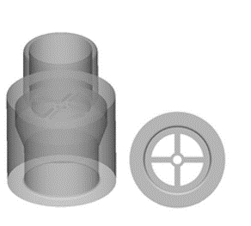 |  | 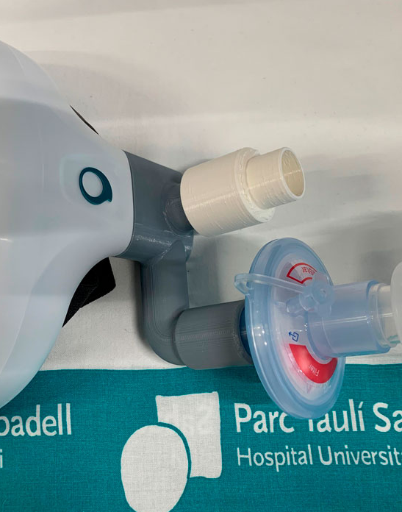

 | 3DPT033 (including 3DPT033-1 and 3DPT033-2)
 | 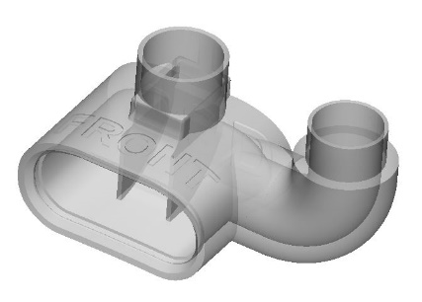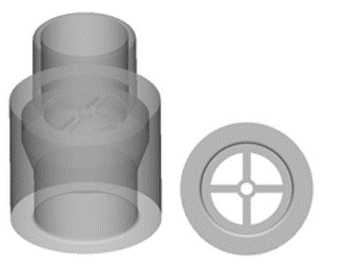 | 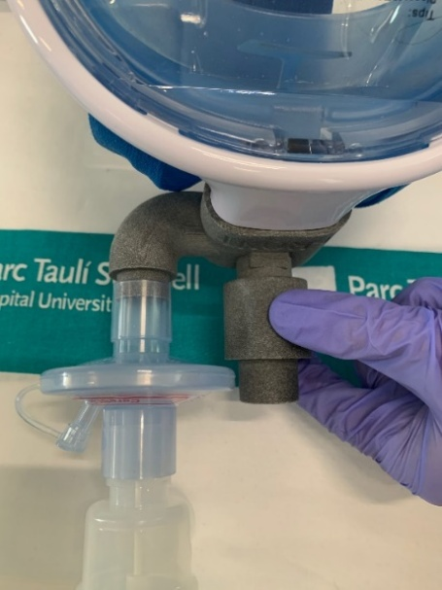

2.- Table S2.-Number, type, and material of items manufactured by 3D printing.
 | MATERIALS
ID | PA12 | PA2200 | Dental Photoreactive Resin | ABS Medical | PET-G | PC | PLA | Other Biocompatible Materials | Unknown materials or Origin | TOTAL
3DPT001 | 767 | 44 | 66 | 82 | 44 | - | 323 | 23 | 112 | 1461
3DPT002 | 1 | - | - | - | - | - | 161 | - | - | 162
3DPT005 | 332 | - | 346 | 395 | 148 | - | 320 | 17 | 95 | 1653
3DPT006 | 2 | - | 2 | - | 4 | - | - | 217 | 4 | 229
3DPT007 | 319 | - | 367 | 339 | 67 | - | 639 | 14 | 187 | 1932
3DPT008 | 243 | - | 186 | 133 | 2 | 30 | 1121 | 249 | 696 | 2660
3DPT009 | 240 | - | 151 | 39 | 2 | 50 | 1248 | 26 | 463 | 2219
3DPT010 | 146 | - | 70 | 53 | 3 | - | 202 | 26 | 31 | 531
3DPT011 | 178 | - | 113 | - | 3 | 30 | 93 | 19 | 7 | 443
3DPT012 | 143 | - | 47 | 73 | 18 | - | 134 | 29 | 20 | 464
3DPT013 | 626 | - | 259 | 1174 | 6 | - | 410 | 37 | 37 | 2549
3DPT014 | 165 | - | 86 | - | 2 | - | 177 | 30 | 44 | 504
3DPT016 | 11 | - | 156 | 108 | 1 | - | 201 | 130 | 29 | 636
3DPT018 | 21 | - | - | 114 | 5 | - | 89 | 244 | 43 | 516
3DPT019 | 42 | - | 8 | 102 | 39 | - | 347 | 269 | 100 | 907
3DPT020 | 1 | - | - | - | - | - | 187 | - | - | 188
3DPT021-1 | 185 | - | 65 | 23 | - | - | 21 | 75 | - | 369
3DPT021-2 | 239 | - | 67 | 31 | 133 | - | 72 | 68 | 66 | 676
3DPT022 | - | - | - | 20 | - | - | 10 | - | - | 30
3DPT023-1 | - | - | - | - | - | - | 10 | - | - | 10
3DPT023-2 | - | - | - | - | - | - | 10 | - | - | 10
3DPT024 | 24 | - | 2 | 69 | - | - | 183 | 104 | 41 | 423
3DPT025 | 2 | - | 43 | - | 294 | - | - | 1042 | 20 | 1401
3DPT026 | - | 61 | - | - | 2 | - | 36 | 43 | - | 142
3DPT027 | - | - | - | - | - | - | 85 | - | - | 85
3DPT029 | - | - | 4 | - | - | - | - | - | - | 4
3DPT031 | - | - | - | - | - | - | 1841 | - | - | 1841
3DPT033 | 4 | - | - | - | - | - | 4 | - | - | 8
Others | - | - | - | - | - | 30 | - | - | 110 | 140
TOTAL | 3691 | 105 | 2038 | 2755 | 773 | 140 | 7924 | 2662 | 2105 | 22193

Abbreviations: PA12, Polyamide 12; PA2200, Polyamide 2200; ABS, Acrylonitrile butadiene styrene; PET-G, Polyethylene terephthalate glycol; PC, Polycarbonate; PLA, Polylactic acid.

