Supplementary material for ‘Human tactile sensing and sensorimotor mechanism: from afferent tactile signals to efferent motor control’
*Corresponding author. Email: lei.ren@manchester.ac.uk and g.wei@salford.ac.uk

This PDF file includes:
Fig. S1. In-vivo grasping experiment.
Fig. S2. The neural activation levels predicted based on summarized transduction function compared with those computed based on the electromyography signals captured from the human subject.
Fig. S3. The neural activation level of the muscle synergy and contact pressure during the active and reactive grasping implemented by ATSS. The biological and neuromorphic 2nd order tactile afferent signals were also presented.
Fig. S4. The hardware setting of the artificial tactile sensory system.
Fig. S5. The computing of discrimination accuracy base on the neural features of spiking rate and Victor-Purpura distance.
Fig. S6. The artificial tactile sensory system mounted on the Kuka robotic arm.
Table. S1-5. The values of poles of the summarized transduction functions representing the sensorimotor control algorithm during active grasping. The cylindrical, spherical grasping and precision gripping were performed for five times and the corresponding transduction function was summarized.
Table. S6-10. The values of poles of the summarized transduction functions representing the sensorimotor control algorithm during reactive grasping. The cylindrical, spherical grasping and precision gripping were performed for five times and the corresponding transduction function was summarized.
Other Supplementary Material for this manuscript includes the following:
Movies. S1(.mp4 format). The neuromorphic afferent tactile signals and the response of tactile sensor during active grasping
Movies. S2(.mp4 format). Active grasping performed by the artificial tactile sensory system under sensorimotor control algorithm
Data. S1. The python code for restoring human-like sensorimotor performance on the artificial tactile sensory system.

Supplementary Materials:

Figs. S1.
(a)
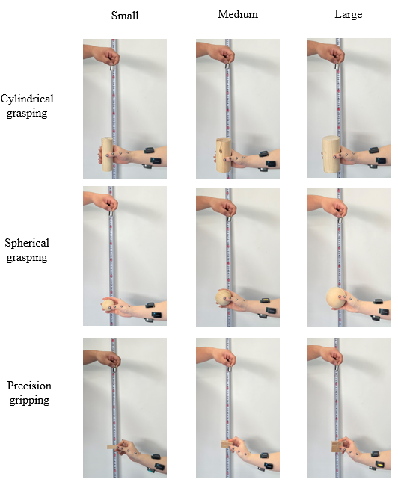
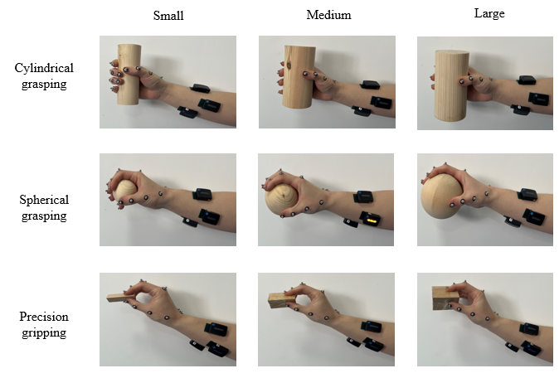
(b)
Fig. S1 In-vivo grasping experiment. (a) Active grasping. The cylinders, spheres and triangle prisms were actively grasped by the human subject from a table and lift up, hold for three seconds. The markers were placed on hand to record the kinematics by using Vicon system and the electromyography signals of the forearm muscles were captured by the Delsys Trigno. Three different sizes (small, large and medium size) of the objects were grasped in the experiment. (b). Reactive grasping. A 20g weight was lifted up to a specified altitude and dropped to the grasped object while the subject was blind folded and can only react to the external stimuli based on the tactile sensing. The cylindrical, spherical grasping and precision gripping were involved.

Figs. S2.
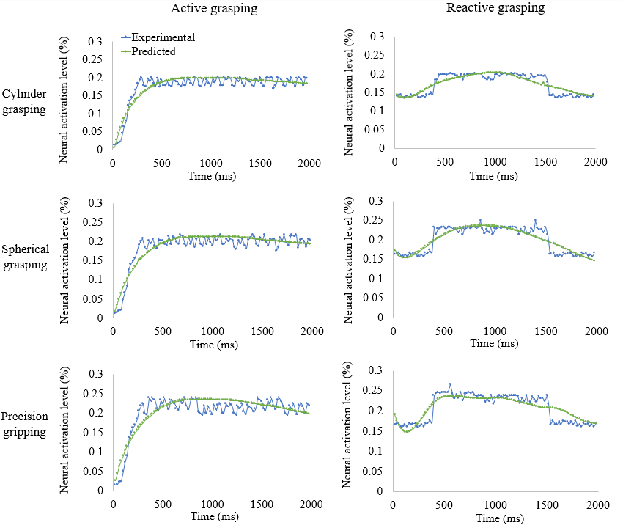
Fig. S2 The neural activation levels predicted based on summarized transduction function compared with those computed based on the electromyography signals captured from the human subject. The activation level over 2s of active and reactive grasping were predicted by input the 2nd order cuneate neural dynamics and summarized transduction function describe the sensory motor control strategy.

Figs. S3.
(a)
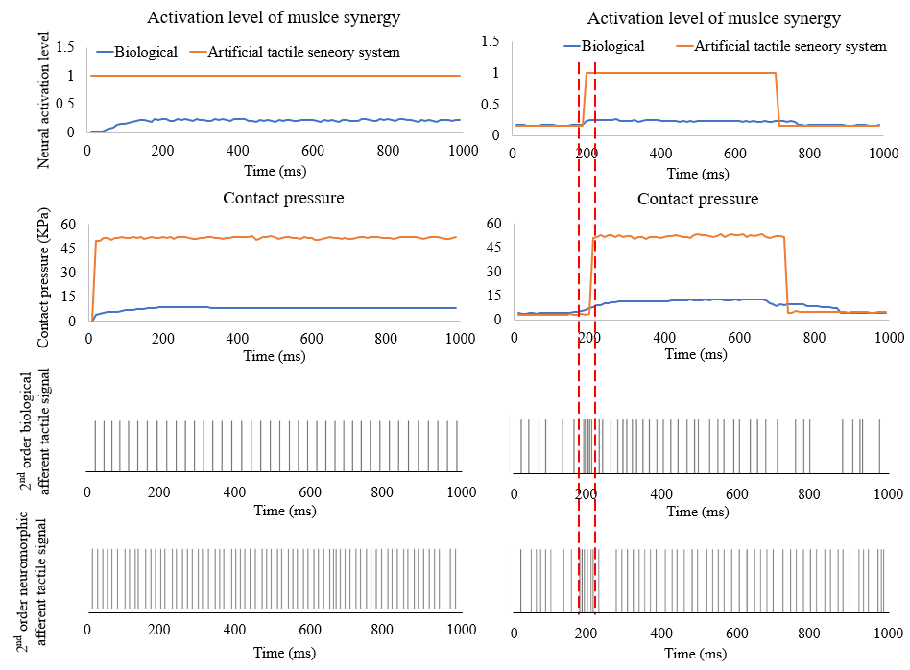
(b)
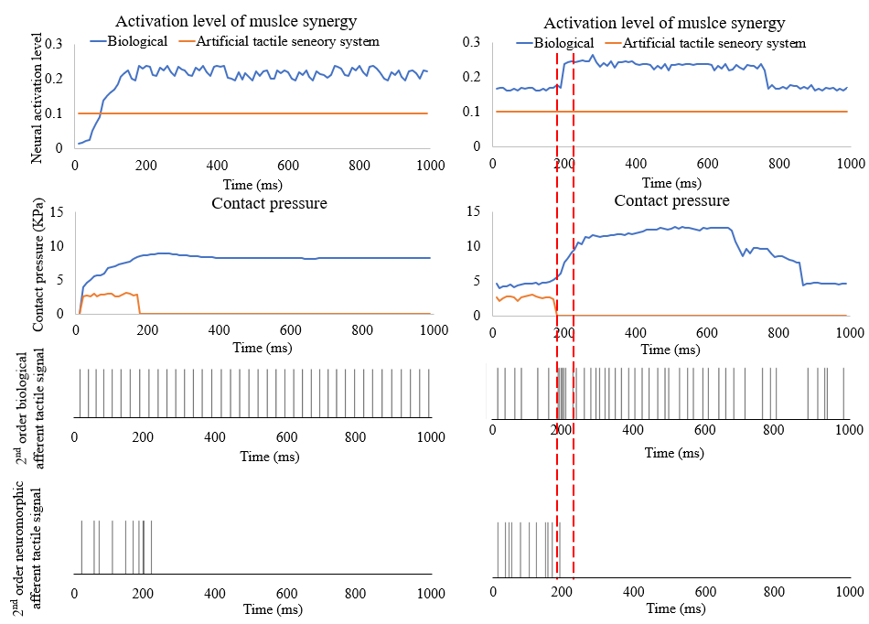
Fig. S3. The neural activation level of muscle synergy and contact pressure during the active and reactive grasping implemented by ATSS. The biological and neuromorphic 2nd order tactile afferent signals were also presented. (a). The contact pressure and afferent tactile signals under the highest neural activation level or maximum voluntary contraction forces. (b). The contact pressure and afferent tactile signals obtained under 10% of the maximum neural activation level of the muscle synergy. An unstable grasping was presented, and the grasped object failed from the biomimetic hand after the onset of the external impact, the contact pressure dropped to zero and no neuromorphic signal was observed after the falling of the object.

Figs. S4.
(b)
(a)
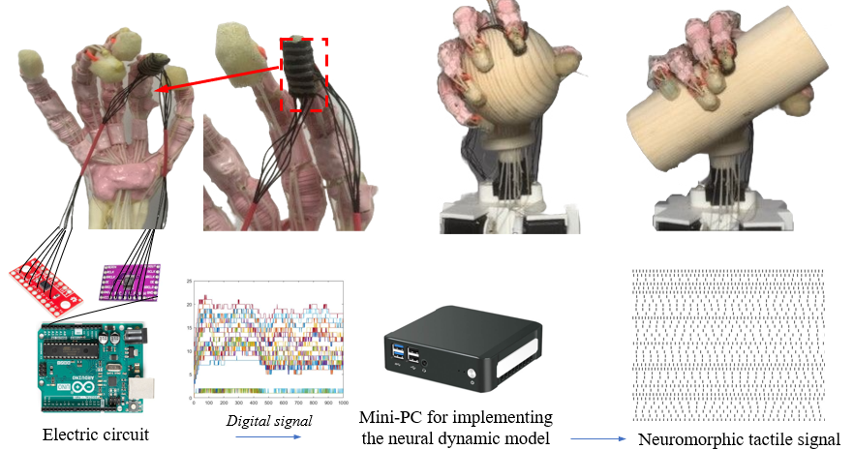
(c)
Fig. S4 The hardware setting of the artificial tactile sensory system. (a) the biomimetic hand with the tactile sensor array 3D printed on distal index phalange. (b) spherical and cylindrical grasping performed by the biomimetic hand without skin. (c) The electrical circuit for processing pressure signal of the tactile sensor. An Arduino Uno board was connected with shift registers and multiplexer for collecting and the analog signal and convert them to digital signal. the mini-PC embedded with the neural dynamic model was applied to process the digital pressure signal into the neuromorphic afferent tactile signals.

Figs. S5.
(a)
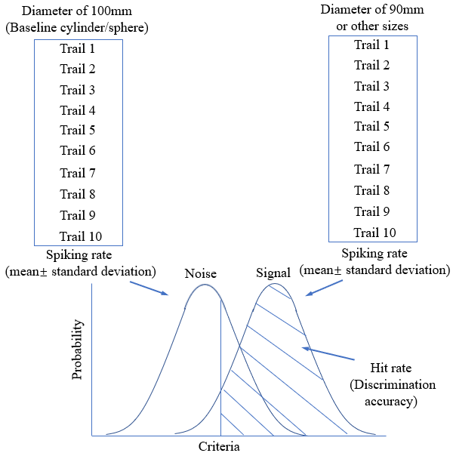

(b)
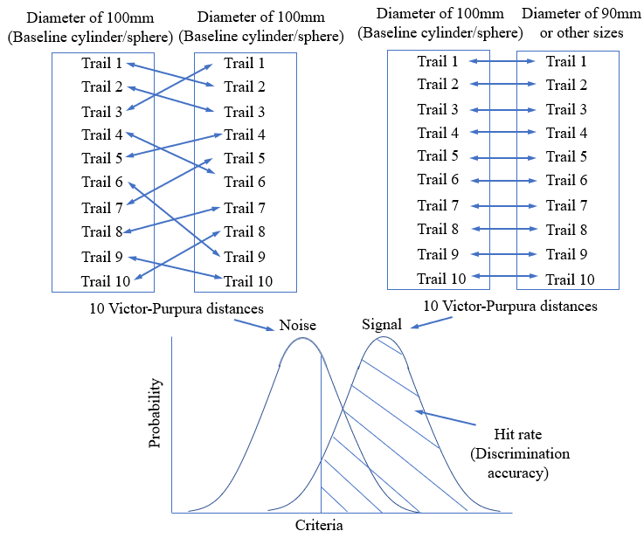
(b)

Fig. S5 The computing of discrimination accuracy is based on the neural features of spiking rate and Victor-Purpura distance. (a) the discrimination accuracy computed based on the rate coding. The neural dynamics evoked during the contact with the baseline object was recorded. The mean and standard deviation of the spiking rates under 10 trails were summarized as the ‘noise’ of the signal detin theory. while the mean and standard deviation of the spiking ate under contact with the objects for discrimination from the baseline object were regarded as the ‘signal’ of SDT. (b) The discrimination accuracy was computed based on Victor-Purpura distance. The ‘noise’ of signal detection theory was defined as the Victor-Purpura distance among the tactile signals under 10 times of touching the baseline objects. Victor-Purpura distances of the neural dynamics evoked during touching the baseline and other objects with diameters below 100mm were regarded as the ‘signal’ of SDT to evaluate the discrimination accuracy, a totally of 100 Victor-Purpura distances were computed. All the cylinders were percept for 10 times, The Victor-Purpura distances between the neuromorphic tactile signals evoked by contacting the cylinders with the diameter of 100 and 90mm, 100 and 80mm, 100 and 70mm, 100 and 60mm, 100 and 50mm. The same method was adopted to compute the discrimination accuracy of recognizing the spheres with different diameters. Therefore, there were a totally of 50 Victor-Purpura distances for differentiating cylinders and another 50 for spheres from the baseline objects. For the in-vivo discrimination test, the subject was blindfolded and asked to sit before the table, the cylinders or spheres were presented in pairs, either with the same or different diameters. The subject was required to judge whether the pair of cylinders or spheres were the same or not. Only the index finger was allowed to touch the objects with the wrist of the subject was fixed. The test was carried out in blocks, each block contained 20 comparisons (10 pairs of 50mm-50mm object and 10 pairs of 50mm-60mm or other diameters, spheres or cylinders with all five different diameters were presented in each session), and the pair of surfaces varied randomly from block to block. In total, 10 blocks were performed (5 blocks for cylinders and 5 for spheres). The probability of detection was calculated for each cylinder or sphere, the whole test was repeated 3 times to achieve the generality. Before the test, a few practice blocks were performed to train the subjects and ensure the reliability of the experimental results. This in-vivo discrimination test was conducted based on the work of Goodwin et al [1].

Figs. S6.
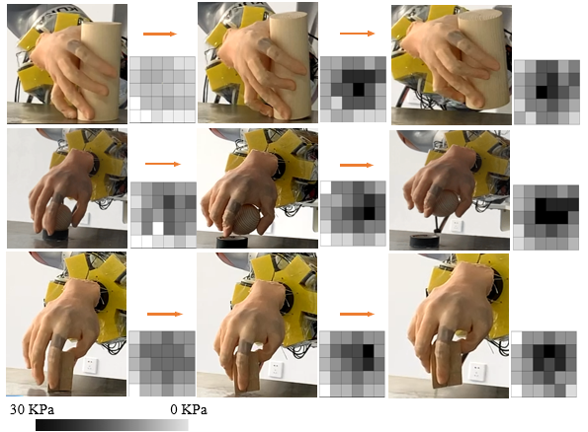
Fig. S6 The cylindrical, spherical grasping and precision gripping were performed by the ATSS. A customized graphical user interface (GUI) was developed to visualize the pressure distribution across the 36 tactile sensing elements mounted on the index of the biomimetic hand. the magnitude of the contact pressure was presented using the greyscale. The active grasping was shown in three stages: before contact, contact in adjustment and stable grasping.

Table S1. The values of poles of the transduction function representing active grasping (Trail 1)
Size | Precision gripping | Cylindrical grasping | Spherical grasping
Small | -0.008784216 | -0.00682638 | -0.005668753
 | -0.004143534 | -0.003751466 | -0.005842522
Medium | -0.007874663 | -0.006210732 | -0.00436093
 | -0.003202536 | -0.00351441 | -0.004313552
Large | -0.00684563 | -0.00506776 | -0.002856651
Large | -0.002559255 | -0.002689282 | -0.003141594

Table S2. The values of poles of the transduction function representing active grasping (Trail 2)
Size | Precision gripping | Cylindrical grasping | Spherical grasping
Small | -0.008685678 | -0.00664576 | -0.00586757
 | -0.004065756 | -0.00369853 | -0.00590674
Medium | -0.007767867 | -0.006210732 | -0.00463467
 | -0.003346784 | -0.003746867 | -0.00474875
Large | -0.00696577 | -0.005124354 | -0.00290675
 | -0.00335746 | -0.00274566 | -0.00305687

Table S3. The values of poles of the transduction function representing active grasping (Trail 3)
Size | Precision gripping | Cylindrical grasping | Spherical grasping
Small | -0.008566834 | -0.006578456 | -0.00557345
 | -0.003865768 | -0.003605346 | -0.005735788
Medium | -0.007344556 | -0.00579548 | -0.00426645
 | -0.00297345 | -0.00326875 | -0.00415645
Large | -0.00646895 | -0.00478073 | -0.002645783
 | -0.00286546 | -0.00245732 | -0.00285577

Table S4. The values of poles of the transduction function representing active grasping (Trail 4)
Size | Precision gripping | Cylindrical grasping | Spherical grasping
Small | -0.00826898 | -0.00726834 | -0.005255256
 | -0.004345663 | -0.00414354 | -0.00602465
Medium | -0.007957897 | -0.00607568 | -0.004046835
 | -0.00347696 | -0.00394679 | -0.004638657
Large | -0.00727783 | -0.00547691 | -0.002578525
 | -0.00306746 | -0.00326816 | -0.003453416

Table S5. The values of poles of the transduction function representing active grasping (Trail 5)
Size | Precision gripping | Cylindrical grasping | Spherical grasping
Small | -0.008256876 | -0.00658678 | -0.00536768
 | -0.00456856 | -0.00396478 | -0.00595678
Medium | -0.007874663 | -0.006210732 | -0.00418794
 | -0.003202536 | -0.00370479 | -0.00445686
Large | -0.00637683 | -0.00478378 | -0.002689468
 | -0.003578937 | -0.00295789 | -0.00326873

Table S6. The values of poles of the transduction function representing reactive grasping (Trail 1)
Size | Precision gripping | Cylindrical grasping | Spherical grasping
Small | -0.01651144 | -0.027385004 | -0.016888312
 | -0.001634424 | -0.000927904 | -0.00375288
 | 0.011566456 | 0.006123652 | 0.013985422
Medium | -0.01531046 | -0.024251904 | -0.014439256
 | -0.001377552 | -0.000625522 | -0.00254328
 | 0.010083395 | 0.005910711 | 0.01316537
Large | -0.01373746 | -0.021380905 | -0.012309367
 | -0.001145848 | -0.000426679 | -0.00132144
 | 0.01563545 | 0.000736416 | 0.014695521

Table S7. The values of poles of the transduction function representing reactive grasping (Trail 2)
Size | Precision gripping | Cylindrical grasping | Spherical grasping
Small | -0.018352421 | -0.031056253 | -0.01763252
 | -0.001761632 | -0.001138205 | -0.00416052
 | 0.012515625 | 0.00706522 | 0.015069241
Medium | -0.017569525 | -0.027296232 | -0.01635241
 | -0.001426582 | -0.001194522 | -0.0028602
 | 0.011653006 | 0.006291475 | 0.014925411
Large | -0.015635226 | -0.02390054 | -0.013526241
 | -0.001262466 | -0.000562342 | -0.001563521
 | 0.017523696 | 0.000923852 | 0.016752632

Table S8. The values of poles of the transduction function representing reactive grasping (Trail 3)
Size | Precision gripping | Cylindrical grasping | Spherical grasping
Small | -0.01762525 | -0.029526041 | -0.016888312
 | -0.001752324 | -0.000927904 | -0.00375288
 | 0.01206221 | 0.006123652 | 0.014262005
Medium | -0.016721605 | -0.024251904 | -0.015232052
 | -0.001410625 | -0.000625522 | -0.002705621
 | 0.012620982 | 0.005910711 | 0.015252452
Large | -0.014160663 | -0.021380905 | -0.013056545
 | -0.001350457 | -0.000426679 | -0.001546586
 | 0.016106235 | 0.000736416 | 0.012182547

Table S9. The values of poles of the transduction function representing reactive grasping (Trail 4)
Size | Precision gripping | Cylindrical grasping | Spherical grasping
Small | -0.014412963 | -0.024012336 | -0.015984216
 | -0.001466923 | -0.000851053 | -0.003501365
 | 0.010362521 | 0.005801547 | 0.012810542
Medium | -0.014262582 | -0.02120136 | -0.013980147
 | -0.001377552 | -0.000590333 | -0.002102681
 | 0.009153621 | 0.005510214 | 0.012001562
Large | -0.012893025 | -0.019845633 | -0.011930217
 | -0.001004153 | -0.000400133 | -0.00132144
 | 0.014580521 | 0.000685405 | 0.01381652

Table S10. The values of poles of the transduction function representing reactive grasping (Trail 5)
Size | Precision gripping | Cylindrical grasping | Spherical grasping
Small | -0.017013652 | -0.029253625 | -0.017963521
 | -0.001762141 | -0.001003266 | -0.004163205
 | 0.013015625 | 0.00656352 | 0.01426352
Medium | -0.016321101 | -0.0285232 | -0.016223521
 | -0.001413601 | -0.000712232 | -0.00352423
 | 0.01266202 | 0.006982336 | 0.01316537
Large | -0.014011034 | -0.025897145 | -0.014652025
 | -0.001293552 | -0.000426679 | -0.001932052
 | 0.016954241 | 0.000736416 | 0.015793611

