916 Appendix A. Methods
917 In this section, we describe the procedure for selecting hyper-parameters for various algorithms for the
918 online Permuted MNIST and Imagent problems.
919 In online permuted MNIST, we tested a wide range of hyperparameters settings for each method. In
920 Figure A.8 we show three different hyperparameter settings for each different algorithm. The performance
921 followed a similar trend for other hyperparameters values. All the algorithms used a step size of 0.003,
922 which was the best-performing step size for backpropagation in Figure 2b (Left). In the case of shrink-
923 and-perturb, the scaling factor was set to the same value as the best regularization parameter found for
924 L²-regularization, which is a suitable choice because shrink-and-perturb is equivalent to L²-regularization
925 with parameter noise.
926 Due to limited computational resources, we only used ten runs for the hyperparameter sweep. For
927 all the methods except for dropout, we selected the hyperparameter setting that resulted in the highest
928 average percent correct during the whole training period and ran 20 more runs with that hyperparameter
929 value. For dropout, we selected a dropout probability of 0.1 instead of the hyperparameter setting with
930 the highest online classification accuracy. We did this because the hyperparameter setting with the highest
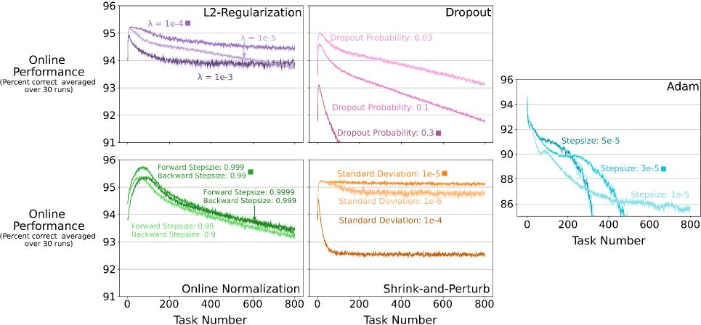
Figure A.8: Parameter sensitivity of various algorithms on Online Permuted MNIST. In clockwise order and starting from the top left plot, the online classification accuracy of backpropagation with L²-regularization, Dropout, Adam, Shrink-and-Perturb, and Online Normalization for various hyperparameter combinations. For each method, we show three different hyperparameter settings. The parameter settings that were used in the main body of the paper are marked with a solid square next to their label. All the lines for online norm correspond to 3 independent runs. All the other lines correspond to the average of 10 runs. The shaded regions correspond to plus and minus one standard error.
34

hyperparameter Selection in Continual ImageNet
Algorithm Name | values of step size | values of weight decay /replacement-rate | values of noise-variance
L²-regularization Shrink-and-perturb Continual backpropagation | {0.1, 0.03, 0.01, 0.003}  {0.03, 0.01}  {0.03, 0.01} | {3e-5, 1e-5, 3e-6, 1e-6} {3e-5, 1e-5, 3e-6, 1e-6} {3e-3, 1e-3, 3e-4, 1e-4, 3e-5} | Not applicable  {1e-4, 1e-5, 1e-6, 1e-7}  Not applicable

Table A.2: Values of hyperparameters used for the gird searches to find the best set of hyperparameters for all algorithms tested on Continual ImageNet. The best-performing set of values for each algorithm is boldened.
931 online classification accuracy was 0.03, which performs the same and is almost the same algorithm as
932 backpropagation and would not be representative of the behaviour of dropout.
933 The parameter sweep for continual backpropagation is presented in the main body of the paper (6, right).
934 It follows the same experimental design except that all the lines in the plot correspond to the average over
935 30 runs.
936 We now describe the hyperparameter selection for L²-regularization, shrink-and-perturb, and continual
937 backpropagation on Continual ImageNet. The main text presents the results for these algorithms on
938 Continual ImageNet in Figure 7. We performed a grid search for all algorithms to find the best set of
939 hyperparameters. The values of hyperparameters used for the grid search are described in Table A.2
940 L²-regularization has two hyperparameters, step size and weight decay. Shrink-and-perturb has three
941 hyperparameters, step size, weight decay, and noise variance. We swept over two hyperparameters of
942 continual backpropagation, step size and replacement rate. The maturity threshold in continual backpropagation
943 was set to 100 for all sets of hyperparameters. For both backpropagation and L²-regularization, the
944 performance was poor for step sizes of 0.1 or 0.003. So, we chose to only use step sizes of 0.03 and 0.01
945 for continual backpropagation and shrink-and-perturb. We performed ten independent runs for all sets of
946 hyperparameters. We chose the set of hyperparameters with the highest average classification accuracy over
947 5000 tasks as the best-performing set of hyperparameters for a given algorithm. Then we performed 20
948 additional runs to complete 30 runs for the best-performing set of hyperparameters to produce the results
949 in Figure 7.
950 Appendix B. Data and Code Availability
951 The datasets used in this work are publicly available. They can be found using their corresponding
952 citation. The code to replicate all the experiments in this paper will be made publicly available during
953 publication.
35

954 Appendix C. Loss of Plasticity With Different Activations in the Slowly Changing Regression
955 Problem
956 There remains the issue of the network’s activation function. We have been using ReLU, the most
957 popular choice at present, but there are a number of other possibilities. For these experiments, we switched
958 to an even smaller, more idealized problem. Slowly-Changing Regression is a computationally inexpensive
959 problem where we can run a single experiment on a CPU core in 15 minutes, allowing us to do extensive
960 studies. As its name suggests, this problem is a regression problem—meaning the labels are real numbers,
961 with a squared loss, rather than nominal values with a cross-entropy loss—and the nonstationarity is slow
962 and continual rather than abrupt as in a switch from one task to another. In Slowly-Changing Regression,
963 we study loss of plasticity for networks with six popular activation functions: sigmoid, tanh, ELU [89],
964 leaky-ReLU [90], ReLU [91], and Swish [92].
965 In Slowly-Changing Regression, the learner receives a sequence of examples. The input for each example
966 is a binary vector of size m + 1. The input has f slow-changing bits, m - f random bits, and then one
967 constant bit. The first f bits in the input vector change slowly. After every T examples, one of the first f
968 bits is chosen uniformly at random, and its value is flipped. These first f bits remain fixed for the next T
969 examples. The parameter T allows us to control the rate at which the input distribution changes. The next
970 m - f bits are randomly sampled for each example. Lastly, the (m + 1)-th bit is a bias term with a constant
971 value 1.
972 The target output is generated by running input through a neural network, which is set at the start
973 of the experiment and kept fixed. As this network generates the target output and represents the desired
974 solution, we call it the target network. The weights of the target networks are randomly chosen to be +1
975 or -1. The target network has one hidden layer with a Linear Threshold Unit [93], or LTU, activation. The
976 value of the i-th LTU is one if the input is above a threshold Oi, and zero otherwise. ai is set equal to
977 (m+ 1) · [3 - Si, where E [0,1] and Si is the number of input weights with negative value [94]. The details
978 of the input and target function in the slowly-changing regression problem are also described in Figure C.9a.
979 The details of the specific instance of the slowly-changing regression problem we use in this paper and
980 the learning network used to predict its output are listed in Figure C.9b. Note that the target network
981 is more complex than the learning network as the target network is wider, with 100 hidden units, while
982 the learner has just five hidden units. Thus, because the input distribution changes every T example and
983 the target function is more complex than what the learner can represent, there is a need to track the best
984 approximation.
985 We applied learning networks with different activation functions to the slowly-changing regression. The
986 learner used the backpropagation algorithm to learn the weights of the network. We used uniform Kaiming
987 distribution [70] to initialize the learning network’s weights. The distribution is U(-b, b) with bound,
36

0 1.5M 3M 0 1.5M 3M 0 1.5M 3M

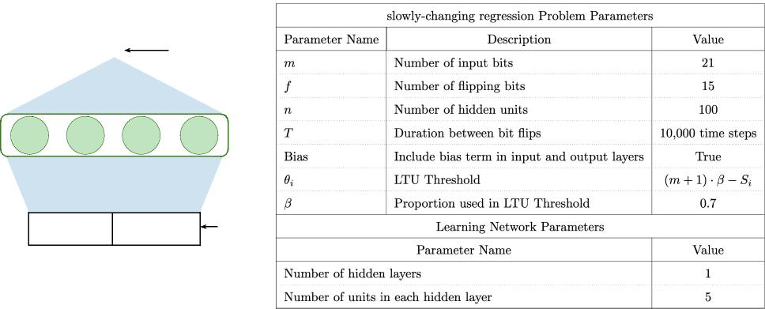
a b
Y Output
Weights ~ U{-1, 1}
x₁ ... x_{f}
flipping bits i.i.d. bits
Input
...
x_{m}
^{x}f+1
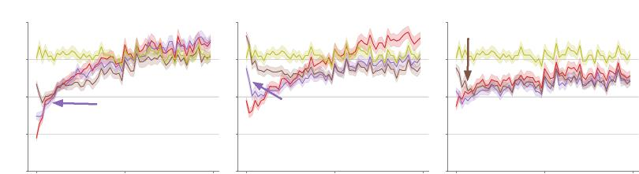
Sigmoid ELU
Tanh
Step size=0.001
Linear
Linear
Linear
Step size=0.001
Step size=0.001
Step size=0.01
Step size=0.01
Step size=0.003
Step size=0.01
Step size=0.003
Step size=0.003
1.0
0.8
0.6
0.4
0.2
c
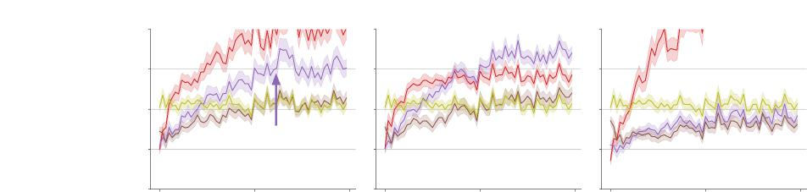
Squared Error (Bins of 40k)
ReLU Leaky-ReLU Swish
Step size=0.01
Linear
Linear
Step size=0.001
Step size=0.003
Step size=0.001
Step size=0.003
Step size=0.001
Step size=0.003
Linear
Step size=0.01
Step size=0.01
1.2
1.0
0.8
0.6
0.4
Example Number
Figure C.9: a: The target function and the input in the Slowly-Changing Regression problem. The input has m + 1 bits. One of the flipping bits is chosen after every T time steps, and its value is flipped. The next m - f bits are i.i.d. at every time step. And, the last bit is always one. The target function is represented by a neural network with a single hidden layer of LTUs. Each weight in the target network is -1 or 1. b: Implementation details for the slowly-changing regression problem and the learning network. c: Loss of plasticity is robust across different activations.
37

, where gain is chosen such that the magnitude of inputs does not change across
_{q} 3
988 b = gain ⇤ num inputs
layers. For tanh, Sigmoid, ReLU, and Leaky-ReLU, gain is 5/3, 1, v'2, and p
989 2/(1 + ↵²) respectively. For
990 ELU and Swish, we used gain = v'2, as was done in the original papers [89, 92].
991 We ran the experiment on the Slowly-changing regression problem for 3M examples. For each activation
992 and value of step size, we performed 100 independent runs. First, we generated 100 sequences of examples
993 (input-output pairs) for the 100 runs. Then these 100 sequences of examples were used for experiments with
994 all activations and values of the step size parameter. We used the same sequence of examples to control the
995 randomness in the data stream across activations and step sizes.
996 The results of the experiments are shown in Figure C.9c. We measured the squared error, the square
997 of the difference between the true target and the prediction made by the learning network. In Figure C.9c,
998 the squared error is presented in bins of 40k examples. This means that the first data point is the average
999 squared error on the first 40k examples, the next is the average squared error on the next 40k examples, 1000 and so on. The shaded region in the Figure shows the standard error of the binned error.
1001 Figure C.9c shows that in Slowly-changing regression, after performing well initially, the error increases
1002 for all step sizes and activations. For some activations like ReLU and tanh, loss of plasticity is severe, and 1003 the error increases to the level of the linear baseline. While for other activations like ELU, loss of plasticity 1004 is less severe, but still there is a significant loss of plasticity. These results mean that the loss of plasticity 1005 is not resolved by using commonly used activations.
1006 Appendix D. Extension to a continual RL problem, Slippery Ant
1007 One of the major consumers of ideas in continual learning is the field of reinforcement learning as there
1008 are many sources of non-stationarity in reinforcement learning. In this section, we explore if the findings from 1009 continual supervised learning transfer to continual reinforcement learning (RL). However, a full exploration 1010 of this idea is beyond the scope of the current work. Fully exploring the issue of loss of plasticity in 1011 reinforcement learning is much harder because many additional confounders arise in reinforcement learning, 1012 and proper empirical research will require an extensive parameter sweep over tens of hyperparameters in 1013 each algorithm. So, the results in this section are preliminary as we did not perform full parameter sweeps 1014 in this section.
1015 We developed a new continual RL problem, Slippery-Ant. Slippery-Ant is a continual variant of
1016 Pybullet’s [95] Ant problem. A continual variant is needed as the problems in Pybullet are stationary. 1017 In our problem, the environment changes after a pre-specified time, making it necessary for the learner to 1018 adapt. We change the friction between the agent and the ground of the standard Pybullet Ant problem. In 1019 the standard problem, the value of friction is 1.5. After every 10M time steps, we change the friction by 1020 log-uniformly sampling it from [10⁻⁴, 10⁺⁴].
38

1021 We used the PPO algorithm [55] to solve the 1022 Slippery-Ant problem. Two separate networks were 1023 used for the policy and the value function, and both 1024 had two hidden layers with 256 units. These networks 1025 had tanh activation as it performs the best with on-1026 policy algorithms like PPO [96]. The networks were 1027 trained using Adam alongside PPO to update the 1028 weights in the network.

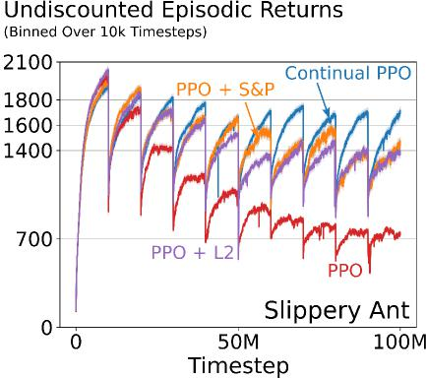
Figure D.10: Performance of PPO, which is based on backpropagation, degraded rapidly on slippery Ant. In contrast, all three Continual PPO, PPO+S&P, and PPO+L² perform substantially better than PPO. Continual PPO performed best and only had a minimal drop in performance over the 100M time steps.
1029 To combine continual backpropagation with 1030 PPO, we used continual backpropagation instead of 1031 back-propagation to update the networks’ weights. 1032 Whenever the weights are updated using Adam, we 1033 also update them using generate-and-test. We call the 1034 resulting algorithm Continual PPO, and we describe 1035 it in Appendix F.
1036 All the algorithms that we tested are built on PPO 1037 and we used a standard set of parameters for PPO. In 1038 addition to the parameters for PPO, all algorithms 1039 require us to choose additional parameters. For L², we chose the best weight decay. For S&P, we chose 1040 the best perturb for the value of weight decay found for L². And for continual PPO, we chose the best 1041 replacement rate, maturity threshold pair. All parameter settings in are described in Appendix F. All other 1042 parameters were the same in PPO, PPO+L², PPO+S&P and continual PPO. The performance of PPO, 1043 PPO+L², PPO+S&P and continual PPO for Lecun initialization [97] on Slippery Ant is shown in Figure 1044 D.10. The results are averaged over 100 runs.
1045 The performance of PPO degrades dramatically as the environment changes in Slippery Ant. Whenever 1046 the environment changes, there will be a drop in performance as the agent has to learn a new policy. Due to 1047 these sudden drops the performance plot looks like a saw tooth, where each tooth shows the performance on 1048 one task. Across tasks, the performance that the PPO agent drops dramatically. This degradation is similar 1049 to the degradation of backpropagation’s performance on continual supervised learning problems, where it 1050 performs well initially, but its performance gets worse over time. This similarity with the performance of 1051 backpropagation is not surprising as backpropagation lies at the foundation of modern deep reinforcement 1052 learning algorithms like PPO.
1053 All three continual PPO, PPO+S&P, and PPO+L² perform substantially better than PPO, and continual 1054 PPO performs best, where it continually performs almost as well as it does initially. There is still a small 1055 performance drop with continual PPO, which could be due to the additional confounders introduced by
39

1056 PPO. Fully understanding the mitigating loss of plasticity in continual RL problems is an important open 1057 avenue for future work.
1058 In this section, we performed preliminary experiments in a reinforcement learning problem. These 1059 preliminary results in continual reinforcement learning problems are largely consistent with those in continual 1060 supervised learning problems. The fact that continual PPO does not fully maintain plasticity is interesting 1061 and worthy of future exploration. Additionally, we showed that continual backpropagation can be directly 1062 combined with existing algorithms. Continual PPO is an example of how to create continual variants of 1063 existing deep reinforcement learning algorithms.
1064 Appendix E. Ablation Study for the utility measure
1065 The overall utility measure consists of two parts, the contribution utility and the adaptation utility. We 1066 compared various parts of the utility measure on the Slowly-changing regression problem. We use a learning 1067 network with tanh activation and Adam with a step size of 0.01. We also compare our utility measure with 1068 random utility and weight-magnitude-based utility. The results for this comparison are presented in Figure 1069 E.11. We compared the following utility measures.
- Random utility: Utility, r at every time step is uniformly randomly sampled from U[0,1] rl,i,t = rand(0,1)
- Weight-magnitude based utility: wm at every time step is updated as:
nl
+1
_{X}
k=1
wml,i,t = (1 - ⌘) *
|wl,i,k,t| + ⌘* wml,i,t⠀1
1070 • Contribution utility, c, at every time step is updated as described in Equation 2
1071 • Mean corrected contribution utility, z, at every time step is updated as described in Equation 3
- Adaptation utility, a, at every time step is updated as:
1
al,i,t = (1 - ⌘) *Pnl⠀1
j=1 |wl,j,i,t | + ⌘ * al,i,t-1
1072 • Overall utility, u ,at every time step is updated as described in Equation 6
1073 The results for various utility measures are presented in Figure E.11. The results show that all the 1074 components of our utility measure are needed for the best performance. They also show that our utility 1075 measure performs significantly better than random utility and weight-magnitude utility.
1076 Next, we compared the two best-performing utility measures from the slowly changing regression, overall 1077 and mean-corrected contribution, on Slippery Ant. The results are presented in Figure E.12. The results
40

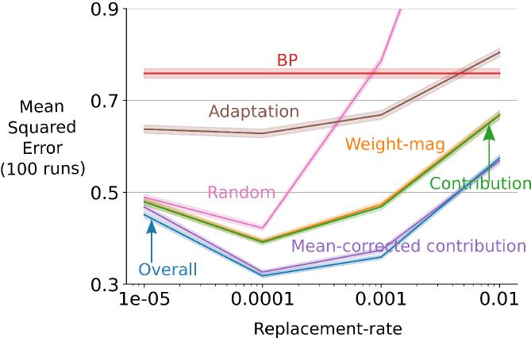
Figure E.11: Parameter sweep for various utility measures on the slowly-changing regression problem. The overall utility measure performs better than all other measures of utility, including the weight-magnitude utility and random utility.
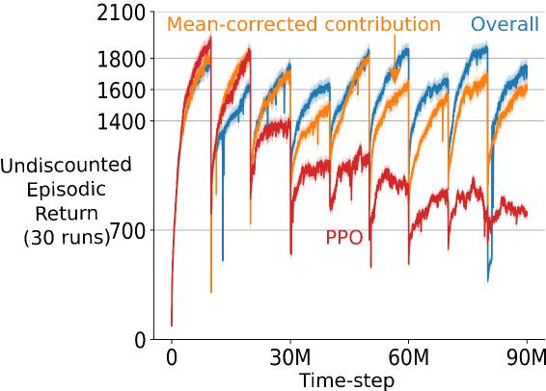
Figure E.12: Continual PPO with overall utility and mean-corrected contribution utility on Slippery Ant. Both utility measures significantly outperformed PPO and overall utility performed better than mean-corrected contribution utility.

41

1078 show that both utility measures perform significantly better than PPO. But, the overall utility performs 1079 significantly better than the other utility measure. This difference is more pronounced near the end when 1080 continual PPO with the overall utility measure performs almost as well as at the beginning.
1081 Appendix F. Continual PPO
1082 We used the following values of the parameters for PPO, PPO+L² and Continual PPO in our experiments 1083 on our non-stationary RL problem. For Continual PPO and PPO+L² specific parameters, we chose the 1084 best-performing values.
1085 • Policy Network: (256, tanh, 256, tanh, Linear) + Standard Deviation variable
1086 • Value Network (256, tanh, 256, tanh, linear)
1087 • iteration size: 4096
1088 • num epochs: 10
1089 • mini-batch size: 128
1090 • GAE, A: 0.95
1091 • Discount factor, 7: 0.99
1092 • clip parameter: 0.2
1093 • Optimizer: Adam
1094 • Optimizer step size: 1e - 4
1095 • Optimizer Os: (0.9, 0.999)
1096 • weight decay (for L²): {10⁻³, 10⁻⁴, 10⁻⁵, 10⁻⁶}
1097 • replacement rate, maturity threshold (for CPPO): {(10⁻³, 1e2), (10⁻³, 5e2), (10⁻⁴, 5e3),
1098 (10⁻⁴,5e2), (10⁻⁵, 1e4), (10⁻⁵, 5e4)}
1099 PPO uses the Adam optimizer. To properly use Adam with continual backpropagation, we need to 1100 modify the Adam optimizer. Adam maintains estimates of the average gradient and the average squared 1101 gradient. Continual backpropagation resets some of the weights whenever a feature is replaced. Whenever 1102 continual backpropagation resets a weight, we set its estimated gradient and squared gradient to zero. 1103 Adam also maintains a ’timestep’ parameter to get an unbiased estimate of the average gradient. Again, 1104 whenever continual backpropagation resets a weight, we set its timestep parameter to zero. The continual 1105 backpropagation algorithm with Adam is described in Algorithm 3. And Algorithm 2 describes the Continual 1106 PPO algorithm.
42

Algorithm 2: Continual PPO
Initialize: All the required parameters for PPO
Initialize: All the required parameters for continual backpropagation
for iteration = 1, 2 ... do
Collect data: Run the current policy to collect a set of trajectories
for epochs = 1, 2 ... do
Divide and shuffle the collected trajectories into mini-batches
for each mini-batch do
Compute the objectives for policy and value networks
Update the weights of both networks using Adam
Update the weights of both networks using selective reinitialization

43

Algorithm 3: Continual backpropagation (CBP) with Adam for a feed forward neural network with L hidden layers
Set: step-size , replacement rate p, decay rate i, and maturity threshold m (e.g. 10_⁴, 10_⁴, 0.99,
and 1000)
Initialize: Set moment estimates1, and /32 (e.g., 0.9, and 0.99)
Initialize: Randomly initialize the weights w0, ..., wL. Let, wl be sampled from a distribution dl
Initialize: Utilities u1, ..., uL, average feature activation f1, ..., fl, and ages a1, ..., aL to 0
* Initialize: Moment vectors m1, ..., mL, and v1, ..., vL to 0, where ml, vl are the first and second
moment vectors for weights in layer l
* Initialize: timestep vectors t1, ..., tL to 0, where tl is the timestep vector for weights in layer l
for each input xt do
Forward pass: pass input through the network, get the prediction, yˆt
Evaluate: Receive loss l(xt, yˆt)
Backward pass: update the weights using stochastic gradient descent
* Update timestep: Increase t1, ..., tL by 1
* Update moment estimates: Update m1, ..., mL, and v1, ..., vL, using the newly computed
gradients
for layer l in 1 : L do
Update age: al += 1
Update feature utility: Using Equation 5
Find eligible features: Features with age more than m
Features to replace: iil ⇤p of eligible features with smallest utility, let their indices be r
Initialize input weights: Reset input weights _{wl_1} [:, r] using random samples from dl
Initialize output weights: Set wl [r,:] to zero
Initialize utility, feature activation, and age: Set ul,r,t, fl,r,t, and _{al,r,t} to 0
* Initialize moment estimates: Set _{ml_1[:,} r], ml[r, :], _{vl_1[:,} r], and vl[r,:] to 0
* Initialize timestep: Set _{tl_1[:,} r], and tl[r,:] to 0
* These are Adam specific updates in continual backpropagation
The inner for-loop specifies selective reinitialization based updates

44

