Supporting information

Sustainable and Recyclable Polymers from CO₂ and Lignin: Enabling Waste to Wealth Transformation

Arijit Ghorai, Hoyong Chung*
Department of Chemical and Biomedical Engineering, FAMU-FSU College of Engineering, Tallahassee, Florida 32310, United States

*Corresponding Author
Hoyong Chung
Email: hchung@eng.famu.fsu.edu

Author
Arijit Ghorai
Email: ag22db@fsu.edu

1. Materials
Lignin (softwood kraft lignin, L0045), triethylenetetramine, and 4-toluenesulfonyl chloride were obtained from TCI America. 1, 8-diazabicyclo (5.4.0) undec-7-ene (DBU), 1, 5, 7-triazabicyclo [4.4.0] dec-5-ene (TBD) and anhydrous dimethylformamide (DMF) were purchased from MilliporeSigma. All additional chemicals were bought from MilliporeSigma and TCI America, and used without further purification. Carbon dioxide (UN1013) was procured from Airgas. The carbon dioxide cylinder was connected to the traditional Schlenk line and CO₂-filled balloons are utilized to introduce the gas into the reaction.

2. Synthesis of CO₂ and lignin-based polycarbonates via ring-opening polymerization using DBU
The P-8 to P-10 polycarbonates (Table 1) were synthesized using DBU as an organocatalytic base. The polymerization process for P-8 polymer (Table 1) is elaborated here. The cyclic carbonate monomer (320 mg, OH content: 4.5 mmol g⁻¹, 1 equivalent) was taken in a pressure relief cap containing 20 mL vial with a magnetic stirrer. 1.3 mL (1 mol L⁻¹) of anhydrous DCM was added in the vial and purged the system with continuous argon gas flow. A solution of DBU (2.19 mg, 0.014 mmol, 0.01 equivalent) was prepared in anhydrous DCM with a concentration of 1 mol L⁻¹. Then, 14 µL of DBU solution was added in the monomer solution under argon atmosphere. The reaction mixture was stirred at room temperature. The reaction mixture stirred for 40 minutes. Subsequently, the collected reaction solutions were quenched with benzoic acid. After removing the solvent under reduced pressure, the crude product was dissolved in the least quantity of DCM and precipitated from diethyl ether. Multiple washes with diethyl ether yielded the light yellowish product. In case of the polymerization reactions of P-9 and P-10, the percentages of DBU were 2 and 5%, respectively.

3. Instrumentations and characterization
Nuclear magnetic resonance (NMR)
The ¹H, ¹³C and two-dimensional heteronuclear single quantum coherence (HSQC) experiments had been performed to characterize the chemical structures of the monomer and polymers. The acquisition parameters for recording the ¹H, ¹³C and HSQC NMR spectra are elaborated as follows: For ¹H NMR, spectra width: 20 ppm; acquisition time: 2.72; size of FID: 65536; FID resolution: 0.37; relaxation delay:1s; flip angle: 30; and digital resolution: 22. For ¹³C NMR, spectra width: 240 ppm; acquisition time: 0.90; size of FID: 65536; FID resolution: 1.10; relaxation delay: 2s; flip angle: 30; spectral resolution: 0.24; digital resolution: 21. For the HSQC (F2×F1) NMR: spectral width: 16×165 ppm; acquisition time: 0.064×0.0062; FID size: 1024×256; FID resolution: 15.65×162.03; digital resolution: 22.¹ The monomer and polymers were dissolved in DMSO-d₆ at room temperature and the NMR experiments were carried out in Bruker Avance 500 MHz spectrometer. The chemical shifts of the ¹H and ¹³C NMR spectra were determined with respect to the solvent peaks DMSO (2.5 ppm in ¹H NMR and 39.5 ppm in ¹³C NMR).

Fourier-transform infrared spectroscopy (FT-IR)
Fourier-transform infrared spectroscopy (FT-IR) spectra were acquired from JASCO 6800 FT-IR Spectrometer. 40 scans at a resolution of 4 cm⁻¹ were employed to collect the spectra.

Gel permeation chromatography (GPC)
The molecular weight (number-average: M_{n} and weight-average: M_{w}) and polydispersity index (Đ = M_{w} / M_{n}) of the polymers were measured in an Agilent−Wyatt assembled gel permeation chromatography (GPC) instrument. The GPC instrument was connected to an Agilent-1260-infinite series pump, three consecutive Agilent-PLgel-Mixed-C columns, an autosampler, a degasser, and an Optilab-TrEX refractive index detector (Wyatt Technology). 10 mmol L⁻¹ Lithium bromide in dimethylformamide (eluent) flowed at a rate of 1 mL min⁻¹ at room temperature for GPC measurements. The polymer samples were prepared at a concentration of 2 mg mL⁻¹ in DMF and 50 μL polymer solution was injected for each experiment. The Astra 6.1 software (Wyatt Technology) was utilized to determine the molecular weights of the polymer using the prior reported dn/dc value (0.1512 mL g⁻¹).²

Thermal properties
The thermal stability of the synthesized polymers had been evaluated from thermogravimetric analysis (TGA) and differential scanning calorimetry (DSC). TGA experiments were performed in TA Instruments simultaneous thermal analyzer (SDT, Model: Q600), where the samples were heated up to 600 °C at a heating rate of 10 °C min⁻¹ under constant argon gas flow (100 mL min⁻¹). T_{d5%} represents 5% weight loss temperature of the polymers. Detailed information on the step-wise decomposition of polymers was also obtained from derivative thermogravimetric (DTG) analysis. TA Instruments Q2000 with a RCS90 refrigeration cooling system was utilized to execute the DSC experiments. Approximately 7-12 mg of polymer samples were transferred on the Tzero Aluminum pans, and three heating-cooling cycles were applied to check thermal transitions. In each cycle, the sample was heated up to 150 °C at a rate of 15.00 °C min⁻¹ and then cooled down to -50 °C with the same ramp rate under constant nitrogen flow (50 mL min⁻¹). After removing the thermal history from the first scan, all T_{g} values were acquired from the second heating scan.

Figure S1. Chemical structure of lignin with different structural units and linkages.
(b)
(a)

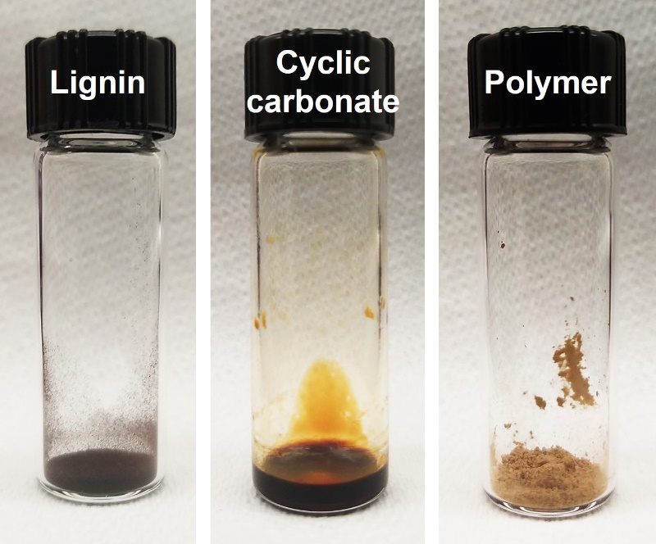
Figure S2. (a) Step-wise synthesis process of CO₂ and lignin-based cyclic carbonate monomer. (b) Photograph of lignin, cyclic carbonate monomer (sticky) and polymer (powder).
Figure S3. 2D HSQC NMR of lignin.
Figure S4. 2D HSQC NMR of CO₂ and lignin-based cyclic carbonate monomer.
Figure S5. Full scale ¹³C NMR of lignin, cyclic carbonate monomer and polycarbonate.
Figure S6. Full scale ¹H NMR of lignin, cyclic carbonate monomer and polycarbonate.

Figure S7. FT-IR spectrum of CO₂ and lignin-based cyclic carbonate monomer.
Figure S8. Stacked 1H NMR spectra of the polymerization reaction during the kinetic study.
Figure S9. 2D HSQC NMR of CO₂ and lignin-based polycarbonate (1% TBD used as a catalyst and reaction time is 30 min).

Figure S10. ¹H NMR spectrum of P-1 (Table 1). [Catalyst: TBD; monomer: catalyst = 100:1, reaction time: 2 min]

Figure S11. HSQC spectrum of P-1 (Table 1). [Catalyst: TBD; monomer: catalyst = 100:1, reaction time: 2 min]
Figure S12. GPC traces of P-1 (Table 1). [Catalyst: TBD; monomer: catalyst = 100:1, reaction time: 2 min]
Figure S13. ¹H NMR spectrum of P-2 (Table 1). [Catalyst: TBD; monomer: catalyst = 100:1, reaction time: 5 min]
Figure S14. ¹³C NMR spectrum of P-2 (Table 1). [Catalyst: TBD; monomer: catalyst = 100:1, reaction time: 30 min]
Figure S15. GPC traces of P-2 (Table 1). [Catalyst: TBD; monomer: catalyst = 100:1, reaction time: 5 min]
Figure S16. ¹H NMR spectrum of P-3 (Table 1). [Catalyst: TBD; monomer: catalyst = 100:1, reaction time: 10 min]
Figure S17. GPC traces of P-3 (Table 1). [Catalyst: TBD; monomer: catalyst = 100:1, reaction time: 10 min]
Figure S18. ¹H NMR spectrum of P-4 (Table 1). [Catalyst: TBD; monomer: catalyst = 100:1, reaction time: 30 min]
Figure S19. ¹³C NMR spectrum of P-4 (Table 1). [Catalyst: TBD; monomer: catalyst = 100:1, reaction time: 30 min]
Figure S20. HSQC spectrum of P-4 (Table 1). [Catalyst: TBD; monomer: catalyst = 100:1, reaction time: 30 min]
Figure S21. FT-IR spectrum of P-4 (Table 1). [Catalyst: TBD; monomer: catalyst = 100:1, reaction time: 30 min]
Figure S22. GPC traces of P-4 (Table 1). [Catalyst: TBD; monomer: catalyst = 100:1, reaction time: 30 min]
Figure S23. ¹H NMR spectrum of P-5 (Table 1). [Catalyst: TBD; monomer: catalyst = 100:2, reaction time: 30 min]
Figure S24. HSQC NMR spectrum of P-5 (Table 1). [Catalyst: TBD; monomer: catalyst = 100:2, reaction time: 30 min]
Figure S25. GPC traces of P-5 (Table 1). [Catalyst: TBD; monomer: catalyst = 100:2, reaction time: 30 min]
Figure S26. HSQC spectrum of P-6 (Table 1). [Catalyst: TBD; monomer: catalyst = 100:5, reaction time: 30 min]
Figure S27. FT-IR spectrum of P-6 (Table 1). [Catalyst: TBD; monomer: catalyst = 100:5, reaction time: 30 min]
Figure S28. GPC traces of P-6 (Table 1). [Catalyst: TBD; monomer: catalyst = 100:5, reaction time: 30 min]
Figure S29. ¹H NMR spectrum of P-7 (Table 1). [Catalyst: TBD; monomer: catalyst = 200:1, reaction time: 30 min]
Figure S30. HSQC NMR spectrum of P-7 (Table 1). [Catalyst: TBD; monomer: catalyst = 200:1, reaction time: 30 min]

Figure S31. GPC traces of P-7 (Table 1). [Catalyst: TBD; monomer: catalyst = 200:1, reaction time: 30 min]
Figure S32. ¹H NMR spectrum of P-8 (Table 1). [Catalyst: DBU; monomer: catalyst = 100:1, reaction time: 40 min]
Figure S33. ¹³C NMR spectrum of P-8 (Table 1). [Catalyst: DBU; monomer: catalyst = 100:1, reaction time: 40 min]
Figure S34. HSQC spectrum of P-8 (Table 1). [Catalyst: DBU; monomer: catalyst = 100:1, reaction time: 40 min]
Figure S35. FT-IR spectrum of P-8 (Table 1). [Catalyst: DBU; monomer: catalyst = 100:1, reaction time: 40 min]
Figure S36. GPC traces of P-8 (Table 1). [Catalyst: DBU; monomer: catalyst = 100:1, reaction time: 40 min]
Figure S37. ¹H NMR spectrum of P-9 (Table 1). [Catalyst: DBU; monomer: catalyst = 100:2, reaction time: 40 min]
Figure S38. HSQC spectrum of P-9 (Table 1). [Catalyst: DBU; monomer: catalyst = 100:2, reaction time: 40 min]

Figure S39. GPC traces of P-9 (Table 1). [Catalyst: DBU; monomer: catalyst = 100:2, reaction time: 40 min]
Figure S40. ¹H NMR spectrum of P-10 (Table 1). [Catalyst: DBU; monomer: catalyst = 100:5, reaction time: 40 min]
Figure S41. HSQC spectrum of P-10 (Table 1). [Catalyst: DBU; monomer: catalyst = 100:5, reaction time: 40 min]

Figure S42. GPC traces of P-10 (Table 1). [Catalyst: DBU; monomer: catalyst = 100:5, reaction time: 40 min]
Figure S43. Derivative thermogravimetry (DTG) plots of P-1, P-2, P-3, and P-4 polymer (Table 1).
Figure S44. TGA plots of P-5, P-6, and P-7 polymer (Table 1).
Figure S45. Derivative thermogravimetry (DTG) plots of P-5, P-6, and P-7 polymer (Table 1).

Figure S46. TGA plots of P-8, P-9, and P-10 polymer (Table 1).
Figure S47. Derivative thermogravimetry (DTG) plots of P-8, P-9, and P-10 polymer (Table 1).
Figure S48. DSC plots of P-5, P-6, and P-7 polymer (Table 1).
Figure S49. DSC plots of P-8, P-9, and P-10 polymer (Table 1).

4. References
1. Kim, S. & Chung, H. Convenient Cross-Linking Control of Lignin-Based Polymers Influencing Structure–Property Relationships. ACS Sustain Chem Eng (2023) doi:10.1021/ACSSUSCHEMENG.2C05651/ASSET/IMAGES/LARGE/SC2C05651_0006.JPEG.
2. Ji, L., Liu, L. Y., Cho, M., Karaaslan, M. A. & Renneckar, S. Revisiting the Molar Mass and Conformation of Derivatized Fractionated Softwood Kraft Lignin. Biomacromolecules 23, 708–719 (2022).

