Supplementary Material Content
Appendix 1. Zhejiang Dialysis Quality Control Platform (ZDQCP)
Appendix 2. Detailed HEWIC Predictor Algorithm
Appendix 3. HEWIC Intervener Supported Clinical Pathways
Appendix 4. Consistency assessment of HEWIC
Appendix 5. Additional AI intervention Group Clinical Staff Responses
Supplementary Table 1. Patient demographic characterization of the retrospective dataset.
Supplementary Table 2. Input and output variables of HEWIC.

Supplementary Table 3. Routine laboratory examination results of the retrospective dataset.
Supplementary Table 4. Comparison of model’s performance on the retrospective test set.
Supplementary Table 5. Sensitivity and specificity of HEWIC on the retrospective dataset under different thresholds.
Supplementary Table 6. Mortality rates for intervention and control clinics at baseline and in follow-up period.
Supplementary Table 7. Specific mortality rates during the study period for each dialysis center.
Supplementary Table 8. Participating dialysis center and clinicians of the RCT.
Supplementary Figure 1. HEWIC performance in hospitals with different HRDI on the retrospective test set.
Supplementary Figure 2. HEWIC performance in hospitals with different ranks on the retrospective test set.
Supplementary Figure 3. HEWIC performance in hospitals with different years on the retrospective test set.
Supplementary Figure 4. Secondary endpoints at the baseline and in the follow-up period.

Appendix 1. Zhejiang Dialysis Quality Control Platform (ZDQCP)
The Zhejiang Dialysis Quality Control Center was established in December 2006, approved by the Zhejiang Provincial Health Department, and affiliated with the First Affiliated Hospital of Zhejiang University. Jianghua Chen (M.D.) has been serving as the chairman since its establishment. Since 2007, the center has been engaged in the province-wide registration and reporting of blood dialysis information, establishing the Zhejiang Dialysis Quality Control Platform. All medical data of dialysis patients are stored in real-time on the platform, and the Zhejiang Dialysis Quality Control Center conducts statistical analysis and publicizes relevant data.
As of the end of 2021, the database has covered 333 hemodialysis centers across the province, encompassing all dialysis centers in Zhejiang Province. It has recorded a total of 97,827 patient visits. The Zhejiang Dialysis Quality Control Platform incorporates data networks related to hospital names, hospital locations, hospital grades, and patient visit volumes, as shown in Table A1.1 below.
Table A1.1 Participating units in the platform of Zhejiang Dialysis Quality Control Centre by the end of 2021.
Hospital | Attribution Region | Hospital Grade | Hospital Ownership | Total number of hemodialysis patients
Chun'an County Second People's Hospital | Hangzhou | Secondary Grade B | Public | 141
Chun'an County First People's Hospital (Zhejiang Provincial People's Hospital Chun'an Branch) | Hangzhou | Secondary Grade A | Public | 393
Chun'an County Weiping Central Health Center | Hangzhou | Unclassified | Public | 36
Chun'an County Traditional Chinese Medicine Hospital | Hangzhou | Tertiary Grade B | Public | 176
Fuyang City Central Integrated Traditional Chinese and Western Medicine Hospital | Hangzhou | Unclassified | Private | 64
Hangzhou Chenghong Hospital | Hangzhou | Unclassified | Private | 202
Hangzhou Fuyang Yile Hospital | Hangzhou | Unclassified | Private | 33
Hangzhou Guliantongji Hospital | Hangzhou | Unclassified | Private | 88
Hangzhou Kangjing Hospital | Hangzhou | Unclassified | Private | 374
Hangzhou Qingchun Hospital | Hangzhou | Secondary Grade A | Public | 203
Hangzhou Renyu Hospital | Hangzhou | Unclassified | Private | 99
Hangzhou Normal University Affiliated Hospital | Hangzhou | Tertiary Grade A | Public | 344
Hangzhou Ninth Hospital (Xiaoshan Fourth Hospital) | Hangzhou | Secondary Grade A | Public | 119
Hangzhou Third People's Hospital | Hangzhou | Tertiary Grade A | Public | 223
Hangzhou First People's Hospital | Hangzhou | Tertiary Grade A | Public | 361
Hangzhou Fuyang District Second People's Hospital | Hangzhou | Secondary Grade A | Public | 230
Hangzhou Fuyang District First People's Hospital | Hangzhou | Tertiary Grade B | Public | 456
Hangzhou Fuyang District Traditional Chinese Medicine Hospital | Hangzhou | Tertiary Grade B | Public | 308
Hangzhou Red Cross Hospital | Hangzhou | Tertiary Grade A | Public | 464
Hangzhou Armed Police Hospital | Hangzhou | Tertiary Grade B | Public | 28
Hangzhou Xixi Hospital | Hangzhou | Tertiary Grade A | Public | 210
Hangzhou Xiaoshan District Second People's Hospital | Hangzhou | Secondary Grade A | Public | 212
Hangzhou Xiaoshan District Third People's Hospital | Hangzhou | Secondary Grade A | Public | 149
Hangzhou Xiaoshan District First People's Hospital | Hangzhou | Tertiary Grade B | Public | 888
Hangzhou Xiaoshan Traditional Chinese Medicine Hospital | Hangzhou | Tertiary Grade B | Public | 219
Hangzhou First Hospital Tonglu Branch | Hangzhou | Secondary Grade B | Public | 126
Hangzhou Yuhang District Xingqiao Street Community Health Service Center | Hangzhou | Unclassified | Public | 73
Hangzhou Traditional Chinese Medicine Hospital | Hangzhou | Tertiary Grade A | Public | 1299
Hangzhou Wenzhong Traditional Chinese Medicine Hospital | Hangzhou | Unclassified | Private | 10
Hangzhou Xingkang Medical Outpatient Department | Hangzhou | Unclassified | Private | 93
Hangzhou Yuhang Bang'er Hospital | Hangzhou | Secondary Grade B | Private | 20
Jiande First People's Hospital | Hangzhou | Tertiary Grade B | Public | 378
Jiande Second People's Hospital | Hangzhou | Secondary Grade B | Public | 45
Jiande Integrated Traditional Chinese and Western Medicine Hospital | Hangzhou | Secondary Grade B | Public | 112
Jiande Traditional Chinese Medicine Hospital | Hangzhou | Secondary Grade A | Public | 594
PLA Joint Logistics Support Force 903 Hospital | Hangzhou | Tertiary Grade A | Public | 154
Lin'an Jinbei Hospital | Hangzhou | Unclassified | Private | 92
Lin'an District Second People's Hospital Medical Community | Hangzhou | Tertiary Grade B | Public | 114
Lin'an District Third People's Hospital | Hangzhou | Secondary Grade B | Public | 101
Lin'an Saikang Hospital | Hangzhou | Unclassified | Private | 23
Lin'an Changhai People's Hospital | Hangzhou | Secondary Grade B | Public | 119
Lin'an People's Hospital | Hangzhou | Tertiary Grade B | Public | 821
Linping District First People's Hospital | Hangzhou | Tertiary Grade B | Public | 628
Linping District Traditional Chinese Medicine Hospital | Hangzhou | Tertiary Grade B | Public | 307
Shulan (Hangzhou) Hospital | Hangzhou | Tertiary Grade A | Private | 493
Tonglu Fuchun River Hospital | Hangzhou | Secondary Grade B | Private | 124
Tonglu City First People's Hospital | Hangzhou | Secondary Grade A | Public | 350
Tonglu County Jiangnan Town Central Health Center | Hangzhou | Unclassified | Public | 15
Tonglu County Traditional Chinese Medicine Hospital | Hangzhou | Secondary Grade A | Public | 136
Yuhang District Second People's Hospital | Hangzhou | Secondary Grade A | Public | 278
Yuhang District Third People's Hospital | Hangzhou | Secondary Grade A | Public | 256
Zhejiang Public Security Border Defense Corps Hospital | Hangzhou | Secondary Grade A | Public | 15
Zhejiang Healthcare Group Hangzhou Hospital | Hangzhou | Secondary Grade A | Public | 169
Zhejiang Xiaoshan Hospital | Hangzhou | Tertiary Grade B | Private | 551
Anji County Third People's Hospital | Huzhou | Secondary Grade B | Public | 354
Anji County People's Hospital | Huzhou | Secondary Grade A | Public | 553
Anji County Tianzihu Town Central Health Center | Huzhou | Unclassified | Public | 21
Deqing County Third People's Hospital | Huzhou | Secondary Grade A | Public | 133
Deqing County People's Hospital | Huzhou | Tertiary Grade B | Public | 567
Deqing County Traditional Chinese Medicine Hospital | Huzhou | Secondary Grade A | Public | 138
Huzhou Anji County Traditional Chinese Medicine Hospital | Huzhou | Tertiary Grade B | Public | 224
Huzhou First People's Hospital | Huzhou | Tertiary Grade A | Public | 520
Huzhou Traffic Hospital (Huzhou Sixth Hospital) | Huzhou | Secondary Grade B | Private | 209
Huzhou Nantaihu Hospital | Huzhou | Unclassified | Private | 58
Huzhou City Nanxun District People's Hospital | Huzhou | Secondary Grade A | Public | 243
Huzhou City Nanxun District Traditional Chinese Medicine Hospital | Huzhou | Secondary Grade A | Public | 25
Huzhou City Wuxing District People's Hospital | Huzhou | Secondary Grade A | Public | 163
Huzhou City Wuxing District Integrated Traditional Chinese and Western Medicine Hospital (Huzhou Fourth Hospital) | Huzhou | Secondary Grade A | Public | 94
Huzhou City Central Hospital | Huzhou | Tertiary Grade A | Public | 383
Huzhou City Traditional Chinese Medicine Hospital | Huzhou | Tertiary Grade A | Public | 600
Huzhou Shushan Geriatric Hospital Co., Ltd. | Huzhou | Unclassified | Private | 15
Lianshi People's Hospital | Huzhou | Secondary Grade B | Public | 90
Nanxun District Linghu People's Hospital | Huzhou | Secondary Grade B | Public | 112
Shulan (Anji) Hospital Co., Ltd. | Huzhou | Unclassified | Private | 33
Changxing Second Hospital | Huzhou | Unclassified | Private | 133
Changxing Guotai Rehabilitation Hospital | Huzhou | Secondary Grade B | Private | 122
Changxing County Third People's Hospital | Huzhou | Unclassified | Public | 74
Changxing County Lincheng Town Health Center | Huzhou | Unclassified | Public | 34
Changxing County People's Hospital | Huzhou | Tertiary Grade B | Public | 313
Changxing County Traditional Chinese Medicine Hospital | Huzhou | Tertiary Grade A | Public | 616
Zhebei Mingzhou Hospital | Huzhou | Unclassified | Private | 169
Haining Kanghua Hospital | Jiaxing | Secondary Grade A | Private | 400
Haining City People's Hospital | Jiaxing | Tertiary Grade B | Public | 359
Haining City Central Hospital | Jiaxing | Secondary Grade B | Public | 227
Haining City Traditional Chinese Medicine Hospital | Jiaxing | Tertiary Grade B | Public | 137
Haiyan Bang'er Hospital | Jiaxing | Unclassified | Private | 81
Haiyan County People's Hospital | Jiaxing | Tertiary Grade B | Public | 317
Haiyan County Traditional Chinese Medicine Hospital | Jiaxing | Secondary Grade A | Public | 165
Jiashan Dongfang Hospital | Jiaxing | Unclassified | Private | 91
Jiashan County Second People's Hospital | Jiaxing | Secondary Grade B | Public | 67
Jiashan County First People's Hospital | Jiaxing | Tertiary Grade B | Public | 426
Jiashan County Traditional Chinese Medicine Hospital | Jiaxing | Tertiary Grade B | Public | 227
Jiaxing Geriatric Medical Center | Jiaxing | Secondary Grade B | Private | 132
Jiaxing City Second Hospital | Jiaxing | Tertiary Grade A | Public | 467
Jiaxing City First Hospital | Jiaxing | Tertiary Grade A | Public | 331
Jiaxing City First Hospital Xiangjiadang Branch | Jiaxing | Unclassified | Public | 253
Jiaxing City Kaiyi Hospital | Jiaxing | Unclassified | Private | 49
Pinghu City First People's Hospital | Jiaxing | Tertiary Grade B | Public | 150
Pinghu City Traditional Chinese Medicine Hospital | Jiaxing | Tertiary Grade B | Public | 669
Pinghu Xinhua Hospital | Jiaxing | Secondary Grade B | Private | 100
Tongxiang City First People's Hospital | Jiaxing | Tertiary Grade B | Public | 478
Tongxiang City Traditional Chinese Medicine Hospital | Jiaxing | Tertiary Grade B | Public | 246
Zhejiang Province Pinghu City Second People's Hospital | Jiaxing | Secondary Grade B | Public | 75
Zhejiang Provincial Veterans Hospital | Jiaxing | Tertiary Grade B | Public | 105
Zhejiang Province Tongxiang Second People's Hospital | Jiaxing | Secondary Grade A | Public | 213
Zhejiang New An International Hospital | Jiaxing | Tertiary Grade B | Private | 532
Zhejiang Chinese Medical University Affiliated Jiaxing City Traditional Chinese Medicine Hospital | Jiaxing | Tertiary Grade A | Public | 386
Chinese People's Armed Police Force Maritime Police General Hospital | Jiaxing | Tertiary Grade A | Public | 206
Dongyang Guangfu Hospital | Jinhua | Unclassified | Public | 19
Dongyang City People's Hospital | Jinhua | Tertiary Grade A | Public | 681
Dongyang City Traditional Chinese Medicine Hospital | Jinhua | Tertiary Grade B | Public | 706
Hangzhou Medical College Affiliated Yiwu Hospital | Jinhua | Secondary Grade B | Private | 78
Hengdian Wenrong Hospital | Jinhua | Secondary Grade A | Private | 130
Jinhua Guangfu Hospital | Jinhua | Tertiary Grade B | Private | 357
Jinhua Lianji Hospital | Jinhua | Secondary Grade B | Private | 114
Jinhua City Fifth Hospital | Jinhua | Secondary Grade B | Public | 49
Jinhua City Jindong District Traditional Chinese Medicine Hospital | Jinhua | Secondary Grade B | Public | 13
Jinhua City People's Hospital | Jinhua | Tertiary Grade B | Public | 344
Jinhua City Central Hospital | Jinhua | Tertiary Grade A | Public | 534
Jinhua City Traditional Chinese Medicine Hospital | Jinhua | Tertiary Grade A | Public | 329
Jinhua Wenrong Hospital | Jinhua | Secondary Grade A | Private | 488
Jinhua Wucheng District First People's Hospital | Jinhua | Secondary Grade B | Public | 100
Lanxi City People's Hospital | Jinhua | Secondary Grade A | Public | 464
Lanxi City Traditional Chinese Medicine Hospital | Jinhua | Secondary Grade A | Public | 962
Pan'an County People's Hospital | Jinhua | Secondary Grade A | Public | 230
Pan'an County Traditional Chinese Medicine Hospital | Jinhua | Secondary Grade B | Public | 9
Pujiang County People's Hospital | Jinhua | Secondary Grade A | Public | 488
Pujiang County Traditional Chinese Medicine Hospital | Jinhua | Secondary Grade A | Public | 306
Wuyi County First People's Hospital | Jinhua | Secondary Grade A | Public | 362
Wuyi County Traditional Chinese Medicine Hospital | Jinhua | Secondary Grade A | Public | 163
Wuyi Xieshi Orthopedic Hospital | Jinhua | Unclassified | Private | 43
Wucheng District Second People's Hospital | Jinhua | Secondary Grade B | Public | 146
Yiwu Chouzhou Hospital | Jinhua | Secondary Grade A | Private | 185
Yiwu Fuyuan Private Hospital | Jinhua | Secondary Grade A | Private | 279
Yiwu City Central Hospital | Jinhua | Tertiary Grade A | Public | 744
Yiwu City Traditional Chinese Medicine Hospital | Jinhua | Tertiary Grade A | Public | 129
Yongkang City Traditional Chinese Medicine Hospital | Jinhua | Tertiary Grade B | Public | 373
Zhejiang University School of Medicine Affiliated Fourth Hospital | Jinhua | Tertiary Grade A | Public | 593
Zhejiang Province Yongkang City First People's Hospital | Jinhua | Tertiary Grade B | Public | 527
Zhejiang Yiwu Tianxiang Medical Oriental Hospital | Jinhua | Secondary Grade A | Private | 119
Jinyun County Second People's Hospital | Lishui | Secondary Grade B | Public | 91
Jinyun County Traditional Chinese Medicine Hospital | Lishui | Secondary Grade A | Public | 142
Jingning County People's Hospital | Lishui | Secondary Grade A | Public | 341
Lishui Overseas Chinese Hospital | Lishui | Unclassified | Private | 184
Lishui City Second People's Hospital | Lishui | Tertiary Grade A | Public | 33
Lishui City Suichang County People's Hospital | Lishui | Secondary Grade A | Public | 395
Lishui City Central Hospital | Lishui | Tertiary Grade A | Public | 1008
Lishui City Traditional Chinese Medicine Hospital | Lishui | Tertiary Grade A | Public | 295
Longquan City People's Hospital | Lishui | Secondary Grade A | Public | 548
Longquan City Comprehensive Welfare Institute Minsheng Hospital | Lishui | Unclassified | Private | 122
Qingtian County People's Hospital | Lishui | Secondary Grade A | Public | 361
Qingtian County Traditional Chinese Medicine Hospital | Lishui | Secondary Grade A | Public | 105
Qingyuan County People's Hospital | Lishui | Secondary Grade A | Public | 258
Songyang County People's Hospital | Lishui | Secondary Grade A | Public | 420
Suichang Kangqiao Hemodialysis Center Co., Ltd. | Lishui | Unclassified | Private | 85
Yunhe County People's Hospital | Lishui | Secondary Grade A | Public | 229
Zhejiang Lishui Jinyun County People's Hospital | Lishui | Secondary Grade A | Public | 260
Zhejiang Province Lishui City People's Hospital | Lishui | Tertiary Grade A | Public | 647
Beilun District People's Hospital Zhe One Hospital Beilun Branch | Ningbo | Tertiary Grade B | Public | 603
Cilin Hospital | Ningbo | Unclassified | Private | 288
Cixi Mingfeng Hospital | Ningbo | Unclassified | Private | 358
Cixi City People's Hospital | Ningbo | Tertiary Grade B | Public | 641
Fenghua City People's Hospital | Ningbo | Secondary Grade A | Public | 347
Ningbo University Affiliated First Hospital | Ningbo | Tertiary Grade A | Public | 632
Ningbo University Affiliated Hospital (City Third Hospital) | Ningbo | Tertiary Grade A | Public | 214
Ningbo Liberation Army 113 Hospital | Ningbo | Tertiary Grade A | Public | 151
Ningbo Development Zone Hospital | Ningbo | Secondary Grade B | Private | 34
Ningbo Urology and Nephrology Hospital (Ningbo Yinzhou Second People's Hospital) | Ningbo | Tertiary Grade B | Public | 1185
Ningbo City Second Hospital | Ningbo | Tertiary Grade A | Public | 341
Ningbo City Fenghua District Traditional Chinese Medicine Hospital | Ningbo | Tertiary Grade B | Public | 29
Ningbo City Hangzhou Bay Hospital | Ningbo | Tertiary Grade A | Public | 129
Ningbo City Huaxin Hospital Co., Ltd. | Ningbo | Secondary Grade B | Private | 105
Ningbo City Xiangshan County First People's Hospital | Ningbo | Tertiary Grade B | Public | 291
Ningbo City Medical Center Li Huili Hospital | Ningbo | Tertiary Grade A | Public | 461
Ningbo City Yinzhou District Qianhu Hospital | Ningbo | Secondary Grade B | Public | 9
Ningbo City Yinzhou People's Hospital | Ningbo | Tertiary Grade A | Public | 443
Ningbo City Traditional Chinese Medicine Hospital | Ningbo | Tertiary Grade A | Public | 332
Ningbo Xiangshan County Red Cross Overseas Chinese Hospital | Ningbo | Secondary Grade A | Public | 187
Ningbo Yinzhou Traditional Chinese Medicine Hospital | Ningbo | Unclassified | Private | 56
Ningbo Yuyao City People's Hospital | Ningbo | Tertiary Grade B | Public | 316
Ningbo Zhenhai Longsai Hospital | Ningbo | Secondary Grade A | Public | 14
Ninghai First Hospital | Ningbo | Tertiary Grade B | Public | 325
Ninghai County Meilin Street Community Health Service Center | Ningbo | Unclassified | Public | 21
Ninghai County Traditional Chinese Medicine Hospital | Ningbo | Secondary Grade A | Public | 226
Shulan (Ningbo) Maternity Hospital | Ningbo | Unclassified | Private | 17
Xiangshan County Traditional Chinese Medicine Hospital | Ningbo | Secondary Grade A | Public | 102
Yinzhou People's Hospital Medical Community Baihe Branch | Ningbo | Unclassified | Public | 24
Yuyao Bang'er Orthopedic Hospital | Ningbo | Unclassified | Private | 11
Yuyao City Fourth People's Hospital | Ningbo | Secondary Grade B | Public | 111
Yuyao City Maternal and Child Health Hospital (Yuyao City Second People's Hospital) | Ningbo | Tertiary Grade B | Public | 97
Yuyao City Liangnong Central Health Center | Ningbo | Unclassified | Public | 15
Yuyao City People's Hospital Mazhu Branch | Ningbo | Unclassified | Public | 181
Yuyao City Traditional Chinese Medicine Hospital | Ningbo | Secondary Grade A | Public | 295
Zhejiang University Mingzhou Hospital | Ningbo | Tertiary Grade B | Private | 313
Zhenhai District People's Hospital | Ningbo | Secondary Grade A | Public | 194
Changshan Second Hospital | Quzhou | Unclassified | Private | 13
Changshan County People's Hospital | Quzhou | Secondary Grade A | Public | 451
Changshan County Traditional Chinese Medicine Hospital | Quzhou | Secondary Grade A | Public | 51
Huachi Geriatric Rehabilitation Hospital | Quzhou | Unclassified | Private | 21
Jiangshan Bang'er Orthopedic Hospital | Quzhou | Secondary Grade B | Private | 105
Jiangshan Beilin Hospital | Quzhou | Secondary Grade B | Private | 233
Jiangshan City People's Hospital | Quzhou | Tertiary Grade B | Public | 479
Jiangshan City Traditional Chinese Medicine Hospital | Quzhou | Secondary Grade A | Public | 240
Kaihua County People's Hospital | Quzhou | Secondary Grade A | Public | 165
Kecheng District Traditional Chinese Medicine Hospital | Quzhou | Secondary Grade B | Public | 8
Longyou County People's Hospital | Quzhou | Secondary Grade A | Public | 323
Longyou County Traditional Chinese Medicine Hospital | Quzhou | Secondary Grade A | Public | 150
Longyou Yijia Hemodialysis Center | Quzhou | Unclassified | Private | 13
Quzhou Jiu'an Cardiovascular Hospital | Quzhou | Unclassified | Private | 25
Quzhou Kecheng Airen Hospital Co., Ltd. | Quzhou | Unclassified | Private | 37
Quzhou Kecheng District People's Hospital | Quzhou | Secondary Grade A | Public | 546
Quzhou Kecheng Xin'an Hospital Co., Ltd. | Quzhou | Unclassified | Private | 62
Quzhou City Second People's Hospital | Quzhou | Tertiary Grade B | Public | 406
Quzhou City Kecheng Xuerong Hospital Co., Ltd. | Quzhou | Unclassified | Private | 50
Quzhou City Quhua Hospital | Quzhou | Tertiary Grade B | Public | 274
Quzhou City Qujiang Kangren Nursing Home Co., Ltd. | Quzhou | Unclassified | Private | 122
Quzhou City Qujiang District Traditional Chinese Medicine Hospital | Quzhou | Secondary Grade A | Public | 35
Quzhou City People's Hospital | Quzhou | Tertiary Grade A | Public | 560
Quzhou City Traditional Chinese Medicine Hospital | Quzhou | Tertiary Grade A | Public | 241
Shulan (Quzhou) Hospital | Quzhou | Unclassified | Private | 48
Zhejiang Province Quzhou City Kaihua County Traditional Chinese Medicine Hospital | Quzhou | Tertiary Grade B | Public | 509
Shangyu Maternal and Child Health Hospital | Shaoxing | Tertiary Grade B | Public | 14
Shangyu City Traditional Chinese Medicine Hospital | Shaoxing | Tertiary Grade A | Public | 251
Shaoxing Kebei Hospital | Shaoxing | Unclassified | Private | 24
Shaoxing City Second Hospital | Shaoxing | Tertiary Grade B | Public | 542
Shaoxing City Keqiao District Traditional Chinese Medicine Hospital | Shaoxing | Tertiary Grade B | Public | 183
Shaoxing City Li Hospital | Shaoxing | Tertiary Grade B | Public | 228
Shaoxing City People's Hospital | Shaoxing | Tertiary Grade A | Public | 720
Shaoxing City Shangyu People's Hospital | Shaoxing | Tertiary Grade B | Public | 588
Shaoxing City Central Hospital | Shaoxing | Tertiary Grade B | Public | 476
Shaoxing City Traditional Chinese Medicine Hospital | Shaoxing | Tertiary Grade A | Public | 226
Shengzhou City People's Hospital | Shaoxing | Tertiary Grade B | Public | 721
Shengzhou City Traditional Chinese Medicine Hospital | Shaoxing | Tertiary Grade B | Public | 118
Shengzhou Siji Hospital | Shaoxing | Secondary Grade B | Private | 409
Xinchang County People's Hospital | Shaoxing | Tertiary Grade B | Public | 470
Xinchang County Traditional Chinese Medicine Hospital | Shaoxing | Tertiary Grade A | Public | 268
New Century Hospital | Shaoxing | Unclassified | Private | 144
Zhuji City Fourth People's Hospital | Shaoxing | Secondary Grade A | Public | 29
Zhuji City People's Hospital | Shaoxing | Tertiary Grade A | Public | 656
Zhuji City Central Hospital | Shaoxing | Secondary Grade A | Public | 86
Zhuji City Traditional Chinese Medicine Hospital | Shaoxing | Tertiary Grade A | Public | 715
Zhejiang University School of Medicine Affiliated Second Hospital | Provincial Directly Administered | Tertiary Grade A | Public | 382
Zhejiang University School of Medicine Affiliated First Hospital | Provincial Directly Administered | Tertiary Grade A | Public | 2759
Zhejiang University School of Medicine Affiliated Children's Hospital | Provincial Directly Administered | Tertiary Grade A | Public | 4
Zhejiang University School of Medicine Affiliated Sir Run Run Shaw Hospital | Provincial Directly Administered | Tertiary Grade A | Public | 382
Zhejiang Provincial People's Hospital | Provincial Directly Administered | Tertiary Grade A | Public | 334
Zhejiang Provincial Tongde Hospital | Provincial Directly Administered | Tertiary Grade A | Public | 329
Zhejiang Provincial Traditional Chinese Medicine Hospital | Provincial Directly Administered | Tertiary Grade A | Public | 220
Zhejiang Provincial Traditional Chinese Medicine Hospital, Xiasha Campus | Provincial Directly Administered | Tertiary Grade A | Public | 212
Zhejiang Hospital | Provincial Directly Administered | Tertiary Grade A | Public | 306
Zhejiang Chinese Medical University Affiliated Second Hospital | Provincial Directly Administered | Tertiary Grade A | Public | 159
Zhejiang Chinese Medical University Affiliated Third Hospital | Provincial Directly Administered | Tertiary Grade A | Public | 40
Linhai City Second People's Hospital | Taizhou | Secondary Grade A | Public | 315
Linhai City First People's Hospital | Taizhou | Secondary Grade A | Public | 235
Taizhou Anmin Hospital | Taizhou | NA | NA | 15
Taizhou Enze Medical Center (Group) Luqiao Hospital | Taizhou | Tertiary Grade A | Public | 653
Taizhou Orthopedic Hospital | Taizhou | Secondary Grade B | Private | 73
Taizhou City Boai Hospital | Taizhou | Secondary Grade A | Private | 331
Taizhou City First People's Hospital | Taizhou | Tertiary Grade A | Public | 814
Taizhou City Huangyan District Traditional Chinese Medicine Hospital | Taizhou | Secondary Grade A | Public | 218
Taizhou City Li Hospital | Taizhou | Tertiary Grade B | Public | 378
Taizhou City Luqiao District Second People's Hospital | Taizhou | Secondary Grade B | Public | 145
Taizhou City Central Hospital | Taizhou | Tertiary Grade A | Public | 448
Taizhou City Traditional Chinese Medicine Hospital | Taizhou | Tertiary Grade A | Public | 119
Tiantai Heji Integrated Traditional Chinese and Western Medicine Hospital | Taizhou | Secondary Grade B | Private | 107
Tiantai County People's Hospital | Taizhou | Tertiary Grade B | Public | 633
Wenling City First People's Hospital | Taizhou | Tertiary Grade A | Public | 848
Wenling City Traditional Chinese Medicine Hospital | Taizhou | Tertiary Grade A | Public | 913
Xianju County People's Hospital | Taizhou | Tertiary Grade B | Public | 552
Yuhuan County Second People's Hospital | Taizhou | Secondary Grade A | Public | 187
Yuhuan County People's Hospital | Taizhou | Tertiary Grade B | Public | 341
Yuhuan Integrated Traditional Chinese and Western Medicine Nephropathy Hospital | Taizhou | Unclassified | Private | 131
Zhejiang Province Sanmen County People's Hospital | Taizhou | Tertiary Grade B | Public | 404
Zhejiang Province Taizhou Hospital | Taizhou | Tertiary Grade A | Public | 856
Cangnan Huimin Hospital | Wenzhou | Unclassified | Private | 138
Cangnan Traditional Chinese Medicine Hospital | Wenzhou | Tertiary Grade B | Public | 229
Yueqing Fifth People's Hospital | Wenzhou | Secondary Grade B | Public | 319
Yueqing Development Zone Tongle Hospital | Wenzhou | Secondary Grade B | Private | 434
Yueqing City Second People's Hospital | Wenzhou | Secondary Grade A | Public | 485
Yueqing City Third People's Hospital | Wenzhou | Secondary Grade A | Public | 493
Yueqing City People's Hospital | Wenzhou | Tertiary Grade B | Public | 721
Yueqing City Traditional Chinese Medicine Hospital | Wenzhou | Secondary Grade A | Public | 82
Yueqing Yining Integrated Traditional Chinese and Western Medicine Hospital | Wenzhou | Unclassified | Private | 186
Longgang City People's Hospital | Wenzhou | Secondary Grade A | Public | 466
Longgang New City Integrated Traditional Chinese and Western Medicine Hospital | Wenzhou | Unclassified | Private | 51
Longgang Traditional Chinese Medicine Hospital | Wenzhou | Secondary Grade B | Public | 250
Pingyang Dekang Hemodialysis Center | Wenzhou | Unclassified | Private | 433
Pingyang Jianankang Rehabilitation Hospital | Wenzhou | Unclassified | Private | 224
Pingyang Runde Hospital | Wenzhou | Unclassified | Private | 44
Pingyang County Second People's Hospital | Wenzhou | Secondary Grade B | Public | 432
Pingyang County Xiaojiang Hospital | Wenzhou | Unclassified | Public | 118
Pingyang County Chang Geng Hospital | Wenzhou | Secondary Grade B | Private | 395
Ruian City Second People's Hospital | Wenzhou | Unclassified | Public | 158
Ruian City Third People's Hospital | Wenzhou | Secondary Grade B | Public | 247
Ruian City Maternal and Child Health Hospital | Wenzhou | Secondary Grade A | Public | 61
Ruian City People's Hospital (Wenzhou Medical University Affiliated Third Hospital) | Wenzhou | Tertiary Grade A | Public | 1296
Ruian City Tangxia People's Hospital | Wenzhou | Secondary Grade B | Public | 266
Ruian City Traditional Chinese Medicine Hospital | Wenzhou | Tertiary Grade B | Public | 462
Taishun County Traditional Chinese Medicine Hospital | Wenzhou | Secondary Grade A | Public | 204
Wenzhou Binhai Hospital | Wenzhou | Secondary Grade B | Private | 157
Wenzhou Cangnan Jincheng Hospital | Wenzhou | Unclassified | Private | 176
Wenzhou Cangnan County Third People's Hospital | Wenzhou | Secondary Grade A | Public | 462
Wenzhou Cangnan County People's Hospital | Wenzhou | Tertiary Grade B | Public | 674
Wenzhou Donghua Hospital | Wenzhou | Unclassified | Private | 125
Wenzhou Kangning Hospital | Wenzhou | Tertiary Grade A | Private | 387
Wenzhou Geriatric Hospital | Wenzhou | Unclassified | Private | 633
Wenzhou Ouhai Yining Geriatric Hospital | Wenzhou | Unclassified | Private | 31
Wenzhou Pingyang County People's Hospital | Wenzhou | Tertiary Grade B | Public | 468
Wenzhou Pingyang County Traditional Chinese Medicine Hospital | Wenzhou | Tertiary Grade B | Public | 314
Wenzhou City Dongtou District People's Hospital | Wenzhou | Secondary Grade A | Public | 117
Wenzhou City Longwan District First People's Hospital | Wenzhou | Secondary Grade A | Public | 304
Wenzhou City Lucheng District People's Hospital | Wenzhou | Secondary Grade B | Public | 193
Wenzhou City Ouhai District People's Hospital | Wenzhou | Secondary Grade B | Public | 252
Wenzhou City People's Hospital | Wenzhou | Tertiary Grade A | Public | 462
Wenzhou City Integrated Traditional Chinese and Western Medicine Hospital | Wenzhou | Tertiary Grade A | Public | 612
Wenzhou City Central Hospital | Wenzhou | Tertiary Grade A | Public | 747
Wenzhou City Traditional Chinese Medicine Hospital | Wenzhou | Tertiary Grade A | Public | 778
Wenzhou Taishun County First People's Hospital | Wenzhou | Secondary Grade A | Public | 321
Wenzhou Wencheng County People's Hospital | Wenzhou | Secondary Grade A | Public | 535
Wenzhou Medical University Affiliated Second Hospital | Wenzhou | Tertiary Grade A | Public | 684
Wenzhou Medical University Affiliated First Hospital | Wenzhou | Tertiary Grade A | Public | 1395
Wenzhou Yining Geriatric Hospital | Wenzhou | Secondary Grade B | Private | 193
Wenzhou You'an Hospital | Wenzhou | Unclassified | Private | 146
Yongjia Limin Hospital | Wenzhou | Unclassified | Private | 400
Yongjia County Third People's Hospital | Wenzhou | Unclassified | Public | 87
Yongjia County People's Hospital | Wenzhou | Secondary Grade A | Public | 449
Yongjia County Traditional Chinese Medicine Hospital | Wenzhou | Tertiary Grade B | Public | 356
Daishan County First People's Hospital | Zhoushan | Secondary Grade A | Public | 120
Shengsi County People's Hospital | Zhoushan | Secondary Grade A | Public | 11
Zhoushan City Dinghai District Central Hospital | Zhoushan | Unclassified | Public | 74
Zhoushan City Putuo District People's Hospital | Zhoushan | Tertiary Grade B | Public | 313
Zhoushan City Traditional Chinese and Bone Injury Hospital | Zhoushan | Tertiary Grade B | Public | 186
Zhoushan Hospital | Zhoushan | Tertiary Grade A | Public | 506
Total |  |  |  | 97, 827

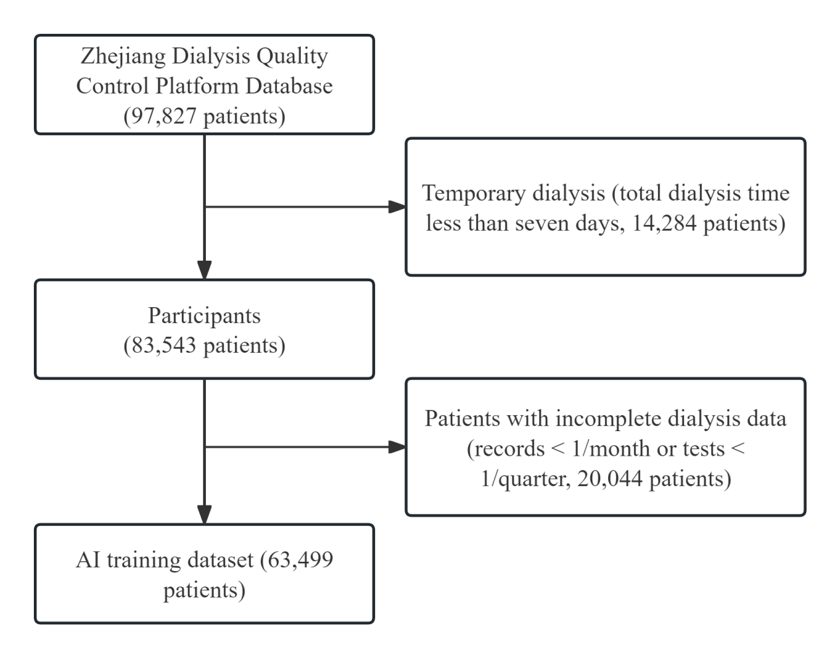
Figure A1.1 Flowchart of Inclusion and Exclusion Criteria for Retrospective Cohort Used in AI Training.

In establishing the retrospective cohort used for AI training, 14,284 individuals with temporary dialysis (total dialysis time less than seven days) and 20,044 individuals with incomplete dialysis data (less than one dialysis record per month or less than one major lab result per quarter) were excluded. The data of the remaining 63,499 patients with 4,940,590 medical records were used to construct the AI training dataset, with their demographic characteristics detailed in Supplementary Table 1.

Appendix 2. Detailed HEWIC Predictor Algorithm
The proposed deep-learning-based HEWIC copilot took three-modalities of patient information as input. (i) Routine laboratory examination results, which were structured time-series (i.e., longitudinal data), including hemoglobin and parathyroid hormone typically recorded daily. Since some test results were missing, a bidirectional GRU-D¹ model with a specific missing value imputation was leveraged to learn a structured time-series representation $Z_{l}$. (ii) Demographic characteristics and vascular pathway information (DCVPI), which were structured static features (i.e., cross-sectional data), including demographic features and vascular access information, which were encoded into the model by a fully connected layer to learn a static structured feature representation $Z_{c}$. (iii) Radiological examination reports of cardiac ultrasound, which were in text format. We utilized the Natural Language Processing (NLP) model Doc2Vec³ to generate a text report representation $Z_{g}$. Finally, these three types of representations were fed into a fully connected layer to jointly yield the mortality probability p (p∈[0,1]) after the sigmoid operation. High-risk patients were then filtered out based on mortality probability exceeding a certain threshold, and the list of high-risk patients was informed to doctors via the instant messaging tool.

1.1 Structured Time-Series Module of the HEWIC Predictor
The structured time-series module aimed to handle periodic laboratory examination results with missing values and irregular time intervals. In the following, we first give some important notations to make the subsequent presentation easier to understand (Sec. 1.1.1). Then, we introduce the developed bidirectional GRU-D (Sec. 1.1.2), which is the core part for learning representations from sparse (i.e., with many missing values) and irregular clinical time-series data. Finally, we provide an interpretability module to measure the importance of each clinical variable, thereby assisting doctors in making decisions (Sec. 1.1.2).
1.1.1 Periodic Laboratory Examination Result Description. At each prediction time point, we processed the lab records within the time window determined by a given duration T (T is the number of days in a specific month). Here we considered a day as the minimum time unit since the patient's condition was often measured daily and thus a day was considered as a timestep). Before feeding variable values into the HEWIC model, we rescaled 27 variables’ values into the range of [0, 1] by the min-max normalization (the maximum and the minimum values for each variable were separately computed across the training samples). We denoted the laboratory records of each patient by $S=\{X,O,∆\}$. Specifically, $X=\left(x_{1},…,x_{t},…,x_{T}\right)∈R^{T×27}$ denoted the clinical variables; $x_{t}$ denoted the vectorial variables presenting laboratory examination results at the $t$-th timestep, where the $d$-th element $x_{t}^{d}$ denoted the$d$-th variable of $x_{t}$, $d∈\{1,2,3,…,27\}$. $O=\left(o_{1},…,o_{t},…,o_{T}\right)∈\{{0,1\}}^{T×27}$ denoted the existence of the $variables$, where $o_{t}$ denoted the existence of the variables’ values at the t-th timestep, with${ o}_{t}^{d}$denoting the$d$-th variable of $o_{t}$ ($o_{t}^{d}is 1$if the $d$-th variable’s value exists, and is 0 for missing value). $∆ = \left(δ_{1},…,δ_{t},…,δ_{T}\right)∈R^{T×27}$recorded the time intervals between two records, where $δ_{t}$ denoted the time intervals between the t-th timestep and the timesteps when the variables were last observed, and $δ_{t}^{d}$ denoted the time interval of the d-th variable of $δ_{t}$. For the rare cases that a patient had multiple records within a day, we used their average recorded value as the input.
1.1.2 Bidirectional GRU-D.
Background. GRU-D^{[1]} is a commonly-used model for interpolating multivariate time series data, and thus it could be used to handle clinical variables with missing values. The core idea of GRU-D lay in utilizing a trainable decay rate to partially forget history information. Since the clinical data were commonly recorded with irregular time intervals, GRU-D fed time intervals into several neural network layers to learn the adaptive decay rate $γ_{t}$. Formally, in the $t$-th timestep, it computed the decay factor $γ_{t}$of clinical variables by:
$$\begin{aligned}γ_{t}=min\left(e^{−\left(δ_{t}W_{γ}+b_{γ}\right)},1\right),\#(1)\end{aligned}$$
where $W_{γ}∈R^{27×27}$ and $b_{γ}∈R^{1×27}$refer to the learnable weight and bias matrices, respectively. Note that $W_{γ}$ was specifically set as a diagonal matrix following the GRU-D’s original setting^{[1]} since intuitively each raw clinical variable was independent of the others. The benefits of using the decay factors were two-fold: (1) The decay factors were varying for different variables, and this was consistent with the situation that different variables had different medical meanings. (2) Trainable decay factors may be capable of capturing missing patterns from the data itself without fine-tuning on different datasets.
In GRU-D, for the $t$-th timestep, if the $d$-th variable was missing, then it was imputed by both the last observed d-th variable in the extracted sequence $S$ (denoted as $x_{t^{'}}^{d}$) and the empirical value of the $d$-th variable of all observed records in the whole dataset (denoted as ${\tilde{x}}_{whole}^{d}$, which was obtained by calculating the mean of each variable of all the patients across all the timesteps of the whole dataset). Further, $γ_{t}^{d}$(the$d$-th entry of $γ_{t}$) was used as the decay factor of $x_{t^{'}}^{d}, as:$
$$\begin{aligned}{\hat{x}}_{t}^{d}←o_{t}^{d}x_{t^{'}}^{d}+\left(1−o_{t}^{d}\right)\left(γ_{t}^{d}{x_{t^{'}}^{d}}_{}^{}+\left(1−γ_{t}^{d}\right){\tilde{x}}_{whole}^{d}\right).\#\left(2\right)\end{aligned}$$
Analogously, to simulate the decay of hidden states, a decay factor $ε_{t}$ for the hidden state $h_{t}$of size 16 for the $t$-th timestep was also calculated. Then, the previous hidden state was multiplied with $ε_{t}:$
$ε_{t}=min\left(e^{−\left(δ_{t}^{'}W_{ε}+b_{ε}\right)},1\right)$,
$$\begin{aligned}{\hat{h}}_{t−1}←ε_{t}⊙h_{t−1},\#(3)\end{aligned}$$
where $δ_{t}^{'}∈ R^{1 × 16}$indicates the time interval from the last hidden state on the t-th timestep, $W_{ε}∈R^{16× 16}$ and $b_{ε}∈R^{1×16}$ refer to the weight and bias matrices, respectively, and $⊙$ denotes element-wise product.
GRU-D followed a similar forward propagation like GRU. For the t-th time step, it also adopted a reset gate $r_{t}$to control the degree of ignoring the previous hidden states and used an update gate $z_{t}$to take information for the next time step. Especially, it fed the variable existence mask $o$ into the model for the calculation of gates $r_{t} and z_{t}$ and hidden state $h_{t}$. Also, it leveraged the decayed hidden state ${\hat{h}}_{t−1}$ instead of the normal one $h_{t−1}$:
$r_{t}=σ\left({\hat{x}}_{t}W_{r}+{\hat{h}}_{t−1}U_{r}+o_{t}V_{r}+b_{r}\right)$,
$z_{t}=σ\left({\hat{x}}_{t}W_{z}+{\hat{h}}_{t−1}U_{z}+o_{t}V_{z}+b_{z}\right)$,
${\tilde{h}}_{t}=tanh \left({\hat{x}}_{t}W+\left(r_{t}⊙{\hat{h}}_{t−1}\right)U+o_{t}V+b\right)$,
$$\begin{aligned}h_{t}=\left(1−z_{t}\right)⊙{\hat{h}}_{t−1}+z_{t}⊙{\tilde{h}}_{t},\#(4)\end{aligned}$$
where $W_{r}∈R^{27×16} ,$ $U_{r}∈R^{16×16}$, $W_{z}∈R^{27×16}$, $U_{z}∈R^{16×16}$, $W∈R^{27×16}$, and $U{∈R}^{16×16}$are weight matrices introduced in GRU, $V_{r}∈R^{27×16},V_{z}∈R^{D_{long}×H}, and V∈R^{27×16}$ are new weight matrices for variable existence vector $o_{t}$, and $b_{r}∈R^{1×16}, b_{z}$ $∈R^{1×16}$, and $b∈R^{1×16}$are bias matrices.
Compared to the vanilla GRU-D, we made some modifications to fit our task. The vanilla GRU-D imputed the missing values with identical ${\tilde{x}}_{whole}^{d}$ , which might make the test results indistinguishable. To resolve this issue, we generated a different ${\tilde{x}}^{d}$ for each prediction by incorporating two kinds of empirical mean values. One was ${\tilde{x}}_{whole}^{d}$, which calculates the mean value of each variable of all the patients across all the timesteps of the whole dataset, and the other one was the observed mean value within each sequence of laboratory records $S$ (denoted as ${\overline{x}}^{d}$)$.$Then a coefficient $λ^{d}$ was used to determine the contribution of these two kinds of mean values. Thus, ${\tilde{x}}^{d}$ can be rewritten as:
$λ^{d}=Tanh\left(N^{d}\right)$,
$$\begin{aligned}{\tilde{x}}^{d}=\left(1−λ^{d}\right){\tilde{x}}_{whole}^{d}+λ^{d}{\overline{x}}^{d},\#(5)\end{aligned}$$
where $λ^{d}$ was positively correlated with the times during which the variables were recorded (i.e., $N^{d}$) since more data records mean more reliability.
Following^{[2-4]}, we replaced the original GRU-D with a bidirectional structure here, which processed the time series data in both the sequential and reversed orders. In the reversed order, analogously, the current value was inferred from the observed values of the next few timesteps, and the hidden state was also propagated from the next few timesteps to the current one. Let $h_{t}^{s}$ and $h_{t}^{r}$ denote the hidden states generated sequentially and reversely, respectively. The representation $Z_{l} ∈R^{1×16}$of laboratory records within a month was computed as follows:
$$\begin{aligned}Z_{l}=\left(\frac{1}{T}\sum_{1}^{T}{\left[h_{t}^{s}|| h_{t}^{r}\right]}\right)W_{l}+b_{l},\#(6)\end{aligned}$$
where $||$ denotes the concatenation operation, and $W_{l} ∈R^{32×16} and b_{l} ∈R^{1×16}$refer to the learnable weight and bias matrices, respectively.

1.2 Static Structured Feature Module of the HEWIC Predictor
Static structured features contained demographic characteristics and vascular pathway information of patients, which were in a structured data format and chronically independent, including sex (F/M), height (m), weight (kg), initial dialysis age (year), and vascular access types. Initial dialysis age was when a patient took the first hemodialysis treatment. For the numerical variables like height and weight, we used mix-max normalization to rescale them to [0, 1]. For the categorical variables, sex was encoded into a one-hot code of size 2, and vascular access types were represented in a multi-hot code of size 4 (a patient may be related to various access types). All the static features were concatenated as a vector $E_{c}∈R^{1×9}$ and fed into the model by a fully connected layer to attain the representation ${ Z}_{c}∈R^{1×16}$, by:
$$\begin{aligned}Z_{c}=E_{c}W_{c}+b_{c},\#(9)\end{aligned}$$
where $W_{c}∈R^{9×16}$and $b_{c}∈R^{1×16}$ refer to the learnable weight and bias matrices, respectively.
1.3 Text Report Module of the HEWIC Predictor
This module was designed to process the cardiac ultrasound reports which depicted the symptoms and examination results of the patients. To integrate imaging diagnosis into the model, we first extracted the descriptions in the ‘Symptom’ and ‘Result’ parts of a report. If a patient had multiple records within a month, all the diagnosis texts would be concatenated by time order. Next, the “Jieba” Python package (a widely-used Chinese word segmentation tool) was leveraged to segment Chinese texts. Then the language model Doc2Vec was used to learn a representation $E_{g}$ of size 100 of the diagnosis text. Similarly, $E_{g}$was fed into a fully connected layer to obtain the representation${ Z}_{g}∈R^{1×16}$:
$$\begin{aligned}Z_{g}=E_{g}W_{g}+b_{g},\#(10)\end{aligned}$$
where $W_{g}∈R^{100×16}$and $b_{g}∈R^{1×16}$ refer to the learnable weight and bias matrices, respectively.
1.4 Mortality Prediction by the HEWIC Predictor
Combining all the above three representations for a patient, the model made the final prediction of the mortality probability, as:
$$\begin{aligned}p=Sigmoid\left(\left(\left[Z_{l}\left|\left|Z_{c}\right|\right|Z_{g}\right]\right)W_{o}+b_{o}\right),\#(11)\end{aligned}$$
where $W_{o}∈R^{48×1}$and $b_{o}∈R^{1×1}$ refer to the learnable weight and bias matrices, respectively.

1.5 Loss Function
We used the focal loss^{[5]} in training the HEWIC model to alleviate the class imbalance problem and mine hard examples to boost performance. Specifically, for the $i$-th test case, the loss was computed as follows:
$$\begin{aligned}L_{i}=−w_{0}p_{i}^{β}\left(1−y_{i}\right)log\left(1−p_{i}\right)−w_{1}{\left(1−p_{i}\right)}^{β}y_{i}log\left(p_{i}\right),\#(12)\end{aligned}$$
where $y_{i}∈\{0,1\}$ is the ground truth label of the i-th test case, and $y_{i}=1$ indicates that in this case, the patient would die within the observation period (one or three months in this study) and 0 otherwise, $p_{i}$ is the predicted mortality probability of the $i$-th test case, $β$ is the focusing parameter and $β$>0, $w_{0}$ is the weight for the negative class, and $w_{1}$ is the weight for the positive class. Focal loss usesd a scaling factor ${\left(1−p_{i}\right)}^{β}$ to adaptively down-weight the loss of those easy samples while forcing the model to mine hard samples. For the positive class, when $p_{i}$ approached 1, it meant that the sample was already well classified, and thus the weight was small. For a hard sample whose $p_{i}$ was still very small, the model increased its weight. An analogous principle worked for the negative class.

1.6 HEWIC Predictor Implementation Details
The model was trained on the training set of the retrospective dataset (see Supplementary Table 1) in 1000 epochs in total. We used the Adam optimizer for optimization with default hyper-parameters, except for the learning rate set as 0.001 and the weight decay set as 0.005. For the one-month prediction, we set $w_{0}$=0.025 for the negative class and $w_{1}$=0.975 for the positive class; for the three-month prediction, $w_{0}$=0.07 for the negative class and $w_{1}$=0.93 for the positive class. As for binary mortality prediction, we chose 0.42 and 0.40 as thresholds for one-month and three-month mortality based on the F1-score, respectively. All the hyper-parameters were fine-tuned on the validation set of the retrospective dataset.

Appendix 3. HEWIC Intervener Supported Clinical Pathways
We developed 11 AI-supported clinical pathways as the main body of the HEWIC intervener: dialysis adequacy, infection, dialysis hypertension, dialysis hypotension, heart failure, hyperparathyroidism, potassium, hyperlipidemia, malnutrition, anemia, and iron metabolism abnormality.

Appendix 3.1 Dialysis adequacy AI-supported clinical pathways
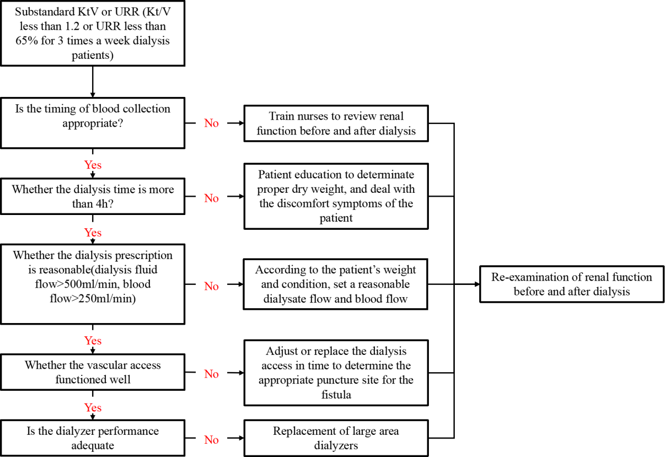

Appendix 3.2 Infection AI-supported clinical pathways
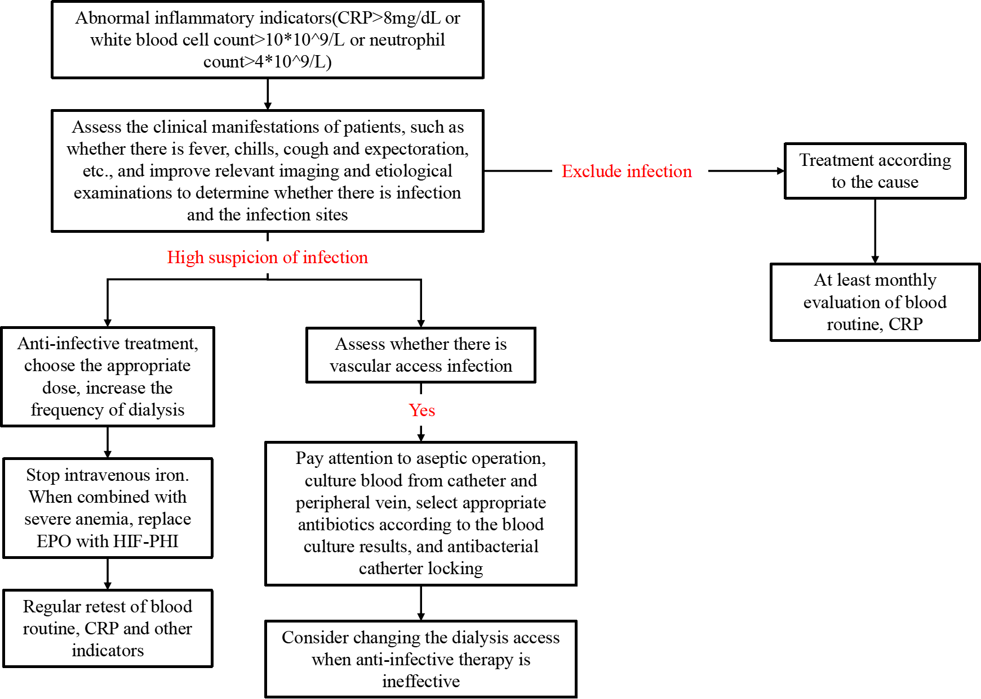

Appendix 3.3 Dialysis hypertension AI-supported clinical pathways
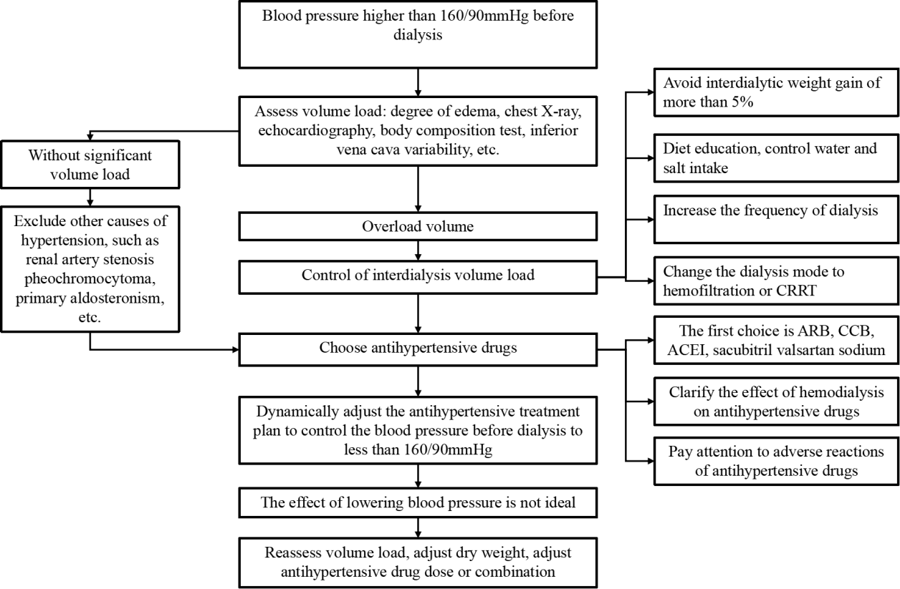

Appendix 3.4 Dialysis hypotension AI-supported clinical pathways
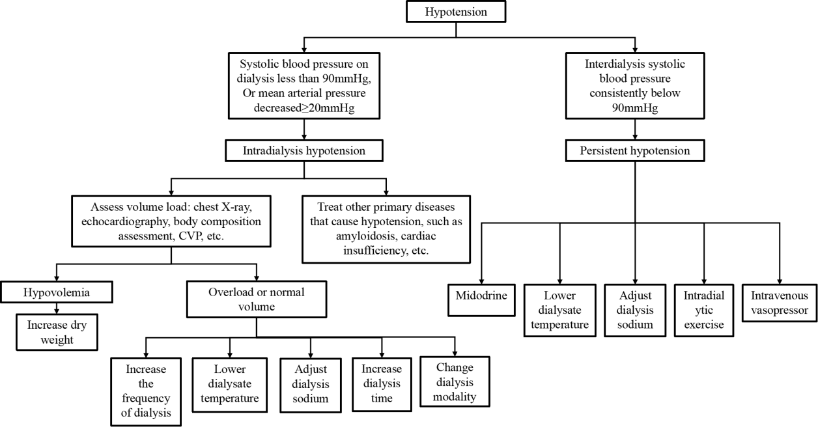

Appendix 3.5 Heart failure AI-supported clinical pathways
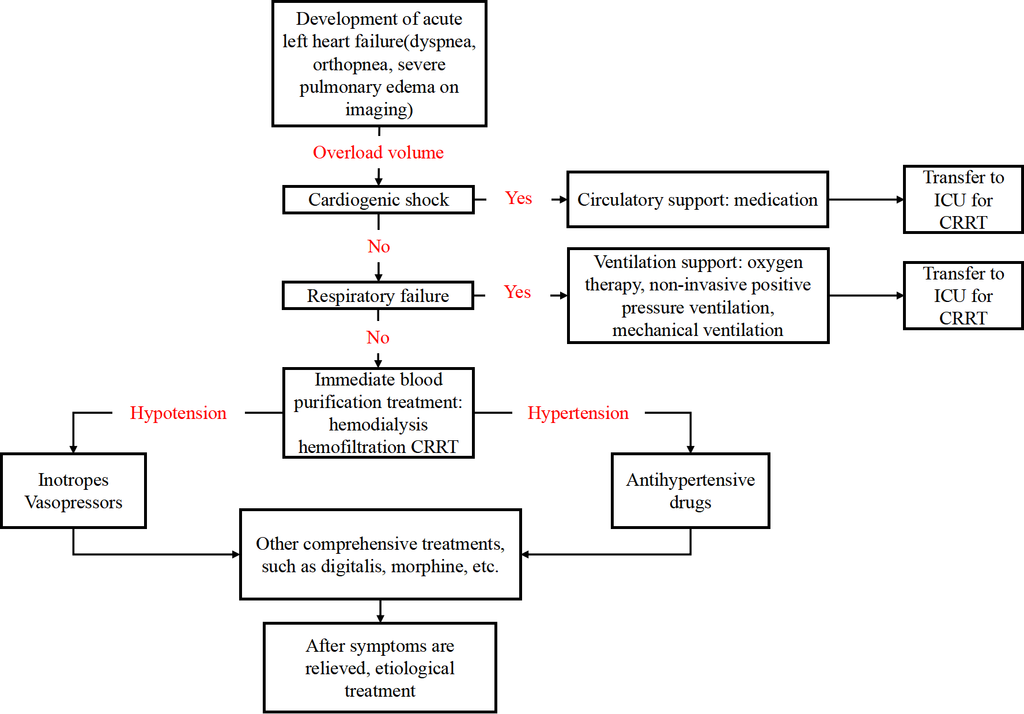

Appendix 3.6 Hyperparathyroidism AI-supported clinical pathways
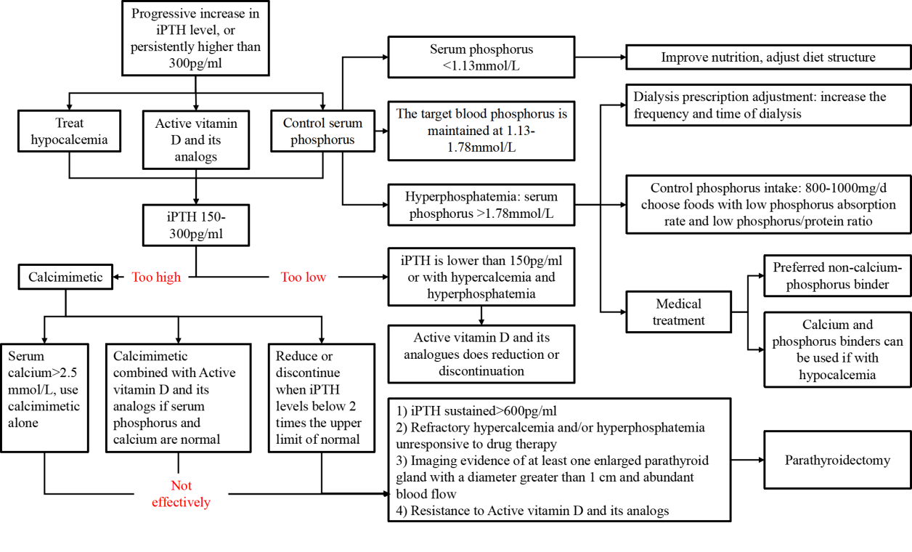

Appendix 3.7 Potassium AI-supported clinical pathways
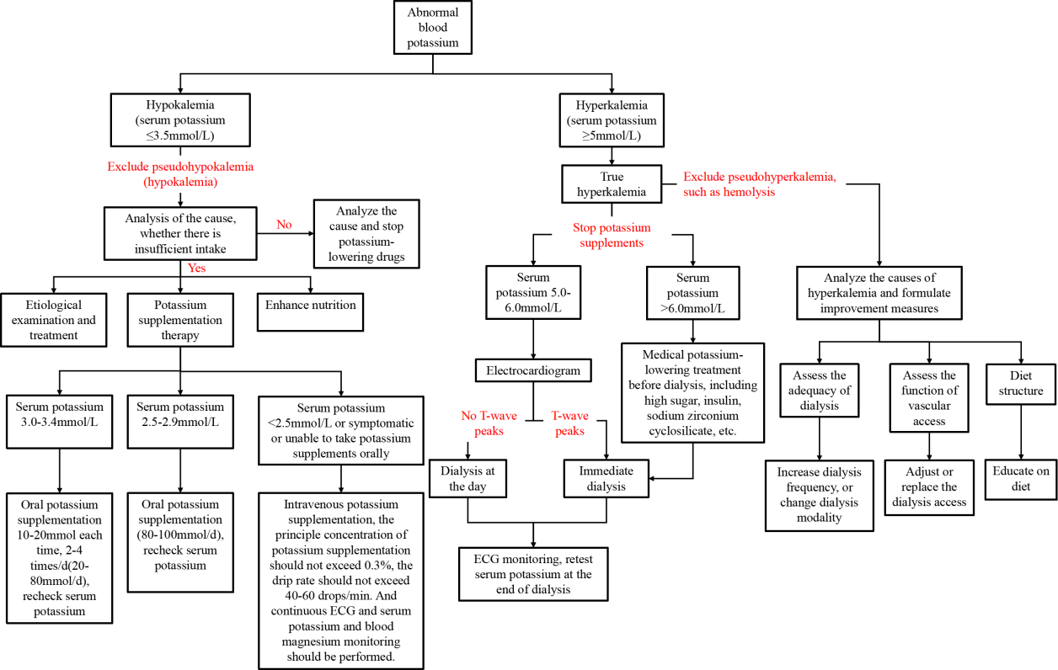

Appendix 3.8 Hyperlipidemia AI-supported clinical pathways
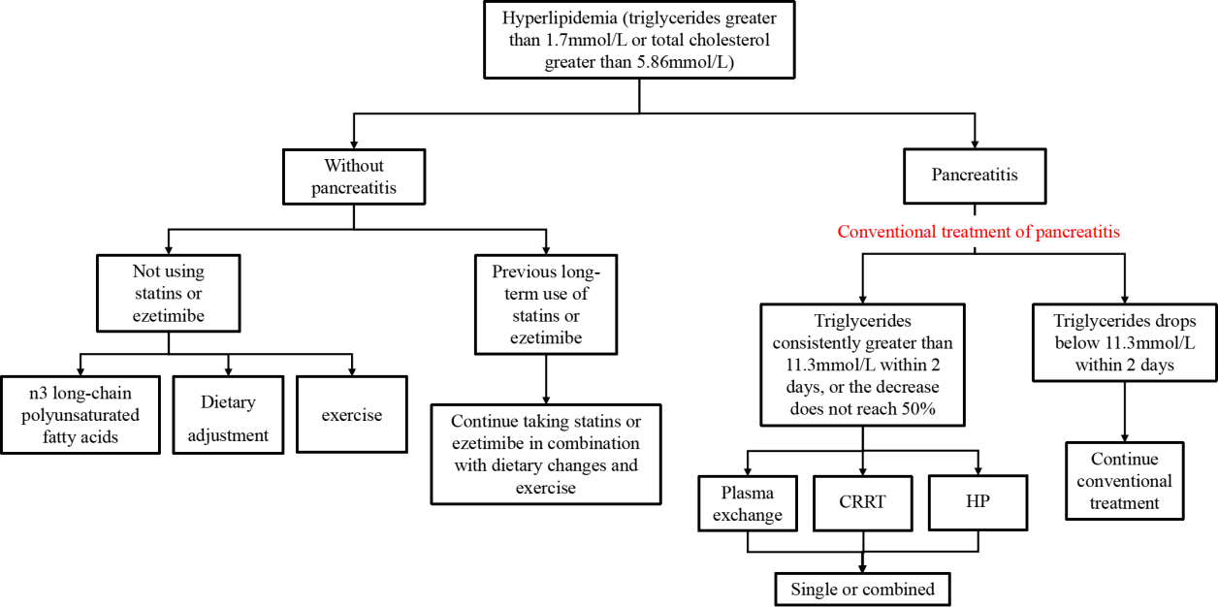

Appendix 3.9 Malnutrition AI-supported clinical pathways
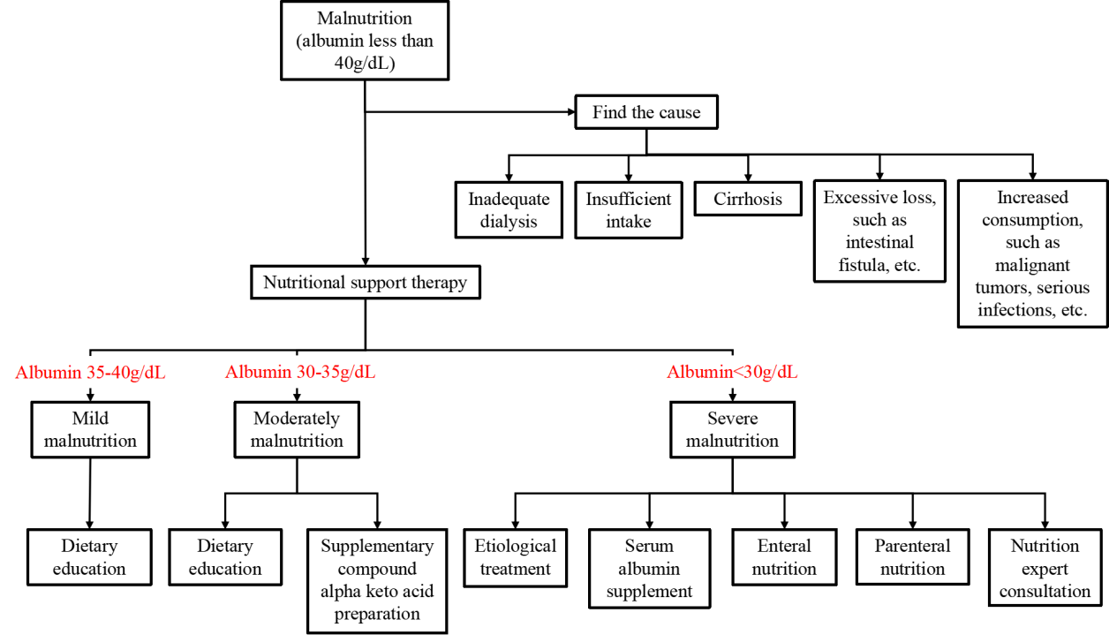

Appendix 3.10 Anemia AI-supported clinical pathways
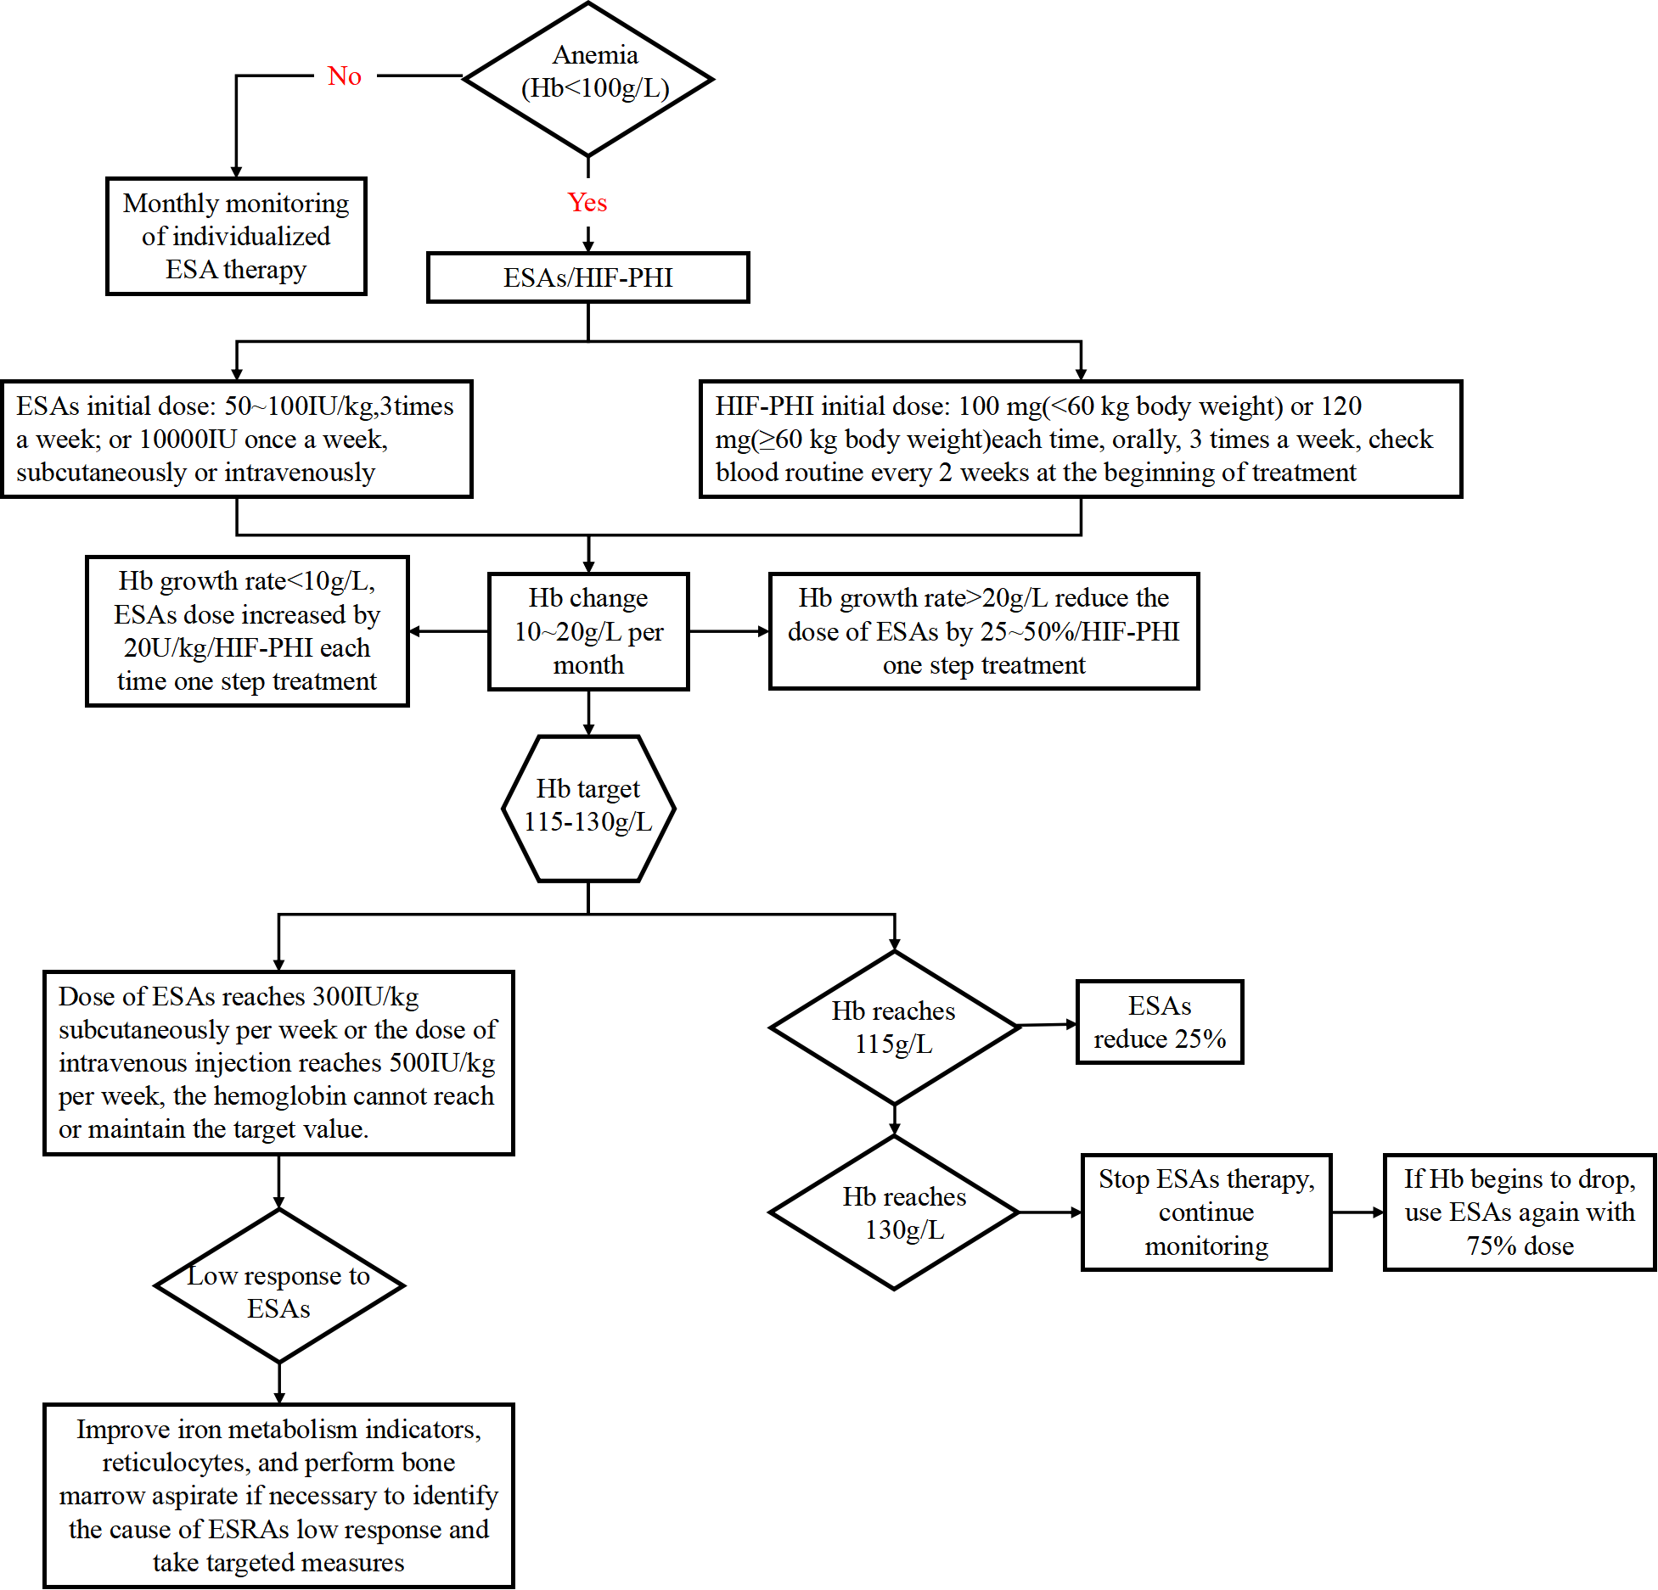

Appendix 3.11 Iron metabolism abnormality AI-supported clinical pathways
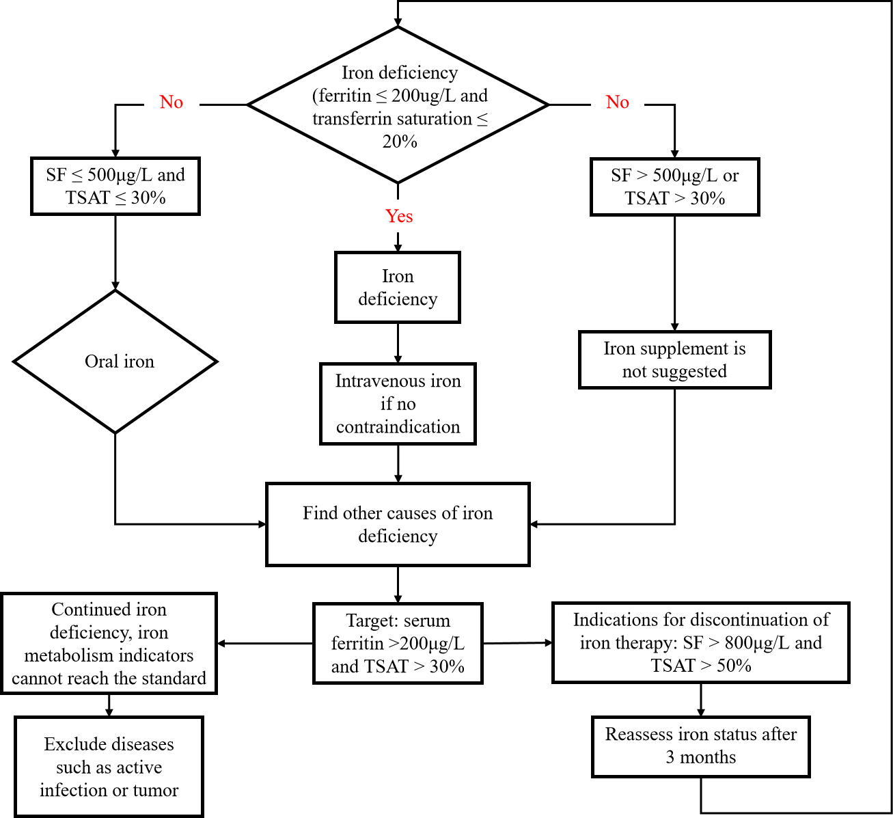

Appendix 4. Consistency Assessment of HEWIC
We selected 150 patients from the retrospective cohort and evenly divided them into five groups, with one group being the common group diagnosed by all four doctors, while the remaining four groups were diagnosed by each of the four healthcare professionals separately. This design ensured that each doctor encountered different mixed samples, avoiding mutual influence in their responses, and kept the individual workload manageable. HEWIC diagnosed all 150 samples for inspecting the consistency compared to the professionals. Consequently, the resulting data is described in Table A4.1.

 | Common | Group1 | Group2 | Group3 | Group4
Professional 1 | √ | √
Professional 2 | √ |  | √
Professional 3 | √ |  |  | √
Professional 4 | √ |  |  |  | √
HEWIC | √ | √ | √ | √ | √
Real Survival Outcomes | √ | √ | √ | √ | √
Table A4.1 Diagnosis Results of 150 Patients across Five Groups.

In each group, the data is presented in the following format:
$$Doctor : 1 0 0 … 0 1$$
$$AI : 1 0 1 … 1 0$$
$$True : 0 0 1 … 0 1$$
Pairs of sequences can form 2*2 contingency tables, and we calculated the tetrachoric correlation coefficients as a measure of consistency, and calculated the variance to evaluate the reliability of the measure. After calculating for each group, we weighted the tetrachoric coefficients of each group using meta-analysis principles as follows:
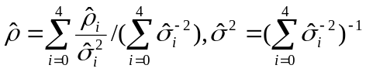
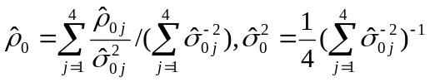

where $i=0$ represents the tetrachoric estimate on the common group, obtained by weighting the diagnostic results of the four professionals in a similar way. Since the cases in the common group were measured four times, the variance here needs to be divided by 4 after weighting.
Based on the definitions above, we obtained the consistency measure results among doctors, AI model, true values, individuals, and human-machine collaboration, as shown in Figure A4.1.

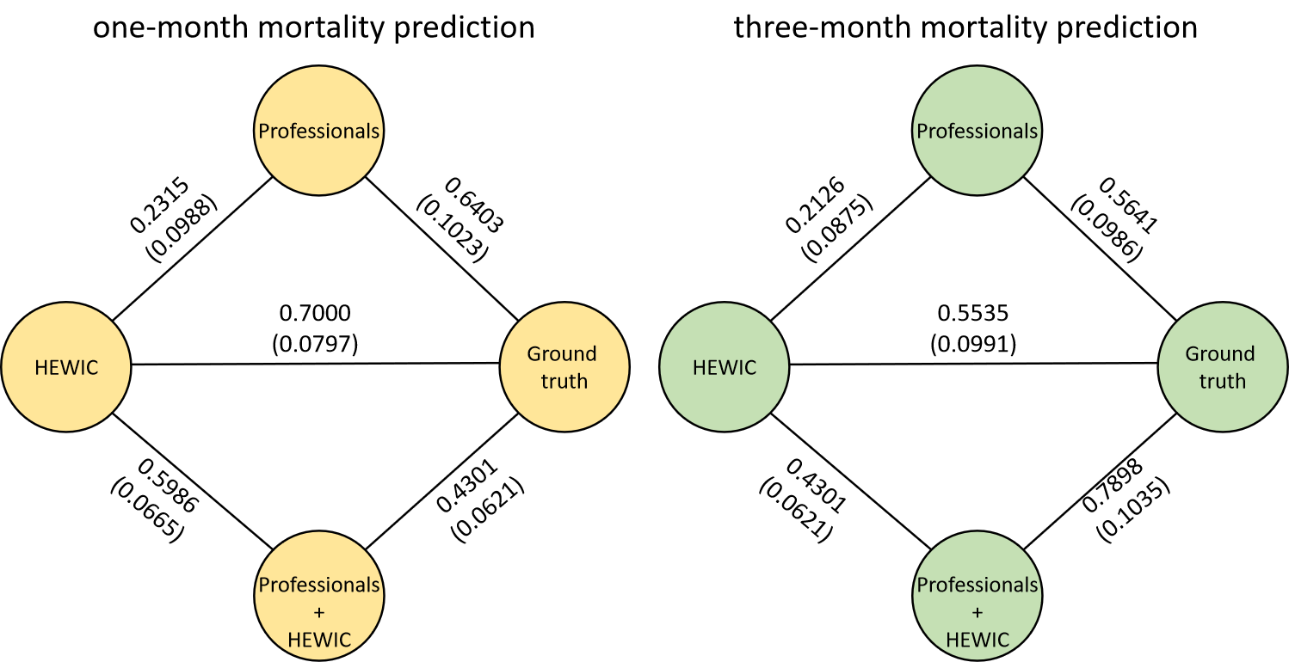
Figure A4.1 Consistency results for 1-month model and 3-month model.

To more intuitively observe the diagnostic performances of "HEWIC", "human professionals", and "HEWIC-Human collaboration", we applied Principal Component Analysis (PCA) to project the above sixteen patient examination features into a three-dimensional space. We first divided the features into three groups: The Electrolyte Disorder Indicator Group, the Anemia and Inflammation Indicator Group, and the Blood Lipid and Nutrition Indicator Group. The Electrolyte Disorder Indicator Group includes 'Parathyroid hormone (mmol/L)', 'Pre-dialysis potassium (mmol/L)', 'Pre-dialysis phosphate (mmol/L)', and 'Pre-dialysis calcium (mmol/L)'. The Anemia and Inflammation Indicator Group consists of 'Hemoglobin (g/L)', 'White blood cell count (10^9/L)', and 'Red blood cell count (10^9/L)'. The Blood Lipid and Nutrition Indicator Group comprises 'Triglycerides (mmol/L)', 'Total cholesterol (mmol/L)', 'High-density lipoprotein (mmol/L)', 'Low-density lipoprotein (mmol/L)', and 'Albumin (g/L)'.
For each group, we used PCA for dimensionality reduction and extracted the first principal component as the representative factor. The scores of these principal components were then calculated, and the scores of the three groups were used as the $X$, $Y$, and $Z$ coordinates in a three-dimensional coordinate system. We plotted the 150 patient sample points in this space. For the classification results of "HEWIC", "Healthcare Professionals", and "Human-HEWIC collaboration", we marked the correctly diagnosed sample points in blue and the incorrect ones in red. This completed the visualization of the multidimensional sample classification results in a three-dimensional coordinate system, as shown in Figure A4.2.
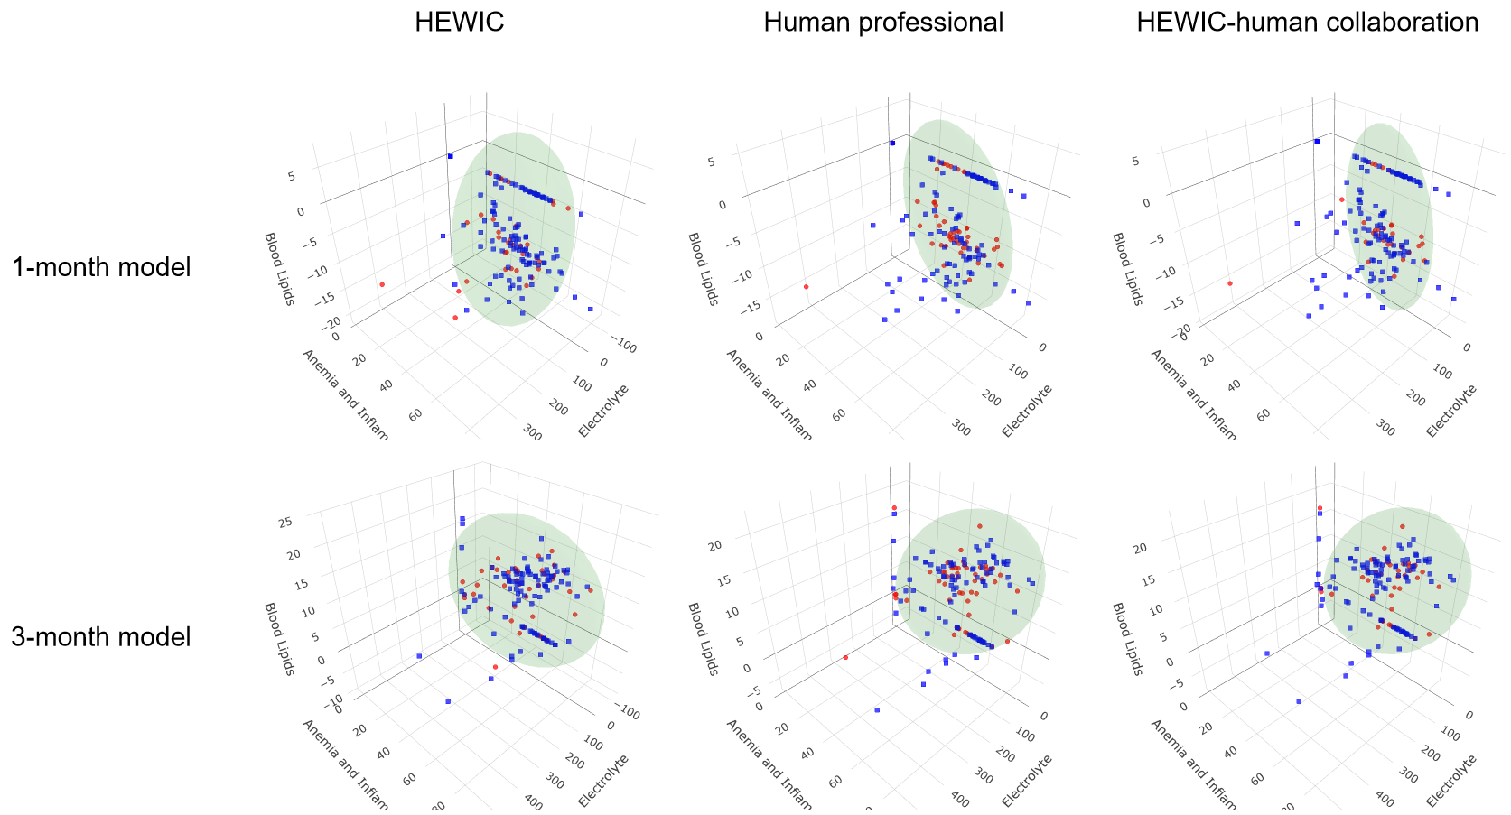
Figure A4.2 Diagnostic Performances of “HEWIC”, “Human professionals”, and “HEWIC-human collaboration”.

Furthermore, to more clearly illustrate the distribution differences in the classifications by “HEWIC”, “Human professionals”, and “HEWIC-human collaboration”, we also plotted the probabilistic normal density ellipsoids of the misclassified samples in Figure A4.2. Specifically, treating the red points as samples from a three-dimensional normal distribution, we calculated the mean vector and covariance matrix to derive their density function:
$f(x;{μ},Σ)=\frac{1}{\sqrt{(2π)^{3}|Σ|}}\exp\left(−\frac{1}{2}(x−μ)'Σ^{−1}(x−μ)\right)$.
The exponential part of this function was used to draw the ellipsoid, whose center and volume reflect the dispersion of the misclassified samples. The ellipsoid was calculated using the formula:
$V=\frac{4}{3}∗π∗√λ_{1}∗√λ_{2}∗√λ_{3}$,
where $λ_{1}$, $λ_{2}$, and $λ_{3}$ are the eigenvalues of the covariance matrix $Σ$.

Table A4.2 Volumes of Probability Ellipsoids for Misclassified Samples in Model Predictions.
 | AI | Doctor | Doctor-AI copilot
1-month model | 3,485,419 | 3,827,606 | 2,448,869
3-month model | 12,678,932 | 12,966,729 | 12,300,153

The results are presented in Table A4.2. We concluded that, on the 1-month or 3-month mortality prediction models, the probability ellipsoid volume for misclassified samples is smaller for the collaborative predictions of doctors and AI than those of AI or doctors alone. This finding explains the increased diagnostic accuracy observed when AI assistants are introduced into clinical practice and highlights the advantages of human-AI collaboration in clinical diagnosis.
But, it is worth noting that the volume for "AI" in the 3-month prediction is much larger than the other two. The reason is that the "AI" model's predictive results tend to be more short-term oriented. When the prediction timeline is extended, the accuracy of the prediction, as seen from the ROC curve, does not significantly change. However, the volume of the probability density ellipsoid becomes larger, indicating a greater dispersion of the misclassified samples. This suggests that while the "AI" model maintains its overall predictive accuracy over a longer term, the confidence in its predictions, as represented by the dispersion of misclassified samples, decreases.
This was due to the fact that AI models, while powerful, are inherently data-driven and rely heavily on the patterns learned from the training data. In the short term, these patterns are likely to hold true, leading to a smaller volume of the probability density ellipsoid. However, as the prediction timeline extends, the inherent uncertainty and variability in the data increase, leading to a larger dispersion of misclassified samples. This does not necessarily mean that the "AI" model's long-term predictions are less reliable. Rather, it reflects the inherent uncertainty in long-term predictions and the challenges faced by AI models in capturing the complex, time-dependent dynamics in health data.
Similarly, we tested the consistency of HEWIC risk factor ranking with physician ranking. In the ranking task, a key result was the rank of features. Given 16 relevant features, the machine would rank each variable, while humans would only rank the top 10 positions. Assuming samples are from an i.i.d. population $X$, with an assumed human ranking function $f_{h}$ and a machine ranking function $f_{m}$, both mapping samples $x_{i}$ to rank, $rank_{i}=f\left(x_{i}\right)$. We established the following hypothesis test:
$H_{0}:f_{h}=f_{m},H_{1}:f_{h}≠f_{m}$.
Assuming $f_{h}\left(X\right)$ and $f_{m}\left(X\right)$ transform the specified i.i.d. samples into two ranking distributions, the hypothesis was to test whether the two multidimensional ranking distributions were entirely equal.
$H_{0}:{rank}_{h}={rank}_{m},H_{1}:{rank}_{h}≠{rank}_{m}$.
This test could utilize the Wilcoxon rank-sum test. However, the sample size was insufficient to support equivalence testing of 16-dimensional distributions, necessitating a dimension reduction function or a metric $m$ to measure the degree of disorder in rank sequences. In this study, we used two metrics to complete the Wilcoxon rank-sum test:
- Spearman correlation coefficient: $m\left(rank_{i}\right)=Spearman\left(rank_{i},1:16\right)$
- Number of inversions: the count of inverse pairs in a sequence:

- $m\left(rank_{i}\right)=\#\{(x_{j},x_{k}), x_{j}>x_{k}, j<k;x_{j},{ x}_{k}∈rank_{i}\}$.
Ideally, if human-machine agreement were perfect, Spearman correlation coefficients and the number of inversions would be equal, both serving as metrics for the similarity of human and machine results. Since doctors only ranked the top ten positions, we only calculated the corresponding metric values for the ten variables ranked by doctors at each sample. We obtain the results in Table A4.3 and a two-tailed P-value < 0.05 will be considered statistically significant.

Table A4.3 Wilcoxon rank-sum test results.
 | 1-month model | 3-month model
Test Statistic | 163.4 | 299.5
P-value | 0.265 | 0.243
Decision Rule | “The null hypothesis is not rejected, indicating that the human-machine distributions are identical, demonstrating consistency between human and machine.” | “The null hypothesis is not rejected, indicating that the human-machine distributions are identical, demonstrating consistency between human and machine.”

Appendix 5. Additional AI Intervention Group Clinical Staff Responses
At the end of the study, we used the following six questions to retrospectively assess the opinions of physicians in the intervention group toward the HEWIC system. Notably, a Chinese version of the questionnaire was used in this survey and we provide its translation into English for readability purpose here.

Q1. In this RCT study, did the use of the Hemodialysis Patients' Survival Prediction and Intervention System (HEWIC) require you to spend additional time outside of your regular working hours? (Note: Additional working hours refer to the time spent working after regular office hours or beyond the scheduled shifts in the dialysis unit.)
A. >4 hours
B. 2-4 hours
C. 0-2 hours
D. Did not increase time outside of regular working hours

Q2. In this RCT study, do you believe that the use of the Hemodialysis Patients' Survival Prediction and Intervention System (HEWIC) has improved your clinical work efficiency?
A. Significantly improved
B. Moderately improved
C. Somewhat improved
D. No improvement

Q3. Did the relevant prediction reports of the Hemodialysis Patients' Survival Prediction and Intervention System (HEWIC) interfere with your normal clinical work?
A. Significant interference
B. Moderate interference
C. Some interference
D. No interference

Q4. How satisfied are you with the Hemodialysis Patients' Survival Prediction and Intervention System (HEWIC) in this RCT study?
A. Very satisfied
B. Moderately satisfied
C. Neutral/average
D. Very dissatisfied

Q5. How helpful do you think the Hemodialysis Patients' Survival Prediction and Intervention System (HEWIC) is for patients?
A. Extremely helpful
B. Very helpful
C. Somewhat helpful
D. Not helpful

Q6. Would you like to have free access to the Hemodialysis Patients' Survival Prediction and Intervention System (HEWIC) for your clinical work?
A. Strongly wish for it
B. Interested
C. Uncertain
D. Completely oppose it

We retrospectively surveyed 58 clinical workers in 29 dialysis centers in the intervention group, with a 100% return rate of the questionnaire, and the findings are as follows.
Table A5.1 Wilcoxon rank-sum test results.
Question | A | B | C | D
Q1 | 2 (0.03) | 6 (0.1) | 24 (0.41) | 26 (0.45)
Q2 | 5 (0.09) | 19 (0.33) | 30 (0.52) | 4 (0.07)
Q3 | 0 (0) | 0 (0) | 11 (0.19) | 47 (0.81)
Q4 | 18 (0.31) | 30 (0.52) | 10 (0.17) | 0 (0)
Q5 | 8 (0.14) | 27 (0.47) | 23 (0.4) | 0 (0)
Q6 | 25 (0.43) | 31 (0.53) | 2 (0.03) | 0 (0)

Our supplementary questionnaire survey indicates that this system requires some learning time (within 2 hours), but apart from that, it does not require doctors to invest any additional working hours nor does it interfere with clinical work. During the RCT period, clinical doctors expressed high satisfaction with HEWIC, stating that it improved their clinical work efficiency and was helpful for patient treatment. The majority of doctors expressed a strong willingness to use the HEWIC system again in future work.

Supplementary Table 1. Patient demographic characterization of the retrospective dataset.
Characteristics | Overall  (N =63,499) | Training  (N=31,867) | Validation  (N=15,877) | Test  (N=15,755)
Initial Dialysis Age, median (IQR), years | 62 (49-73) | 62 (49-73) | 62 (48-73) | 62 (49-73)
Sex, n (%)
Male | 38,567 (60.7) | 19,378 (60.8) | 9,692 (61.0) | 9,497 (60.3)
Female | 24,932 (39.3) | 12,489 (39.2) | 6,185 (39.0) | 6,258 (39.7)
Medical history, n (%)
Diabetes | 26,162 (41.2) | 13,161 (41.3) | 6,541 (41.2) | 6,460 (41.0)
Hypertension | 40,677 (64.1) | 20,305 (63.7) | 10,288 (64.8) | 10,084 (64.0)
Anemia | 24,003 (37.8) | 12,045 (37.8) | 5,986 (37.7) | 5,972 (37.9)
Cardiovascular diseases | 47,180 (74.3) | 23,741 (74.5) | 11,765 (74.1) | 11,674 (74.1)
Note: Initial Dialysis Age is defined as the patient's age at the time of the first dialysis treatment. The training set was used for training the parameters of the neural network, the validation set was used for selecting the model parameters, and the test set was used to test the generalization ability of the trained model.

Supplementary Table 2. Input and output variables of HEWIC.

Supplementary Table 2(a). List of input variables.
No. | Input variable | Unit | Type | Processing method
Logitudinal data
1 | Parathyroid hormone | mmol/L | Numerical | min-max normalization
2 | Haemoglobin | g/L | Numerical | min-max normalization
3 | Leukocyte count | 10⁹/L | Numerical | min-max normalization
4 | Hematokrit | 10⁹/L | Numerical | min-max normalization
5 | Red blood cell count | 10⁹/L | Numerical | min-max normalization
6 | Platelet crit | 10⁹/L | Numerical | min-max normalization
7 | Platelet | 10⁹/L | Numerical | min-max normalization
8 | Creatinine | μmol/L | Numerical | min-max normalization
9 | Pre-dialysis blood urea nitrogen, | mmol/L | Numerical | min-max normalization
10 | Pre-dialysis blood urea | mmol/L | Numerical | min-max normalization
11 | Fasting blood-glucose | mmol/L | Numerical | min-max normalization
12 | Triglycerides | mmol/L | Numerical | min-max normalization
13 | Cholesterol | mmol/L | Numerical | min-max normalization
14 | High-density lipoprotein | mmol/L | Numerical | min-max normalization
15 | Low-density lipoprotein | mmol/L | Numerical | min-max normalization
16 | Pre-dialysis blood potassium | mmol/L | Numerical | min-max normalization
17 | Pre-dialysis blood chloride | mmol/L | Numerical | min-max normalization
18 | Pre-dialysis blood sodium | mmol/L | Numerical | min-max normalization
19 | Pre-dialysis blood phosphorus, | mmol/L | Numerical | min-max normalization
20 | Pre-dialysis blood calcium | mmol/L | Numerical | min-max normalization
21 | Pre-dialysis blood magnesium | mmol/L | Numerical | min-max normalization
22 | Albumin, | g/L | Numerical | min-max normalization
23 | Glutamic pyruvic transaminase | U/L | Numerical | min-max normalization
24 | Glutamic oxalacetic transaminase | U/L | Numerical | min-max normalization
25 | Total bilirubin | μmol/L | Numerical | min-max normalization
26 | Alkaline phosphatase | U/L | Numerical | min-max normalization
27 | KT/V |  | Numerical | min-max normalization
Cross-Sectional Data
1 | Sex |  | Categorical | one-hot encoding
2 | Weight,cm |  | Numerical | min-max normalization
3 | Height,kg |  | Numerical | min-max normalization
4 | Initial dialysis age,year |  | Numerical | min-max normalization
5 | Vascular Access Types |  | Categorical | multi-hot encoding
Text Data
1 | cardiac ultrasound reports |  | Textual | Doc2Vec’s⁴¹ embedding

Supplementary Table 2(b). List of output variables.
No. | Output variable
1 | Estimated risk of the one(three)-month mortality
2 | High risk patient of the one(three)-month mortality
3 | One(three)-month risk factors ranking

Supplementary Table 3. Routine laboratory examination results of the retrospective dataset.
Variable | Value
Parathyroid hormone, median (IQR), mmol/L | 257.70 (124.20-481.20)
Haemoglobin, median (IQR), g/L | 100.00 (87.67-111.00)
Leukocyte count, median (IQR),10⁹/L | 6.00 (4.80-7.50)
Hematokrit, median (IQR),10⁹/L | 28.40 (0.41-33.00)
Red blood cell count, median (IQR),10⁹/L | 3.33 (2.89-3.73)
Platelet crit, median (IQR),10⁹/L | 0.17 (0.13-0.23)
Platelet, median (IQR),10⁹/L | 169.00 (128.00-217.00)
Creatinine, median (IQR), μmol/L | 700.00 (457.00-923.50)
Pre-dialysis blood urea nitrogen, median (IQR), mmol/L | 19.25 (13.80-24.60)
Pre-dialysis blood urea, median (IQR), mmol/L | 393.00 (307.20-472.00)
Fasting blood-glucose, median (IQR), mmol/L | 6.15 (4.92-8.43)
Triglycerides, median (IQR), mmol/L | 1.52 (1.06-2.25)
Cholesterol, median (IQR), mmol/L | 3.95 (3.28-4.73)
High-density lipoprotein, median (IQR), mmol/L | 1.01 (0.81-1.26)
Low-density lipoprotein, median (IQR), mmol/L | 2.10 (1.60-2.68)
Pre-dialysis blood potassium, median (IQR), mmol/L | 4.50 (3.98-5.10)
Pre-dialysis blood chloride, median (IQR), mmol/L | 101.00 (98.00-104.00)
Pre-dialysis blood sodium, median (IQR), mmol/L | 138.90 (136.40-141.00)
Pre-dialysis blood phosphorus, median (IQR), mmol/L | 1.56 (1.20-1.98)
Pre-dialysis blood calcium, median (IQR), mmol/L | 2.19 (2.05-2.34)
Pre-dialysis blood magnesium, median (IQR), mmol/L | 0.98 (0.87-1.10)
Albumin, median (IQR), g/L | 37.80 (34.10-40.80)
Glutamic pyruvic transaminase, median (IQR), U/L | 12.00 (8.00-18.00)
Glutamic oxalacetic transaminase, median (IQR), U/L | 16.00 (12.00-21.20)
Total bilirubin, median (IQR), μmol/L | 6.50 (4.60-9.20)
Alkaline phosphatase, median (IQR), U/L | 86.00 (66.00-117.00)
KT/V, median (IQR) | 1.45 (1.27-1.67)
Note: KT/V is a number used to quantify hemodialysis and peritoneal dialysis treatment adequacy, which can be thought of as a multiple of the volume of plasma cleared of urea divided by the distribution volume of urea.

Supplementary Table 4. Comparison of models’ performances on the retrospective test set.
Model | one-month |  |  | three-month
Model | AUC (%) | events NRI (%) | non-events NRI (%) | AUC (%) | events NRI (%) | non-events NRI (%)
LR | 71.38 (70.75-2.01) | 33.03(32.82-33.24) | 3.84(3.83-3.85) | 68.70 (68.22-9.17) | 22.23 (22.11-2.35) | 2.75(2.75-2.76)
RF | 73.21 (72.61-3.81) | 27.35 (27.08- 7.62) | 3.65(3.64-3.66) | 70.48 (70.02-0.94) | 18.65(18.49-18.82) | 2.50(2.50-2.51)
XGBoost | 79.12(78.62-79.62) | 24.34(24.14-24.54) | 3.43(3.42-3.44) | 76.00 (75.60-6.40) | 16.58 (16.46-6.70) | 2.39(2.38-2.39)
MLP | 78.80(78.20-79.39) | 27.67(27.47-27.86) | 2.81(2.81-2.82) | 76.70(76.24-77.16) | 21.22(21.08-21.36) | 2.63(2.62-2.63)
GRU-D | 81.26(80.72-81.81) | 16.72(16.55-16.89) | 2.67(2.66-2.67) | 78.92(78.50-79.35) | 5.11(5.01-5.22) | 0.88(0.87-0.88)
HEWIC | 82.00(81.44-82,50) | Reference | Reference | 79.61(79.19-80.02) | Reference | Reference

Note: LR: Logistic Regression; RF: Random Forest; XGBoost: Extreme Gradient Boosting; MLP: Multilayer Perceptron; GRU-D¹: the variant of HEWIC in wihch we replaced the improved GRU-D with the original version; AUC: the area under the ROC curve. NRI was computed by comparing baseline models with our proposed model, and the values show the percentage reduction in performance of the model over HEWIC. The confidence intervals were estimated by bootstrapping. For each model, we selected a threshold from the interval [0.1, 0.5] to determine the classification of positive and negative samples based on the F1 score.

Supplementary Table 5(a). Sensitivity and specificity of HEWIC on the retrospective test set under different thresholds (one-month mortality prediction).
Threshold | Specificity (95% CI) | Sensitivity (95% CI) | PPV (95% CI) | NPV (95% CI)
0.30 | 0.2696 (0.2596-0.2797) | 0.9508 (0.9491-0.9524) | 0.0101(0.0077-0.0126) | 0.9986(0.9985-0.9987)
0.32 | 0.4066 (0.3961-0.4170) | 0.9188 (0.9161-0.9214) | 0.0120(0.0094-0.0147) | 0.9984(0.9983-0.9985)
0.34 | 0.5535 (0.5439-0.5631) | 0.8705 (0.8664-0.8745) | 0.0151(0.0121-0.0181) | 0.9982(0.9980-0.9983)
0.36 | 0.6865 (0.6786-0.6944) | 0.8011 (0.7954-0.8086) | 0.0197(0.0163-0.0231) | 0.9977(0.9976-0.9979)
0.38 | 0.7793 (0.7731-0.7854) | 0.7246 (0.7173-0.7319) | 0.0252(0.0214-0.0290) | 0.9972(0.9971-0.9974)
0.40 | 0.8413 (0.8365-0.8461) | 0.6518 (0.6434-0.6603) | 0.0313(0.0271-0.0356) | 0.9968(0.9966-0.9969)
0.42 | 0.8876 (0.8841-0.8912) | 0.5687 (0.5592-0.5782) | 0.0383(0.0337-0.0430) | 0.9962(0.9960-0.9964)
0.44 | 0.9229 (0.9204-0.9254) | 0.4793 (0.4691-0.4895) | 0.0467(0.0415-0.0518) | 0.9956(0.9954-0.9958)
0.46 | 0.9460 (0.9441-0.9478) | 0.4087 (0.3983-0.4192) | 0.0562(0.0506-0.0618) | 0.9951(0.9949-0.9953)
0.48 | 0.9611 (0.9579-0.9624) | 0.3388 (0.3284-0.3492) | 0.0641(0.0582-0.0701) | 0.9946(0.9944-0.9949)
0.50 | 0.9715 (0.9704-0.9725) | 0.2820 (0.2719-0.2921) | 0.0722(0.0660-0.0784) | 0.9942(0.9940-0.9945)

Note: Sensitivity means the true positive rate; Specificity (the true negative rate) refers to the probability of a negative test, conditioned on truly being negative; 95% CI: 95% Confidence Interval; PPV: Positive Predictive Value, The proportion of true positive results among all positive test results; NPV: Negative Predictive Value, the proportion of true negative results among all negative test results.

Supplementary Table 5(b). Sensitivity and specificity of HEWIC on the retrospective test set under different thresholds (three-month mortality prediction).
Threshold | Specificity (95% CI) | Sensitivity (95% CI) | PPV (95% CI) | NPV (95% CI)
0.30 | 0.4928 (0.4856-0.4999) | 0.8733 (0.8704-0.8761) | 0.0266(0.0238-0.0294) | 0.9959(0.9958-0.9961)
0.32 | 0.6275(0.6213-0.6338) | 0.8036 (0.7996-0.8076) | 0.0331(0.0300-0.0362) | 0.9951(0.9949-0.9953)
0.34 | 0.7377 (0.7327-0.7427) | 0.7228 (0.7176-0.7280) | 0.0419(0.0385-0.0453) | 0.9941(0.9939-0.9943)
0.36 | 0.8143 (0.8104-0.8182) | 0.6420 (0.6359-0.6482) | 0.0520(0.0482-0.0558) | 0.9931(0.9928-0.9933)
0.38 | 0.8670 (0.8640-0.8699) | 0.5556 (0.5488-0.5624) | 0.0622(0.0580-0.0663) | 0.9919(0.9917-0.9922)
0.40 | 0.9063 (0.9041-0.9085) | 0.4660 (0.4588-0.4733) | 0.0731(0.0687-0.0766) | 0.9907(0.9904-0.9910)
0.42 | 0.9366 (0.9351-0.9382) | 0.3727 (0.3653-0.3801) | 0.0854(0.0806-0.0901) | 0.9895(0.9891-0.9898)
0.44 | 0.9584 (0.9574-0.9595) | 0.2900 (0.2828-0.2972) | 0.0997(0.0947-0.1048) | 0.9884(0.9880-0.9887)
0.46 | 0.9720 (0.9713-0.9728) | 0.2259 (0.2191-0.2327) | 0.1136(0.1082-0.1189) | 0.9875(0.9871-0.9879)
0.48 | 0.9808 (0.9803-0.9814) | 0.1752 (0.1689-0.1815) | 0.1267(0.1211-0.1323) | 0.9868(0.9864-0.9872)
0.5 | 0.9873 (0.9869-0.9877) | 0.1319 (0.1262-0.1376) | 0.1412(0.1354-0.1470) | 0.9862(0.9858-0.9867)

Note: Sensitivity means the true positive rate; Specificity (the true negative rate) refers to the probability of a negative test, conditioned on truly being negative; 95% CI: 95% Confidence Interval; PPV: Positive Predictive Value, The proportion of true positive results among all positive test results; NPV: Negative Predictive Value, the proportion of true negative results among all negative test results.

Supplementary Table 6. Mortality rates for intervention and control clinics at the baseline and in the follow-up period.
Time Period | Control |  |  | Intervention
Time Period | No. of patients | No. of events | Mortality rate | No. of patients | No. of events | Mortality rate
Q4 2021 | 4771 | 180 | 3.77 | 5302 | 210 | 3.96
October 2021 | 4182 | 57 | 1.36 | 4638 | 64 | 1.38
November 2021 | 4113 | 60 | 1.46 | 4750 | 72 | 1.52
December 2021 | 3991 | 63 | 1.58 | 4795 | 74 | 1.54
Q1 2022 | 4749 | 186 | 3.92 | 5216 | 126 | 2.42
January 2022 | 4352 | 59 | 1.36 | 4850 | 47 | 0.97
February 2022 | 4356 | 64 | 1.47 | 4718 | 38 | 0.81
March 2022 | 4428 | 63 | 1.42 | 4902 | 41 | 0.84

No. of patients: the total number of dialysis patients at the dialysis centers in this group during the specified period, excluding those who were transferred to other hospitals.
Mortality rate: the average mortality rate of dialysis patients at the dialysis centers in this group during the specified period, expressed as a percentage.
Supplementary Table 7. Specific mortality rates during the study period for each dialysis center.
Hospital | Group | Time | No. of patients | No. of death | Death rate, %
Affiliated Hospital of Hangzhou Normal University | intervention | 21-Oct | 91 | 1 | 1.1
Affiliated Hospital of Hangzhou Normal University | intervention | 21-Nov | 132 | 7 | 5.3
Affiliated Hospital of Hangzhou Normal University | intervention | 21-Dec | 129 | 4 | 3.1
Affiliated Hospital of Hangzhou Normal University | intervention | 21-Q4 summary | 144 | 12 | 8.33
Affiliated Hospital of Hangzhou Normal University | intervention | 22-Jan | 124 | 6 | 4.84
Affiliated Hospital of Hangzhou Normal University | intervention | 22-Feb | 126 | 2 | 1.59
Affiliated Hospital of Hangzhou Normal University | intervention | 22-Mar | 130 | 2 | 1.54
Affiliated Hospital of Hangzhou Normal University | intervention | 22-Q1 summary | 135 | 10 | 7.41
Beilun District People's Hospital (Zhejiang First Hospital Beilun Branch) | intervention | 21-Oct | 216 | 0 | 0
Beilun District People's Hospital (Zhejiang First Hospital Beilun Branch) | intervention | 21-Nov | 230 | 1 | 0.43
Beilun District People's Hospital (Zhejiang First Hospital Beilun Branch) | intervention | 21-Dec | 227 | 2 | 0.88
Beilun District People's Hospital (Zhejiang First Hospital Beilun Branch) | intervention | 21-Q4 summary | 251 | 3 | 1.2
Beilun District People's Hospital (Zhejiang First Hospital Beilun Branch) | intervention | 22-Jan | 225 | 0 | 0
Beilun District People's Hospital (Zhejiang First Hospital Beilun Branch) | intervention | 22-Feb | 225 | 1 | 0.44
Beilun District People's Hospital (Zhejiang First Hospital Beilun Branch) | intervention | 22-Mar | 236 | 1 | 0.42
Beilun District People's Hospital (Zhejiang First Hospital Beilun Branch) | intervention | 22-Q1 summary | 245 | 2 | 0.82
Changshan County People's Hospital | intervention | 21-Oct | 186 | 1 | 0.54
Changshan County People's Hospital | intervention | 21-Nov | 189 | 1 | 0.53
Changshan County People's Hospital | intervention | 21-Dec | 180 | 1 | 0.56
Changshan County People's Hospital | intervention | 21-Q4 summary | 206 | 3 | 1.46
Changshan County People's Hospital | intervention | 22-Jan | 201 | 0 | 0
Changshan County People's Hospital | intervention | 22-Feb | 196 | 1 | 0.51
Changshan County People's Hospital | intervention | 22-Mar | 197 | 2 | 1.02
Changshan County People's Hospital | intervention | 22-Q1 summary | 209 | 3 | 1.44
Eastern Campus of Ningbo Medical Center Lihuili Hospital | intervention | 21-Oct | 237 | 4 | 1.69
Eastern Campus of Ningbo Medical Center Lihuili Hospital | intervention | 21-Nov | 228 | 1 | 0.44
Eastern Campus of Ningbo Medical Center Lihuili Hospital | intervention | 21-Dec | 238 | 3 | 1.26
Eastern Campus of Ningbo Medical Center Lihuili Hospital | intervention | 21-Q4 summary | 260 | 8 | 3.08
Eastern Campus of Ningbo Medical Center Lihuili Hospital | intervention | 22-Jan | 241 | 6 | 2.49
Eastern Campus of Ningbo Medical Center Lihuili Hospital | intervention | 22-Feb | 237 | 4 | 1.69
Eastern Campus of Ningbo Medical Center Lihuili Hospital | intervention | 22-Mar | 257 | 1 | 0.39
Eastern Campus of Ningbo Medical Center Lihuili Hospital | intervention | 22-Q1 summary | 267 | 11 | 4.12
Fenghua City People's Hospital | intervention | 21-Oct | 85 | 2 | 2.35
Fenghua City People's Hospital | intervention | 21-Nov | 87 | 5 | 5.75
Fenghua City People's Hospital | intervention | 21-Dec | 83 | 3 | 3.61
Fenghua City People's Hospital | intervention | 21-Q4 summary | 95 | 10 | 10.53
Fenghua City People's Hospital | intervention | 22-Jan | 93 | 1 | 1.08
Fenghua City People's Hospital | intervention | 22-Feb | 82 | 0 | 0
Fenghua City People's Hospital | intervention | 22-Mar | 100 | 0 | 0
Fenghua City People's Hospital | intervention | 22-Q1 summary | 104 | 1 | 0.96
Haiyan County Traditional Chinese Medicine Hospital | intervention | 21-Oct | 43 | 0 | 0
Haiyan County Traditional Chinese Medicine Hospital | intervention | 21-Nov | 70 | 1 | 1.43
Haiyan County Traditional Chinese Medicine Hospital | intervention | 21-Dec | 75 | 2 | 2.67
Haiyan County Traditional Chinese Medicine Hospital | intervention | 21-Q4 summary | 82 | 3 | 3.66
Haiyan County Traditional Chinese Medicine Hospital | intervention | 22-Jan | 71 | 0 | 0
Haiyan County Traditional Chinese Medicine Hospital | intervention | 22-Feb | 75 | 0 | 0
Haiyan County Traditional Chinese Medicine Hospital | intervention | 22-Mar | 79 | 3 | 3.8
Haiyan County Traditional Chinese Medicine Hospital | intervention | 22-Q1 summary | 82 | 3 | 3.66
Huzhou First People's Hospital | intervention | 21-Oct | 212 | 6 | 2.83
Huzhou First People's Hospital | intervention | 21-Nov | 217 | 0 | 0
Huzhou First People's Hospital | intervention | 21-Dec | 219 | 5 | 2.28
Huzhou First People's Hospital | intervention | 21-Q4 summary | 239 | 11 | 4.6
Huzhou First People's Hospital | intervention | 22-Jan | 215 | 2 | 0.93
Huzhou First People's Hospital | intervention | 22-Feb | 213 | 6 | 2.82
Huzhou First People's Hospital | intervention | 22-Mar | 210 | 1 | 0.48
Huzhou First People's Hospital | intervention | 22-Q1 summary | 224 | 9 | 4.02
Huzhou Wuxing District People's Hospital | intervention | 21-Oct | 90 | 1 | 1.11
Huzhou Wuxing District People's Hospital | intervention | 21-Nov | 93 | 1 | 1.08
Huzhou Wuxing District People's Hospital | intervention | 21-Dec | 93 | 2 | 2.15
Huzhou Wuxing District People's Hospital | intervention | 21-Q4 summary | 102 | 4 | 3.92
Huzhou Wuxing District People's Hospital | intervention | 22-Jan | 89 | 0 | 0
Huzhou Wuxing District People's Hospital | intervention | 22-Feb | 83 | 0 | 0
Huzhou Wuxing District People's Hospital | intervention | 22-Mar | 86 | 2 | 2.33
Huzhou Wuxing District People's Hospital | intervention | 22-Q1 summary | 93 | 2 | 2.15
Kaihua County Traditional Chinese Medicine Hospital | intervention | 21-Oct | 254 | 10 | 3.94
Kaihua County Traditional Chinese Medicine Hospital | intervention | 21-Nov | 261 | 0 | 0
Kaihua County Traditional Chinese Medicine Hospital | intervention | 21-Dec | 269 | 2 | 0.74
Kaihua County Traditional Chinese Medicine Hospital | intervention | 21-Q4 summary | 294 | 12 | 4.08
Kaihua County Traditional Chinese Medicine Hospital | intervention | 22-Jan | 271 | 0 | 0
Kaihua County Traditional Chinese Medicine Hospital | intervention | 22-Feb | 264 | 3 | 1.14
Kaihua County Traditional Chinese Medicine Hospital | intervention | 22-Mar | 267 | 3 | 1.12
Kaihua County Traditional Chinese Medicine Hospital | intervention | 22-Q1 summary | 282 | 6 | 2.13
Lanxi City People's Hospital | intervention | 21-Oct | 174 | 3 | 1.72
Lanxi City People's Hospital | intervention | 21-Nov | 171 | 1 | 0.58
Lanxi City People's Hospital | intervention | 21-Dec | 170 | 1 | 0.59
Lanxi City People's Hospital | intervention | 21-Q4 summary | 190 | 5 | 2.63
Lanxi City People's Hospital | intervention | 22-Jan | 167 | 0 | 0
Lanxi City People's Hospital | intervention | 22-Feb | 175 | 0 | 0
Lanxi City People's Hospital | intervention | 22-Mar | 178 | 2 | 1.12
Lanxi City People's Hospital | intervention | 22-Q1 summary | 185 | 2 | 1.08
Lishui Central Hospital | intervention | 21-Oct | 300 | 2 | 0.67
Lishui Central Hospital | intervention | 21-Nov | 308 | 6 | 1.95
Lishui Central Hospital | intervention | 21-Dec | 317 | 4 | 1.26
Lishui Central Hospital | intervention | 21-Q4 summary | 340 | 12 | 3.53
Lishui Central Hospital | intervention | 22-Jan | 344 | 4 | 1.16
Lishui Central Hospital | intervention | 22-Feb | 336 | 0 | 0
Lishui Central Hospital | intervention | 22-Mar | 352 | 0 | 0
Lishui Central Hospital | intervention | 22-Q1 summary | 364 | 4 | 1.1
Lishui City People's Hospital | intervention | 21-Oct | 210 | 6 | 2.86
Lishui City People's Hospital | intervention | 21-Nov | 200 | 2 | 1
Lishui City People's Hospital | intervention | 21-Dec | 208 | 6 | 2.88
Lishui City People's Hospital | intervention | 21-Q4 summary | 229 | 14 | 6.11
Lishui City People's Hospital | intervention | 22-Jan | 212 | 9 | 4.25
Lishui City People's Hospital | intervention | 22-Feb | 206 | 1 | 0.49
Lishui City People's Hospital | intervention | 22-Mar | 219 | 3 | 1.37
Lishui City People's Hospital | intervention | 22-Q1 summary | 228 | 13 | 5.7
Ningbo First Hospital | intervention | 21-Oct | 243 | 4 | 1.65
Ningbo First Hospital | intervention | 21-Nov | 248 | 0 | 0
Ningbo First Hospital | intervention | 21-Dec | 247 | 0 | 0
Ningbo First Hospital | intervention | 21-Q4 summary | 271 | 4 | 1.48
Ningbo First Hospital | intervention | 22-Jan | 257 | 0 | 0
Ningbo First Hospital | intervention | 22-Feb | 245 | 0 | 0
Ningbo First Hospital | intervention | 22-Mar | 271 | 0 | 0
Ningbo First Hospital | intervention | 22-Q1 summary | 282 | 0 | 0
Ningbo Xiangshan County First People's Hospital | intervention | 21-Oct | 91 | 3 | 3.3
Ningbo Xiangshan County First People's Hospital | intervention | 21-Nov | 97 | 3 | 3.09
Ningbo Xiangshan County First People's Hospital | intervention | 21-Dec | 105 | 8 | 7.62
Ningbo Xiangshan County First People's Hospital | intervention | 21-Q4 summary | 115 | 14 | 12.17
Ningbo Xiangshan County First People's Hospital | intervention | 22-Jan | 100 | 0 | 0
Ningbo Xiangshan County First People's Hospital | intervention | 22-Feb | 102 | 0 | 0
Ningbo Xiangshan County First People's Hospital | intervention | 22-Mar | 106 | 0 | 0
Ningbo Xiangshan County First People's Hospital | intervention | 22-Q1 summary | 110 | 0 | 0
Pingyang Chang Geng Hospital | intervention | 21-Oct | 148 | 1 | 0.68
Pingyang Chang Geng Hospital | intervention | 21-Nov | 147 | 1 | 0.68
Pingyang Chang Geng Hospital | intervention | 21-Dec | 156 | 0 | 0
Pingyang Chang Geng Hospital | intervention | 21-Q4 summary | 170 | 2 | 1.18
Pingyang Chang Geng Hospital | intervention | 22-Jan | 155 | 1 | 0.65
Pingyang Chang Geng Hospital | intervention | 22-Feb | 149 | 2 | 1.34
Pingyang Chang Geng Hospital | intervention | 22-Mar | 92 | 0 | 0
Pingyang Chang Geng Hospital | intervention | 22-Q1 summary | 161 | 3 | 1.86
Pingyang County Second People's Hospital | intervention | 21-Oct | 160 | 0 | 0
Pingyang County Second People's Hospital | intervention | 21-Nov | 157 | 1 | 0.64
Pingyang County Second People's Hospital | intervention | 21-Dec | 156 | 1 | 0.64
Pingyang County Second People's Hospital | intervention | 21-Q4 summary | 175 | 2 | 1.14
Pingyang County Second People's Hospital | intervention | 22-Jan | 183 | 1 | 0.55
Pingyang County Second People's Hospital | intervention | 22-Feb | 176 | 0 | 0
Pingyang County Second People's Hospital | intervention | 22-Mar | 179 | 2 | 1.12
Pingyang County Second People's Hospital | intervention | 22-Q1 summary | 190 | 3 | 1.58
Quzhou Second People's Hospital | intervention | 21-Oct | 155 | 0 | 0
Quzhou Second People's Hospital | intervention | 21-Nov | 157 | 0 | 0
Quzhou Second People's Hospital | intervention | 21-Dec | 166 | 0 | 0
Quzhou Second People's Hospital | intervention | 21-Q4 summary | 181 | 0 | 0
Quzhou Second People's Hospital | intervention | 22-Jan | 164 | 4 | 2.44
Quzhou Second People's Hospital | intervention | 22-Feb | 161 | 4 | 2.48
Quzhou Second People's Hospital | intervention | 22-Mar | 163 | 0 | 0
Quzhou Second People's Hospital | intervention | 22-Q1 summary | 171 | 8 | 4.68
Shaoxing People's Hospital | intervention | 21-Oct | 231 | 2 | 0.87
Shaoxing People's Hospital | intervention | 21-Nov | 218 | 3 | 1.38
Shaoxing People's Hospital | intervention | 21-Dec | 221 | 1 | 0.45
Shaoxing People's Hospital | intervention | 21-Q4 summary | 252 | 6 | 2.38
Shaoxing People's Hospital | intervention | 22-Jan | 211 | 0 | 0
Shaoxing People's Hospital | intervention | 22-Feb | 198 | 2 | 1.01
Shaoxing People's Hospital | intervention | 22-Mar | 224 | 4 | 1.79
Shaoxing People's Hospital | intervention | 22-Q1 summary | 233 | 6 | 2.58
Shulan (Hangzhou) Hospital | intervention | 21-Oct | 211 | 4 | 1.9
Shulan (Hangzhou) Hospital | intervention | 21-Nov | 233 | 16 | 6.87
Shulan (Hangzhou) Hospital | intervention | 21-Dec | 219 | 9 | 4.11
Shulan (Hangzhou) Hospital | intervention | 21-Q4 summary | 254 | 29 | 11.42
Shulan (Hangzhou) Hospital | intervention | 22-Jan | 192 | 0 | 0
Shulan (Hangzhou) Hospital | intervention | 22-Feb | 137 | 0 | 0
Shulan (Hangzhou) Hospital | intervention | 22-Mar | 165 | 0 | 0
Shulan (Hangzhou) Hospital | intervention | 22-Q1 summary | 200 | 0 | 0
Taizhou Huangyan District Traditional Chinese Medicine Hospital | intervention | 21-Oct | 92 | 6 | 6.52
Taizhou Huangyan District Traditional Chinese Medicine Hospital | intervention | 21-Nov | 88 | 5 | 5.68
Taizhou Huangyan District Traditional Chinese Medicine Hospital | intervention | 21-Dec | 89 | 3 | 3.37
Taizhou Huangyan District Traditional Chinese Medicine Hospital | intervention | 21-Q4 summary | 100 | 14 | 14
Taizhou Huangyan District Traditional Chinese Medicine Hospital | intervention | 22-Jan | 94 | 0 | 0
Taizhou Huangyan District Traditional Chinese Medicine Hospital | intervention | 22-Feb | 95 | 0 | 0
Taizhou Huangyan District Traditional Chinese Medicine Hospital | intervention | 22-Mar | 96 | 3 | 3.12
Taizhou Huangyan District Traditional Chinese Medicine Hospital | intervention | 22-Q1 summary | 100 | 3 | 3
Tongxiang Second People's Hospital | intervention | 21-Oct | 112 | 3 | 2.68
Tongxiang Second People's Hospital | intervention | 21-Nov | 110 | 0 | 0
Tongxiang Second People's Hospital | intervention | 21-Dec | 114 | 1 | 0.88
Tongxiang Second People's Hospital | intervention | 21-Q4 summary | 124 | 4 | 3.23
Tongxiang Second People's Hospital | intervention | 22-Jan | 115 | 1 | 0.87
Tongxiang Second People's Hospital | intervention | 22-Feb | 116 | 1 | 0.86
Tongxiang Second People's Hospital | intervention | 22-Mar | 118 | 1 | 0.85
Tongxiang Second People's Hospital | intervention | 22-Q1 summary | 123 | 3 | 2.44
Wenzhou Lucheng District People's Hospital | intervention | 21-Oct | 48 | 0 | 0
Wenzhou Lucheng District People's Hospital | intervention | 21-Nov | 46 | 2 | 4.35
Wenzhou Lucheng District People's Hospital | intervention | 21-Dec | 46 | 2 | 4.35
Wenzhou Lucheng District People's Hospital | intervention | 21-Q4 summary | 52 | 4 | 7.69
Wenzhou Lucheng District People's Hospital | intervention | 22-Jan | 47 | 3 | 6.38
Wenzhou Lucheng District People's Hospital | intervention | 22-Feb | 49 | 0 | 0
Wenzhou Lucheng District People's Hospital | intervention | 22-Mar | 55 | 1 | 1.82
Wenzhou Lucheng District People's Hospital | intervention | 22-Q1 summary | 57 | 4 | 7.02
Wenzhou Taishun County First People's Hospital | intervention | 21-Oct | 121 | 2 | 1.65
Wenzhou Taishun County First People's Hospital | intervention | 21-Nov | 118 | 0 | 0
Wenzhou Taishun County First People's Hospital | intervention | 21-Dec | 125 | 3 | 2.4
Wenzhou Taishun County First People's Hospital | intervention | 21-Q4 summary | 136 | 5 | 3.68
Wenzhou Taishun County First People's Hospital | intervention | 22-Jan | 120 | 1 | 0.83
Wenzhou Taishun County First People's Hospital | intervention | 22-Feb | 126 | 0 | 0
Wenzhou Taishun County First People's Hospital | intervention | 22-Mar | 124 | 0 | 0
Wenzhou Taishun County First People's Hospital | intervention | 22-Q1 summary | 131 | 1 | 0.76
Xinchang County People's Hospital | intervention | 21-Oct | 181 | 0 | 0
Xinchang County People's Hospital | intervention | 21-Nov | 190 | 0 | 0
Xinchang County People's Hospital | intervention | 21-Dec | 187 | 1 | 0.53
Xinchang County People's Hospital | intervention | 21-Q4 summary | 207 | 1 | 0.48
Xinchang County People's Hospital | intervention | 22-Jan | 186 | 4 | 2.15
Xinchang County People's Hospital | intervention | 22-Feb | 188 | 6 | 3.19
Xinchang County People's Hospital | intervention | 22-Mar | 190 | 1 | 0.53
Xinchang County People's Hospital | intervention | 22-Q1 summary | 198 | 11 | 5.56
Yiwu Central Hospital | intervention | 21-Oct | 277 | 0 | 0
Yiwu Central Hospital | intervention | 21-Nov | 270 | 2 | 0.74
Yiwu Central Hospital | intervention | 21-Dec | 278 | 3 | 1.08
Yiwu Central Hospital | intervention | 21-Q4 summary | 301 | 5 | 1.66
Yiwu Central Hospital | intervention | 22-Jan | 281 | 0 | 0
Yiwu Central Hospital | intervention | 22-Feb | 277 | 2 | 0.72
Yiwu Central Hospital | intervention | 22-Mar | 292 | 0 | 0
Yiwu Central Hospital | intervention | 22-Q1 summary | 303 | 2 | 0.66
Yunhe County People's Hospital | intervention | 21-Oct | 101 | 0 | 0
Yunhe County People's Hospital | intervention | 21-Nov | 107 | 0 | 0
Yunhe County People's Hospital | intervention | 21-Dec | 105 | 3 | 2.86
Yunhe County People's Hospital | intervention | 21-Q4 summary | 117 | 3 | 2.56
Yunhe County People's Hospital | intervention | 22-Jan | 116 | 3 | 2.59
Yunhe County People's Hospital | intervention | 22-Feb | 116 | 0 | 0
Yunhe County People's Hospital | intervention | 22-Mar | 114 | 0 | 0
Yunhe County People's Hospital | intervention | 22-Q1 summary | 121 | 3 | 2.48
Zhejiang Medical Health Group Hangzhou Hospital | intervention | 21-Oct | 63 | 2 | 3.17
Zhejiang Medical Health Group Hangzhou Hospital | intervention | 21-Nov | 61 | 6 | 9.84
Zhejiang Medical Health Group Hangzhou Hospital | intervention | 21-Dec | 63 | 0 | 0
Zhejiang Medical Health Group Hangzhou Hospital | intervention | 21-Q4 summary | 69 | 8 | 11.59
Zhejiang Medical Health Group Hangzhou Hospital | intervention | 22-Jan | 70 | 0 | 0
Zhejiang Medical Health Group Hangzhou Hospital | intervention | 22-Feb | 68 | 0 | 0
Zhejiang Medical Health Group Hangzhou Hospital | intervention | 22-Mar | 77 | 3 | 3.9
Zhejiang Medical Health Group Hangzhou Hospital | intervention | 22-Q1 summary | 80 | 3 | 3.75
Zhejiang Xinan International Hospital | intervention | 21-Oct | 234 | 1 | 0.43
Zhejiang Xinan International Hospital | intervention | 21-Nov | 239 | 5 | 2.09
Zhejiang Xinan International Hospital | intervention | 21-Dec | 237 | 2 | 0.84
Zhejiang Xinan International Hospital | intervention | 21-Q4 summary | 261 | 8 | 3.07
Zhejiang Xinan International Hospital | intervention | 22-Jan | 233 | 1 | 0.43
Zhejiang Xinan International Hospital | intervention | 22-Feb | 236 | 1 | 0.42
Zhejiang Xinan International Hospital | intervention | 22-Mar | 241 | 4 | 1.66
Zhejiang Xinan International Hospital | intervention | 22-Q1 summary | 251 | 6 | 2.39
Zhoushan Traditional Chinese Orthopedics Joint Hospital | intervention | 21-Oct | 72 | 0 | 0
Zhoushan Traditional Chinese Orthopedics Joint Hospital | intervention | 21-Nov | 78 | 2 | 2.56
Zhoushan Traditional Chinese Orthopedics Joint Hospital | intervention | 21-Dec | 73 | 2 | 2.74
Zhoushan Traditional Chinese Orthopedics Joint Hospital | intervention | 21-Q4 summary | 85 | 4 | 4.71
Zhoushan Traditional Chinese Orthopedics Joint Hospital | intervention | 22-Jan | 73 | 0 | 0
Zhoushan Traditional Chinese Orthopedics Joint Hospital | intervention | 22-Feb | 61 | 2 | 3.28
Zhoushan Traditional Chinese Orthopedics Joint Hospital | intervention | 22-Mar | 84 | 2 | 2.38
Zhoushan Traditional Chinese Orthopedics Joint Hospital | intervention | 22-Q1 summary | 87 | 4 | 4.6
Cangnan Traditional Chinese Medicine Hospital | control | 21-Oct | 94 | 0 | 0
Cangnan Traditional Chinese Medicine Hospital | control | 21-Nov | 94 | 0 | 0
Cangnan Traditional Chinese Medicine Hospital | control | 21-Dec | 19 | 2 | 10.53
Cangnan Traditional Chinese Medicine Hospital | control | 21-Q4 summary | 101 | 2 | 1.98
Cangnan Traditional Chinese Medicine Hospital | control | 22-Jan | 99 | 1 | 1.01
Cangnan Traditional Chinese Medicine Hospital | control | 22-Feb | 100 | 2 | 2
Cangnan Traditional Chinese Medicine Hospital | control | 22-Mar | 103 | 2 | 1.94
Cangnan Traditional Chinese Medicine Hospital | control | 22-Q1 summary | 107 | 5 | 4.67
Chun'an County Traditional Chinese Medicine Hospital | control | 21-Oct | 86 | 0 | 0
Chun'an County Traditional Chinese Medicine Hospital | control | 21-Nov | 85 | 2 | 2.35
Chun'an County Traditional Chinese Medicine Hospital | control | 21-Dec | 85 | 0 | 0
Chun'an County Traditional Chinese Medicine Hospital | control | 21-Q4 summary | 92 | 2 | 2.17
Chun'an County Traditional Chinese Medicine Hospital | control | 22-Jan | 86 | 2 | 2.33
Chun'an County Traditional Chinese Medicine Hospital | control | 22-Feb | 85 | 2 | 2.35
Chun'an County Traditional Chinese Medicine Hospital | control | 22-Mar | 87 | 0 | 0
Chun'an County Traditional Chinese Medicine Hospital | control | 22-Q1 summary | 90 | 4 | 4.44
Cixi City People's Hospital | control | 21-Oct | 255 | 2 | 0.78
Cixi City People's Hospital | control | 21-Nov | 258 | 3 | 1.16
Cixi City People's Hospital | control | 21-Dec | 262 | 3 | 1.15
Cixi City People's Hospital | control | 21-Q4 summary | 280 | 8 | 2.86
Cixi City People's Hospital | control | 22-Jan | 259 | 4 | 1.54
Cixi City People's Hospital | control | 22-Feb | 262 | 4 | 1.53
Cixi City People's Hospital | control | 22-Mar | 262 | 0 | 0
Cixi City People's Hospital | control | 22-Q1 summary | 272 | 8 | 2.94
Daishan County First People's Hospital | control | 21-Oct | 60 | 2 | 3.33
Daishan County First People's Hospital | control | 21-Nov | 61 | 0 | 0
Daishan County First People's Hospital | control | 21-Dec | 60 | 0 | 0
Daishan County First People's Hospital | control | 21-Q4 summary | 65 | 2 | 3.08
Daishan County First People's Hospital | control | 22-Jan | 62 | 0 | 0
Daishan County First People's Hospital | control | 22-Feb | 61 | 3 | 4.92
Daishan County First People's Hospital | control | 22-Mar | 61 | 0 | 0
Daishan County First People's Hospital | control | 22-Q1 summary | 64 | 3 | 4.69
Jiangshan City People's Hospital | control | 21-Oct | 137 | 4 | 2.92
Jiangshan City People's Hospital | control | 21-Nov | 133 | 7 | 5.26
Jiangshan City People's Hospital | control | 21-Dec | 134 | 0 | 0
Jiangshan City People's Hospital | control | 21-Q4 summary | 147 | 11 | 7.48
Jiangshan City People's Hospital | control | 22-Jan | 139 | 1 | 0.72
Jiangshan City People's Hospital | control | 22-Feb | 144 | 1 | 0.69
Jiangshan City People's Hospital | control | 22-Mar | 139 | 4 | 2.88
Jiangshan City People's Hospital | control | 22-Q1 summary | 150 | 6 | 4
Jiashan County First People's Hospital | control | 21-Oct | 224 | 5 | 2.23
Jiashan County First People's Hospital | control | 21-Nov | 224 | 3 | 1.34
Jiashan County First People's Hospital | control | 21-Dec | 222 | 3 | 1.35
Jiashan County First People's Hospital | control | 21-Q4 summary | 240 | 11 | 4.58
Jiashan County First People's Hospital | control | 22-Jan | 221 | 3 | 1.36
Jiashan County First People's Hospital | control | 22-Feb | 225 | 3 | 1.33
Jiashan County First People's Hospital | control | 22-Mar | 223 | 5 | 2.24
Jiashan County First People's Hospital | control | 22-Q1 summary | 234 | 11 | 4.7
Jingning County People's Hospital | control | 21-Oct | 140 | 2 | 1.43
Jingning County People's Hospital | control | 21-Nov | 143 | 3 | 2.1
Jingning County People's Hospital | control | 21-Dec | 135 | 3 | 2.22
Jingning County People's Hospital | control | 21-Q4 summary | 153 | 8 | 5.23
Jingning County People's Hospital | control | 22-Jan | 143 | 4 | 2.8
Jingning County People's Hospital | control | 22-Feb | 137 | 1 | 0.73
Jingning County People's Hospital | control | 22-Mar | 143 | 0 | 0
Jingning County People's Hospital | control | 22-Q1 summary | 149 | 5 | 3.36
Jinhua Central Hospital | control | 21-Oct | 197 | 7 | 3.55
Jinhua Central Hospital | control | 21-Nov | 196 | 7 | 3.57
Jinhua Central Hospital | control | 21-Dec | 203 | 2 | 0.99
Jinhua Central Hospital | control | 21-Q4 summary | 217 | 16 | 7.37
Jinhua Central Hospital | control | 22-Jan | 202 | 3 | 1.49
Jinhua Central Hospital | control | 22-Feb | 211 | 8 | 3.79
Jinhua Central Hospital | control | 22-Mar | 211 | 5 | 2.37
Jinhua Central Hospital | control | 22-Q1 summary | 219 | 16 | 7.31
Lishui Overseas Chinese Hospital | control | 21-Oct | 53 | 1 | 1.89
Lishui Overseas Chinese Hospital | control | 21-Nov | 52 | 3 | 5.77
Lishui Overseas Chinese Hospital | control | 21-Dec | 52 | 3 | 5.77
Lishui Overseas Chinese Hospital | control | 21-Q4 summary | 57 | 7 | 12.28
Lishui Overseas Chinese Hospital | control | 22-Jan | 49 | 0 | 0
Lishui Overseas Chinese Hospital | control | 22-Feb | 58 | 0 | 0
Lishui Overseas Chinese Hospital | control | 22-Mar | 61 | 2 | 3.28
Lishui Overseas Chinese Hospital | control | 22-Q1 summary | 63 | 2 | 3.17
Lishui Suichang County People's Hospital | control | 21-Oct | 187 | 4 | 2.14
Lishui Suichang County People's Hospital | control | 21-Nov | 186 | 3 | 1.61
Lishui Suichang County People's Hospital | control | 21-Dec | 184 | 3 | 1.63
Lishui Suichang County People's Hospital | control | 21-Q4 summary | 200 | 10 | 5
Lishui Suichang County People's Hospital | control | 22-Jan | 178 | 3 | 1.69
Lishui Suichang County People's Hospital | control | 22-Feb | 184 | 0 | 0
Lishui Suichang County People's Hospital | control | 22-Mar | 182 | 0 | 0
Lishui Suichang County People's Hospital | control | 22-Q1 summary | 191 | 3 | 1.57
Ningbo Huaxin Hospital Co., Ltd. | control | 21-Oct | 39 | 0 | 0
Ningbo Huaxin Hospital Co., Ltd. | control | 21-Nov | 43 | 2 | 4.65
Ningbo Huaxin Hospital Co., Ltd. | control | 21-Dec | 37 | 0 | 0
Ningbo Huaxin Hospital Co., Ltd. | control | 21-Q4 summary | 46 | 2 | 4.35
Ningbo Huaxin Hospital Co., Ltd. | control | 22-Jan | 39 | 2 | 5.13
Ningbo Huaxin Hospital Co., Ltd. | control | 22-Feb | 43 | 0 | 0
Ningbo Huaxin Hospital Co., Ltd. | control | 22-Mar | 44 | 2 | 4.55
Ningbo Huaxin Hospital Co., Ltd. | control | 22-Q1 summary | 46 | 4 | 8.7
Ninghai First Hospital | control | 21-Oct | 72 | 0 | 0
Ninghai First Hospital | control | 21-Nov | 116 | 2 | 1.72
Ninghai First Hospital | control | 21-Dec | 106 | 2 | 1.89
Ninghai First Hospital | control | 21-Q4 summary | 124 | 4 | 3.23
Ninghai First Hospital | control | 22-Jan | 105 | 2 | 1.9
Ninghai First Hospital | control | 22-Feb | 122 | 2 | 1.64
Ninghai First Hospital | control | 22-Mar | 113 | 5 | 4.42
Ninghai First Hospital | control | 22-Q1 summary | 127 | 9 | 7.09
Pujiang County Traditional Chinese Medicine Hospital | control | 21-Oct | 156 | 1 | 0.64
Pujiang County Traditional Chinese Medicine Hospital | control | 21-Nov | 154 | 1 | 0.65
Pujiang County Traditional Chinese Medicine Hospital | control | 21-Dec | 155 | 2 | 1.29
Pujiang County Traditional Chinese Medicine Hospital | control | 21-Q4 summary | 167 | 4 | 2.4
Pujiang County Traditional Chinese Medicine Hospital | control | 22-Jan | 161 | 4 | 2.48
Pujiang County Traditional Chinese Medicine Hospital | control | 22-Feb | 158 | 0 | 0
Pujiang County Traditional Chinese Medicine Hospital | control | 22-Mar | 166 | 0 | 0
Pujiang County Traditional Chinese Medicine Hospital | control | 22-Q1 summary | 173 | 4 | 2.31
Qingtian County People's Hospital | control | 21-Oct | 1 | 0 | 0
Qingtian County People's Hospital | control | 21-Nov | 7 | 1 | 14.29
Qingtian County People's Hospital | control | 21-Dec | 134 | 1 | 0.75
Qingtian County People's Hospital | control | 21-Q4 summary | 143 | 2 | 1.4
Qingtian County People's Hospital | control | 22-Jan | 141 | 4 | 2.84
Qingtian County People's Hospital | control | 22-Feb | 142 | 0 | 0
Qingtian County People's Hospital | control | 22-Mar | 154 | 0 | 0
Qingtian County People's Hospital | control | 22-Q1 summary | 160 | 4 | 2.5
Qingyuan County People's Hospital | control | 21-Oct | 133 | 2 | 1.5
Qingyuan County People's Hospital | control | 21-Nov | 131 | 0 | 0
Qingyuan County People's Hospital | control | 21-Dec | 127 | 3 | 2.36
Qingyuan County People's Hospital | control | 21-Q4 summary | 142 | 5 | 3.52
Qingyuan County People's Hospital | control | 22-Jan | 137 | 0 | 0
Qingyuan County People's Hospital | control | 22-Feb | 134 | 2 | 1.49
Qingyuan County People's Hospital | control | 22-Mar | 138 | 6 | 4.35
Qingyuan County People's Hospital | control | 22-Q1 summary | 143 | 8 | 5.59
Rui'an Traditional Chinese Medicine Hospital | control | 21-Oct | 174 | 4 | 2.3
Rui'an Traditional Chinese Medicine Hospital | control | 21-Nov | 177 | 1 | 0.56
Rui'an Traditional Chinese Medicine Hospital | control | 21-Dec | 178 | 3 | 1.69
Rui'an Traditional Chinese Medicine Hospital | control | 21-Q4 summary | 190 | 8 | 4.21
Rui'an Traditional Chinese Medicine Hospital | control | 22-Jan | 184 | 5 | 2.72
Rui'an Traditional Chinese Medicine Hospital | control | 22-Feb | 186 | 3 | 1.61
Rui'an Traditional Chinese Medicine Hospital | control | 22-Mar | 184 | 0 | 0
Rui'an Traditional Chinese Medicine Hospital | control | 22-Q1 summary | 193 | 8 | 4.15
Second Affiliated Hospital of Wenzhou Medical University | control | 21-Oct | 249 | 6 | 2.41
Second Affiliated Hospital of Wenzhou Medical University | control | 21-Nov | 250 | 1 | 0.4
Second Affiliated Hospital of Wenzhou Medical University | control | 21-Dec | 242 | 3 | 1.24
Second Affiliated Hospital of Wenzhou Medical University | control | 21-Q4 summary | 267 | 10 | 3.75
Second Affiliated Hospital of Wenzhou Medical University | control | 22-Jan | 253 | 5 | 1.98
Second Affiliated Hospital of Wenzhou Medical University | control | 22-Feb | 251 | 3 | 1.2
Second Affiliated Hospital of Wenzhou Medical University | control | 22-Mar | 241 | 4 | 1.66
Second Affiliated Hospital of Wenzhou Medical University | control | 22-Q1 summary | 263 | 12 | 4.56
Shangyu City Traditional Chinese Medicine Hospital | control | 21-Oct | 120 | 1 | 0.83
Shangyu City Traditional Chinese Medicine Hospital | control | 21-Nov | 119 | 1 | 0.84
Shangyu City Traditional Chinese Medicine Hospital | control | 21-Dec | 20 | 3 | 15
Shangyu City Traditional Chinese Medicine Hospital | control | 21-Q4 summary | 128 | 5 | 3.91
Shangyu City Traditional Chinese Medicine Hospital | control | 22-Jan | 104 | 1 | 0.96
Shangyu City Traditional Chinese Medicine Hospital | control | 22-Feb | 104 | 1 | 0.96
Shangyu City Traditional Chinese Medicine Hospital | control | 22-Mar | 111 | 1 | 0.9
Shangyu City Traditional Chinese Medicine Hospital | control | 22-Q1 summary | 115 | 3 | 2.61
Shengzhou People's Hospital | control | 21-Oct | 245 | 5 | 2.04
Shengzhou People's Hospital | control | 21-Nov | 253 | 2 | 0.79
Shengzhou People's Hospital | control | 21-Dec | 266 | 4 | 1.5
Shengzhou People's Hospital | control | 21-Q4 summary | 285 | 11 | 3.86
Shengzhou People's Hospital | control | 22-Jan | 241 | 1 | 0.41
Shengzhou People's Hospital | control | 22-Feb | 271 | 2 | 0.74
Shengzhou People's Hospital | control | 22-Mar | 238 | 1 | 0.42
Shengzhou People's Hospital | control | 22-Q1 summary | 282 | 4 | 1.42
Songyang County People's Hospital | control | 21-Oct | 195 | 0 | 0
Songyang County People's Hospital | control | 21-Nov | 186 | 3 | 1.61
Songyang County People's Hospital | control | 21-Dec | 38 | 0 | 0
Songyang County People's Hospital | control | 21-Q4 summary | 209 | 3 | 1.44
Songyang County People's Hospital | control | 22-Jan | 192 | 2 | 1.04
Songyang County People's Hospital | control | 22-Feb | 184 | 0 | 0
Songyang County People's Hospital | control | 22-Mar | 185 | 0 | 0
Songyang County People's Hospital | control | 22-Q1 summary | 200 | 2 | 1
Tonglu City First People's Hospital | control | 21-Oct | 171 | 1 | 0.58
Tonglu City First People's Hospital | control | 21-Nov | 176 | 1 | 0.57
Tonglu City First People's Hospital | control | 21-Dec | 179 | 0 | 0
Tonglu City First People's Hospital | control | 21-Q4 summary | 192 | 2 | 1.04
Tonglu City First People's Hospital | control | 22-Jan | 179 | 1 | 0.56
Tonglu City First People's Hospital | control | 22-Feb | 174 | 4 | 2.3
Tonglu City First People's Hospital | control | 22-Mar | 183 | 4 | 2.19
Tonglu City First People's Hospital | control | 22-Q1 summary | 190 | 9 | 4.74
Wenzhou Cangnan County People's Hospital | control | 21-Oct | 277 | 0 | 0
Wenzhou Cangnan County People's Hospital | control | 21-Nov | 278 | 5 | 1.8
Wenzhou Cangnan County People's Hospital | control | 21-Dec | 259 | 3 | 1.16
Wenzhou Cangnan County People's Hospital | control | 21-Q4 summary | 297 | 8 | 2.69
Wenzhou Cangnan County People's Hospital | control | 22-Jan | 260 | 2 | 0.77
Wenzhou Cangnan County People's Hospital | control | 22-Feb | 268 | 4 | 1.49
Wenzhou Cangnan County People's Hospital | control | 22-Mar | 264 | 0 | 0
Wenzhou Cangnan County People's Hospital | control | 22-Q1 summary | 279 | 6 | 2.15
Wenzhou Longwan District First People's Hospital | control | 21-Oct | 127 | 1 | 0.79
Wenzhou Longwan District First People's Hospital | control | 21-Nov | 130 | 4 | 3.08
Wenzhou Longwan District First People's Hospital | control | 21-Dec | 123 | 4 | 3.25
Wenzhou Longwan District First People's Hospital | control | 21-Q4 summary | 139 | 9 | 6.47
Wenzhou Longwan District First People's Hospital | control | 22-Jan | 144 | 2 | 1.39
Wenzhou Longwan District First People's Hospital | control | 22-Feb | 153 | 4 | 2.61
Wenzhou Longwan District First People's Hospital | control | 22-Mar | 151 | 6 | 3.97
Wenzhou Longwan District First People's Hospital | control | 22-Q1 summary | 159 | 12 | 7.55
Wenzhou Traditional Chinese and Western Medicine Combined Hospital | control | 21-Oct | 223 | 2 | 0.9
Wenzhou Traditional Chinese and Western Medicine Combined Hospital | control | 21-Nov | 220 | 3 | 1.36
Wenzhou Traditional Chinese and Western Medicine Combined Hospital | control | 21-Dec | 229 | 3 | 1.31
Wenzhou Traditional Chinese and Western Medicine Combined Hospital | control | 21-Q4 summary | 245 | 8 | 3.27
Wenzhou Traditional Chinese and Western Medicine Combined Hospital | control | 22-Jan | 224 | 3 | 1.34
Wenzhou Traditional Chinese and Western Medicine Combined Hospital | control | 22-Feb | 218 | 4 | 1.83
Wenzhou Traditional Chinese and Western Medicine Combined Hospital | control | 22-Mar | 223 | 8 | 3.59
Wenzhou Traditional Chinese and Western Medicine Combined Hospital | control | 22-Q1 summary | 233 | 15 | 6.44
Yuhang District Second People's Hospital | control | 21-Oct | 119 | 1 | 0.84
Yuhang District Second People's Hospital | control | 21-Nov | 118 | 1 | 0.85
Yuhang District Second People's Hospital | control | 21-Dec | 122 | 3 | 2.46
Yuhang District Second People's Hospital | control | 21-Q4 summary | 131 | 5 | 3.82
Yuhang District Second People's Hospital | control | 22-Jan | 119 | 1 | 0.84
Yuhang District Second People's Hospital | control | 22-Feb | 121 | 4 | 3.31
Yuhang District Second People's Hospital | control | 22-Mar | 121 | 0 | 0
Yuhang District Second People's Hospital | control | 22-Q1 summary | 126 | 5 | 3.97
Yuyao City People's Hospital Mazhu Branch | control | 21-Oct | 66 | 0 | 0
Yuyao City People's Hospital Mazhu Branch | control | 21-Nov | 62 | 0 | 0
Yuyao City People's Hospital Mazhu Branch | control | 21-Dec | 6 | 2 | 33.33
Yuyao City People's Hospital Mazhu Branch | control | 21-Q4 summary | 71 | 2 | 2.82
Yuyao City People's Hospital Mazhu Branch | control | 22-Jan | 62 | 0 | 0
Yuyao City People's Hospital Mazhu Branch | control | 22-Feb | 5 | 0 | 0
Yuyao City People's Hospital Mazhu Branch | control | 22-Mar | 1 | 0 | 0
Yuyao City People's Hospital Mazhu Branch | control | 22-Q1 summary | 64 | 0 | 0
Zhejiang Hospital | control | 21-Oct | 124 | 6 | 4.84
Zhejiang Hospital | control | 21-Nov | 1 | 0 | 0
Zhejiang Hospital | control | 21-Dec | 130 | 4 | 3.08
Zhejiang Hospital | control | 21-Q4 summary | 139 | 10 | 7.19
Zhejiang Hospital | control | 22-Jan | 133 | 3 | 2.26
Zhejiang Hospital | control | 22-Feb | 109 | 6 | 5.5
Zhejiang Hospital | control | 22-Mar | 143 | 5 | 3.5
Zhejiang Hospital | control | 22-Q1 summary | 149 | 14 | 9.4
Zhoushan Hospital | control | 21-Oct | 128 | 0 | 0
Zhoushan Hospital | control | 21-Nov | 131 | 1 | 0.76
Zhoushan Hospital | control | 21-Dec | 154 | 1 | 0.65
Zhoushan Hospital | control | 21-Q4 summary | 165 | 2 | 1.21
Zhoushan Hospital | control | 22-Jan | 108 | 0 | 0
Zhoushan Hospital | control | 22-Feb | 118 | 0 | 0
Zhoushan Hospital | control | 22-Mar | 168 | 1 | 0.6
Zhoushan Hospital | control | 22-Q1 summary | 175 | 1 | 0.57
Zhoushan Putuo District People's Hospital | control | 21-Oct | 130 | 0 | 0
Zhoushan Putuo District People's Hospital | control | 21-Nov | 129 | 0 | 0
Zhoushan Putuo District People's Hospital | control | 21-Dec | 130 | 3 | 2.31
Zhoushan Putuo District People's Hospital | control | 21-Q4 summary | 139 | 3 | 2.16
Zhoushan Putuo District People's Hospital | control | 22-Jan | 128 | 0 | 0
Zhoushan Putuo District People's Hospital | control | 22-Feb | 128 | 1 | 0.78
Zhoushan Putuo District People's Hospital | control | 22-Mar | 128 | 2 | 1.56
Zhoushan Putuo District People's Hospital | control | 22-Q1 summary | 133 | 3 | 2.26
Summary
Group | Time |  | No. of patients | No. of death | Death rate, %
Control group total | 2021 Fourth quarter |  | 4771 | 180 | 3.77
Intervention group total | 2021 Fourth quarter |  | 5302 | 210 | 3.96
Control group total | 2022 First Quarter |  | 4749 | 186 | 3.92
Intervention group total | 2022 First Quarter |  | 5216 | 126 | 2.42

Supplementary Table 8. Participating dialysis center and clinicians of the RCT.
Hospital | Group | Healthcare Professional 1 |  | Healthcare Professional 2
Hospital | Group | Name | Profession title | Name | Profession title
Affiliated Hospital of Hangzhou Normal University | intervention | Juzhen Yan | Associate Senior | Mi Zhou | Intermediate
Beilun District People's Hospital (Zhejiang First Hospital Beilun Branch) | intervention | Min Xia | Associate Senior | Xiapei Fei | Associate Senior
Changshan County People's Hospital | intervention | Huaqing Xu | Senior | Zishui Cheng | Associate Senior
Eastern Campus of Ningbo Medical Center Lihuili Hospital | intervention | Jiang Liu | Senior | Pengjie Xu | Associate Senior
Fenghua City People's Hospital | intervention | Hongbo Ju | Associate Senior | Fu Zhao | Associate Senior
Haiyan County Traditional Chinese Medicine Hospital | intervention | Anlin Jiang | Senior | Xiaoyan Chu | Associate Senior
Huzhou First People's Hospital | intervention | Zhanqin Shi | Senior | Hulin Lu | Intermediate
Huzhou Wuxing District People's Hospital | intervention | Xiner Yao | Associate Senior | Lizhen Quan | Associate Senior
Kaihua County Traditional Chinese Medicine Hospital | intervention | Qiaoxia Hu | Junior | Weihua Zheng | Senior
Lanxi City People's Hospital | intervention | Jianming Jiang | Associate Senior | Saijun Lu | Junior
Lishui Central Hospital | intervention | Lie Jin | Senior | Jie Li | Senior
Lishui City People's Hospital | intervention | Jianyun Peng | Senior | Ju Jin | Intermediate
Ningbo First Hospital | intervention | Xueyan Bian | Senior | Chunlei Luo | Intermediate
Ningbo Xiangshan County First People's Hospital | intervention | Yongqi Kong | Senior | Zhuqing Chen | Associate Senior
Pingyang Chang Geng Hospital | intervention | Jiafeng Lin | Intermediate | Xingqi Gao | Junior
Pingyang County Second People's Hospital | intervention | Tingting Wang | Intermediate | Yang Xu | Intermediate
Quzhou Second People's Hospital | intervention | Xianghua Zheng | Associate Senior | Sanzhi Qiu | Intermediate
Shaoxing People's Hospital | intervention | Ruming Chen | Associate Senior | Yanfang Li | Intermediate
Shulan (Hangzhou) Hospital | intervention | Xiaofei Chen | Junior | Feng Wang | Intermediate
Taizhou Huangyan District Traditional Chinese Medicine Hospital | intervention | Qi Yu | Associate Senior | Minhui Tong | Junior
Tongxiang Second People's Hospital | intervention | Xiongjie Gong | Associate Senior | Jun Zhou | Associate Senior
Wenzhou Lucheng District People's Hospital | intervention | Ming Lei | Associate Senior | Shengxuan Liu | Intermediate
Wenzhou Taishun County First People's Hospital | intervention | Jianfeng Chen | Associate Senior | Yanxiao Lei | Intermediate
Xinchang County People's Hospital | intervention | Xiaorong Xu | Senior | Fangfang Yang | Associate Senior
Yiwu Central Hospital | intervention | Hongqing Lou | Senior | Ziping Weng | Junior
Yunhe County People's Hospital | intervention | Xiaoyan Mao | Junior | Jing Ren | Junior
Zhejiang Medical Health Group Hangzhou Hospital | intervention | Junhai Shi | Intermediate | Yazhen Huang | Intermediate
Zhejiang Xinan International Hospital | intervention | Xiang Li | Senior | Jiahong Pan | Intermediate
Zhoushan Traditional Chinese Orthopedics Joint Hospital | intervention | Xiaolong Yu | Intermediate | Junhua Hu | Senior
Cangnan Traditional Chinese Medicine Hospital | control | Shuangchun Wu | Intermediate | Sumiao Xue | Intermediate
Chun'an County Traditional Chinese Medicine Hospital | control | Meixia Wang | Intermediate | Wei Xu | Intermediate
Cixi City People's Hospital | control | Xiaoxiang Jiang | Intermediate | Li Qian | Intermediate
Daishan County First People's Hospital | control | Ling Wang | Intermediate | Mei Lu | Associate Senior
Jiangshan City People's Hospital | control | Jiancai Wang | Associate Senior | Yan Xu | Intermediate
Jiashan County First People's Hospital | control | Hua Ye | Senior | Yang Xia | Associate Senior
Jingning County People's Hospital | control | Weimin Wu | Associate Senior | Tao Chen | Intermediate
Jinhua Central Hospital | control | Jian Huang | Senior | Hongying Ye | Intermediate
Lishui Overseas Chinese Hospital | control | Lingying Zhu | Senior | Feifei Lu | Junior
Lishui Suichang County People's Hospital | control | Zhou Hua | Associate Senior | Shuping Zhou | Junior
Ningbo Huaxin Hospital Co., Ltd. | control | Yajun Fang | Senior | Hongyan Zhou | Junior
Ninghai First Hospital | control | Yunyong Yang | Senior | Lin Ying | Junior
Pujiang County Traditional Chinese Medicine Hospital | control | Xinyan Yu | Associate Senior | Ye Zhang | Junior
Qingtian County People's Hospital | control | Gongcai Huang | Senior | Xiuyun Chen | Intermediate
Qingyuan County People's Hospital | control | Chuifen Wu | Senior | Linping Hu | Associate Senior
Rui'an Traditional Chinese Medicine Hospital | control | Jiansheng Chen | Senior | Yinhua Huang | Intermediate
Second Affiliated Hospital of Wenzhou Medical University | control | Yu Zheng | Associate Senior | Hanyang Ye | Associate Senior
Shangyu City Traditional Chinese Medicine Hospital | control | Yi Tao | Associate Senior | Luzan Zhu | Intermediate
Shengzhou People's Hospital | control | Lijun Tong | Associate Senior | Linfei Zhang | Senior
Songyang County People's Hospital | control | Fa Pan | Senior | Kexin Lou | Associate Senior
Tonglu City First People's Hospital | control | Geiping Yu | Senior | Xiao Xu | Intermediate
Wenzhou Cangnan County People's Hospital | control | Kecai Wu | Intermediate | Shanshan Liu | Intermediate
Wenzhou Longwan District First People's Hospital | control | Haoyue Cai | Senior | Jingjing Tu | Associate Senior
Wenzhou Traditional Chinese and Western Medicine Combined Hospital | control | Yongqiang Lin | Associate Senior | Chaochao Wang | Associate Senior
Yuhang District Second People's Hospital | control | Guodui Chen | Intermediate | Lan Chen | Intermediate
Yuyao City People's Hospital Mazhu Branch | control | Qijun Xiao | Intermediate | Liang Feng | Intermediate
Zhejiang Hospital | control | Jianguo Chen | Senior | Qingqing Duan | Intermediate
Zhoushan Hospital | control | Xuebo Chen | Senior | Sishi Yan | Associate Senior
Zhoushan Putuo District People's Hospital | control | Pan Zhou | Senior | Yihong Yan | Intermediate

Supplementary Figure 1(a). HEWIC performances in hospitals with different HRDI for one-month mortality prediction on the retrospective test set.
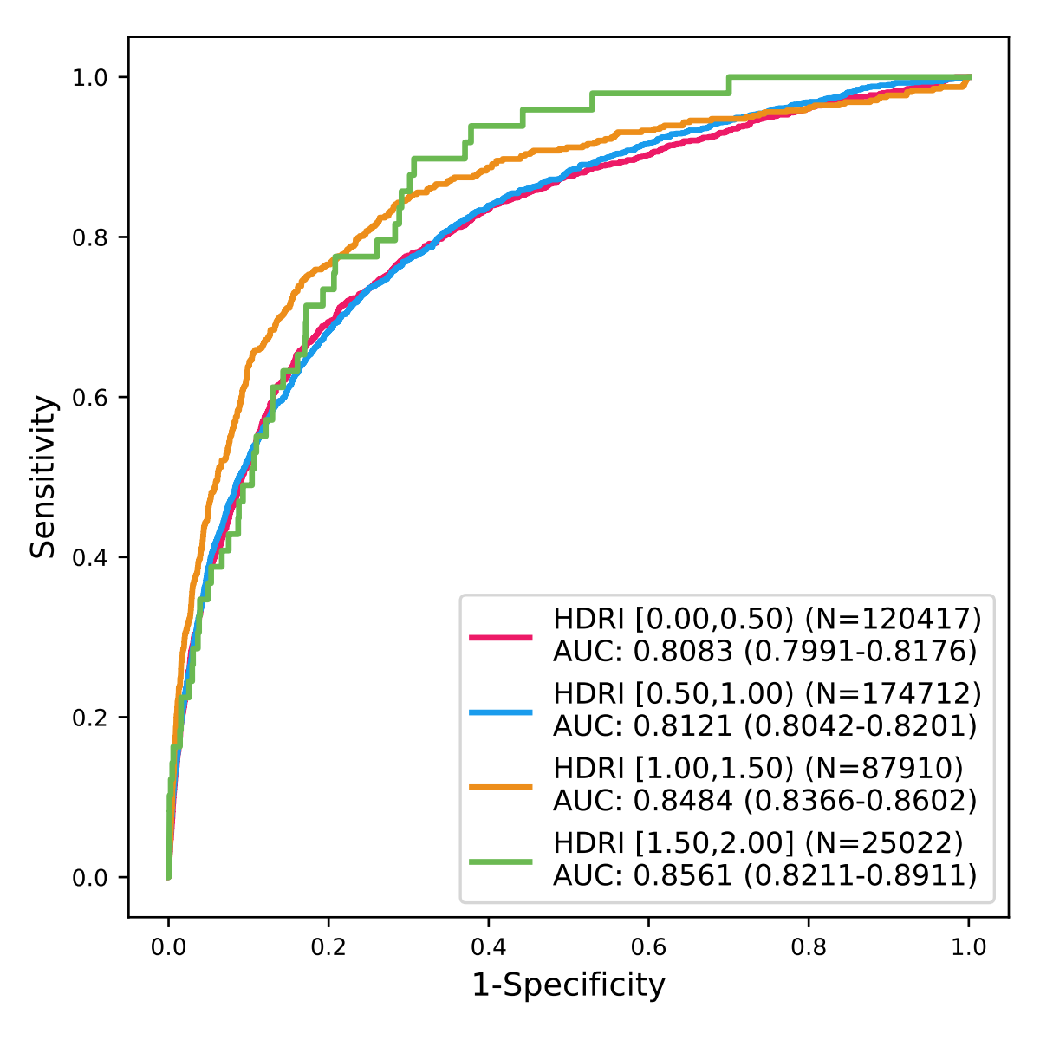

Note: AUC: the area under the ROC curve.
We split the hospitals into 4 subgroups based on the health resources density index (HRDI) to evaluate the performances of HEWIC. The subgroup with HRDI between 0.00-0.5 had 34 hospitals and the AUC was 0.8083 (95 CI: 0.7991-0.8176); the subgroup with HRDI between 0.5-1.00 had 69 hospitals and the AUC was 0.8121 (95 CI: 0.8042-0.8201); the subgroup with HRDI between 1,00-1.5 had 129 hospitals and the AUC was 0.8484 (95 CI: 0.8366-0.8602); the subgroup with HRDI between 1.5-2.0 had 53 hospitals and the AUC was 0.8561 (95 CI: 0.8211-0.8911).

Supplementary Figure 1(b). HEWIC performances in hospitals with different HRDI for three-month mortality prediction on the retrospective test set.
.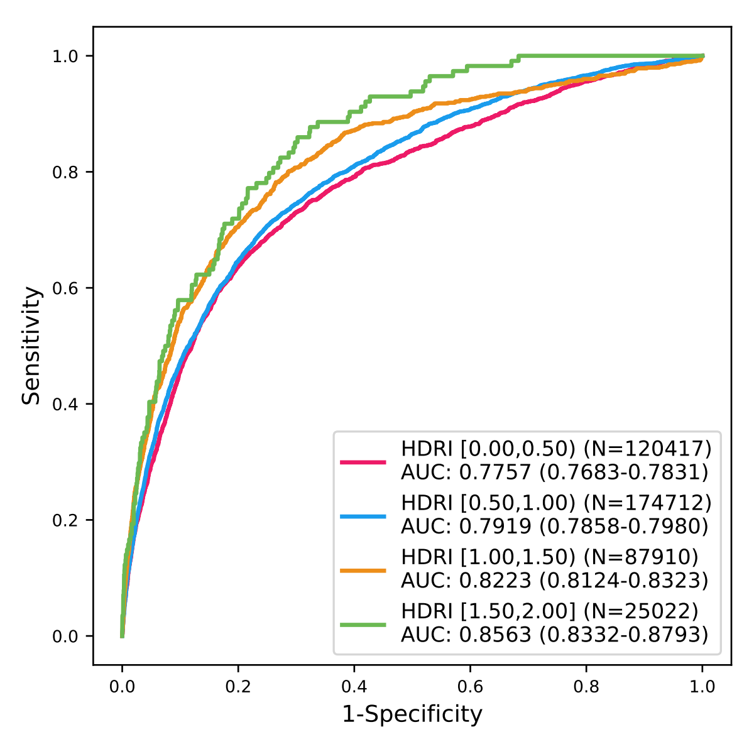
The areas under the ROC curve (AUC) of the subgroup with HRDI between 0.00-0.5 was 0.7757 (95 CI: 0.7683-0.7831); the AUC of the subgroup with HRDI between 0.5-1.00 was 0.7919 (95 CI: 0.7858-0.7980); the AUC of the subgroup with HRDI between 1.00-1.5 was 0.8223 (95 CI: 0.8124-0.8323); the AUC of the subgroup with HRDI between 1.5-2.0 was 0.8563 (95 CI: 0.8332-0.8793).

Supplementary Figure 2(a). HEWIC performances in hospitals with different ranks for one-month mortality prediction on the retrospective test set.
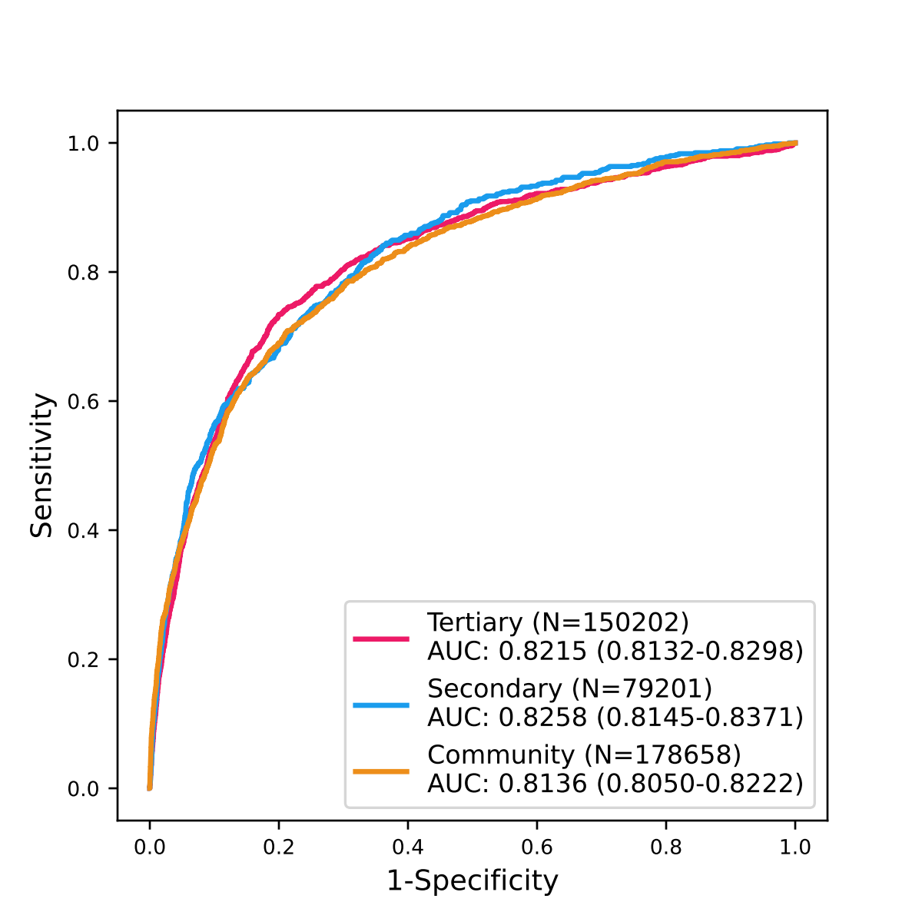

The areas under the ROC curve (AUC) of the subgroup of the tertiary hospitals was 0.8215 (95 CI: 0.8132-0.8298); the AUC of the subgroup of the secondary hospitals was 0.8258 (95 CI: 0.8145-0.8371); the AUC of the subgroup of the community hospitals was 0.8136 (95 CI: 0.8050-0.8222).

Supplementary Figure 2(b). HEWIC performances in hospitals with different ranks for three-month mortality prediction on the retrospective test set.
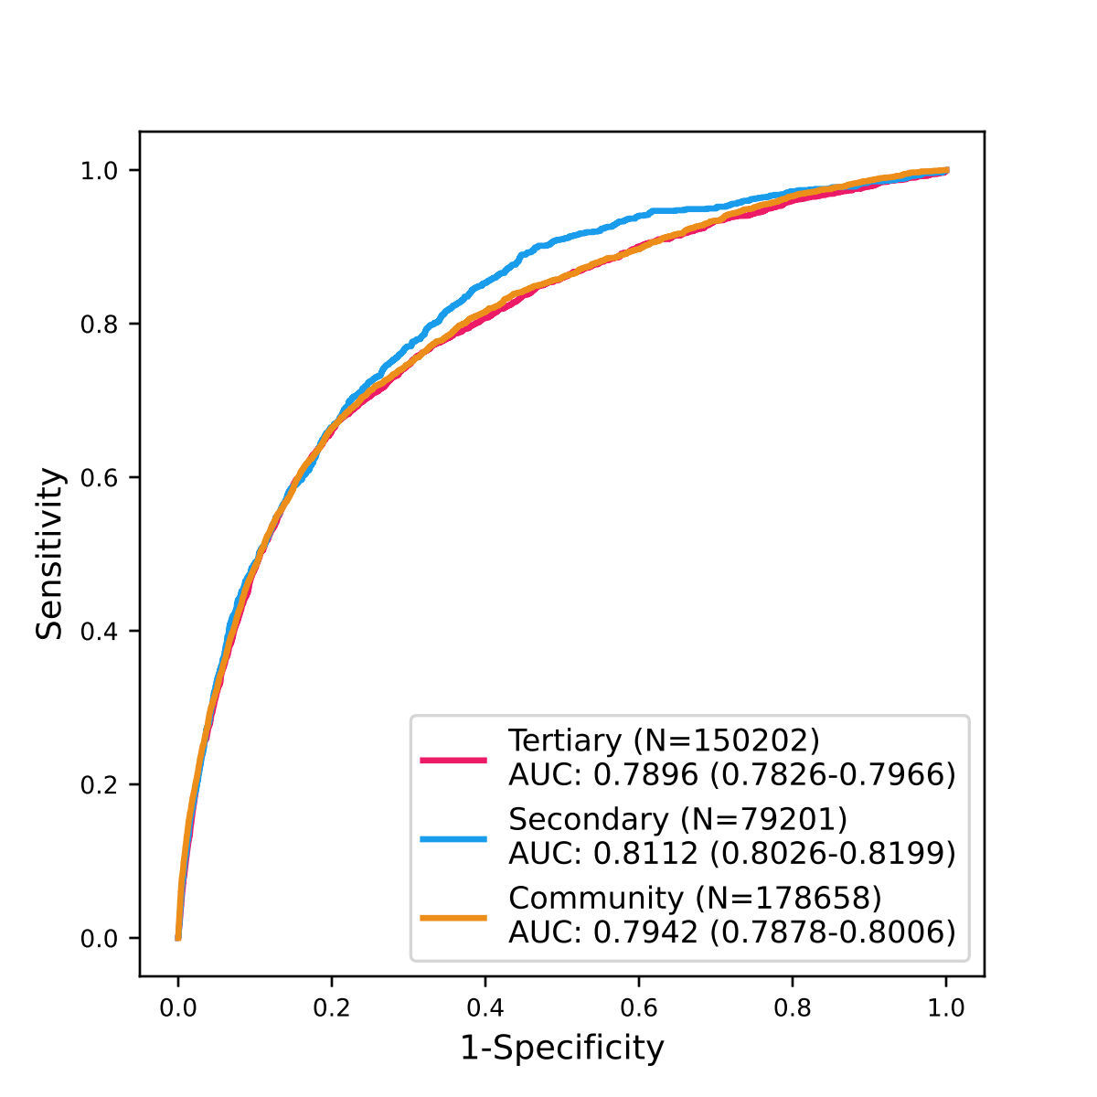

The areas under the ROC curve (AUC) of the subgroup of the tertiary hospitals was 0.7896 (95 CI: 0.7826-0.7966); the AUC of the subgroup of the secondary hospitals was 0.8112 (95 CI: 0.8026-0.8199); the AUC of the subgroup of the community hospitals was 0.7942 (95 CI: 0.7878-0.8006).

Supplementary Figure 3(a). HEWIC performances in hospitals with different years for one-month mortality prediction on the retrospective test set.
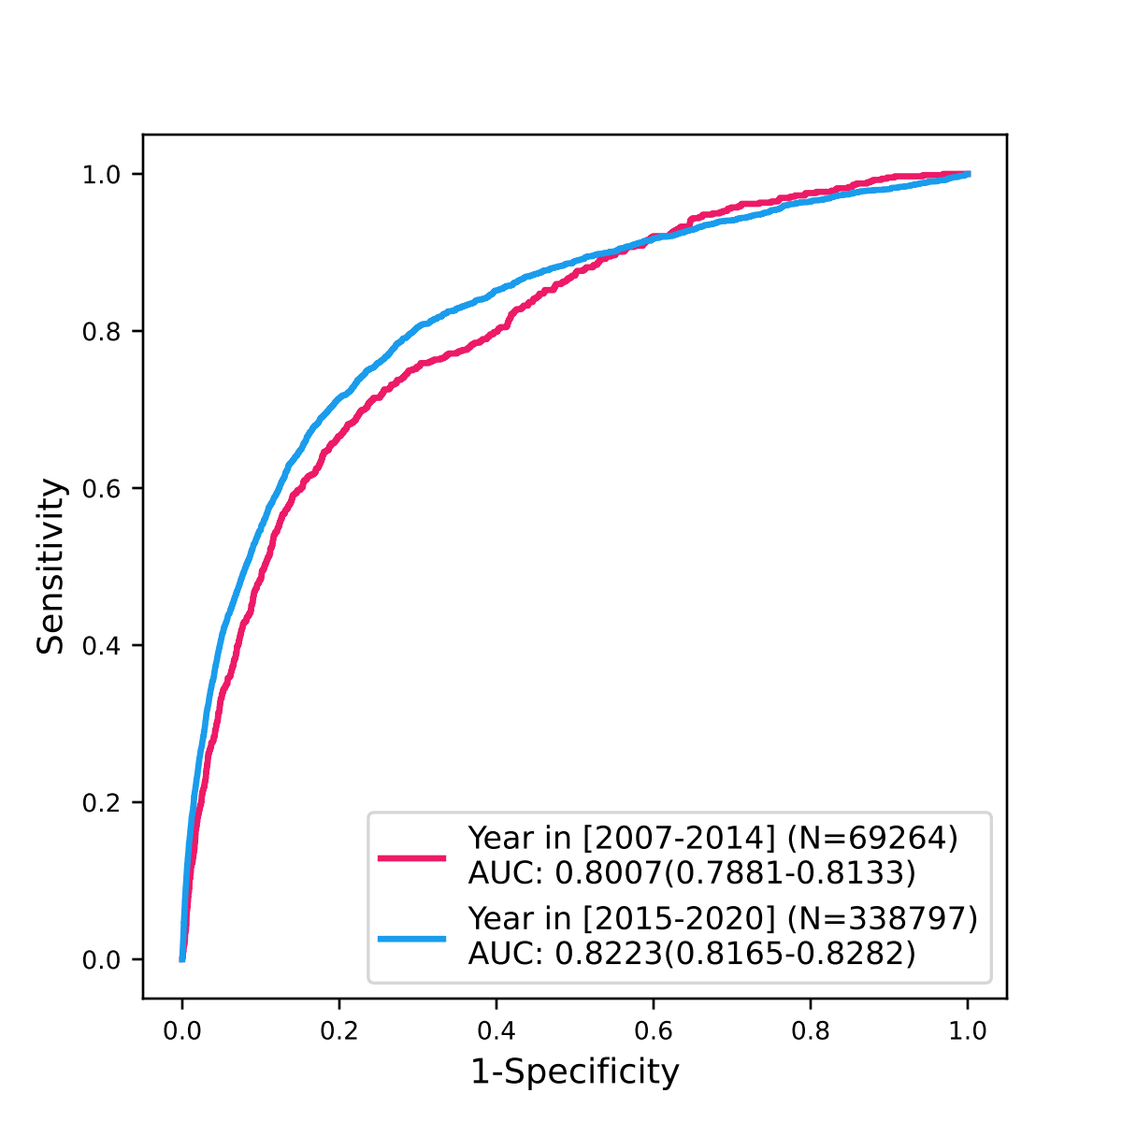
The areas under the ROC curve (AUC) of the subgroup with year between 2007 and 2014 was 0.8007 (95 CI: 0.7881-0.8133); the AUC of the subgroup with year between 2015 and 2020 was 0.8223 (95 CI: 0.8165-0.8282).

Supplementary Figure 3(b). HEWIC performances in hospitals with different years for three-month mortality prediction on the retrospective test set.
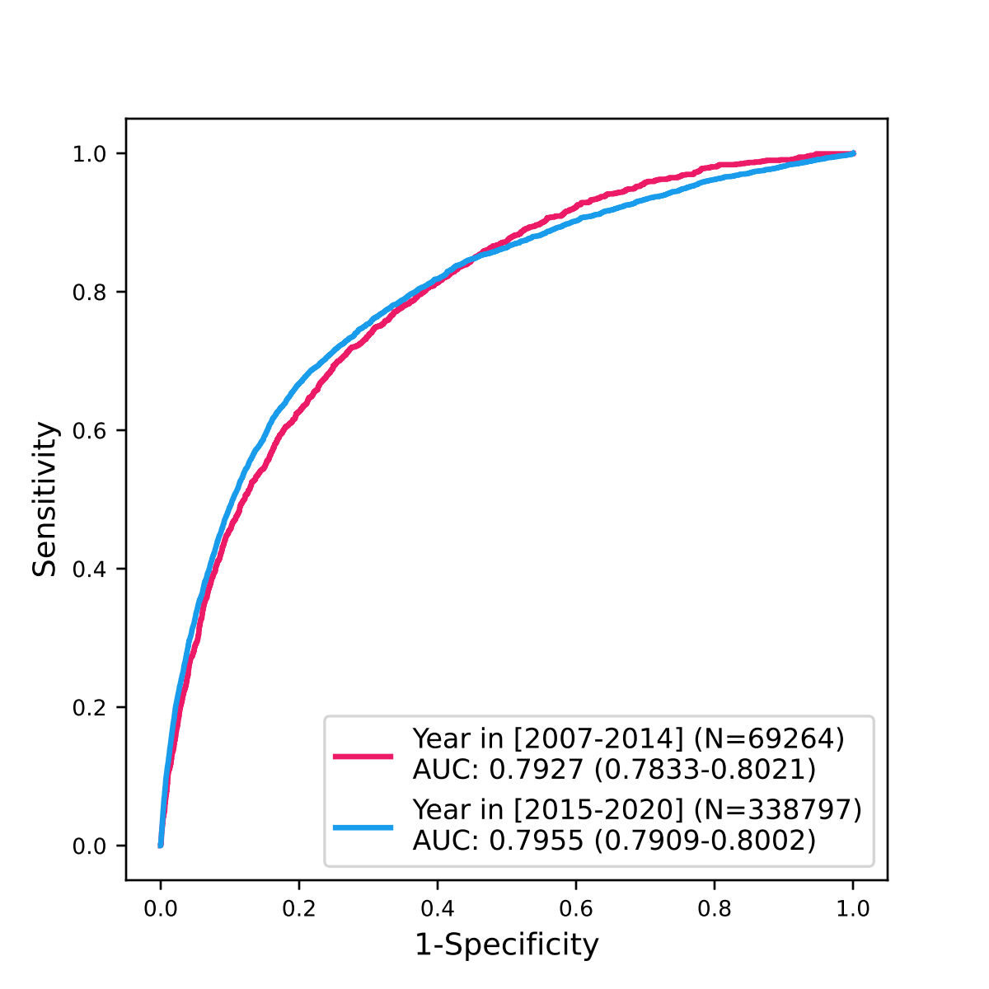
The areas under the ROC curve (AUC) of the subgroup with year between 2007 and 2014 was 0.7927 (95 CI: 0.7833-0.8021); the AUC of the subgroup with year between 2015 and 2020 was 0.7955 (95 CI: 0.7909-0.8002).

Supplementary Figure 4. Secondary endpoints at the baseline and in the follow-up period.
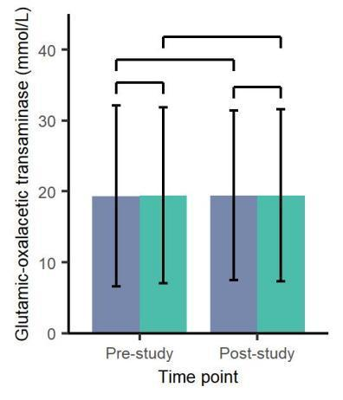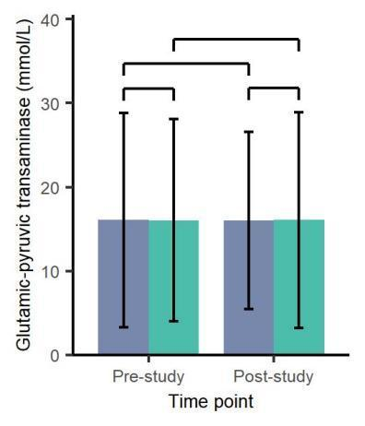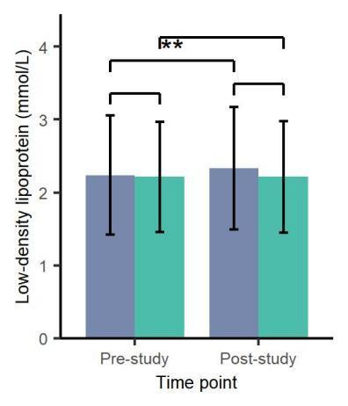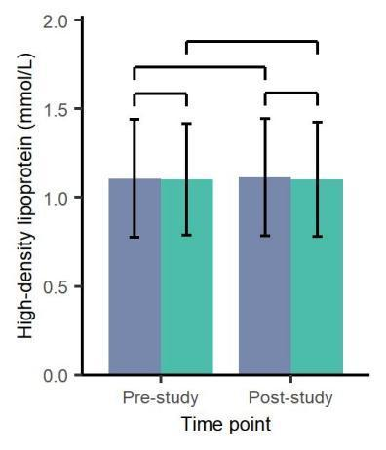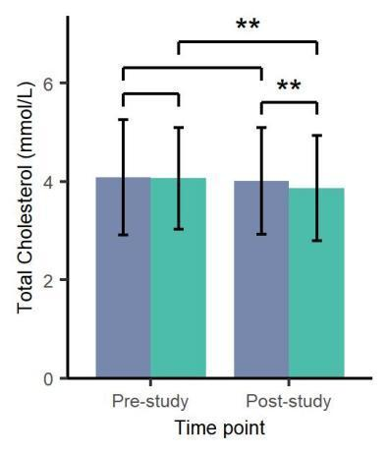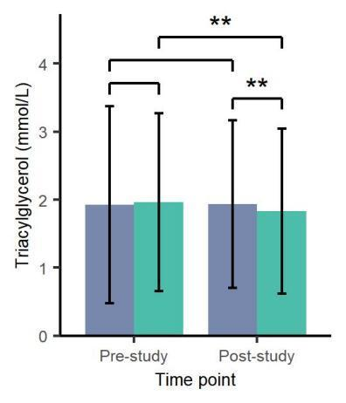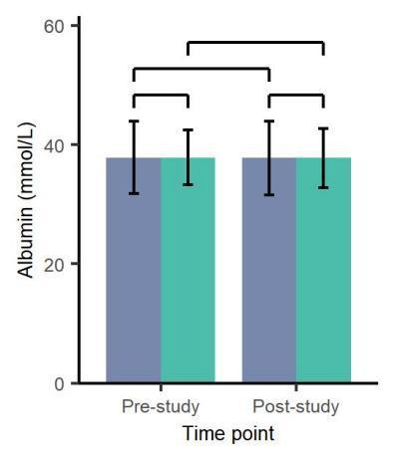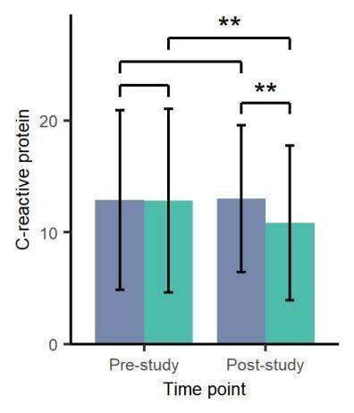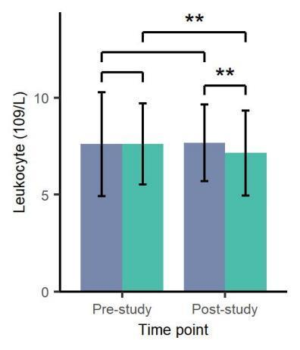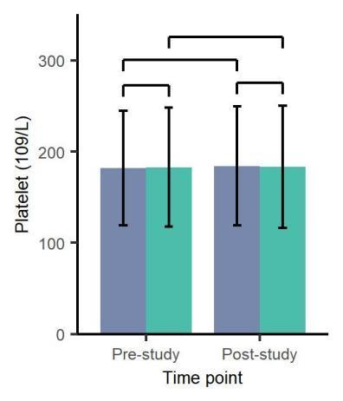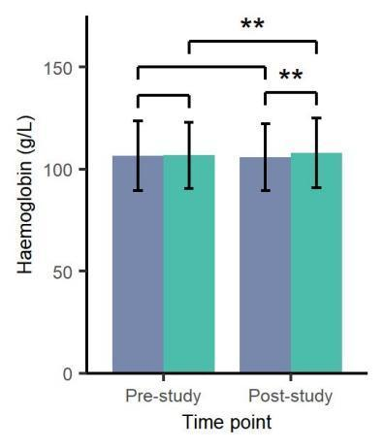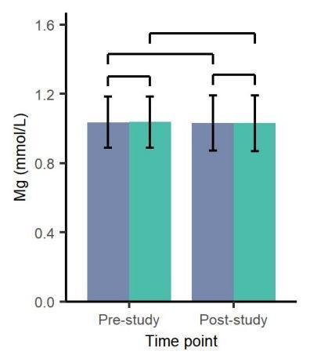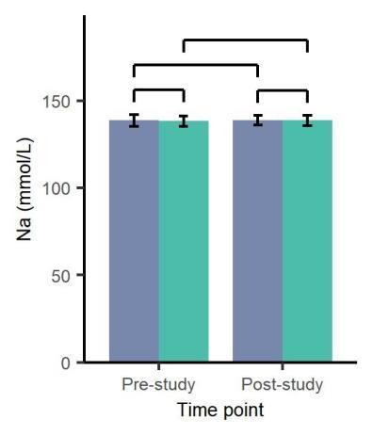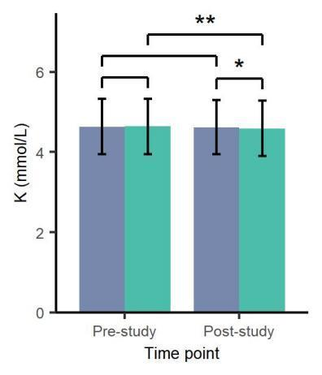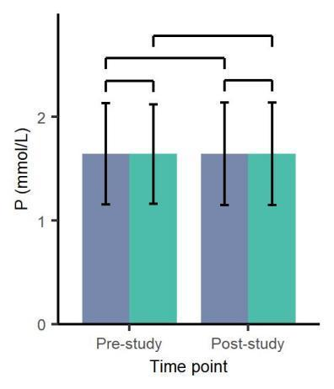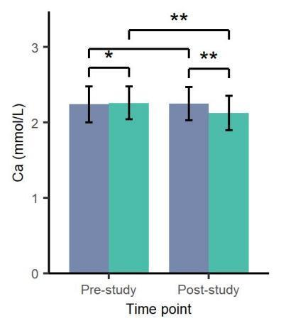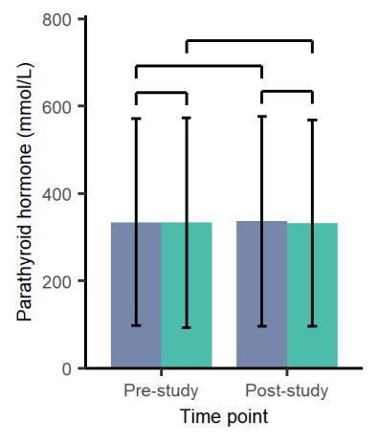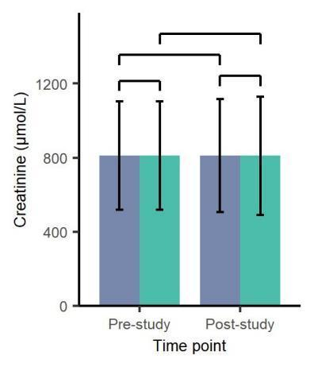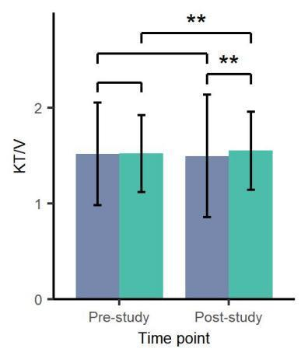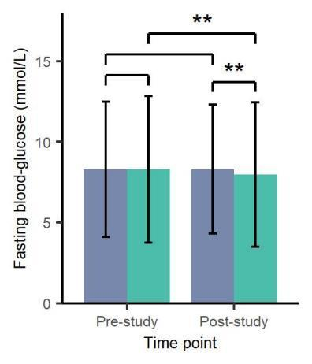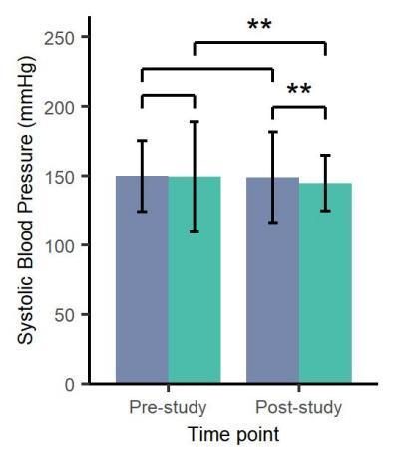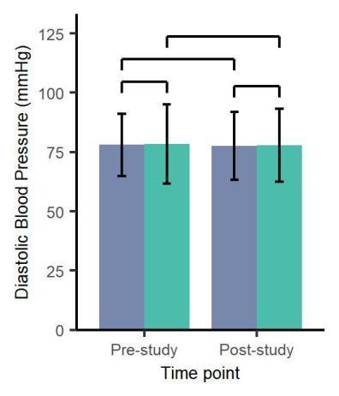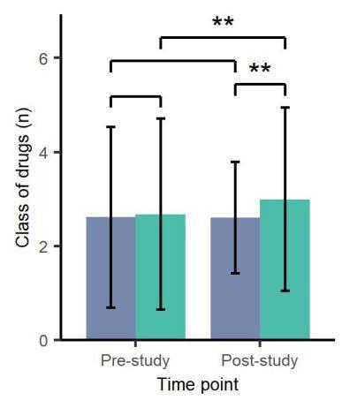
The sub-plots above show the differences between and within the intervention and control groups before and after the experiment, respectively. Green bars represent the AI intervention group and blue bars represent the conventional control group. ** indicates t-test p<0.001, and * indicates t-test p<0.05.
References
- Che, Z., Purushotham, S., Cho, K., Sontag, D. & Liu, Y. Recurrent neural networks for multivariate time series with missing values. Scientific Reports 8, 1–12 (2018).
- Althelaya K A, El-Alfy E S M, Mohammed S. Stock market forecast using multivariate analysis with bidirectional and stacked (LSTM, GRU)[C]//2018 21st Saudi Computer Society National Computer Conference (NCC). IEEE, 2018: 1-7.
- Deng Y, Wang L, Jia H, et al. A sequence-to-sequence deep learning architecture based on bidirectional GRU for type recognition and time location of combined power quality disturbance[J]. IEEE Transactions on Industrial Informatics, 2019, 15(8): 4481-4493.
- Li X, Ma X, Xiao F, et al. Time-series production forecasting method based on the integration of Bidirectional Gated Recurrent Unit (Bi-GRU) network and Sparrow Search Algorithm (SSA)[J]. Journal of Petroleum Science and Engineering, 2022, 208: 109309.
- Lin, T.-Y., Goyal, P., Girshick, R., He, K. & Dollár, P. Focal loss for dense object detection. Proceedings of the IEEE International Conference on Computer Vision, in 2980–2988 (2017).

https://github.com/fxsjy/jieba

