Table 1: Measurement protocols and example images/measurements for IISI and other cervical degeneration radiological parameters on MRI and X-ray.

IISI | Measurement Protocol
Definition of IISI [10] | Presence of hyperintensity noted on T2W MRI (figure 1) was binarized into dichotomous variables (1) IISI and (2) NO IISI for statistical analysis. Level of IISI was also recorded.
X-ray Parameter | Measurement Protocol | Images
Anterior, middle, and posterior disc height | Disc height was measured from inferior endplate to superior endplate of adjacent vertebral bodies at anterior, middle, and posterior positions. | 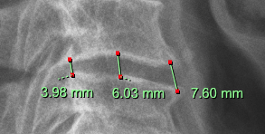  Anterior, middle, and posterior disk height was measured at 7.60mm, 6.03mm and 3.98mm, respectively.
Sung Hoon Choi disc height measurement [11] | Determine the four corners of two adjacent vertebral bodies and draw a straight bisecting line passing through the corners. Calculate the sum of shortest distances from upper and lower endplates to the bisecting line. | 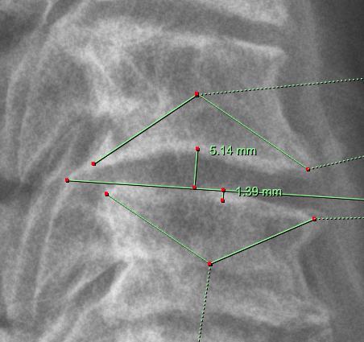  The sum of the shortest distance was 5.14mm + 1.39mm. Therefore, the Sung Hoon Choi disk height was 6.53mm.
Horizontal Intervertebral Displacement | Horizontal shift in vertebral body compared to superior adjacent vertebral body. Greater than 3.5mm was considered displacement instability. | 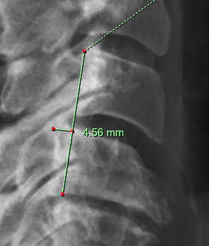  There was a forward slip of the C3 vertebrae on C4 vertebrae of 4.56mm. Therefore, this was considered displacement instability.
Torg-Pavlov ratio [12]. | Canal stenosis was assessed through Torg-Pavlov ratio defined as the ratio between diameter of cervical spine canal and width of cervical body on lateral view. | 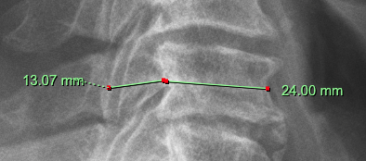  Diameter of cervical spine canal was measured at 13.07mm. Diameter of adjacent cervical vertebral body was measured at 24.00mm. Torg-Pavlov ratio was calculated as 0.545.
Rotational angle | The angle between the lines parallel to the inferior margin of two adjacent vertebral bodies. A difference in rotational angle between two adjacent vertebrae >11° was classified as rotation instability. | 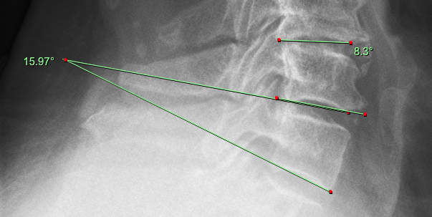  The angle between C7 and C6 measured 15.97 degrees whilst C6 and C5 measured 8.3 degrees. The difference was <11 degrees, therefore no instability.
Sagittal Alignment | C2-C7 Cobb angle. Segment alignment. Sagittal vertical axis. T1-slope. | 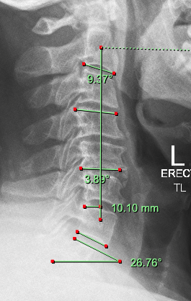  Measurements of sagittal alignment: C2-C7 Cobb angle (9.37 degrees), segmental alignment (3.89 degrees), T1 slope (26.76 degrees), sagittal vertical axis (10.10 mm).
Facet Joint Degeneration [13]. | Cervical facet joint degeneration on lateral view was categorized into grades 0-4. Facet joint degeneration was dichotomized into no facet joint degeneration (grade 0-1) and facet joint degeneration (grade 2-4). | 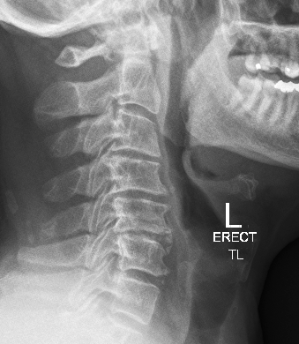  B  C  A  Facet joint degeneration. A: osteophyte formation, B: subchondral sclerosis, C: joint space narrowing.
MRI Parameter | Measurement Protocol | Images
Nucleus pulposus and annulus fibrosus distinction | Distinction of nucleus pulposus and annulus fibrosis was categorized into two grades: (1) distinct, and (2) indistinct. | 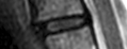  Example of a cervical disk with distinct annulus fibrosis and nucleus pulposus on left. Example of indistinct disk on right.
Posterior disc bulge/protrusion | Disc protruding beyond posterior margin of vertebral body. Bulge width was measured from posterior aspect of herniation to extent of disc invasion into spinal canal. | 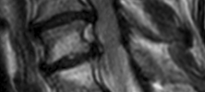  Posterior disk bulge shown on both the C3/4 disc as well as the C4/5 disc.
Maximum spinal cord compression (MSCC) | Ratio of midsagittal diameter of spinal cord at site of compression divided by average diameter of spinal cord at closest non-compressed regions above and below. | 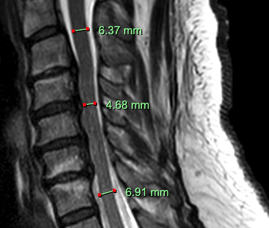  Site of maximal compression was measured at 4.68mm the average diameter of spinal cord at non-compressed regions measured 6.64mm. Ratio was calculated to be 0.705.
Endplate changes | Hypointense and hyperintense vertebral endplate lesions signal patterns on T1- and T2-weighted sagittal MRI. | 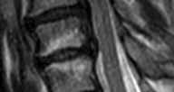  Hyperintense T2W MRI changes observed on the endplates of the superior endplate of C5 and the inferior endplate of C4.
Foraminal stenosis [14]. | Perineural fat obliteration surrounding nerve root and categorized into two grades on axial MRI: (1) foraminal stenosis (<4.0mm) and, (2) no foraminal stenosis (>4.0mm). | 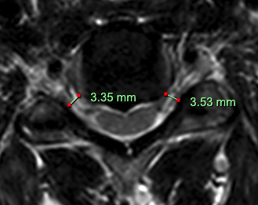  Measurement of nerve root diameter with foraminal stenosis (<4.0mm) on both sides.
Vertebral tilt | Cervical tilt (angle between perpendicular line from T1 upper endplate and line from centroid of T1 upper endplate to centroid of C2 vertebral body). Cranial tilt (angle between line from centroid of T1 upper endplate to centroid of C2 vertebral body to the vertical). | 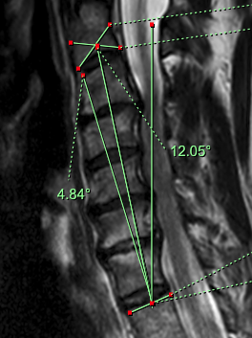  The cervical tilt was measured to be 4.84 degrees and cranial tilt was measured to be 12.05 degrees.

