Supplementary Table 1：General information of IVs used in MR analyses.
SNP | Chr | Position | Effect allele | Other allele | Beta | Eaf | Se | P-value | F-statistic
rs117372722 | 17 | 59478616 | T | G | 0.4556 | 0.02437 | 0.0637 | 8.29E-13 | 2165.239355
rs117725035 | 17 | 57289661 | G | A | 0.5924 | 0.02591 | 0.0629 | 4.63E-21 | 3916.955516
rs141585217 | 17 | 59199184 | T | C | 0.4604 | 0.02919 | 0.0592 | 7.43E-15 | 2641.056944
rs144860043 | 17 | 57375753 | T | C | 0.2572 | 0.06306 | 0.0392 | 5.17E-11 | 1711.219384
rs62081796 | 17 | 56098211 | C | T | 0.2484 | 0.05209 | 0.0432 | 8.59E-09 | 1331.584884
rs75362578 | 17 | 58819628 | G | A | 0.5601 | 0.02459 | 0.0650 | 7.13E-18 | 3318.578209
rs75421338 | 17 | 58042083 | C | T | 0.5085 | 0.02979 | 0.0579 | 1.53E-18 | 3295.704719

Supplementary Table 2: Two-Sample MR estimates of relationship between iron deficiency anemia and outcomes
Outcome | Method | nSNP | b | SE | P-value | or | or_lci95 | or_uci95
Epilepsy | MR Egger | 7 | 0.126 | 0.141 | 0.411 | 1.135 | 0.861 | 1.496
Epilepsy | Weighted median | 7 | 0.170 | 0.060 | 0.005 | 1.185 | 1.054 | 1.332
Epilepsy | Inverse variance weighted | 7 | 0.142 | 0.046 | 0.002 | 1.153 | 1.054 | 1.261
Epilepsy | Simple mode | 7 | 0.207 | 0.091 | 0.064 | 1.230 | 1.029 | 1.471
Epilepsy | Weighted mode | 7 | 0.167 | 0.086 | 0.099 | 1.182 | 0.999 | 1.398
Focal Epilepsy | MR Egger | 7 | 0.634 | 0.356 | 0.136 | 1.884 | 0.937 | 3.788
Focal Epilepsy | Weighted median | 7 | 0.653 | 0.146 | 7.294E-06 | 1.922 | 1.444 | 2.556
Focal Epilepsy | Inverse variance weighted | 7 | 0.682 | 0.116 | 3.975E-09 | 1.978 | 1.576 | 2.482
Focal Epilepsy | Simple mode | 7 | 0.653 | 0.227 | 0.028 | 1.920 | 1.230 | 2.998
Focal Epilepsy | Weighted mode | 7 | 0.638 | 0.206 | 0.021 | 1.893 | 1.263 | 2.837
Generalized Epilepsy | MR Egger | 7 | 0.093 | 0.258 | 0.732 | 1.098 | 0.662 | 1.819
Generalized Epilepsy | Weighted median | 7 | 0.115 | 0.103 | 0.266 | 1.121 | 0.916 | 1.372
Generalized Epilepsy | Inverse variance weighted | 7 | 0.098 | 0.084 | 0.242 | 1.103 | 0.936 | 1.300
Generalized Epilepsy | Simple mode | 7 | 0.122 | 0.150 | 0.447 | 1.130 | 0.842 | 1.516
Generalized Epilepsy | Weighted mode | 7 | 0.115 | 0.135 | 0.429 | 1.121 | 0.861 | 1.461
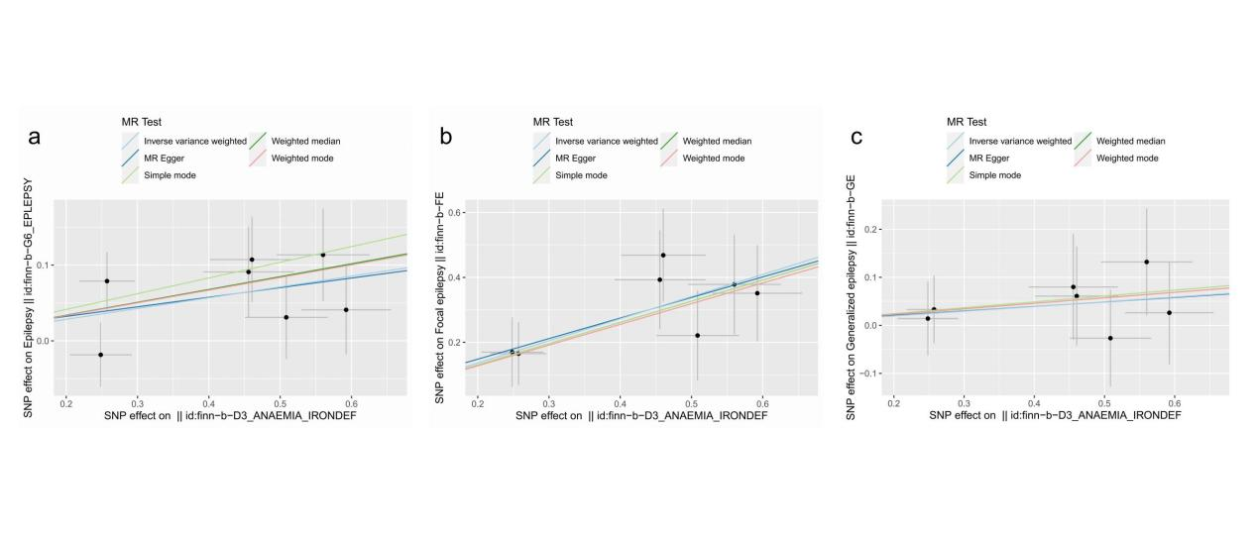
Supplementary Fig. 1 Scatter plots of the causal relationship between iron deficiency anemia and outcomes
a.Epilepsy; b. Focal epilepsy; c. Generalized epilepsy
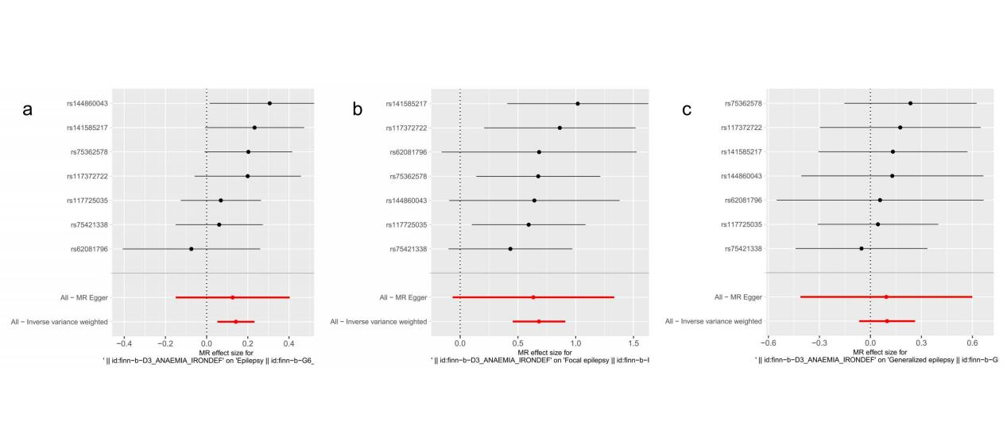
Supplementary Fig. 2 Forest plots of the causal relationship between iron deficiency anemia and outcomes
a.Epilepsy; b. Focal epilepsy; c. Generalized epilepsy

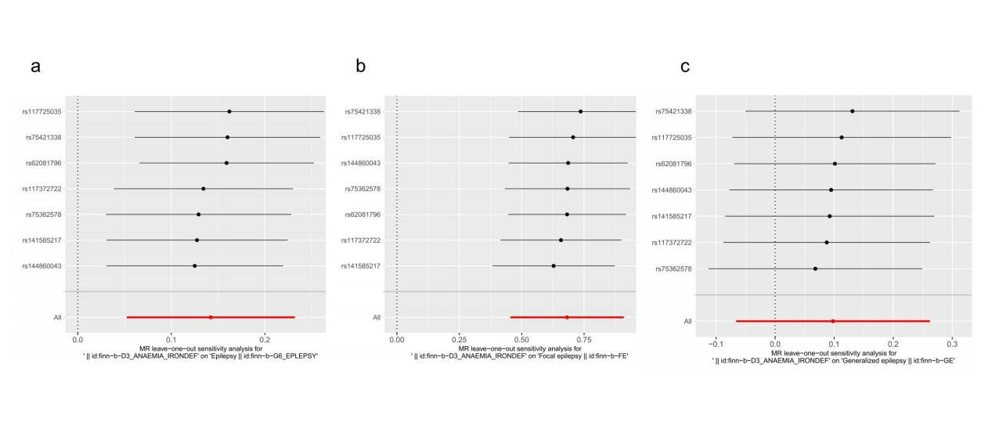
Supplementary Fig. 3 Leave-one-out method sensitivity analysis
a.Epilepsy; b. Focal epilepsy; c. Generalized epilepsy

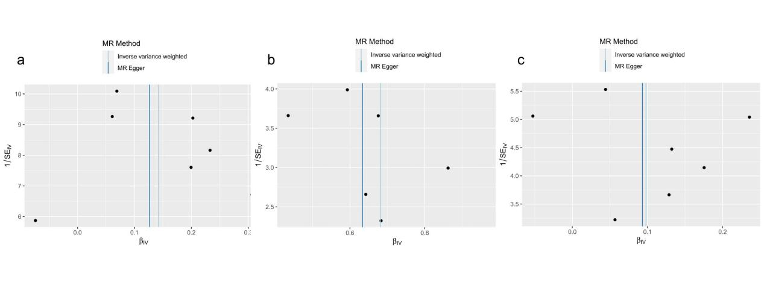

Supplementary Fig. 4 Funnel plots of the causal relationship between iron deficiency anemia and outcomes
a.Epilepsy; b. Focal epilepsy; c. Generalized epilepsy

