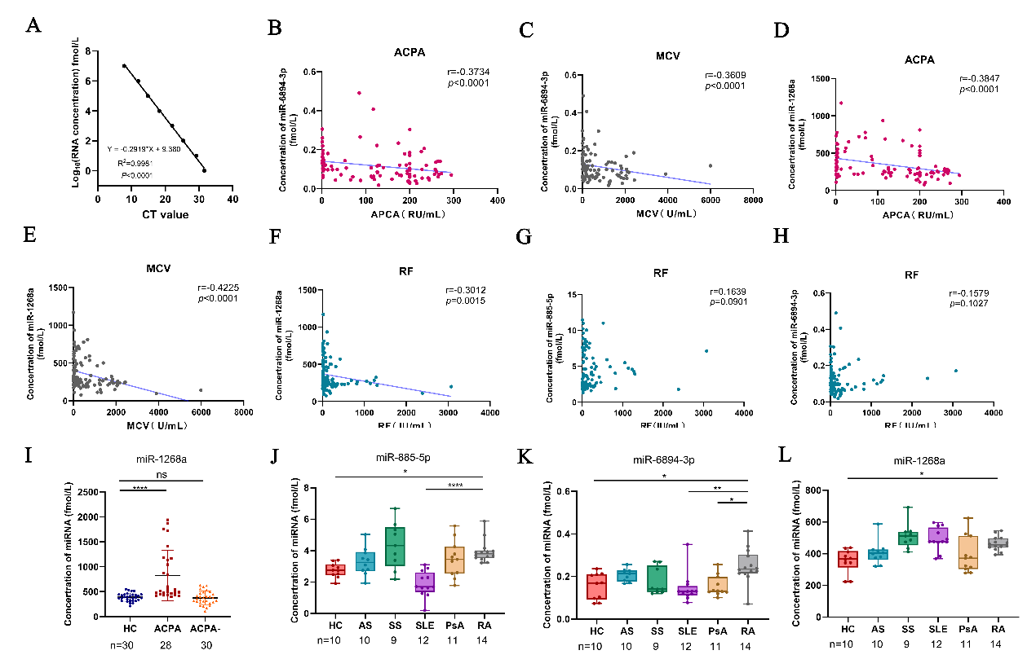
Supplementary Figure S1 Diagnostic evaluation of miRNAs in RA patients. (A) Linear standard curve of serum derived exosomes miRNAs concentration. (B) Correlation analyses between miR-6894-3p and ACPA. (C) Correlation analyses between miR-6894-3p and MCV. (D) Correlation analyses between miR-1268a and ACPA. (E) Correlation analyses between miR-1268a and MCV. (F) Correlation analyses between miR-1268a and RF. (G) Correlation analyses between miR-885-5p and RF. (H) Correlation analyses between miR-6894-3p and RF. (I) Expression of miR-1268a in ACPA-negative RA, ACPA-positive RA and healthy controls. (****P <0.0001) (J, K, L) Differential expression analysis of miR-885-5p, miR-6894-3p and miR-1268a in different autoimmune diseases. (HC, healthy control; AS, ankylosing spondylitis; SS, Sjogren’s syndrome; SLE, systemic lupus erythematosus; PsA, psoriatic arthritis; RA, rheumatoid arthritis）

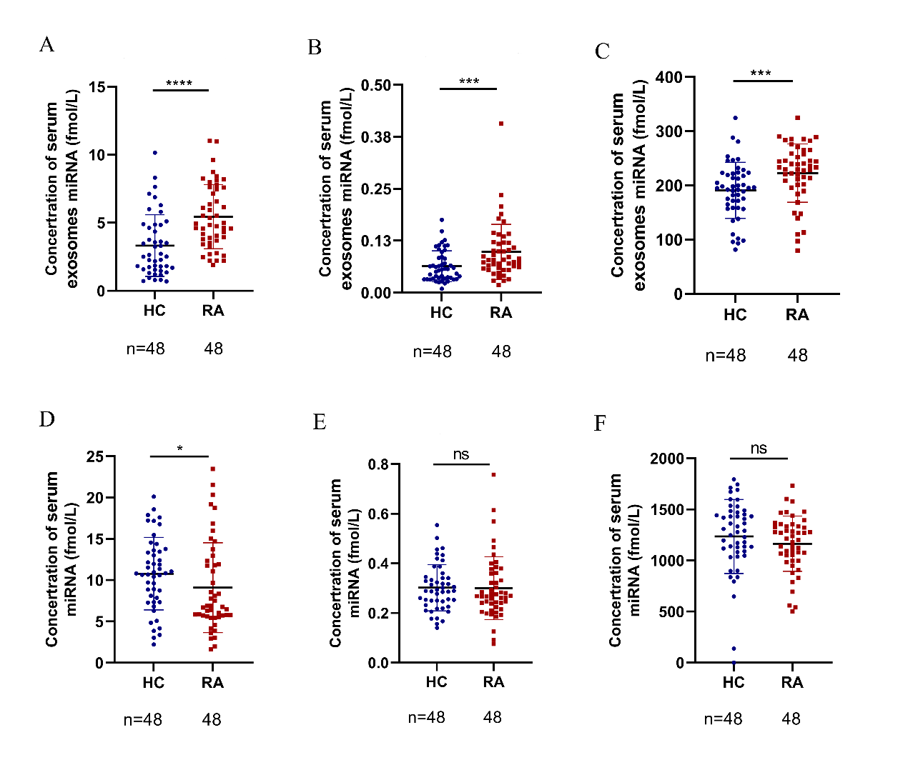Supplementary Figure S2 The differences in miRNA expression in serum exosomes were significantly greater than in serum between RA and healthy controls. (A, B, C) Expression of miR-885-5p, miR-6894-3p and miR-1268a in serum exosomes between RA and healthy control. (D, E, F) Expression of miR-885-5p, miR-6894-3p and miR-1268a in serum between RA and healthy controls. (*P <0.05, ***P < 0.001, ****P < 0.0001)

