Supporting information
Clay-supported bio-based Lewis acid ionic liquid as a potent catalyst for the dehydration of fructose to 5-hydroxymthylfurfural
Soheila Yaghoubi¹, Samahe Sadjadi^{2*}, Xuemin Zhong³, Peng Yuan⁴, Majid M. Heravi*¹

Characterization of the catalyst
Thermogravimetric analysis (TGA, METTLER TOLEDO, under O₂ atmosphere and ramp rate of 10 °C/min) was applied to study the thermal stability of Hal-IL and estimating the loading of IL on Hal. The structure and crystalline phase of Hal and Hal-IL were investigated using X-ray diffraction (XRD, Rigaku Ultima $Ⅳ$ with Cu-Kα). Conjugation of IL on Hal was confirmed using Fourier-Infrared spectroscopy (FTIR, BRUKER TENSOR 35 spectrophotometer 65 with a scan time of 1s and spectral resolution of 2 cm⁻¹ by using potassium bromide (KBr) pellets). The specific surface area (S_{BET}) of the catalyst was measured using Brunauer-Emmett-Teller (BET) method employing BELSORP MINI II, BEL instrument with pre-heating at 150 °C for 3 h. The morphological study was conducted using Scanning electron microscope (SEM) coupled with energy-dispersive X-ray spectroscopy (EDS, VEGAII TESCAN device, equipped with QX2, RONTEC energy dispersive X-ray analyzer).

Scheme S1. Schematic synthetic route of Hal-IL1 control catalyst.

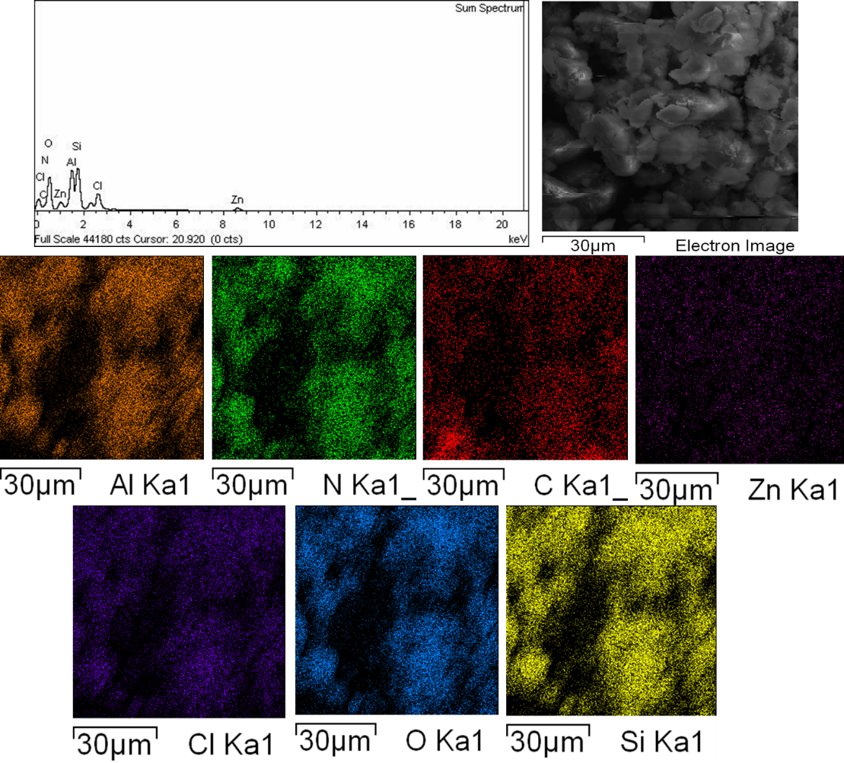
Figure S1. EDS and elemental mapping analysis of Hal-IL.

Figure S2. Nitrogen adsorption-desorption isotherm of Hal-IL

