Supplementary Materials
Estimation of Tectonic Stress Rates
Using the generalized Hooke’s law, the relationship between the stress ($σ$) and strain ($ε$) tensor components in 2D plane can be defined in matrix form as follow:
$$\left[\begin{matrix}σ_{xx} \\ σ_{yy} \\ σ_{xy}\end{matrix}\right]= \frac{E}{\left(1+v\right)\left(1-2v\right)}\left[\begin{matrix}\left(1-v\right) & v & 0 \\ v & \left(1-v\right) & 0 \\ 0 & 0 & \left(1-2v\right)\end{matrix}\right]\left[\begin{matrix}ε_{xx} \\ ε_{yy} \\ ε_{xy}\end{matrix}\right]$$
Where $E$ and $v$ are the Young’s modulus and Poisson’s ratio, respectively.
The strain tensor components are obtained through geodetic plate model of GSRMv2.1 by Kreemer et al. (2014) at coordinate 1.75°S and 120.90°E (see Figure S1). By assuming $E$ is 80 GPa and $v$ is 0.25, we get the stress tensor components to be:
$$\left[\begin{matrix}-3.69 kPa \\ 6.31 kPa \\ -0.97 kPa\end{matrix}\right]= \frac{80 GPa}{\left(1+0.25\right)\left(1-2*0.25\right)}\left[\begin{matrix}\left(1-0.25\right) & 0.25 & 0 \\ 0.25 & \left(1-0.25\right) & 0 \\ 0 & 0 & \left(1-2*0.25\right)\end{matrix}\right]\left[\begin{matrix}-67.9 nanostrain \\ 88.4 nanostrain \\ -15.1 nanostrain\end{matrix}\right]$$
The stress tensor components are then evaluated to generate its principal stresses ($σ_{1},σ_{2}$) by determining its eigenvalues. Then we compute the normal and shear stress changes using Coulomb-failure criterion using the equation as follow:
$$σ_{N}= \frac{1}{2}\left(σ_{1}+ σ_{2}\right)- \frac{1}{2}\left(σ_{1}- σ_{2}\right)cos2θ$$
$$σ_{S}= \frac{1}{2}\left(σ_{1}- σ_{2}\right)sin2θ$$
Where $θ$ is the angle between the direction of the surface normal on a plane and the orientation of the maximum principal stress. Where $σ_{N}$ and $σ_{S}$ are normal and stress stresses, respectively. From these equations we get $\left[\begin{aligned}σ_{N} \\ σ_{s}\end{aligned}\right]=\left[\begin{aligned}6.13 kPa \\ -0.017 kPa\end{aligned}\right]$ and assuming $μ'$ is 0.4, the tectonic stress rate is ~2.4 kPa.
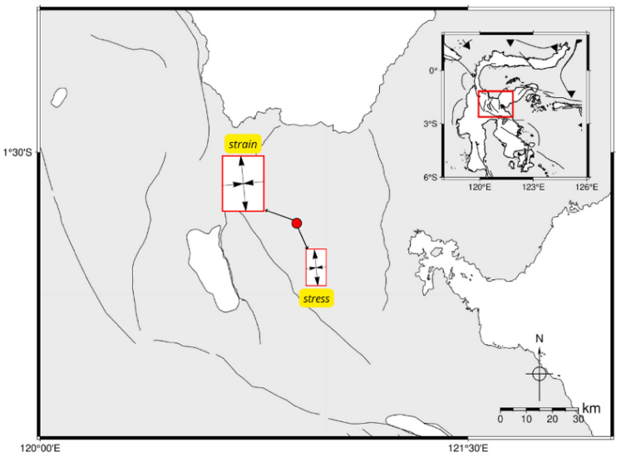
Figure S1. The point observation of strain rate used to calculate tectonic stress rate indicated by red circle. The red boxes near the red circle are the azimuth of strain and stress from calculated eigenvectors. The inset box shows the Island of Sulawesi with the focus study area indicated by red box.
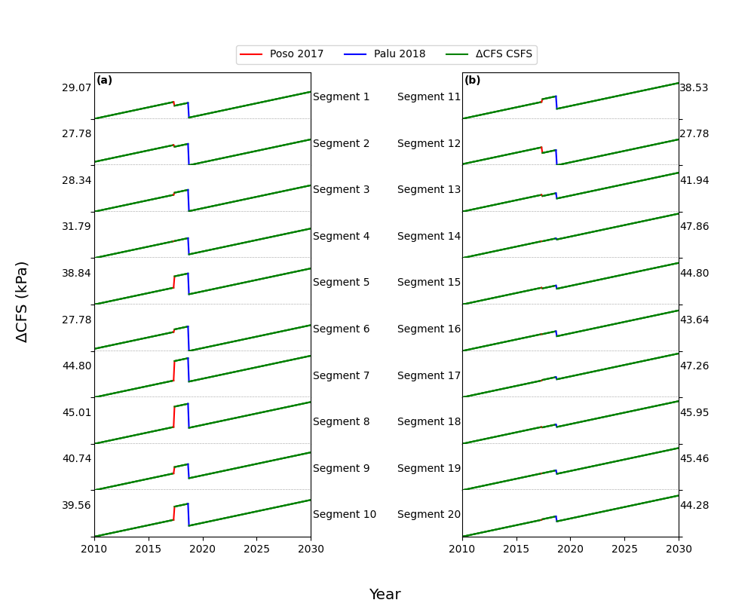
Figure S2. ΔCFS time function on each Poso fault segment using $μ^{'}$=0.1 and dip=25°, (a) for segment 1 – 10 and (b) for segment 11 - 20. Coseismic changes in CFS due to the occurrence of the 2017 Poso and the 2018 Palu-Donggala earthquakes (blue and red lines, respectively) as well as the tectonic stress rate (green) around Central Sulawesi Fault System (CSFS) are indicated. The absolute value of the range of change in CFS from these sources, accumulated over 20 years for each segment is indicated on the left of (a) and the right of (b).
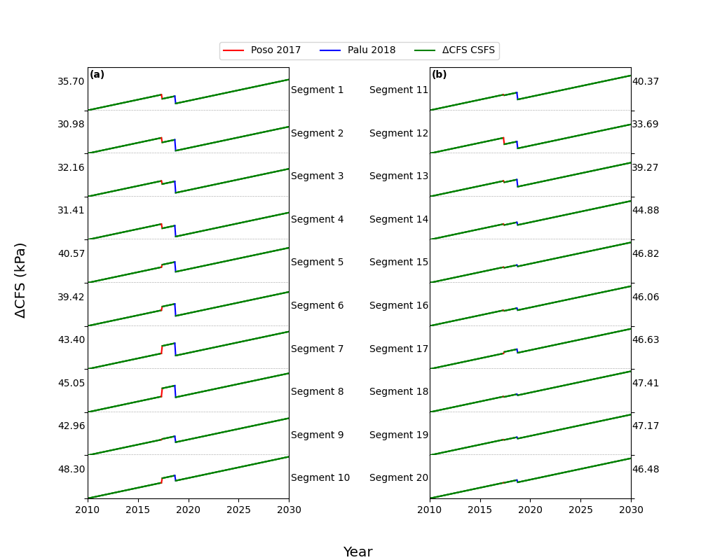
Figure S3. ΔCFS time function on each Poso fault segment using $μ^{'}$=0.4 and dip=45°, (a) for segment 1 – 10 and (b) for segment 11 - 20. Coseismic changes in CFS due to the occurrence of the 2017 Poso and the 2018 Palu-Donggala earthquakes (blue and red lines, respectively) as well as the tectonic stress rate (green) around Central Sulawesi Fault System (CSFS) are indicated. The absolute value of the range of change in CFS from these sources, accumulated over 20 years for each segment is indicated on the left of (a) and the right of (b).
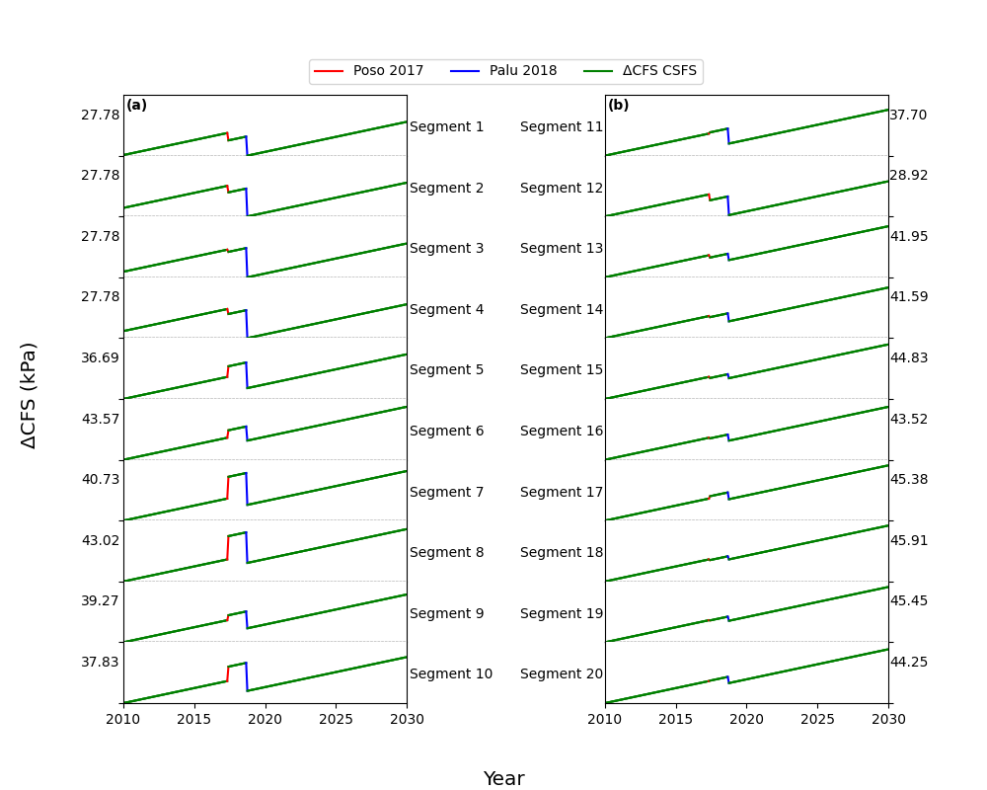
Figure S4. ΔCFS time function on each Poso fault segment using $μ^{'}$=0.1 and dip=45°, (a) for segment 1 – 10 and (b) for segment 11 - 20. Coseismic changes in CFS due to the occurrence of the 2017 Poso and the 2018 Palu-Donggala earthquakes (blue and red lines, respectively) as well as the tectonic stress rate (green) around Central Sulawesi Fault System (CSFS) are indicated. The absolute value of the range of change in CFS from these sources, accumulated over 20 years for each segment is indicated on the left of (a) and the right of (b).

