Supplemental Information:
Supplemental Table 1. Representation of responses from 28 participants across times and category. T1, T2, T3 represent the frequency of a participant’s performance. Symbols- *-sleep, #-calmness, 0- neutral
S.N. | Gender | T1 | T2 | T3
1 | F | # | *
2 | F | # | #
3 | F | * | *
4 | F | *
5 | F | # | *
6 | F | * | # | #
7 | F | # | * | #
8 | F | * | 0
9 | M | * | * | *
10 | F | *
11 | F | *
12 | F | * | *
13 | F | *
14 | F | # | * | *
15 | F | # | #
16 | F | # | #
17 | M | * | * | #
18 | F | #
19 | F | # | #
20 | F | 0
21 | M | # | * | *
22 | F | #
23 | M | #
24 | F | * | # | #
25 | M | #
26 | F | * | * | *
27 | F | #
28 | M | #
Age: 18-30 Years | Sleep | Calmness | Neutral | Total
First time | 12 | 15 | 1 | 28
Second time | 10 | 6 | 1 | 17
Third time | 4 | 4 |  | 08
Total response | 26 | 25 | 2 | 53
Percentage | 49.06% | 47.17% | 3.77%

Supplemental Figure 1. Representation of karmala and mala japa: A positional view.

Supplemental Figure 2.Representation of an EEG signal collected from three channels in three different states.

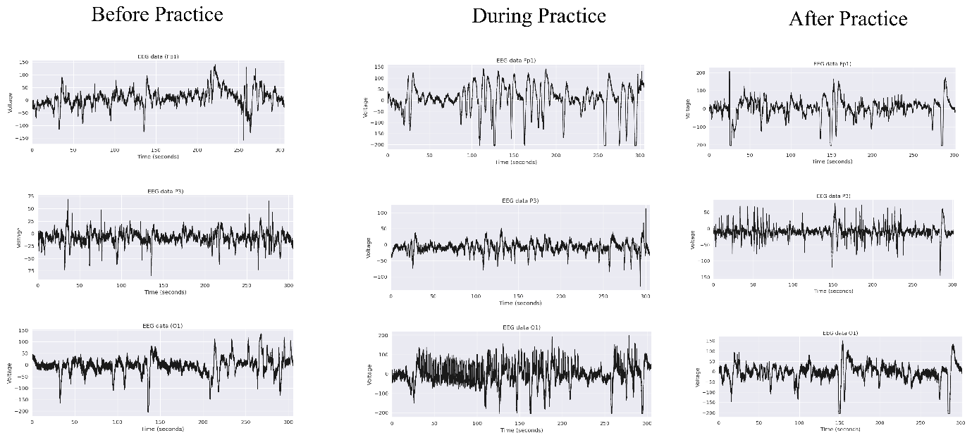

The sample format (containing 8 items) used to collect the responses from the participants performing meditation.
