Supporting Information
Ultralow overpotential 465 mV: Ni and Fe synergistically promote the conversion of nitrate to ammonia
Ziwang Kan,^{1, #} Kang-Shun Peng,^{2,#} Lei Shi,¹ Mengcheng Chen, ² Peidong Ren,¹ Yan Hong, ¹ Siqi Li,¹ Sung-Fu Hung^{*,1} Song Liu,^{*,1}
¹ College of Chemistry, Chemical Engineering and Resource Utilization, Northeast Forestry University, Harbin 150040, China
² Department of Applied Chemistry and Center for Emergent Functional Matter Science, National Yang Ming Chiao Tung University, Hsinchu, 300, Taiwan
# Ziwang Kan and Kangshun Peng contribute equally to this work.
To whom correspondence should be addressed. Email: sungfuhung@nycu.edu.tw (S. Hung) and carlosliusong@nefu.edu.cn (S. Liu).

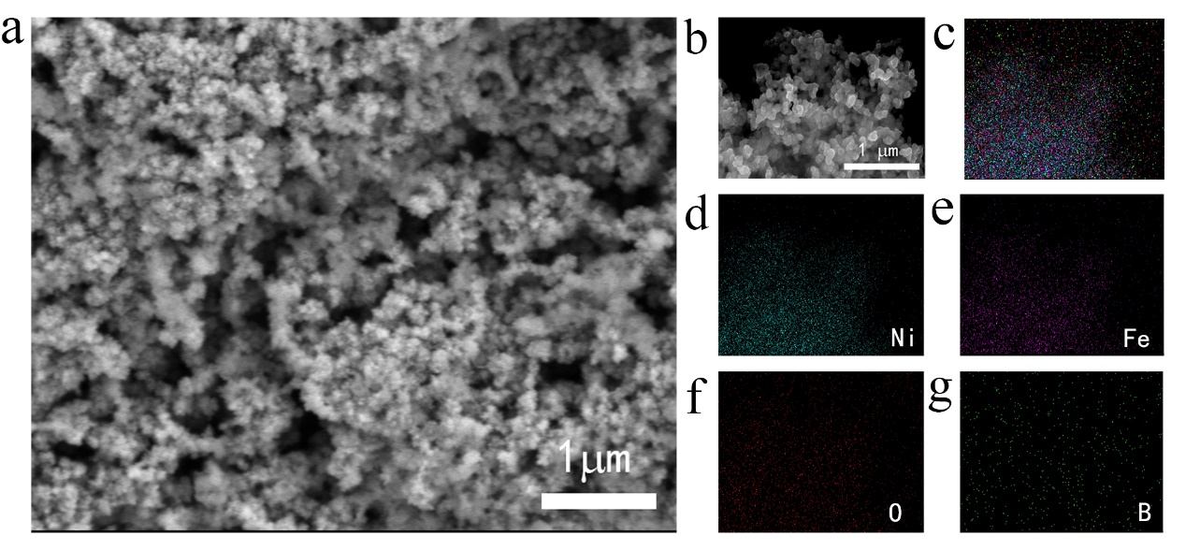
Figure S1. SEM (a) and EDS mapping (b-g) image of the precatalyst-NiFe NPs.
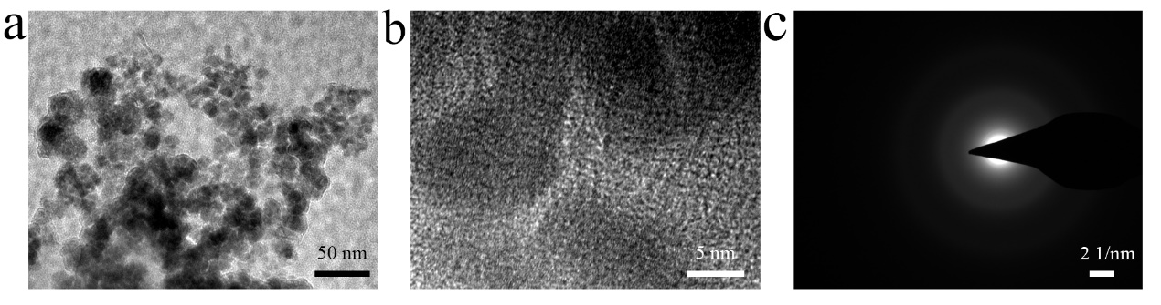Figure S2. TEM and HRTEM (a,b) image of the precatalyst-NiFe NPs and SAED (c) patterns of precatalyst. 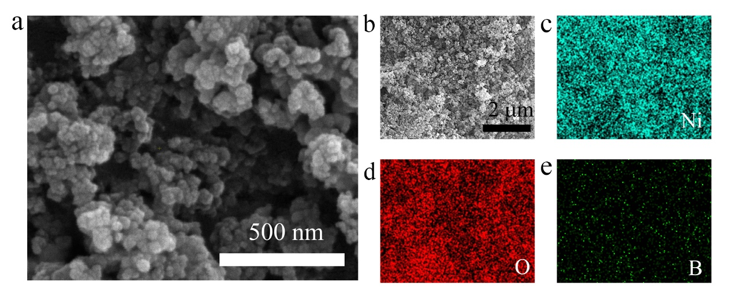
Figure S3. SEM (a) and EDS mapping (b-g) image of the Ni NPs.
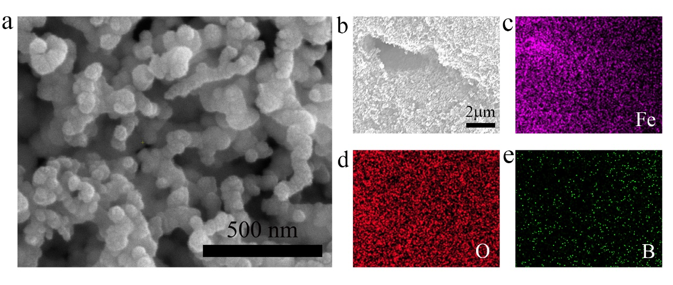
Figure S4. SEM (a) and EDS mapping (b-g) image of the Fe NPs.
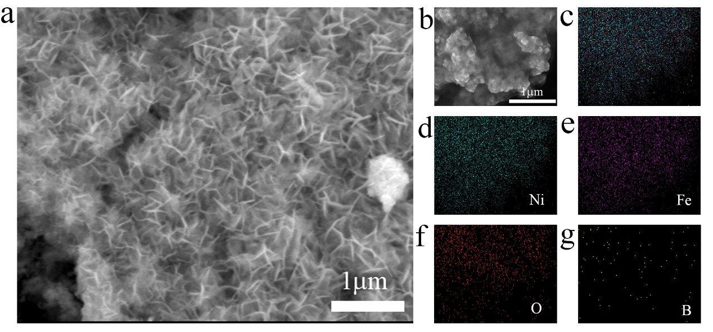
Fig S5. SEM (a) and EDS mapping (b-g) image of the A-Ni_{0.7}Fe_{0.3} NSs.
Fig S6. The lattice spacing of A-Ni_{0.7}Fe_{0.3} NSs. The lattice spacing analysis of A-Ni_{0.7}Fe_{0.3} NSs is 0.2156 nm.
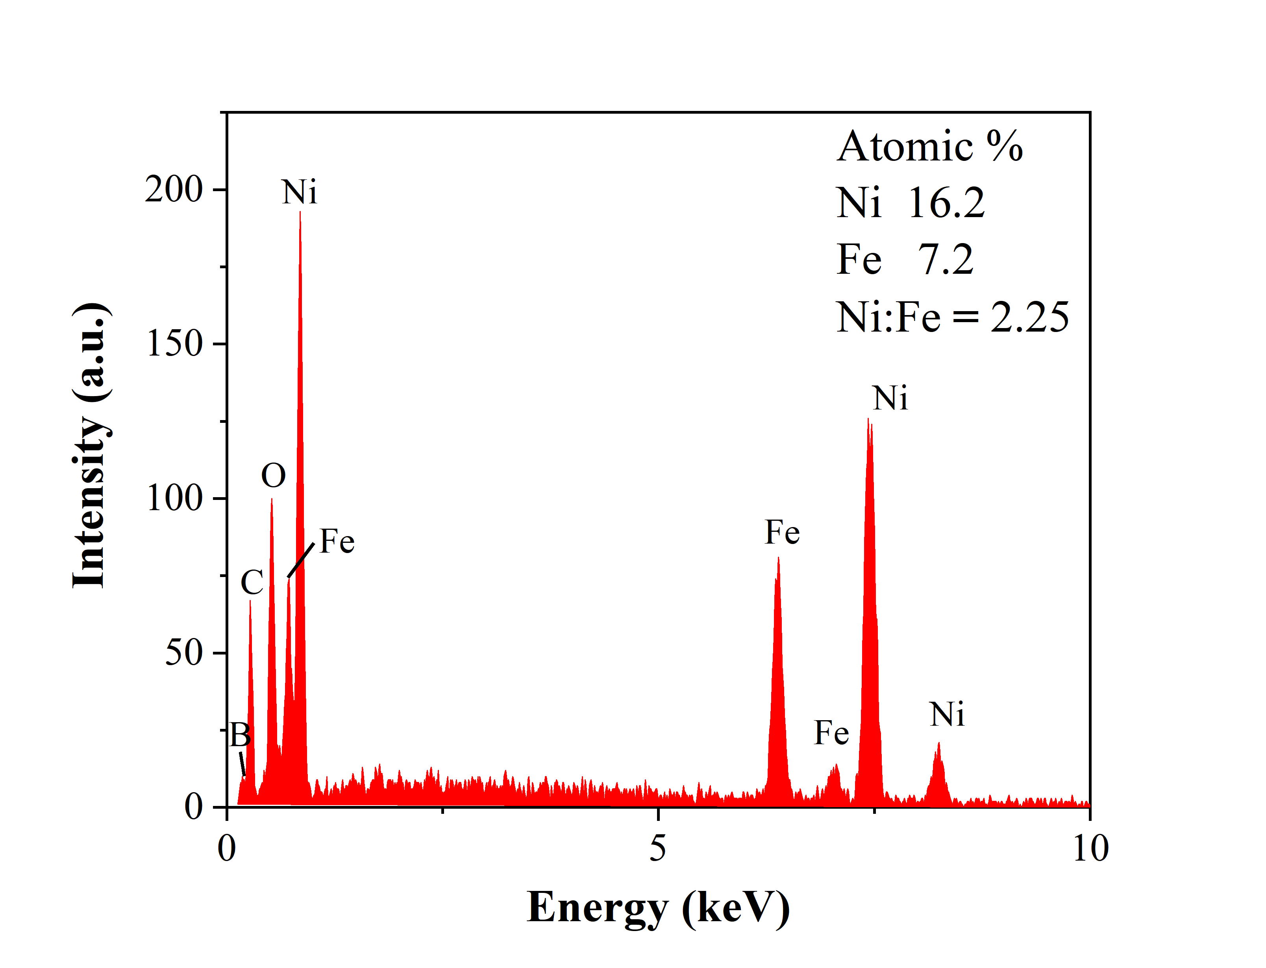
Fig S7. The corresponding energy dispersive X−ray spectroscopy (EDS) of A-Ni_{0.7}Fe_{0.3} NSs. The value of Ni: Fe is about 2.25.
Figure S8. Ni (a) and Fe (b) K edge FT-EXAFS spectra of A-Ni_{0.7}Fe_{0.3} NSs.
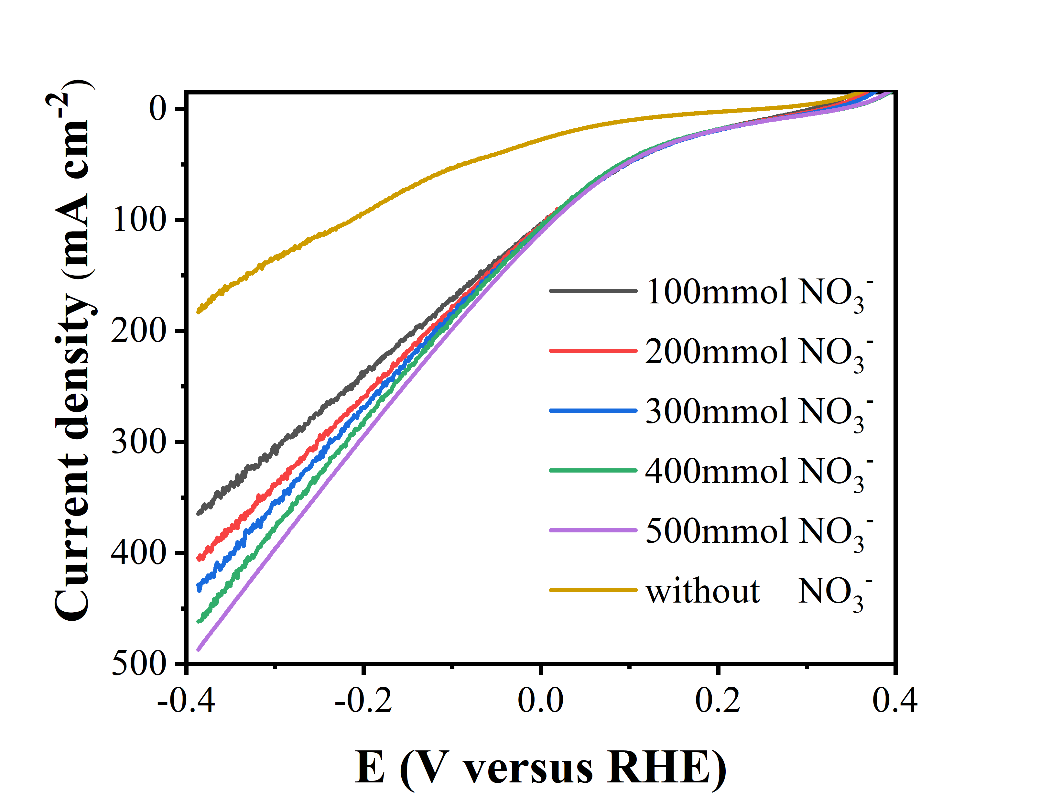
Figure S9. The LSV polarization curve of without nitrate and different concentrations of nitrate.
Figure S10. The absorption curves (a) and the corresponding concentration-absorbance calibration curve (b) of ammonia.
Figure S11. The absorption curves (a) and the corresponding concentration-absorbance calibration curve (b) of nitrite.
Figure S12. The absorption curves (a) and the corresponding concentration-absorbance calibration curve (b) of nitrate.
Figure S13. (a)The i-t curve of A-Ni_{0.7}Fe_{0.3} NSs for NO₃RR at 465 mV overpotential. (b) The corresponding electrolyte.
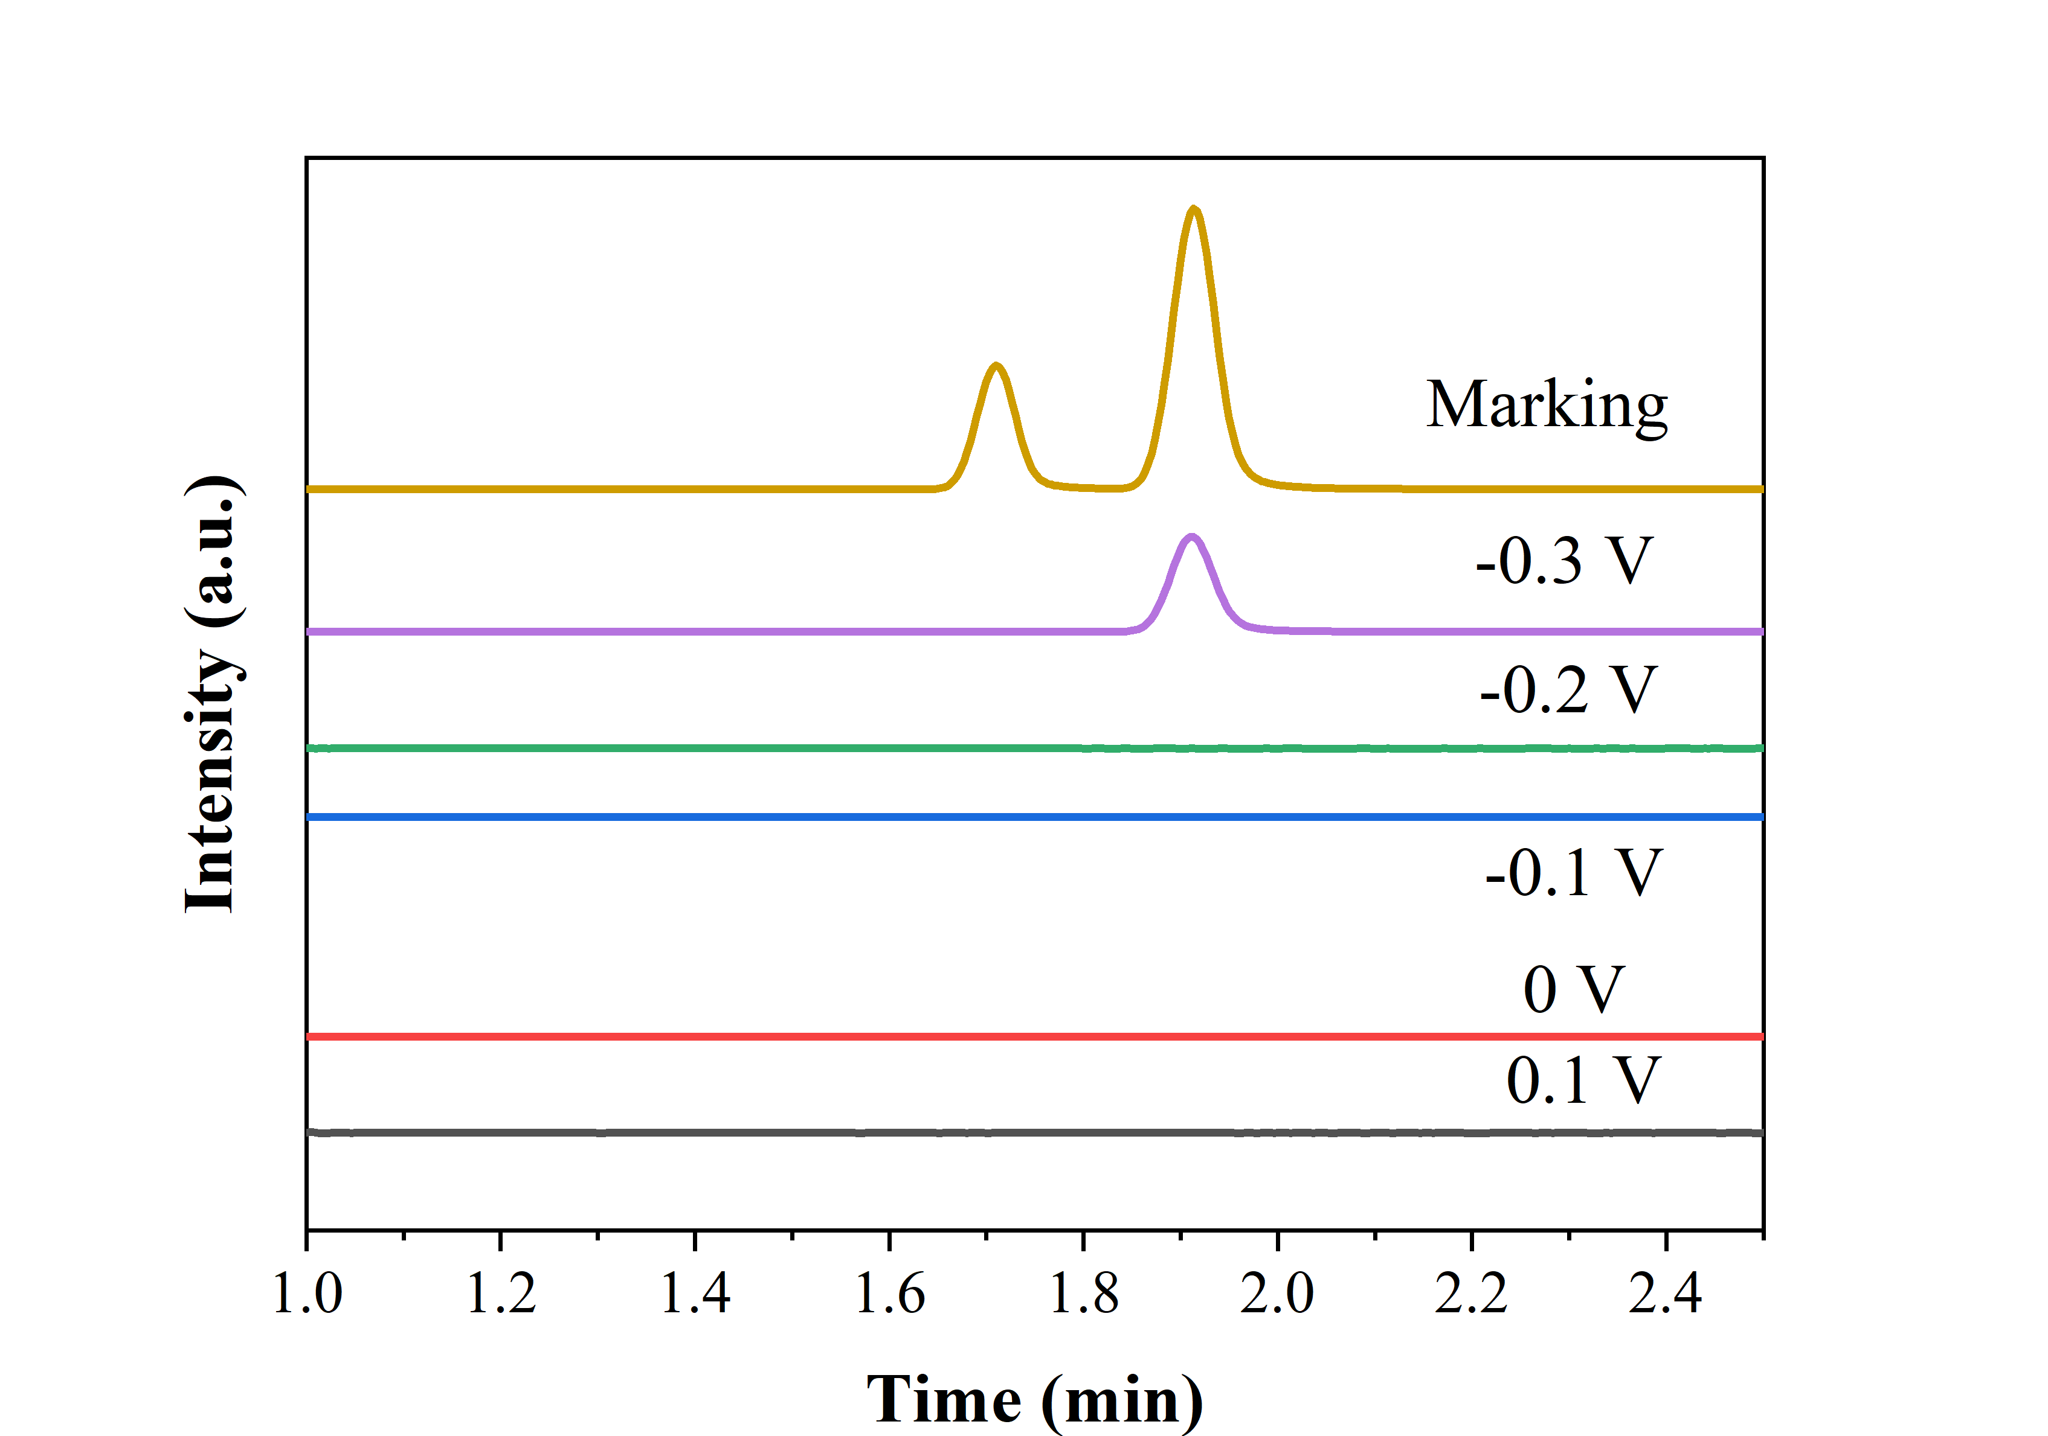
Figure S14. The gas chromatographic test results at different potentials. The marking curve of the peak at 1.71 and 1.91 is respectively attribute to He and H₂. He is used as the internal standard gas. The tested potential from 0.1 V to -0.2 V vs. RHE without the peak of H₂ indicates that without HER occurs over the catalyst. At -0.3 V vs. RHE potential, the HER begins to appear.
Figure S15. The N-selectivity of A-Ni_{0.7}Fe_{0.3} NSs (a), Ni NPs (b) and Fe NPs (c) at different potential.
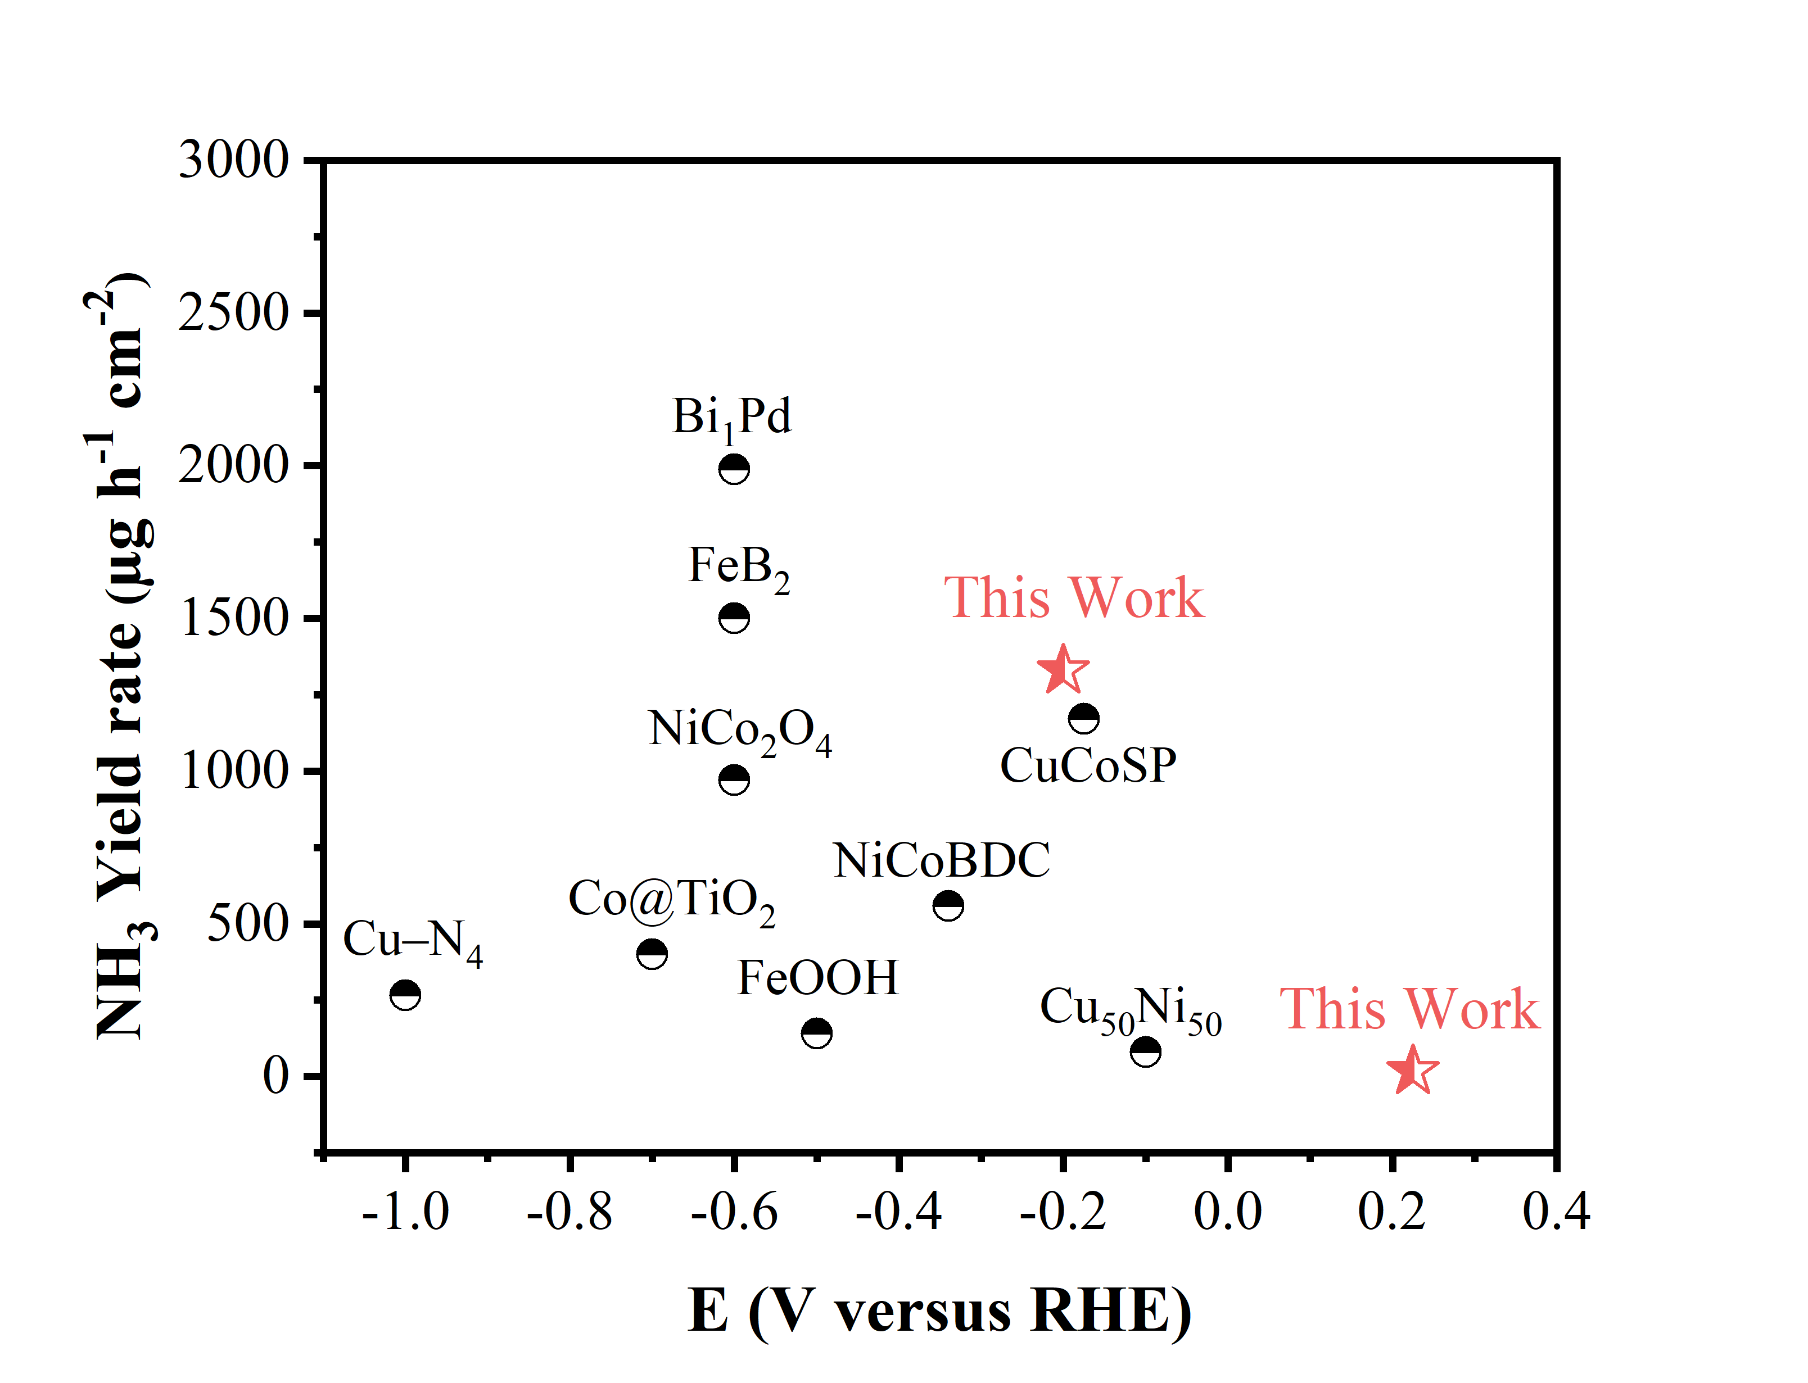
Figure S16. Comparison NH₃ yields and overpotential of NH₃ over A-Ni_{0.7}Fe_{0.3} NSs with other reported electrocatalyst (Cu-N₄¹, Bi₁Pd², FeB₂³, NiCo₂O₄⁴, Co@TiO₂⁵, FeOOH⁶, NiCoBDC⁷, CuCoSP⁸ and Cu₅₀Ni₅₀⁹).
Figure S17. (a) The NH₃ yields and Faradaic efficiency of Ni foams at different potentials. (b) The NH₃ yields of A-Ni_{0.7}Fe_{0.3} NSs at different potentials in the electrolyte without KNO₃.
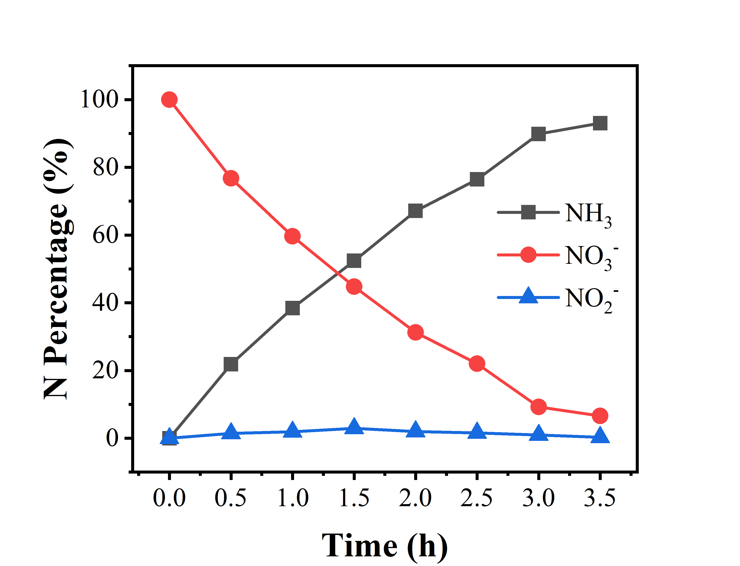
Figure S18. Concentration evolution curves of NO₃⁻, NH₃, and NO₂⁻ at −0.2 V vs. RHE.
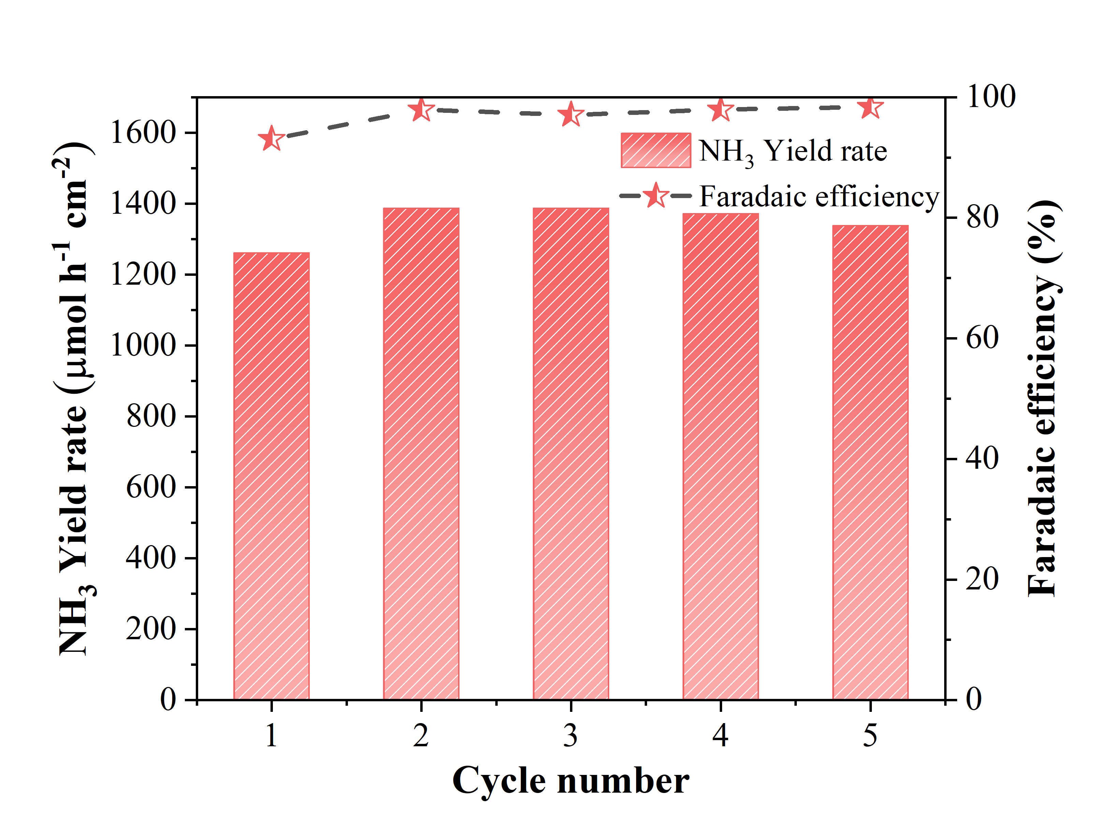
Figure S19. The cycle performance of A-Ni_{0.7}Fe_{0.3} NSs at −0.2 V vs RHE at 1 M KOH, 100 mM K₂SO₄ and 100 mM KNO₃.
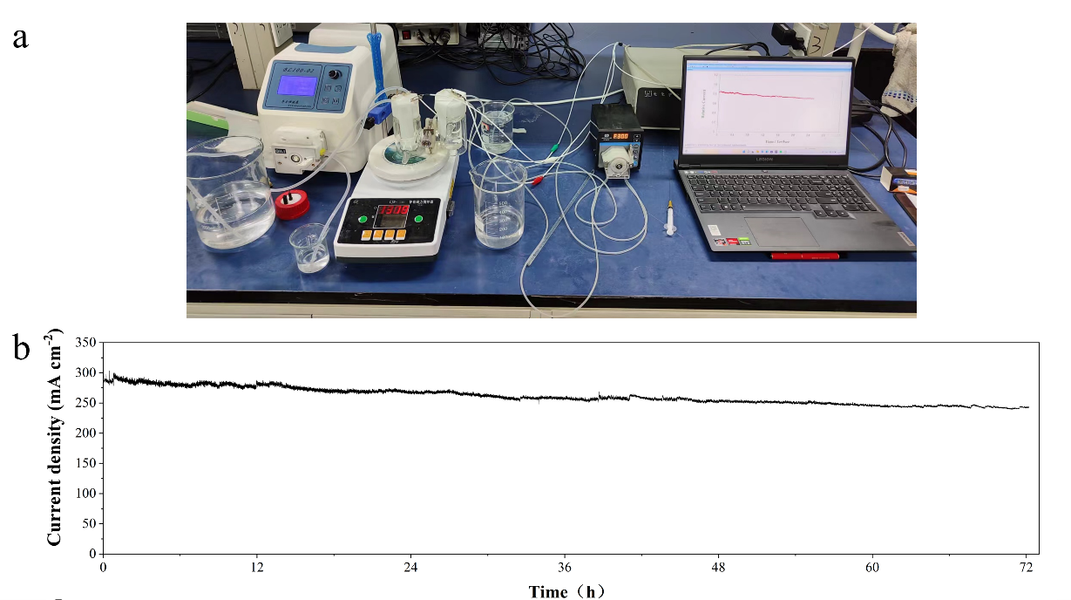
Figure S20. (a) The long-term stability device for NO₃RR. (b) The i-t curve of long-term stability at -0.2V vs. RHE.
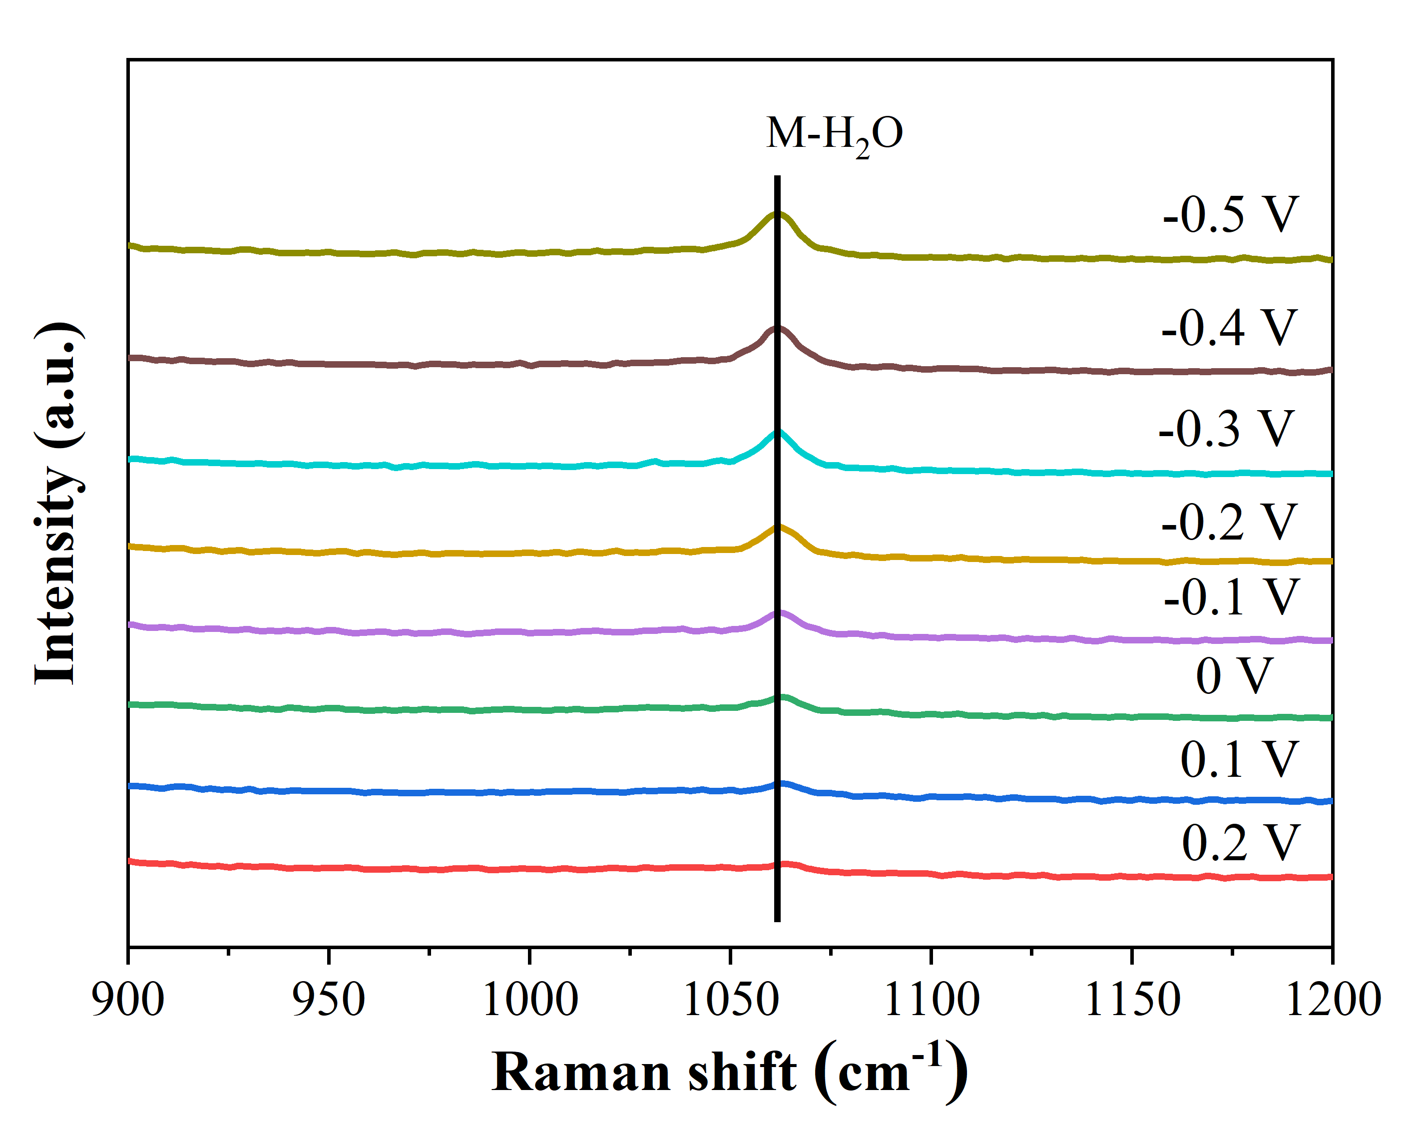
Figure S21. The in-situ Raman for A-Ni_{0.7}Fe_{0.3} NSs in 1M KOH electrolyte. Only the peak at 1062 cm⁻¹ appears.

Table S1. The atomic content of surface species of A-Ni_{0.7}Fe_{0.3} NSs identified by XPS analysis.
Catalyst | C (at%) | O (at%) | Fe (at%) | Ni (at%)
A-Ni_{0.7}Fe_{0.3} NSs | 23.87 | 55.85 | 6.61 | 13.68

Table S2. The weight content of surface species of Ni₂Fe₁B identified by ICP-OES.
Catalyst | Fe (wt%) | Ni (wt%)
A-Ni_{0.7}Fe_{0.3} NSs | 26 | 58

1. Yang, J.; Qi, H.; Li, A.; Liu, X.; Yang, X.; Zhang, S.; Zhao, Q.; Jiang, Q.; Su, Y.; Zhang, L.; Li, J. F.; Tian, Z. Q.; Liu, W.; Wang, A.; Zhang, T., Potential-Driven Restructuring of Cu Single Atoms to Nanoparticles for Boosting the Electrochemical Reduction of Nitrate to Ammonia. J. Am. Chem. Soc. 2022, 144 (27), 12062-12071.
2. Chen, K.; Ma, Z.; Li, X.; Kang, J.; Ma, D.; Chu, K., Single‐Atom Bi Alloyed Pd Metallene for Nitrate Electroreduction to Ammonia. Adv. Funct. Mater. 2023, 33 (12).
3. Zhang, G.; Li, X.; Chen, K.; Guo, Y.; Ma, D.; Chu, K., Tandem Electrocatalytic Nitrate Reduction to Ammonia on MBenes. Angew. Chem. Int. Ed. Engl. 2023, 62 (13), e202300054.
4. Liu, Q.; Xie, L.; Liang, J.; Ren, Y.; Wang, Y.; Zhang, L.; Yue, L.; Li, T.; Luo, Y.; Li, N.; Tang, B.; Liu, Y.; Gao, S.; Alshehri, A. A.; Shakir, I.; Agboola, P. O.; Kong, Q.; Wang, Q.; Ma, D.; Sun, X., Ambient Ammonia Synthesis via Electrochemical Reduction of Nitrate Enabled by NiCo(2) O(4) Nanowire Array. Small 2022, 18 (13), e2106961.
5. Fan, X.; Zhao, D.; Deng, Z.; Zhang, L.; Li, J.; Li, Z.; Sun, S.; Luo, Y.; Zheng, D.; Wang, Y.; Ying, B.; Zhang, J.; Alshehri, A. A.; Lin, Y.; Tang, C.; Sun, X.; Zheng, Y., Constructing Co@TiO(2) Nanoarray Heterostructure with Schottky Contact for Selective Electrocatalytic Nitrate Reduction to Ammonia. Small 2023, 19 (17), e2208036.
6. Liu, Q.; Liu, Q.; Xie, L.; Ji, Y.; Li, T.; Zhang, B.; Li, N.; Tang, B.; Liu, Y.; Gao, S.; Luo, Y.; Yu, L.; Kong, Q.; Sun, X., High-Performance Electrochemical Nitrate Reduction to Ammonia under Ambient Conditions Using a FeOOH Nanorod Catalyst. ACS Appl. Mater. Interfaces. 2022, 14 (15), 17312-17318.
7. Ma, J.; Zhang, Y.; Wang, B.; Jiang, Z.; Zhang, Q.; Zhuo, S., Interfacial Engineering of Bimetallic Ni/Co-MOFs with H-Substituted Graphdiyne for Ammonia Electrosynthesis from Nitrate. ACS Nano 2023, 17 (7), 6687-6697.
8. He, W.; Zhang, J.; Dieckhofer, S.; Varhade, S.; Brix, A. C.; Lielpetere, A.; Seisel, S.; Junqueira, J. R. C.; Schuhmann, W., Splicing the active phases of copper/cobalt-based catalysts achieves high-rate tandem electroreduction of nitrate to ammonia. Nat. Commun. 2022, 13 (1), 1129.
9. Wang, Y.; Xu, A.; Wang, Z.; Huang, L.; Li, J.; Li, F.; Wicks, J.; Luo, M.; Nam, D. H.; Tan, C. S.; Ding, Y.; Wu, J.; Lum, Y.; Dinh, C. T.; Sinton, D.; Zheng, G.; Sargent, E. H., Enhanced Nitrate-to-Ammonia Activity on Copper-Nickel Alloys via Tuning of Intermediate Adsorption. J. Am. Chem. Soc. 2020, 142 (12), 5702-5708.

