TABLE 1.Structural formula of synthetic UV filters and natural molecules adopted in the study
MOLECULE  (ABBREVIATION / IUPAC NAME) | CAS | STRUCTURAL FORMULA
BENZOPHENONE  BZF  Diphenylmethanone | 119-61-9 | 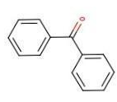
BENZOPHENONE-3  (OXIBENZONE)  BZF-3  2-hydroxy-4-methoxyphenyl)-phenylmethanone | 131-57-7 | 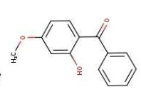
BENZOPHENONE -4 (SULISOBENZONE)  BZF-4  2-hydroxy-4-methoxybenzophenone-5-sulfonic acid | 4065-45-6 | 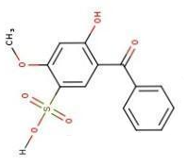
BENZOPHENONE-8  (DIOXIBENZONA)  BZF-8  2,2'-dihydroxy-4-methoxybenzophenone | 131-53-3 | 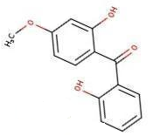
4-METHYL BENZYLIDENE CAMPHOR  4-MBC  (3Z)-1,7,7-trimethyl-3-[(4-methylphenyl) methylidene]bicyclo[2.2.1]heptan-2-one | 36861-47-9 | 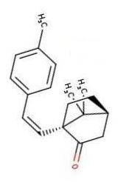
3- BENZYLIDENE CAMPHOR  3-BC  (3E)-3-benzylidene-1,7,7-trimethylbicyclo [2.2.1]heptan-2-one | 15087-24-8 | 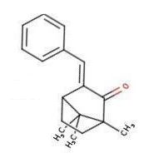
OCTOCRYLENE  OCR  2-ethylhexyl 2-cyano-3,3-diphenylprop-2-enoate | 6197-30-4 | 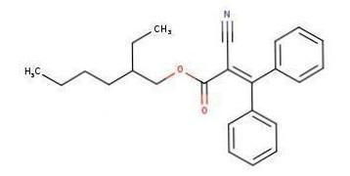
CINOXATE  MCE  2-ethoxyethyl (E)-3-(4-methoxyphenyl)prop-2-enoate | 104-28-9 | 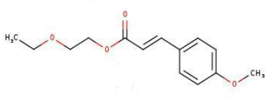
OCTYL METHOXYCINNAMATE  OMC  2-ethylhexyl (E)-3-(4-methoxyphenyl)prop-2-enoate | 5466-77-3 | 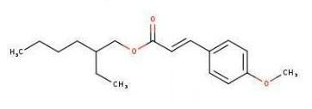
AMILOXATE  IMC  3-methylbutyl (E)-3-(4-methoxyphenyl)prop-2-enoate | 71617-10-2 | 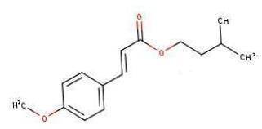
CAFFEIC ACID  (E)-3-(3,4-dihydroxyphenyl)prop-2-enoic acid | 331-39-5 | 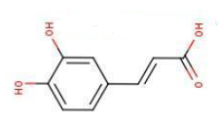
FERULIC ACID  (E)-3-(4-hydroxy-3-methoxyphenyl)prop-2-enoic acid | 537-98-4 | 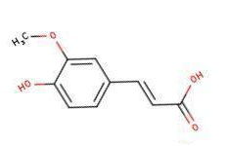
COUMARINIC ACID  (E)-3-(4-hydroxyphenyl)prop-2-enoic acid | 501-98-4 | 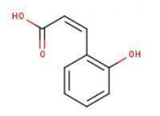
CURCUMIN  (E,E)-1,7-bis(4-Hydroxy-3-methoxyphenyl)-1,6-heptadiene-3,5-dione | 458-37-7 | 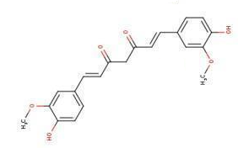
BISDEMETHOXYCURCUMIN  BMC  E,E)-1,7-Bis(4-hydroxyphenyl)-1,6-heptadiene-3,5-dione | 33171-05-0 | 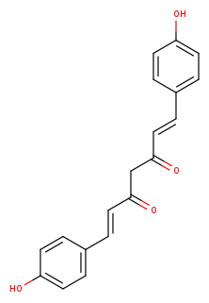
DEMETHOXYCURCUMIN  DMC  (E,E)-1-(4-Hydroxy-3-methoxyphenyl)-7-(4-hydroxyphenyl)-1,6-heptadiene-3,5-dione | 22608-11-3 | 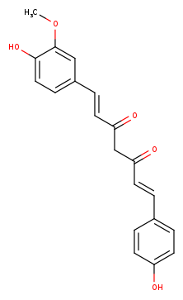
APIGENIN  APIG  5,7-dihydroxy-2-(4-hydroxyphenyl)chromen-4-one | 520-36-5 | 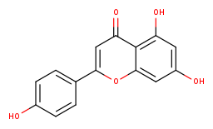
CRYSIN  5,7-dihydroxy-2-phenylchromen-4-one | 480-40-0 | 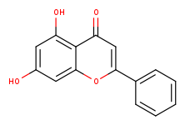
QUERCETIN  2-(3,4-dihydroxyphenyl)-3,5,7-trihydroxychromen-4-one | 117-39-5 | 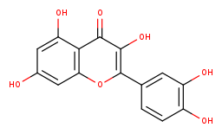
GENISTEIN  5,7-dihydroxy-3-(4-hydroxyphenyl)chromen-4-one | 446-72-0 | 