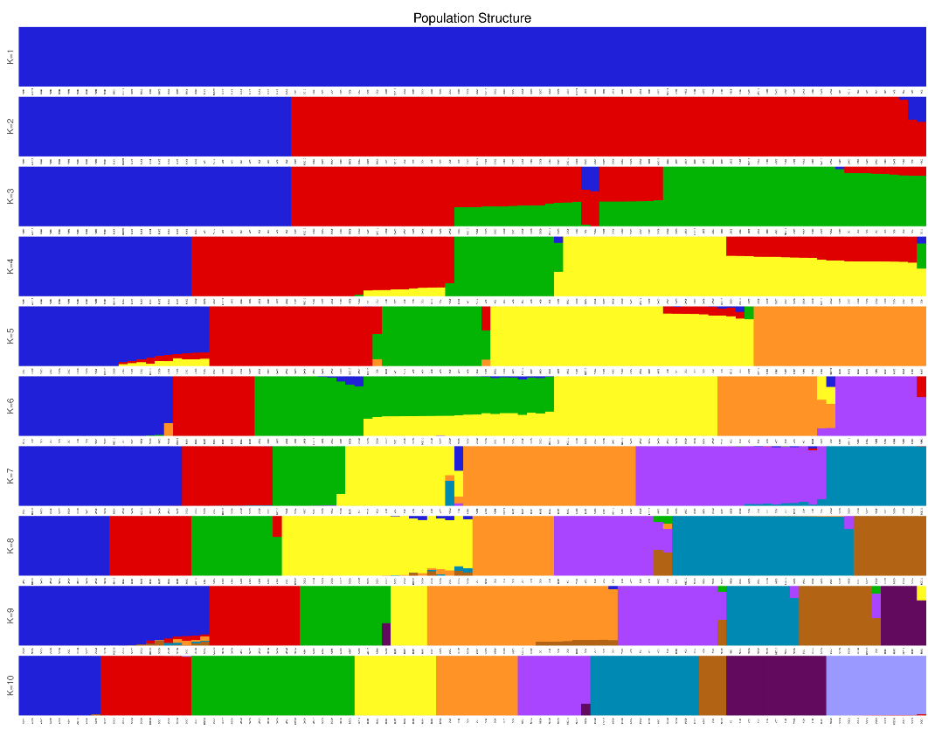
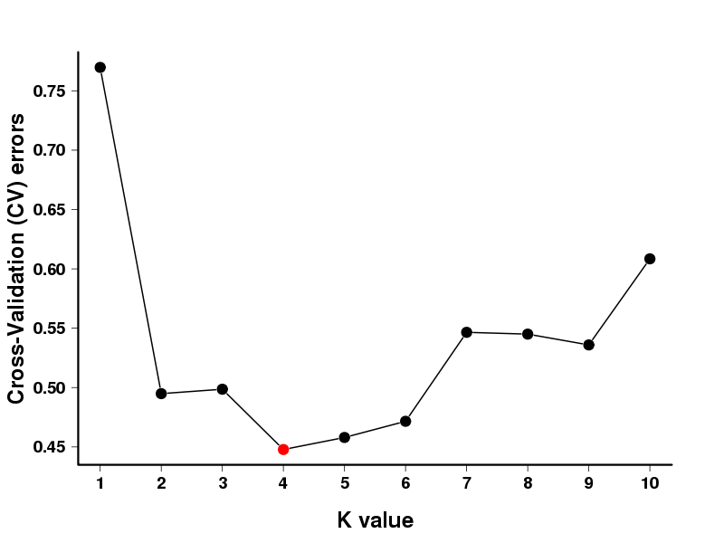
Figure S1. Cross-validation errors of Admixture for 10 Artemia populations
Figure S2. Population structure of Artemia in 10 inland salt lakes of China obtained based on Admixture

Figure S3. Explanatory variance for migration events. When the number of migrations was 10, the explanatory variables reached highest (99.987%).

Tab.S1 GPS points used for building species distribution models for Artemia.
Number | Longitude | Latitude | Groups | Locality
1 | 82.67083333 | 44.94583333 | Xinjiang | ABH
2 | 82.6875 | 44.89583333 | Xinjiang | ABH
3 | 82.69583333 | 44.87916667 | Xinjiang | ABH
4 | 82.7875 | 44.9375 | Xinjiang | ABH
5 | 82.8125 | 44.8625 | Xinjiang | ABH
6 | 82.89583333 | 44.8875 | Xinjiang | ABH
7 | 82.90416667 | 44.87916667 | Xinjiang | ABH
8 | 82.92916667 | 44.95416667 | Xinjiang | ABH
9 | 82.9375 | 44.9125 | Xinjiang | ABH
10 | 83.00416667 | 44.87916667 | Xinjiang | ABH
11 | 83.00416667 | 44.92083333 | Xinjiang | ABH
12 | 83.02083333 | 44.95416667 | Xinjiang | ABH
13 | 83.14583333 | 44.87083333 | Xinjiang | ABH
14 | 83.87916667 | 44.92083333 | Xinjiang | ABH
15 | 92.72916667 | 43.67083333 | Xinjiang | BLK
16 | 92.74583333 | 43.69583333 | Xinjiang | BLK
17 | 92.7625 | 43.6375 | Xinjiang | BLK
18 | 92.7625 | 43.6625 | Xinjiang | BLK
19 | 92.79583333 | 43.65416667 | Xinjiang | BLK
20 | 92.79583333 | 43.67083333 | Xinjiang | BLK
21 | 92.79583333 | 43.7125 | Xinjiang | BLK
22 | 92.80416667 | 43.62083333 | Xinjiang | BLK
23 | 92.8375 | 43.64583333 | Xinjiang | BLK
24 | 92.84583333 | 43.62083333 | Xinjiang | BLK
25 | 92.84583333 | 43.67083333 | Xinjiang | BLK
26 | 93.00416667 | 43.50416667 | Xinjiang | BLK
27 | 110.8041667 | 34.90416667 | Shanxi | YC
28 | 110.8875 | 34.92083333 | Shanxi | YC
29 | 110.8875 | 34.92916667 | Shanxi | YC
30 | 110.9041667 | 34.90416667 | Shanxi | YC
31 | 110.9291667 | 34.94583333 | Shanxi | YC
32 | 110.9458333 | 34.95416667 | Shanxi | YC
33 | 110.9708333 | 34.97916667 | Shanxi | YC
34 | 110.9791667 | 34.97083333 | Shanxi | YC
35 | 111.0041667 | 34.97916667 | Shanxi | YC
36 | 111.0041667 | 35.00416667 | Shanxi | YC
37 | 111.0125 | 34.9875 | Shanxi | YC
38 | 111.0208333 | 34.9875 | Shanxi | YC
39 | 111.0375 | 34.99583333 | Shanxi | YC
40 | 111.0541667 | 35.0125 | Shanxi | YC
41 | 111.0791667 | 35.02916667 | Shanxi | YC
42 | 111.9208333 | 35.72916667 | Shanxi | YC
43 | 89.8875 | 32.44583333 | Eastern Nagri | QXC
44 | 89.89583333 | 32.4125 | Eastern Nagri | QXC
45 | 89.92083333 | 32.42083333 | Eastern Nagri | QXC
46 | 89.92083333 | 32.4625 | Eastern Nagri | QXC
47 | 89.95416667 | 32.4625 | Eastern Nagri | QXC
48 | 89.9625 | 32.4375 | Eastern Nagri | QXC
49 | 90.00416667 | 32.49583333 | Eastern Nagri | QXC
50 | 90.00416667 | 32.50416667 | Eastern Nagri | QXC
51 | 90.02083333 | 32.42916667 | Eastern Nagri | QXC
52 | 90.05416667 | 32.44583333 | Eastern Nagri | QXC
53 | 90.07083333 | 32.47916667 | Eastern Nagri | QXC
54 | 89.44583333 | 31.74583333 | Eastern Nagri | BGC
55 | 89.45416667 | 31.7125 | Eastern Nagri | BGC
56 | 89.47083333 | 31.6875 | Eastern Nagri | BGC
57 | 89.5125 | 31.72916667 | Eastern Nagri | BGC
58 | 89.5125 | 31.7625 | Eastern Nagri | BGC
59 | 89.52083333 | 31.70416667 | Eastern Nagri | BGC
60 | 89.5375 | 31.75416667 | Eastern Nagri | BGC
61 | 89.54583333 | 31.8125 | Eastern Nagri | BGC
62 | 89.57916667 | 31.77916667 | Eastern Nagri | BGC
63 | 89.60416667 | 31.75416667 | Eastern Nagri | BGC
64 | 86.6875 | 31.54583333 | Eastern Nagri | DQC
65 | 86.70416667 | 31.5375 | Eastern Nagri | DQC
66 | 86.7125 | 31.5875 | Eastern Nagri | DQC
67 | 86.72083333 | 31.5625 | Eastern Nagri | DQC
68 | 86.7375 | 31.54583333 | Eastern Nagri | DQC
69 | 86.74583333 | 31.52916667 | Eastern Nagri | DQC
70 | 86.74583333 | 31.59583333 | Eastern Nagri | DQC
71 | 86.77083333 | 31.55416667 | Eastern Nagri | DQC
72 | 86.77083333 | 31.5875 | Eastern Nagri | DQC
73 | 86.7875 | 31.57083333 | Eastern Nagri | DQC
74 | 85.67083333 | 30.84583333 | Eastern Nagri | DDC
75 | 85.67083333 | 30.85416667 | Eastern Nagri | DDC
76 | 85.67916667 | 30.82916667 | Eastern Nagri | DDC
77 | 85.67916667 | 30.8375 | Eastern Nagri | DDC
78 | 85.67916667 | 30.84583333 | Eastern Nagri | DDC
79 | 85.67916667 | 30.85416667 | Eastern Nagri | DDC
80 | 85.6875 | 30.8375 | Eastern Nagri | DDC
81 | 84.69583333 | 32.2125 | Western Nagri | DC
82 | 84.70416667 | 32.17083333 | Western Nagri | DC
83 | 84.72083333 | 32.14583333 | Western Nagri | DC
84 | 84.7375 | 32.2125 | Western Nagri | DC
85 | 84.74583333 | 32.12916667 | Western Nagri | DC
86 | 84.74583333 | 32.17916667 | Western Nagri | DC
87 | 84.77916667 | 32.14583333 | Western Nagri | DC
88 | 84.77916667 | 32.20416667 | Western Nagri | DC
89 | 84.7875 | 32.1625 | Western Nagri | DC
90 | 84.7875 | 32.1875 | Western Nagri | DC
91 | 84.00416667 | 32.00416667 | Western Nagri | LGC
92 | 84.0375 | 31.9875 | Western Nagri | LGC
93 | 84.0375 | 32.0125 | Western Nagri | LGC
94 | 84.07083333 | 32.02916667 | Western Nagri | LGC
95 | 84.09583333 | 32.00416667 | Western Nagri | LGC
96 | 84.10416667 | 32.02916667 | Western Nagri | LGC
97 | 84.10416667 | 32.04583333 | Western Nagri | LGC
98 | 84.1375 | 32.0625 | Western Nagri | LGC
99 | 84.14583333 | 32.00416667 | Western Nagri | LGC
100 | 84.17083333 | 32.32916667 | Western Nagri | LGC
101 | 84.17916667 | 32.00416667 | Western Nagri | LGC
102 | 84.17916667 | 32.0625 | Western Nagri | LGC
103 | 84.1875 | 32.02916667 | Western Nagri | LGC
104 | 84.22083333 | 32.04583333 | Western Nagri | LGC
105 | 84.22083333 | 32.05416667 | Western Nagri | LGC
106 | 82.17916667 | 32.30416667 | Western Nagri | NEC
107 | 82.1875 | 32.29583333 | Western Nagri | NEC
108 | 82.19583333 | 32.27916667 | Western Nagri | NEC
109 | 82.20416667 | 32.3125 | Western Nagri | NEC
110 | 82.2125 | 32.27083333 | Western Nagri | NEC
111 | 82.2125 | 32.29583333 | Western Nagri | NEC
112 | 82.22083333 | 32.29583333 | Western Nagri | NEC
113 | 82.2375 | 32.25416667 | Western Nagri | NEC
114 | 82.2375 | 32.27916667 | Western Nagri | NEC
115 | 82.24583333 | 32.27083333 | Western Nagri | NEC

Tab. S2 Summary of SLAF data collected in the final assembly of 100 samples of Artemia.
Population | Sample ID | Total Reads | GC Percentage(%) | Q30 Percentage(%) | SLAF number | Total depth | Average depth
1 | ABH1 | 1699828 | 38.78 | 92.23 | 97690 | 1464659 | 14.9929
1 | ABH10 | 3262696 | 38.6 | 92.88 | 125695 | 2847310 | 22.6525
1 | ABH2 | 3564923 | 36.75 | 91.93 | 116844 | 3068494 | 26.2615
1 | ABH3 | 3499317 | 37.72 | 92.74 | 133044 | 3066526 | 23.049
1 | ABH4 | 4142237 | 37.02 | 92.46 | 123397 | 3630086 | 29.4179
1 | ABH5 | 3902474 | 37.09 | 92.3 | 124570 | 3394305 | 27.2482
1 | ABH6 | 2894818 | 36.92 | 92.42 | 115240 | 2526865 | 21.927
1 | ABH7 | 5744939 | 36.99 | 92.82 | 131753 | 5054207 | 38.3612
1 | ABH8 | 4028403 | 36.99 | 92.59 | 123170 | 3518325 | 28.5648
1 | ABH9 | 4841954 | 36.7 | 92.39 | 127996 | 4200712 | 32.8191
2 | BGC1 | 2551544 | 36.68 | 93.17 | 110059 | 2224917 | 20.2157
2 | BGC10 | 2340448 | 36.63 | 92.87 | 127104 | 2011836 | 15.8283
2 | BGC2 | 3510949 | 36.98 | 93.11 | 142219 | 3076398 | 21.6314
2 | BGC3 | 2441528 | 36.71 | 93.16 | 124889 | 2112630 | 16.9161
2 | BGC4 | 2463736 | 36.86 | 93.2 | 124507 | 2135843 | 17.1544
2 | BGC5 | 2913786 | 36.58 | 93.02 | 137653 | 2520211 | 18.3084
2 | BGC6 | 2450389 | 37.03 | 93.01 | 125797 | 2138391 | 16.9987
2 | BGC7 | 2869300 | 36.86 | 93.08 | 140197 | 2494791 | 17.7949
2 | BGC8 | 4142840 | 36.85 | 93.01 | 165909 | 3593784 | 21.6612
2 | BGC9 | 2516997 | 36.93 | 93.01 | 128438 | 2167548 | 16.8762
3 | BLK1 | 2975777 | 36.96 | 92.33 | 121460 | 2488142 | 20.4853
3 | BLK10 | 4697499 | 37.27 | 92.08 | 144438 | 4068775 | 28.1697
3 | BLK2 | 3234659 | 36.21 | 92.02 | 134701 | 2788038 | 20.698
3 | BLK3 | 4077422 | 36.56 | 92.04 | 149140 | 3499627 | 23.4654
3 | BLK4 | 3826911 | 36.4 | 91.74 | 145625 | 3260632 | 22.3906
3 | BLK5 | 4347280 | 36.89 | 92.08 | 144099 | 3774290 | 26.1923
3 | BLK6 | 3298337 | 37.34 | 91.81 | 138452 | 2835904 | 20.4829
3 | BLK7 | 3879356 | 37.11 | 91.5 | 143074 | 3331318 | 23.2839
3 | BLK8 | 4389326 | 37.49 | 91.76 | 144816 | 3781069 | 26.1095
3 | BLK9 | 5723387 | 36.97 | 92.06 | 150657 | 4970713 | 32.9936
4 | DC1 | 1535238 | 38.82 | 92.64 | 111298 | 1312435 | 11.7921
4 | DC10 | 2190241 | 38.71 | 92.48 | 124948 | 1885585 | 15.091
4 | DC2 | 2266807 | 38.26 | 92.17 | 121743 | 1962053 | 16.1164
4 | DC3 | 3746241 | 37.44 | 92.18 | 135250 | 3270957 | 24.1845
4 | DC4 | 1634710 | 38.42 | 92.32 | 110212 | 1407707 | 12.7727
4 | DC5 | 3543805 | 37.38 | 91.7 | 138235 | 3044192 | 22.0219
4 | DC6 | 3272007 | 36.16 | 92.52 | 96738 | 2906148 | 30.0414
4 | DC7 | 1843655 | 38.17 | 92.48 | 116874 | 1585339 | 13.5645
4 | DC8 | 2792645 | 37.61 | 91.96 | 135462 | 2384208 | 17.6006
4 | DC9 | 3353456 | 38.09 | 92.41 | 137641 | 2924627 | 21.2482
5 | DDC1 | 2399048 | 38.07 | 91.83 | 125674 | 2078327 | 16.5374
5 | DDC10 | 4521743 | 36.97 | 92.03 | 152376 | 3951592 | 25.9332
5 | DDC2 | 940769 | 39.64 | 92.69 | 92528 | 787200 | 8.5077
5 | DDC3 | 4036207 | 37.68 | 92.62 | 158219 | 3525774 | 22.2841
5 | DDC4 | 3376597 | 37.64 | 92.54 | 144720 | 2944308 | 20.3449
5 | DDC5 | 3321071 | 36.45 | 89.59 | 150437 | 2719264 | 18.0758
5 | DDC6 | 4235565 | 37.11 | 91.88 | 128192 | 3704458 | 28.8977
5 | DDC7 | 2813487 | 37.94 | 92.62 | 124823 | 2458396 | 19.6951
5 | DDC8 | 4533370 | 37.44 | 92.75 | 142786 | 3977867 | 27.8589
5 | DDC9 | 4723535 | 37.35 | 92.32 | 144293 | 4139248 | 28.6864
6 | DQC1 | 3120385 | 37.95 | 93.15 | 153976 | 2711551 | 17.6102
6 | DQC10 | 2903427 | 37.6 | 92.99 | 147704 | 2536848 | 17.1752
6 | DQC2 | 2866912 | 38.06 | 93.36 | 152503 | 2492503 | 16.344
6 | DQC3 | 2377279 | 38.36 | 93.32 | 136511 | 2072802 | 15.1841
6 | DQC4 | 2951373 | 38 | 93.12 | 148845 | 2561824 | 17.2114
6 | DQC5 | 1890707 | 38.76 | 93.31 | 130810 | 1626416 | 12.4334
6 | DQC6 | 3398993 | 38 | 93.31 | 147880 | 2982489 | 20.1683
6 | DQC7 | 1455594 | 38.77 | 93.17 | 118538 | 1238224 | 10.4458
6 | DQC8 | 2100942 | 38.07 | 92.99 | 134112 | 1819185 | 13.5647
6 | DQC9 | 3255839 | 37.52 | 93.16 | 151854 | 2860618 | 18.8379
7 | LGC1 | 4029460 | 36.79 | 91.75 | 182148 | 3379421 | 18.5532
7 | LGC10 | 4203491 | 36.78 | 91.92 | 175701 | 3559675 | 20.2598
7 | LGC2 | 2384033 | 36.53 | 91.65 | 156989 | 2035285 | 12.9645
7 | LGC3 | 2362934 | 36.67 | 91.65 | 158358 | 1996738 | 12.609
7 | LGC4 | 2104124 | 36.39 | 91.62 | 147229 | 1736172 | 11.7923
7 | LGC5 | 2712261 | 37.23 | 92.22 | 157845 | 2271615 | 14.3914
7 | LGC6 | 3363987 | 36.64 | 91.87 | 160301 | 2868263 | 17.893
7 | LGC7 | 3427560 | 36.63 | 91.85 | 167230 | 2900533 | 17.3446
7 | LGC8 | 3518415 | 36.41 | 91.27 | 155020 | 2966337 | 19.1352
7 | LGC9 | 3736168 | 36.89 | 91.8 | 173828 | 3143179 | 18.0821
8 | NEC1 | 2551731 | 37.34 | 93.04 | 130951 | 2208176 | 16.8626
8 | NEC10 | 2327363 | 38.07 | 93.07 | 148007 | 1979879 | 13.3769
8 | NEC2 | 2004955 | 36.37 | 93.05 | 89987 | 1725729 | 19.1775
8 | NEC3 | 1888183 | 38.36 | 92.82 | 146511 | 1593068 | 10.8734
8 | NEC4 | 2591814 | 38.37 | 93.12 | 142999 | 2247531 | 15.7171
8 | NEC5 | 1900417 | 39.09 | 93.5 | 133354 | 1639157 | 12.2918
8 | NEC6 | 3374576 | 37.12 | 93.01 | 141885 | 2962785 | 20.8816
8 | NEC7 | 1655557 | 38.07 | 92.77 | 128631 | 1398768 | 10.8743
8 | NEC8 | 2693136 | 37.98 | 93.12 | 174095 | 2305972 | 13.2455
8 | NEC9 | 1919523 | 38.25 | 92.96 | 142980 | 1610006 | 11.2604
9 | QXC1 | 2500655 | 36.5 | 92.06 | 147851 | 2146841 | 14.5203
9 | QXC10 | 1969900 | 37.18 | 92.03 | 126961 | 1682240 | 13.2501
9 | QXC2 | 2543087 | 37.09 | 92.15 | 151400 | 2174754 | 14.3643
9 | QXC3 | 2680081 | 37.01 | 92.33 | 169389 | 2260655 | 13.3459
9 | QXC4 | 2725764 | 37.71 | 92.71 | 183306 | 2290058 | 12.4931
9 | QXC5 | 2112240 | 37.57 | 92.49 | 148582 | 1798337 | 12.1033
9 | QXC6 | 2317864 | 37.61 | 92.61 | 165513 | 1983634 | 11.9848
9 | QXC7 | 2710691 | 37.54 | 92.53 | 169214 | 2308957 | 13.6452
9 | QXC8 | 1977022 | 37.27 | 91.8 | 134704 | 1668300 | 12.3849
9 | QXC9 | 1686456 | 36.89 | 91.85 | 127630 | 1436179 | 11.2527
10 | YC1 | 3865041 | 36.96 | 91.89 | 131300 | 3257341 | 24.8084
10 | YC10 | 4424317 | 37.21 | 91.55 | 138605 | 3694062 | 26.6517
10 | YC2 | 4564211 | 36.5 | 91.87 | 134609 | 3864269 | 28.7074
10 | YC3 | 4338756 | 37.23 | 92.31 | 133857 | 3683415 | 27.5175
10 | YC4 | 3782956 | 36.68 | 92.06 | 129273 | 3203692 | 24.7824
10 | YC5 | 4527029 | 36.63 | 91.9 | 134291 | 3825407 | 28.486
10 | YC6 | 5101369 | 36.61 | 92.07 | 139979 | 4337499 | 30.9868
10 | YC7 | 5288504 | 37.14 | 91.72 | 141374 | 4459837 | 31.5464
10 | YC8 | 3918596 | 36.89 | 91.56 | 133692 | 3294781 | 24.6446
10 | YC9 | 5121619 | 37.21 | 91.56 | 152372 | 4285472 | 28.1251

Tab. S3 Summary statistics of pairwise F_{ST} values between the 10 populations of Artemia, all the F_{ST} values are statistically significatn (P < 0.05).
Population | ABL | BLK | YC | QXC | BGC | DQC | DDC | DC | LGC | NEC
ABL | 0
BLK | 0.229897 | 0
YC | 0.62095 | 0.484243 | 0
QXC | 0.516369 | 0.45947 | 0.50551 | 0
BGC | 0.501837 | 0.445055 | 0.494539 | 0.084811 | 0
DQC | 0.496393 | 0.443122 | 0.493703 | 0.098299 | 0.091905 | 0
DDC | 0.485158 | 0.433213 | 0.481174 | 0.089222 | 0.081536 | 0.065088 | 0
DC | 0.508036 | 0.450292 | 0.508578 | 0.115179 | 0.099544 | 0.094581 | 0.085844 | 0
LGC | 0.49253 | 0.440626 | 0.492571 | 0.117324 | 0.095379 | 0.093 | 0.083868 | 0.089567 | 0
NEC | 0.477059 | 0.427793 | 0.481681 | 0.116279 | 0.100884 | 0.091316 | 0.083707 | 0.088778 | 0.079332 | 0

Tab. S4 Best fit MAXENT model based upon delta AICc from ENMeval. AUC= Area under the curve, OR5= omission rate of testing locNagrities at the 5% training threshold, AICc = Akaike’s Information Criterion corrected for small sample sizes, and n = number of parameters in model.
Groups | Mean.AUC | Mean.OR5 | AICc | delta.AICc | n
Xinjiang | 1.997236255 | 0.166666667 | 646.4244705 | 0 | 14
Shanxi | 1.999699573 | 0 | 375.8223147 | 0 | 7
Eastern Nagri | 1.924703908 | 0 | 1150.072665 | 0 | 15
Western Nagri | 1.999729772 | 0 | 720.6115062 | 0 | 9

Table S5. AUC values for the model.
Period | Groups | Climate model | AUC values
Present | Xinjiang |  | 0.965
Present | Shanxi |  | 0.998
Present | Eastern Nagri |  | 0.976
Present | Western Nagri |  | 0.999
Future | Xinjiang | CCSM4 | 0.967
Future | Shanxi | CCSM4 | 0.998
Future | Eastern Nagri | CCSM4 | 0.974
Future | Western Nagri | CCSM4 | 0.999
Mid-Helocene | Xinjiang | CCSM4 | 0.984
Mid-Helocene | Shanxi | CCSM4 | 0.998
Mid-Helocene | Eastern Nagri | CCSM4 | 0.980
Mid-Helocene | Western Nagri | CCSM4 | 0.999
LGM | Xinjiang | CCSM4 | 0.982
LGM | Shanxi | CCSM4 | 0.998
LGM | Eastern Nagri | CCSM4 | 0.970
LGM | Western Nagri | CCSM4 | 0.999
LIG | Xinjiang |  | 0.976
LIG | Shanxi |  | 0.998
LIG | Eastern Nagri |  | 0.977
LIG | Western Nagri |  | 0.999

Table S6. Proportion of present distribution area.
 | Xinjiang | Shanxi | Eastern Nagri | Western Nagri
Non-suitable area | 67.65% | 65.33% | 55.77% | 82.33%
Low suitable area | 23.31% | 27.08% | 21.85% | 15.55%
Mid suitable area | 7.76% | 5.12% | 14.09% | 1.81%
High suitable area | 1.27% | 2.48% | 8.29% | 0.31%

