Supporting Information for
ScaffoldGVAE: Scaffold Generation and Hopping of Drug Molecules
via a Variational Autoencoder Based on Multi-View Graph Neural
Networks

Chao Hu, ^{2, 3, †} Song Li, ^{1, 2, †} Chenxing Yang, ² Jun Chen, ² Yi Xiong,^{4, 5} Guisheng Fan, ³ Hao Liu, ^{2, *} Liang Hong ^{1, 4, 5 *}

¹School of Physics and Astronomy & Institute of Natural Sciences, Shanghai Jiao Tong University, Shanghai 200240, China
²Shanghai Matwings Technology Co., Ltd., Shanghai, 200240, China
³School of Information Science and Engineering, East China University of Science and Technology, Shanghai 200237, China
⁴School of Life Sciences and Biotechnology, Shanghai Jiao Tong University, Shanghai 200240, China
⁵Zhangjiang Institute for Advanced Study, Shanghai Jiao Tong University, Shanghai 201203, China
†These authors contributed equally: Chao Hu, Song Li
*These authors jointly supervised this work: Hao Liu (chaohao2010@sjtu.edu.cn); Liang Hong (hongl3liang@sjtu.edu.cn)

The molecular diagrams and scaffolds of 100 reference molecules, the red part represents the scaffold we extracted. Principle of scaffold selection: Select the scaffold that binds to the kinase hinge region as the scaffold that needs to hop.

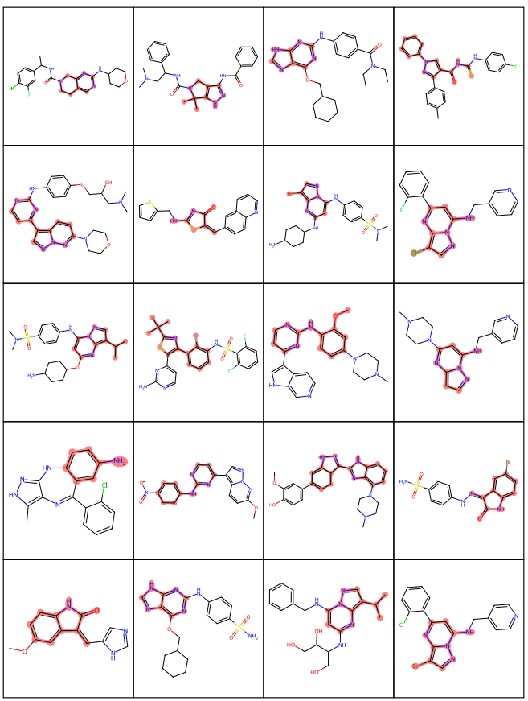
Fig.S1 Reference molecules and scaffolds on the CDK2 protein

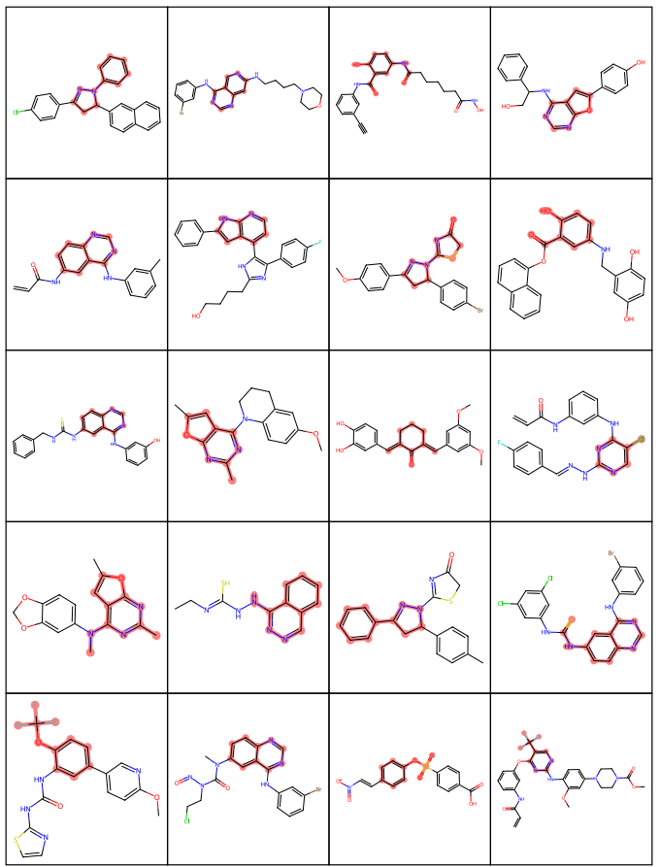
Fig. S2 Reference molecules and scaffolds on the EGFR protein

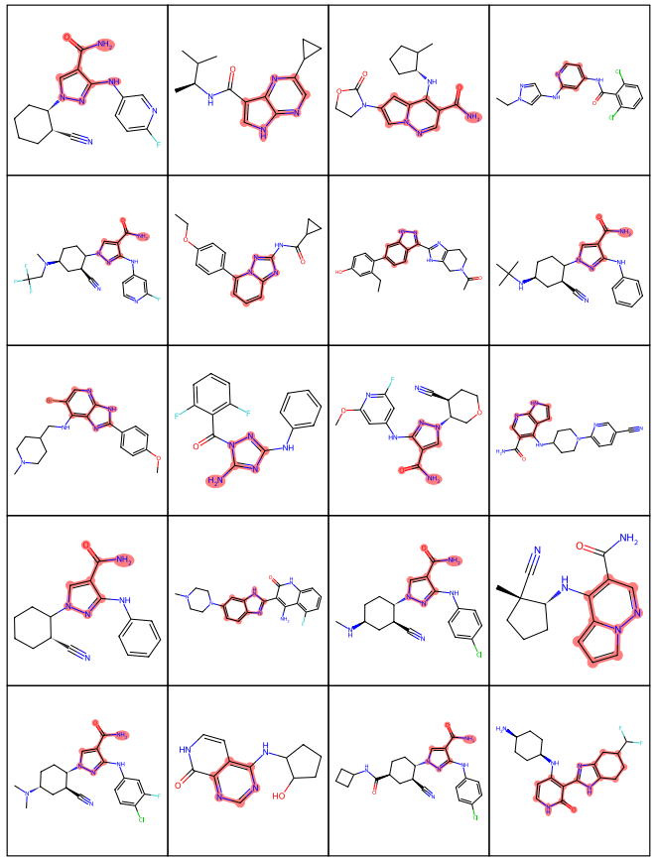
Fig. S3 Reference molecules and scaffolds on the JAK1 protein

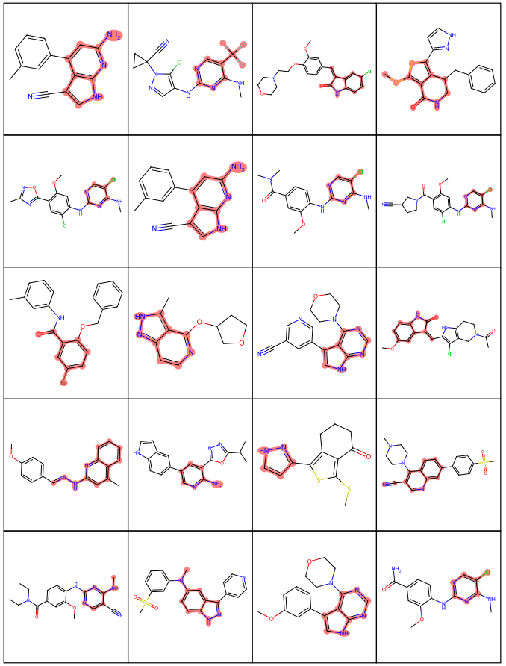
Fig. S4 Reference molecules and scaffolds on the LRRK2 protein

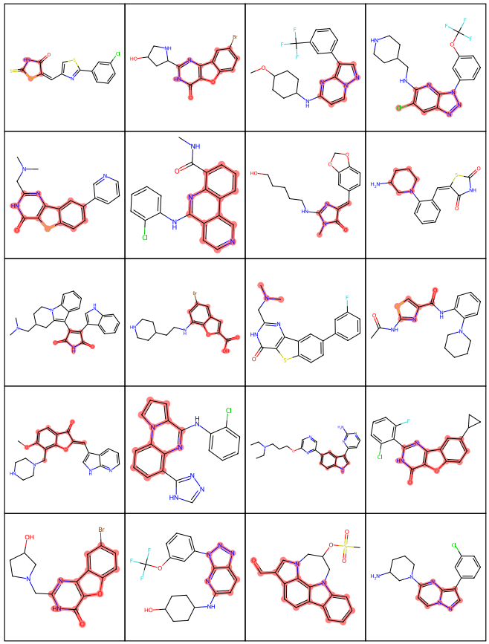
Fig. S5 Reference molecules and scaffolds on the PIM1 protein

The five baselines were fine-tuned with five targets: CDK2, EGFR, JAK1, LRRK2, and PIM1, sampled, and the results of the generated molecules were calculated against the conventional molecular generation evaluation criteria.
TableS1 The result of the AAE model on general generative model evaluation metrics (GEM)
Protein | Validity |  | Uniqueness1K | Uniqueness5K | Filter | Scaffold uniqueness | Scaffold novelty | Novelty
EGFR | 0.8802 |  | 0.8158 | 0.6842 | 0.7801 | 0.4191 | 0.2618 | 0.7593
CDK2 | 0.8847 |  | 0.6757 | 0.5186 | 0.8679 | 0.3334 | 0.2174 | 0.7851
JAK1 | 0.8877 |  | 0.7900 | 0.6215 | 0.9020 | 0.3495 | 0.2199 | 0.7311
LRRK2 | 0.8769 |  | 0.7663 | 0.6272 | 0.9107 | 0.3677 | 0.2373 | 0.7952
PIM1 | 0.8276 |  | 0.7307 | 0.5933 | 0.9135 | 0.3864 | 0.2412 | 0.7695

TableS2 The result of the VAE model on general generative model evaluation metrics (GEM)
Protein | Validity | Uniqueness1K | Uniqueness5K | Filter | Scaffold uniqueness | Scaffold novelty | Novelty
EGFR | 0.9794 | 0.8101 | 0.4848 | 0.6233 | 0.2371 | 0.1032 | 0.5090
CDK2 | 0.9874 | 0.3799 | 0.1460 | 0.9177 | 0.0851 | 0.0407 | 0.5712
JAK1 | 0.9773 | 0.6799 | 0.3718 | 0.9099 | 0.1792 | 0.0827 | 0.4907
LRRK2 | 0.9884 | 0.5849 | 0.2426 | 0.9523 | 0.1227 | 0.0476 | 0.4396
PIM1 | 0.9661 | 0.5678 | 0.2383 | 0.9211 | 0.1356 | 0.0556 | 0.4400

TableS3 The result of the LatentGAN model on general generative model evaluation metrics (GEM)
Protein | Validity | Uniqueness1k | Uniqueness5K | Filter | Scaffold uniqueness | Scaffold novelty | Novelty
EGFR | 0.7341 | 0.7307 | 0.7304 | 0.6321 | 0.7789 | 0.7160 | 1.0
CDK2 | 0.6203 | 0.6172 | 0.6186 | 0.6352 | 0.8263 | 0.7807 | 1.0
JAK1 | 0.5199 | 0.5237 | 0.5194 | 0.3686 | 0.9309 | 0.8989 | 1.0
LRRK2 | 0.7993 | 0.7452 | 0.6998 | 0.8463 | 0.5549 | 0.5080 | 1.0
PIM1 | 0.6763 | 0.6776 | 0.6673 | 0.7435 | 0.8483 | 0.8022 | 1.0

TableS4 The result of the QBMG model on general generative model evaluation metrics (GEM)
Protein | Validity | Uniqueness1k | Uniqueness5K | Filter | Scaffold uniqueness | Scaffold novelty | Novelty
EGFR | 1.0 | 1.0 | 1.0 | 0.6456 | 0.4074 | 0.2358 | 0.6942
CDK2 | 1.0 | 1.0 | 1.0 | 0.8978 | 0.4903 | 0.3667 | 0.9250
JAK1 | 1.0 | 1.0 | 1.0 | 0.8931 | 0.4000 | 0.2763 | 0.7803
LRRK2 | 1.0 | 1.0 | 1.0 | 0.8884 | 0.4031 | 0.2758 | 0.7840
PIM1 | 1.0 | 1.0 | 1,0 | 0.8543 | 0.5162 | 0.3717 | 0.8469

TableS5 The result of the SyntaLinker model on general generative model evaluation metrics (GEM)
Protein | Validity | Uniqueness1k | Uniqueness5K | Filter | Scaffold uniqueness | Scaffold novelty | Novelty
EGFR | 0.3169 | 0.3889 | 0.3145 | 0.5955 | 0.5051 | 0.4258 | 0.9964
CDK2 | 0.2561 | 0.3306 | 0.2555 | 0.7791 | 0.4924 | 0.4495 | 0.9977
JAK1 | 0.2204 | 0.2754 | 0.2192 | 0.8235 | 0.4962 | 0.4691 | 0.9992
LRRK2 | 0.2789 | 0.3516 | 0.2784 | 0.884 | 0.4924 | 0.4473 | 0.9978
PIM1 | 0.2554 | 0.3203 | 0.2544 | 0.8188 | 0.6106 | 0.5681 | 0.9984

This part introduced supplementary information on scaffold hopping and activity retention evaluations. FigS6 showed the correlation between the experimental activity values of 100 reference molecules and the activity prediction of GraphDTA, to verify the accuracy of GraphDTA scores. The correlation between the two can reach 0.6590. The value of RMSE is only 0.8848. The correlation was high, indicating that GraphDTA was accurate in predicting activity. TableS6 is the top 30% of optimal results after LeDock and GraphDTA scores of 5,000 molecules generated per reference molecule. To calculate the scaffold hopping generative model evaluation metrics (SEM) and compare them with baselines. At the same time, FigS7 represents the success rate of the best 30% molecules evaluated by GraphDTA and LeDock represented as swarm plots. Swarm plot of success rate evaluated by GraphDTA for 20 reference compounds among the five targets. It is similar to the results of the first 10% of the best in the text.
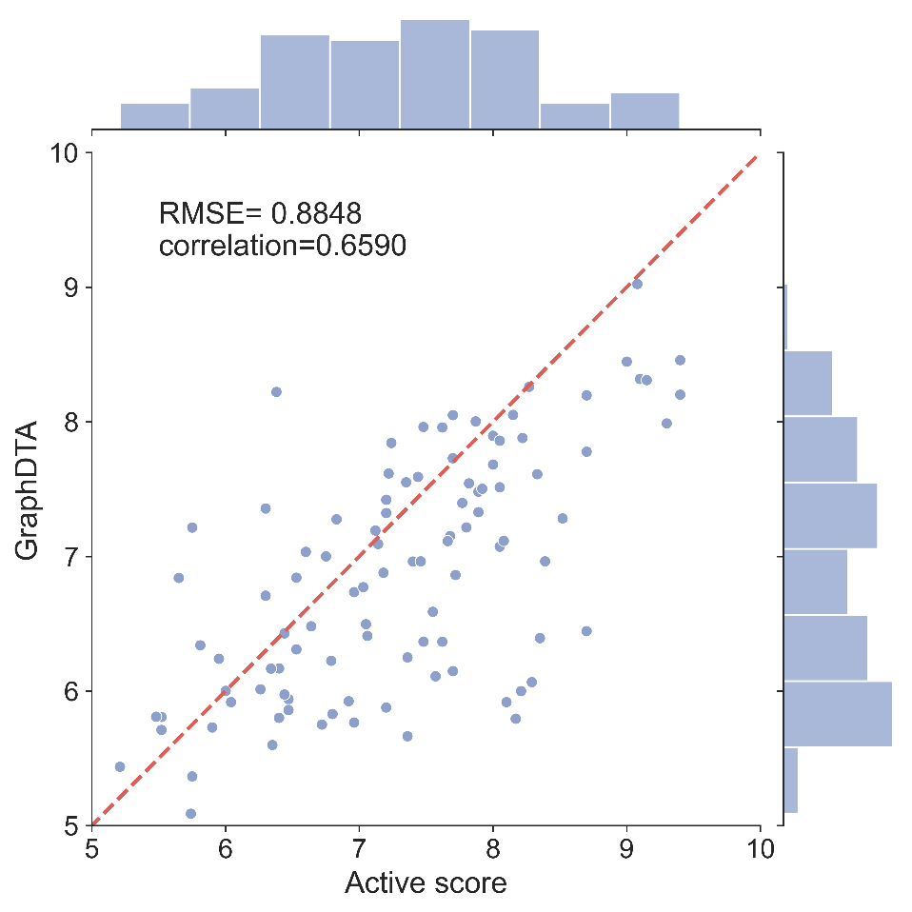
Fig. S6 Correlation between the experimental activity values of 100 reference molecules and the activity values predicted by GraphDTA
Table S6 The performance comparison between our model and baseline models on scaffold hopping generative model evaluation metrics (SEM) among five distinct targets: CDK2, JAK1, EGFR, LRRK2, and PIM1. The best 10% of molecules generated by each model were evaluated.
Protein | Model | GraphDTA |  |  |  | Ledock
Protein | Model | Active mean | Active rate | Hop rate | Success rate | Active mean | Active rate | Hop rate | Success rate
CDK2 | AAE | 7.559±0.432 | 0.787±0.332 | 0.005±0.012 | 0.007±0.017 | -9.522±0.119 | 0.950±0.122 | 0.016±0.041 |  | 0.012±0.024
CDK2 | VAE | 8.006±0.007 | 0.992±0.037 | 0.003±0.010 | 0.003±0.010 | -9.335±0.018 | 0.928±0.176 | 0.014±0.043 |  | 0.009±0.025
CDK2 | LatentGAN | 7.610±0.015 | 0.863±0.271 | 0.007±0.017 | 0.005±0.011 | -9.182±0.029 | 0.882±0.250 | 0.009±0.019 |  | 0.009±0.019
CDK2 | QBMG | 7.873±0.006 | 0.971±0.132 | 0.003±0.010 | 0.003±0.008 | -9.339±0.022 | 0.911±0.201 | 0.010±0.017 |  | 0.008±0.014
CDK2 | SyntaLinker | 6.753±0.431 | 0.469±0.423 | 0.296±0.254 | 0.113±0.160 | -8.164±0.726 | 0.559±0.381 | 0.314±0.265 |  | 0.176±0.250
CDK2 | our | 7.151±0.361 | 0.676±0.381 | 1.000±0.000 | 0.676±0.381 | -8.208±0.863 | 0.622±0.420 | 1.000±0.000 |  | 0.622±0.420
EGFR | AAE | 8.295±0.134 | 0.929±0.216 | 0.007±0.017 | 0.006±0.017 | -10.880±0.036 | 0.947±0.162 | 0.003±0.007 | 0.003±0.007
EGFR | VAE | 8.304±0.014 | 0.948± 0.160 | 0.008±0.022 | 0.008±0.022 | -10.960±0.030 | 0.945±0.170 | 0.002±0.006 | 0.002±0.006
EGFR | LatentGAN | 7.901±0.016 | 0.872±0.287 | 0.003±0.012 | 0.003±0.012 | -10.320±0.031 | 0.913±0.270 | 0.002±0.005 | 0.002±0.005
EGFR | QBMG | 8.221±0.008 | 0.941±0.182 | 0.006±0.017 | 0.006±0.017 | -10.980±0.024 | 0.952±0.150 | 0.002±0.005 | 0.001±0.005
EGFR | SyntaLinker | 6.895±0.550 | 0.506±0.348 | 0.337±0.339 | 0.167±0.256 | -8.480±0.681 | 0.721±0.396 | 0.366±0.331 | 0.331±0.347
EGFR | our | 7.018±0.480 | 0.613±0.439 | 1.000±0.000 | 0.613±0.439 | -8.874±1.323 | 0.923±0.241 | 1.000±0.000 | 0.923±0.241
JAK1 | AAE | 8.014±1.031 | 0.627±0.473 | 0.001±0.003 | 0.001±0.003 | -8.979±0.205 | 0.996±0.018 | 0.001±0.002 | 0.001±0.002
JAK1 | VAE | 8.972±0.012 | 1.000±0.000 | 0.063±0.192 | 0.063±0.192 | -8.797±0.018 | 0.996±0.017 | 0.010±0.020 | 0.010±0.020
JAK1 | LatentGAN | 7.984±0.016 | 0.613±0.378 | 0.001±0.001 | 0.001±0.001 | -8.778±0.033 | 0.970±0.092 | 0.001±0.002 | 0.001±0.002
JAK1 | SyntaLinker | 7.196±0.733 | 0.283±0.238 | 0.215±0.190 | 0.053±0.079 | -7.331±0.511 | 0.498±0.303 | 0.233±0.184 | 0.109±0.125
JAK1 | QBMG | 8.920±0.008 | 1.000±0.000 | 0.053±0.164 | 0.053±0.164 | -8.957±0.020 | 1.000±0.000 | 0.012±0.025 | 0.012±0.025
JAK1 | our | 7.739±0.370 | 0.510±0.444 | 0.952± 0.213 | 0.462±0.440 | -7.861±0.619 | 0.721±0.369 | 0.955±0.200 | 0.676±0.387
LRRK2 | AAE | 7.109±0.119 | 1.000±0.000 | 0.062±0.145 | 0.062±0.145 | -8.471±0.571 | 0.992±0.037 | 0.064±0.177 | 0.064±0.177
LRRK2 | VAE | 7.177±0.014 | 1.000±0.000 | 0.033±0.054 | 0.033±0.054 | -7.888±0.016 | 0.991±0.039 | 0.065±0.169 | 0.065±0.161
LRRK2 | LatentGAN | 6.981±0.014 | 0.988±0.053 | 0.042±0.076 | 0.042±0.076 | -7.878±0.019 | 0.986±0.061 | 0.072±0.149 | 0.072±0.149
LRRK2 | SyntaLinker | 6.542±0.332 | 0.860±0.219 | 0.355±0.273 | 0.295±0.274 | -6.980±0.649 | 0.839±0.308 | 0.373±0.286 | 0.336±0.288
LRRK2 | QBMG | 7.485±0.090 | 1.000±0.000 | 0.072±0.163 | 0.072±0.163 | -8.562±0.486 | 0.950±0.223 | 0.028±0.048 | 0.022±0.042
LRRK2 | our | 6.663±0.267 | 0.924±0.190 | 1.000±0.000 | 0.924±0.190 | -7.205±0.781 | 0.928±0.229 | 1.000±0.000 | 0.928±0.229
PIM1 | AAE | 8.179±0.251 | 0.893±0.272 | 0.007±0.027 | 0.007±0.027 | -7.869±0.394 | 0.988±0.052 | 0.005±0.019 | 0.005±0.019
PIM1 | VAE | 9.012±0.035 | 0.971±0.128 | 0.013±0.036 | 0.011±0.034 | -7.582±0.020 | 0.986±0.043 | 0.016±0.040 | 0.015±0.041
PIM1 | LatentGAN | 8.059±0.015 | 0.885±0.273 | 0.016±0.064 | 0.015±0.061 | -7.454±0.013 | 0.956±0.137 | 0.014±0.058 | 0.014±0.058
PIM1 | SyntaLinker | 7.329±0.528 | 0.622±0.378 | 0.239±0.275 | 0.129±0.169 | -6.626±0.750 | 0.645±0.377 | 0.242±0.263 | 0.142±0.229
PIM1 | QBMG | 8.648±0.018 | 0.949±0.179 | 0.013±0.037 | 0.012±0.037 | -7.661±0.016 | 0.991±0.030 | 0.012±0.033 | 0.012±0.033
PIM1 | our | 8.310±0.259 | 0.943±0.216 | 1.000±0.000 | 0.943±0.216 | -6.879±0.697 | 0.796±0.347 | 1.000±0.000 | 0.796±0.347

Table S7 the performance comparison between our model and baseline models on scaffold hopping generative
model evaluation metrics (SEM) among five distinct targets: CDK2, JAK1, EGFR, LRRK2, and PIM1. The best
30% of molecules generated by each model were evaluated.
Protein | Model | GraphDTA |  |  |  | Ledock
Protein | Model | Active mean | Active rate | Hop rate | Success rate | Active mean | Active rate | Hop rate | Success rate
CDK2 | AAE | 7.169±0.537 | 0.654±0.409 | 0.012±0.018 | 0.005±0.008 | -8.963±0.067 | 0.819±0.302 | 0.013±0.023 | 0.010±0.016
CDK2 | VAE | 7.795±0.010 | 0.936±0.173 | 0.007±0.014 | 0.003±0.006 | -8.903±0.015 | 0.817±0.315 | 0.012±0.020 | 0.008±0.012
CDK2 | LatentGAN | 7.152±0.015 | 0.587±0.351 | 0.009±0.020 | 0.003±0.006 | -8.599±0.018 | 0.710±0.355 | 0.010±0.023 | 0.010±0.023
CDK2 | QBMG | 7.533±0.009 | 0.809±0.268 | 0.005±0.007 | 0.003±0.004 | -8.778±0.023 | 0.772±0.334 | 0.007±0.010 | 0.006±0.009
CDK2 | SyntaLinker | 6.202±0.413 | 0.270±0.285 | 0.306±0.240 | 0.080±0.150 | -7.494±0.808 | 0.347±0.298 | 0.309±0.239 | 0.108±0.180
CDK2 | our | 6.853±0.434 | 0.499±0.433 | 1.000±0.000 | 0.499±0.433 | -7.787±0.884 | 0.441±0.401 | 1.000±0.000 | 0.441±0.401
EGFR | AAE | 7.895±0.135 | 0.838±0.305 | 0.005±0.010 | 0.004±0.009 | -9.965±0.083 | 0.888±0.266 | 0.004±0.008 | 0.004±0.008
EGFR | VAE | 7.941±0.010 | 0.872±0.273 | 0.005±0.013 | 0.005±0.013 | -10.070±0.023 | 0.892±0.264 | 0.003±0.008 | 0.003±0.008
EGFR | LatentGAN | 7.505±0.017 | 0.737±0.366 | 0.003±0.010 | 0.003±0.009 | -9.596±0.027 | 0.856±0.309 | 0.003±0.007 | 0.003±0.007
EGFR | QBMG | 7.864±0.007 | 0.853±0.291 | 0.005±0.011 | 0.004±0.010 | -10.120±0.020 | 0.903±0.254 | 0.003±0.008 | 0.003±0.008
EGFR | SyntaLinker | 6.340±0.478 | 0.291±0.268 | 0.344±0.337 | 0.087±0.139 | -7.851±0.641 | 0.484±0.340 | 0.349±0.338 | 0.251±0.302
EGFR | our | 6.663±0.517 | 0.443±0.414 | 1.000±0.000 | 0.443±0.414 | -8.365±1.353 | 0.731±0.317 | 1.000±0.000 | 0.731±0.317
JAK1 | AAE | 7.468±1.285 | 0.545±0.473 | 0.003±0.012 | 0.003±0.012 | -8.442±0.175 | 0.892±0.215 | 0.003±0.009 | 0.001±0.004
JAK1 | VAE | 8.685±0.008 | 0.989±0.034 | 0.056±0.148 | 0.054±0.145 | -8.351±0.014 | 0.902±0.216 | 0.025±0.056 | 0.024±0.056
JAK1 | LatentGAN | 7.316±0.024 | 0.396±0.389 | 0.001±0.002 | 0.001±0.001 | -8.091±0.026 | 0.780±0.275 | 0.001±0.001 | 0.001±0.001
JAK1 | SyntaLinker | 6.600±0.665 | 0.174±0.194 | 0.229±0.172 | 0.030±0.044 | -6.789±0.526 | 0.288±0.229 | 0.232±0.175 | 0.055±0.053
JAK1 | QBMG | 8.655±0.006 | 0.981±0.059 | 0.046±0.136 | 0.046±0.135 | -8.405±0.015 | 0.903±0.207 | 0.019±0.049 | 0.019±0.049
JAK1 | our | 7.415±0.467 | 0.366±0.418 | 0.952±0.216 | 0.331±0.417 | -7.360±0.627 | 0.511±0.399 | 0.954±0.204 | 0.465±0.392
LRRK2 | AAE | 6.809±0.145 | 0.948±0.111 | 0.050±0.121 | 0.049±0.120 | -8.006±0.435 | 0.964±0.161 | 0.057±0.149 | 0.057±0.149
LRRK2 | VAE | 6.802±0.013 | 0.950±0.146 | 0.050±0.091 | 0.048±0.091 | -7.602±0.011 | 0.964±0.162 | 0.086±0.187 | 0.086±0.187
LRRK2 | LatentGAN | 6.630±0.012 | 0.882±0.213 | 0.054±0.096 | 0.051±0.096 | -7.511±0.012 | 0.948±0.175 | 0.088±0.171 | 0.083±0.162
LRRK2 | SyntaLinker | 6.173±0.255 | 0.590±0.246 | 0.373±0.279 | 0.227±0.247 | -6.401±0.580 | 0.563±0.302 | 0.375±0.276 | 0.247±0.220
LRRK2 | QBMG | 7.282±0.123 | 1.000±0.000 | 0.056±0.115 | 0.056±0.115 | -7.961±0.344 | 0.933±0.232 | 0.036±0.062 | 0.029±0.058
LRRK2 | our | 6.401±0.247 | 0.776±0.333 | 1.000±0.000 | 0.776±0.333 | -6.741±0.804 | 0.720±0.326 | 1.000±0.000 | 0.720±0.326
PIM1 | AAE | 7.683±0.263 | 0.715±0.347 | 0.006±0.016 | 0.004±0.012 | -7.339±0.357 | 0.926±0.189 | 0.005±0.016 | 0.004±0.016
PIM1 | VAE | 8.273±0.017 | 0.887±0.243 | 0.015±0.031 | 0.013±0.028 | -7.172±0.014 | 0.916±0.220 | 0.013±0.031 | 0.012±0.031
PIM1 | LatentGAN | 7.658±0.012 | 0.713±0.353 | 0.013±0.052 | 0.006±0.021 | -6.93±0.012 | 0.854±0.270 | 0.013±0.052 | 0.013±0.052
PIM1 | SyntaLinker | 6.586±0.444 | 0.367±0.269 | 0.233±0.26 | 0.068±0.074 | -6.215±0.664 | 0.458±0.339 | 0.232±0.253 | 0.083±0.123
PIM1 | QBMG | 8.071±0.011 | 0.849±0.282 | 0.012±0.028 | 0.009±0.022 | -7.182±0.011 | 0.910±0.217 | 0.010±0.026 | 0.010±0.026
PIM1 | our | 7.898±0.329 | 0.854±0.292 | 1.000±0.000 | 0.854±0.292 | -6.435±0.707 | 0.606±0.385 | 1.000±0.000 | 0.606±0.385

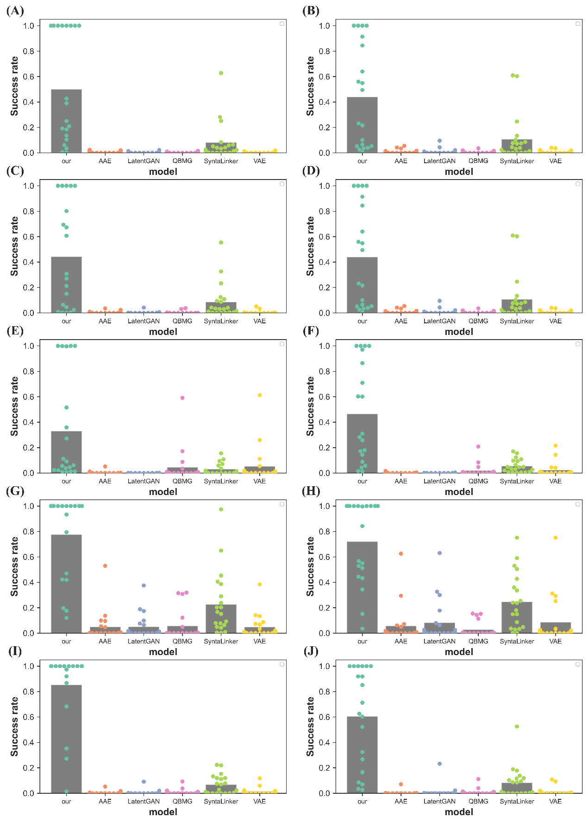
Fig. S7 The success rate of the best 30% molecules evaluated by GraphDTA and LeDock represented as a swarm plot. Swarm plot of success rate evaluated by GraphDTA for 20 reference compounds among the target of (A) CDK2; (C) EGFR; (E) JAK1; (G) LRRK2; (I) PIM1. Swarm plot of success rate evaluated by LeDock for 20 reference compounds among the target of (B) CDK2; (D) EGFR; (F) JAK1; (H) LRRK2; (J) PIM1. The points denote the success rate of generated molecules, and the gray bars are the average success rate for 20 reference compounds.

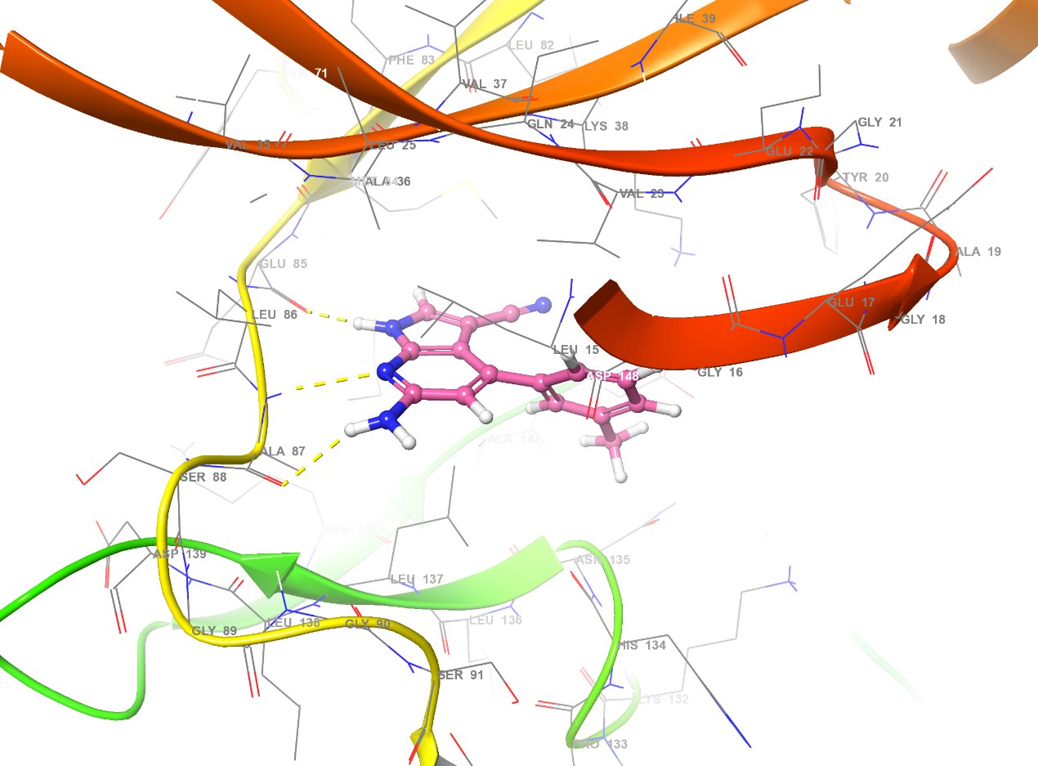
Fig. S8 The binding poses of the reference compound against LRRK2. the yellow dot line denotes the hydrogen bond.

