Table S1: The composition of RCV-sucrose medium
Ingredients | Unit | Quantity
Yeast extract | g L⁻¹ | 0.1
Nutrient solution (S-II) | mL | 50
Tampon phosphate solution | mL | 15
Sodium chloride | g L⁻¹ | 15
Agar | g L⁻¹ | 15
Sugar (sucrose) | g L⁻¹ | 40
pH | - | 6.8
Distilled water was used to prepare the RCV-medium. Nutrient solution(S-II) was prepared by adding EDTA titriplex-2 (0.4g), MgSO₄ (2 g), CaCl₂ (2 g), FeSO4. 7H2O (0.44 g), super salt solution (20 mL) in 1000 mL distilled water. Super salt solution was prepared by adding ZnSO₄.7H₂O (0.42 g), MnSO₄.7H₂O (1.30 g), Na₂MoO₄.2H₂O (0.75g), H₃BO₃ (2.80 g), CuSO₄.5H₂O (0.02255 g), CoSO₄.7H₂O (0.07 g) in 1000mL distilled water. Tampon phosphate solution was prepared by adding KH₂PO₄ (40 g) and K₂HPO₄ (60 g) in 1000mL distilled water.

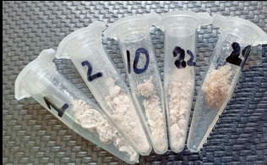
MK29
MK22
MK10
MK2
MK1
Fig. S1: Powdered form of exopolysaccharides from the selected bacterial isolates grown on RCV salt medium

