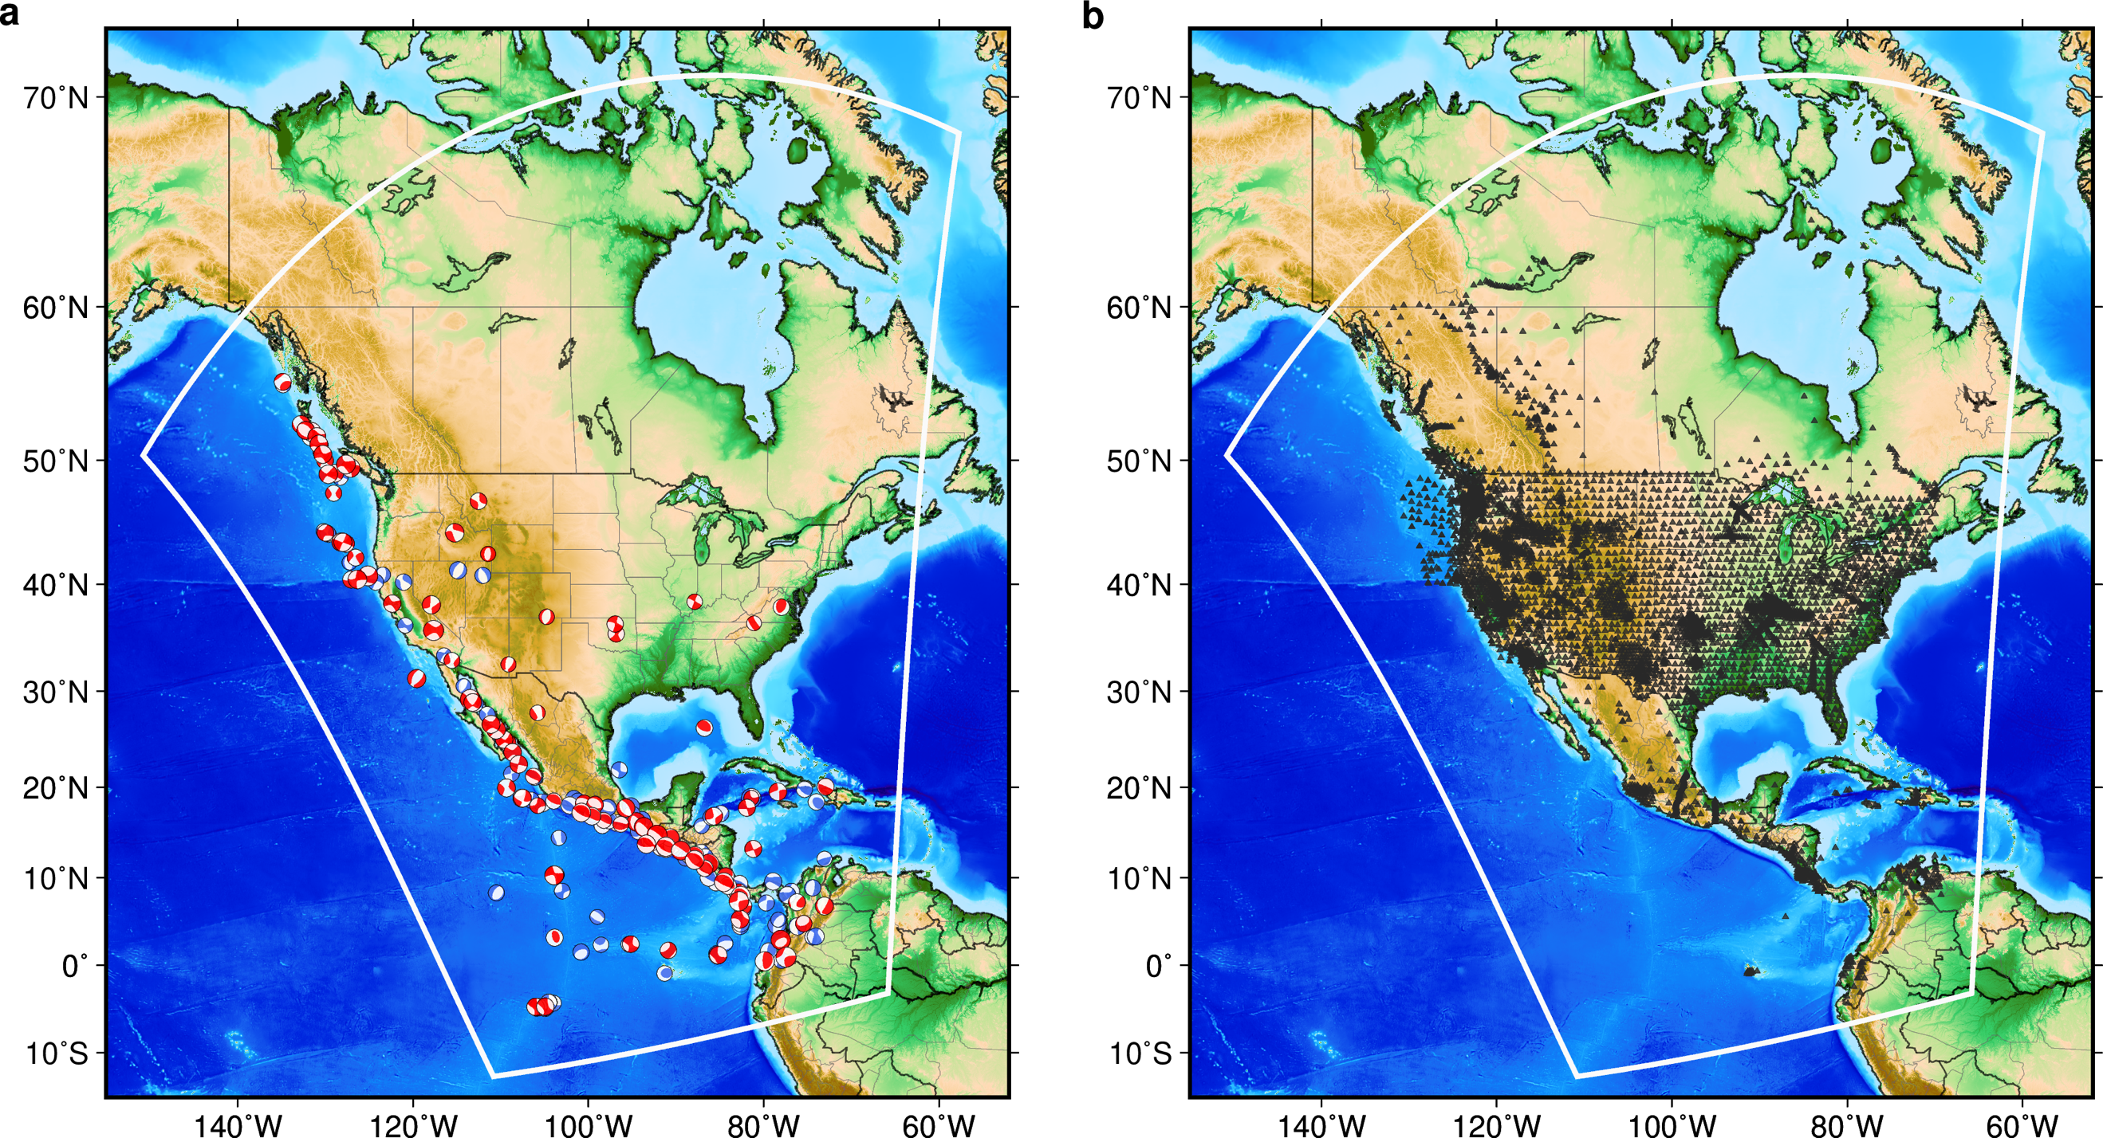
Extended Data Fig. 1 | The distribution of earthquakes and stations. a. Map of earthquakes symbolized by their focal mechanisms after source inversions. Red earthquakes are included during both coarse and fine stages, while blue earthquakes are only used during the coarse stage. The white solid line outlines the simulation domain. b. Map of stations (black triangles) used in the inversion.

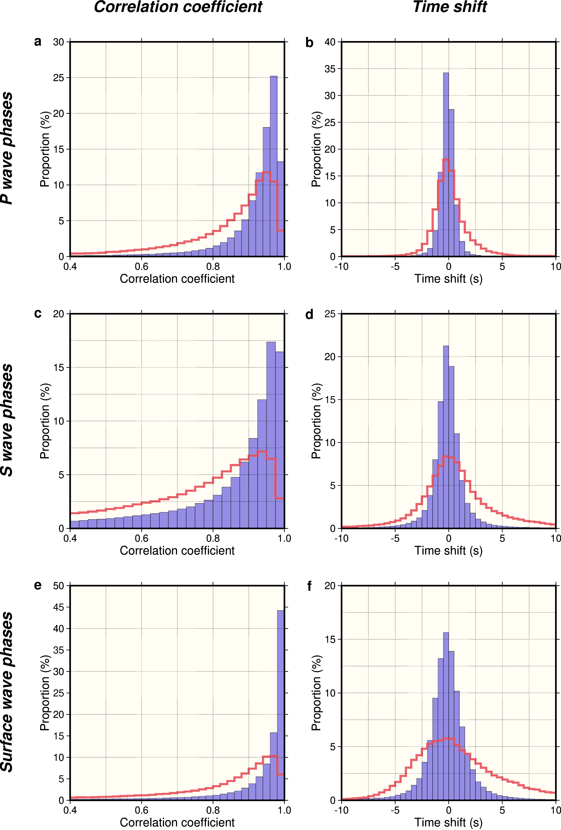
Extended Data Fig. 2 | Improvement on data-fitting through inversion. Figures in the left column (a, c, and e) show the distribution of correlation coefficient between synthetic and observed seismograms before (red line) and after (blue bars) the 206 iterations. Figures in the right column (b, d, and f) are illustrated in the same way, but are for the time shift between synthetic and observed data. The first row is for all P motion related body wave segments (e.g., P, PP, etc.); the second row is for S motion related segments (e.g., S, SS, etc.); and the third row is for surface wave segments (Rayleigh and Love waves). To be consistent, only the 110 earthquakes that are included in the fine-grid stage are used here, and only segments with signal-to-noise ratio¹⁶ > 8 are counted. Waveforms used for distributions before inversion for the coarse-grid stage (red lines) were filtered at lower frequencies, which are supposed to be easier for data-fitting than ones after inversion (blue bars).

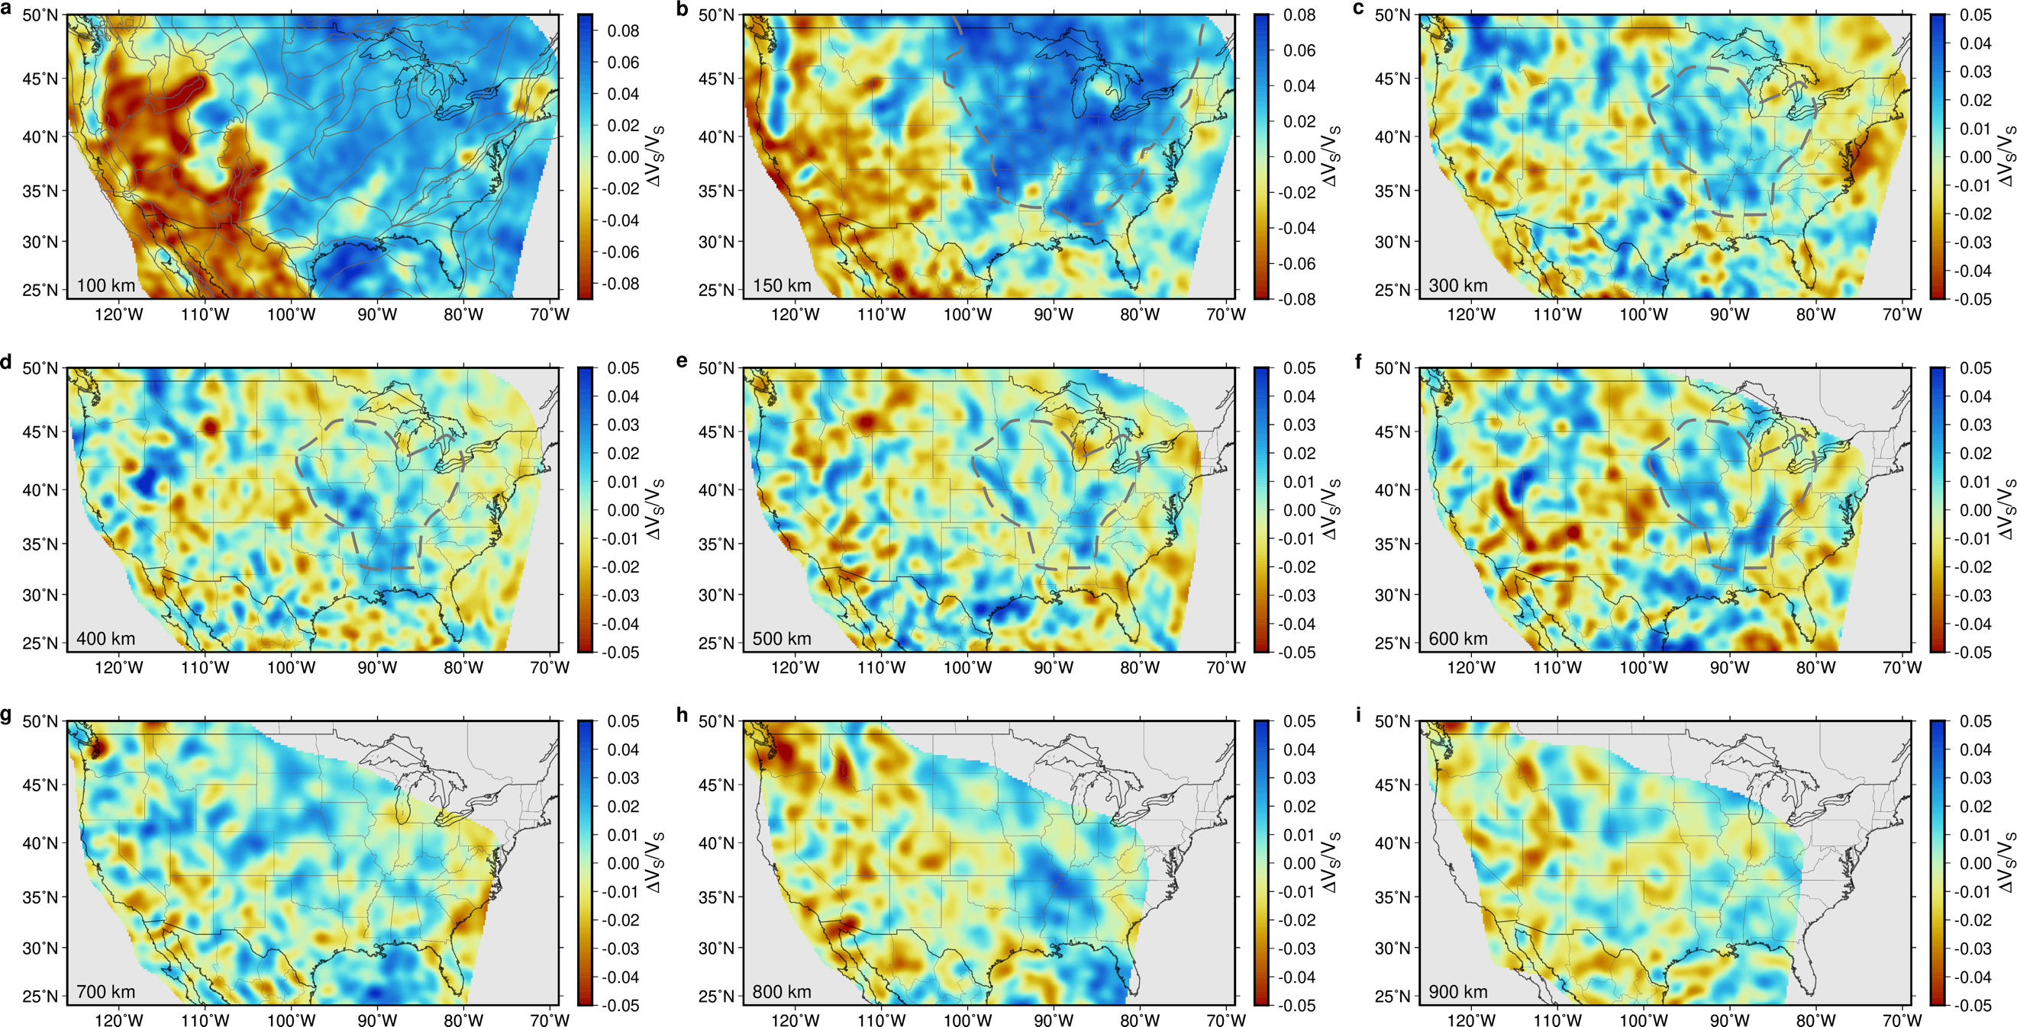
Extended Data Fig. 3 | Isotropic V_{S} distribution at different depths. a-i. V_{S} perturbations at 100, 150, 300, 400, 500, 600, 700, 800, and 900 km depths. Only reliable regions (Extended Data Fig. 5) are shown colored (note variable color bars). Tectonic regions²⁰ are outlined in a. The craton boundary in Fig. 1 is plotted as gray dashed lines on b. The boundary for dripping bodies in Fig. 2c is plotted as gray dashed lines on c-f.

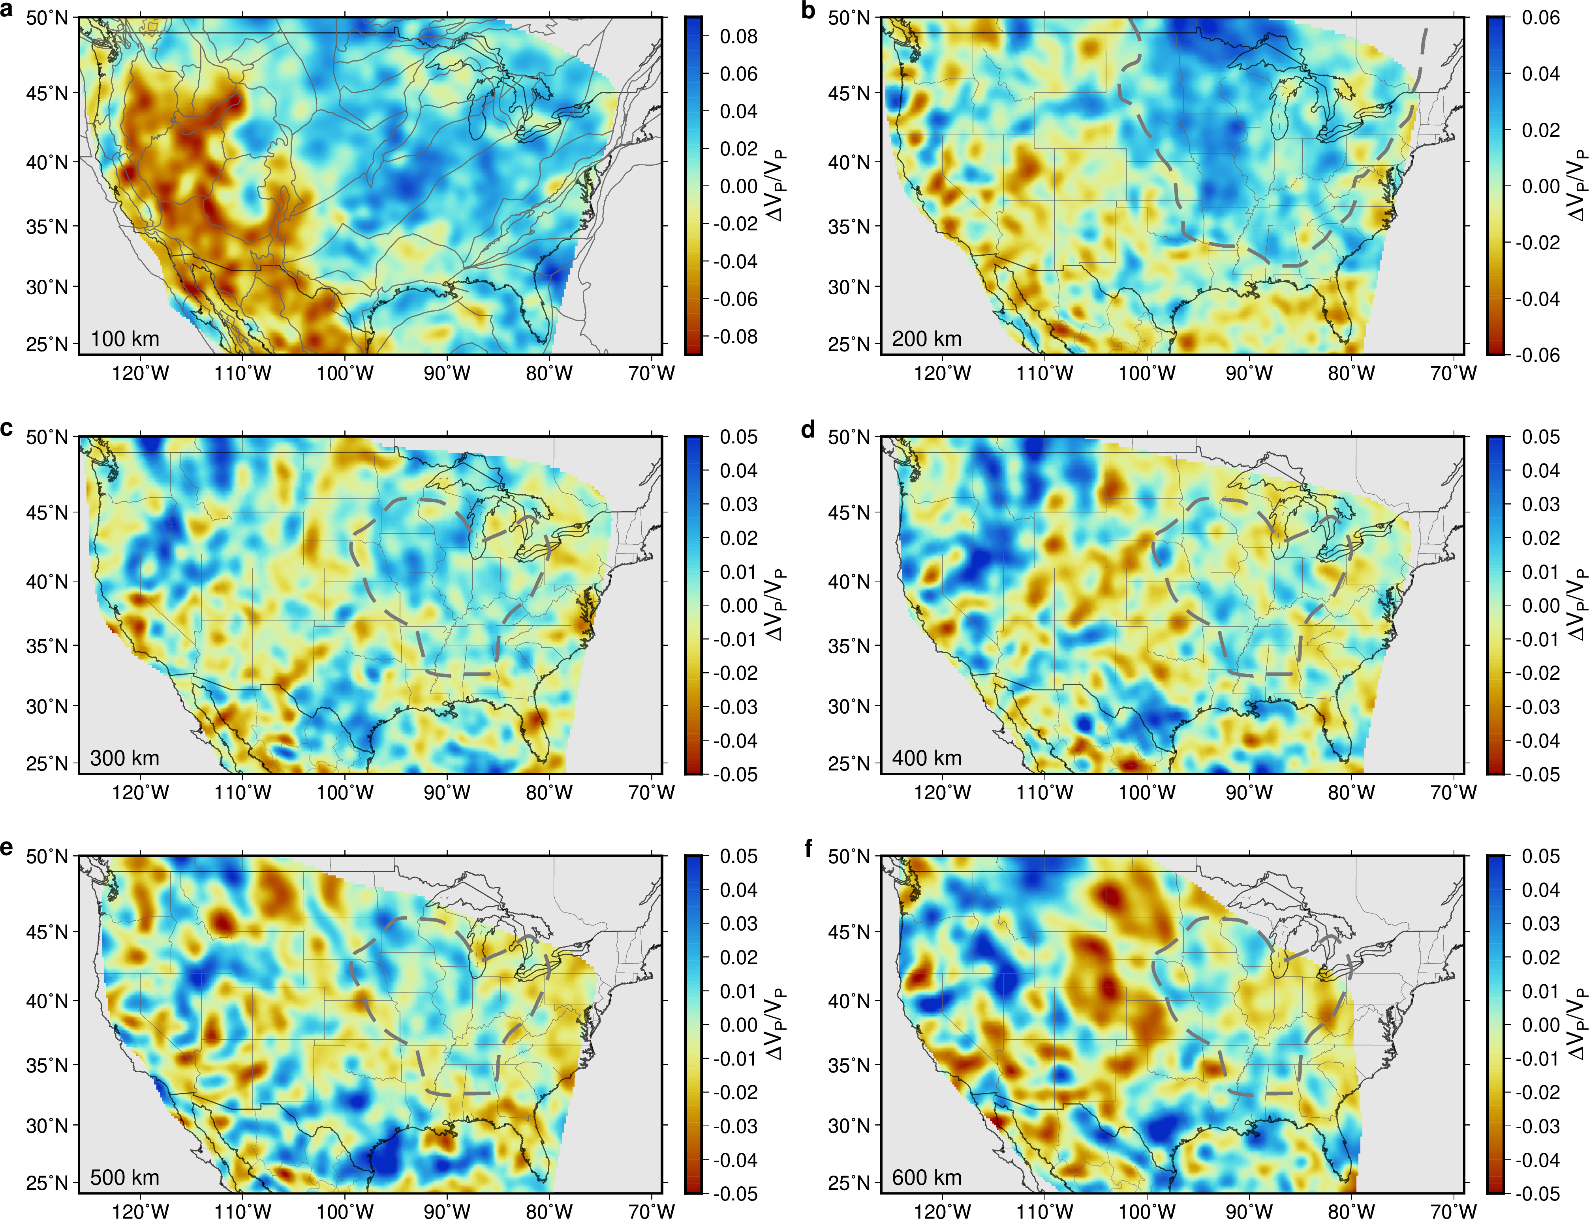
Extended Data Fig. 4 | Isotropic V_{P} distribution at different depths. a-f. Similar to Extended Data Fig. 3, but are for V_{P} perturbations at 100, 200, 300, 400, 500, and 600 km depths.

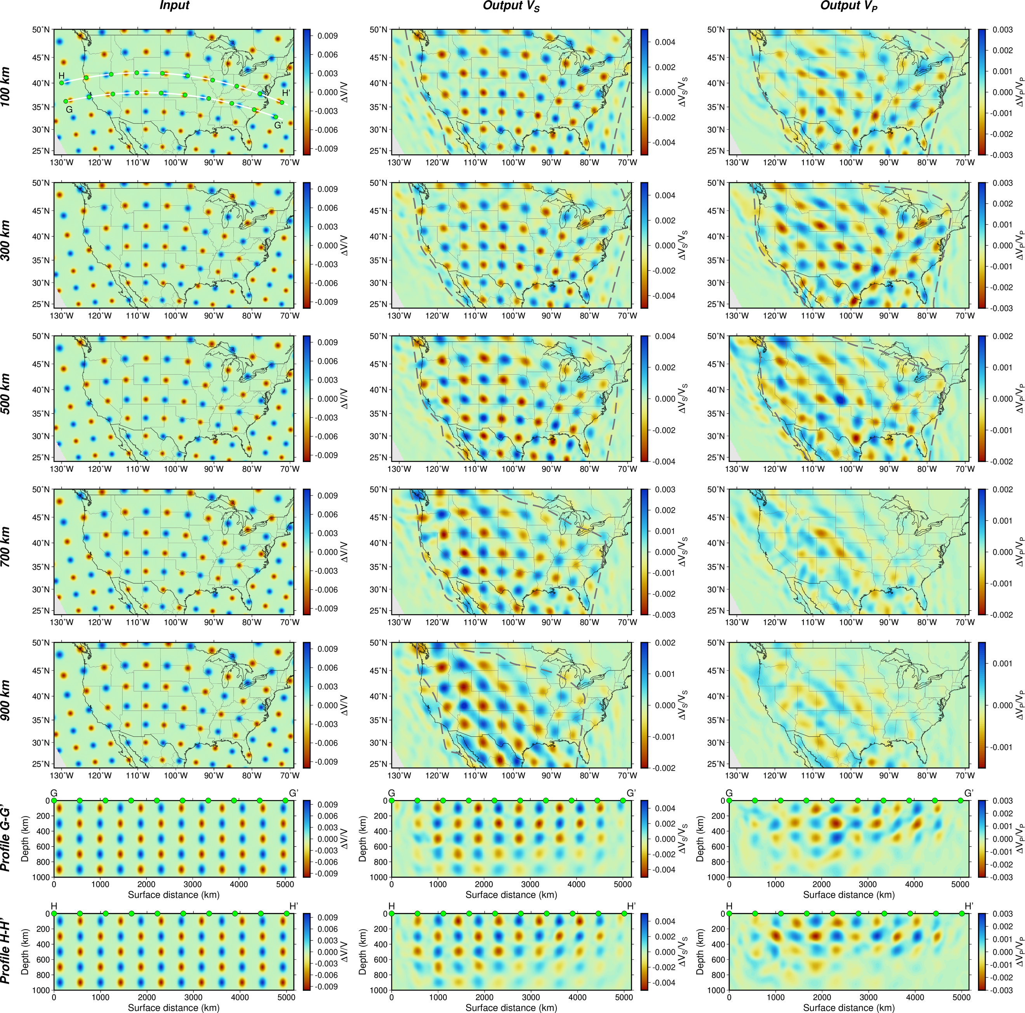
Extended Data Fig. 5 | Resolution tests for SATONA. This multi-panel figure contains 3 columns and 7 rows. The first column shows the input velocity structures, and the second and third columns are outputs for V_{S} and V_{P} after 16 iterations of inversions. Though in this figure V_{S} and V_{P} are plotted together, and the same input V_{S} and V_{P} structure was used, V_{S} and V_{P} resolutions are tested separately. The first five rows are velocity maps at 100, 300, 500, 700, and 900 km depths. Regions that are reliable to interpret are outlined by gray dashed lines in the second and third columns for these five rows. The last two rows show two cross-sections that pass through the region with the dripping body (Fig. 2c). Locations of these profiles are shown as white lines on the panel at the first column and first row. Green markers on the cross-sections and the map have the same meaning as in Fig. 2.

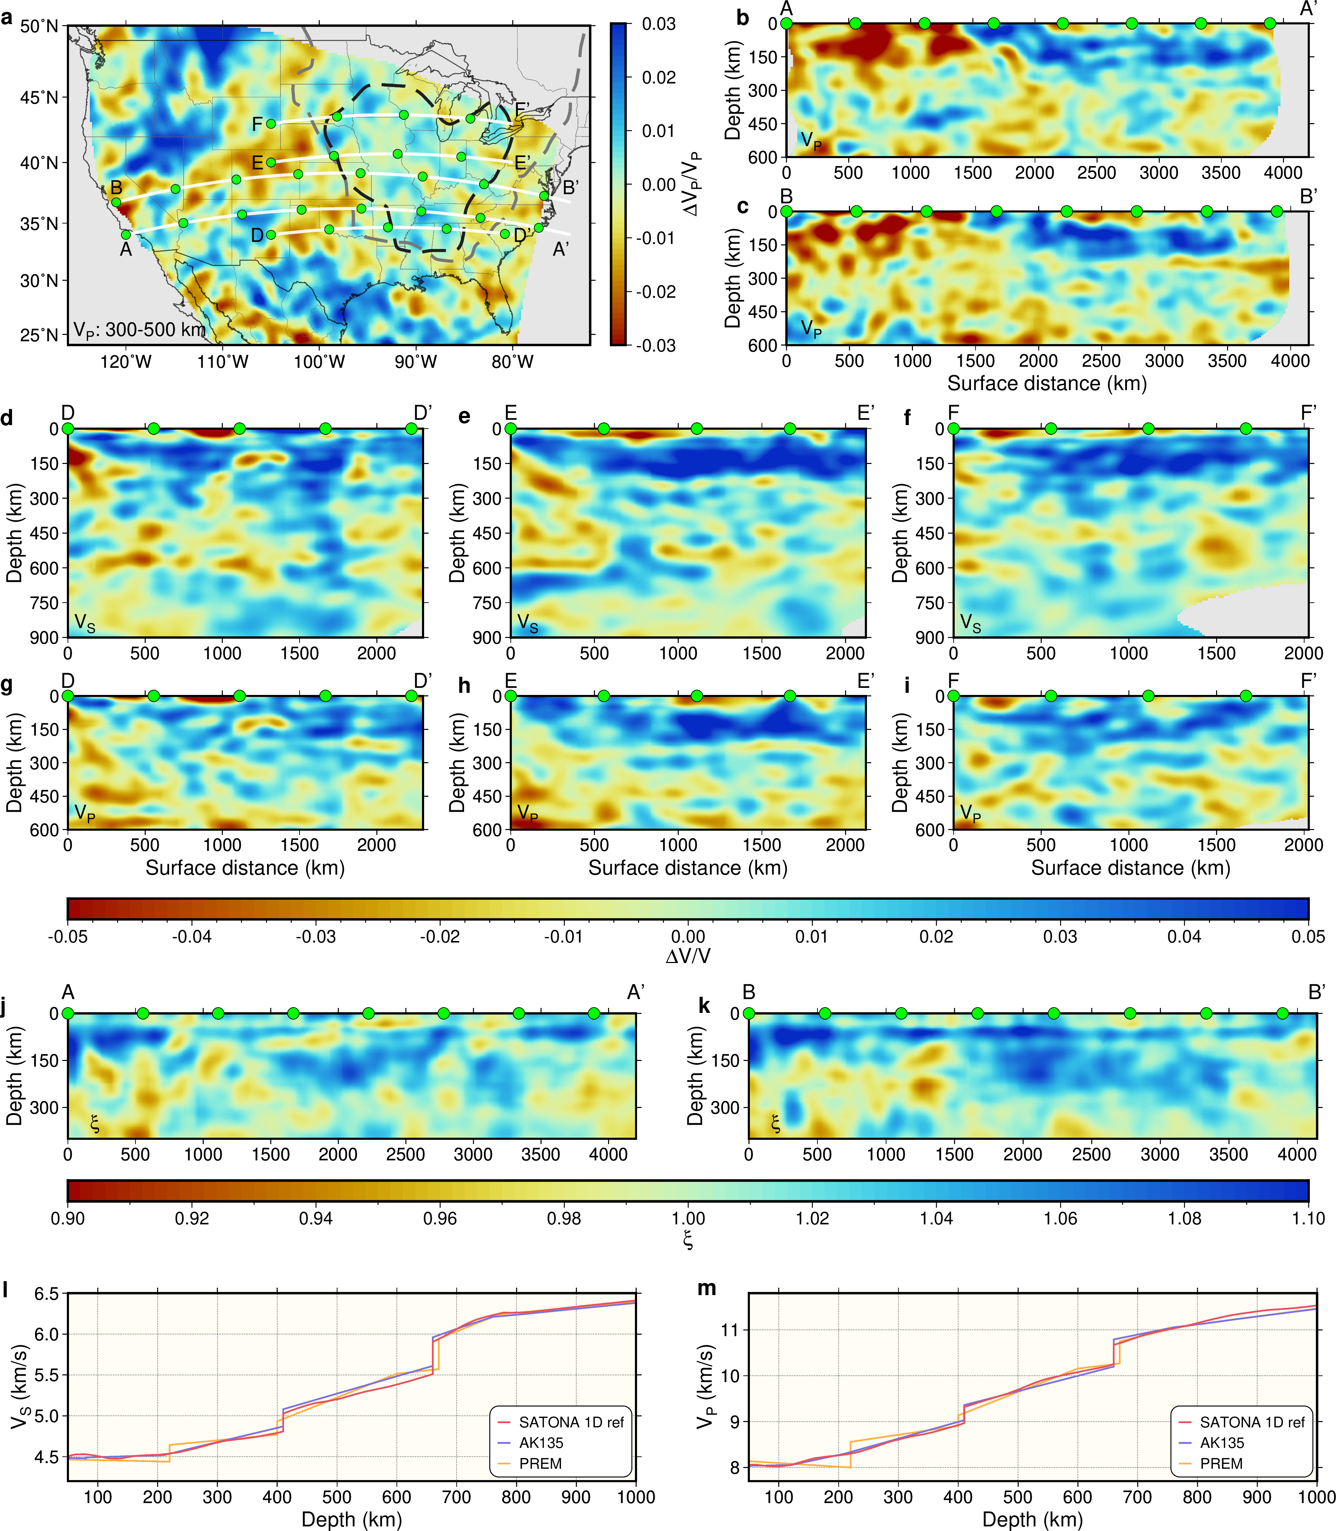
Extended Data Fig. 6 | Velocity perturbation diagrams related to the dripping body, lithospheric anisotropy and the 1D reference velocity model. A. Similar to Fig. 2c, but for V_{P}. b-c. Similar to Fig. 2a, b, but for V_{P}. d-f. Three additional V_{S} cross-sections that pass through the dripping body at different latitudes. Locations of the profiles are shown as white lines in a, and green geographic markers in a correspond to ones on top of the cross-sections. g-i. Similar to d-f, but for V_{P}. All V_{S} cross-sections extend to 900 km depths, while V_{P} ones only extend to 600 km due to the resolution (Extended Data Fig. 5). All cross-sections share a color bar beneath g-i. j-k. Like Fig. 2a, b, but for the radial anisotropy factor ξ (square of the ratio between SH and SV velocities) in the top 400 km depths. The color bar is beneath the two panels. Horizontally aligned features near Moho might be real or influenced by the assumed Moho depth in CRUST1.0⁶⁰. l-m. Mantle 1D reference V_{S} and V_{P} structures obtained by averaging the SATONA model (red lines). These models are used to convert absolute velocities to velocity perturbations. AK135⁹⁶ (blue lines) and PREM⁷⁸ (yellow lines) models are also shown for comparison.

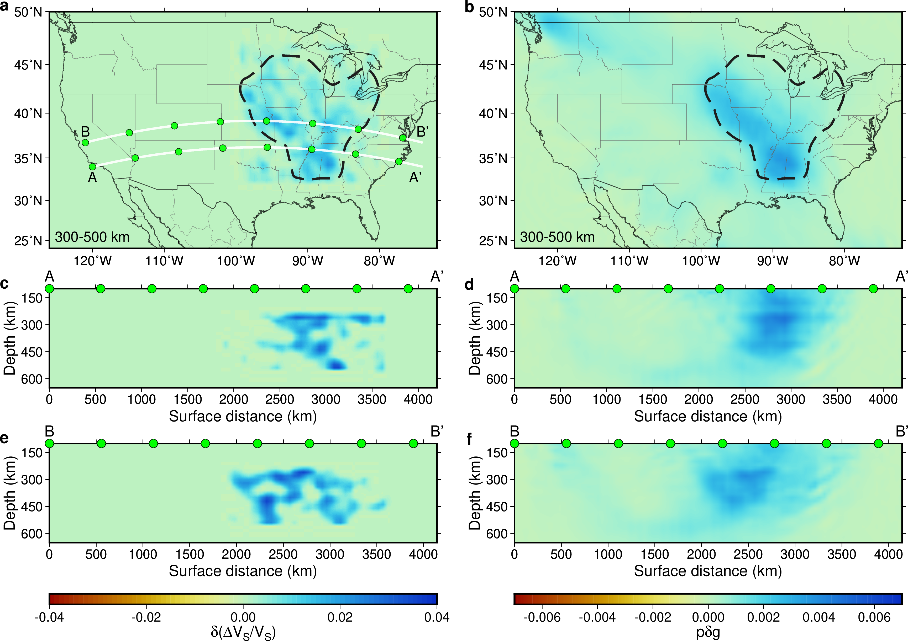
Extended Data Fig. 7 | Resolution test for the dripping body. Panels in the left column show the dripping structures that are removed for the test. Panels in the right column show the difference in preconditioned ΔV_{S} /V_{S} kernel between original and modified V_{S} models, and such difference represents the data-favored velocity change to compensate for the removed dripping structures. The three rows correspond to Fig. 2c, Fig. 2a, and Fig. 2b for the average between 300-500 km depths, cross-sections A-A’ and B-B’. Locations of the cross-sections are shown in a. It is shown that with only one iteration, dripping bodies can be illuminated by the data at the right location.

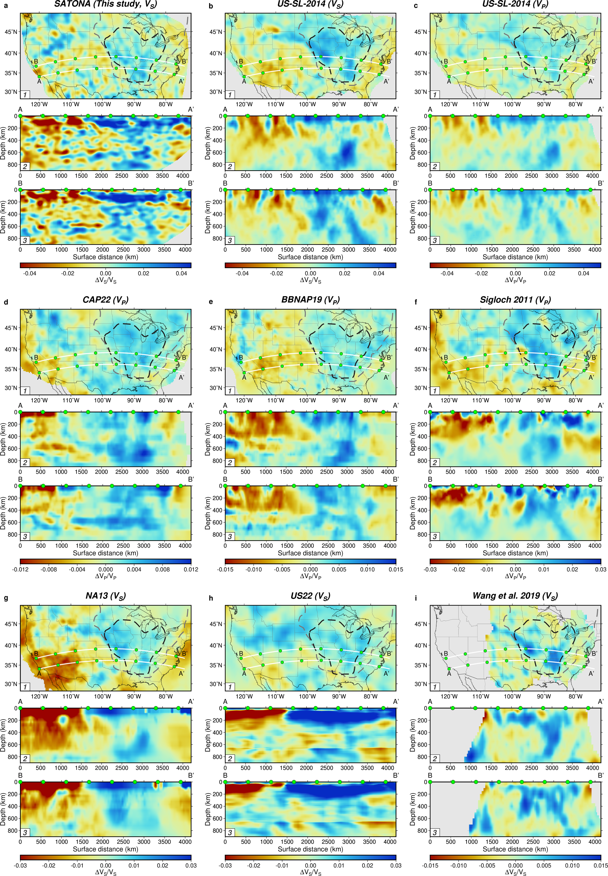
Extended Data Fig. 8 | Comparisons of the dripping structure with previous models. a. V_{S} from this study. b. V_{S} from US-SL-2014²². c. V_{P} from US-SL-2014²². d. V_{P} from CAP22⁹³. e. V_{P} from BBNAP19²¹. f. V_{P} from ref.²³. g. V_{S} from NA13⁹⁴. h. V_{S} from US22⁵⁷. i. V_{S} from ref.²⁵. Each panel contains three sub-panels corresponding to Figs. 2c, 2a and 2b, for the average between 300 and 500 km depths, cross-sections A-A’ and B-B’.
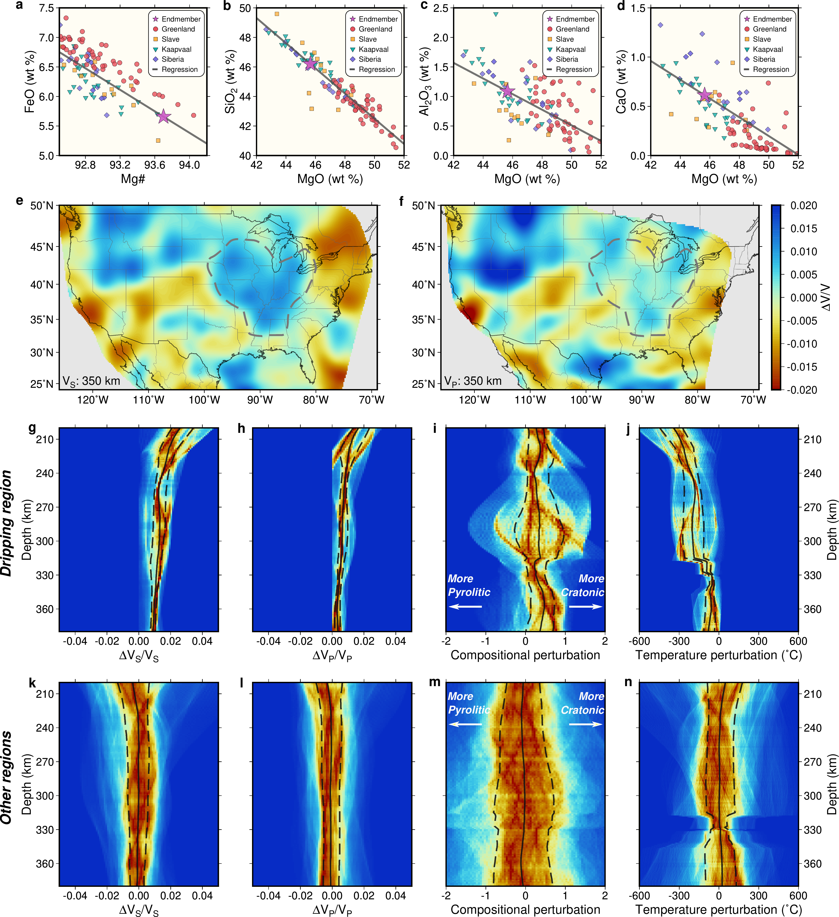
Extended Data Fig. 9 | Thermal and compositional states for the dripping body. a-d. Major element compositions for cratonic lithosphere. The four panels are for Mg#-FeO (a), MgO-SiO₂ (b), MgO-Al₂O₃ (c), and MgO-CaO (d) relationships. Samples from different cratons are shown with different symbols, the generalized linear relationships through regression are shown as lines, and the craton endmember used in this study is shown as stars. e-f. The smoothed V_{S} and V_{P} perturbations at 350 km depth that contribute to Fig. 2d-e. The gray dashed line shows the boundary for dripping bodies, and within it, at each geographic location, the temperature and composition will be estimated later as one sample. g. The heatmap of V_{S} perturbations at different depths for the dripping area (e), and warmer colors suggest larger amounts of sample. h-j. Similar to g, but are for perturbations in V_{P} (h), composition (i), and temperature (j). A unit in composition represents the compositional difference between the two endmembers as also for Fig. 3d, and higher values are more cratonic. The uncertainty in i is big between 250 and 320 km depths, as the difference between V_{S} and V_{P} around those depths is not very sensitive to variations in composition. k-n. Similar to g-j, but for the rest of the regions (regions excluding the dripping area) with good resolution (Extended Data Fig. 5).

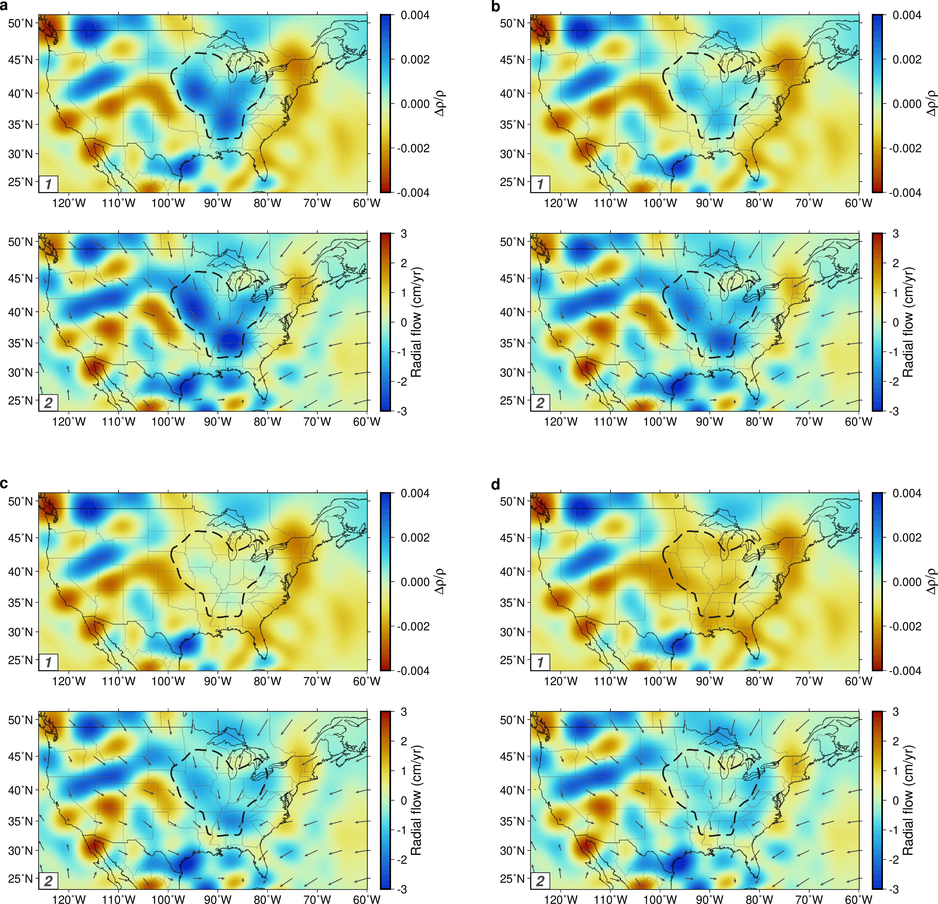
Extended Data Fig. 10 | Upper mantle radial flow for dripping bodies with different densities. Each panel consists of two sub-panels, and the upper sub-panel shows the average density anomaly at 300-500 km depths that drives the mantle flow (spherical harmonic degree < 64), while the lower sub-panel shows the corresponding average radial flow at the same depth range (negative value means flowing downward). Arrows in the lower sub-panels show the average horizontal flow at 300-500 km depths. The four panels are for different V_{S}-density scaling factors. a. Positive V_{S} perturbations within the dripping area scaled to density the same as the rest of the areas; b. V_{S} perturbations scaled to half of the density perturbations for the rest of the areas; c. V_{S} perturbations scaled to zero; d. V_{S} perturbations scaled to −0.5 of the density perturbations for the rest of the areas so that these dripping bodies are positively buoyant. No matter the assumed density, the dripping area constantly shows downward flows, though weaker when the dripping bodies are more buoyant. Meanwhile, the local density structure has a very limited effect on the horizontal flow, which carries materials from other places to near the dripping area and sink.

