Contents of Supplementary Materials

Supplementary Figure 1: Project Happy Apples extended virtual befriending to St. Andrew’s Community Hospital Palliative patients

Supplementary Table 1: Historical Milestones and Development of Project Happy Apples over the Last Decade

Supplementary Table 2: Social demographics of PHA Public Exhibition’s participants in 2022

Supplementary Data: Project Happy Apples Exhibition Questionnaire

Supplementary Figure 1: Project Happy Apples extended virtual befriending to St. Andrew’s Community Hospital Palliative patients

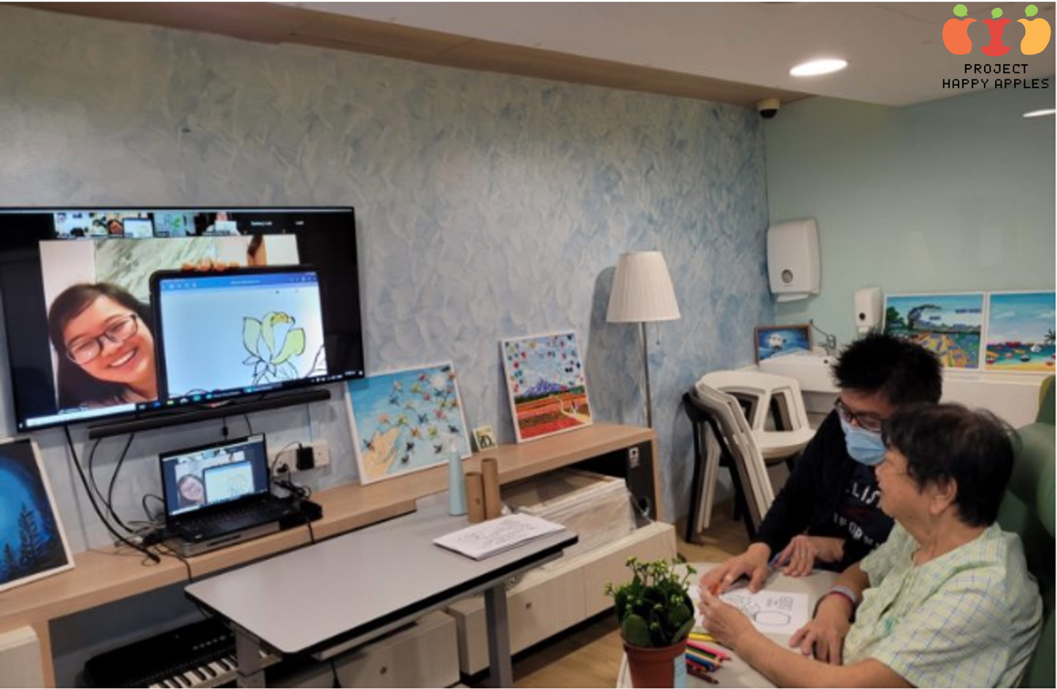

Supplementary Table 1: Historical Milestones and Development of Project Happy Apples over the Last Decade

Year | Milestones
2012 | - Registration of Project Happy Apples (PHA) in National University of Singapore as an organization focused on advocacy and awareness of palliative care  - Commencement of annual medical-student befriending programme for palliative patients with various national service providers
2013 - 2014 | - Debut of the first public outreach event during the Voices for Hospices Concert organised by the Singapore Hospice Council  - Start of PHA’s annual public exhibition across various hospitals and public spaces in Singapore
2015 | - PHA brought the “Before-I-Die” Project to Singapore, a global arts initiative aimed at engaging members of the community to share their dreams and aspirations on walls or boards in public spaces  - In collaboration with Ngee Ann Polytechnic's School of Film, Sound, and Video, PHA published a film compiling interviews of palliative care patients sharing their life stories and thoughts about the end-of-life
2016 -2020 | - PHA hosted “The Last Call” art exhibition in partnership with Nanyang Academy of Fine Arts  - PHA hosted the Life Stories Exhibition @Toa Payoh HDB Hub
2020 - 2022 | - Creation of PHA’s official website and Instagram page  - PHA initiated its online Podcast & Web Series for public outreach during the COVID outbreak  - Organised online befriending services during the COVID outbreak  - PHA participated in Run against Cancer 2022 in partnership with Singapore Cancer Society

Supplementary Table 2: Social demographics of PHA Public Exhibition’s participants in 2022
Characteristics | Total number of respondents (n = 208), n (%)
Gender
Female | 148 (71.2)
Male | 60 (28.8)
Age
Mean (SD) | 41.4 (17.3)
Education
Primary or lower | 6 (2.9)
Secondary | 45 (21.6)
Junior College or Polytechnic | 72 (34.6)
University | 61 (29.3)
Post-Graduate | 24 (11.5)
Religion
Buddhism | 73 (35.1)
Christianity | 57 (27.4)
No religion | 53 (25.5)
Others | 25 (12.0)
Income
<$1000 | 19 (9.1)
$1000 to 2999 | 39 (18.8)
$3000 to 4999 | 42 (20.2)
$5000 to 6999 | 15 (7.2)
$7000 to 8999 | 10 (4.8)
>$9000 | 9 (4.3)
No income | 74 (35.6)
Nationality
Singaporeans | 187 (89.9)
Permanent Resident | 13 (6.3)
Others | 8 (3.8)
Marital Status
Married | 97 (46.6)
Divorced | 5 (2.4)
Single | 101 (48.6)
Widowed | 5 (2.4)
Is a Healthcare professional?
No | 185 (88.9)
Yes | 23 (11.1)
Had prior experience with serious illness?
No | 90 (43.3)
Yes | 118 (56.7)
Heard of advance care planning?
No | 104 (50.0)
Yes | 104 (50.0)

Supplementary Data: Project Happy Apples Exhibition Questionnaire

- What is your gender?
☐Male
☐Female
☐Others, please specify:

- What is your age (years)?

- What is your highest level of education?
☐Primary
☐Secondary
☐Tertiary
☐University
☐Post-Graduate
☐Did not receive any education

- What is your religion?
☐Buddhism
☐Christianity
☐Hinduism
☐Catholicism
☐No religion
☐Others, please specify:

- What is your monthly income (in SGD)?
☐$0
☐<$1000
☐$1000 t0 $2999
☐$3000 to $4999
☐$5000 to $6999
☐$7000 to $899
☐>$9000

- What is your nationality?
☐Singaporean
☐Permanent Resident
☐Others, please specify:
- What is your marital status?
☐Single
☐Married
☐Divorced
☐Widowed
☐Others, please specify:

- Are you a healthcare worker?
Healthcare worker: Someone who works in the healthcare sector (E.g. Doctor, Nurse, Allied health professional).
☐No
☐Yes

- Have you ever had experience with serious illness either yourself, or a family member or friend?
For example, being admitted into the Intensive Care Unit
☐No
☐Yes

- Have you thought about what would be important to you if you were near the end of life, prior to the exhibition?
☐No
☐Yes

Engagement with Advance Care Planning (ACP)
This section contains several statements related to your personal engagement with ACP. Please read each statement carefully and select the option that best describes yourself. There are no correct or wrong answers, so please answer the questions truthfully.

- How ready are you to SIGN OFFICIAL PAPERS naming a person or group of people to be your spokesperson or to make decisions for you?
This question asks about Nominated Healthcare Spokespersons. A Nominated Healthcare Spokesperson (NHS) is a family member or friend who can speak for you if you were to become too sick to speak for yourself.
☐I have never thought about it
☐I have thought about it, but I am not ready to do it
☐I am thinking about doing it in the next 6 months
☐I am definitely planning to do it in the next 30 days
☐I have already done it

- The following questions are about specific medical treatments (E,g performing emergency resuscitation, being put on a breathing tube) that people may or may never want if they were near the end of life.
There are no correct or wrong answers, so please answer the questions truthfully.
  - How ready are you to talk with your Nominated Healthcare Spokesperson (NHS) about the kind of medical care you would want if you were near the end of life?
☐I have never thought about it
☐I have thought about it, but I am not ready to do it
☐I am thinking about doing it in the next 6 months
☐I am definitely planning to do it in the next 30 days
☐I have already done it
  - How ready are you to talk with your HEALTHCARE PROFESSIONAL about the kind of medical care you would want if you were near the end of life?
☐I have never thought about it
☐I have thought about it, but I am not ready to do it
☐I am thinking about doing it in the next 6 months
☐I am definitely planning to do it in the next 30 days
☐I have already done it
  - How ready are you to SIGN OFFICIAL PAPERS putting your wishes in writing about the kind of medical care you would want if you were near the end of life?
☐I have never thought about it
☐I have thought about it, but I am not ready to do it
☐I am thinking about doing it in the next 6 months
☐I am definitely planning to do it in the next 30 days
☐I have already done it

- The following statements are related to different attitudes toward death.
Read each statement carefully, and please select between “Strongly Disagree (1)” to “Strongly Agree (7)” to indicate your response. There are no correct or wrong answers, so please answer the questions truthfully.
  - Thinking about my own death makes me anxious.
☐Strongly disagree (1)
☐ Disagree (2)
☐Moderately disagree (3)
☐Neutral (4)
☐Moderately agree (5)
☐Agree (6)
☐Strongly agree (7)
  - I avoid death thoughts at all costs.
☐Strongly disagree (1)
☐Disagree (2)
☐Moderately disagree (3)
☐Neutral (4)
☐Moderately agree (5)
☐Agree (6)
☐Strongly agree (7)

Knowledge & Perceptions about Palliative Care
This section contains several questions regarding your attitude towards palliative care, prior to the exhibition and after.

- BEFORE the exhibition, my level of familiarity towards the issues surrounding palliative care is
☐Completely unfamiliar (1)
☐Unfamiliar (2)
☐Neutral (3)
☐Familiar (4)
☐Very familiar (5)

- AFTER the exhibition, my level of familiarity towards the issues surrounding palliative care is
☐Completely unfamiliar (1)
☐Unfamiliar (2)
☐Neutral (3)
☐Familiar (4)
☐Very familiar (5)

- BEFORE the exhibition, my understanding towards the concerns of palliative care patients is
☐Completely do not understand (1)
☐Do not understand (2)
☐Neutral (3)
☐Understand (4)
☐Completely understand (5)

- AFTER the exhibition, my understanding towards the concerns of palliative care patients is
☐Completely do not understand (1)
☐Do not understand (2)
☐Neutral (3)
☐Understand (4)
☐Completely understand (5)

- BEFORE the exhibition, my comfort level when talking about death is
☐Very uncomfortable (1)
☐Uncomfortable (2)
☐Neutral (3)
☐Comfortable (4)
☐Very comfortable (5)

- AFTER the exhibition, my comfort level when talking about death is
☐Very uncomfortable (1)
☐Uncomfortable (2)
☐Neutral (3)
☐Comfortable (4)
☐Very comfortable (5)

- BEFORE the exhibition, when I think of palliative care, I automatically think of death.
☐Strongly disagree (1)
☐Disagree (2)
☐Neutral (3)
☐Agree (4)
☐Strongly agree (5)

- AFTER the exhibition, when I think of palliative care, I automatically think of death.
☐Strongly disagree (1)
☐Disagree (2)
☐Neutral (3)
☐Agree (4)
☐Strongly agree (5)

- BEFORE the exhibition, I have heard of Advance Care Planning.
☐No
☐Yes

- AFTER the exhibition, I understand the importance of Advance Care Planning.
☐Strongly disagree (1)
☐Disagree (2)
☐Neutral (3)
☐Agree (4)
☐Strongly agree (5)

- AFTER the exhibition, I am likely to start Advance Care Planning.
☐Strongly disagree (1)
☐Disagree (2)
☐Neutral (3)
☐Agree (4)
☐Strongly agree (5)

- When thinking about end-of-life, how important are the following factors to you?
Among the 4 factors, rank them from the MOST important to the LEAST important Companionship (family/friends/loved ones)
Relief of suffering
Life completion activities (To fulfill final wishes)
Having family cared for after death
☐Most important (1)
☐Important (2)
☐Not important (3)
☐Least important (4)

- When thinking about the end-of-life, besides the factors mentioned above, what other important factors would you consider?

Exhibition Feedback
This section asks several questions to gauge your response to the exhibition, and how much it may have benefitted you

- I found the exhibition informative.
☐Strongly disagree (1)
☐Disagree (2)
☐Neutral (3)
☐Agree (4)
☐Strongly agree (5)

- Which exhibition activities did you participate in?
☐Postcard writing
☐Quiz Game – How Well Do I Know Palliative Care?
☐Conversation starters.- How Well Do I Know Your Loved Ones?
☐Snakes and Ladders – What Choices Will You Make?

- How useful were the activities in helping to improve your understanding of palliative care?
Among the 4 activities, rank them from the MOST useful to the LEAST useful.
Postcard writing
Quiz Game - How Well Do I Know Palliative Care?
Conversation Starters - How Well Do You Know Your Loved Ones?
Snakes and Ladders - What Choices Will You Make?
☐Most useful (1)
☐Useful (2)
☐Not useful (3)
☐Least useful (4)

- How much did you enjoy the activities?
  - Postcard writing
☐Thoroughly did not enjoy (1)
☐Did not enjoy (2)
☐Neutral (3)
☐Enjoy (4)
☐ Thoroughly enjoy (5)

  - Quiz Game - How Well Do I Know Palliative Care
☐Thoroughly did not enjoy (1)
☐Did not enjoy (2)
☐Neutral (3)
☐Enjoy (4)
☐ Thoroughly enjoy (5)
  - Conversation Starters - How Well Do You Know Your Loved Ones?
☐Thoroughly did not enjoy (1)
☐Did not enjoy (2)
☐Neutral (3)
☐Enjoy (4)
☐ Thoroughly enjoy (5)
  - Snakes and Ladders - What Choices Will You Make?
☐Thoroughly did not enjoy (1)
☐Did not enjoy (2)
☐Neutral (3)
☐Enjoy (4)
☐ Thoroughly enjoy (5)

- I found the booths well-designed.
☐Strongly disagree (1)
☐Disagree (2)
☐Neutral (3)
☐Agree (4)
☐Strongly agree (5)

- We were able to answer all of your questions regarding palliative care.
☐Strongly disagree (1)
☐Disagree (2)
☐Neutral (3)
☐Agree (4)
☐Strongly agree (5)

- I am likely to attend similar events in the future
☐Strongly disagree (1)
☐Disagree (2)
☐Neutral (3)
☐Agree (4)
☐Strongly agree (5)

- I will recommend others to attend this exhibition.
☐Strongly disagree (1)
☐Disagree (2)
☐Neutral (3)
☐Agree (4)
☐Strongly agree (5)

- What is your biggest takeaway from this exhibition?

- How can we improve?
Any feedback is highly appreciated.

https://www.projecthappyapples.com/
https://www.instagram.com/projecthappyapples/

