5-Hydroxymethylcytosine profiles in circulating cell-free DNA serve as potential biomarkers for diagnosis and classification of adenomyosis
Lei Zhang†^{1, 3, 4, 6}, Xiaotong Han†¹, Hangyu Chen², Chunliang Shang¹, Long Chen,^{2, 3, 4, 5}, Jian Lin*^{2, 3, 4, 5}, Hongyan Guo*¹
1 Gynecology and obstetrics, Peking University Third Hospital, Beijing, China.
2 Department of Pharmacy, Peking University Third Hospital, Beijing, China.
3 Synthetic and Functional Biomolecules Center, Peking University, Beijing, China.
4 Key Laboratory of Tropical Biological Resources of Ministry of Education, School of Pharmaceutical Sciences, Hainan University, Haikou, China.
5 Peking University Third Hospital Cancer Center, Beijing, China.
6 Natural Medicine Institute of Zhejiang YangShengTang Co. Ltd., Hangzhou, China.

†First authors:
†Lei Zhang, †Xiaotong Han

*Corresponding authors:
Hongyan Guo* (bysyghy@163.com), Gynecology and obstetrics, Peking University Third Hospital, Beijing, China.
Jian Lin*, (linjian@pku.edu.cn), Department of Pharmacy Peking University Third Hospital.

Supplementary Information:
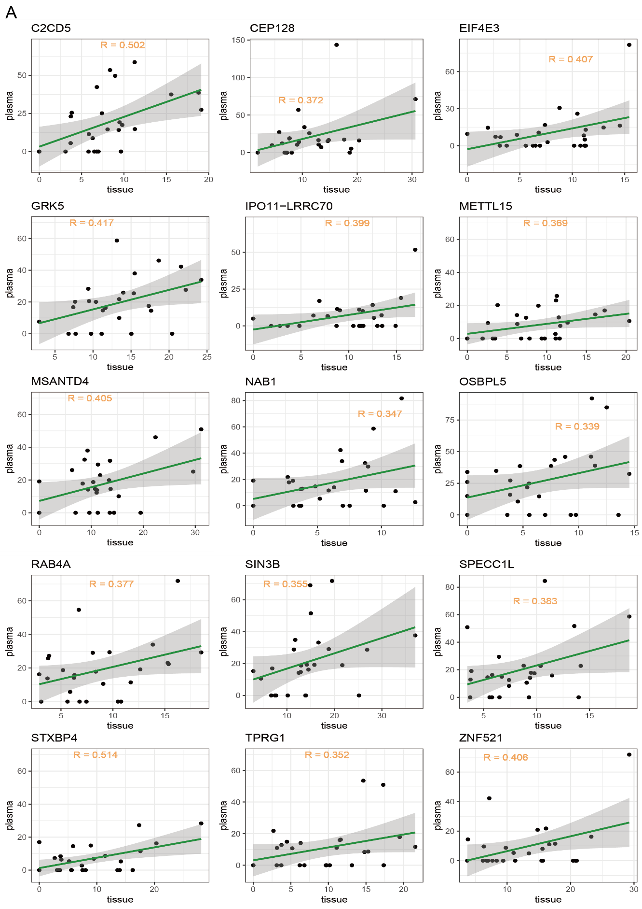
Figure S1. Correlation between some genes expressed by the same markers in plasma and tissues. A. 5hmC markers in plasma cfDNA correlated with 5hmC markers in pathological tissue genomic DNA.
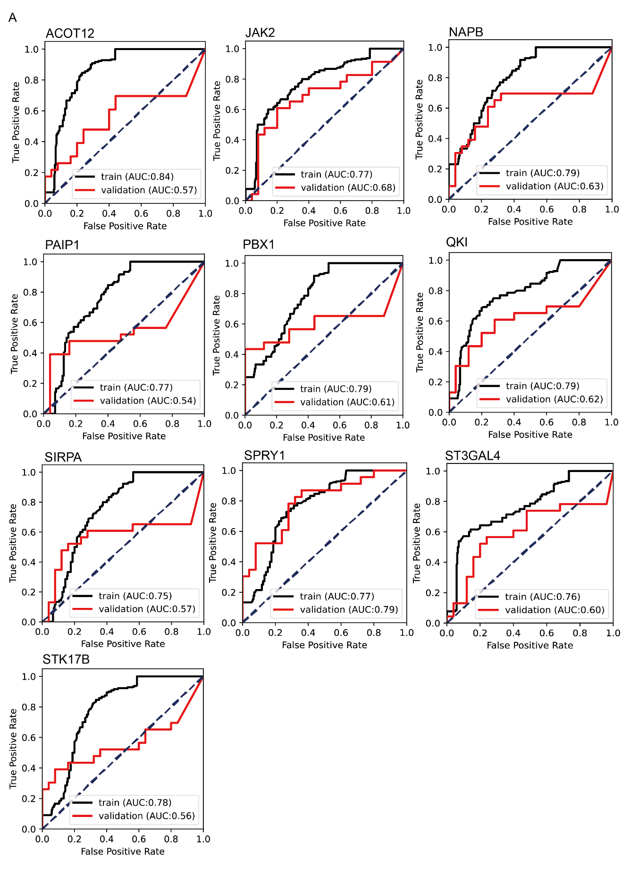
Figure S2. The individual diagnosis performance of each marker in the ten markers in the training and validation cohort. A. Individual ROC curves for each of the ten 5hmC markers in the training and validation cohorts.
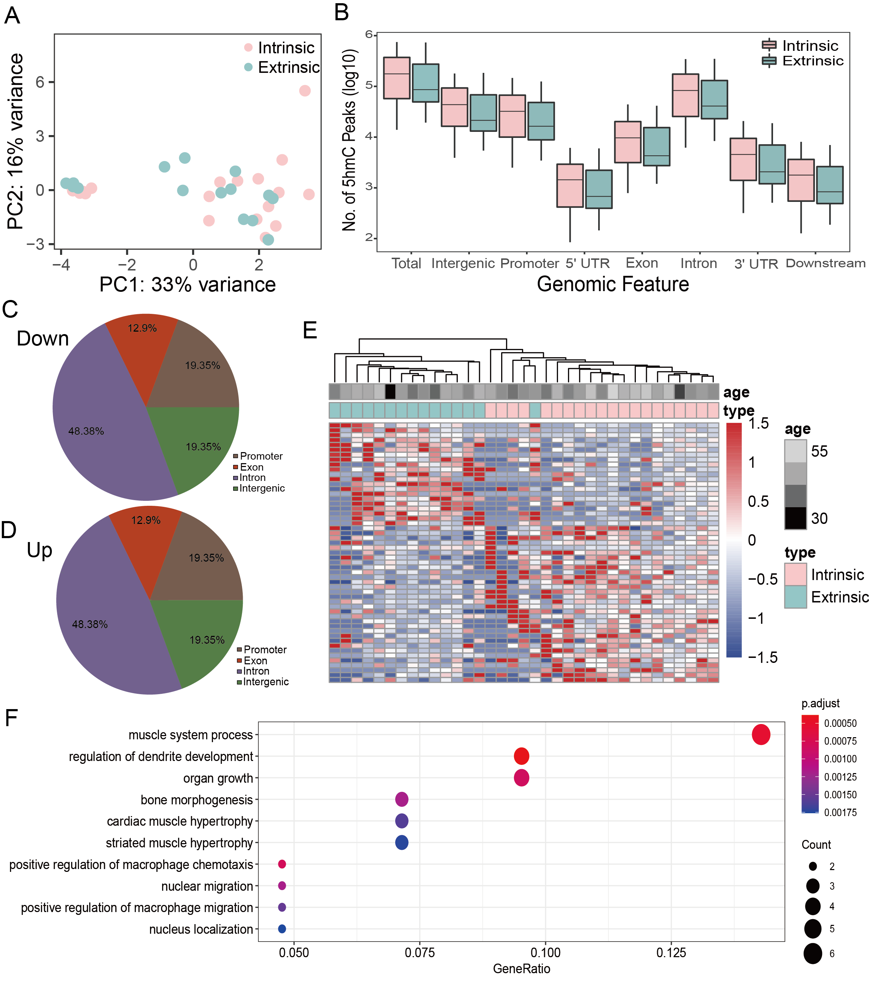
Figure S3. Distribution characteristics of intrinsic and extrinsic plasma of 5hmC in adenomyosis. A. PCA differentiation between intrinsic and extrinsic plasma (extrinsic in blue, intrinsic in pink). B. Genome-wide distribution of 5hmC in different genomic feature groups in cfDNA of intrinsic (n= 20) and extrinsic (n=15) plasma in adenomyosis patients (n= 35). C.D. The pie chart shows the percentage of 5hmC peaks for up-regulated and down-regulated genes in each category of Genomic traits. The Promoter region is defined as 2KB around TSS. E. The top 200 DhMRs (p-value<0. 05 & |log2FoldChange|≥0. 5) (extrinsic in blue, intrinsic in pink) map of 20 intrinsic and heat maps of 23 cases of extrinsic. Unsupervised hierarchical clustering was performed across genes and samples. F. Dot graph for viewing 5hmC markers in GO enrichment clusters.
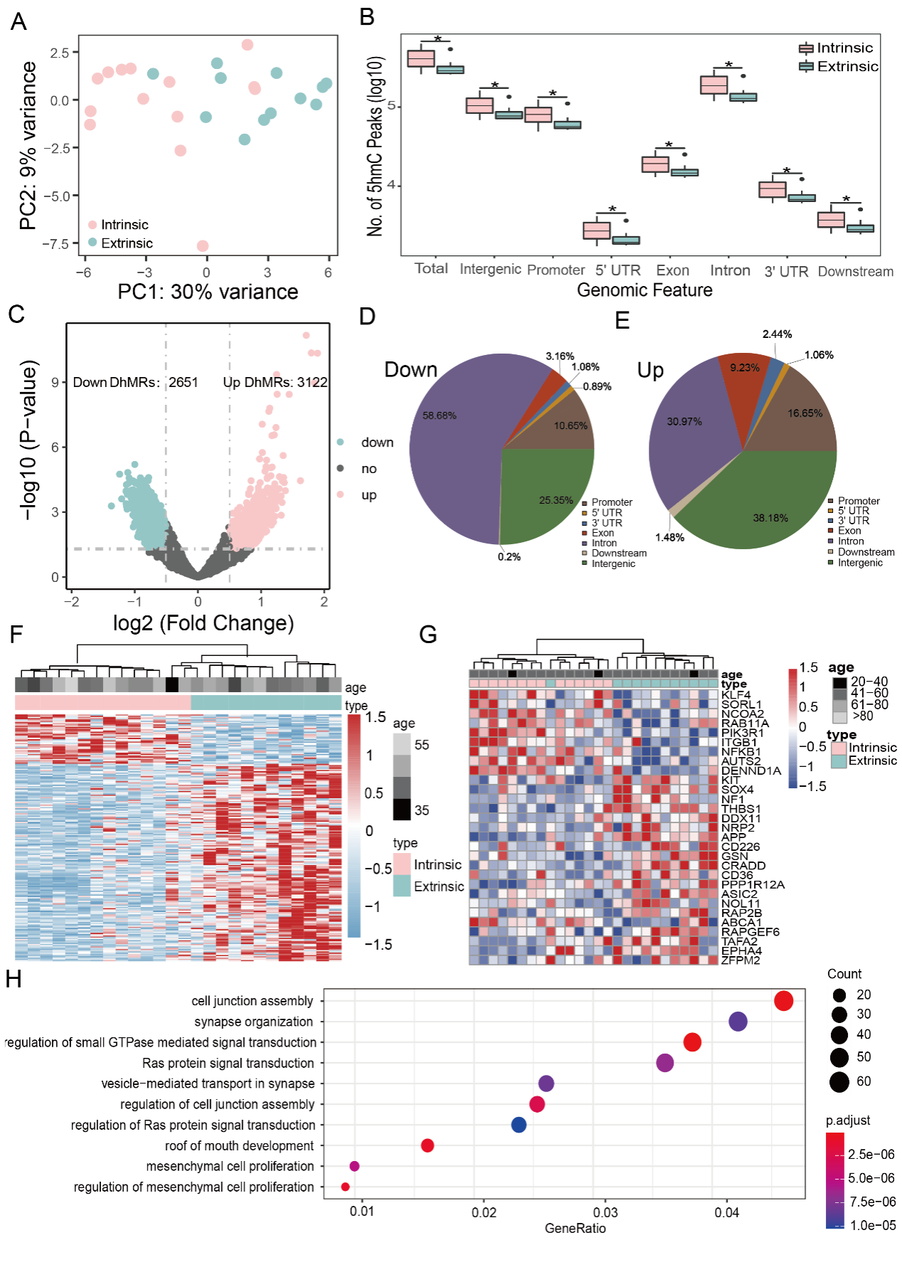
Figure S4. Distribution characteristics of intrinsic and extrinsic 5hmC in adenomyosis tissues. A. PCA differentiation between intrinsic and extrinsic tissue (extrinsic in blue, intrinsic in pink). B. Genome-wide distribution of 5hmC in different genomic feature groups in cfDNA of intrinsic (n= 20) and extrinsic (n=15) plasma in adenomyosis patients (n= 35). C. Volcano map (intrinsic vs. Extrinsic). HMR significantly changed (p-value<0. 05 & |log2FoldChange|≥0. 5) are indicated in pink (up) or blue (down). The black dots represent The HMR with no difference. D.E. The pie chart shows the percentage of 5hmC peaks for up-regulated and down-regulated genes in each category of Genomic traits. The Promoter region is defined as 2KB around TSS. F. The top 200 DhMRs (p-value<0. 05 & |log2FoldChange|≥0. 5) (extrinsic in blue, intrinsic in pink) map of 20 intrinsic and heat maps of 23 cases of extrinsic. Unsupervised hierarchical clustering was performed across genes and samples. G. Based on the differences between 31 gene (p-value<0. 05 & |log2FoldChange|≥0. 5) in 15 heat maps of extrinsic and intrinsic 20 (pink in intrinsic, blue in extrinsic). H. Dot graph for viewing 5hmC markers in GO enrichment clusters.

