Supplementary Information:

Prophylactic domain-based vaccine against SARS-CoV-2, causative agent of COVID-19 pandemic
Mohammad Mostafa Pourseif¹, Sepideh Parvizpour¹, Behzad Jafari^{4,1}, Jaber Dehghani¹, Behrouz Naghili³, Yadollah Omidi^{1,2}*
¹ Research Center for Pharmaceutical Nanotechnology, Biomedicine Institute, Tabriz University of Medical Sciences, Tabriz, Iran
² Department of Pharmaceutics, Faculty of Pharmacy, Tabriz University of Medical Sciences, Tabriz, Iran
³ Research Center for Infectious and Tropical Diseases, Tabriz University of Medical Sciences, Tabriz, Iran
⁴ Department of Medicinal Chemistry, Faculty of Pharmacy, Urmia University of Medical Sciences, Urmia, Iran

*Corresponding author: Department of Pharmaceutics, Faculty of Pharmacy, Tabriz University of Medical Sciences, Tabriz, Iran. E-mail address: yomidi@tbzmed.ac.ir
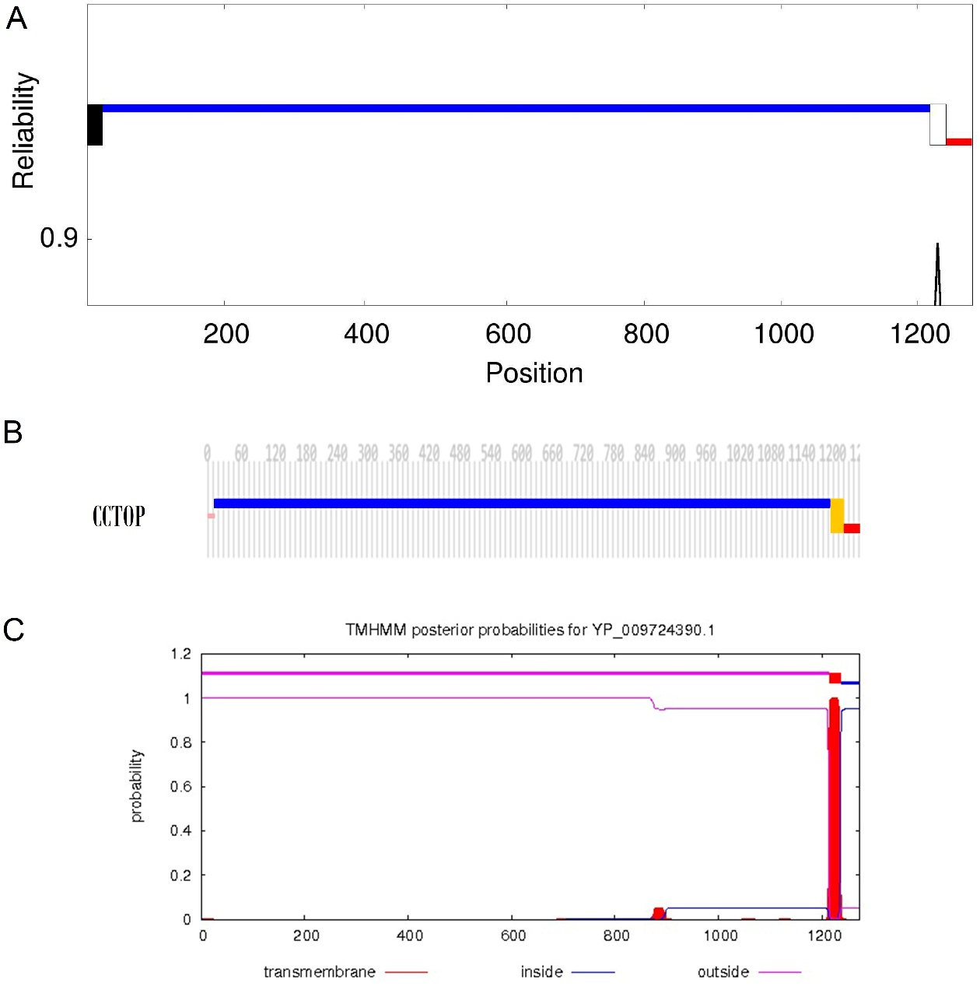
Figure S1. The potential transmembrane topology and signal peptide in the SARS-CoV-2 spike glycoprotein sequence. A) The consensus prediction plot of the potential transmembrane and intracellular regions of the glycoprotein S which is predicted using the TOPCONS server. B) The CCTOP plot shows transmembrane topology of the Glycoprotein S. C) The residue-based topology prediction plot obtained from TMHMM online server.

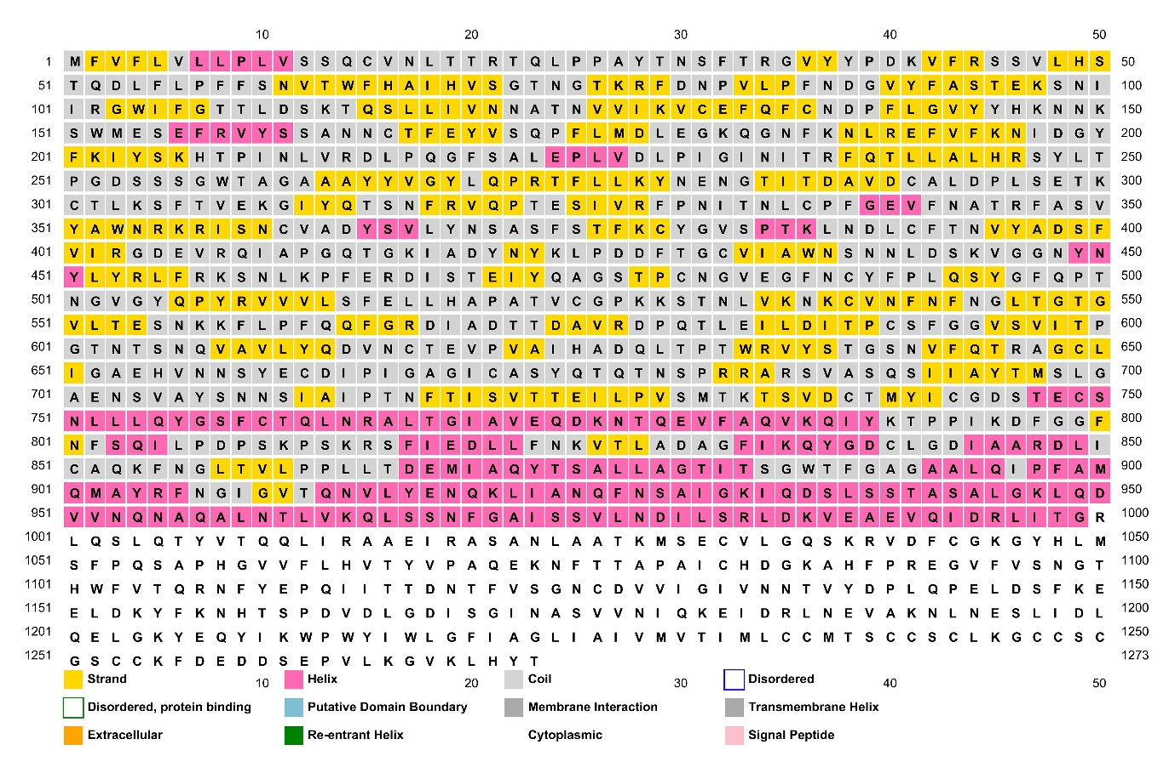
Figure S2. The secondary structure of the reference sequence of SARS-CoV-2 spike glycoprotein.

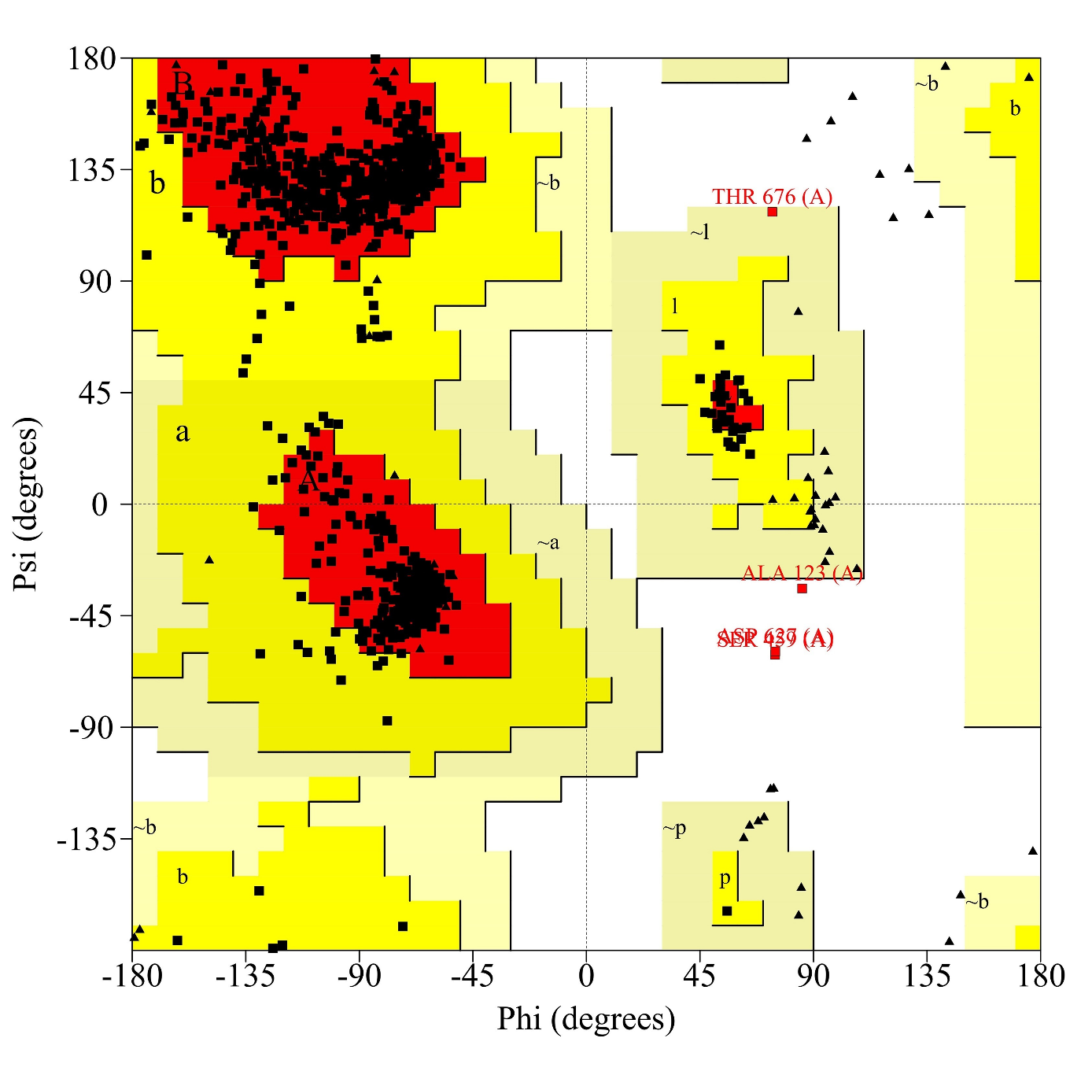
Figure S3. The 3D structure validation of the homology modeled SARS-CoV-2 protein S. Ramachandran plot of the modeled 3D structure. The plot indicates that only three residues (Asp627, Ser459, and Ala123) are located in the disallowed region (marked by a dash dotted circle), while 92.1% of the residues are in the most favorable region, and the rest of them (7.6%) are located in the additionally and generously allowed regions of the map.

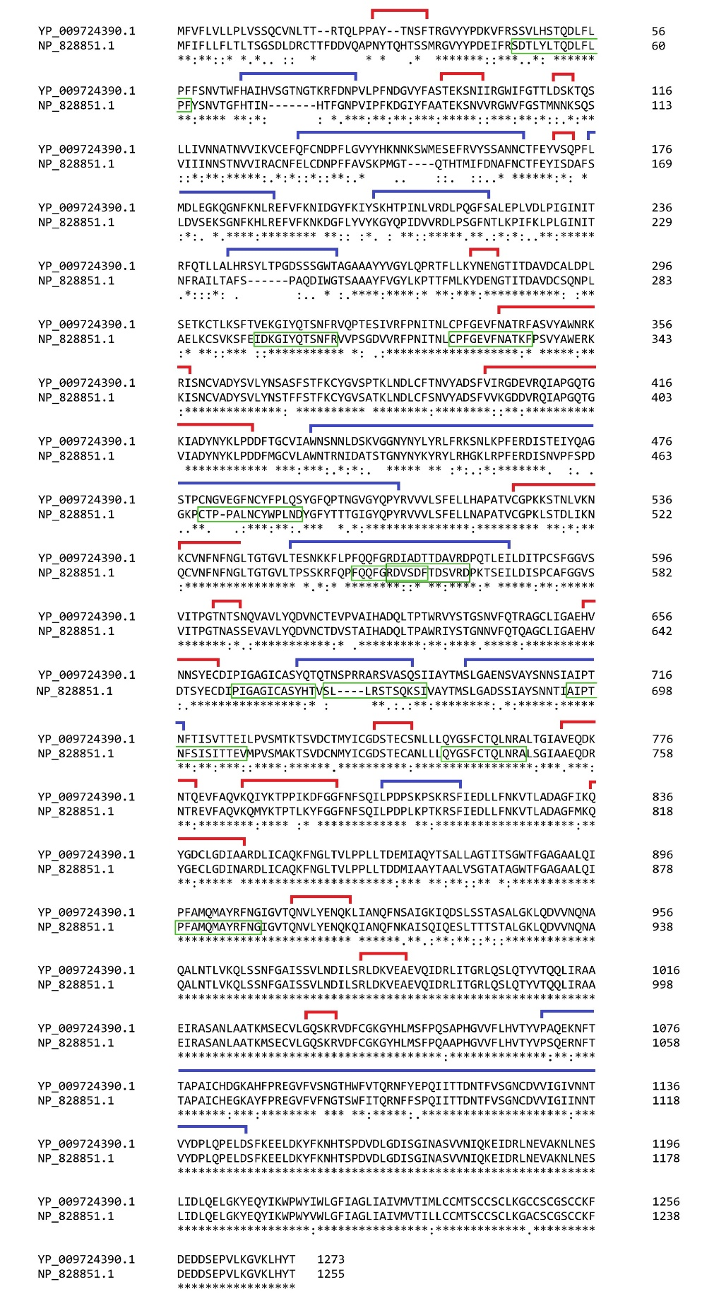
Figure S4. Pairwise sequence alignment of the reference sequences of the spike proteins of SARS-CoV (accession ID: NP_828851.1) and SARS-CoV-2 (accession ID: YP_009724390.1). The sequence alignment performed using Clustal Omega server (https://www.ebi.ac.uk/Tools/msa/clustalo/). Total 28 predicted B-cell epitopes are shown by red lines, and the final dominant epitopes are indicated as blue lines. the residues marked by green line are the membrane peptides of SARS-CoV spike protein recognized in SARS convalescent sera by antibodies to IgG, IgM, and IgA. Identical residues are shown by asterisk.
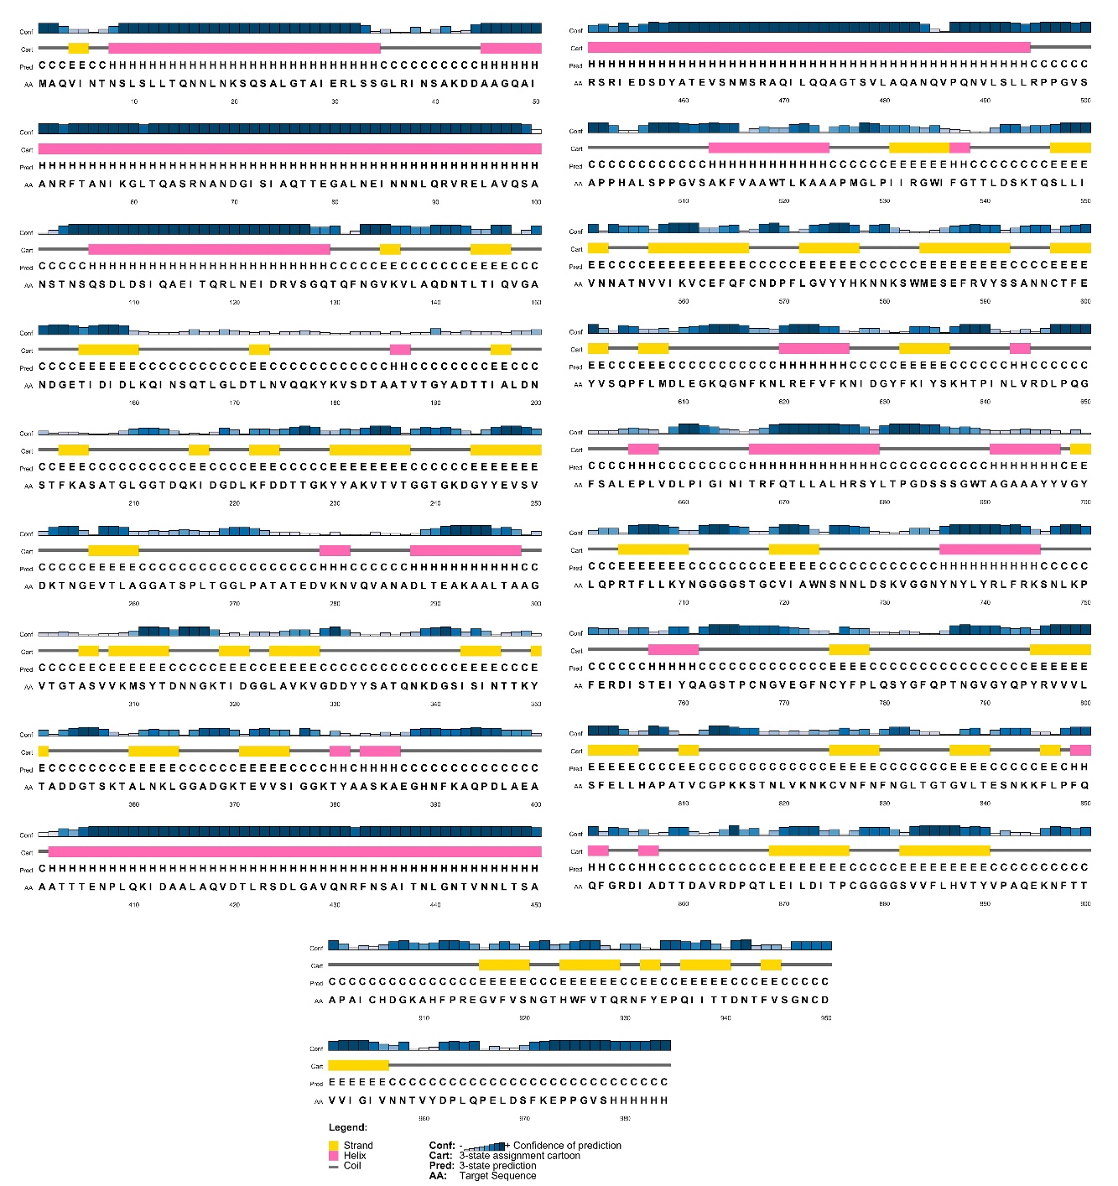
Figure S5. The secondary structure of the designed multi-domain vaccine construct, predicted by PSIPRED web server.

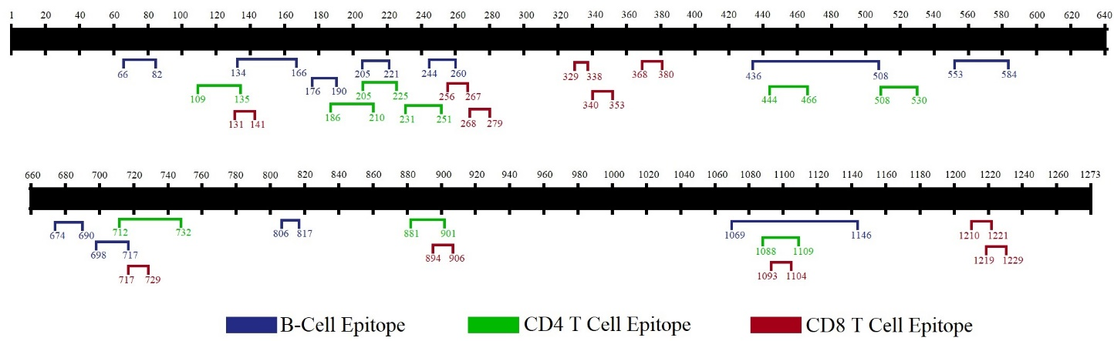
Figure S6. The scaled map shows the position of final chosen immunodominant B- and T-cell epitopes in the spike glycoprotein sequence. We selected three residue fragments as important domains for vaccine design, including I₁₀₀–N₂₈₀, T₄₃₀–C₅₉₀, and V₁₀₆₀–E₁₁₅₀.

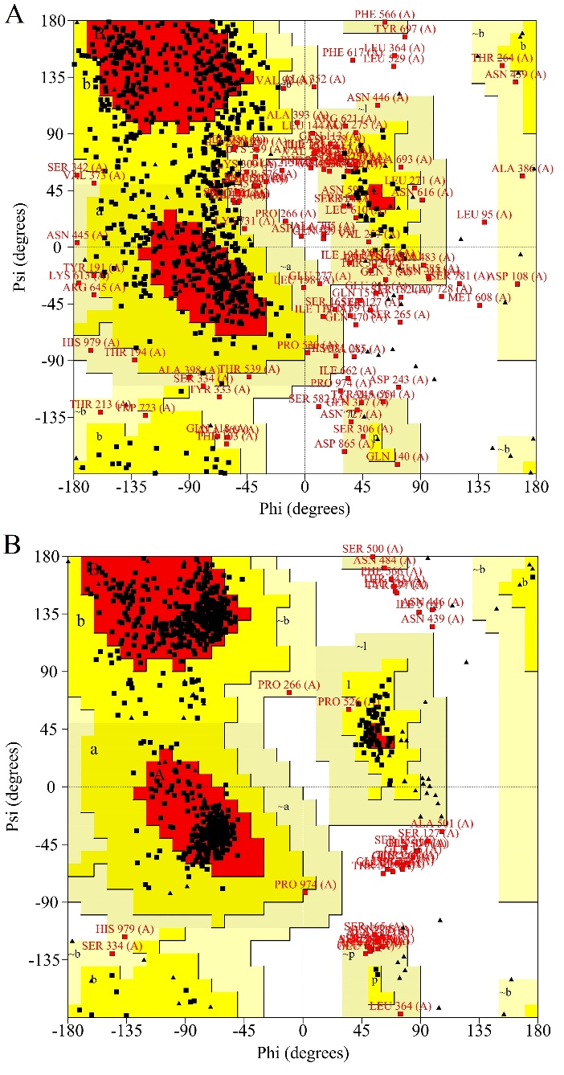
Figure S7. Modeling validation of the 3D structure of the multi-domain vaccine construct. A) The Ramachandran plot of the initially modeled vaccine. The Ramachandran plot indicates 26 residues (3.0%) are located in the disallowed region, while 399 of the residues (46.6%) are in the most favorable region, and the rest of them (50.4%) are located in the additionally and generously allowed regions. B) The Ramachandran plot of the energy minimized vaccine model. The Ramachandran plot shows 23 residues (2.7%) are placed in the disallowed region, while 710 residues (82.8%) are in the most favorable region, and the rest of them (14.5%) are located in the additionally and generously allowed regions.

