Supplementary File 1
Supervision Materials

As described in the Integrated Model for Supervision created by the International Federation of Red Cross and Red Crescent Societies, “Supervision is a safe, supportive, confidential and collaborative relationship between a supervisor and/ or supervisee(s), where supervisees can voice their difficulties, discuss mistakes and be recognized for their successes, receive constructive feedback and emotional support, and build their technical skills and capacity [1].
The model that Australian institutions now predominantly disseminate is based on Competency-Based models of supervision [2]. The program was design to improve key competencies outlined in international psychology professional practice guidelines (IPCP; AHPRA) and humanitarian organisation practice guidelines (IFRC; MSF; GIZ) [3–5], World Health Organisation guidelines (WHO EQUIP and MHGap) and the Interagency Standing Committee Guidelines (IASC) [6] . The key competencies are outlined below.
All supervisors were provided with a handbook to guide their involvement in the program, which is further provided below.

References
1. Perera C, McBride KA, Travers Á, Tingsted Blum P, Wiedemann N, Dinesen C, et al. Towards an integrated model for supervision for mental health and psychosocial support in humanitarian emergencies: A qualitative study. PLoS ONE. 2021;16:e0256077.
2. Gonsalvez CJ, Calvert FL. Competency-based Models of Supervision: Principles and Applications, Promises and Challenges. Australian Psychologist. 2014;49:200–8.
3. Böhm B, Palma M, Ousley J, Keane G. Competency-based mental health supervision: evidence-based tool needs for the humanitarian context – ERRATUM. Glob Ment Health (Camb). 9:249.
4. PS Centre Competency Framework for Psychosocial Support Delegates in Emergencies - Psychosocial Support IFRC. 2016. https://pscentre.org/?resource=competency-framework. Accessed 15 Sep 2023.
5. German Cooperation Deutsche Zusammenarbeit. Recommendation Paper on Training and Capacity Development in Mental Health and Psychosocial Support (MHPSS) in Development Cooperation As Exemplified in the Context of the Crises in Syria and Iraq. 2019.
6. IASC Guidelines on Mental Health and Psychosocial Support in Emergency Settings, 2007 | IASC. https://interagencystandingcommittee.org/iasc-task-force-mental-health-and-psychosocial-support-emergency-settings/iasc-guidelines-mental-health-and-psychosocial-support-emergency-settings-2007. Accessed 15 Sep 2023.

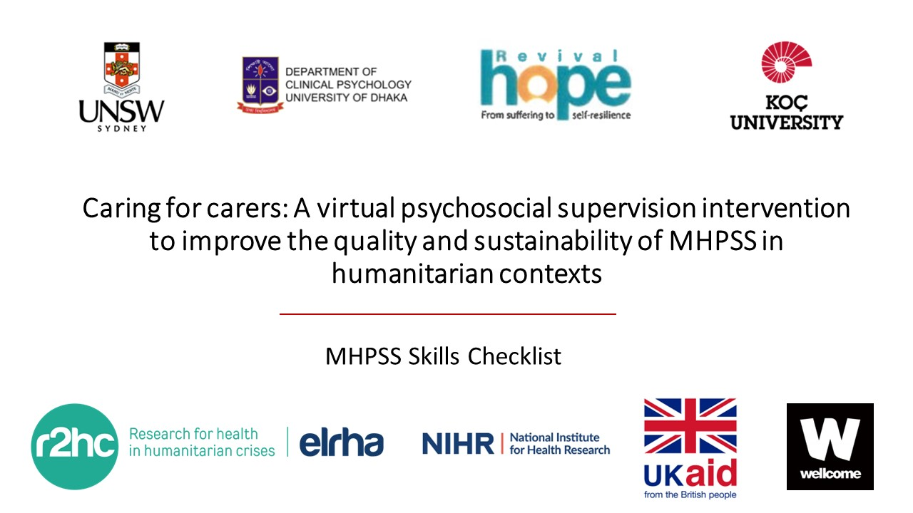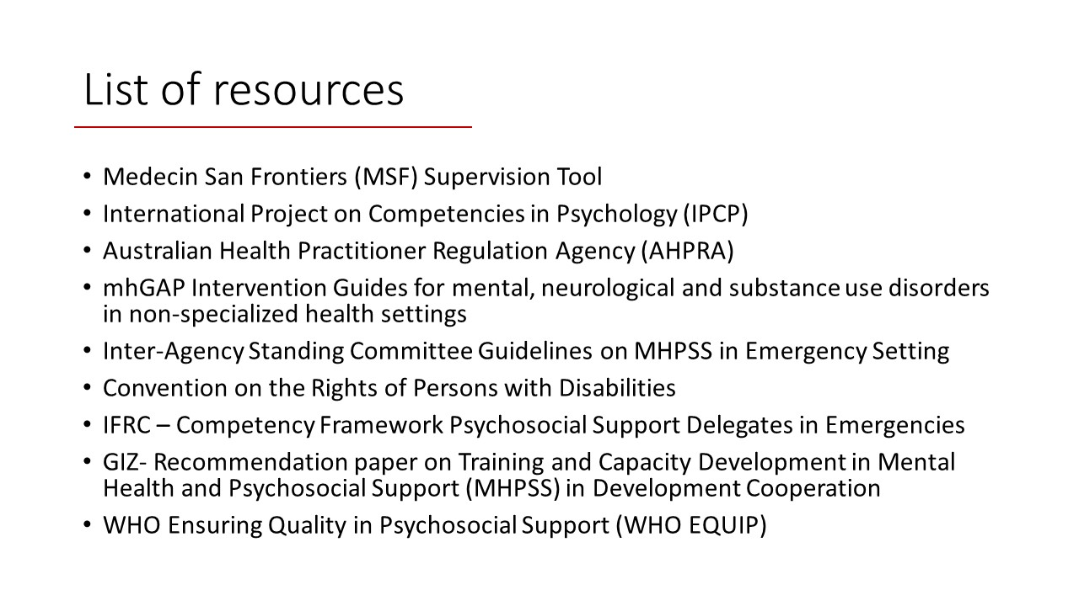
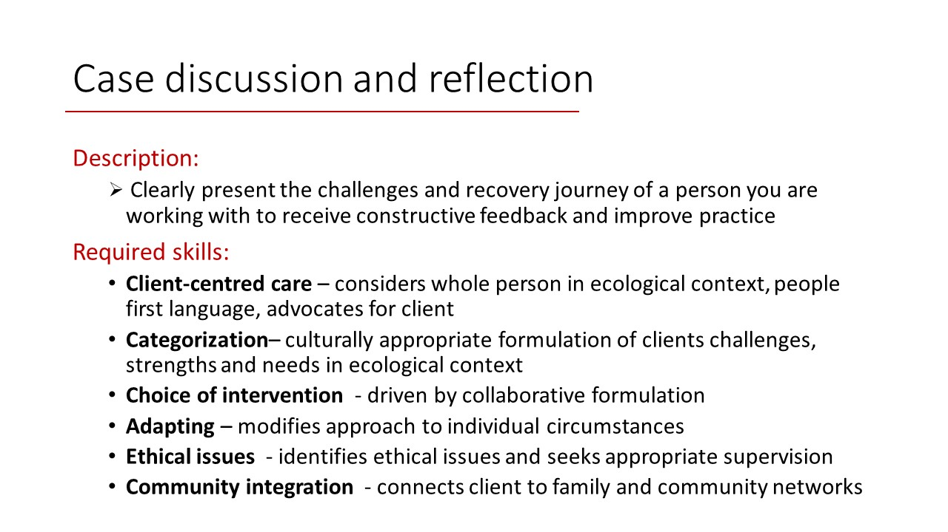
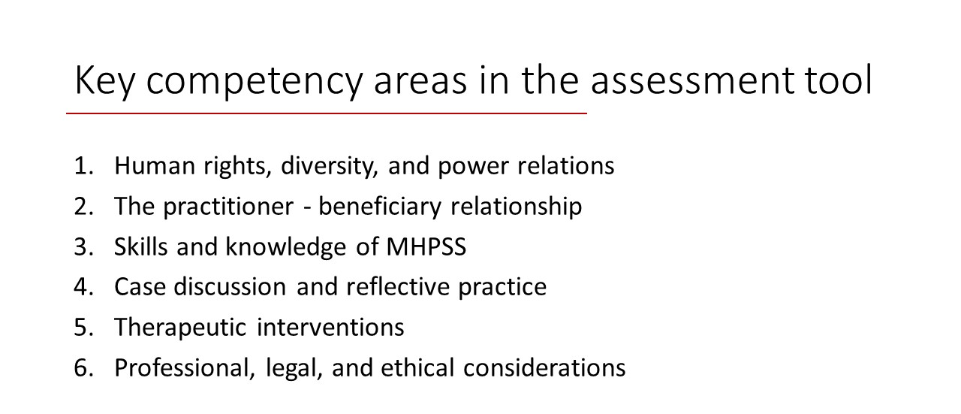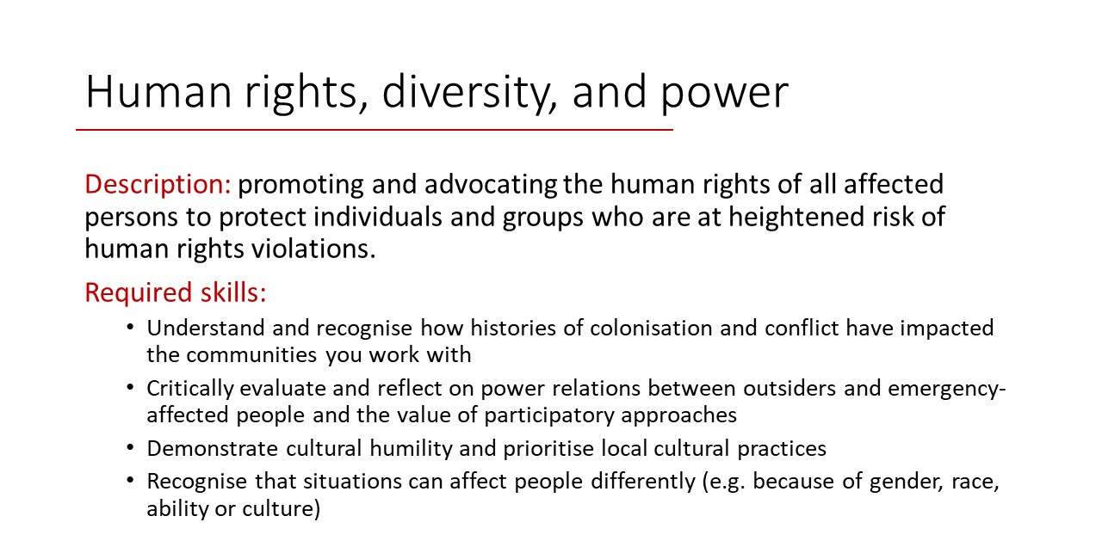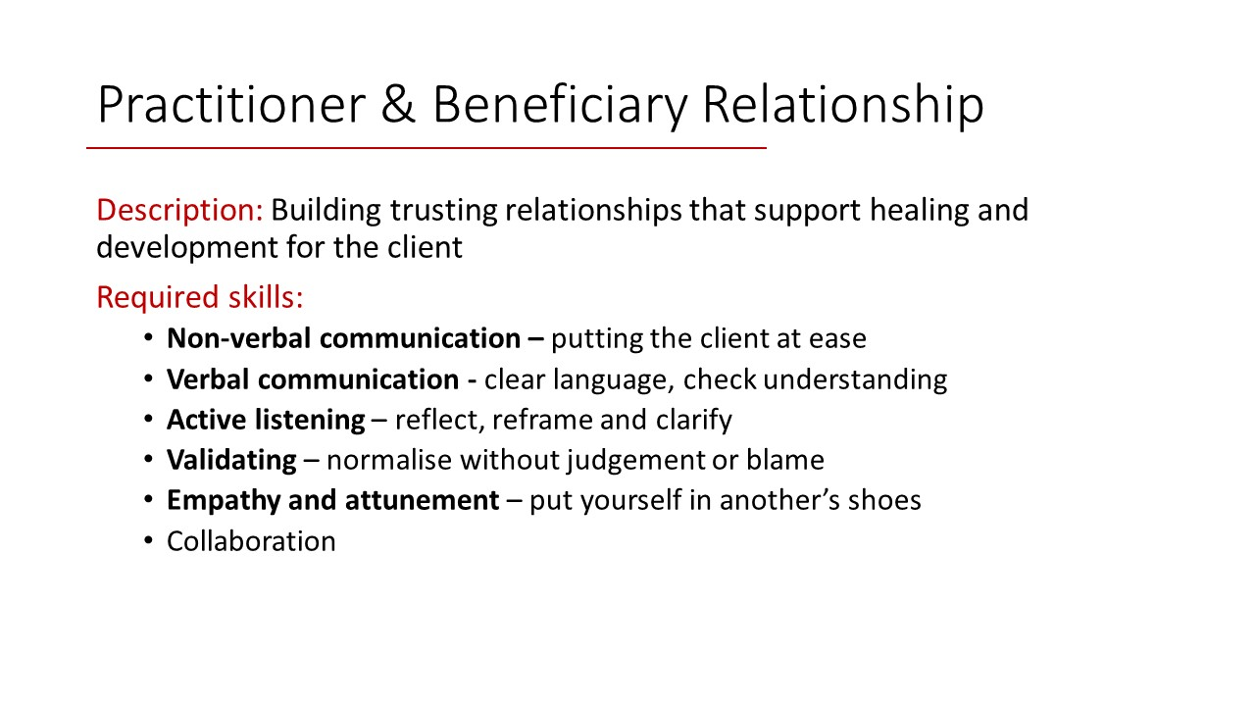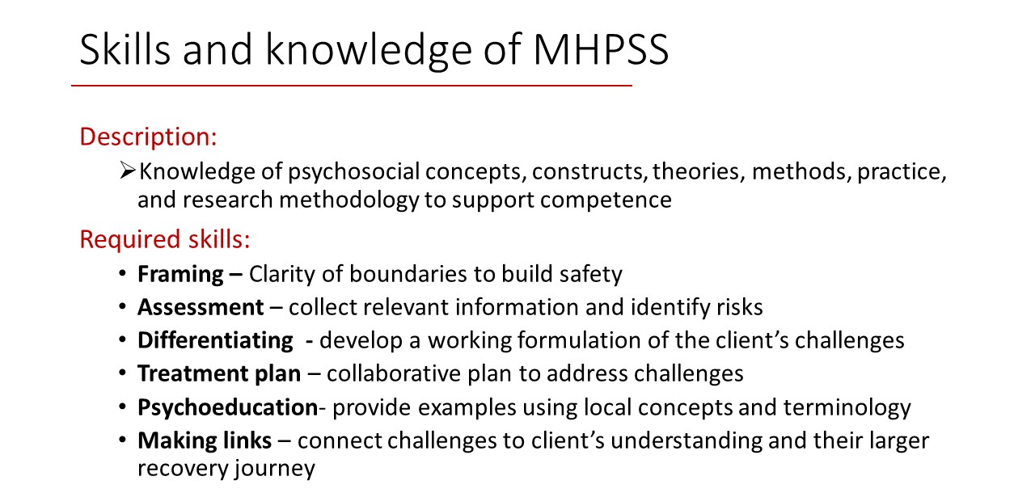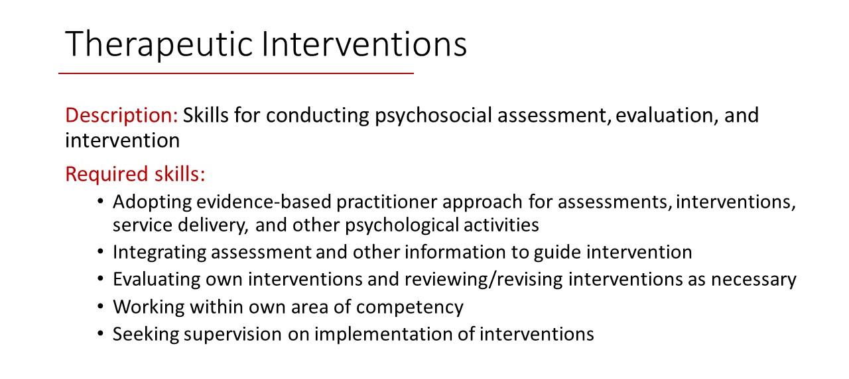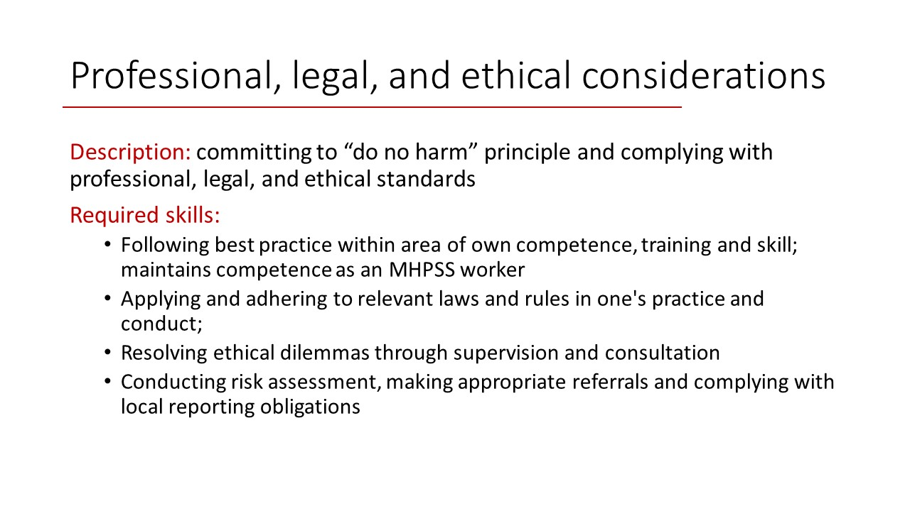

CARING FOR CARERS: A PSYCHOSOCIAL SUPERVISION INTERVENTION FOR MENTAL HEALTH PRACTITIONERS


SUPERVISOR HANDBOOK

Preface

This handbook was prepared to provide guidance to the local and international supervisors to help them with group supervision facilitation. Although this book summarizes the key points and gives a list of useful documents for supervision, it does not aim to provide exhaustive information or guidance to the supervisors. We rely on the ever-changing relationship dynamics between and experiences of supervisors and supervisees in this exciting journey.

The following members of the Caring for Carers Project contributed to preparing the handbook. Please do not share with anyone outside the group until the supervision program is completed.

Scarlett Wong, scarlett.wong@unsw.edu.au
Ruth Wells, ruth.wells@unsw.edu.au
Salah Lekkeh, salah.lekkeh@hope-revival.ngo
Gülşah Kurt, g.kurt@unsw.edu.au

Our partners:
University of New South Wales, Sydney Australia
Koc University, Istanbul, Türkiye
Hope Revival Organization, Gaziantep, Türkiye
Dhaka University, Dhaka, Bangladesh


Our funding agencies:
This project is funded by Elrha’s Research for Health in Humanitarian Crises (R2HC) Program, which aims to improve health outcomes by strengthening the evidence base for public health interventions in humanitarian crisis. R2HC is funded by the UK foreign, Commonwealth and Development Office (FCDO), Wellcome, and the Department of Health and Social Care (DHSC) through the National Institute for Health Research (NIHR). The funding body had no role in the conceptualization; writing of this handbook; or the decision to submit the handbook for publication.

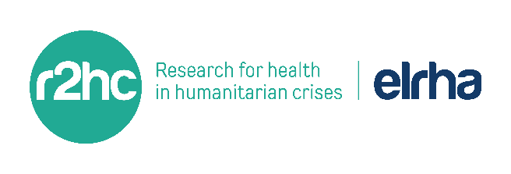



Contents
1. POCKET SUMMARY 4
1.1. Checklist 4
1.2. Key Points 4
2. GUIDED CO-SUPERVISOR CONVERSATION ON ZOOM 5
2.1. Areas to cover: 5
3. OVERVIEW OF PROGRAM STRUCTURE 6
3.1. Pre-Supervision Program Resources 6
3.2. UNSW Badge and Requirements 6
3.3. CANVAS Platform 6
3.4. Integrated Model for Supervision Handbook Chapters 7
4. CONTEXT AND BACKGROUND 8
4.1. Türkiye 8
4.2. Northwest Syria 8
5. INTRODUCTION TO GROUP SUPERVISION 10
5.1. What constitutes ‘supervision’ in this program? 10
5.2. First 1-3 Sessions 11
5.4. Group Supervision Structure – Suggestions 12
5.5. Co-Supervision Ideas 14
6. SUPERVISION CONTRACT SAMPLES 15
6.1. Sample 1 15
2. Sample 2 19
7. CASE PRESENTATION SAMPLES 21
7.1. Sample 1 21
7.2. Sample 2 22
8. PRACTITIONER COMPETENCY TOOL 22
9. SUPERVISION ALLIANCE STRATEGIES 23
9.1. Supervision Alliance Scale 23

1. POCKET SUMMARY

Checklist

- Have we done the Co-Supervisor Guided Conversation?
- Have we discussed the structure of the first 1-3 sessions?
- Have we agreed on Roles and Responsibilities as Co-Facilitators?
- Have agreed on the Templates we want to use?
- Have we discussed Group Rules and Group Contract?
- Have we agreed on feedback for each other and feedback from the group?
- Have we agreed on how to get supervision alliance feedback?
- Have we discussed Risk and Ethic-legal issues and how to manage this?

Key Points

- Co-Supervisor Relationship:
  - Take time to get to know each other and discuss how you want to co-facilitate a safe and effective Group Supervision Space
- Group forming and norming:
  - Will take 1-3 sessions
- Group Supervision Structure Suggestions:
  - Box of Chocolates
  - IMS Handbook
- Feedback Strategies:
  - One word, One sentence, Supervisor Alliance Scale
- Templates:
  - Practitioner Competency Self-Assessment Tool,
  - Supervision Alliance Scale,
  - Case Presentation Template

GUIDED CO-SUPERVISOR CONVERSATION ON ZOOM

Introduction: In the lead-up to the commencement of the Supervision Program, here are some conversation topics that might be helpful to discuss:

- Organise a time before the supervision session begin to meet with your translator to discuss the topics below
- Remember to Press Record on this Zoom Meeting!
- Please reflect on how many meetings you have had prior to this meeting and in what form (WhatsApp, Zoom, etc.)

Areas to cover:

- Therapy Preference:
- What kind of intervention, counselling model, technique, or strategies do we usually prefer in counselling?
- If our backgrounds and approaches are different, how will we manage our different approaches in supervision?

- Structure and Process:
- How can we structure and/or share the roles in Group Supervision?
- If unsure, you can use the handbook for some ideas about co-facilitation and group supervision structures
- How will we know if there is an issue with supervision?
- How will we communicate with each other if we need to discuss an issue or challenge about the group?
- What are the needs of the translator, how do they want us to work together?

- Getting to know each other:
- What are we curious about or would like to know about each other?
- What do we both think are the qualities of a good supervisor? And a not so good supervisor?

- Needs:
- What information, help, or support do we both need, and how can support each other to achieve this?

- How do we each feel about supervising in this program?

OVERVIEW OF PROGRAM STRUCTURE

Pre-Supervision Program Resources

MHPSS practitioners have been provided with resources on key areas of clinical practice such as human rights, counseling skills and relationships, and ethical issues. Written materials (e.g., journal articles and policy reports) were selected and then translated into Arabic and Bangla.

You can find all these materials on the CANVAS course site (see below for information about CANVAS). They are organized under the headings:
    - Human rights, diversity, and power
    - Practitioner–beneficiary relationship
    - Skills and Knowledge of MHPSS
    - Case Discussion and reflection
    - Professional and Ethical issues

UNSW Badge and Requirements

Practitioners participating in this program are offered access to UNSW Medicine Short Courses so that they can receive official accreditation of their learning. People who complete the short course will be able to get a micro-credential, which is like a university subject completed outside the structure of a degree. These courses can be counted towards a future degree – although access to a full degree is extremely unlikely for many of the people enrolled in this program because of their refugee status and the huge barriers that exist to migration for our colleagues. This micro-credential is a rare opportunity for them to receive official recognition from an international university. They will receive a digital badge which they can put on their LinkedIn on their CV.

CANVAS Platform

You will receive an invitation to log into CANVAS (the online platform for the course), where you will find all the information that the students receive, as well as the links to the zoom meetings for your supervision sessions and online discussion boards for your group. Research assistants will share the link for navigating in CANVAS. This short video will guide you through the CANVAS platform and show how to use it as a course registrar.

You can log into CANVAS here and the course outline here.

The main points you need to know each practitioner is required to:
- complete a case presentation during a supervision session
- upload their completed case template at least three days before their presentation
- submit a completed supervision and clinical practice log of their hours of supervision and supervised practice.

Note: Syrian co-supervisors will also be offered this micro-credential, which means they will also need to complete a case presentation.

Integrated Model for Supervision Handbook Chapters

We are happy to share with you the Integrated Model for Supervision (https://pscentre.org/?resource=integrated-model-for-supervision&selected=single-resource) developed by the International Federation of Red Cross Red Crescent Societies. This is the first resource about supervision developed specifically for humanitarian settings and addresses a significant gap in the field.

This document is extremely helpful because it provides an introduction to supportive supervision for supervisors, organisations and supervisees. Most organisations and practitioners working in MHPSS in humanitarian settings have no or very limited experience with clinical supervision. Often the concept is confused with management supervision, so there is a lot of work to be done to help everyone understand the purpose of supportive supervision, which is focused purely on wellbeing and clinical development. It also provides a great framework for practitioners to help them understand what to expect in coming into supervision.

We suggest using this framework as a jumping-off point for coming to a shared understanding with your group.

Chapter 3 provides a basic background for running supervision, including many concepts you are likely very familiar with.
Chapter 4 is the section we have translated and shared with the supervisees. You can draw on this chapter to introduce topics such as case presentations, reflective practice and making use of feedback.

Of course- you will have your own style for supervision which we encourage you to use. We also hope that this framework provides some consistency across groups to help supervisees as they work through uncertainties in building trust in their new groups.

4.CONTEXT AND BACKGROUND

We have prepared a series of videos which aim to introduce you to the contextual information you will need to help you understand the context in which these clinicians work. We will continue to share resources with you to support development of cultural competence and help answer the questions which we are sure will come up for you.

We are also happy to meet with you if you need to discuss the complexities of working with people in these humanitarian crises – so please don’t hesitate to reach out if you have any questions.

4.1. Türkiye

Currently, Türkiye hosts the largest number of Syrians, with 3.7 million. More than 98 percent of Syrians live in the cities, mainly in Istanbul, Turkey¹ (United Nations High Commissioner for Refugees, 2022). They are given a legal status called “temporary protection status,” which provides them access to basic services such as employment, education, and health. Despite this status, Syrian refugees are likely to experience a multitude of socio-economic (e.g., language barrier, discrimination, social isolation) and structural stressors (e.g., not being recognized as a refugee and difficulties with the asylum process) in daily life, all of which adversely impact their mental health^{2,3} (Acarturk et al., 2021; Kurt et al., 2022). Considering conflict and displacement-related stressors, mental health problems are highly prevalent among Syrians. Almost half are at risk of developing depression, anxiety, or posttraumatic stress disorder³ (Kurt et al., 2022).

4.2. Northwest Syria⁴

About 4.5 million are living in NWS, among them are 2.8 million IDPs. In other words, 20% of the Syrian population are living in an area that is less than 11% of the Syrian Arab Republic lands, in which MHPSS practitioners in NWS are striving to provide their services within this area with limited resources and capabilities, in line with the constant hostilities.

The majority of MHPSS interventions in NWS are sorted in the second and third levels (focused non-specialized) of the IASC Pyramid of MHPSS interventions, and the majority of MHPSS practitioners work as psychosocial support workers (PSW), which is a unique job title set by Syrian MHPSS specialists in the context of NWS, after developing a manual in 2017 dedicated to the rehabilitation, training, and supervision of these PSWs at the level of focused non-specialized interventions. The number of these workers at the beginning of 2022 was about 308 employees working in almost 15 organizations.

Given that the available psychiatrists and psychologists are very few in NWS, there are 2 specialized psychiatrists and 8 resident psychiatrists who have not completed their specializations yet, besides the availability of 25 to 50 clinical psychologists. The WHO developed the mhGAP Manual to scale mental health services in non-specialized health settings to achieve universal health coverage. In this context, almost 100 mhGAP practitioners provide psychotropics for the most common mental disorders listed in the mhGAP program, where WHO provides essential psycho-drugs to the organizations working in the MHPSS field in NWS according to the availability of funding sources or the active MHPSS projects.

Regarding clinical supervision, many initiatives have been launched, especially by the WHO, to provide supervision for both the mhGAP program, problem management plus (PM+), and the health and MHPSS workers after receiving suicide management training. Whereas the most important initiative to improve the supervision capacity, was launched by the German International Cooperation Agency (GIZ) through a training program lasted for two years from 2019 to 2020 to prepare 20 Syrian qualified supervisors, besides launching another training program in 2021 to qualify 20 new supervisors, and it is still ongoing.

The majority of MHPSS practitioners are working in primary health care centers, hospitals, community centers, or in mobile clinics that visit IDPs, while residents and specialized psychiatrists are working in specialized MHPSS centers or Hospitals. PSWs are providing group awareness sessions on MHPSS topics, mental disorders, and some group PSS programs for children and adults, in addition to conducting outreach visits to IDPs communities and homes to assess their cases, provide psychological first aid and psychological counselling, referral to the necessary required MHPSS services, where available, while following up on the cases that need psychotropics, in addition to providing counselling according to the PM+, which they were already trained on.

It is worth noting that most of the PSWs are graduated from the faculties of education, psychological counselling, or psychology, whereas the others are graduated from universities or other intermediate institutes. Taking into consideration that only graduates of psychology or psychological counselling are eligible to work as psychologists.

Quotes from MHPSS practitioners:
- A psychological counselor in the countryside of Aleppo said, "Here, none of the specialists in psychological counseling and psychology has attended accredited training in a specific clinical field and completed a full supervision period!"
- “Being a PSW, is being a humanitarian worker in the first place. Consequently, my job is to raise awareness about issues related to MHPSS, such as diseases, disorders, and problems... I help people to access services... I help patients by applying the techniques I learned before to help them adapt positively. The most important characteristic of my work is my commitment to the principles of confidentiality, privacy, respect, discrimination, and equality.”
- My role is to provide support and assistance to people, help them to recover and enhance their ability to cope positively with difficult and new situations and provide group psychoeducation sessions to the community to raise their awareness about MHPSS issues.

¹United Nations High Commissioner for Refugees. (2022). UNHCR Turkey Bi-Annual Factsheet, https://www.unhcr.org/tr/en/factsheets-and-dashboards
²Acarturk, C., McGrath, M., Roberts, B., Ilkkursun, Z., Cuijpers, P., Sijbrandij, M., ... & Fuhr, D. C. (2021). Prevalence and predictors of common mental disorders among Syrian refugees in Istanbul, Turkey: a cross-sectional study. Social psychiatry and psychiatric epidemiology, 56(3), 475-484.
³Kurt, G., Ventevogel, P., Ekhtiari, M., Ilkkursun, Z., Erşahin, M., Akbiyik, N., & Acarturk, C. (2022). Estimated prevalence rates and risk factors for common mental health problems among Syrian and Afghan refugees in Türkiye. BJPsych Open, 8(5), e167.
⁴World Health Organization. (2021). NW Syria MHPSS Mapping October-December 2021. https://app.powerbi.com/view?r=eyJrIjoiNTMwNjY0N2MtODE0Ni00N2JmLWEwYzEtYTM5ZjNmOGRjYTZjIiwidCI6ImY2MTBjMGI3LWJkMjQtNGIzOS04MTBiLTNkYzI4MGFmYjU5MCIsImMiOjh9

5.INTRODUCTION TO GROUP SUPERVISION

5.1. What constitutes ‘supervision’ in this program?

Reflect on supervision you may have had.... it probably involved bringing up some issues you had with delivering and intervention or therapy technique, difficulties regarding your relationship with your patient/client/beneficiary, questions about why patients/clients/beneficiaries are not improving, ethical issues. Similar things will be brought up in this supervision program as well.

There will also be thing you may not be accustomed to. In some cultures, supervision is more didactic or about teaching. Also in some cultures, it is not as safe to show vulnerability, particularly in a group setting. It is also not always usual to be asked reflective questions.

Also, sometimes the supervisees will be psychosocial workers and not qualified psychologists or not allowed to work in the role of a psychologist. As such, it’s good to be clear with the supervisees about what they need from supervision and what is within their scope of responsibility.

Sometimes, supervision may involve sharing resources that you know about or demonstrating how you do certain types of techniques. It’s not uncommon for supervisees in other contexts with limited resources and access to training to ask for training on treating conditions, e.g., Trauma therapy. It’s ok to say upfront your experience and modalities that you feel confident working with. You can help and suggest information and send them links or articles you know about. In these contexts, they often do not have as much awareness due to the limited translated resources internationally.

Your role as Supervisor can involve:

  - Facilitating safety in the group
  - Reminding the group of respectful communication, rules, etc.
  - Prioritising the needs of the presenter during Case Presentation sessions
  - Directing “traffic.”
  - Being aware of members who may not have as much “airtime” and supporting them to participate if needed
  - Guiding discussions that are difficult
  - Giving reflections about the process when appropriate
  - Bringing your skills, expertise, and knowledge when there is a clear absence and need for your input
  - Using your wisdom and experience to support Group cohesion and safety
  - Keeping boundaries, like time management, topics that are able or not to be discussed, rules, etc

5.2. First 1-3 Sessions

In the lead up to beginning the supervision program, you will have hopefully met with your co-supervisor on-line a few times, had discussions on WhatsApp and gone through your guided conversation.

Now you are ready to meet your group and begin group Supervision!

The first few sessions are very important in establishing the norms, safety, structure and processes of the group. Given there are different cultures, languages, experience, exposure to group supervision, technical difficulties etc it will take time and patience to develop a relationship and understanding. In the first few sessions we suggest considering:

- Ice breaker and getting to know your activities
  - E.g., Go around and introduce self, one thing interesting about yourself, your favourite food
- Discussing and agreeing on the Group Supervision Contract (see Supervision Contract Samples for topics to consider)
- Discuss Goals
  - Individual and Group goals
- Group Rules
  - Safety
  - Confidentiality
  - Respect
  - Timeliness
  - Others?
- Discuss with the Content and structure of Group Supervision
  - E.g., cases for sessions 3-11, and then counselling skills for session 12-16
  - “Box of Chocolates” approach (see Group Supervision structure example)
- Go through a Case Template and Case Presentation example
  - Talk through and show the group how to present a case presentation
  - Encourage them to submit the case template to CANVAS at least 2 days prior to supervision in their chosen language so that you can put it into Google Translate if you need to
  - Reassure the group that they only need to fill out a few words for each section, and to spend no more than 15 minutes introducing the case so that all the time can be spent on receiving the support needed in the session
- Feedback and Alliance
  - Discuss ways that feedback can happen
  - E.g., You might give them 10 minutes at the end of the session to discuss:
    - 1 word to describe how you’re feeling
    - 1 sentence to describe anything new you’ve learned or thought about today
    - Fill out the anonymous Supervisor Alliance Scale for you as co-supervisors to discuss briefly after the session to improve or change future sessions
  - Email or WhatsApp for personal issues if necessary if you are ok with this

- Risk and Safety
  - In your Group Supervision contract conversations, you may consider discussing what to do if there is a risk or safety issue relating to themselves or a beneficiary. There is no one size fits all response, but in general, risk and ethic-legal issues should be resolved within the appropriate channels within the organisation the practitioner is a part of. However, Group Supervision can be used to discuss how to find the appropriate channels, role play or brainstorm ideas.

5.4. Group Supervision Structure – Suggestions

As you may know, there are pros and cons to Group Supervision compared to Individual Supervision. The pros include efficiencies of scale when there are limited resources, more ideas and sharing of resources when learning from others, support and normalisation of difficulties. The cons include less tailored individual time spent on individual difficulties and unsafe or unhelpful group dynamics.

A major benefit of group supervision relevant to cross-cultural contexts, especially when the supervisors are not so experienced with the clinical presentations in context, is that we can draw on the collective wisdom of the group t.

However, too often, if not well facilitated, the presenter can take the entire time just presenting the case, with no time to hear feedback or have their needs met for supervision. The idea of this structure below is to support the needs of each presenter each week. Ideally, one case is presented each week only.

The suggested structure is the “box of chocolates” structure for case presentations:

- Supervisor A asks the Practitioner to briefly summarise the case (that they have already emailed or WhatsApped to the group) - 15 minutes
- Supervisor A asks Presenter something like: “what are your needs for today” or “where are you stuck, needing more thinking space”....
- Supervisor A asks each group member for clarifying questions, about the case to help them to form their answer. Presenter answers (15 minutes)
  - Genuine questions not hidden directions, e.g, try to avoid asking, “why didn’t you try CBT”
- Supervisor B is supporting with noticing questions, reminding about slowing down for translation, supporting requests by the group in the chat or the translator, noting the time, giving any reflections or support to Supervisor A, and noting down any suggestions for future learning/training, taking minutes if necessary
- Supervisor B then asks everyone to think for a few minutes to write down some thoughts
- Supervisor A then asks for a Round of Reflections:
  - “let’s go around and each of us to offer a reflection or thought”
  - “Remember, Presenter is asking for ___________ (remind of the stated need they said at the beginning)”
  - Each member, including Supervisors, offer a reflection
    - e.g. ‘I was wondering about whether this might be linked to the practical situation and their sense of security in their currently living situation, rather than your ability as a therapist’...
- Supervisor B then suggests a few minutes for Presenter to think and reflect
- Supervisor A then asks the Presenter, which offerings, or reflections would they like to comment on, or if any reflections or offerings helped to spark new thinking (like a box of chocolates, each reflection is uniqiue and helpful, and the presenter may want to choose one right now to pursue or that has triggered something for them to work with)
- Presenter discusses any new thinking
- If there is enough time, Supervisor B can let Supervisor A know that there is time for another round of reflections, based on what the presenter has said,
- Supervisor A asks Presenter to ‘tie down any main reflections’.... asking them to reflect on any new directions, or main learnings new thinking from the session
- Supervisor B then leads the last 10 minutes for Feedback (see Supervision Alliance Strategies section)

5.5. Co-Supervision Ideas

Co-supervision is a dynamic that not many practitioners or supervisors are accustomed to. Here are some considerations that you might like to discuss together on how to work together as co-supervisors.

- You might want to consider whether you want to keep these roles throughout the program, whether you want to change it depending on different situations e.g. strengths, skills, knowledge experience etc

- You might want to discuss how you will share and articulate the roles to the group. For example, you might want to say “Mary will be the timekeeper today, summarising responses, and taking feedback at the end. Salah will be asking the questions and facilitating the safety of the group through handling the questions from the group”.

- You might want to consider how comfortable you both feel with different modalities and therapies, populations and presentations and other areas.

- You might want to consider how to feel equally involved and equally respected in the program.

- You might want to consider whether you’d like to meet up before or after supervision sessions, especially in the initial stages when you are working out a structure and norms.

- You might want to agree on case presentation preparation, how far in advance you’d like cases sent to you and how translation will be done. E.g. the supervisee sends the template 1 day in advance in Arabic and this can be translated using Google translate by the Australian Supervisor.

- You might want to consider how to create a thinking space within the session, or time for reflection, including time for you both to check in with one another on how you think the session is going and would like to alter it.

- How do you want to handle different scenarios. E.g., if a group member is being overly critical of the presenter
- Agree on how many and what sessions that you might want to have that are not related to case presentations e.g., a number of session on ACT, or psychodynamic

- You might want to decide on who will take different roles and responsibilities:
- Who introduces the session and its structure (eg welcomes newcomers, answers the question, “What is the history of this meeting?”);
- Who facilitates a brief grounding exercise;
- Who directs ‘traffic’ and is the ‘lead’ in guiding the questioning
- Who is the timekeeper (usually Supervisor B – best seated opposite the clock in the room);
- Who facilitates the discussion toward the end of the supervision session about process.

6.SUPERVISION CONTRACT SAMPLES

6.1. Sample 1
Supervision Agreement

The purpose of the agreement/contract is to ensure safety by clarifying goals, boundaries, role, responsibilities, assessment and reporting procedures, etc. I suggest discussing each of the items listed below.
Agreement Between Supervisor And Practitioner
- Purpose of the supervision Identify the requirements of all stakeholders such as University, Registration board and Manager. Also elicit the practitioner's needs and wishes - there's more to supervision than meeting external requirements!
- Goals Short-term, specific goals (SMART: Specific, Measurable, Achievable, Realistic, Time scheduled) Break down the requirements and wishes into manageable chunks and specify the goals on a timeline
- Roles and Responsibilities Who is responsible for what? Be clear about the supervisor's and practitioner's roles and responsibilities in each of the supervisory spaces (Directive, Evaluative, Passive, Restorative, Active and Reflective;; see chapter A3 in Reflective Practice in Supervision). For example, the practitioner is the principle explorer and the supervisor is a mindful friend, not an advisor, when in Reflective Space.
- Accountability Who is accountable to whom for what? Be clear about each parties' accountability to each other and to Manager and University/Board.
- Assessment What will be assessed, when will it be assessed and what criteria will be used. Due process requires that all requirements and criteria are specified clearly from the start.
- Reporting processes to Board, Manager and University What reports? To whom? When? In what form? Who can see them? What are the limits on confidentiality? What are the mandatory reporting requirements? A statement such as the following ensures safety within legal/ethical accountability: Everything that happens in supervision is completely confidential except for (1) required reports to University/Board/Manager as specified in this agreement, and (2) if the practitioner practices in a dangerous, illegal or unethical manner.
No reports will be made without giving notice to the practitioner. The practitioner will have access to all written reports before submission (with right of response) and/or will be present (physically or by phone conference) during verbal reports.
- Methods What methods will be used in each of the supervisory spaces? (e.g. perhaps live observation, roleplay and problem-solving will be used in Active Space)
- Therapeutic orientation for case discussions You don't have to be rigid about the approach you're using, but supervision can get very confusing if the supervisor is using e.g a psychodynamic approach and the practitioner is using e.g. a CBT approach.
- Degree of self-disclosure Different therapeutic orientations and different supervisory spaces require different levels of self-disclosure. It is unethical to require self-disclosure without freely given informed consent. What degree of self-disclosure is needed for the supervisory approach you are using? Discuss the fine line between reflective supervision and therapy, and negotiate that either of you can voice your concerns if you experience that the process is crossing the line.
- Record keeping What records (such as log books and session notes) are required? What format? Who does it? How will they be safely stored? Also, what information will go into client’s files regarding supervision discussions?
- Policies to be followed. What legal and organisational policies must be followed? What about procedures for when external requirements haven't been set. Examples of policies to be identified or written: how to respond to risk of harm to self or others, intoxicated clients, weapons or threat of violence during sessions, illegal or unsafe behaviours (such as non-safe sex), home visits, use of touch, working alone with minors, notification of suspected abuse.
- Schedule Times and place of supervision and who books formal supervision meetings (especially after cancelled sessions)
- Emergency back-up Who to go to when supervisor is unavailable? (this is an essential item for supervision of trainees)
- Informal supervision arrangements. Is all supervision 'formal' or is it also available 'on the run' (e.g. as you pass in a corridor) or during a social tea break? I put 'No informal supervision' in my agreements. The practitioner can ask for a quick, formal session, but I don't do supervision 'on the run'.
- Supervisory alliance Ruptures in the supervisory alliance can undermine supervision and, if not addressed, have the potential to do harm to the practitioner. On the other hand, ruptures can be valuable learning opportunities It's best to discuss the potential for problems, and even ruptures, in the relationship and make an agreement that the relationship will be nurtured and any concerns will be addressed as quickly and safely as possible. Also, agree on what to do if either party has concerns that can't be addressed within the relationship. Discuss the supervisor’s role as a ‘mindful friend’ in reflective space, and clarify the boundaries between being an ally and forming a friendship. Agree on regular times (perhaps every six months) to review the supervisory relationship and agree that either party can ask to discuss the relationship at any time.
- Due process needs to be followed if there are concerns about competence or professional behaviour. Specify in the agreement the steps that will be taken. For example, initial alert, then highlight issue, then strong warning, then remediation plan with support.
- Reflective practice Acknowledge that reflective supervision can be unsettling especially when it queries deep assumptions (including the assumptions of the organisation). How will painful feelings, such as shame, and discomfort as the practitioner approaches their 'growing edge', be shared and contained? Negotiate ways the supervisor can support the practitioner through the process if they choose to challenge established workplace or professional cultures.
- Fees The 'fee' is sometimes money, but it can also be work in exchange, or the satisfaction of nurturing a trainee's professional development, or challenging one's usual practices, or learning by teaching. Both parties need to be clear about what the supervisor needs to keep them enriched and engaged.
- Review dates At least every six months.
- Termination Date when this supervision agreement will terminate or when a new agreement will be negotiated

Note: Ideally, an agreement should also be negotiated with the management of the practitioner’s organization that addresses requirements, accountability, reporting, and limits on confidentiality.

Sample Supervision Group Agreement
This agreement is between ………………………………………………….. (Supervisor) and (Supervisees) ……………………………………………………………………..

Group Members’ Goals

Purpose | Consultation group to meet Board's CPD requirements
Frequency | Fortnightly - Feb to Nov (about 22 meetings in the year)
Duration | 2.5 hours
Times | 9 to 11.30am
Type of group | Co-operative/reflective (i.e. supervisor will facilitates active consultation to each other by each group member)
Timetable | 9.00 Check in/negotiate agenda  9.15 Consultation 1  10.15 Consultation 2  11.15 Debrief process/learning statements/sign logs 11.30 Close
Format | - Each member will have one hour in alternate meetings to focus on their work (about 10 hours per year)  - If a member has an urgent issue, they can negotiate to swap time with another group member  - Each member is responsible to choose their content and tool and to bring 5 copies of their Notable Incident to distribute
Venue | The venue will rotate;; each group member will host every fourth meeting and provide a quiet, private space as a meeting room
Catering | The host will provide water/tea/coffee throughout the meeting. Each member brings their own snacks.
Preparation | - Members are responsible for ensuring they are meeting Board requirements for CPD (plan is 8 hrs group and 2 hrs individual)  - Members will acquire skills in facilitating reflective practice  - Members will come to meetings prepared for their hour
Confidentiality | - Except in the event that dangerous, illegal or unethical behaviour is disclosed (see next page) everything discussed in the group is absolutely confidential  - Members must not include any identifying information in the notes they take during the meeting
Self-  disclosure | • Self-disclosure is not required. Member may invite relevant personal disclosure from others but each person has the right to refuse to discuss personal issues in the group
Attendance | • Each group member will attend all meetings except in the case of leave, illness or emergencies
Responsibility and accountability  Assessment/reporting | - Each group member is responsible for their own work and is accountable only to themselves and/or their manager;; they are not accountable to their peers  - The group members are not responsible for the work of other group members and do not have the right to give instructions or to follow-up on outcomes  - No evaluation or reporting will occur except in the case of dangerous, unethical or illegal practice
Methods/Spaces | • The consultation will be mainly in Reflective Space, using the principles and tools of reflective supervision. Where needed, problem solving in Active Space and debriefing in Restorative space will be provided. It is not expected that any time will be spent in Directive, Evaluative, or Passive Space
Safety, alliances and problems | • All group members appreciate that a safe, cohesive group is needed for optimal supervision. Relationships will be nurtured. Members will deal with small issues before they escalate. If bigger problems arise, the group members will vote to either:  - reduce or cancel the time allocated for one or more  consultations in a regular group meeting to address  the problem, or  - schedule an extra meeting to address the problem
Dangerous, Illegal or unethical practice | - All group members are aware of the mandatory and voluntary notification procedures. Members will follow due process in that:  - they will raise any concerns they have about another  group members behaviour as soon as possible  - they will give the person the opportunity to remedy  the problem (unless it is a mandatory report issue) o they will inform the person that that are intending to  notify before the notification is made  - All group members appreciate the responsibility of other members to abide by notification standards and welcome early feedback on any concerns other group members have about their professional functioning
Fees | • The supervisor will be paid $xx per session, with equal contributions by each of the four group members (even if one or more is absent).
Duration | - This contract will terminate at the last meeting of the year  - The members will renegotiate the contract at the first meeting next year

DATE: ……………………………………… Supervisor ………………………...……………….

Name………………………………………… Signature ……………………………………………

Name………………………………………… Signature ……………………………………………

Name………………………………………… Signature ……………………………………………

Name………………………………………… Signature ……………………………………………

2. Sample 2

This supervisory agreement is being agreed by……………(supervisee) and ……………(supervisor) and sets out the terms and objectives of the supervisory sessions that began on ……………. (date).

We have discussed the purpose of supervision together, including consideration of each of our expectations, and we have jointly agreed that the main purposes of supervision are as follows (please edit as necessary):

To provide………. (supervisee) with knowledge and information to improve their professional skills.

To collaboratively assess ………. (supervisee's) progress in developing his/her professional skills.

To provide support to ………. (supervisee) in all aspects of his/her work. The agreed frequency of meetings is: ………. The agreed duration of meetings is: ………. Describe how supervision will be delivered (e.g., remotely, in groups, individually): ……….

An agenda will be agreed upon by the supervisor and supervisee at the beginning of each session. A supervision record form will be used to document the main points of discussion in each session and any agreed actions. The final minutes of each session will be used to briefly discuss feedback on the session, such as what the supervisee has found useful in the session and what they would like more support with next time.

Supervisor agreement
I agree, to the best of my ability, to provide ………. with a safe and confidential space to discuss his/her work. I will provide information, guidance and support and will communicate feedback clearly and constructively. I will explain how progress will be measured. I will keep a record of each supervisory meeting that will be accessible to the supervisee.
Supervisee agreement
I agree that I will reflect on my practice before supervision sessions, and bring any issues arising in my practice to supervision at the earliest possible opportunity. I will do my best to integrate the feedback provided within supervision sessions into my practice, and I will ask questions when anything is unclear. If either the supervisor or supervisee have concerns that cannot be resolved within supervision, the course of action is: ……….

In the event of an emergency, the supervisee agrees to contact supervisor. If not available, then contact ………. (alternative contact name).

This agreement may be revised as needed, upon the request of either the supervisee or the supervisor, but only with the consent of the supervisee and approval of supervisor.

Declaration of supervisor and supervisee
We agree, to the best of our ability, to uphold the guidelines outlined in this supervision agreement.

………. ……….
Supervisor Supervisee

As a representative of the organisational management, I guarantee that I will endeavor to protect the time and space to enable supervision to take place.

………. ……….
Organizational representation Date

7.CASE PRESENTATION SAMPLES

7.1. Sample 1

Supervision Session Form
Case Formulation

Name of the presenter:
Date:
Client Code:

How many sessions have you seen the client?

When did you last see the client? (date)

Why are you presenting the case (e.g., where do you feel stuck?)

What input would you like today? (e.g., to have someone listen to me only, to give advice, to help think of ideas)

Presenting Problem (why did the client come to seek your help, what issues do you think they need help with)?

Who is in the family that is involved or important to this case? e.g., Mother, Father, children, brothers, sisters, grandparents....

Your understanding of the presenting problems (how do you understand the problem the client is having, what do you think is affecting the problem e.g., grief and loss, lack of support, avoidance)

Hypothesis/Formulation (what are your hypotheses about the presenting problem, diagnoses, counseling planning, and goals)
Progress of counseling (how have you worked with the client to date, what have been the main issues addressed, models of counseling you have used, other issues

Reflections on counselor functioning (e.g., how are you feeling about your sessions, what do you think you did well, what do you think you would like to improve, what did you feel uncomfortable about, what did you feel happy about?)

7.2. Sample 2

Supervision Session Form
Case Formulation

Name of the presenter:
Date:
Goals for supervision (why you are presenting this case, where you are stuck, what input you would like, what clinical issues you brought up here for supervision):

Reason for referral, referral info, specific contextual issues:

Current hypothesis / formulation/ case conceptualization:

Context: Any outside events affecting practitioner functioning or sessions (e.g. fire, funding related issue, monsoon, flood or other disruption)

Reflections on practitioner functioning:

Genogram/ background and family-related information of the case:

8. PRACTITIONER COMPETENCY TOOL

We have developed a practitioner competency tool to support practitioners in identifying which areas of their practice they would like to focus on developing. The tool is explicitly designed for their eyes only (unless they choose to share it with someone else) and is not an assessment or exam. We hope that tool provides a common framework for discussing competencies. In particular, we hope that it encourages practitioners to think beyond gaining knowledge of specific modalities (e.g., CBT, EMDR) to developing reflective practice about their own counselling skills, ethical considerations, human rights practice and relationship building. You will find the tool on the CANVAS website.

9. SUPERVISION ALLIANCE STRATEGIES

In order to gain feedback and/or get a sense of how the sessions are going, for you to be able to adjust your session, here are some suggestions:

Leave 10 minutes at the end of the session for everyone to:
  - Say one thing that you will take away from the session
  - In a couple of words, say how you feel about today
  - Complete the supervisor alliance scale on Zoom Poll (either anonymously or not) and ask for them submit to zoom poll. Then you both can meet after the session for 15 minutes to discuss the feedback and decide if you need to change process for the following session, bring it up in the group for discussion or some other resolution

You can model this by starting with yourselves e.g., “one thing that I’m taking away today is even though it is complicated to treat xyz, there are creative ways to get help... and a word that describes how I feel about today is ‘curious’ ”

9.1. Supervision Alliance Scale

After the session: please rate where today’s session was for you on the below-given poles.

High challenge Low challenge
High support Low support

 | Approach
This supervision session was not focused. |  | This supervision session was focused.
 | Relationship
My supervisor and I did not understand each other in this session. |  | My supervisor and I understood each other in this session.
 | Meeting my needs
This supervision session was not helpful for me. |  | This supervision session was helpful for me.

