SUPPLEMENTARY MATERIAL

Fragment library screening by X-ray crystallography and hit optimization against thioredoxin glutathione reductase of Schistosoma mansoni

Lauro Ribeiro de Souza Neto^{1ǂ}, Bogar Omar Montoya^{1ǂ}, José Teófilo Moreira-Filho^{2ǂ}, José Brandão-Neto^{7,8}, Anil Verma⁵, Sebastian Bowyer⁶, Rafael Ferreira Dantas¹, Bruno Junior Neves³, Frank von Delft^{7,8,9,10}, Raymond J. Owens^{4,5}*, Nicholas Furnham⁶*, Carolina Horta Andrade^{2,11}*, Floriano Paes Silva-Jr¹*

Table S1 | Amino acid residue composition of fragment binding sites.
S1 | S2 | S3 | S4 | S5 | S6 | S7 | S8 | S9 | S10 | S11 | S12 | S13 | S14 | S15 | S16
D137a | E140a | Y296a | V316a | G6a | K32a | K408a | Q167a | K262a | K561a | Y138a | E403a | T147a | K356a | R317b | F285a
Y138a | P141a | R322a | S318a | T7a | K33a | V416a | L170a | I292a | D565a | Y223a | G406a | S195a | D359a | L346b | G287a
V139a | T142a | G323a | I319a | W10a | D36a | C417a | H173a | G293a | T579a | L224a | V407a | V198a | N362a | C347b | K288a
E140a | P143a | F324a | L320a | T47a | V37a | T418a | A174a | A294a | T580a | N225a | K408a | E199a | K364a | V348b | G309a
P141a | R260a | G437a | L321a | I48a | E40a | Q422a | D177a | S295a | L581a | A226a | T424a | Q202a |  | H373b | G310a
T147a | P261a | K438a | Q326a | L53a | L89a | T423a | Y335a | M315a | H582a | K227a |  | S281a |  | Y374b | D311a
N225a | Y263a | P439a | A329a | N55a | Y92a | T424a | P476a | V316a | K561a | I238a |  | L282a |  | T375b | G340a
A226a | P264a | Q440a | E330a | I59a |  | V425a | L477a | R317a | D565a | T239a |  | P283a |  |  | K342a
K227a | E265a | L441a | G333a | Y129a |  | S426a | E478a | S318a |  | D240a |  |  |  |  | E385a
T239a | V270a | V469a | D334a | R454a |  |  | P507a | C347a |  | K241a
D240a | K399a | A470a | E337a | A458a |  |  | E509a | V348a |  | K244a
K241a |  | T471a | F343a | G459a |  |  | W510a | P349a |  | V245a
N242a |  | T472a | K345a | A460a |  |  | R515a | A390a |  | S246a
Q243a |  | V473a | L346a | T461a |  |  | G541a | V391a
K399a |  |  |  |  |  |  | P542a | G392a
 |  |  |  |  |  |  | N543a | R393a
 |  |  |  |  |  |  | C574a
 |  |  |  |  |  |  | K163b
 |  |  |  |  |  |  | Q167b
 |  |  |  |  |  |  | L170b
 |  |  |  |  |  |  | L171b
 |  |  |  |  |  |  | A174b
 |  |  |  |  |  |  | N543b
 |  |  |  |  |  |  | E546b

Table S2 | Number of hydrogen bond acceptors, donors and hydrophobic groups of the pockets with DoGSite druggability score above 5 Å
Pocket | Drugganbility score | H-acceptor | H-donor | Hydrophobic interactions | Volumn (Å³)
P0 | 0.805067 | 168 | 77 | 101 | 2601.05
P1 | 0.806665 | 148 | 66 | 102 | 2499.9
P2 | 0.807569 | 80 | 23 | 50 | 1339.63
P3 | 0.825454 | 48 | 22 | 34 | 929.48
P4 | 0.74593 | 54 | 19 | 38 | 715.13
P5 | 0.626951 | 32 | 18 | 17 | 465.41
P6 | 0.658511 | 32 | 10 | 20 | 398.68
P7 | 0.650559 | 12 | 14 | 31 | 381.85
P8 | 0.505491 | 28 | 14 | 14 | 364.64
P9 | 0.672195 | 28 | 11 | 25 | 340.93
P12 | 0.611388 | 22 | 12 | 19 | 302.5
P13 | 0.512289 | 20 | 6 | 30 | 286.24
P16 | 0.597747 | 28 | 12 | 12 | 263.68
P17 | 0.557921 | 20 | 8 | 23 | 248.96
P18 | 0.539942 | 10 | 12 | 15 | 246.47
P19 | 0.597388 | 28 | 8 | 4 | 219.7
P21 | 0.578139 | 32 | 9 | 4 | 201.92

Table S3 | Purchased SAR by catalog compounds.
SMILES | Structure | Catalog code | Supplier
[H]N(N([H])C1([H])C(=O)N(C(=O)C1([H])[H])C1=C(Cl)C([H])=C(Cl)C([H])=C1[H])C(=O)C1=NOC(=C1[H])C([H])([H])[H] |  | 8817258 | ChemBridge
  N(NC1C(=O)N(C(=O)C1)C1=C(Cl)C=C(Cl)C=C1)C(=O)C1=NOC(=C1)C
[H]OC([H])(C1=C([H])C([H])=C([H])O1)C([H])([H])N([H])C1([H])C([H])([H])C([H])([H])N(C2=NN=C(S2)C2=C([H])C([H])=C([H])C([H])=C2[H])C([H])([H])C1([H])[H] |  | 82554721 | ChemBridge
  OC(C1=CC=CO1)CNC1CCN(C2=NN=C(S2)C2=CC=CC=C2)CC1
[H]N(C([H])=C1C(=O)N([H])C(=O)N([H])C1=O)C([H])([H])C([H])([H])N1C([H])([H])C([H])([H])N(C(=O)C2=C([H])C([H])=C([H])C([H])=C2[H])C([H])([H])C1([H])[H] |  | 7111460 | ChemBridge
  N(C=C1C(=O)NC(=O)NC1=O)CCN1CCN(C(=O)C2=CC=CC=C2)CC1
[H]OC(C#CC1=C([H])C([H])=C(C([H])=C1[H])C(=O)N1C([H])([H])C([H])([H])N(C(=O)C2=C([H])C([H])=C([H])O2)C([H])([H])C1([H])[H])(C([H])([H])[H])C([H])([H])[H] |  | 6433400 | ChemBridge
  OC(C#CC1=CC=C(C=C1)C(=O)N1CCN(C(=O)C2=CC=CO2)CC1)(C)C
[H]N1N=C(C([H])=C1[H])C1=C([H])C([H])=C(C([H])=C1[H])C(=O)N1C([H])([H])C([H])([H])N(C(=O)C2=C([H])C([H])=C([H])O2)C([H])([H])C1([H])[H] |  | 59806987 | ChemBridge
  N1N=C(C=C1)C1=CC=C(C=C1)C(=O)N1CCN(C(=O)C2=CC=CO2)CC1
[H]C1=C([H])C([H])=C([H])C(=N1)C([H])([H])N1C([H])([H])C([H])([H])C([H])(OC2=C([H])C([H])=C(C([H])=C2[H])C(=O)N2C([H])([H])C([H])([H])N(C(=O)C2([H])C([H])([H])[H])C([H])([H])[H])C([H])([H])C1([H])[H] |  | 86455936 | ChemBridge
  C1=CC=CC(=N1)CN1CCC(OC2=CC=C(C=C2)C(=O)N2CCN(C(=O)C2C)C)CC1
[H]C1=C([H])C([H])=C(O1)C(=O)N1C([H])([H])C([H])([H])N(C(=O)C2=C([H])C([H])=C3OC(=NC3=C2[H])C([H])([H])C([H])([H])C([H])([H])C2=C([H])C([H])=C([H])C([H])=C2[H])C([H])([H])C1([H])[H] |  | 86456924 | ChemBridge
  C1=CC=C(O1)C(=O)N1CCN(C(=O)C2=CC=C3OC(=NC3=C2)CCCC2=CC=CC=C2)CC1
[H]C1=C([H])C([H])=C(O1)C(=O)N1C([H])([H])C([H])([H])C2=C([H])C([H])=C(OC([H])([H])C(=O)N3C([H])([H])C([H])([H])C([H])([H])C3([H])[H])C([H])=C2C1([H])C1=C([H])C([H])=C([H])C([H])=C1[H] |  | V017-2774 | ChemDiv
  C1=CC=C(O1)C(=O)N1CCC2=CC=C(OCC(=O)N3CCCC3)C=C2C1C1=CC=CC=C1
[H]N(C(=O)C1=C(OC([H])([H])[H])C([H])=C([H])C([H])=C1[H])C1=NC(=NS1)S(=O)(=O)C([H])([H])C1=C([H])C([H])=C(F)C([H])=C1[H] |  | C301-9355 | ChemDiv
  N(C(=O)C1=C(OC)C=CC=C1)C1=NC(=NS1)S(=O)(=O)CC1=CC=C(F)C=C1
[H]N(C([H])=C1C(=O)N([H])C(=O)N(C1=O)C1=C([H])C([H])=C([H])C(Cl)=C1[H])C1=NN=C(S1)C1=C([H])C([H])=C(Cl)C([H])=C1Cl |  | 8010-2471 | ChemDiv
  N(C=C1C(=O)NC(=O)N(C1=O)C1=CC=CC(Cl)=C1)C1=NN=C(S1)C1=CC=C(Cl)C=C1Cl
[H]C1=C(N(N=C1C([H])([H])[H])C1=C(N=C2C([H])=C([H])C([H])=C([H])C2=N1)N1C([H])([H])C([H])([H])N(C(=O)C2=C([H])C([H])=C(Cl)C([H])=C2[H])C([H])([H])C1([H])[H])C([H])([H])[H] |  | 7421-3371 | ChemDiv
  C1=C(N(N=C1C)C1=C(N=C2C=CC=CC2=N1)N1CCN(C(=O)C2=CC=C(Cl)C=C2)CC1)C
[H]C1=C([H])C([H])=C(O1)C(=O)N1C([H])([H])C([H])([H])N(C(=O)C2=C([H])C([H])=C(C([H])=C2[H])C([H])([H])N2C(=O)C([H])([H])SC3=C2C([H])=C([H])C([H])=N3)C([H])([H])C1([H])[H] |  | E772-0278 | ChemDiv
  C1=CC=C(O1)C(=O)N1CCN(C(=O)C2=CC=C(C=C2)CN2C(=O)CSC3=C2C=CC=N3)CC1
[H]C1=C([H])C([H])=C(O1)C(=O)N1C([H])([H])C([H])([H])N(C(=O)C2=C([H])C([H])=C(C([H])=C2[H])N2N=C(C3=C2C([H])([H])C(C([H])([H])[H])(C([H])([H])[H])C([H])([H])C3=O)C([H])([H])[H])C([H])([H])C1([H])[H] |  | G904-0361 | ChemDiv
  C1=CC=C(O1)C(=O)N1CCN(C(=O)C2=CC=C(C=C2)N2N=C(C3=C2CC(C)(C)CC3=O)C)CC1
[H]C1=C([H])C([H])=C(O1)C(=O)N1C([H])([H])C([H])([H])N(C(=O)C2=C([H])C([H])=C(C([H])=C2[H])C2=C([H])SC(=N2)C([H])([H])C([H])([H])[H])C([H])([H])C1([H])[H] |  | M033-0481 | ChemDiv
  C1=CC=C(O1)C(=O)N1CCN(C(=O)C2=CC=C(C=C2)C2=CSC(=N2)CC)CC1
[H]N1C(=O)N([H])C(=O)C(=C([H])C2=C([H])C([H])=C(OC([H])([H])C(=O)N3C([H])([H])C([H])([H])C([H])([H])C3([H])[H])C([H])=C2[H])C1=O |  | STK356030 | Vitas M Labs
  N1C(=O)NC(=O)C(=CC2=CC=C(OCC(=O)N3CCCC3)C=C2)C1=O
[H]N(C(=O)C([H])=C([H])C1=C([H])C([H])=C([H])O1)C1=C([H])C(=C([H])C([H])=C1C([H])([H])[H])C1=NN2C([H])=NN=C2S1 |  | STK520155 | Vitas M Labs
  N(C(=O)C=CC1=CC=CO1)C1=CC(=CC=C1C)C1=NN2C=NN=C2S1
[H]N(C(=S)N([H])C([H])([H])C1=C([H])C([H])=C(C([H])=C1[H])C1=NN2C(S1)=NN=C2C([H])([H])[H])C(=O)C([H])=C([H])C1=C([H])C([H])=C([H])O1 |  | STK344396 | Vitas M Labs
  N(C(=S)NCC1=CC=C(C=C1)C1=NN2C(S1)=NN=C2C)C(=O)C=CC1=CC=CO1
[H]N(C(=O)C([H])=C([H])C1=C([H])C([H])=C([H])O1)C1=C([H])C([H])=C([H])C(=C1[H])C1=NN2C([H])=NN=C2S1 |  | STK261610 | Vitas M Labs
  N(C(=O)C=CC1=CC=CO1)C1=CC=CC(=C1)C1=NN2C=NN=C2S1
[H]N(C(=O)C([H])=C([H])C1=C([H])C([H])=C([H])O1)C1=C([H])C(=C([H])C([H])=C1OC([H])([H])[H])C1=NN2C(S1)=NN=C2C([H])([H])[H] |  | STK345057 | Vitas M Labs
  N(C(=O)C=CC1=CC=CO1)C1=CC(=CC=C1OC)C1=NN2C(S1)=NN=C2C
[H]N(C([H])=C1C(=O)N([H])C(=O)N(C1=O)C1=C([H])C(=C([H])C([H])=C1[H])C([H])([H])[H])C1=NN=C(S1)C1=C([H])C([H])=C(OC([H])([H])[H])C([H])=C1[H] |  | AG-690/12949026 | Specs
  N(C=C1C(=O)NC(=O)N(C1=O)C1=CC(=CC=C1)C)C1=NN=C(S1)C1=CC=C(OC)C=C1
[H]N(C([H])=C1C(=O)N([H])C(=O)N(C1=O)C1=C([H])C([H])=C([H])C([H])=C1[H])C1=NN=C(S1)C1=C([H])C([H])=C([H])C([H])=C1[H] |  | STL359443 | Vitas M Labs
  N(C=C1C(=O)NC(=O)N(C1=O)C1=CC=CC=C1)C1=NN=C(S1)C1=CC=CC=C1
[H]N(C([H])=C1C(=O)N([H])C(=O)N(C1=O)C1=C([H])C([H])=C([H])C(Cl)=C1[H])C1=NN=C(S1)C1=C([H])C([H])=C([H])C([H])=C1[H] |  | STL295894 | Vitas M Labs
  N(C=C1C(=O)NC(=O)N(C1=O)C1=CC=CC(Cl)=C1)C1=NN=C(S1)C1=CC=CC=C1
[H]N(C(=S)N([H])C1=C([H])C([H])=C(C([H])=C1[H])N1C([H])([H])C([H])([H])N(C(=O)C2=C(F)C([H])=C([H])C([H])=C2[H])C([H])([H])C1([H])[H])C(=O)C1=C([H])C([H])=C([H])S1 |  | AP-970/43336993 | Specs
  N(C(=S)NC1=CC=C(C=C1)N1CCN(C(=O)C2=C(F)C=CC=C2)CC1)C(=O)C1=CC=CS1
[H]N(C(=O)C([H])=C([H])C1=C([H])C([H])=C([H])O1)C1=C([H])C([H])=C(C([H])=C1[H])N1C([H])([H])C([H])([H])N(C(=O)C2=C(F)C([H])=C([H])C([H])=C2[H])C([H])([H])C1([H])[H] |  | STL089128 | Vitas M Labs
  N(C(=O)C=CC1=CC=CO1)C1=CC=C(C=C1)N1CCN(C(=O)C2=C(F)C=CC=C2)CC1
[H]N(C(=O)C([H])=C([H])C1=C([H])C([H])=C(Br)O1)C1=C([H])C(OC([H])([H])C(=O)N2C([H])([H])C([H])([H])C([H])([H])C2([H])[H])=C([H])C([H])=C1[H] |  | Z393860874 | Enamine Screening Compounds
  N(C(=O)C=CC1=CC=C(Br)O1)C1=CC(OCC(=O)N2CCCC2)=CC=C1
[H]N(C(=O)C([H])([H])C1=C([H])SC(=N1)C1=C([H])C([H])=C(O1)C([H])([H])[H])C1([H])C([H])([H])N(C(=O)C([H])([H])OC2=C([H])C([H])=C([H])C([H])=C2[H])C([H])([H])C1([H])[H] |  | Z2012642609 | Enamine Screening Compounds
  N(C(=O)CC1=CSC(=N1)C1=CC=C(O1)C)C1CN(C(=O)COC2=CC=CC=C2)CC1
[H]N(N([H])C(=O)C1=C([H])C([H])=C([H])C(=C1[H])S(=O)(=O)N([H])C1=C(OC([H])([H])[H])C([H])=C([H])C([H])=C1[H])C(=O)C1=NOC(=C1[H])C1=C([H])C([H])=C([H])O1 |  | Z225249278 | Enamine Screening Compounds
  N(NC(=O)C1=CC=CC(=C1)S(=O)(=O)NC1=C(OC)C=CC=C1)C(=O)C1=NOC(=C1)C1=CC=CO1
[H]N(N([H])C(=O)C12C([H])([H])C3([H])C([H])([H])C([H])(C([H])([H])C([H])(C3([H])[H])C1([H])[H])C2([H])[H])C(=O)C1=NOC(=C1[H])C1=C([H])C([H])=C([H])O1 |  | Z224727374 | Enamine Screening Compounds
  N(NC(=O)C12CC3CC(CC(C3)C1)C2)C(=O)C1=NOC(=C1)C1=CC=CO1
[H]N(N([H])C(=O)C1=NC2=C(C([H])=C([H])C([H])=C2[H])C([H])=C1[H])C(=O)C1=NOC(=C1[H])C1=C([H])C([H])=C([H])O1 |  | Z225246850 | Enamine Screening Compounds
  N(NC(=O)C1=NC2=C(C=CC=C2)C=C1)C(=O)C1=NOC(=C1)C1=CC=CO1
[H]N(C(=O)C1=C(OC([H])=N1)C1=C([H])C([H])=C([H])O1)C1=NC(SC([H])([H])[H])=NS1 |  | Z1374410546 | Enamine Screening Compounds
  N(C(=O)C1=C(OC=N1)C1=CC=CO1)C1=NC(SC)=NS1
[H]OC1=C([H])C([H])=C(SC([H])(C2=NN=C(S2)C2=C(F)C([H])=C([H])C([H])=C2[H])C([H])([H])[H])C([H])=C1[H] |  | Z1737969140 | Enamine Screening Compounds
  OC1=CC=C(SC(C2=NN=C(S2)C2=C(F)C=CC=C2)C)C=C1
[H]C1=C([H])C([H])=C(O1)C(=O)N1C([H])([H])C([H])([H])N(C(=O)C2=C([H])C([H])=C(C([H])=C2[H])N2N=C(C(Cl)=C2C([H])([H])[H])C([H])([H])[H])C([H])([H])C1([H])[H] |  | Z30622376 | Enamine Screening Compounds
  C1=CC=C(O1)C(=O)N1CCN(C(=O)C2=CC=C(C=C2)N2N=C(C(Cl)=C2C)C)CC1
[H]C1=C([H])C([H])=C(O1)C(=O)N1C([H])([H])C([H])([H])N(C(=O)C2=C([H])C([H])=C(OC([H])([H])C3=C(ON=C3C([H])([H])[H])C([H])([H])[H])C([H])=C2[H])C([H])([H])C1([H])[H] |  | Z30621208 | Enamine Screening Compounds
  C1=CC=C(O1)C(=O)N1CCN(C(=O)C2=CC=C(OCC3=C(ON=C3C)C)C=C2)CC1
[H]C1=C([H])C([H])=C(O1)C(=O)N1C([H])([H])C([H])([H])N(C([H])([H])C2=C([H])C(=O)C(OC([H])([H])C(=O)N3C([H])([H])C([H])([H])C([H])([H])C3([H])[H])=C([H])O2)C([H])([H])C1([H])[H] |  | F2617-0114 | Life Chemicals
  C1=CC=C(O1)C(=O)N1CCN(CC2=CC(=O)C(OCC(=O)N3CCCC3)=CO2)CC1
[H]N(C(=O)N([H])C1=C([H])C([H])=C([H])C([H])=C1[H])C1=NC(=NS1)S(=O)(=O)C([H])([H])C1=C([H])C([H])=C([H])C([H])=C1[H] |  | F2298-0462 | Life Chemicals
  N(C(=O)NC1=CC=CC=C1)C1=NC(=NS1)S(=O)(=O)CC1=CC=CC=C1
[H]N1N=C(C([H])=C1C(=O)N1C([H])([H])C([H])([H])C([H])([H])C([H])(C2=NN=C(S2)C2=C(F)C([H])=C([H])C([H])=C2[H])C1([H])[H])C1=C([H])C([H])=C([H])O1 |  | F5493-0329 | Life Chemicals
  N1N=C(C=C1C(=O)N1CCCC(C2=NN=C(S2)C2=C(F)C=CC=C2)C1)C1=CC=CO1
[H]C1=C([H])C([H])=C(O1)C(=O)N1C([H])([H])C([H])([H])N(C(=O)C2=C([H])C([H])=C(C([H])=C2[H])C([H])([H])N2N=NC3=C(C([H])=C([H])C([H])=C3[H])C2=O)C([H])([H])C1([H])[H] |  | F0916-6774 | Life Chemicals
  C1=CC=C(O1)C(=O)N1CCN(C(=O)C2=CC=C(C=C2)CN2N=NC3=C(C=CC=C3)C2=O)CC1
[H]C1=C([H])C(=C([H])C([H])=C1C(=O)N1C([H])([H])C([H])([H])N(C([H])([H])C([H])([H])[H])C([H])([H])C1([H])[H])C1=NC(=C(O1)C([H])([H])[H])C([H])([H])S(=O)(=O)C1=C([H])C([H])=C(C([H])=C1[H])C([H])([H])[H] |  | E776-1789 | Life Chemicals
  C1=CC(=CC=C1C(=O)N1CCN(CC)CC1)C1=NC(=C(O1)C)CS(=O)(=O)C1=CC=C(C=C1)C

Table S3 | Crystallographic parameters of data collection and statistics of refinement by fragment.
Fragment |  | x2053 | x2058 | x2069 | x2077 | x2082 | x2098
PDB ID | 8PDD | 8PL0 | 8PL1 | 8PL2 | 8PL3 | 8PL4 | 8PL5
Hit Number |  | 1 | 2 | 3 | 4 | 5 | 6
Wavelength | 0,97626 | 0,92819 | 0,92819 | 0,92819 | 0,92819 | 0,92819 | 0,92819
Resolution range | 61.85 - 1.25 (1.295 - 1.25) | 29.67 - 1.7 (1.761 - 1.7) | 57.47 - 2.46 (2.548 - 2.46) | 66.04 - 1.88 (1.947 - 1.88) | 57.27 - 1.65 (1.709 - 1.65) | 57.27 - 1.97 (2.04 - 1.97) | 62.5 - 2.15 (2.227 - 2.15)
Space group | P 1 21 1 | P 1 21 1 | P 1 21 1 | P 1 21 1 | P 1 21 1 | P 1 21 1 | P 1 21 1
Unit cell | 61.9 102.4 131.46 90 92.39 90 | 62.626 103.919 134.14 90 91.975 90 | 62.57 104.04 135.25 90 91.86 90 | 62.49 103.41 132.21 90 92.62 90 | 62.42 103.41 134.22 90 91.81 90 | 62.35 103.37 133.73 90 92.06 90 | 62.544 103.623 133.76 90 92.172 90
Total reflections | 2964675 (249539) | 353982 (34425) | 116170 (11535) | 260864 (26403) | 390830 (39194) | 227846 (22587) | 174186 (16758)
Unique reflections | 450259 (44965) | 185712 (18391) | 61995 (6121) | 135955 (13591) | 203600 (20278) | 119349 (11859) | 92954 (9202)
Multiplicity | 6.6 (5.5) | 1.9 (1.9) | 1.9 (1.9) | 1.9 (1.9) | 1.9 (1.9) | 1.9 (1.9) | 1.9 (1.8)
Completeness (%) | 99.93 (99.96) | 98.60 (98.16) | 98.23 (97.31) | 99.69 (99.98) | 99.61 (99.90) | 99.55 (99.80) | 99.10 (99.62)
Mean I/sigma(I) | 13.71 (1.62) | 10.53 (1.50) | 7.92 (1.49) | 8.45 (1.51) | 8.31 (1.21) | 6.62 (1.23) | 7.85 (2.09)
Wilson B-factor | 14,51 | 23,69 | 37,13 | 19,41 | 19,35 | 23 | 28,55
R-merge | 0.05989 (1.078) | 0.03515 (0.3893) | 0.1244 (0.6438) | 0.07922 (0.5675) | 0.05719 (0.6503) | 0.08447 (0.6607) | 0.06005 (0.3691)
R-meas | 0.06499 (1.191) | 0.04971 (0.5505) | 0.176 (0.9104) | 0.112 (0.8025) | 0.08088 (0.9196) | 0.1195 (0.9344) | 0.08493 (0.522)
R-pim | 0.02498 (0.4981) | 0.03515 (0.3893) | 0.1244 (0.6438) | 0.07922 (0.5675) | 0.05719 (0.6503) | 0.08447 (0.6607) | 0.06005 (0.3691)
CC1/2 | 0.999 (0.544) | 0.999 (0.722) | 0.958 (0.504) | 0.994 (0.523) | 0.997 (0.507) | 0.996 (0.529) | 0.995 (0.772)
CC* | 1 (0.839) | 1 (0.916) | 0.989 (0.819) | 0.999 (0.828) | 0.999 (0.82) | 0.999 (0.832) | 0.999 (0.933)
Reflections used in refinement | 450219 (44965) | 185569 (18391) | 61891 (6118) | 135911 (13591) | 203483 (20278) | 119137 (11859) | 91866 (9202)
Reflections used for R-free | 22369 (2206) | 9267 (916) | 3190 (335) | 6687 (632) | 10055 (1035) | 5882 (523) | 4652 (461)
R-work | 0.1430 (0.2465) | 0.1888 (0.2761) | 0.1939 (0.2898) | 0.1905 (0.2646) | 0.1933 (0.2983) | 0.2098 (0.3026) | 0.1982 (0.2763)
R-free | 0.1628 (0.2684) | 0.2124 (0.2992) | 0.2489 (0.3505) | 0.2200 (0.2929) | 0.2157 (0.3195) | 0.2397 (0.3273) | 0.2344 (0.3186)
CC(work) | 0.972 (0.742) | 0.967 (0.824) | 0.956 (0.695) | 0.960 (0.762) | 0.963 (0.701) | 0.964 (0.735) | 0.954 (0.639)
CC(free) | 0.969 (0.721) | 0.957 (0.780) | 0.930 (0.549) | 0.946 (0.703) | 0.956 (0.618) | 0.957 (0.693) | 0.941 (0.563)
Number of non-hydrogen atoms | 11087 | 10223 | 9807 | 9907 | 10242 | 9917 | 9886
macromolecules | 9492 | 9017 | 8998 | 9002 | 9006 | 9006 | 9006
ligands | 199 | 122 | 142 | 122 | 157 | 160 | 158
solvent | 1396 | 1084 | 667 | 783 | 1079 | 751 | 722
Protein residues | 1176 | 1175 | 1176 | 1176 | 1176 | 1176 | 1176
RMS(bonds) | 0,006 | 0,022 | 0,008 | 0,056 | 0,056 | 0,081 | 0,088
RMS(angles) | 0,9 | 0,99 | 0,95 | 1,38 | 1,58 | 1,78 | 3,15
Ramachandran favored (%) | 97,6 | 97,35 | 96,84 | 97,44 | 97,1 | 96,84 | 97,18
Ramachandran allowed (%) | 2,4 | 2,65 | 3,16 | 2,39 | 2,9 | 3,16 | 2,82
Ramachandran outliers (%) | 0 | 0 | 0 | 0,17 | 0 | 0 | 0
Rotamer outliers (%) | 2,16 | 0,72 | 2,56 | 0,41 | 0,61 | 0,51 | 1,33
Clashscore | 2,35 | 1,86 | 3,07 | 1,37 | 1,53 | 1,31 | 1,64
Average B-factor | 25,11 | 29,62 | 41,05 | 23,03 | 25,71 | 28,25 | 34,97
macromolecules | 22,72 | 29,01 | 41,34 | 22,75 | 25,07 | 28,07 | 34,97
ligands | 30,89 | 26,22 | 39,81 | 26,45 | 26,94 | 33,86 | 37,46
solvent | 40,6 | 35,09 | 37,48 | 25,77 | 30,84 | 29,27 | 34,5
Fragment | x2122 | x2132 | x2137 | x2146 | x2149 | x2156 | x2172
PDB ID | 8PL6 | 8PL7 | 8PL8 | 8PL9 | 8PLA | 8PLB | 8PLC
Hit Number | 7 | 8 | 9 | 10 | 11 | 12 | 13
Wavelength | 0,92819 | 0,92819 | 0,92819 | 0,92819 | 0,92819 | 0,92819 | 0,92819
Resolution range | 57.15 - 1.81 (1.875 - 1.81) | 29.62 - 1.77 (1.833 - 1.77) | 29.79 - 2.35 (2.434 - 2.35) | 66.66 - 1.98 (2.051 - 1.98) | 57.46 - 1.66 (1.719 - 1.66) | 37.87 - 2.0 (2.071 - 2.0) | 55.55 - 2.34 (2.424 - 2.34)
Space group | C 1 2 1 | P 1 21 1 | C 1 2 1 | P 1 21 1 | P 1 21 1 | P 1 21 1 | P 1 21 1
Unit cell | 144.96 103.15 62.19 90 113.22 90 | 62.386 103.815 133.743 90 92.06 90 | 144.915 103.158 61.136 90 113.117 90 | 62.27 103.39 133.39 90 91.92 90 | 62.5 103.13 131.65 90 92.72 90 | 62.28 103.38 133.33 90 92.06 90 | 62.12 103.29 133.61 90 92.03 90
Total reflections | 143400 (14527) | 318512 (31731) | 65281 (6511) | 221445 (21886) | 374197 (37458) | 212779 (21562) | 132418 (12839)
Unique reflections | 75910 (7596) | 164978 (16435) | 34053 (3347) | 116452 (11549) | 195559 (19541) | 112267 (11322) | 70234 (6959)
Multiplicity | 1.9 (1.9) | 1.9 (1.9) | 1.9 (1.9) | 1.9 (1.9) | 1.9 (1.9) | 1.9 (1.9) | 1.9 (1.8)
Completeness (%) | 99.26 (99.70) | 99.55 (99.47) | 98.55 (98.07) | 99.01 (98.67) | 99.54 (99.81) | 98.38 (99.77) | 98.16 (98.29)
Mean I/sigma(I) | 9.31 (1.35) | 11.59 (1.53) | 9.05 (1.51) | 5.10 (1.07) | 10.97 (1.41) | 6.79 (1.33) | 4.34 (1.28)
Wilson B-factor | 22,2 | 23,62 | 36,88 | 24,03 | 19,26 | 19,73 | 23,61
R-merge | 0.08568 (0.6127) | 0.04244 (0.4995) | 0.07918 (0.5354) | 0.1149 (0.7451) | 0.04959 (0.5793) | 0.1046 (0.626) | 0.1479 (0.6509)
R-meas | 0.1212 (0.8665) | 0.06002 (0.7064) | 0.112 (0.7571) | 0.1625 (1.054) | 0.07013 (0.8193) | 0.1479 (0.8853) | 0.2091 (0.9205)
R-pim | 0.08568 (0.6127) | 0.04244 (0.4995) | 0.07918 (0.5354) | 0.1149 (0.7451) | 0.04959 (0.5793) | 0.1046 (0.626) | 0.1479 (0.6509)
CC1/2 | 0.991 (0.505) | 0.999 (0.586) | 0.991 (0.654) | 0.988 (0.505) | 0.997 (0.532) | 0.989 (0.549) | 0.967 (0.633)
CC* | 0.998 (0.819) | 1 (0.859) | 0.998 (0.889) | 0.997 (0.819) | 0.999 (0.834) | 0.997 (0.842) | 0.992 (0.881)
Reflections used in refinement | 75906 (7596) | 164850 (16434) | 33994 (3347) | 116301 (11549) | 195504 (19541) | 112068 (11322) | 69903 (6959)
Reflections used for R-free | 3759 (415) | 8265 (865) | 1663 (155) | 5747 (509) | 9641 (1004) | 5560 (510) | 3475 (313)
R-work | 0.1970 (0.2851) | 0.1867 (0.2748) | 0.1989 (0.2889) | 0.2191 (0.3341) | 0.1925 (0.2842) | 0.2129 (0.2870) | 0.2269 (0.2943)
R-free | 0.2217 (0.3142) | 0.2093 (0.2899) | 0.2439 (0.3461) | 0.2553 (0.3624) | 0.2155 (0.3150) | 0.2436 (0.3134) | 0.2664 (0.3369)
CC(work) | 0.953 (0.626) | 0.966 (0.751) | 0.932 (0.476) | 0.953 (0.524) | 0.959 (0.671) | 0.963 (0.787) | 0.961 (0.807)
CC(free) | 0.949 (0.600) | 0.956 (0.751) | 0.904 (0.404) | 0.939 (0.520) | 0.952 (0.621) | 0.947 (0.783) | 0.935 (0.736)
Number of non-hydrogen atoms | 5009 | 10222 | 4784 | 9946 | 9911 | 9908 | 10110
macromolecules | 4503 | 9006 | 4503 | 9006 | 9006 | 9006 | 9006
ligands | 87 | 154 | 75 | 134 | 140 | 154 | 130
solvent | 419 | 1062 | 206 | 806 | 765 | 748 | 974
Protein residues | 588 | 1176 | 588 | 1176 | 1176 | 1176 | 1176
RMS(bonds) | 0,031 | 0,036 | 0,008 | 0,026 | 0,043 | 0,008 | 0,035
RMS(angles) | 1,38 | 1,66 | 0,93 | 1,3 | 1,79 | 0,96 | 1,63
Ramachandran favored (%) | 97,61 | 97,18 | 96,59 | 96,76 | 97,53 | 97,1 | 95,9
Ramachandran allowed (%) | 2,39 | 2,82 | 3,41 | 3,24 | 2,47 | 2,9 | 4,1
Ramachandran outliers (%) | 0 | 0 | 0 | 0 | 0 | 0 | 0
Rotamer outliers (%) | 0,61 | 0,41 | 1,64 | 0,72 | 0,41 | 1,12 | 1,64
Clashscore | 1,64 | 2,3 | 2,63 | 1,75 | 0,93 | 1,53 | 2,96
Average B-factor | 26,47 | 30,22 | 40,45 | 29,66 | 24,03 | 23,27 | 27,43
macromolecules | 26,09 | 29,68 | 40,5 | 29,55 | 23,63 | 23,1 | 27,33
ligands | 30,5 | 31,7 | 42,55 | 31,44 | 30,59 | 25,99 | 24,42
solvent | 29,68 | 34,64 | 38,55 | 30,59 | 27,51 | 24,76 | 28,84
Fragment | x2211 | x2242 | x2258 | x2262 | x2265 | x2267 | x2285
PDB ID | 8PLD | 8PLE | 8PLF | 8PLG | 8PLH | 8PLI | 8PLJ
Hit Number | 14 | 15 | 16 | 17 | 18 | 19 | 20
Wavelength | 0,92819 | 0,92819 | 0,92819 | 0,92819 | 0,92819 | 0,92819 | 0,92819
Resolution range | 33.83 - 1.85 (1.916 - 1.85) | 62.20 - 1.94 (2.009 - 1.94) | 29.53 - 1.95 (2.023 - 1.95) | 29.57 - 1.75 (1.813 - 1.75) | 29.43 - 1.62 (1.678 - 1.62) | 41.16 - 2.33 (2.413 - 2.33) | 29.52 - 2.18 (2.258 - 2.18)
Space group | P 1 21 1 | P 1 21 1 | P 1 21 1 | C 1 2 1 | C 1 2 1 | P 1 21 1 | P 1 21 1
Unit cell | 62.11 103.2 133.97 90 91.85 90 | 62.23 103.79 134.41 90 91.76 90 | 62.24 103.472 133.568 90 92.016 90 | 144.793 103.563 59.629 90 113.001 90 | 146.154 103.498 62.207 90 113.433 90 | 62.47 103.84 133.54 90 91.96 90 | 62.069 103.48 134.549 90 91.911 90
Total reflections | 275462 (28082) | 237474 (23724) | 234928 (23096) | 152505 (14867) | 206639 (20670) | 129566 (12600) | 159885 (15377)
Unique reflections | 143472 (14328) | 124633 (12385) | 121963 (11976) | 79750 (7879) | 107317 (10717) | 70758 (6959) | 86402 (8534)
Multiplicity | 1.9 (2.0) | 1.9 (1.9) | 1.9 (1.9) | 1.9 (1.9) | 1.9 (1.9) | 1.8 (1.8) | 1.9 (1.8)
Completeness (%) | 99.65 (99.90) | 98.57 (98.40) | 99.40 (98.18) | 97.72 (96.85) | 99.68 (99.86) | 96.99 (95.64) | 97.23 (96.91)
Mean I/sigma(I) | 8.49 (1.41) | 5.80 (1.14) | 7.69 (1.54) | 11.35 (1.55) | 12.48 (1.65) | 10.57 (2.18) | 6.67 (1.13)
Wilson B-factor | 22,19 | 25,97 | 25,8 | 23,55 | 21,29 | 33,36 | 34,04
R-merge | 0.06232 (0.5934) | 0.07617 (0.7164) | 0.06584 (0.4874) | 0.04019 (0.4664) | 0.03286 (0.4185) | 0.1605 (0.7515) | 0.08138 (0.674)
R-meas | 0.08814 (0.8391) | 0.1077 (1.013) | 0.09311 (0.6893) | 0.05684 (0.6596) | 0.04647 (0.5919) | 0.227 (1.063) | 0.1151 (0.9531)
R-pim | 0.06232 (0.5934) | 0.07617 (0.7164) | 0.06584 (0.4874) | 0.04019 (0.4664) | 0.03286 (0.4185) | 0.1605 (0.7515) | 0.08138 (0.674)
CC1/2 | 0.997 (0.512) | 0.996 (0.477) | 0.997 (0.668) | 0.998 (0.578) | 0.999 (0.694) | 0.958 (0.244) | 0.995 (0.501)
CC* | 0.999 (0.823) | 0.999 (0.804) | 0.999 (0.895) | 1 (0.856) | 1 (0.905) | 0.989 (0.626) | 0.999 (0.817)
Reflections used in refinement | 143372 (14328) | 124393 (12385) | 121736 (11972) | 79582 (7879) | 107248 (10717) | 70674 (6952) | 86242 (8534)
Reflections used for R-free | 7022 (649) | 6193 (615) | 6045 (552) | 3959 (418) | 5406 (561) | 3520 (322) | 4321 (454)
R-work | 0.1968 (0.2819) | 0.2053 (0.3126) | 0.2012 (0.2734) | 0.2078 (0.2522) | 0.2184 (0.2689) | 0.2267 (0.3223) | 0.1965 (0.3001)
R-free | 0.2243 (0.3127) | 0.2353 (0.3313) | 0.2302 (0.2860) | 0.2350 (0.2667) | 0.2344 (0.2969) | 0.2886 (0.3831) | 0.2368 (0.3272)
CC(work) | 0.962 (0.724) | 0.966 (0.758) | 0.965 (0.807) | 0.950 (0.778) | 0.946 (0.735) | 0.943 (0.657) | 0.963 (0.647)
CC(free) | 0.949 (0.661) | 0.952 (0.717) | 0.949 (0.784) | 0.943 (0.727) | 0.948 (0.699) | 0.901 (0.475) | 0.942 (0.513)
Number of non-hydrogen atoms | 9919 | 10298 | 10244 | 4738 | 4763 | 10167 | 10112
macromolecules | 8995 | 9006 | 8988 | 4483 | 4483 | 8980 | 9006
ligands | 158 | 178 | 142 | 66 | 92 | 119 | 134
solvent | 766 | 1114 | 1114 | 189 | 188 | 1068 | 972
Protein residues | 1175 | 1176 | 1174 | 586 | 586 | 1174 | 1176
RMS(bonds) | 0,009 | 0,198 | 0,074 | 0,037 | 0,035 | 0,061
RMS(angles) | 0,97 | 3,89 | 3,01 | 1,57 | 2,59 | 1,85 | 0,099
Ramachandran favored (%) | 97,35 | 97,1 | 97,17 | 97,07 | 96,9 | 95,45 | 1,85
Ramachandran allowed (%) | 2,65 | 2,9 | 2,74 | 2,93 | 3,1 | 4,38 | 96,59
Ramachandran outliers (%) | 0 | 0 | 0,09 | 0 | 0 | 0,17 | 3,41
Rotamer outliers (%) | 0,51 | 0,61 | 0,82 | 0,62 | 0,21 | 3,18 | 0
Clashscore | 1,59 | 3,23 | 2,63 | 1,65 | 1,54 | 3,3 | 1,02
Average B-factor | 26,51 | 31,4 | 30,53 | 27,65 | 26,81 | 36,95 | 2,52
macromolecules | 26,36 | 30,8 | 30 | 27,54 | 26,64 | 36,82 | 39,76
ligands | 26,2 | 33,36 | 30,76 | 27,62 | 30,18 | 34,08 | 39,62
solvent | 28,27 | 35,91 | 34,76 | 30,17 | 29,26 | 38,39 | 37,07
Fragment | x2305 | x2306 | x2330 | x2343 | x2350 | x2351 | x2352
PDB ID | 8PLK | 8PLL | 8PLM | 8PLN | 8PLO | 8PLP | 8PLQ
Hit Number | 21 | 22 | 23 | 24 | 25 | 26 | 27
Wavelength | 0,92819 | 0,92819 | 0,92819 | 0,92819 | 0,92819 | 0,92819 | 0,92819
Resolution range | 29.49 - 1.82 (1.885 - 1.82) | 54.84 - 1.85 (1.916 - 1.85) | 57.14 - 1.95 (2.02 - 1.95) | 29.48 - 2.8 (2.9 - 2.8) | 62.11 - 1.74 (1.802 - 1.74) | 29.64 - 2.28 (2.362 - 2.28) | 29.61 - 2.291 (2.373 - 2.291)
Space group | P 1 21 1 | C 1 2 1 | C 1 2 1 | C 1 2 1 | P 1 21 1 | P 1 21 1 | P 1 21 1
Unit cell | 62.159 103.298 133.332 90 92.221 90 | 145.18 103.63 59.61 90 113.08 90 | 145.989 103.984 62.22 90 113.317 90 | 146.56 103.571 62.254 90 113.294 90 | 62.14 103.56 134.42 90 91.82 90 | 62.103 104.095 134.786 90 91.679 90 | 62.301 103.838 134.815 90 91.598 90
Total reflections | 286699 (28116) | 131335 (12971) | 117617 (11630) | 37879 (3770) | 334704 (33262) | 148564 (13877) | 147390 (14316)
Unique reflections | 149097 (14708) | 68740 (6805) | 61549 (6042) | 20462 (2003) | 173699 (17313) | 77296 (7314) | 76578 (7483)
Multiplicity | 1.9 (1.9) | 1.9 (1.9) | 1.9 (1.9) | 1.9 (1.9) | 1.9 (1.9) | 1.9 (1.9) | 1.9 (1.9)
Completeness (%) | 98.98 (97.90) | 99.40 (98.97) | 98.98 (98.52) | 96.66 (95.43) | 99.68 (99.84) | 98.55 (93.97) | 99.12 (97.66)
Mean I/sigma(I) | 11.22 (1.62) | 9.11 (1.53) | 12.91 (1.93) | 6.53 (1.59) | 7.03 (1.07) | 9.29 (1.49) | 10.55 (1.49)
Wilson B-factor | 25,05 | 24,75 | 28,7 | 45,29 | 22,87 | 39,04 | 41,09
R-merge | 0.04599 (0.4794) | 0.07364 (0.5403) | 0.04085 (0.4263) | 0.1448 (0.5474) | 0.05697 (0.693) | 0.07063 (0.6402) | 0.05117 (0.5047)
R-meas | 0.06504 (0.6779) | 0.1041 (0.7641) | 0.05776 (0.6029) | 0.2047 (0.7741) | 0.08057 (0.9801) | 0.09988 (0.9053) | 0.07236 (0.7137)
R-pim | 0.04599 (0.4794) | 0.07364 (0.5403) | 0.04085 (0.4263) | 0.1448 (0.5474) | 0.05697 (0.693) | 0.07063 (0.6402) | 0.05117 (0.5047)
CC1/2 | 0.998 (0.581) | 0.9 (0.523) | 0.999 (0.728) | 0.955 (0.579) | 0.997 (0.518) | 0.996 (0.681) | 0.998 (0.806)
CC* | 1 (0.857) | 0.973 (0.829) | 1 (0.918) | 0.988 (0.857) | 0.999 (0.826) | 0.999 (0.9) | 1 (0.945)
Reflections used in refinement | 149017 (14707) | 68734 (6805) | 61455 (6041) | 20433 (2003) | 173477 (17313) | 77080 (7314) | 76465 (7483)
Reflections used for R-free | 7432 (733) | 3380 (347) | 3031 (289) | 991 (91) | 8517 (880) | 3831 (372) | 3810 (386)
R-work | 0.1862 (0.2735) | 0.2106 (0.2676) | 0.2227 (0.2831) | 0.2316 (0.2788) | 0.2096 (0.3187) | 0.1885 (0.3086) | 0.1841 (0.2774)
R-free | 0.2157 (0.3060) | 0.2376 (0.2914) | 0.2502 (0.3140) | 0.3195 (0.4055) | 0.2309 (0.3460) | 0.2296 (0.3438) | 0.2273 (0.3113)
CC(work) | 0.963 (0.735) | 0.948 (0.708) | 0.937 (0.671) | 0.898 (0.419) | 0.962 (0.702) | 0.958 (0.662) | 0.957 (0.652)
CC(free) | 0.947 (0.678) | 0.938 (0.721) | 0.922 (0.615) | 0.824 (0.231) | 0.958 (0.652) | 0.936 (0.582) | 0.935 (0.496)
Number of non-hydrogen atoms | 10229 | 4754 | 4630 | 4729 | 9920 | 10044 | 10348
macromolecules | 8988 | 4494 | 4494 | 4503 | 8978 | 9006 | 9006
ligands | 166 | 69 | 81 | 68 | 157 | 136 | 121
solvent | 1075 | 191 | 55 | 158 | 785 | 902 | 903
Protein residues | 1174 | 587 | 587 | 588 | 1174 | 1176 | 1176
RMS(bonds) | 0,119 | 0,03 | 0,085 | 0,065 | 0,06 | 0,038 | 0,024
RMS(angles) | 1,71 | 1,47 | 3,3 | 1,87 | 2,01 | 1,46 | 1,38
Ramachandran favored (%) | 97 | 97,43 | 97,6 | 90,44 | 96,82 | 96,42 | 96,25
Ramachandran allowed (%) | 2,83 | 2,57 | 2,4 | 8,7 | 3,09 | 3,58 | 3,58
Ramachandran outliers (%) | 0,17 | 0 | 0 | 0,85 | 0,09 | 0 | 0,17
Rotamer outliers (%) | 0,92 | 0,41 | 0,41 | 5,52 | 1,03 | 1,23 | 1,64
Clashscore | 1,92 | 1,21 | 1,87 | 11,51 | 1,43 | 3,01 | 3,89
Average B-factor | 30,59 | 27,7 | 31,27 | 46,25 | 28,99 | 47,22 | 47,41
macromolecules | 30,05 | 27,59 | 31,21 | 46,51 | 28,75 | 47,35 | 47,41
ligands | 28,12 | 29,51 | 35,88 | 48,62 | 30,66 | 40,53 | 45
solvent | 35,49 | 29,67 | 29,32 | 37,9 | 31,43 | 46,85 | 47,78
Fragment | x2353 | x2361 | x2382 | x2387 | x2439 | x2442 | x2456
PDB ID | 8PLR | 8PLS | 8PLT | 8PLU | 8PLV | 8PLW | 8PLX
Hit Number | 28 | 29 | 30 | 31 | 32 | 33 | 34
Wavelength | 0,92819 | 0,92819 | 0,92819 | 0,92819 | 0,92819 | 0,92819 | 0,92819
Resolution range | 62.09 - 2.72 (2.817 - 2.72) | 29.58 - 1.8 (1.864 - 1.8) | 29.52 - 2.33 (2.415 - 2.33) | 56.15 - 2.04 (2.113 - 2.04) | 34.58 - 2.46 (2.548 - 2.46) | 28.04 - 1.78 (1.844 - 1.78) | 51.69 - 1.77 (1.833 - 1.77)
Space group | P 1 21 1 | P 1 21 1 | P 1 21 1 | P 1 21 1 | P 1 21 1 | P 1 21 1 | P 1 21 1
Unit cell | 62.12 104.35 135.17 90 91.78 90 | 62.242 103.71 134.47 90 91.841 90 | 61.944 103.565 134.011 90 91.98 90 | 62.15 103.38 133.84 90 91.95 90 | 62.08 103.85 134.73 90 91.8 90 | 62.24 103.44 134.4 90 91.96 90 | 62.04 103.38 133.87 90 91.92 90
Total reflections | 81226 (8498) | 304888 (30389) | 136967 (13707) | 200060 (20260) | 111542 (11122) | 311351 (30629) | 311865 (30881)
Unique reflections | 45094 (4573) | 157488 (15702) | 71304 (7082) | 106299 (10642) | 59309 (5753) | 162092 (16143) | 162302 (16125)
Multiplicity | 1.8 (1.9) | 1.9 (1.9) | 1.9 (1.9) | 1.9 (1.9) | 1.9 (1.9) | 1.9 (1.9) | 1.9 (1.9)
Completeness (%) | 96.80 (98.11) | 99.67 (99.78) | 98.49 (98.28) | 98.58 (99.40) | 95.21 (93.76) | 99.46 (99.73) | 98.67 (98.72)
Mean I/sigma(I) | 9.39 (2.08) | 11.02 (1.64) | 8.38 (1.42) | 5.92 (1.27) | 7.41 (0.93) | 5.90 (0.96) | 6.18 (0.93)
Wilson B-factor | 46,75 | 25,51 | 41,12 | 28,28 | 37,79 | 20,68 | 21,44
R-merge | 0.06819 (0.4352) | 0.04119 (0.4775) | 0.06334 (0.5477) | 0.1152 (0.7952) | 0.1011 (0.9646) | 0.07581 (0.8242) | 0.06811 (0.873)
R-meas | 0.09644 (0.6154) | 0.05825 (0.6753) | 0.08957 (0.7746) | 0.1629 (1.125) | 0.1429 (1.364) | 0.1072 (1.166) | 0.09632 (1.235)
R-pim | 0.06819 (0.4352) | 0.04119 (0.4775) | 0.06334 (0.5477) | 0.1152 (0.7952) | 0.1011 (0.9646) | 0.07581 (0.8242) | 0.06811 (0.873)
CC1/2 | 0.997 (0.756) | 0.999 (0.616) | 0.996 (0.607) | 0.99 (0.4) | 0.985 (0.242) | 0.985 (0.531) | 0.996 (0.484)
CC* | 0.999 (0.928) | 1 (0.873) | 0.999 (0.869) | 0.997 (0.756) | 0.996 (0.624) | 0.996 (0.833) | 0.999 (0.808)
Reflections used in refinement | 44993 (4573) | 157313 (15701) | 71120 (7079) | 106052 (10642) | 59173 (5753) | 161743 (16143) | 161922 (16125)
Reflections used for R-free | 2336 (224) | 7849 (798) | 3540 (317) | 5334 (560) | 3035 (315) | 8098 (839) | 8130 (869)
R-work | 0.1946 (0.2607) | 0.1912 (0.2937) | 0.1911 (0.2712) | 0.2206 (0.3146) | 0.2164 (0.3325) | 0.2234 (0.3597) | 0.2463 (0.4351)
R-free | 0.2785 (0.3537) | 0.2162 (0.3172) | 0.2296 (0.2927) | 0.2579 (0.3630) | 0.2802 (0.3937) | 0.2496 (0.3812) | 0.2660 (0.4573)
CC(work) | 0.949 (0.723) | 0.967 (0.804) | 0.968 (0.821) | 0.962 (0.803) | 0.944 (0.527) | 0.964 (0.777) | 0.959 (0.696)
CC(free) | 0.911 (0.529) | 0.955 (0.772) | 0.947 (0.746) | 0.940 (0.660) | 0.918 (0.482) | 0.951 (0.737) | 0.948 (0.702)
Number of non-hydrogen atoms | 9807 | 10197 | 9997 | 10267 | 9794 | 10244 | 10243
macromolecules | 9006 | 9006 | 9006 | 8977 | 8989 | 8977 | 9006
ligands | 118 | 142 | 122 | 178 | 142 | 157 | 138
solvent | 683 | 1049 | 869 | 1112 | 663 | 1110 | 1099
Protein residues | 1176 | 1176 | 1176 | 1173 | 1174 | 1173 | 1176
RMS(bonds) | 0,015 | 0,044 | 0,055 | 0,107 | 0,052 | 0,047 | 0,033
RMS(angles) | 0,99 | 1,37 | 1,5 | 1,93 | 1,91 | 2,03 | 1,71
Ramachandran favored (%) | 93,52 | 97,1 | 96,25 | 96,73 | 95,03 | 96,9 | 96,93
Ramachandran allowed (%) | 6,4 | 2,9 | 3,75 | 3,18 | 4,63 | 3,01 | 2,9
Ramachandran outliers (%) | 0,09 | 0 | 0 | 0,09 | 0,34 | 0,09 | 0,17
Rotamer outliers (%) | 5,01 | 0,72 | 1,43 | 1,03 | 2,87 | 0,62 | 0,51
Clashscore | 6,09 | 1,37 | 2,52 | 2,85 | 4,39 | 2,31 | 2,19
Average B-factor | 52,06 | 31,03 | 47,26 | 33,91 | 39,38 | 26,66 | 27,83
macromolecules | 52,49 | 30,57 | 47,37 | 33,39 | 39,71 | 26,07 | 27,34
ligands | 48,55 | 29,59 | 44,12 | 35,78 | 34,88 | 27,96 | 26,75
solvent | 46,97 | 35,2 | 46,54 | 37,78 | 35,87 | 31,22 | 31,97
Fragment | x2457
PDB ID | 8PLY
Hit Number | 35
Wavelength | 0,92819
Resolution range | 62.17 - 2.43 (2.517 - 2.43)
Space group | P 1 21 1
Unit cell | 62.21 103.43 134.22 90 91.97 90
Total reflections | 120223 (12399)
Unique reflections | 63272 (6369)
Multiplicity | 1.9 (1.9)
Completeness (%) | 98.51 (99.72)
Mean I/sigma(I) | 5.03 (1.20)
Wilson B-factor | 30,33
R-merge | 0.1445 (0.8005)
R-meas | 0.2044 (1.132)
R-pim | 0.1445 (0.8005)
CC1/2 | 0.98 (0.47)
CC* | 0.995 (0.8)
Reflections used in refinement | 63154 (6369)
Reflections used for R-free | 3241 (330)
R-work | 0.2035 (0.2575)
R-free | 0.2639 (0.3343)
CC(work) | 0.952 (0.741)
CC(free) | 0.928 (0.636)
Number of non-hydrogen atoms | 9835
macromolecules | 9006
ligands | 121
solvent | 708
Protein residues | 1176
RMS(bonds) | 0,019
RMS(angles) | 0,99
Ramachandran favored (%) | 96,33
Ramachandran allowed (%) | 3,5
Ramachandran outliers (%) | 0,17
Rotamer outliers (%) | 2,25
Clashscore | 3,62
Average B-factor | 32,2
macromolecules | 32,44
ligands | 27,05
solvent | 30,01

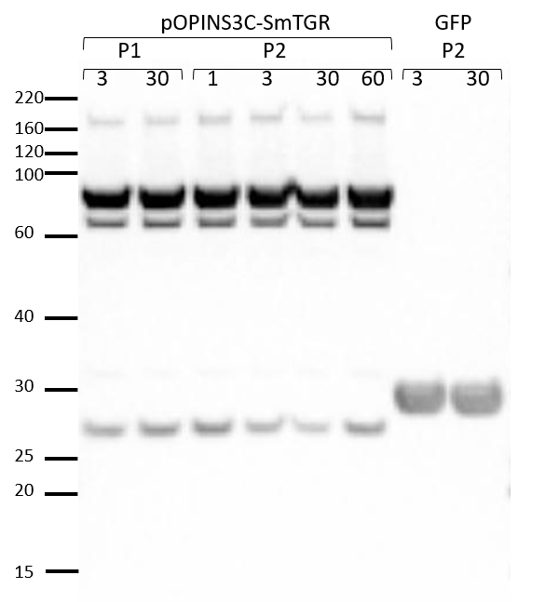
Figure S1 | Western blot of the intracellular expression of SmTGR in Sf9 insect cells analyzed on SDS-PAGE 4-12% and detected with anti-His antibody (Sigma). For P1 expression test, 3 and 30 μL from P1 were used to infect 3 mL of 106/mL Sf9 cells. For P2 expression test, 1, 3, 30 and 60 μL from P2 were used to infect the same amount of Sf9 cells. For control GFP, 3 and 30 μL from P2 were also used to infect Sf9 cells as mentioned before.

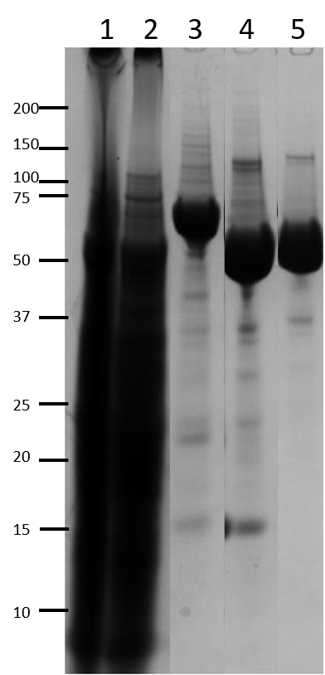
Figure S2 | SDS-PAGE 4-12 % analysis of SmTGR expressed intracellularly in large-scale culture of Sf9 cells, digested and purified. Lane 1, total cell extract load for Ni2+-IMAC; lane 2, flow-through; lane 3, elution; lane 4, flow-through from reverse IMAC of S3C-digested SmTGR; lane 5, SEC fraction of rSmTGR. Note the reduction in size after digestion with S3C protease (lane 4). The estimated purity was 80 %.

Figure S3 | SmTGR crystal formed in crystallization solution containing 0.1 M tris pH 8.5, 0.2 M magnesium chloride and 15 % w/v polyethylene glycol 4000. The yellow color is caused by the FAD molecule in its fully reduced form attached to the enzyme.

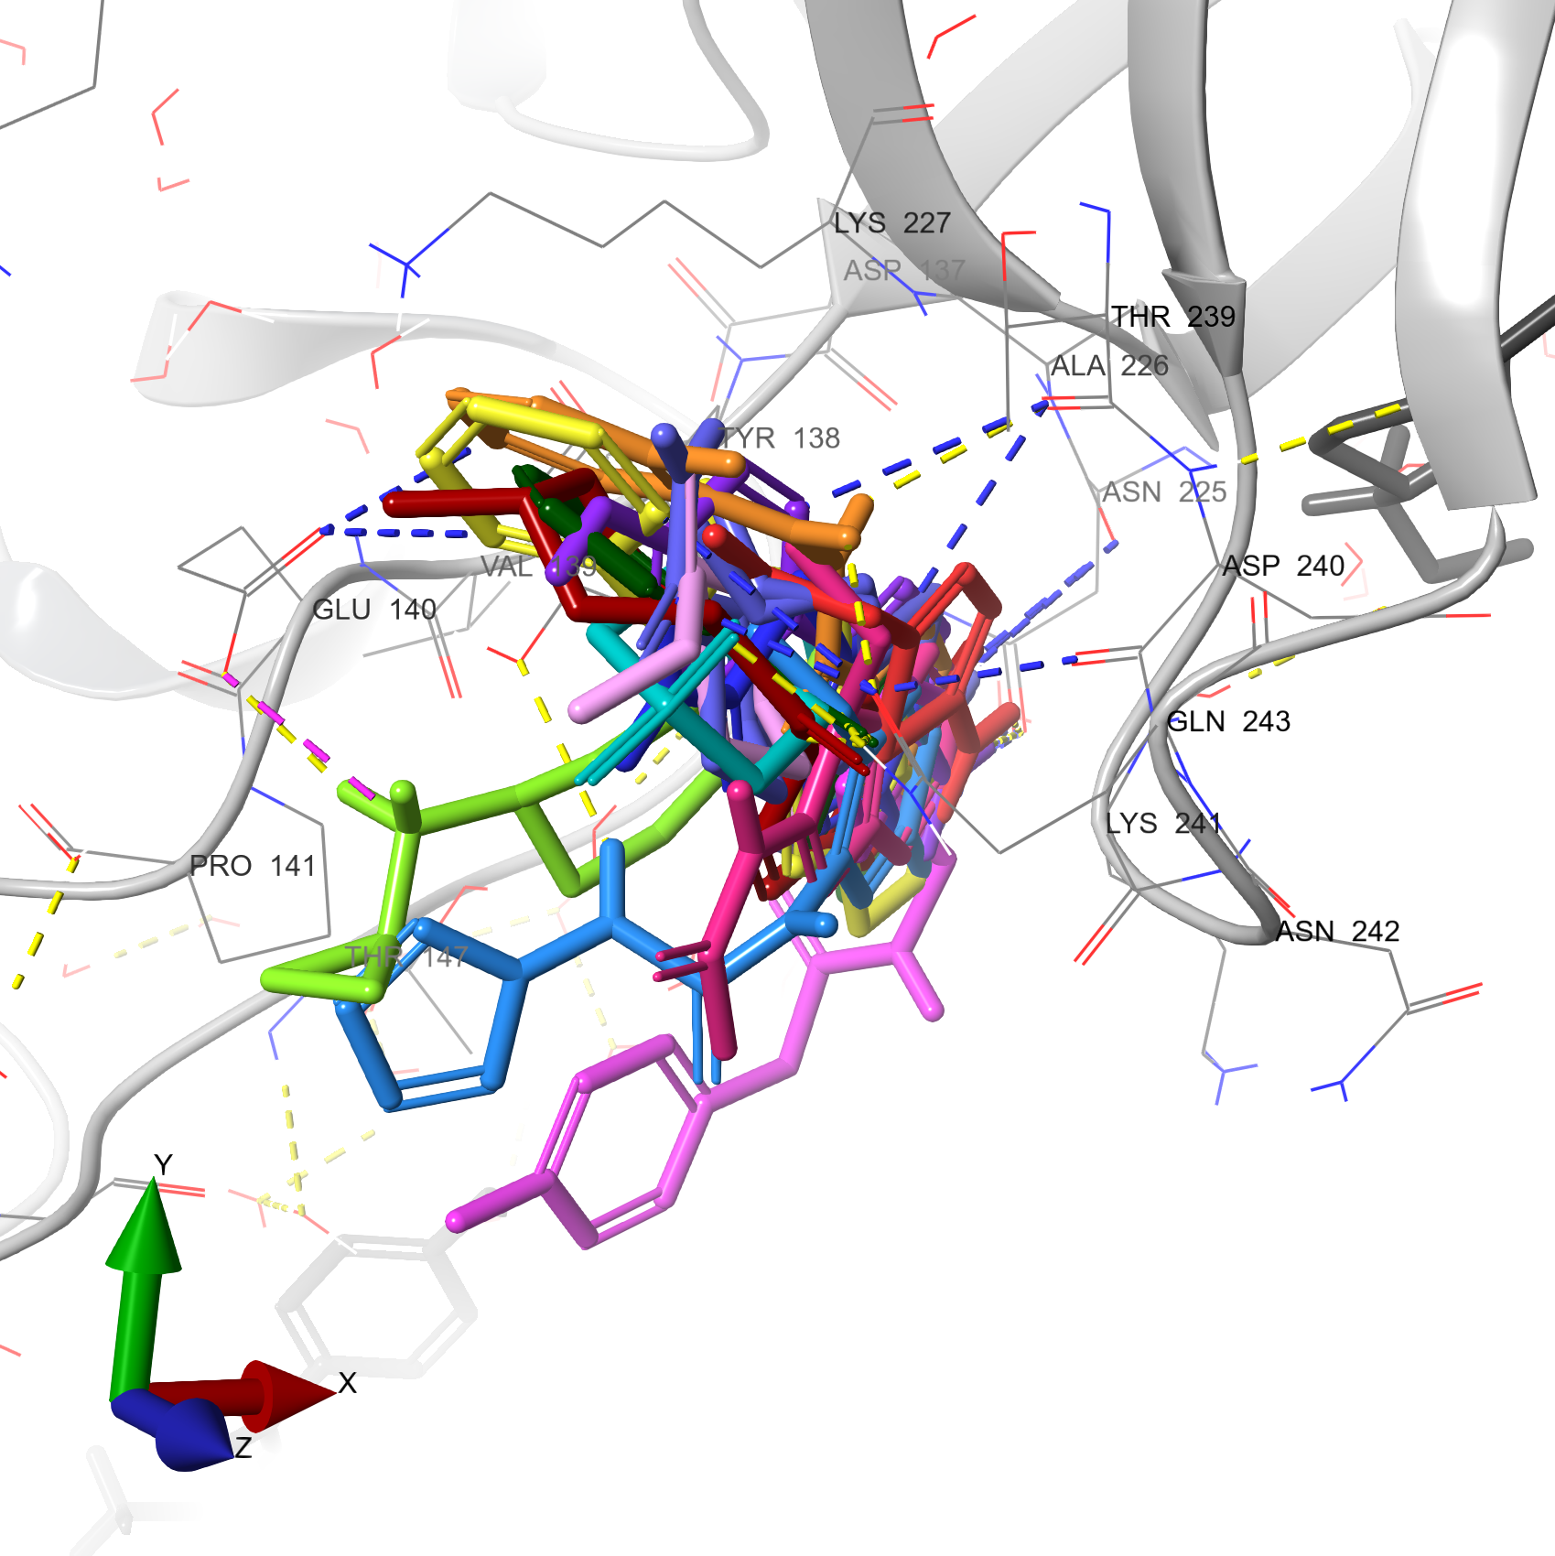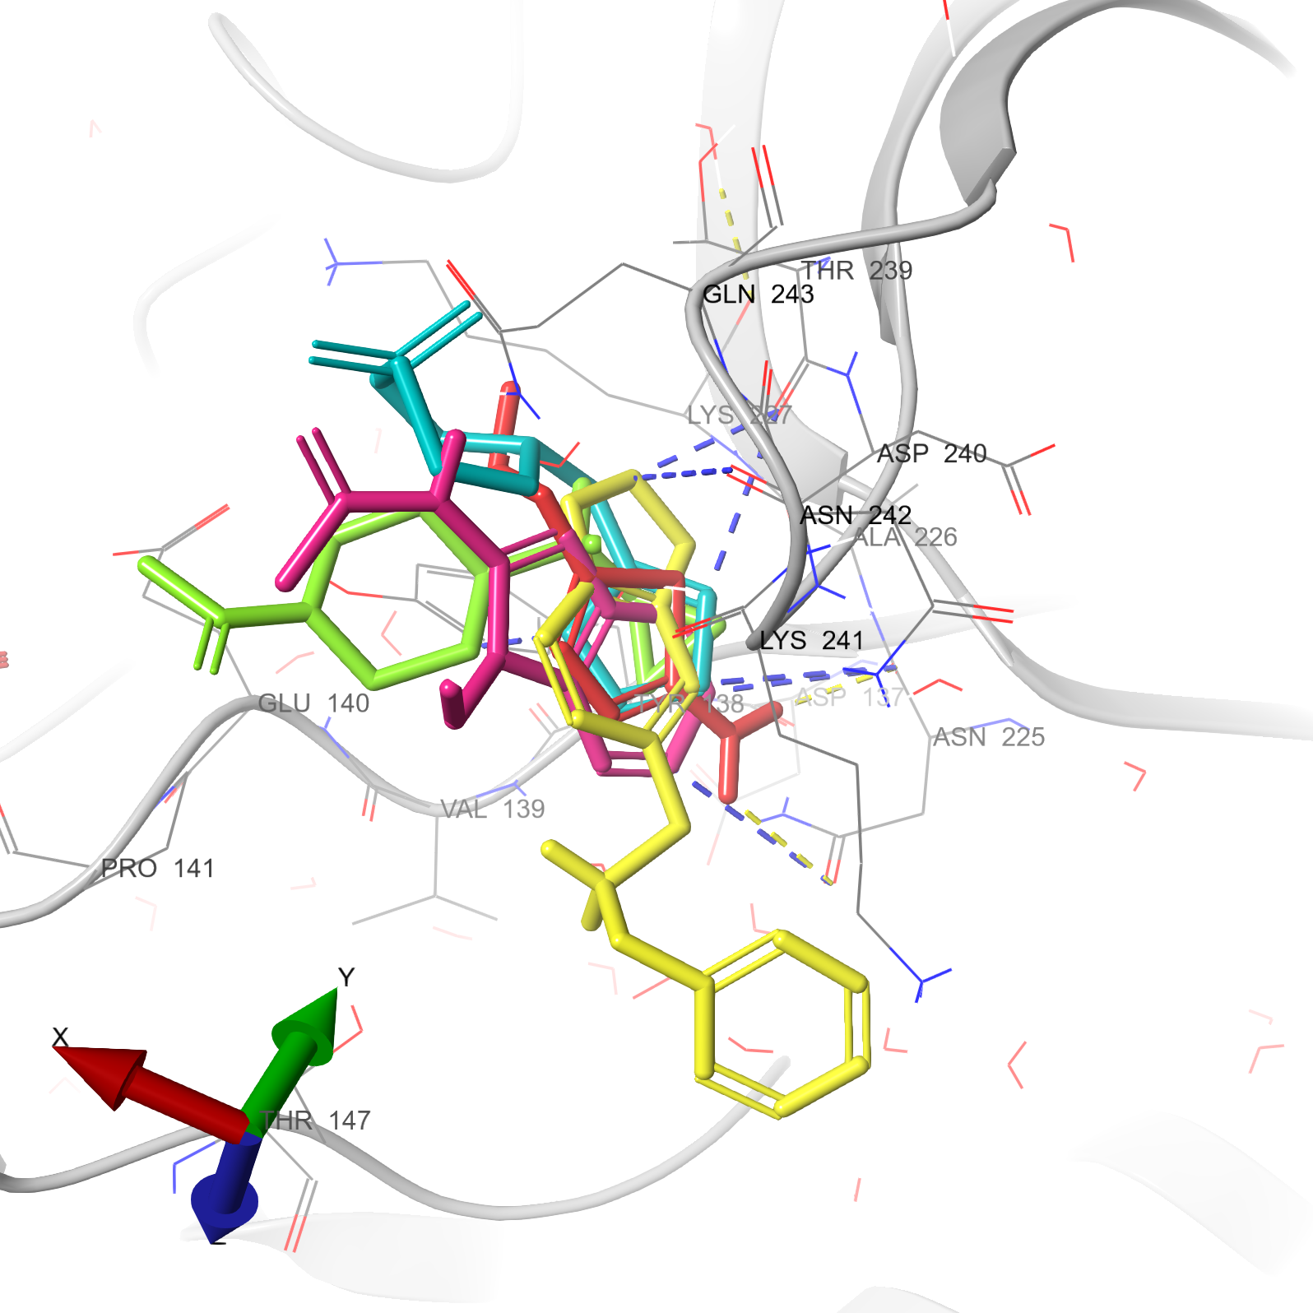
A
B
Figure S4 | Fragment cluster at site S1. Each one of the 14 fragments is represented as thick sticks in different colors. The fragments forming this cluster were modelled in SmTGR monomers A (A) and B (B). The SmTGR is represented as a gray colored ribbon. The water molecules and protein side chains within a radius of 5Å are represented by thin sticks in CPK colors with light gray carbons. Hydrogen bonds, π-H and salt bridges are represented by dashed yellow, blue and pink lines, respectively. Finally, 11 fragments showed 16 π-H, while 11 hydrogen bonds were formed between SmTGR and 6 fragments. The residue Asn225 makes the highest contribution to the number of polar interactions (9), through both side chain and backbone atoms. In this site, the π-π and π-cation are mainly mediated by Phe343 and Lys345, respectively.

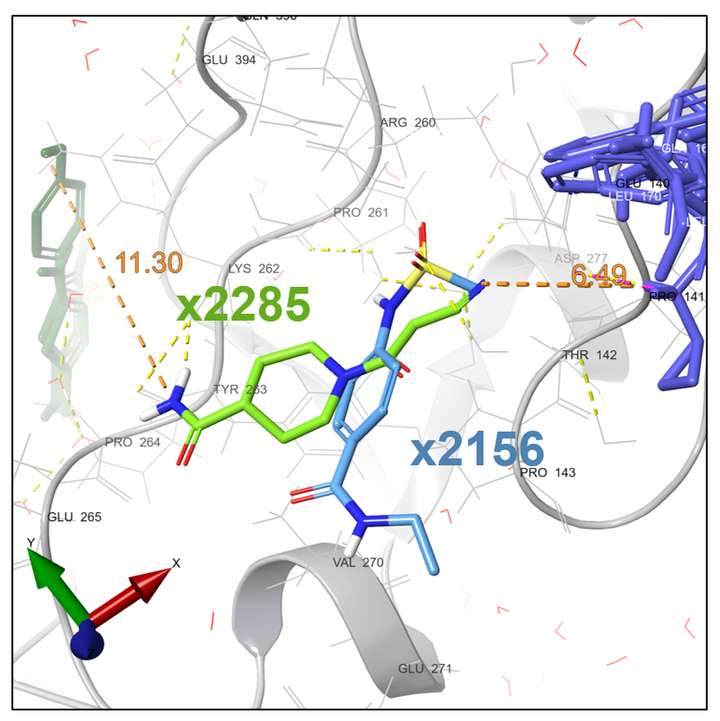
Figure S5 | Fragments bound to site S2. This binding site was shared by 2 different fragments, the x2285 (light green) and x2156 (light blue). The SmTGR is represented as a gray colored ribbon. The water molecules and protein side chains within a radius of 5Å are represented by thin sticks in CPK colors with light gray carbons. Hydrogen bonds are represented by dashed yellow lines. The distances from sites 1 (dark blue) and 9 (dark green) are represented as orange dashed lines. Fragment x2285 was seen in a hydrogen bond interaction with residue Tyr263, mediated by a water molecule.

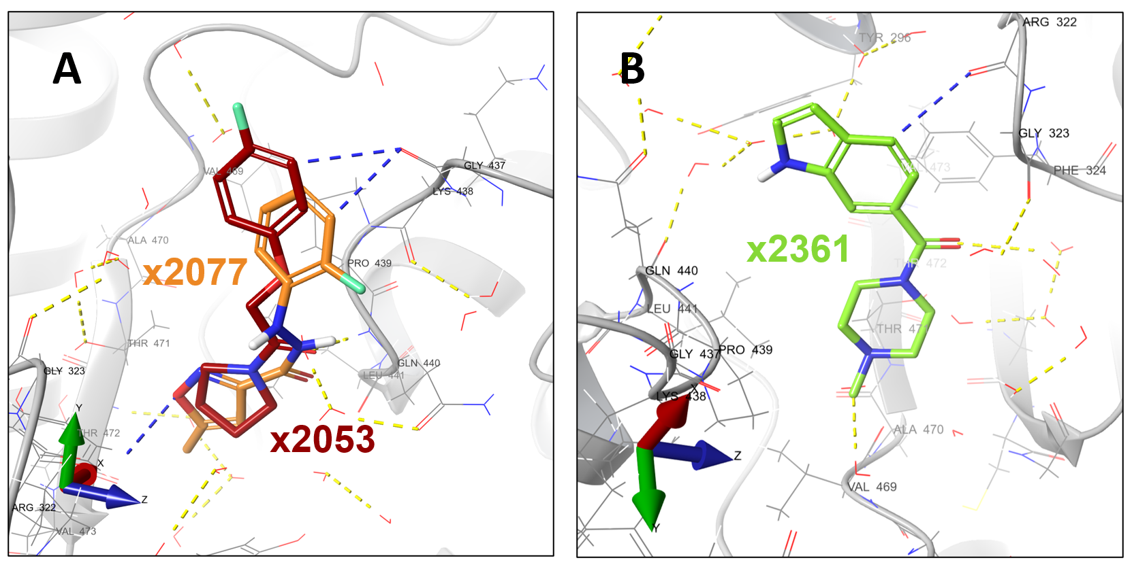
Figure S6 | Fragments bound to binding site S3. The fragments forming this cluster were modelled in SmTGR monomers A (A) and B (B). The SmTGR is represented as a gray colored ribbon. The water molecules and protein side chains within a radius of 5 Å from the fragments are represented by thin sticks in CPK colors with light gray carbons. Hydrogen bonds and π-H bonds are represented by dashed yellow and blue lines, respectively. The fragments x2053 and x2361 interacted through a hydrogen bond with the residue Gln440 and a water molecule, respectively.

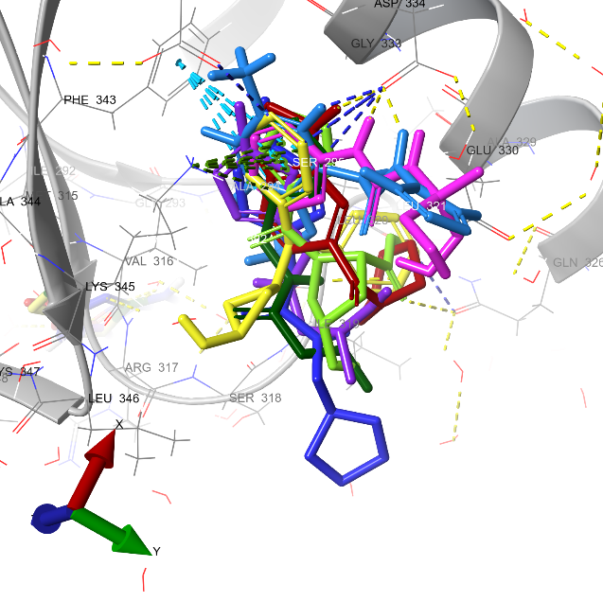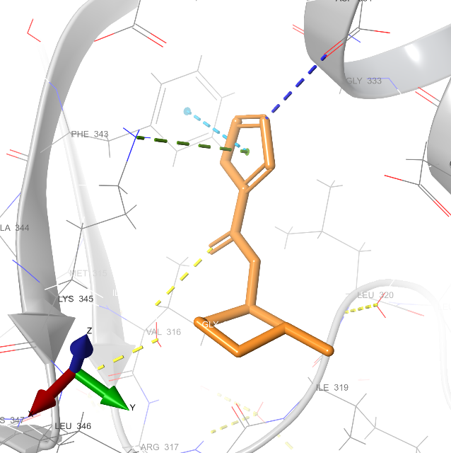
B
A
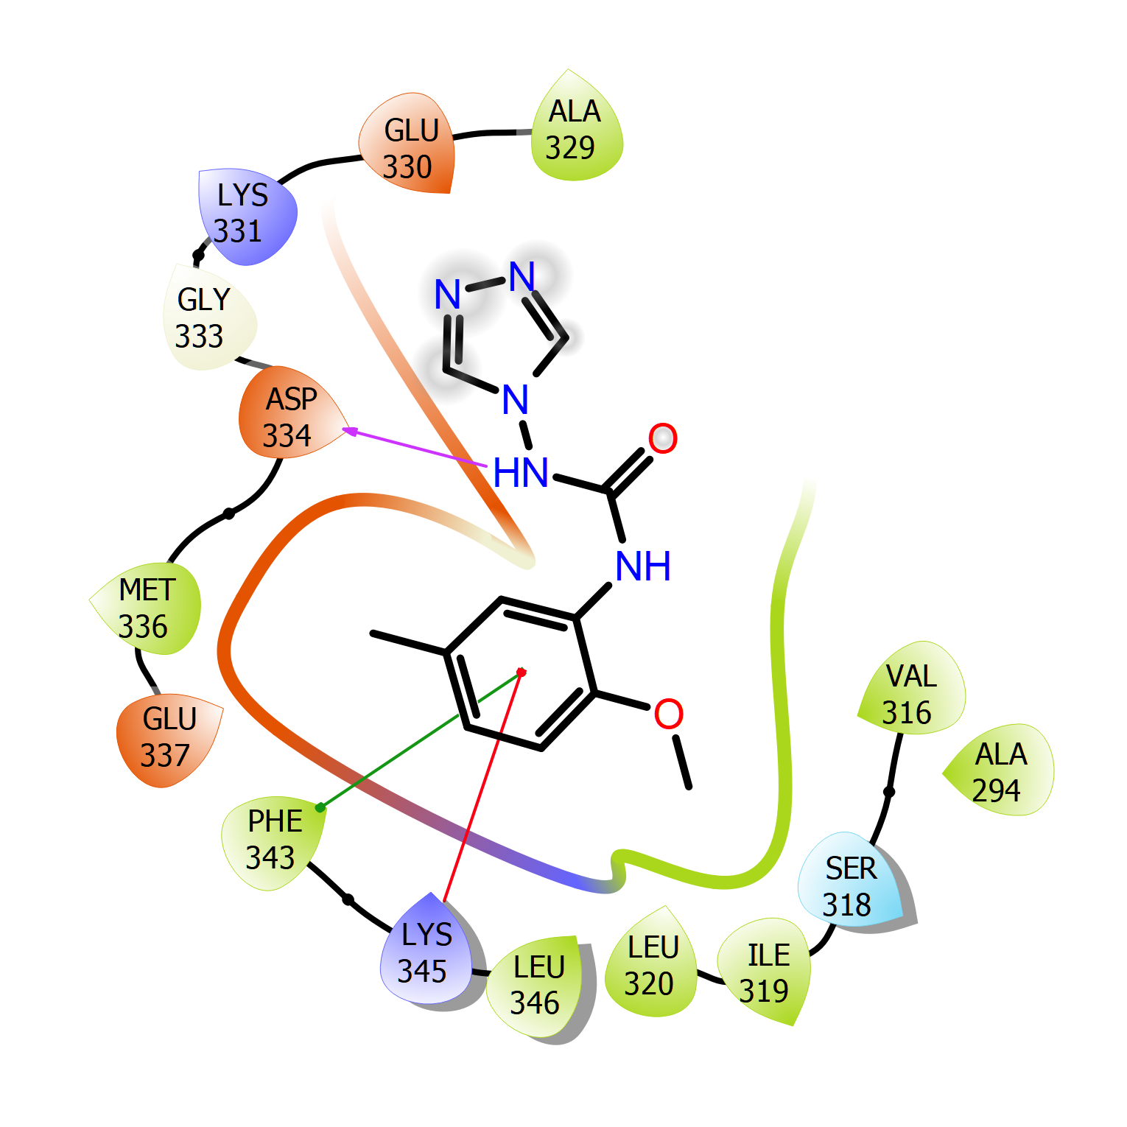
C
Figure S7 | Fragment cluster bound to site 4. These ligands were modelled in SmTGR monomers A (A) and B (B). Each one of the 9 fragments is represented as thick sticks in different colors. The SmTGR is represented as a gray colored ribbon. The water molecules and protein side chains within a radius of 5Å are represented by thin sticks in CPK colors with light gray carbons. The hydrogen bonds, π-π and π-cátion interactions are represented by yellow, cyan and green dashed lines, respectively. The 2D interaction diagram of fragment x2242 (C) depicts the hydrogen bonding, π-π and π-cátion (pink, green and red lines, respectively) interactions with Gln243 and Thr239. The pink arrow points towards de hydrogen acceptor atom. We observed 7 π-H interactions between 4 fragments and the enzyme, while hydrogen bonds were observed 3 times in 3 fragments. In this site we also observed a major abundance of π-π and π-cation interactions across the experimental dataset. The π-π stacking and π-cation interactions were observed in 8 and 7 fragments, respectively.

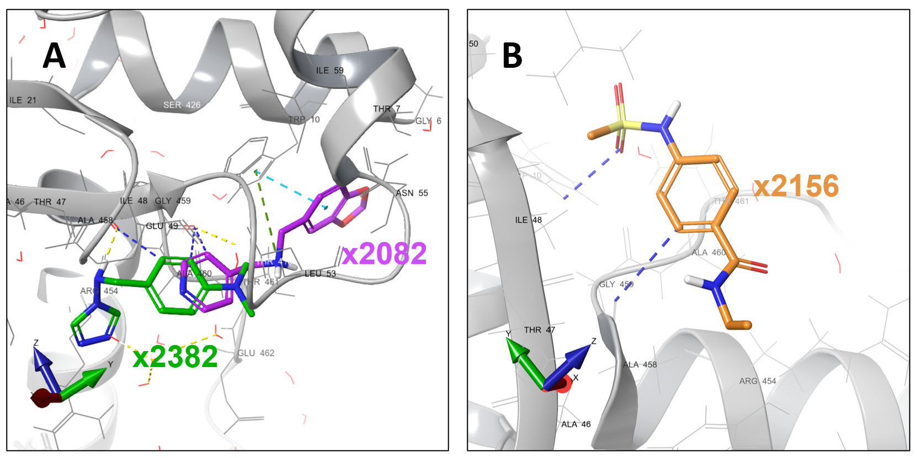
Figure S8 | Fragments bound to site S5. This binding site is shared by 3 different fragments: x2156 (orange), x2082 (red) and x2382 (green). The fragments forming this cluster were modelled in SmTGR monomers A (A) and B (B). The SmTGR is represented as a gray colored ribbon. The water molecules and protein side chains within a radius of 5 Å from the fragments are represented by thin sticks in CPK colors with light gray carbons. The hydrogen bonds (yellow), π-H (blue), π-π (cyan) and π-cation (green) interactions are represented by dashed lines in different colors. Fragments x2382 and x2156 showed 2 π-H and x2156 only one. A hydrogen bonding was seen between fragment x2382 and Ala458. Fragment x2082 formed π-π and π-cation with Trp10 residue.

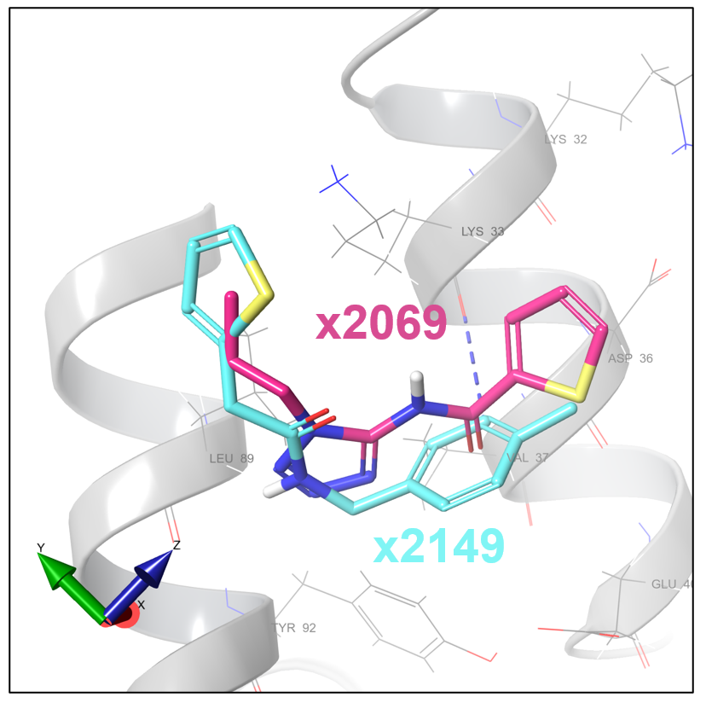
Figure S9 | Fragments bound to site S6. This binding site was shared between fragments x2149 (cyan) and x2069 (magenta). These fragments are represented as thick sticks in CPK color with different carbon colors. The SmTGR is represented as a gray colored ribbon. The protein side chains within a radius of 5 Å from the fragments are represented by thin sticks in CPK colors with light gray carbons. The π-H is represented by blue dashed lines. Only one π-H interaction was observed between the x2149 fragment and the Lys33.

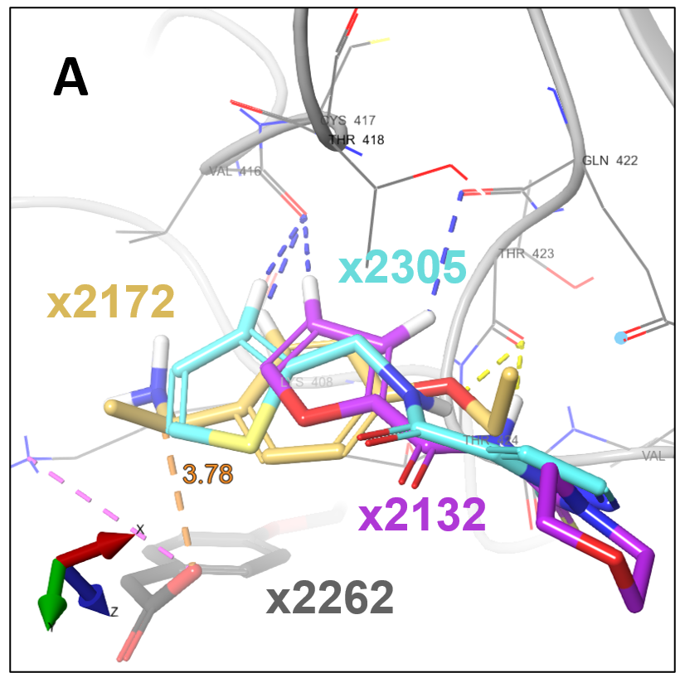
Figure S10 | Fragments linked to the S7 site. This binding site was common to fragments x2132 (lilac), x2172 (yellow) and x2305 (cyan). These fragments are represented as rods in CPK staining with different carbon colors. SmTGR is represented by a gray ribbon. Protein side chains within a 5 Å radius of the fragments are represented by thin rods in CPK staining, with light gray carbons. The interactions between hydrogen bonds (yellow), π-H (blue) and salt bridge (magenta) are represented by dashed lines. The orange dashed line represents the distance (3.78 Ǻ) between x2172 and x2262 (S12).

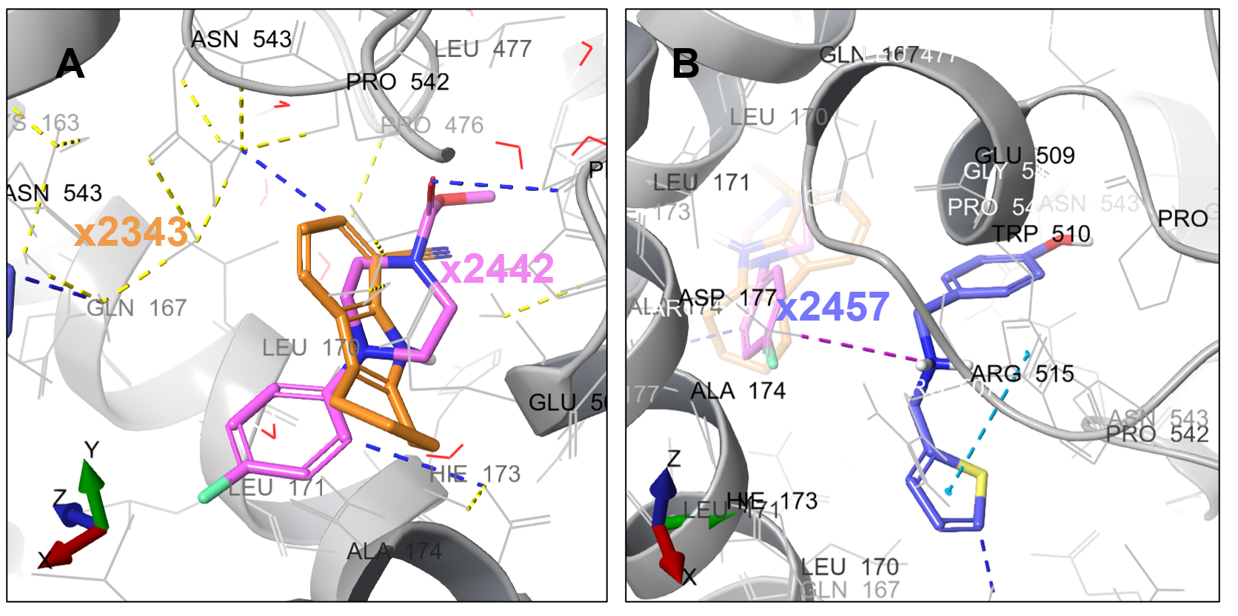
Figure S11 | Fragments bound to site S8. The fragments in this site are the x2343 (pink), x2442 (orange) and x2457 (blue). The fragments forming this cluster were modelled in the two monomers represented by (A) and (B). The SmTGR is represented as a gray colored ribbon. The side chain of residues within a radius of 5 Å are represented by gray sticks. Interactions such as hydrogen bonds, π-π and π-H are represented by yellow, cyan and blue dashed lines, respectively. The x2442 fragment interacted through two π-H interactions with the residues Asp177 and Trp510. Fragments x2343 and x2457 formed the same interactions with Glu478 and Pro476, respectively. Water molecules, important for intermolecular interactions, can be seen mediating a π-H with fragment x2343. Compound x2457 was also observed to form π-π and a salt bridge with residues Trp510 and Asp177, respectively.

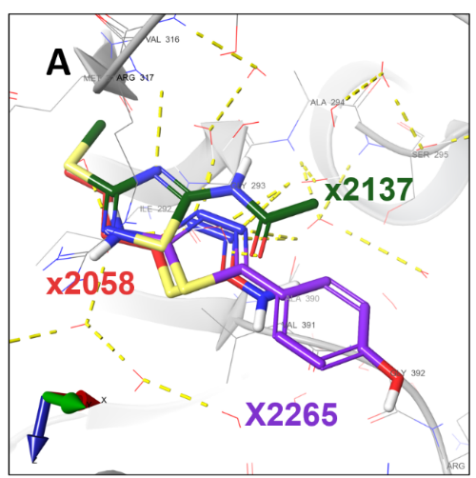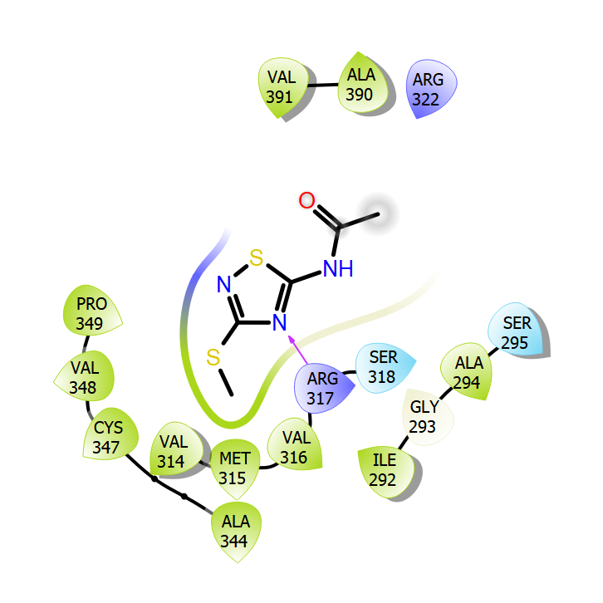
B
Figure S12 | Fragments bound to site S9. (A) The fragments x2137 (green), x2058 (red) and x2265 (purple) are colored in CPK with green, red, and purple carbons, respectively. (B) Fragment x2137 2D interaction diagram. The H-bond is represented by a pink arrow pointing towards the hydrogen acceptor in the thiadiazole ring. The SmTGR is represented as a gray colored ribbon. The water molecules and protein side chains within a radius of 5 Å from the fragments are represented by thin sticks in CPK colors with light gray carbons. Hydrogen bonds are represented by dashed yellow lines.

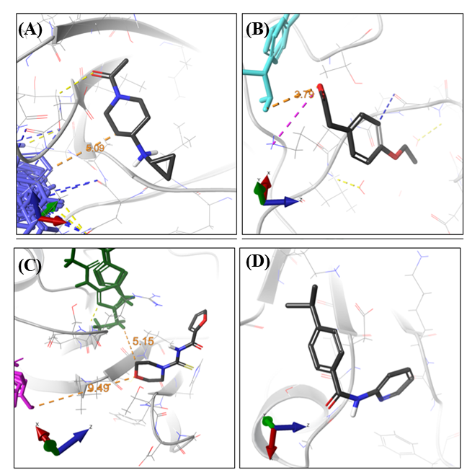

Figure S13 | Some fragments associated with SmTGR sites binding to a single fragment molecule. (A) Fragment x2098 (S10) interactions and its relative location to S1. (B) Fragment x2262 (S11) interactions and its relative location to binding S7. (C) Fragment x2132 (S14) interactions and relative location to binding S4 (magenta) and S9 (dark green). (D) Fragment x2387 (S15). The SmTGR is represented as a gray colored ribbon while the fragment is represented as thick colored sticks in CPK color pattern with dark gray carbons. The side chain of residues within a radius of 5 Å away from the fragments are represented by thin gray sticks. The π-H bonding, H bonding and salt bridges are represented by blue, yellow, and magenta dashed lines, respectively. The distance is represented as an orange dashed line. In S10, the only interaction seen was a hydrogen bond between fragment x2098 carbonyl group and the side chain of the Asp240 residue. In site S12, the fragment x2267 showed two interactions with its binding site. One of these is a π-H interaction between x2267 aromatic ring and Ser281 side chain. Besides, a salt-bridge between the fragment’s C8 atom and Glu199 was also observed. Fragment x2132 (site 14) is at NADPH subdomain, at the TrxR domain. This fragment shares residues with flanking sites S9 (Arg317, Cys347 and Val348) and S4 (Leu346).
Figure S14 | Screening of selected fragment hits at 100 µM against SmTGR enzymatic activity.

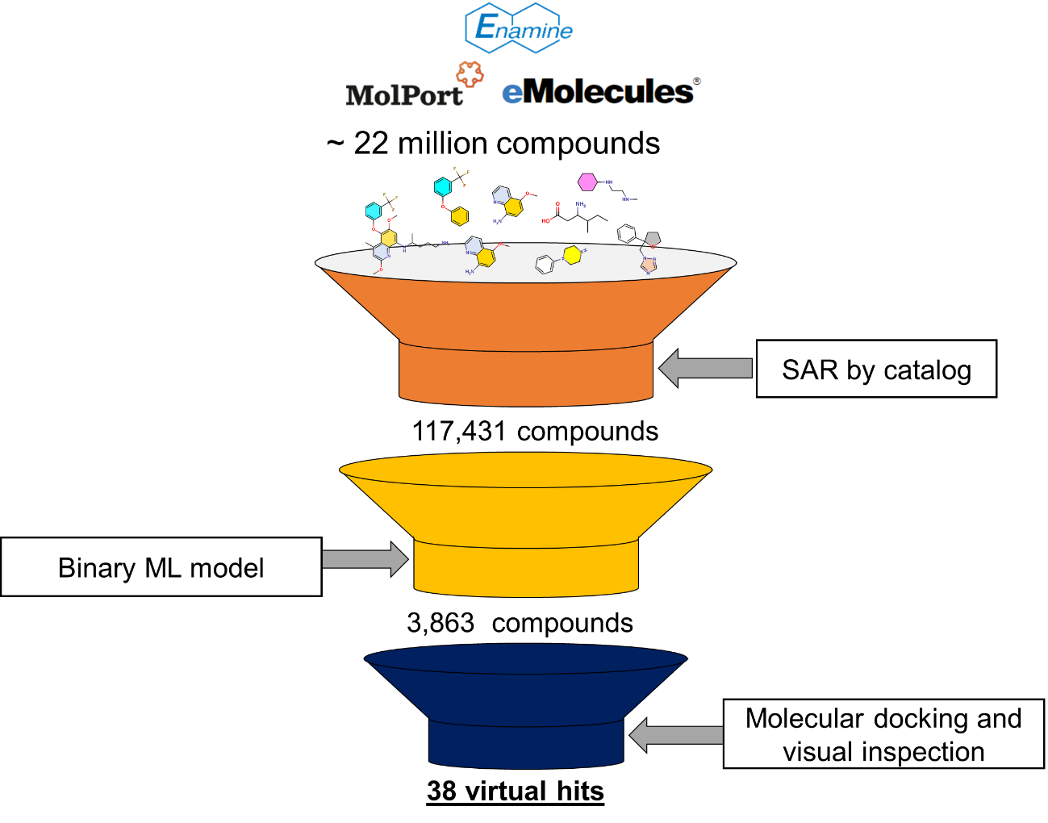
Figure S15 | Process of fragment optimization.

Figure S16 | IC₅₀ curve of compound 14 with 95 % confidence interval (22.08-49.65). The curve isn’t complete due to the maximal tolerance of SmTGR to DMSO. The hypothetical value of 100% of inhibition at 103.5 µM is represented by the red asterisk.

