Table 1: Descriptive Summary of selected variables
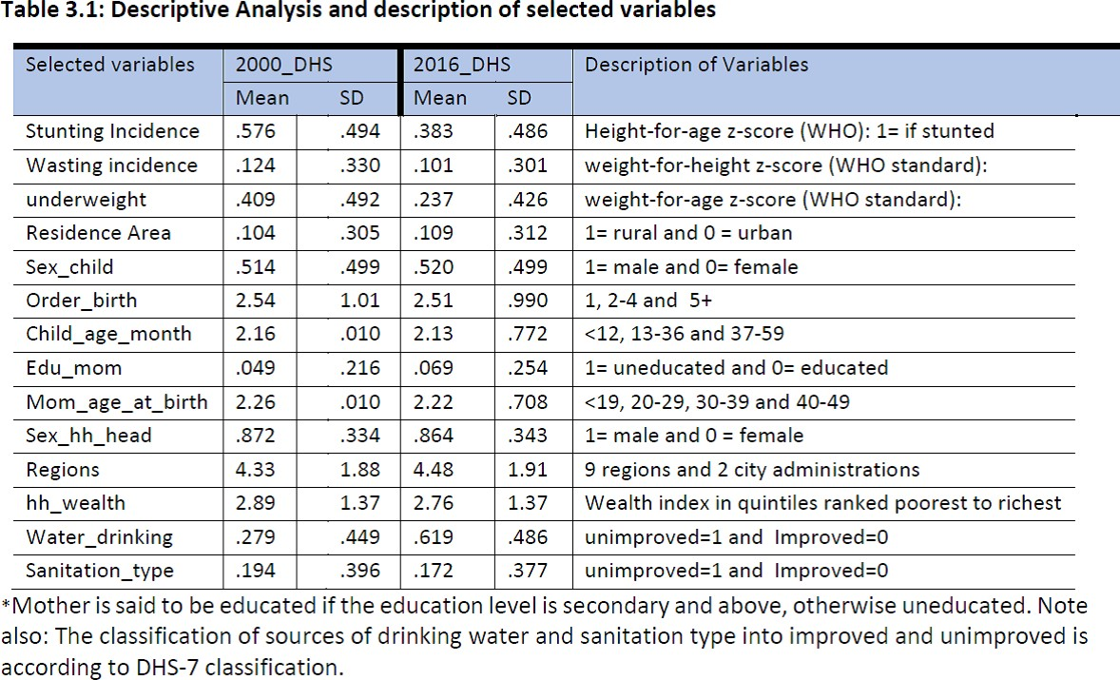

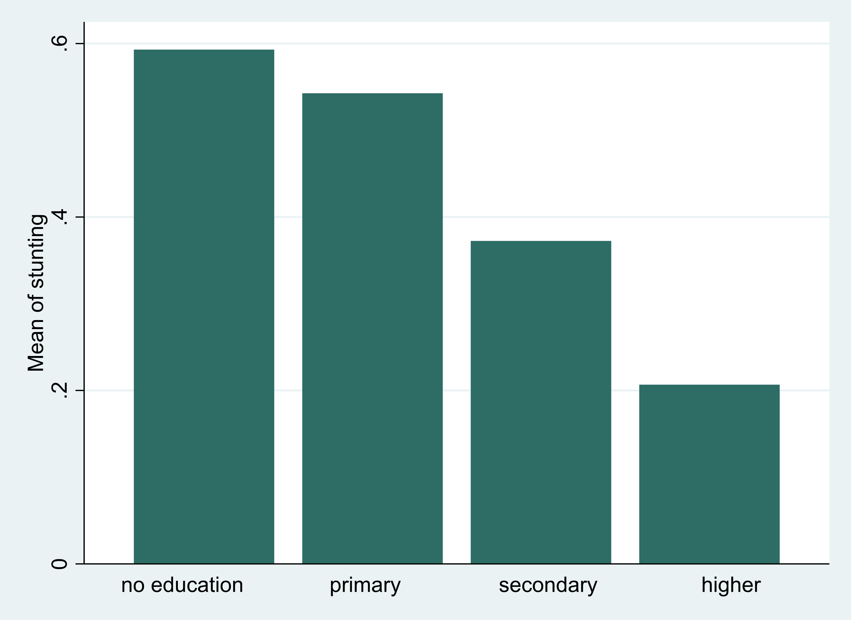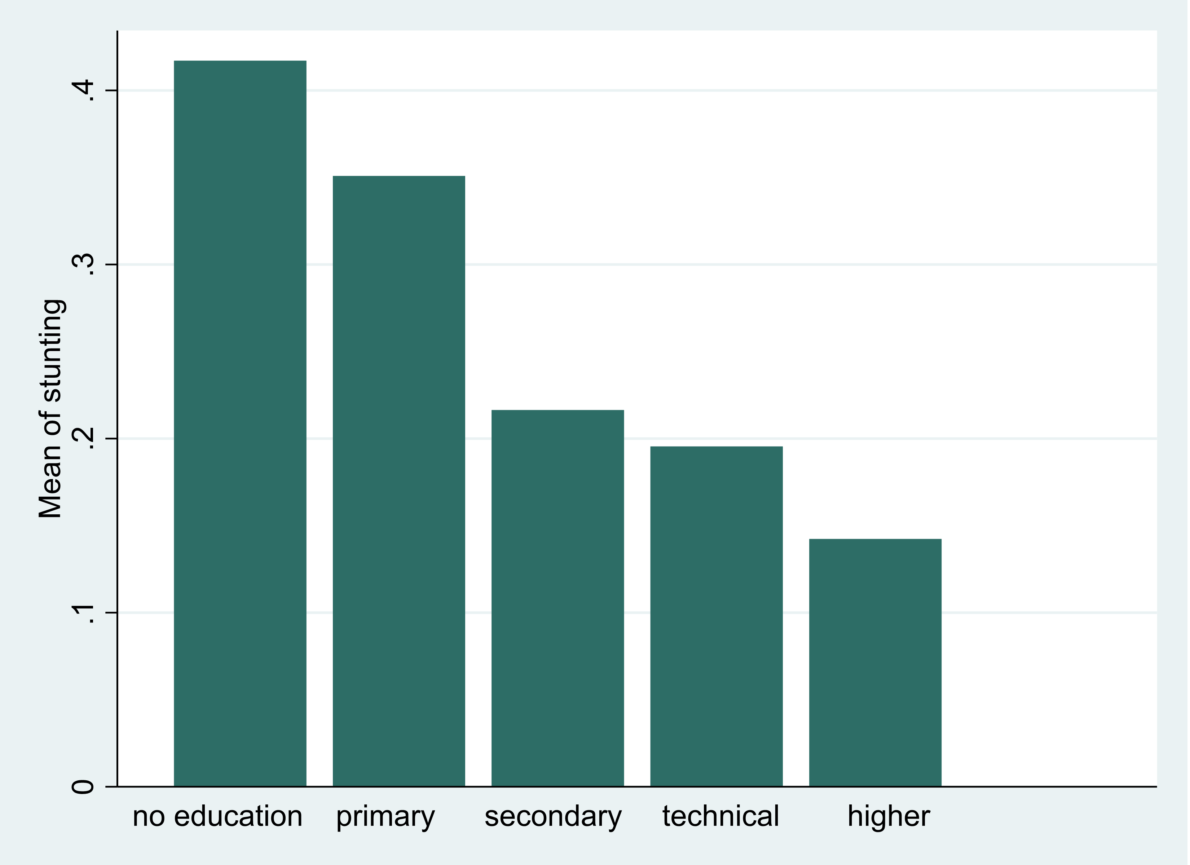

Figure 2: Stunting prevalence across mother’s education in 2000
Figure 3: Stunting prevalence across mother’s education in 2000

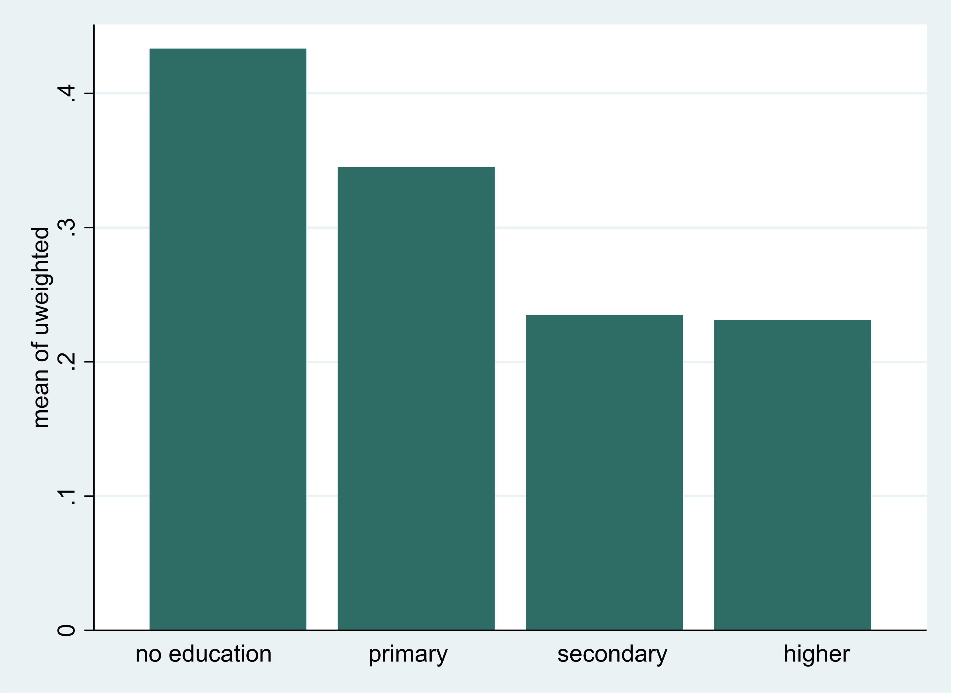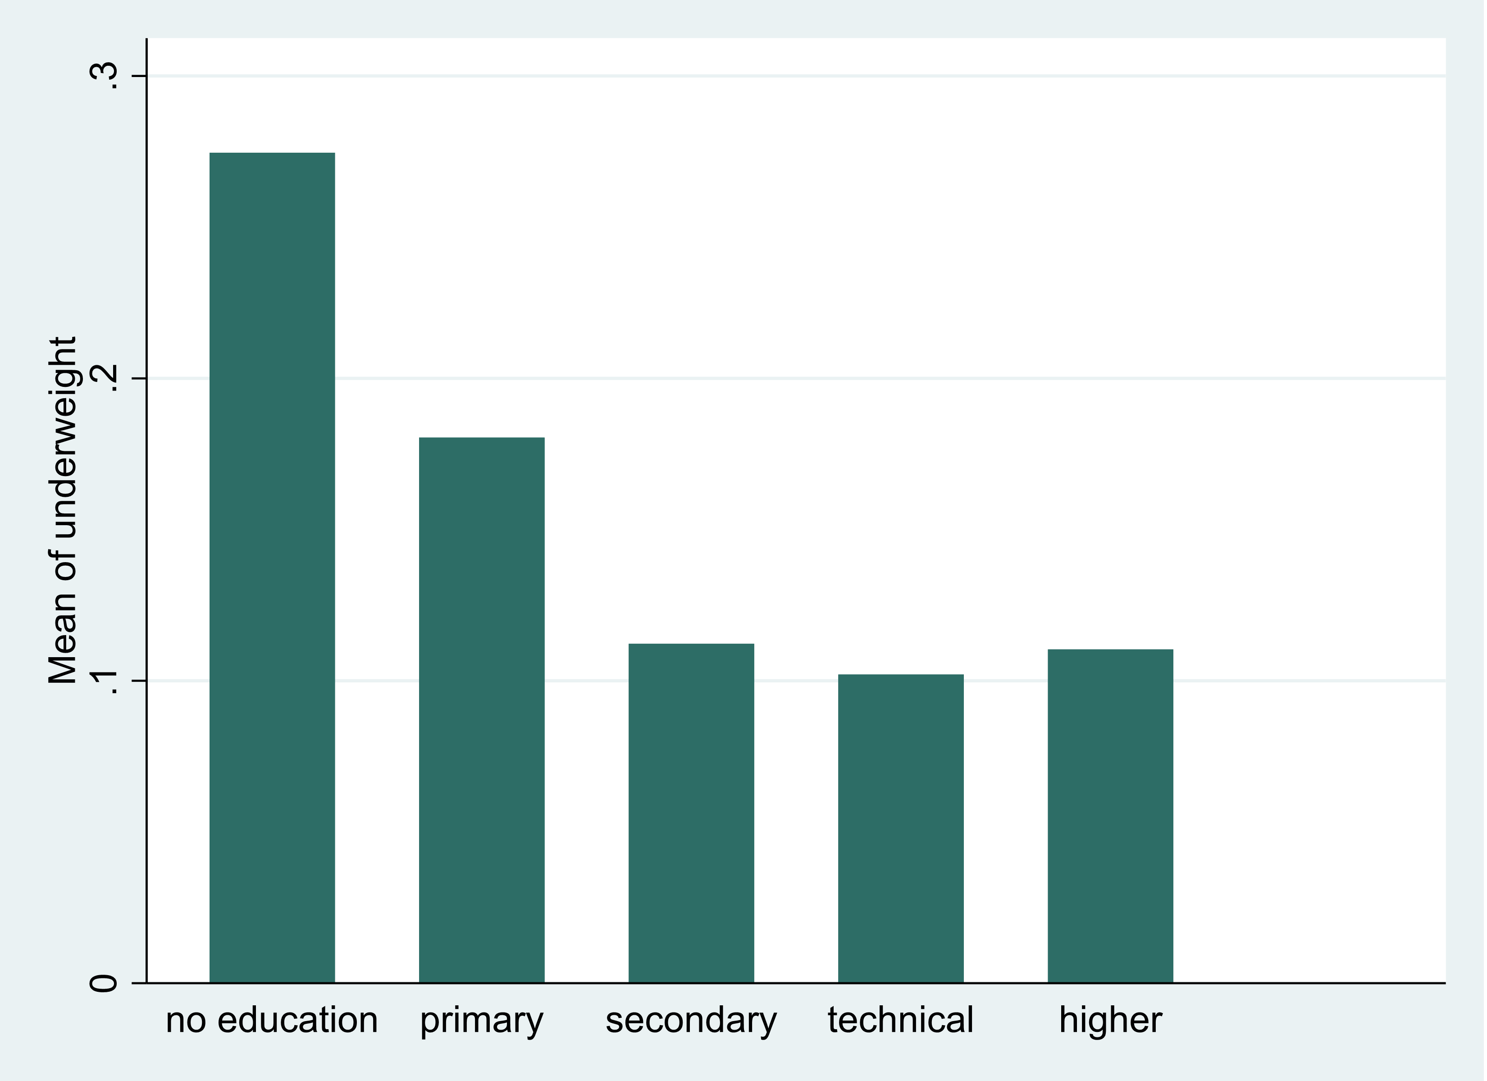

Figure 4: Underweight prevalence across mother’s education in 2000
Figure 5: Underweight prevalence across mother’s education in 2000

Table 2: Relative and Absolute Inequality levels of undernutrition variables
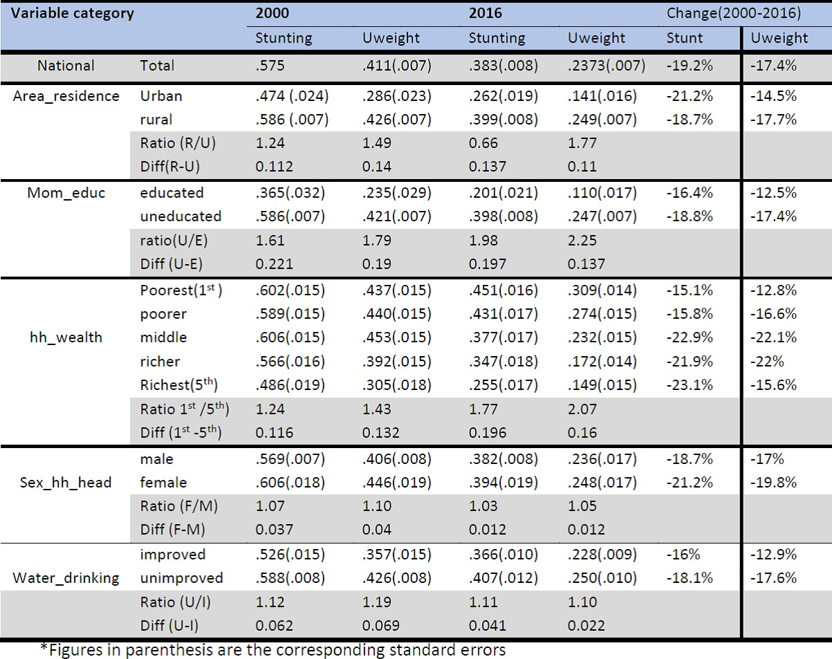

Table 7: Estimated CI of undernutrition variables using 2000 and 2016 DHS
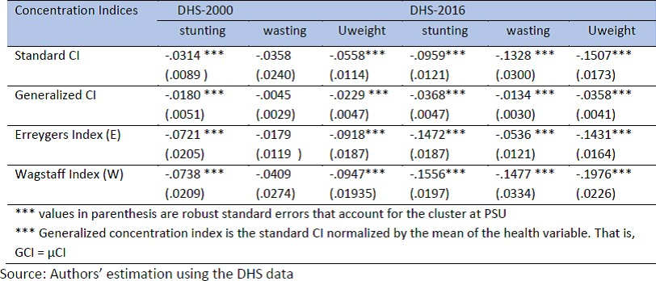

Table 8: The Standard CI of undernutrition variables across socioeconomic and demographic indicators
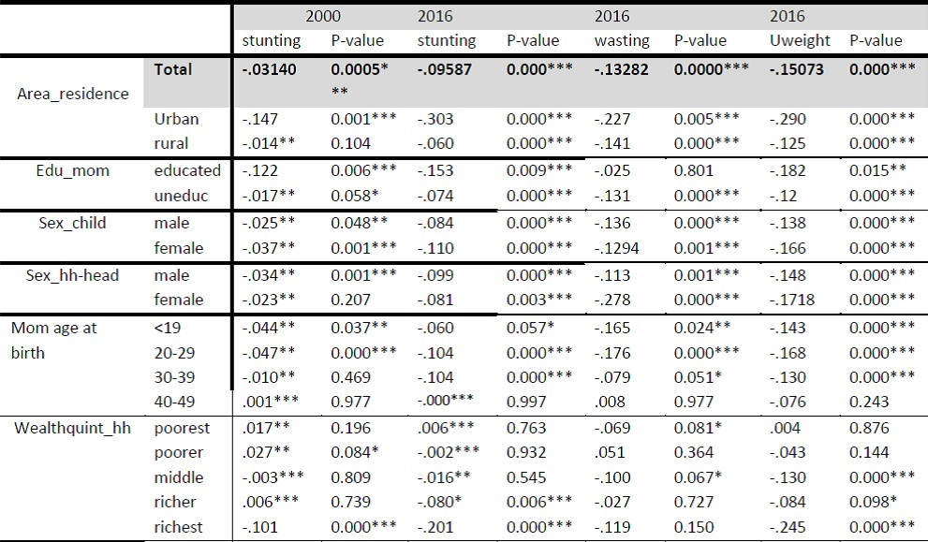

Figure 9: Multivariate Analysis: Stunting in 2000 and 2016
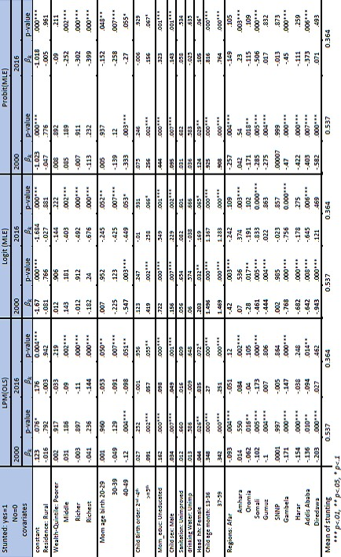

Figure 10: Multivariate Analysis: Underweight in 2000 and 2016
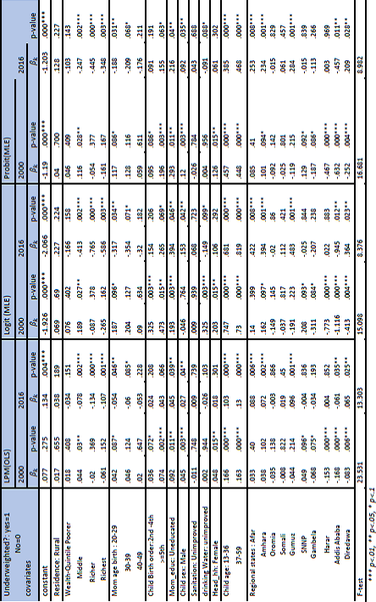

Figure 11: Decomposing the contribution of determinants of inequality in child undernutrition: 2000 DHS
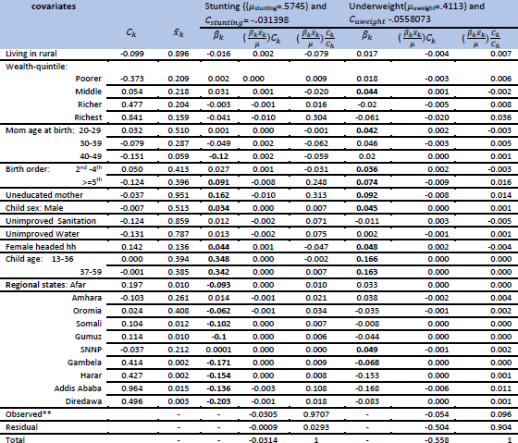

Figure 12: Decomposing the contribution of determinants of inequality in child undernutrition: 2016 DHS
