Supporting Information for
What makes blood clots break off? A back-of-the-envelope computation to de-mystify blood clot embolization

Osman Gültekin, Matthew J. Lohr, Grace N. Bechtel, Manuel K. Rausch

Manuel K. Rausch
Email: manuel.rausch@utexas.edu

This PDF file includes:

Figures S1 to S4
Legends for Movies S1 to S2

Other supporting materials for this manuscript include the following:

Movies S1 to S2

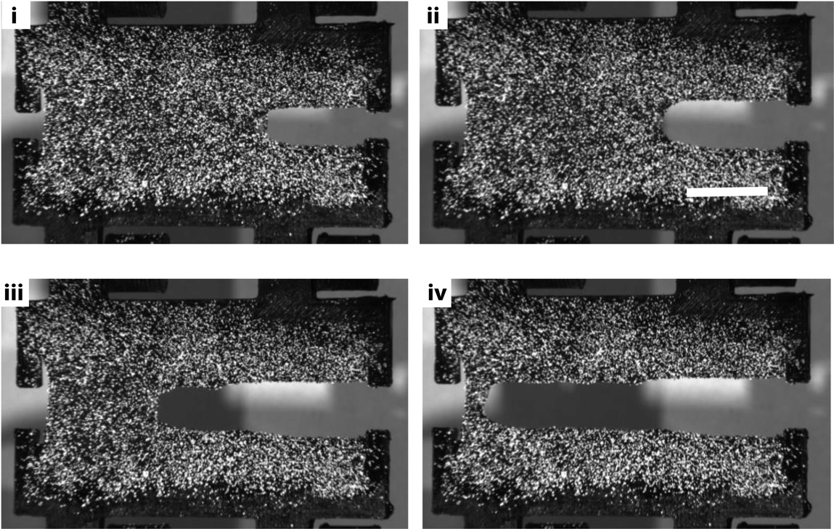

Fig. S1. Photos of blood clot mode-I fracture experiment. Time points i) through iv) correspond to points along the Force-displacement graph of panel B in Figure 1 in the main manuscript. The speckle pattern was applied for deformation field visualization via digital image correlation.

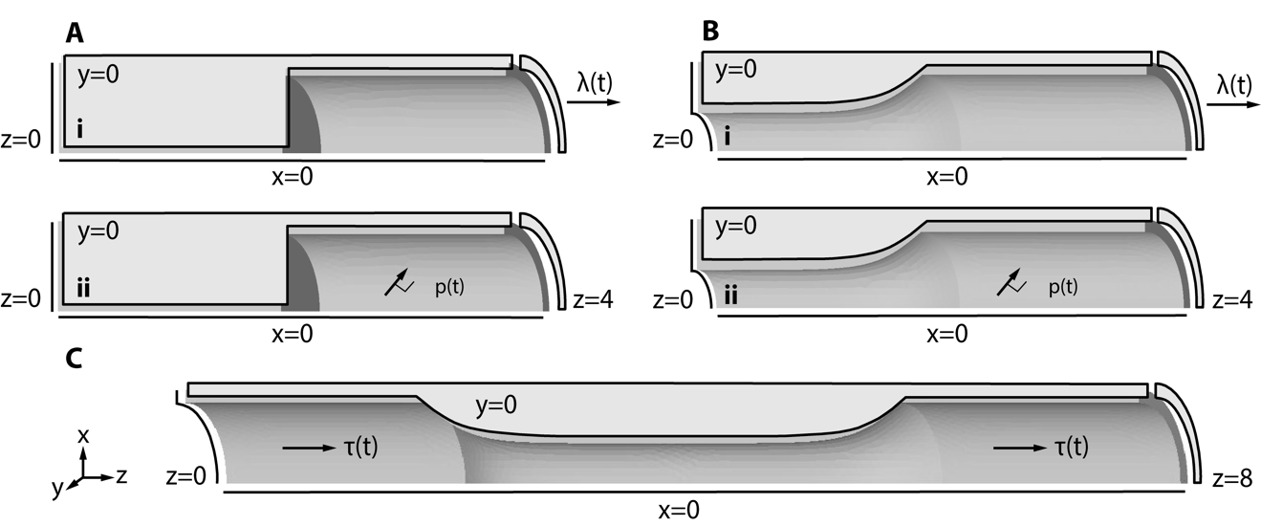

Fig. S2. Displacement and traction boundary condition for each occlusive and non-occlusive case. A) Occlusive clot where wall stretch $λ$ was simulated by applying displacements to the right boundary (top) and pressure p was simulated by applying normal tractions to the inner wall lumen and the free surface of the clot (bottom). B) Non-occlusive clot where wall stretch and pressure were applied as in A). C) Non-occlusive clot where fluid shear stress $τ$ was applied as a shear traction to the inner wall lumen and the inner surface of the partial clot (bottom). Note, because shear stress broke the z-symmetry of our other load cases, here we simulated a full length of the problem, i.e., a quarter of the full domain, rather than an eighth.

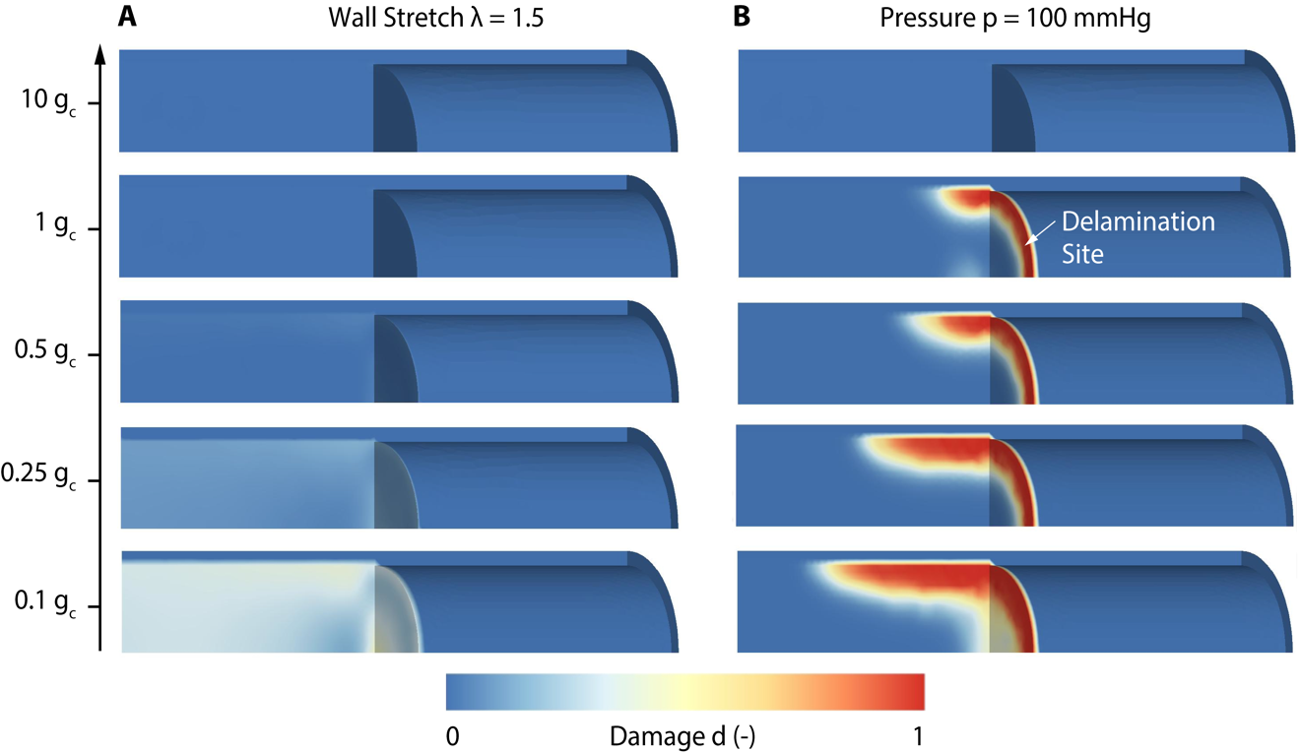

Fig. S3. Occlusive clot with different loading amplitudes: Finite element simulations showing the evolution of the damage variable d, for multiples and fractions of experimentally determined fracture toughness $g_{c}$ ; A) Axial wall stretch up to $λ=1.5$ and B) pressure up to p=100 mmHg. Note that d=1 represents the fully damaged state, whereas d=0 indicates the intact state.

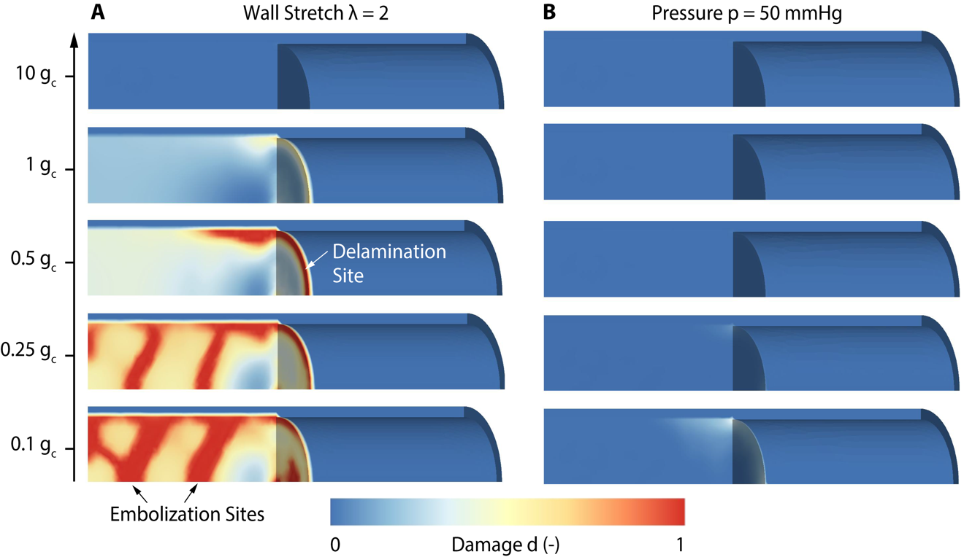

Fig. S4. Occlusive clot in one tenth geometry: Finite element simulations showing the evolution of the damage variable d, for multiples and fractions of experimentally determined fracture toughness $g_{c}$ ; A) Axial wall stretch up to $λ=2$ and B) pressure up to p=50 mmHg. Here $κ=1$ [MPa]. Note that d=1 represents the fully damaged state, whereas d=0 indicates the intact state.

Movie S1 (separate file). Animation of occlusive clot damage in response to wall stretch-induced interfacial forces.

Movie S2 (separate file). Animation of non-occlusive clot damage in response to wall stretch-induced interfacial forces.

