Appendix 2i. Sample participant and maize flour recipient ID cards. A = Adult, C = Child, R = Recipient. Recipients are households in the study area but not participating in the trial. Recipient and Adult ID cards will be used at flour distribution points to ensure the correct allocation of flour for non-participant and participant households, respectively.

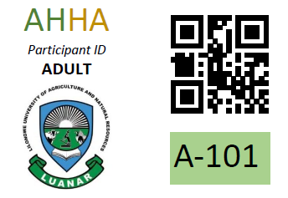
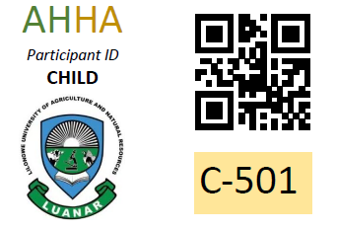
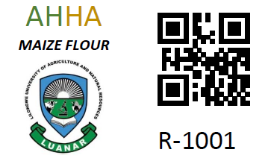

Reverse of all cards:
