Supplemental Information

A Lego-like reconfigurable microfluidic stabilizer system with tuneable fluidic RC constants
Wuyang Zhuge^{1,2}, Weihao Li ^{1,3}, Chunhui Wu¹, Kyle Jiang ² Jun Ding ³ and Xing Cheng^{1*}
*Correspondence: Xing Cheng (chengx@sustech.edu.cn)
¹ Department of Material Science and Engineering, Southern University of Science and Technology, Shenzhen, Guangdong, P.R. China
²Department of Mechanic Engineering, University of Birminham, Edgbaston, Birmingham, B152TT,United Kingdom
³Department of Materials Science and Engineering, National University of Singapore, 9 Engineering Drive 1, 117576, Singapore
⁴Yangtze Delta Region Institute of Tsinghua University，705 Yatai Road, Jiaxing, Zhejiang, China

These authors contributed equally: Weihao Li, Wuyang Zhuge

S1. Design iterations of Lego-like pluggable microfluidic system
Figure S1 depicts the design iterations based on the feedback from experiments. With 3D printing, we could efficiently modify and test different device designs in order to figure out the optimal design for the proposed system in this work. There are three key elements when it comes to device designing: connection, bonding, and combination. The model structure using luer-fitting connection is shown in Figure S1(a). However, this design lacks sufficient waterproofing capabilities. As demonstrated in Fig. S1(c), the luer connector is removed and replaced by tubing connection. Tubing connections can achieve the appropriate tightness. The screw-bonding design is shown in Fig. S1(b), where the six holes are utilized for screws to connect this part to a cover portion (see Fig. S1(b)). However, because this bonding approach is unable to completely seal the entire device, photocurable resin is utilized to successfully bind the various parts in subsequent iterations. Figures S1(d) and (e) show the optimized forms of device design used in this study, which are suited for modular combinations and allow for easy reconfiguration.
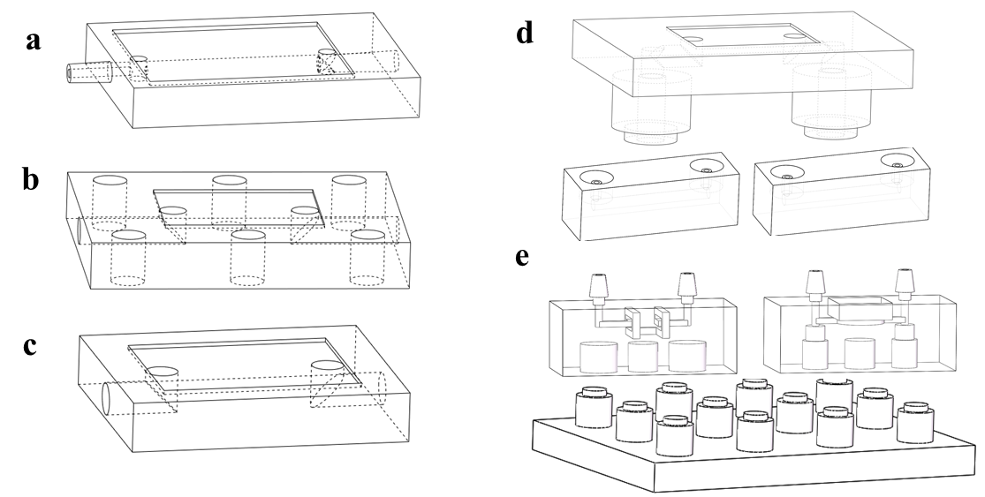
Fig. S1. Evolution of device design from (a) to (e). (a) Luer-fitting connection, (b) screw bonding, (c) tubing-connection, (d) modular design with independent unit base, and (e) modular design with Lego-like platform.

S2. Simplified circuit modelling
The derivation process is shown as following. Applying Kirchhoff’s current law to the two nodes (marked by blue dots) in Fig. 4(a), we get:
$\frac{P_{in}-P_{c0}\left(t\right)}{R_{0}}=C_{0}\frac{dP_{c0}\left(t\right)}{dt}+\frac{P_{c0}\left(t\right)-P_{c}\left(t\right)}{R_{c}}$ (S-1)
$\frac{P_{c0}\left(t\right)-P_{c}\left(t\right)}{R_{c}}=C\frac{dP_{c}\left(t\right)}{dt}+\frac{P_{c}\left(t\right)}{R_{loading}}$ (S-2)
Rearrange Eqn. S-2, we have:
$P_{c0}\left(t\right)=R_{c}C\frac{dP_{c}\left(t\right)}{dt}+\frac{{R_{c}P}_{c}\left(t\right)}{R_{loading}}{+P}_{c}\left(t\right)$ (S-3)
Applying the Kirchhoff’s current law to the node (marked by a blue dot) in the simplified circuit model described in Fig. 4(b) yields the following equation:
$\frac{P_{in}-P_{c}\left(t\right)}{R_{1}}=C_{overall}\frac{dP_{c}\left(t\right)}{dt}+\frac{P_{c}\left(t\right)}{R_{2}}$ (S-4)
In order to justify the correctness of the simplification, we could plug Eqn. S-3 into Eqn. S-1, we have:
$\frac{P_{in}-R_{c}C\frac{dP_{c}\left(t\right)}{dt}-\frac{{R_{c}P}_{c}\left(t\right)}{R_{loading}} {-P}_{c}\left(t\right)}{R_{0}}=C_{0}\frac{d(R_{c}C\frac{dP_{c}\left(t\right)}{dt}+\frac{{R_{c}P}_{c}\left(t\right)}{R_{loading}} {+P}_{c}\left(t\right))}{dt}+C\frac{dP_{c}\left(t\right)}{dt}+\frac{P_{c}\left(t\right)}{R_{loading}}$ (S-5)
Reorganize Eqn. S-5, we have:
$\frac{P_{in}{-P}_{c}\left(t\right)}{R_{0}}=\left(\frac{R_{c}}{R_{0}}C+C_{0}\frac{R_{c}}{R_{loading}}+C_{0}+C\right)\frac{dP_{c}\left(t\right)}{dt}+P_{c}\left(t\right)\left(\frac{1}{R_{loading}}+\frac{R_{c}}{R_{loading}R_{0}}\right)+R_{c}CC_{0}\frac{d^{2}P_{c}\left(t\right)}{dt^{2}}$ (S-6)
Neglecting the last second-order differential terms, Eqn. S-6 has the same form as Eqn. S-4 with $C_{overall}=\left(\frac{R_{c}}{R_{0}}C+C_{0}\frac{R_{c}}{R_{loading}}+C_{0}+C\right)$.

S3. Extraction of RC constants
$Q\left(T\right)={(Q}_{avg}-Q_{L})exp⁡(-\frac{T-T_{0}}{τ})$ S-7
Q(T) is the flowrate of the system at time T, $Q_{avg}$ is defined as the average flowrate of the working state of the MSS, $Q_{L}$ refers to the low point of the flowrate when the pump is stopped, which also represents the flowrate driving by the pressure drop due to gravity (height difference between the inlet and outlet of the experimental setup). $T_{0}$ is the cutoff time of the input signal. The transient behavior of the fluidic system is characterized by a time constant 𝜏 that equals to the value of resistor R times the value of capacitor C, which is the response time of the fluidic system. In Fig. S2, the data illustrates the ramp-down response of the MSS. With an initial pumping pressure oscillating at 1HZ, the average flowrate of the microfluidic channel is locked at $Q_{avg}$=350ul/min. The input signal cuts off at $T_{0}$, and finally the flowrate of the system drops to $Q_{L}$=0. By reforming Eqn. (3), we can get Eqn. (S-8) as following:
$ln(\frac{Q\left(T\right)}{Q_{avg}-Q_{L}})=-\frac{(T-T_{0})}{τ}$ S-8
Fig. S2. An example of the transient amplitude response of the MSS system recorded by the flow sensor. $Q_{min}$ and $Q_{max}$ , $Q_{avg}$ , $Q_{L}$are recorded.
Fig. S3. An example of LSM fitting with R = 0.997.
In Fig. S3, an example of least-square method (LSM) fitting according to Eqn. S-8 is given. The MSS contains 1 capacitor and 3 resistors. The slope of the curve refers to $-\frac{1}{τ}=-0.246$. The RC constant 𝜏 is calculated as 4.07s.

S4. Configuration of microfluidic system for droplet generation
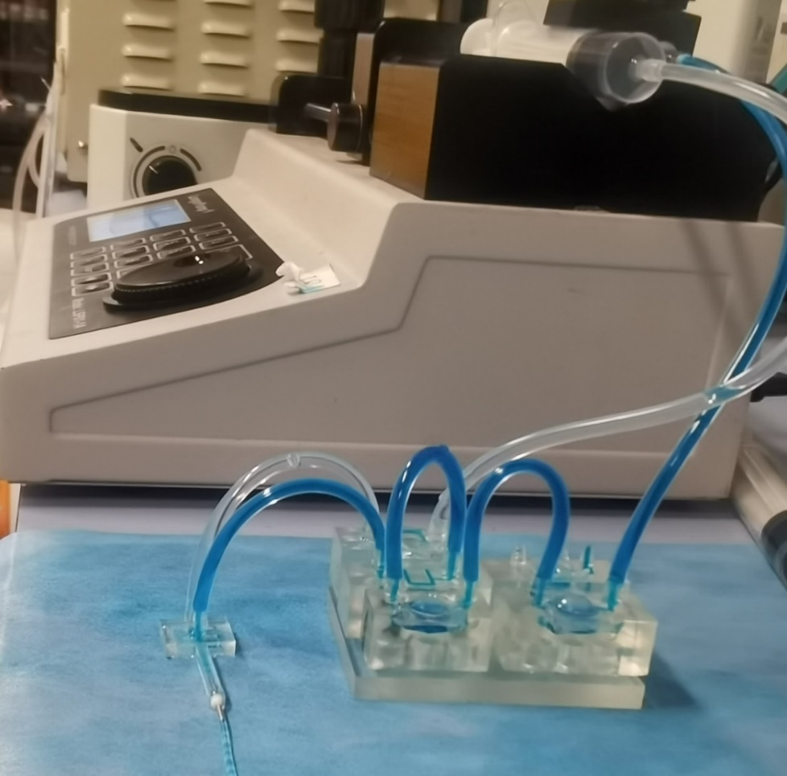
Fig. S4. A photograph of the experiment configuration for droplet generation.
Figure S4 shows a photograph of the fluidic system configuration for droplet generation, which consists of a syringe pump, the microfluidic stabilizer system, and a cross-flow fluidic device for droplet generation. The flowrate ratio of the ink phase and the oil phase is 1:2.

