Extended data figures and tables

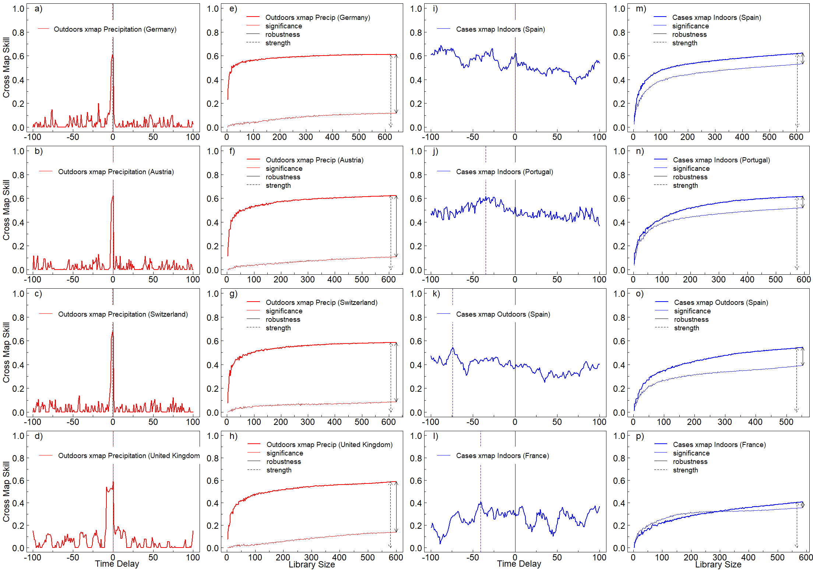
Extended data Fig 1 | Robustness of the casual signal as reflected in TDCCM and CCM representations. Red TDCCM and CCM graphs depict high robustness, while blue ones depict low robust signals. Panels a)-d) depict TDCCM representations for Germany, Austria, Switzerland and the United Kingdom for Outdoors cross map Precipitation. Adjacently, corresponding CCM representations are depicted in panels e)-h). Blue panels i), j) and l) show TDCCM graphs for the Cases xmap Indoors link Spain, Portugal and France, while panel k) shows a TDCCM for Cases xmap Outdoors also for Spain. Figures m)-p) show the mirror CCMs. Red TDCCM graphs show clear causal signals with a narrow, high profile. Their corresponding CCMs have high robustness accordingly. Blue TDCCM representations have less distinct causal signals and low robustness CCMs as a consequence

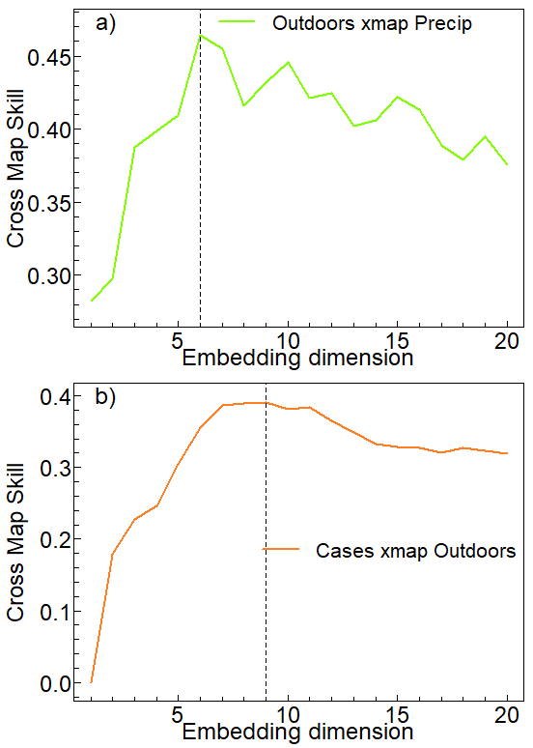
Extended Data Fig 2 | Embedding dimension CCM. Cross map skill at maximum library length as a function of embedding dimension for the corresponding CCM links shown in Figure 1 in the main text. Panel a) (green line) Outdoors cross mapping to Precipitation, showing a maximum cross-prediction at E=6. Panel b) (orange line) Cases cross mapping to Outdoors showing a maximum embedding dimension of E=9.

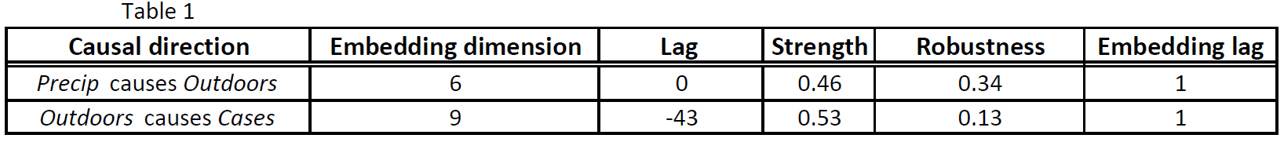
Extended Data Table 1 | CCM parameters for Figure 1. In Figure 1 of the main article, Parameters for CCM include Embedding dimension, lag, strength of causality and robustness.

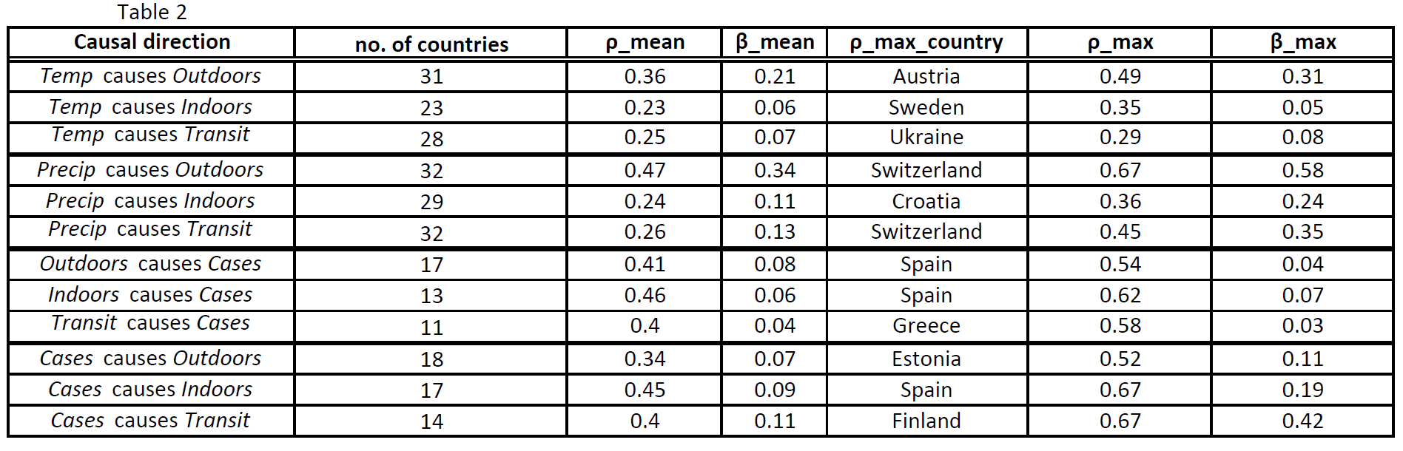
Extended data Table 2 | Statistics of Figure 2. Number of countries, average strength ρ_{mean}, average robustness β_{mean}, country for maximum strength, ρ_{max}, β_{max}

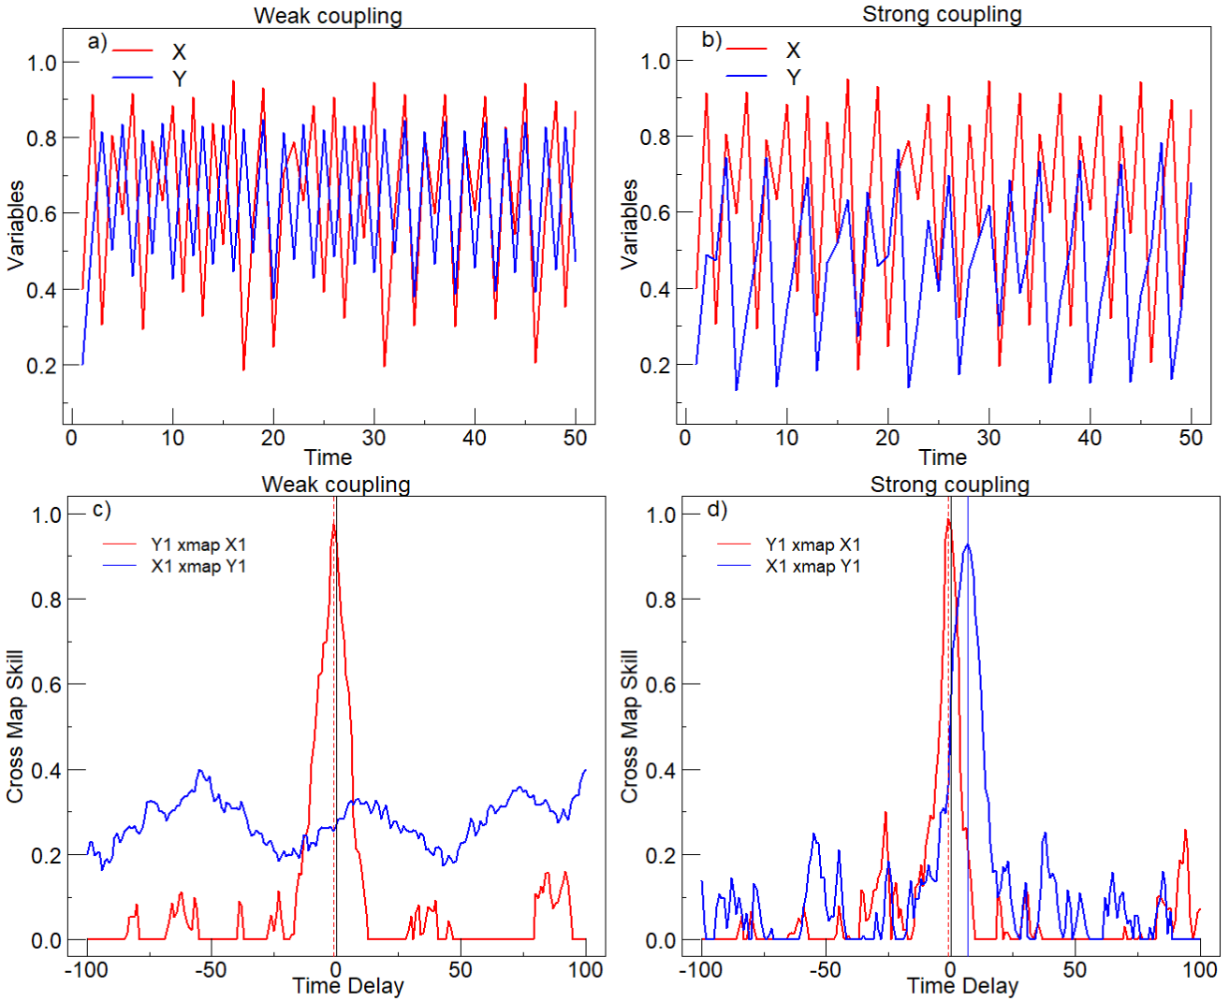

Extended data Fig 3 | TDCCM causal signal in weakly vs strongly coupled model. Panels a) and b) show the first 50 points of the two variables, X and Y, generated with a weakly (a) and strongly (b) coupled model. Panels (c) and (d) depict TDCCM for the two models. Panel (c) shows clear unidirectional forcing for the weakly coupled model, but panel (d) shows also a false reverse causal link associated with a positive lag (blue line).
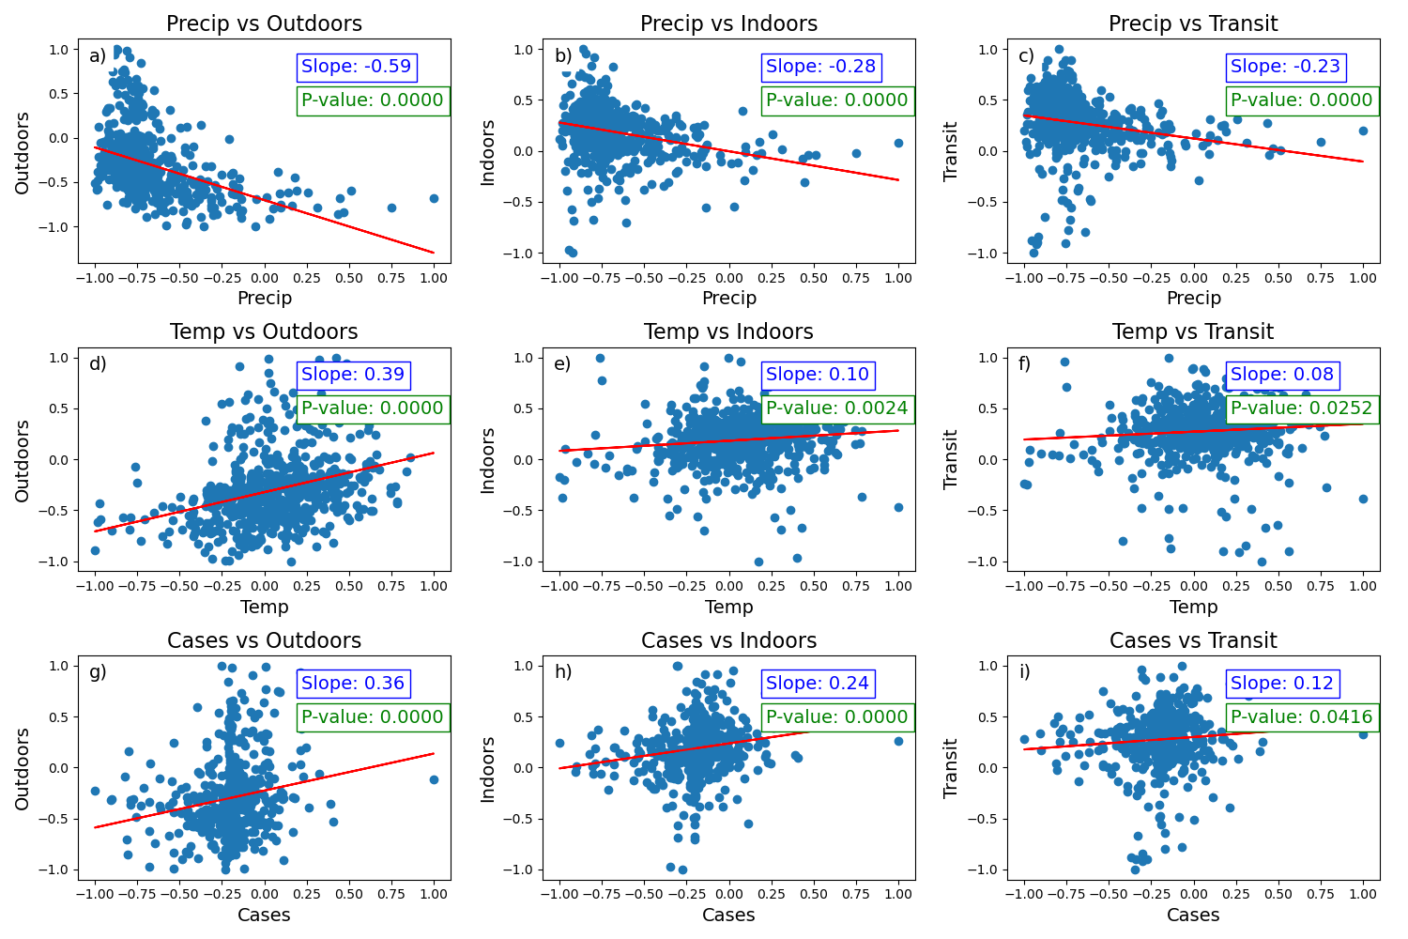
Extended data Fig 4 | Linear correlation for individual links in Bulgaria. Normalized scatter plots for all variables in the causal links analyzed: first row includes Precip vs Outdoors (a), Indoors (b), Transit (c); the second row includes Temp vs. Outdoors (d), Indoors (e), Transit (f); third row includes Cases vs Outdoors (g), Indoors (h), Transit (i); Red lines represent linear fits associated to which is the slope (blue) and the p-value of the fit (green). The same linear correlations were performed for all countries mentioned in the principal material.

