Additional File 1

Additional Results For All Patients And Mild Patients Only With Comparisons Of 2 Mg AD04 Against 1 Mg AD04 And All Other Study Arms Combined
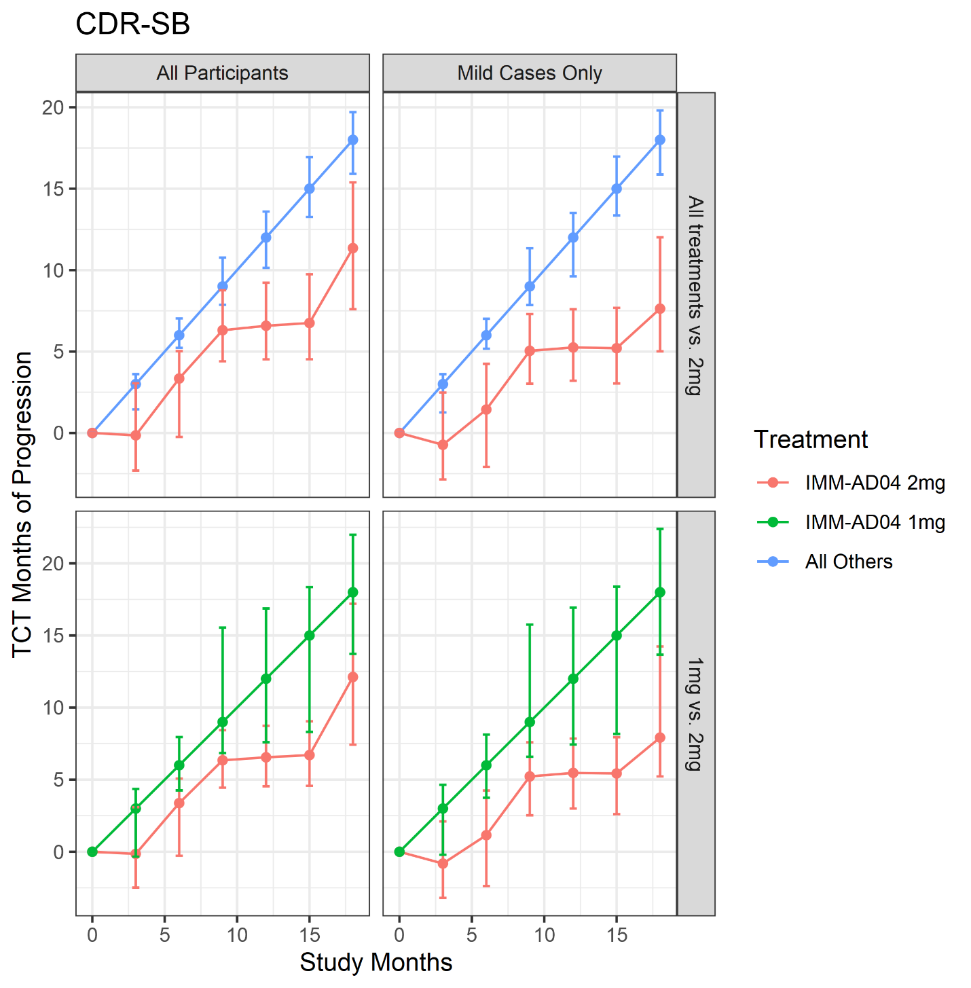
Figure S1A. Mean changes over time in the active vs control group on CDR-sb

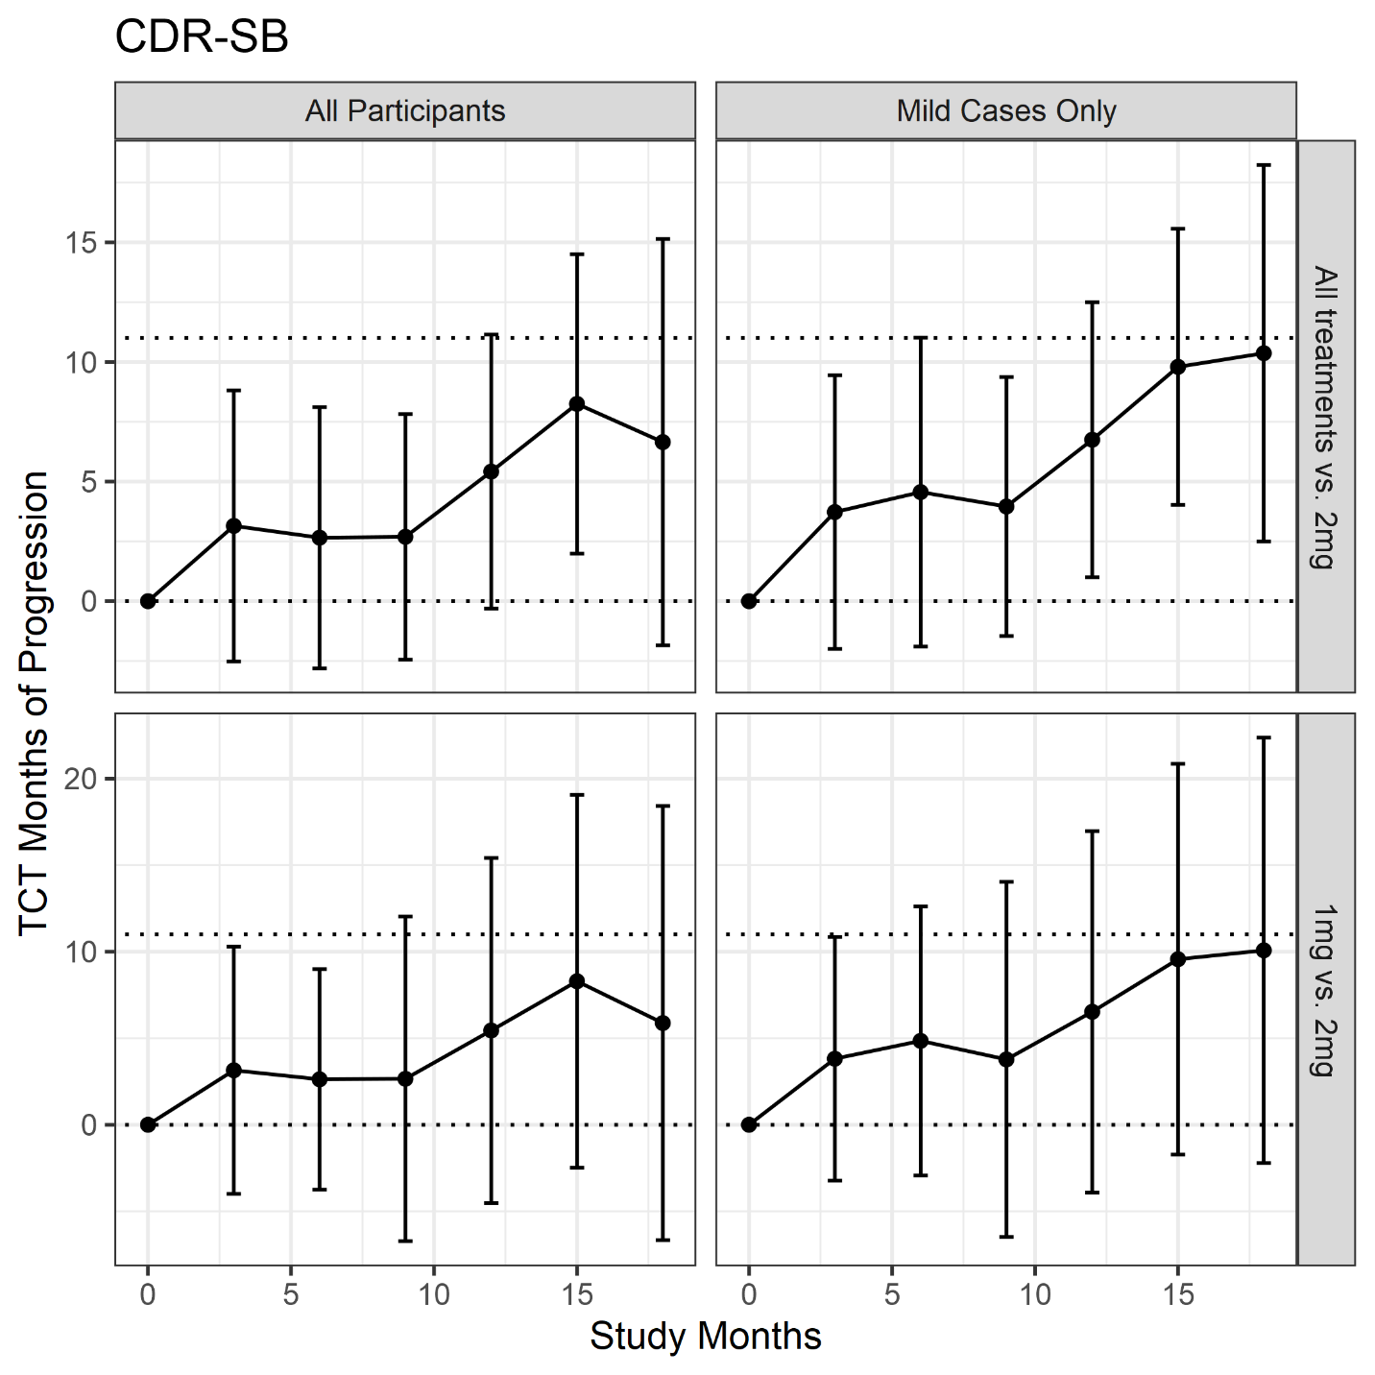
Figure S1B. Time saved with active treatment (i.e., the horizontal difference between study arms) for CDR-sb.
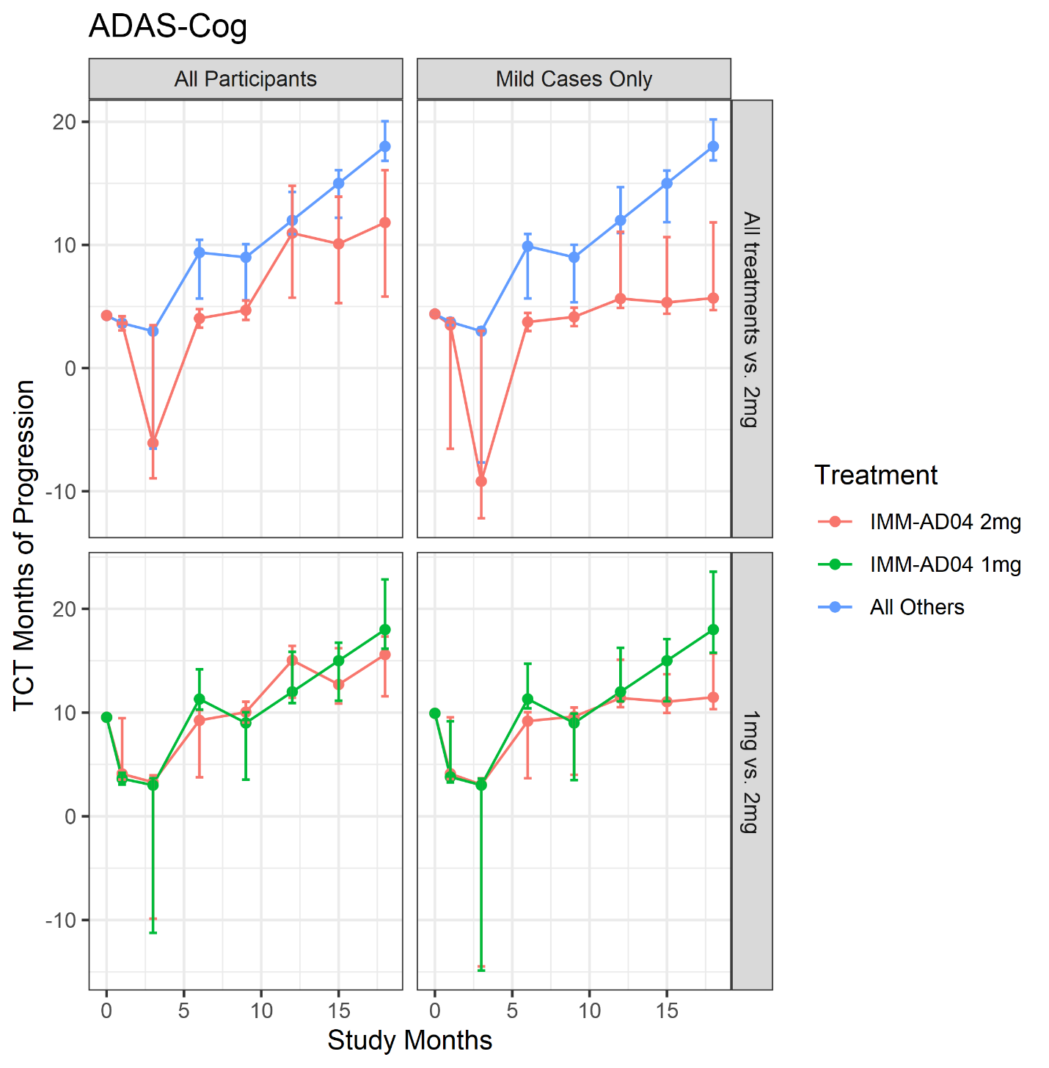
Figure S2A. Mean changes over time in the active vs control group on aADAS-Cog

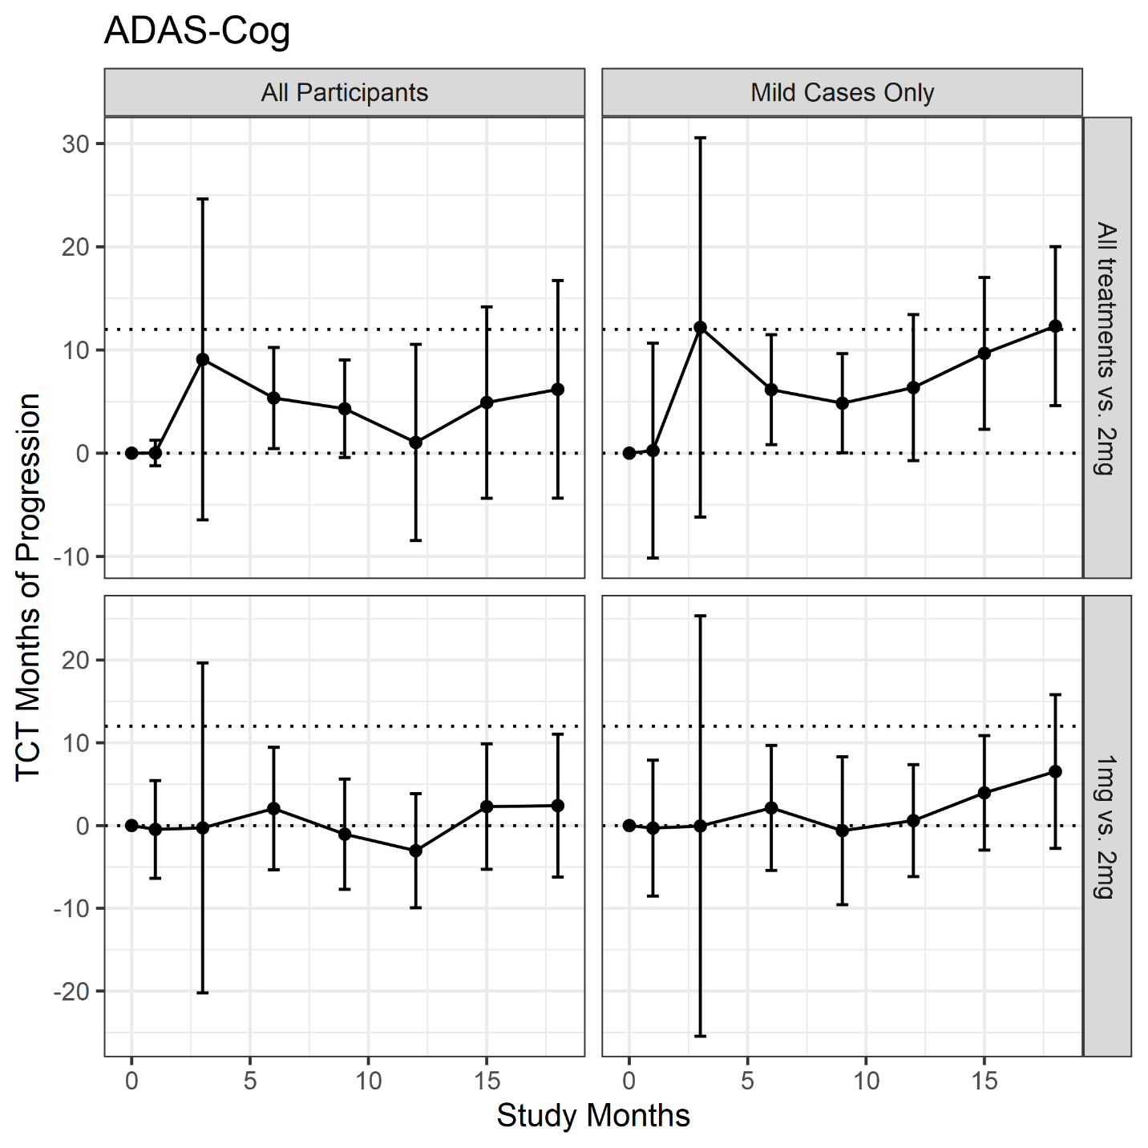
Figure S2B. Time saved with active treatment (i.e., the horizontal difference between study arms) for aADAS-Cog.
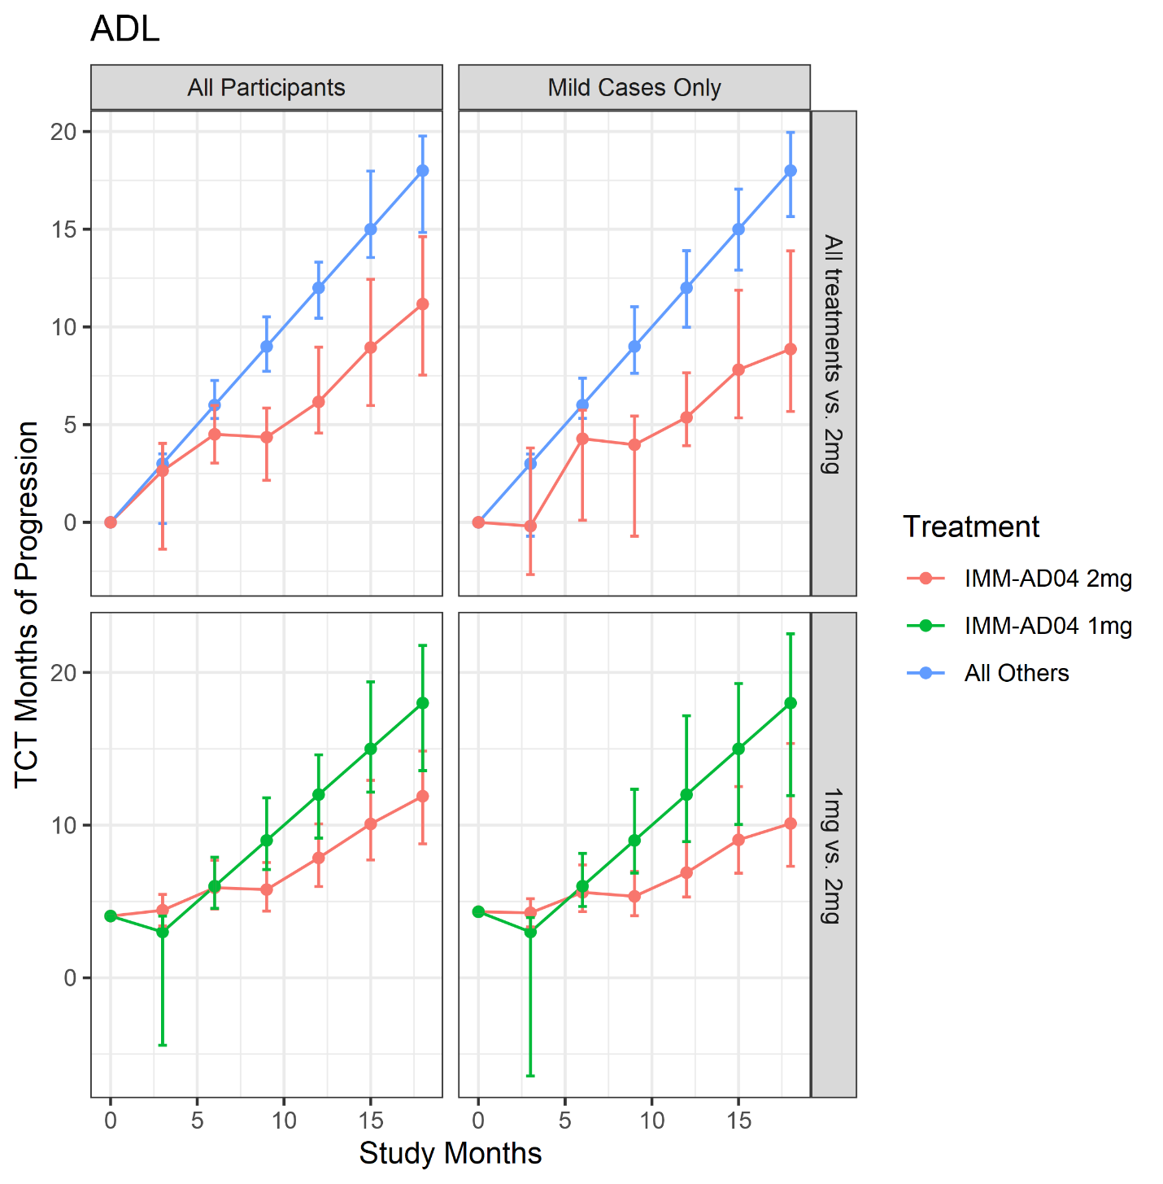
Figure S3A. Mean changes over time in the active vs control group on aADL
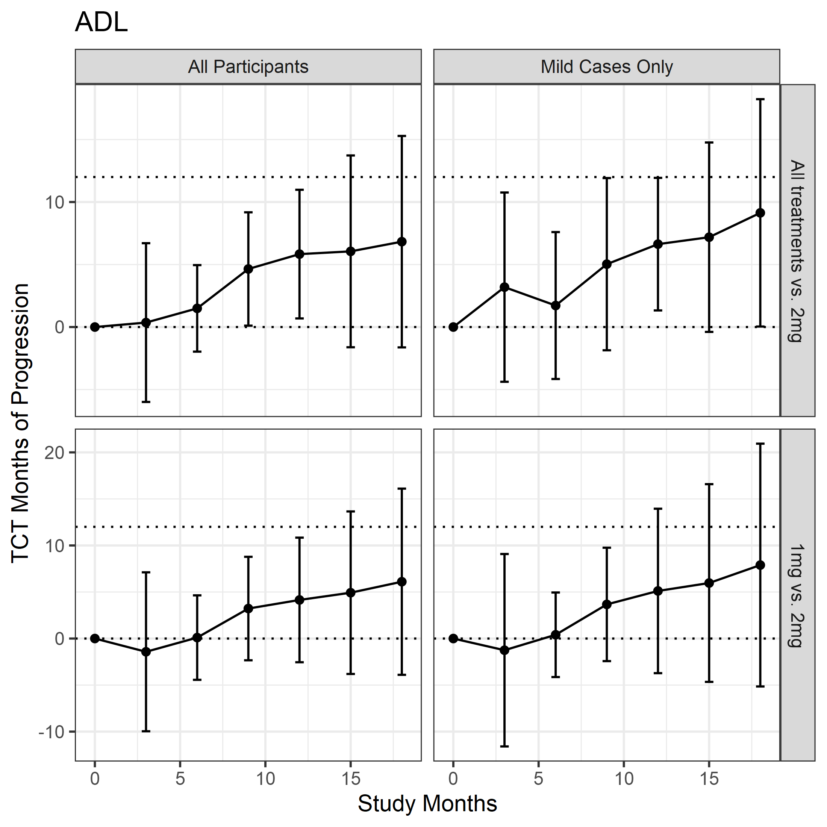
Figure S3B. Time saved with active treatment (i.e., the horizontal difference between study arms) for aADL.

Cohort | Comparison arm | Endpoint | Mean change (SE) to month 18 |  |  |  |  | Mean difference (95% CI) |  | Time saved (months – 95% CI)
Cohort | Comparison arm | Endpoint | 2mg AD04 arm |  |  | Comparison arm |  |  |  | Time saved (months – 95% CI)
All patients | All other study arms | aADAS | 3.04 (1.68) |  |  | 6.69 (0.83) |  | -3.65 (-7.32, 0.02) |  | 8.72 (-1.81, 19.25)
All patients | All other study arms | aADL | -8.32 (2.74) |  |  | -14.19 (1.38) |  | 5.87 (-0.15, 11.88) |  | 9.52 (1.19, 17.86)
All patients | All other study arms | CDR-sb | 1.33 (0.38) |  |  | 1.95 (0.18) |  | -0.61 (-1.45, 0.22) |  | 6.65 (-1.84, 15.14)
All patients | All other study arms | Composite | 2.43 (1.81) |  |  | 6.27 (0.90) |  | -3.85 (-7.82, 0.12) |  | 11.11 (2.22, 20.01)
All patients | All other study arms | ADAS-cog | 3.49 (1.38) |  |  | 5.99 (0.68) |  | -2.51 (-5.52, 0.51) |  | 6.18 (-4.36, 16.72)
All patients | All other study arms | ADCS-ADL | -5.89 (1.72) |  |  | -8.57 (0.84) |  | 2.68 (-1.08, 6.44) |  | 6.83 (-1.63, 15.29)
All patients | All other study arms | gTCT1: aADAS, aADL, and CDR-sb |  |  |  |  |  |  |  | 8.34 (1.18, 15.50)
All patients | All other study arms | gTCT2: CDR-sb and Composite |  |  |  |  |  |  |  | 8.70 (1.32, 16.07)
All patients | All other study arms | gTCT3: ADAS-cog, ADCS-ADL, and CDR-sb |  |  |  |  |  |  |  | 6.63 (-0.70, 13.96)
All patients | 1mg AD04 | aADAS |  | 3.10 (1.68) |  | 6.17 (1.82) |  |  | -3.06 (-7.92, 1.80) | 2.10 (-7.32, 11.52)
All patients | 1mg AD04 | aADL |  | -8.34 (2.76) |  | -14.71 (3.04) |  |  | 6.37 (-1.67, 14.41) | 6.65 (-3.43, 16.74)
All patients | 1mg AD04 | CDR-sb |  | 1.34 (0.38) |  | 1.81 (0.40) |  |  | -0.48 (-1.57, 0.61) | 5.88 (-6.67, 18.43)
All patients | 1mg AD04 | Composite |  | 2.44 (1.82) |  | 6.43 (1.98) |  |  | -3.99 (-9.27, 1.28) | 8.41 (-4.08, 20.89)
All patients | 1mg AD04 | ADAS-cog |  | 3.53 (1.39) |  | 5.45 (1.46) |  |  | -1.91 (-5.86, 2.04) | 2.41 (-6.23, 11.05)
All patients | 1mg AD04 | ADCS-ADL |  | -5.90 (1.73) |  | -8.70 (1.82) |  |  | 2.80 (-2.12, 7.72) | 6.10 (-3.90, 16.11)
All patients | 1mg AD04 | gTCT1: aADAS, aADL, and CDR-sb |  |  |  |  |  |  |  | 4.17 (-3.85, 12.19)
All patients | 1mg AD04 | gTCT2: CDR-sb and Composite |  |  |  |  |  |  |  | 7.15 (-3.48, 17.79)
All patients | 1mg AD04 | gTCT3: ADAS-cog, ADCS-ADL, and CDR-sb |  |  |  |  |  |  |  | 3.80 (-4.06, 11.67)
Mild patients | All other study arms | aADAS |  |  | 1.26 (1.69) |  | 6.57 (0.85) |  | -5.31 (-9.01, -1.61) | 12.56 (6.62, 18.50)
Mild patients | All other study arms | aADL |  |  | -6.71 (2.80) |  | -13.22 (1.40) |  | 6.51 (0.38, 12.64) | 11.24 (3.10, 19.37)
Mild patients | All other study arms | CDR-sb |  |  | 0.89 (0.38) |  | 1.84 (0.18) |  | -0.95 (-1.79, -0.12) | 10.37 (2.50, 18.24)
Mild patients | All other study arms | Composite |  |  | 1.33 (1.83) |  | 6.21 (0.91) |  | -4.88 (-8.89, -0.87) | 12.42 (6.55, 18.29)
Mild patients | All other study arms | ADAS-cog |  |  | 1.83 (1.38) |  | 5.67 (0.69) |  | -3.84 (-6.87, -0.82) | 12.31 (4.61, 20.01)
Mild patients | All other study arms | ADCS-ADL |  |  | -4.62 (1.75) |  | -7.85 (0.85) |  | 3.23 (-0.58, 7.03) | 9.13 (0.04, 18.23)
Mild patients | All other study arms | gTCT1: aADAS, aADL, and CDR-sb |  |  |  |  |  |  |  | 11.95 (6.56, 17.34)
Mild patients | All other study arms | gTCT2: CDR-sb and Composite |  |  |  |  |  |  |  | 11.86 (6.38, 17.35)
Mild patients | All other study arms | gTCT3: ADAS-cog, ADCS-ADL, and CDR-sb |  |  |  |  |  |  |  | 11.08 (4.61, 17.55)
Mild patients | 1mg AD04 | aADAS |  |  | 1.30 (1.69) |  | 5.77 (1.85) |  | -4.47 (-9.38, 0.45) | 7.85 (-4.73, 20.43)
Mild patients | 1mg AD04 | aADL |  |  | -6.70 (2.81) |  | -12.58 (3.12) |  | 5.89 (-2.35, 14.12) | 8.13 (-3.80, 20.06)
Mild patients | 1mg AD04 | CDR-sb |  |  | 0.89 (0.38) |  | 1.66 (0.40) |  | -0.76 (-1.85, 0.33) | 10.08 (-2.22, 22.37)
Mild patients | 1mg AD04 | Composite |  |  | 1.31 (1.84) |  | 5.51 (2.01) |  | -4.20 (-9.54, 1.14) | 9.77 (-0.74, 20.27)
Mild patients | 1mg AD04 | ADAS-cog |  |  | 1.86 (1.38) |  | 4.78 (1.48) |  | -2.92 (-6.89, 1.06) | 6.53 (-2.76, 15.81)
Mild patients | 1mg AD04 | ADCS-ADL |  |  | -4.63 (1.75) |  | -7.38 (1.86) |  | 2.74 (-2.26, 7.75) | 7.89 (-5.15, 20.93)
Mild patients | 1mg AD04 | gTCT1: aADAS, aADL, and CDR-sb |  |  |  |  |  |  |  | 8.55 (-1.13, 18.23)
Mild patients | 1mg AD04 | gTCT2: CDR-sb and Composite |  |  |  |  |  |  |  | 9.88 (0.48, 19.29)
Mild patients | 1mg AD04 | gTCT3: ADAS-cog, ADCS-ADL, and CDR-sb |  |  |  |  |  |  |  | 7.40 (-1.24, 16.04)
Table S1. Summary of mean changes from baseline to 18 months and time saved results for the 2mg AD04 arm as compared with all other study arms combined or the 1mg AD04 arm in the overall patient cohort or in patients with mild Alzheimer’s disease (Baseline MMSE >=20).

Cohort | Comparison arm | Endpoint | Mean change (SE) to month 12 |  |  |  |  | Mean difference (95% CI) |  | Time saved (months – 95% CI)
Cohort | Comparison arm | Endpoint | 2mg AD04 arm |  |  | Comparison arm |  |  |  | Time saved (months – 95% CI)
All patients | All other study arms combined | aADAS | 3.09 (1.39) |  |  | 4.43 (0.65) |  | -1.35 (-4.35, 1.66) |  | 5.93 (-5.00, 16.86)
All patients | All other study arms combined | aADL | -5.27 (2.34) |  |  | -10.35 (1.12) |  | 5.08 (-0.00, 10.16) |  | 6.63 (1.27, 12.00)
All patients | All other study arms combined | CDR-sb | 0.82 (0.34) |  |  | 1.39 (0.16) |  | -0.57 (-1.30, 0.16) |  | 5.42 (-0.31, 11.14)
All patients | All other study arms combined | Composite | 2.51 (1.50) |  |  | 4.01 (0.72) |  | -1.50 (-4.75, 1.75) |  | 4.94 (-4.13, 14.01)
All patients | All other study arms combined | ADAS-cog | 3.09 (1.11) |  |  | 3.57 (0.52) |  | -0.48 (-2.87, 1.91) |  | 1.04 (-8.47, 10.55)
All patients | All other study arms combined | ADCS-ADL | -3.45 (1.47) |  |  | -6.26 (0.68) |  | 2.81 (-0.37, 5.99) |  | 5.83 (0.69, 10.98)
All patients | All other study arms combined | gTCT1: aADAS, aADL, and CDR-sb |  |  |  |  |  |  |  | 6.11 (1.28, 10.93)
All patients | All other study arms combined | gTCT2: CDR-sb and Composite |  |  |  |  |  |  |  | 5.34 (-0.21, 10.88)
All patients | All other study arms combined | gTCT3: ADAS-cog, ADCS-ADL, and CDR-sb |  |  |  |  |  |  |  | 5.53 (0.80, 10.26)
All patients | 1mg AD04 | aADAS |  | 3.07 (1.39) |  | 3.38 (1.46) |  |  | -0.31 (-4.26, 3.64) | 0.21 (-6.49, 6.92)
All patients | 1mg AD04 | aADL |  | -5.22 (2.34) |  | -8.83 (2.56) |  |  | 3.60 (-3.20, 10.41) | 6.04 (-2.05, 14.14)
All patients | 1mg AD04 | CDR-sb |  | 0.82 (0.34) |  | 1.33 (0.35) |  |  | -0.52 (-1.48, 0.45) | 5.45 (-4.53, 15.42)
All patients | 1mg AD04 | Composite |  | 2.51 (1.50) |  | 4.61 (1.65) |  |  | -2.09 (-6.46, 2.27) | 6.02 (-3.30, 15.34)
All patients | 1mg AD04 | ADAS-cog |  | 3.10 (1.10) |  | 2.60 (1.15) |  |  | 0.50 (-2.62, 3.62) | -3.04 (-9.93, 3.85)
All patients | 1mg AD04 | ADCS-ADL |  | -3.45 (1.47) |  | -5.95 (1.53) |  |  | 2.50 (-1.66, 6.66) | 4.15 (-2.55, 10.84)
All patients | 1mg AD04 | gTCT1: aADAS, aADL, and CDR-sb |  |  |  |  |  |  |  | 2.39 (-3.54, 8.33)
All patients | 1mg AD04 | gTCT2: CDR-sb and Composite |  |  |  |  |  |  |  | 5.77 (-2.28, 13.81)
All patients | 1mg AD04 | gTCT3: ADAS-cog, ADCS-ADL, and CDR-sb |  |  |  |  |  |  |  | 0.72 (-4.91, 6.35)
Mild patients | All other study arms combined | aADAS |  |  | 1.66 (1.36) |  | 4.24 (0.64) |  | -2.58 (-5.52, 0.36) | 9.80 (2.75, 16.85)
Mild patients | All other study arms combined | aADL |  |  | -4.24 (2.31) |  | -9.44 (1.11) |  | 5.20 (0.19, 10.21) | 7.17 (0.38, 13.95)
Mild patients | All other study arms combined | CDR-sb |  |  | 0.55 (0.34) |  | 1.27 (0.16) |  | -0.73 (-1.46, 0.01) | 6.75 (1.00, 12.49)
Mild patients | All other study arms combined | Composite |  |  | 1.10 (1.42) |  | 4.20 (0.68) |  | -3.10 (-6.18, -0.02) | 6.57 (0.01, 13.13)
Mild patients | All other study arms combined | ADAS-cog |  |  | 1.77 (1.07) |  | 3.29 (0.50) |  | -1.52 (-3.84, 0.80) | 6.36 (-0.72, 13.43)
Mild patients | All other study arms combined | ADCS-ADL |  |  | -2.57 (1.45) |  | -5.70 (0.68) |  | 3.13 (-0.01, 6.27) | 6.63 (1.33, 11.93)
Mild patients | All other study arms combined | gTCT1: aADAS, aADL, and CDR-sb |  |  |  |  |  |  |  | 7.73 (2.73, 12.72)
Mild patients | All other study arms combined | gTCT2: CDR-sb and Composite |  |  |  |  |  |  |  | 6.68 (1.58, 11.77)
Mild patients | All other study arms combined | gTCT3: ADAS-cog, ADCS-ADL, and CDR-sb |  |  |  |  |  |  |  | 6.61 (1.99, 11.23)
Mild patients | 1mg AD04 | aADAS |  |  | 1.65 (1.35) |  | 3.50 (1.43) |  | -1.84 (-5.70, 2.01) | 1.32 (-5.55, 8.19)
Mild patients | 1mg AD04 | aADL |  |  | -4.22 (2.31) |  | -8.24 (2.55) |  | 4.02 (-2.73, 10.76) | 6.48 (-3.14, 16.10)
Mild patients | 1mg AD04 | CDR-sb |  |  | 0.54 (0.34) |  | 1.18 (0.35) |  | -0.64 (-1.60, 0.33) | 6.53 (-3.92, 16.98)
Mild patients | 1mg AD04 | Composite |  |  | 1.12 (1.42) |  | 4.59 (1.57) |  | -3.47 (-7.62, 0.68) | 9.64 (-0.92, 20.19)
Mild patients | 1mg AD04 | ADAS-cog |  |  | 1.78 (1.07) |  | 2.50 (1.11) |  | -0.72 (-3.74, 2.30) | 0.60 (-6.16, 7.36)
Mild patients | 1mg AD04 | ADCS-ADL |  |  | -2.58 (1.46) |  | -5.55 (1.51) |  | 2.97 (-1.15, 7.09) | 5.11 (-3.72, 13.95)
Mild patients | 1mg AD04 | gTCT1: aADAS, aADL, and CDR-sb |  |  |  |  |  |  |  | 2.91 (-3.41, 9.22)
Mild patients | 1mg AD04 | gTCT2: CDR-sb and Composite |  |  |  |  |  |  |  | 8.06 (-0.73, 16.84)
Mild patients | 1mg AD04 | gTCT3: ADAS-cog, ADCS-ADL, and CDR-sb |  |  |  |  |  |  |  | 2.13 (-4.02, 8.28)
Table S2. Summary of mean changes from baseline to 12 months and time saved results for the 2mg AD04 arm as compared with all other study arms combined or the 1mg AD04 arm in the overall patient cohort or in patients with mild Alzheimer’s disease (Baseline MMSE >=20).

Cohort | Comparison arm | Endpoint | Mean change (SE) to month 6 |  |  |  |  | Mean difference (95% CI) |  | Time saved (months – 95% CI)
Cohort | Comparison arm | Endpoint | 2mg AD04 arm |  |  | Comparison arm |  |  |  | Time saved (months – 95% CI)
All patients | All other study arms combined | aADAS | -1.12 (1.33) |  |  | 2.48 (0.60) |  | -3.60 (-6.46, -0.74) |  | 1.95 (-1.94, 5.83)
All patients | All other study arms combined | aADL | -2.65 (2.16) |  |  | -6.25 (1.04) |  | 3.60 (-1.10, 8.30) |  | 2.31 (-2.16, 6.78)
All patients | All other study arms combined | CDR-sb | 0.27 (0.30) |  |  | 0.74 (0.14) |  | -0.47 (-1.11, 0.17) |  | 2.66 (-2.80, 8.11)
All patients | All other study arms combined | Composite | -1.46 (1.47) |  |  | 2.00 (0.70) |  | -3.46 (-6.66, -0.27) |  | 2.33 (-10.62, 15.28)
All patients | All other study arms combined | ADAS-cog | -0.32 (1.03) |  |  | 2.37 (0.48) |  | -2.69 (-4.91, -0.46) |  | 5.35 (0.45, 10.25)
All patients | All other study arms combined | ADCS-ADL | -1.92 (1.43) |  |  | -3.36 (0.66) |  | 1.44 (-1.64, 4.52) |  | 1.49 (-1.97, 4.95)
All patients | All other study arms combined | gTCT1: aADAS, aADL, and CDR-sb |  |  |  |  |  |  |  | 2.18 (-1.05, 5.41)
All patients | All other study arms combined | gTCT2: CDR-sb and Composite |  |  |  |  |  |  |  | 2.63 (-2.72, 7.98)
All patients | All other study arms combined | gTCT3: ADAS-cog, ADCS-ADL, and CDR-sb |  |  |  |  |  |  |  | 2.50 (-0.63, 5.62)
All patients | 1mg AD04 | aADAS |  | -1.14 (1.34) |  | 1.41 (1.39) |  |  | -2.55 (-6.33, 1.23) | 5.31 (-4.97, 15.59)
All patients | 1mg AD04 | aADL |  | -2.62 (2.17) |  | -5.30 (2.34) |  |  | 2.68 (-3.58, 8.94) | 1.50 (-4.59, 7.59)
All patients | 1mg AD04 | CDR-sb |  | 0.27 (0.30) |  | 0.73 (0.30) |  |  | -0.46 (-1.29, 0.38) | 2.63 (-3.75, 9.00)
All patients | 1mg AD04 | Composite |  | -1.49 (1.48) |  | 1.56 (1.60) |  |  | -3.06 (-7.33, 1.21) | 2.04 (-12.01, 16.10)
All patients | 1mg AD04 | ADAS-cog |  | -0.31 (1.04) |  | 1.86 (1.08) |  |  | -2.17 (-5.10, 0.75) | 2.05 (-5.35, 9.45)
All patients | 1mg AD04 | ADCS-ADL |  | -1.90 (1.43) |  | -2.00 (1.49) |  |  | 0.10 (-3.94, 4.14) | 0.10 (-4.44, 4.64)
All patients | 1mg AD04 | gTCT1: aADAS, aADL, and CDR-sb |  |  |  |  |  |  |  | 2.26 (-2.75, 7.26)
All patients | 1mg AD04 | gTCT2: CDR-sb and Composite |  |  |  |  |  |  |  | 2.57 (-3.64, 8.77)
All patients | 1mg AD04 | gTCT3: ADAS-cog, ADCS-ADL, and CDR-sb |  |  |  |  |  |  |  | 0.94 (-3.17, 5.04)
Mild patients | All other study arms combined | aADAS |  |  | -1.91 (1.33) |  | 2.32 (0.61) |  | -4.22 (-7.08, -1.36) | 2.24 (-1.86, 6.33)
Mild patients | All other study arms combined | aADL |  |  | -1.76 (2.21) |  | -6.12 (1.06) |  | 4.36 (-0.44, 9.17) | 2.71 (-2.84, 8.25)
Mild patients | All other study arms combined | CDR-sb |  |  | 0.08 (0.30) |  | 0.67 (0.14) |  | -0.59 (-1.23, 0.05) | 4.56 (-1.89, 11.01)
Mild patients | All other study arms combined | Composite |  |  | -2.20 (1.51) |  | 1.97 (0.72) |  | -4.17 (-7.45, -0.89) | 2.73 (-12.14, 17.60)
Mild patients | All other study arms combined | ADAS-cog |  |  | -0.92 (1.04) |  | 2.27 (0.48) |  | -3.20 (-5.44, -0.95) | 6.15 (0.83, 11.48)
Mild patients | All other study arms combined | ADCS-ADL |  |  | -1.47 (1.47) |  | -3.20 (0.68) |  | 1.73 (-1.45, 4.90) | 1.72 (-4.16, 7.60)
Mild patients | All other study arms combined | gTCT1: aADAS, aADL, and CDR-sb |  |  |  |  |  |  |  | 2.71 (-0.91, 6.32)
Mild patients | All other study arms combined | gTCT2: CDR-sb and Composite |  |  |  |  |  |  |  | 4.39 (-1.91, 10.69)
Mild patients | All other study arms combined | gTCT3: ADAS-cog, ADCS-ADL, and CDR-sb |  |  |  |  |  |  |  | 4.49 (0.29, 8.70)
Mild patients | 1mg AD04 | aADAS |  |  | -1.92 (1.33) |  | 1.03 (1.40) |  | -2.95 (-6.74, 0.83) | 5.36 (-4.80, 15.53)
Mild patients | 1mg AD04 | aADL |  |  | -1.73 (2.21) |  | -5.19 (2.42) |  | 3.45 (-2.97, 9.88) | 1.71 (-4.85, 8.27)
Mild patients | 1mg AD04 | CDR-sb |  |  | 0.08 (0.30) |  | 0.61 (0.31) |  | -0.54 (-1.37, 0.30) | 4.85 (-2.93, 12.63)
Mild patients | 1mg AD04 | Composite |  |  | -2.24 (1.52) |  | 0.90 (1.66) |  | -3.14 (-7.54, 1.26) | 2.08 (-15.50, 19.65)
Mild patients | 1mg AD04 | ADAS-cog |  |  | -0.91 (1.04) |  | 1.67 (1.09) |  | -2.57 (-5.54, 0.39) | 2.13 (-5.41, 9.68)
Mild patients | 1mg AD04 | ADCS-ADL |  |  | -1.48 (1.47) |  | -1.95 (1.54) |  | 0.47 (-3.71, 4.64) | 0.40 (-4.14, 4.95)
Mild patients | 1mg AD04 | gTCT1: aADAS, aADL, and CDR-sb |  |  |  |  |  |  |  | 3.23 (-2.38, 8.83)
Mild patients | 1mg AD04 | gTCT2: CDR-sb and Composite |  |  |  |  |  |  |  | 4.58 (-3.01, 12.17)
Mild patients | 1mg AD04 | gTCT3: ADAS-cog, ADCS-ADL, and CDR-sb |  |  |  |  |  |  |  | 1.26 (-3.00, 5.51)
Table S3. Summary of mean changes from baseline to 6 months and time saved results for the 2mg AD04 arm as compared with all other study arms combined or the 1mg AD04 arm in the overall patient cohort or in patients with mild Alzheimer’s disease (Baseline MMSE >=20).

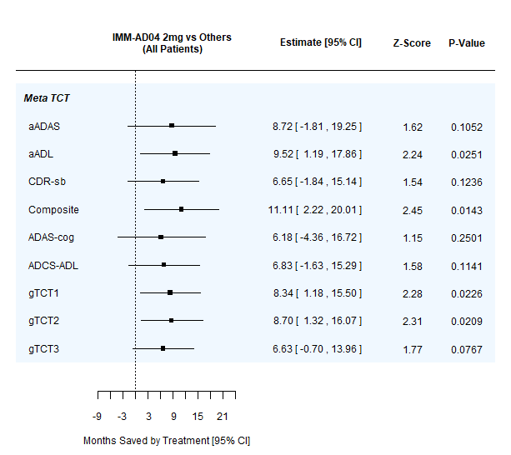 | 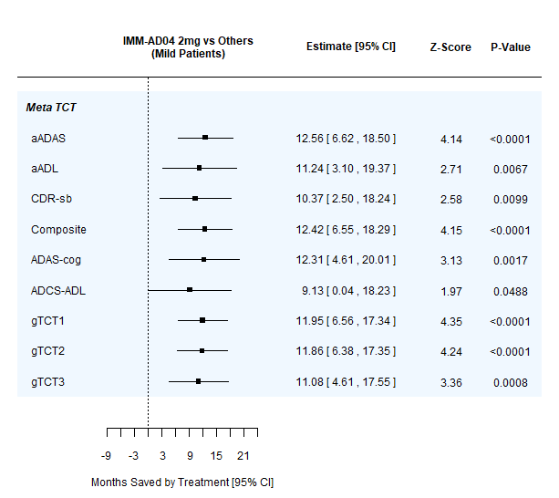
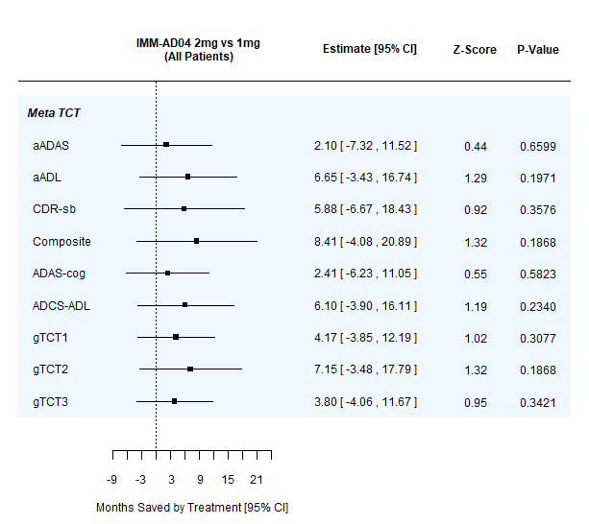 | 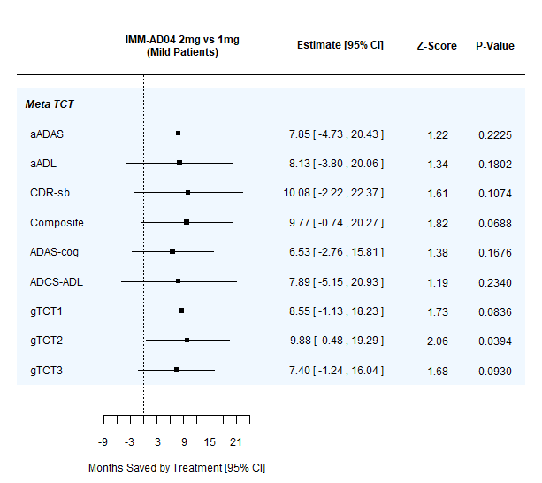
Table S4. Forest plots summarizing time savings analyses at 18 months; left panels show full patient cohort, right panels show mild Alzheimer’s subgroup (baseline MMSE >=20); upper panels show 2mg AD04 vs. other treatment arms combined, lower panels show 2mg AD04 vs. 1mg AD04.

