Table 5 Transition of different ecological risk type from 1998 to 2013 in the study area
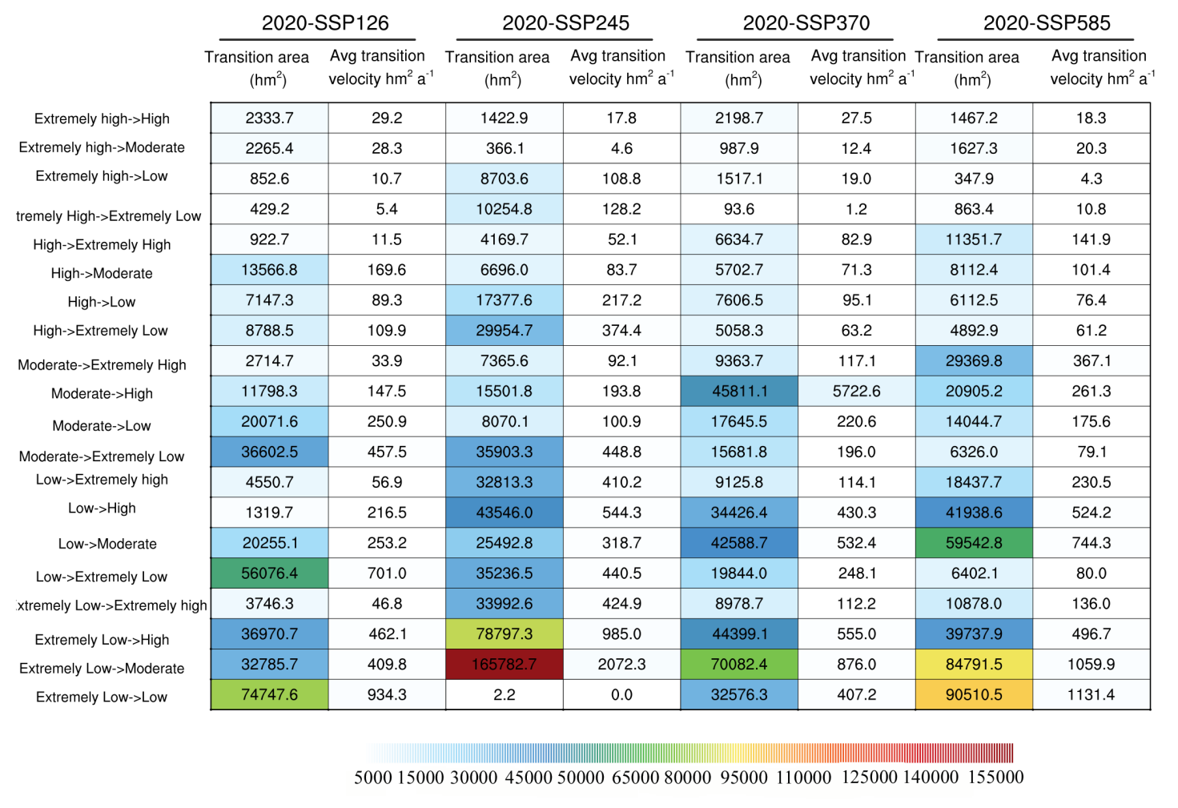
12:Extremely low risk->Low risk; 13:Extremely low risk->Moderate risk; 14:Extremely Low risk->High risk; 15:Extremely low risk->Extremely high risk
21:Low risk->Extremely low risk; 23:Low risk->Moderate risk; 24:Low risk->High risk; 25:Low risk->Extremelyhigh risk
31:Moderate risk->Extremely low risk; 32:Moderate risk->Low risk; 34:Moderate risk->High risk; 35:Moderate risk->Extremelyhigh risk 35:Moderate risk->Extremely high risk
41:High risk->Extremely low risk; 42:High risk->Low risk; 43:High risk->Moderate risk; 45:High risk->Extremely high risk
51:Extremely high risk->Extremely low risk; 52:Extremely high risk->Low risk 53 Extremely high risk->Moderate risk 54:Extremely high risk->High risk

