SUPPLEMENTAL MATERIAL
Safety run-in
The initial safety run-in consisted of six patients being treated with the BCR drug regimen at a cyclophosphamide dose level of 250mg/m². The study would only proceed to the randomised stage if no treatment-related death occurred and one or fewer patients experienced dose-limiting toxicity, defined as: febrile neutropenia or infection requiring antibiotics in the presence of grade 3 or 4 neutropenia; grade 3 or 4 neuropathy; failure to start cycle 2 on time due to grade 3 or 4 haematological toxicity; any other treatment-related non-haematological toxicity of grade 2 or higher. A further six patients could be treated with BCR at a reduced cyclophosphamide dose of 200mg/m², and then 150mg/m², if excess toxicity was observed.

Efficacy in the FCR internal control arm (N=17)
End of treatment ORR in the FCR group (N=17) was 82.4% (95% CI: 56.6-96.2): 3 (17.6%) VGPR, 10 (58.8%) PR and 1 (5.9%) MR, 2 (11.8%) SD and 1 (5.9%) patient stopped early due to toxicity. The median relative change from baseline in serum IgM was -90.7% (range: -99.6% to -20.0%) in the FCR group. The median time to a 50% reduction in serum IgM was 3.1 months (95% CI: 2.2-5.5) and median time to best response was 23.2 months (95% CI: 12.9-29.7).
Two- and 3-year PFS rates in the FCR group are 81.3% (95% CI: 52.5-93.5) and 61.4% (95% CI: 33.3-80.5) respectively; one FCR patient received further treatment for progression, rituximab and bendamustine. Seven (41.2%) FCR patients have died: myelodysplasia (n=2), sepsis as a consequence of myelodysplasia chemotherapy, lung adenocarcinoma, infective endocarditis, paraneoplastic syndrome, and one cause unknown. Two- and 3-year OS rates are 81.3% (95% CI: 52.5-93.5) and 61.4% (95% CI: 33.3-80.5) respectively. Censoring non-WM deaths, in patients whose disease had not progressed, 2- and 3-year TTP rates in the FCR group are 100% (95% CI: 75.3-100) and 100% (95% CI: 66.4-100).

Supplementary Table 1.
Recruiting sites – registered patients (N=60)
Recruiting Site | Patients Registered  (N=60)
St James's University Hospital | 7 (12%)
Colchester General Hospital | 5 (8%)
Good Hope Hospital, Birmingham | 4 (7%)
Kings College Hospital | 4 (7%)
Royal Devon and Exeter Hospital | 4 (7%)
Heartlands Hospital, Birmingham | 3 (5%)
Leicester Royal Infirmary | 3 (5%)
Maidstone and Tunbridge Wells, Maidstone Hospital | 3 (5%)
Royal Liverpool University Hospital | 3 (5%)
Sandwell General Hospital, Sandwell | 3 (5%)
St Bartholomew's Hospital, London | 3 (5%)
BHRUH Queen's Hospital, Romford | 2 (3%)
Musgrove Park Hospital | 2 (3%)
Torbay District General Hospital | 2 (3%)
University College London Hospital | 2 (3%)
Worthing Hospital | 2 (3%)
Basingstoke and North Hampshire Hospital | 1 (2%)
Darent Valley Hospital | 1 (2%)
Derriford Hospital | 1 (2%)
Grantham and District Hospital | 1 (2%)
Northwick Park Hospital | 1 (2%)
Royal Hampshire County Hospital | 1 (2%)
Royal United Hospital | 1 (2%)
Salisbury District Hospital | 1 (2%)

Supplementary Table 2.
Baseline characteristics – registered patients (N=60)

Baseline Characteristic | BCR  (N=43) | FCR  (N=17) | Total  (N=60)
Age in years, median (range) | 67 (43,78) | 67 (44,87) | 67 (43,87)
Gender, n (%)  Female  Male | 14 (33%)  29 (67%) | 2 (12%)  15 (88%) | 16 (27%)  44 (73%)
IPSSWM risk group, n (%)  Low  Intermediate  High | 12 (28%)  12 (28%)  19 (44%) | 4 (24%)  5 (29%)  8 (47%) | 16 (27%)  17 (28%)  27 (45%)
ECOG performance status, n (%)  0  1  2 | 18 (42%)  23 (53%)  2 (5%) | 9 (53%)  6 (35%)  2 (12%) | 27 (45%)  29 (48%)  4 (7%)
Lymphadenopathy present, n (%)  Hepatomegaly present, n (%)  Splenomegaly present, n (%)  B Symptoms present, n (%)  Signs of hyperviscosity present, n (%)  Peripheral neuropathy present, n (%) | 12 (28%)  2 (5%)  7 (16%)  9 (21%)  28 (65%)  8 (19%) | 6 (35%)  2 (12%)  2 (12%)  4 (24%)  10 (59%)  0 (0%) | 18 (30%)  4 (7%)  9 (15%)  13 (22%)  38 (63%)  8 (13%)
White blood cell x10⁹/L, median (range) | 6.2 (2.8,10.5) | 5.3 (2.8,7.7) | 5.6 (2.8,10.5)
Platelets x10⁹/L, median (range) | 200.0 (4.0,510.0) | 229.0 (44.0,437.0) | 204.0 (4.0,510.0)
Haemoglobin g/dL, median (range) | 9.8 (6.5,14.0) | 9.8 (7.5,13.4) | 9.8 (6.5,14.0)
Absolute neutrophil count x10⁹/L, median (range) | 3.3 (1.4,7.2) | 2.9 (1.0,4.6) | 3.3 (1.0,7.2)
Lymphocytes x10⁹/L, median (range) | 1.7 (0.1,4.1) | 1.6 (0.9,3.5) | 1.6 (0.1,4.1)
Serum IgM paraprotein g/L, median (range) | 32.0 (3.2,80.2) | 37.0 (6.3,63.9) | 34.0 (3.2,80.2)

Supplementary Table 3.
Maximum grade 3-5 adverse events – patients who started trial treatment (N=59)
Adverse Event | BCR  (N=42) | FCR  (N=17) | Total  (N=59)
Neutrophil count decreased | 11* (26%) | 13† (76%) | 24 (41%)
Platelet count decreased | 6** (14%) | 6*** (35%) | 13 (22%)
Anaemia | 5 (12%) | 3 (18%) | 8 (14%)
Febrile neutropenia | 1 (2%) | 5* (29%) | 7 (12%)
Rituximab infusion reaction | 1 (2%) | 1* (6%) | 2 (3%)
Hyponatremia | 0 (0%) | 2 (12%) | 2 (3%)
Diarrhoea | 2 (5%) | 0 (0%) | 2 (3%)
Pain | 2 (5%) | 0 (0%) | 2 (3%)
Sepsis | 0 (0%) | 1 x grade 5 (6%) | 1 (2%)
Alanine aminotransferase increased | 0 (0%) | 1 (6%) | 1 (2%)
Lymphocyte count decreased | 0 (0%) | 1 (6%) | 1 (2%)
Orchitis | 0 (0%) | 1 (6%) | 1 (2%)
Upper respiratory infection | 0 (0%) | 1 (6%) | 1 (2%)
Back pain | 1 (2%) | 0 (0%) | 1 (2%)
Hearing impairment | 1 (2%) | 0 (0%) | 1 (2%)
Heart failure | 1 (2%) | 0 (0%) | 1 (2%)
Hypertension | 1 (2%) | 0 (0%) | 1 (2%)
Hypotension | 1 (2%) | 0 (0%) | 1 (2%)
Lung infection | 1 (2%) | 0 (0%) | 1 (2%)
Neoplasms benign, malignant and unspecified | 1 (2%) | 0 (0%) | 1 (2%)
Renal impairment | 1 (2%) | 0 (0%) | 1 (2%)
HIGHEST GRADE TOXICITY  3  4  5 | 24 (57%)  3 (7%)  0 (0%) | 0 (0%)  12 (71%)  1 (6%) | 24 (41%)  15 (25%)  1 (2%)
ANY GRADE 3-5 TOXICITY | 27 (64%) | 13 (76%) | 40 (68%)
*including 1x grade 4; **2x grade 4; ***3x grade 4; †12x grade 4
Supplementary Table 4.
Quality of life at baseline and end of treatment (A), and change from baseline (B) – eligible patients who started trial treatment (N=58)
(ST 4A)
EQ-5D | BCR (N=41) |  | FCR (N=17) |  | Total (N=58)
EQ-5D | Baseline | End of Treatment | Baseline | End of Treatment | Baseline | End of Treatment
EQ visual analogue score  (scale: 0-100)  median (range)  missing | 70 (10,100)  4 | 80 (30,100)  8 | 80 (20,100)  1 | 81 (55,100)  5 | 70 (10,100)  5 | 80 (30,100)  13
Mobility, n (%)  No problems  Some problems  Extreme problems  missing | 24 (67%)  12 (33%)  0 (0%)  5 | 24 (69%)  11 (31%)  0 (0%)  6 | 13 (81%)  3 (19%)  0 (0%)  1 | 12 (92%)  1 (8%)  0 (0%)  4 | 37 (71%)  15 (29%)  0 (0%)  6 | 36 (75%)  12 (12%)  0 (0%)  10
Self-care, n (%)  No problems  Some problems  Extreme problems  missing | 34 (94%)  2 (6%)  0 (0%)  5 | 31 (89%)  4 (11%)  0 (0%)  6 | 15 (94%)  1 (6%)  0 (0%)  1 | 13 (100%)  0 (0%)  0 (0%)  4 | 49 (94%)  3 (6%)  0 (0%)  6 | 44 (92%)  4 (8%)  0 (0%)  10
Usual activities, n (%)  No problems  Some problems  Extreme problems  missing | 17 (47%)  17 (47%)  2 (6%)  5 | 22 (63%)  12 (34%)  1 (3%)  6 | 14 (88%)  2 (13%)  0 (0%)  1 | 10 (77%)  3 (23%)  0 (0%)  4 | 31 (60%)  19 (37%)  2 (4%)  6 | 32 (67%)  15 (31%)  1 (2%)  10
Pain/discomfort, n (%)  No problems  Some problems  Extreme problems  missing | 17 (47%)  19 (53%)  0 (0%)  5 | 20 (57%)  12 (34%)  3 (9%)  6 | 12 (75%)  4 (25%)  0 (0%)  1 | 9 (69%)  4 (31%)  0 (0%)  4 | 29 (56%)  23 (44%)  0 (0%)  6 | 29 (60%)  16 (33%)  3 (6%)  10
Anxiety/depression, n (%)  No problems  Some problems  Extreme problems  missing | 22 (61%)  14 (39%)  0 (0%)  5 | 27 (77%)  8 (23%)  0 (0%)  6 | 12 (75%)  4 (25%)  0 (0%)  1 | 11 (85%)  2 (15%)  0 (0%)  4 | 34 (65%)  18 (35%)  0 (0%)  6 | 38 (79%)  10 (21%)  0 (0%)  10

(ST 4B)
Change from baseline in EQ-5D  (End of Treatment - Baseline) | BCR (N=41) | FCR (N=17) | Total (N=58)
EQ visual analogue score (scale: 0-100)  median (range)  missing | 15 (-50,70)  8 | 6 (-40,79)  5 | 15 (-50,79)  13
Mobility, n (%)  Improvement  No change  Deterioration  missing | 6 (18%)  23 (68%)  5 (15%)  7 | 2 (15%)  10 (77%)  1 (8%)  4 | 8 (17%)  33 (70%)  6 (13%)  11
Self-care, n (%)  Improvement  No change  Deterioration  missing | 1 (3%)  30 (88%)  3 (9%)  7 | 1 (8%)  12 (92%)  0 (0%)  4 | 2 (4%)  42 (89%)  3 (6%)  11
Usual activities, n (%)  Improvement  No change  Deterioration  missing | 10 (29%)  20 (59%)  4 (12%)  7 | 1 (8%)  10 (77%)  2 (15%)  4 | 11 (23%)  30 (64%)  6 (13%)  11
Pain/discomfort, n (%)  Improvement  No change  Deterioration  missing | 5 (15%)  24 (71%)  5 (15%)  7 | 2 (15%)  8 (62%)  3 (23%)  4 | 7 (15%)  32 (68%)  8 (17%)  11
Anxiety/depression, n (%)  Improvement  No change  Deterioration  missing | 6 (18%)  26 (76%)  2 (6%)  7 | 2 (15%)  10 (77%)  1 (8%)  4 | 8 (17%)  36 (77%)  3 (6%)  11

Supplementary Figure 1.
Progression-Free Survival (A), Overall Survival (B) and Time-To-Progression (C) – eligible patients who started trial treatment (N=58)
(SF 1A)
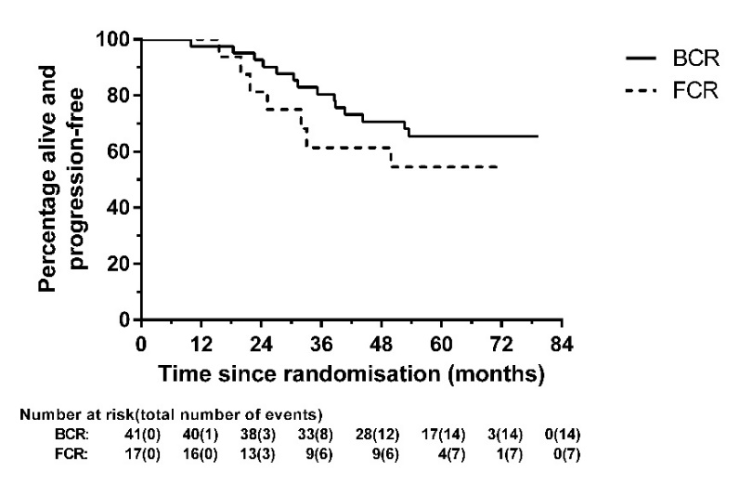
(SF 1B)
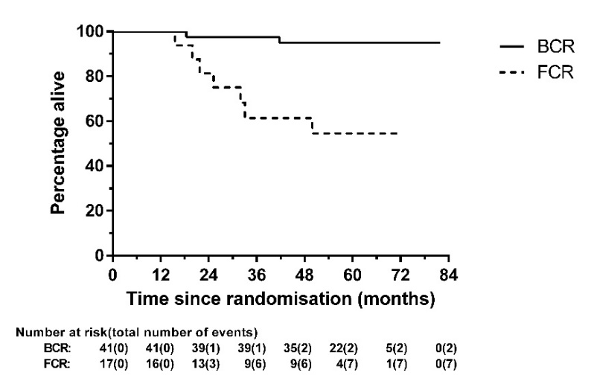
(SF 1C)
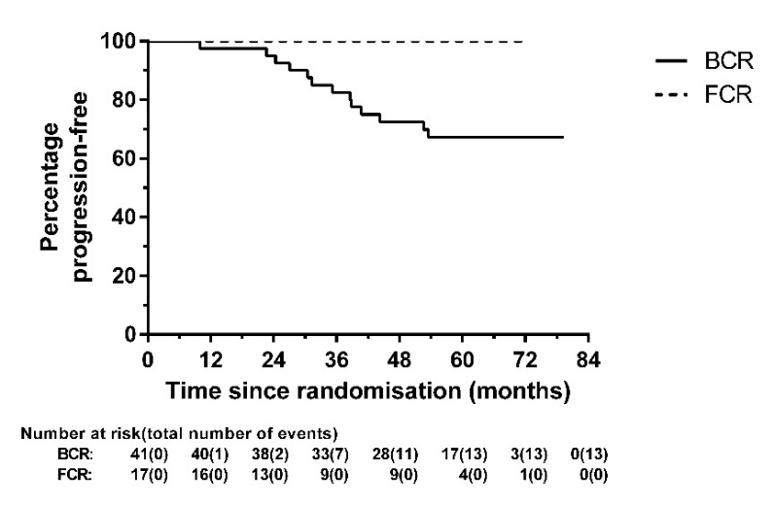

Supplementary Figure 2.
Progression-Free Survival by BM B-cell depletion after cycle 3 (A) and at the end of treatment (B) – eligible patients who started trial treatment (N=58, where available)
(SF 2A)
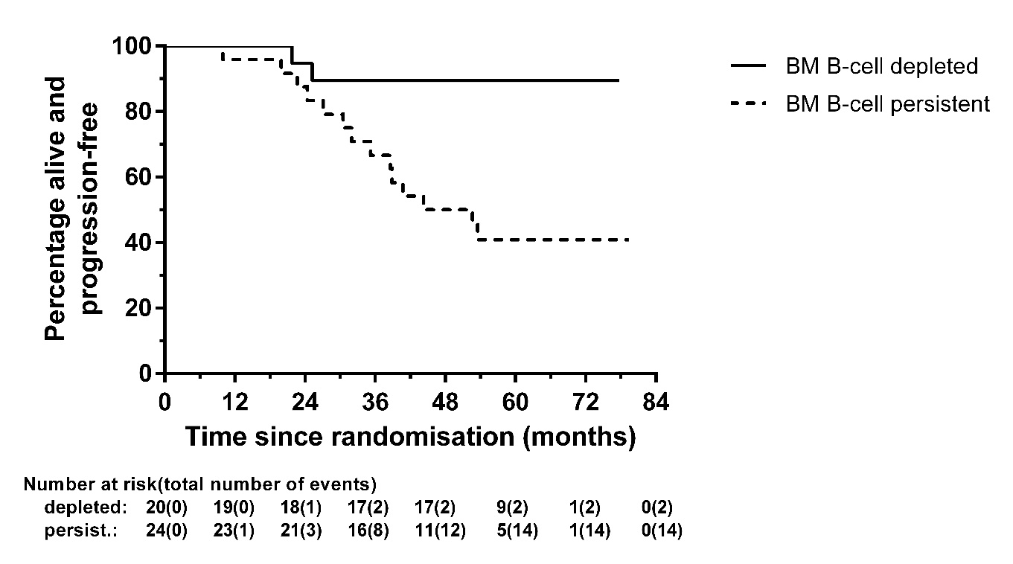
(SF 2B)
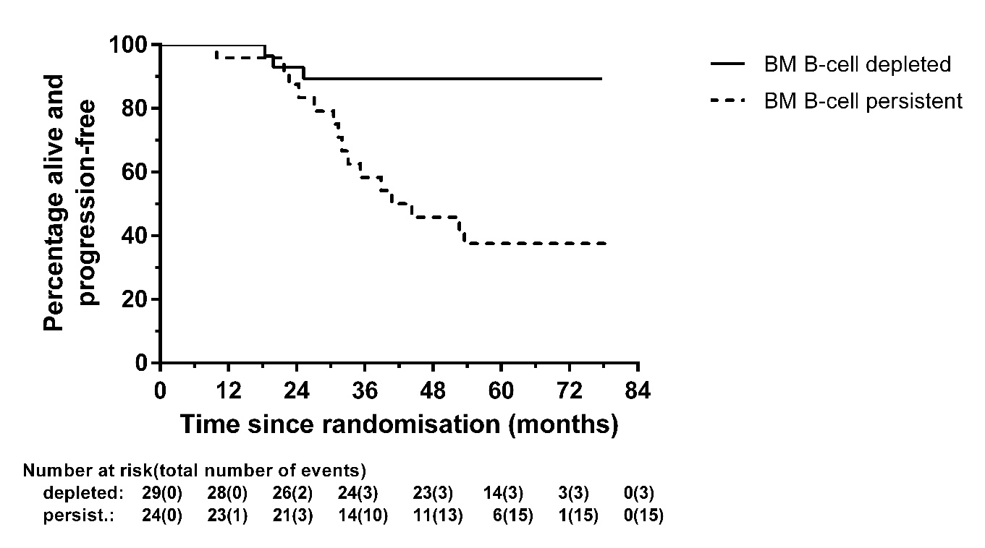

Supplementary Figure 3.
Progression-Free Survival by baseline IPSSWM criteria (A) and by end of treatment investigator-assessed response (B) – eligible patients who started trial treatment (N=58)
(SF 3A)
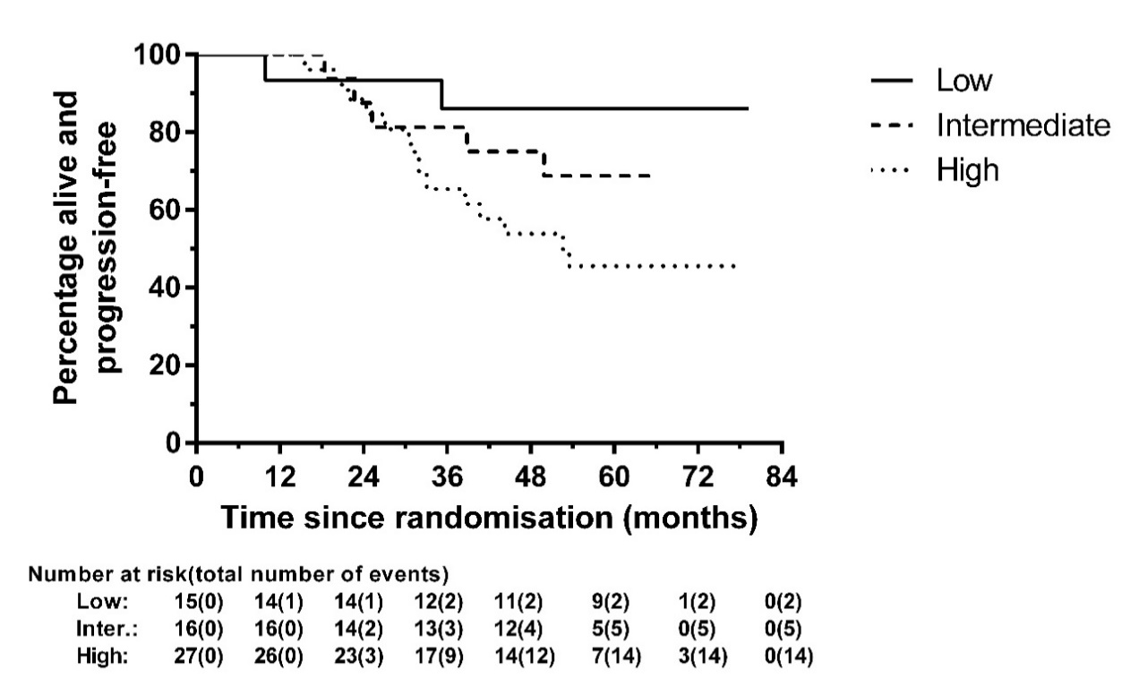
(SF 3B)
