Supplementary materials
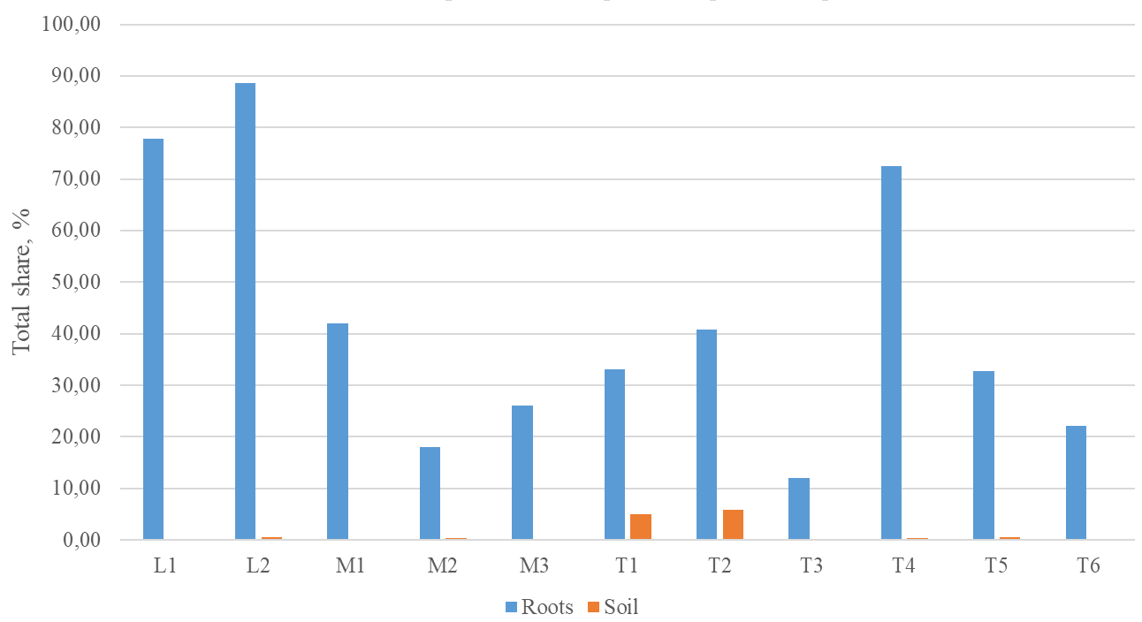
Figure S1. Shares of Ceratobasidiaceae mycobionts in G. repens roots and soil (for designation of sample sites see Table 1)

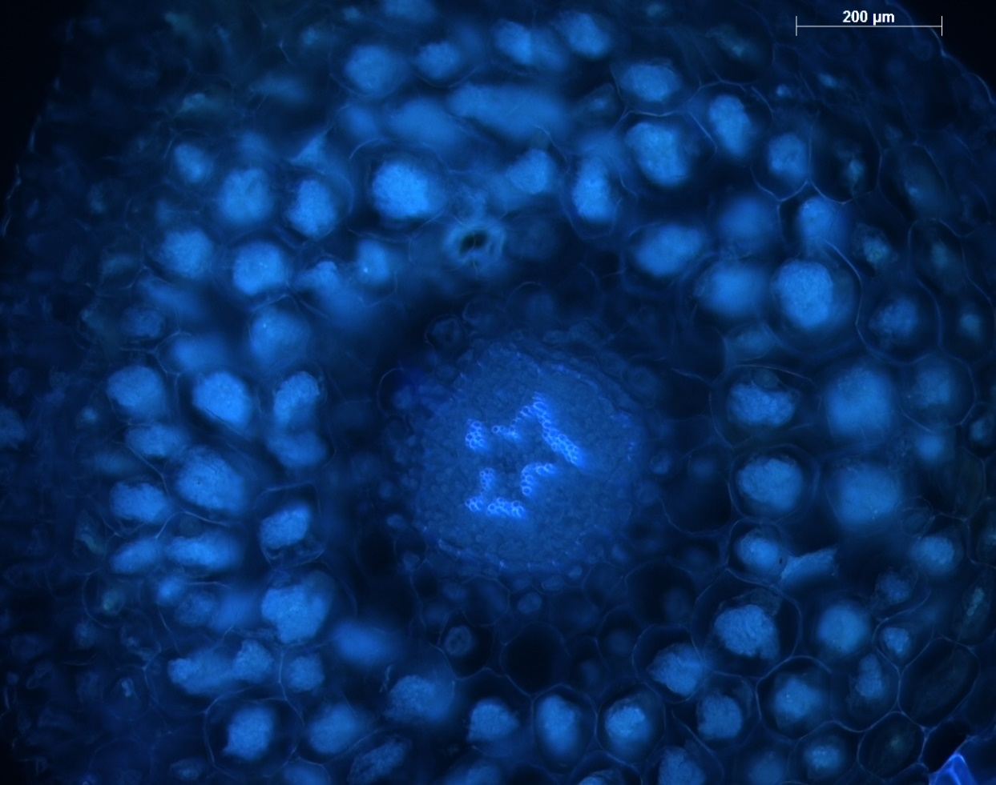
Figure S2. Colonized root of G. repens
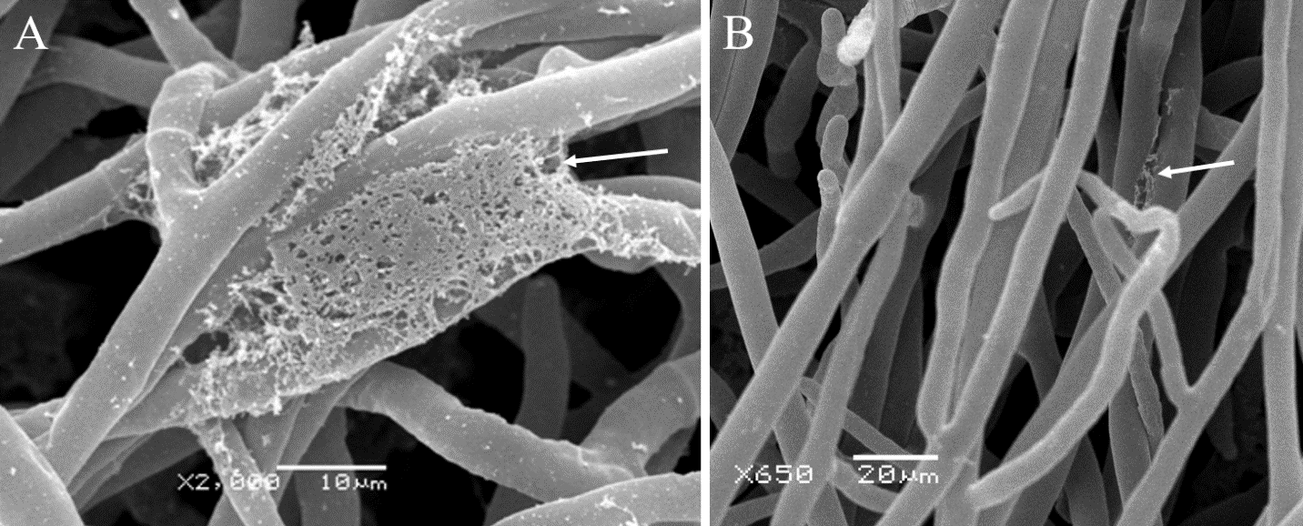
Figure S3. SEM images of polysaccharide sheath (pointed by arrows). A – Massive sheath of Ceratobasidium sp1, B – weak sheath of K3-3
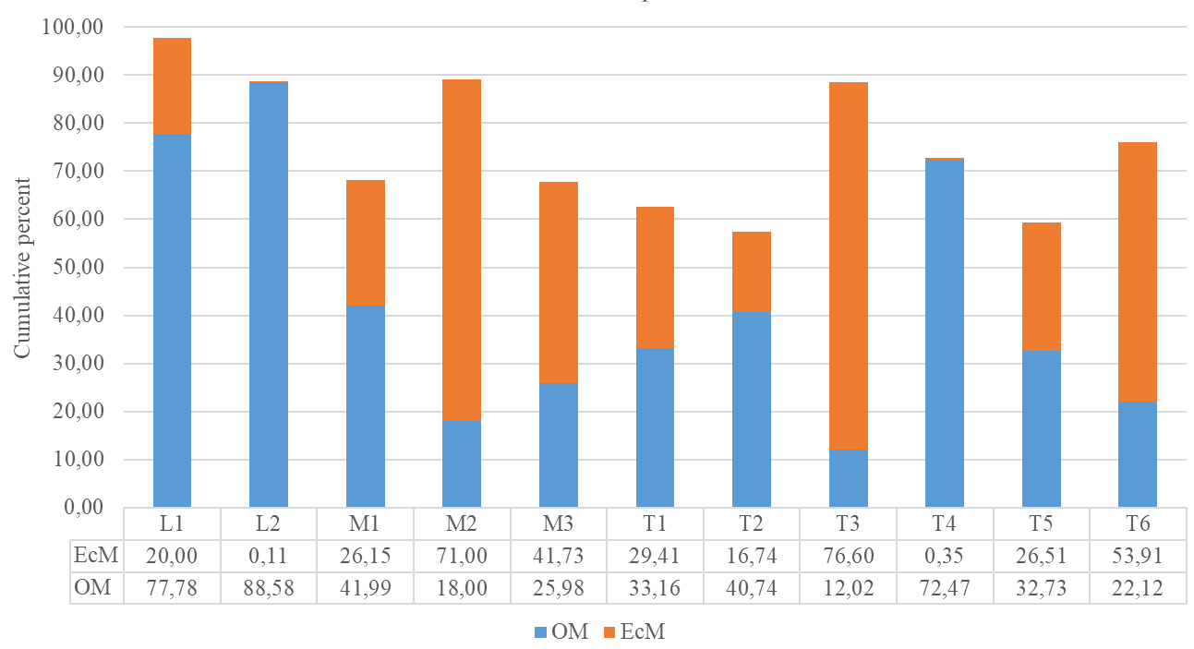
Figure S4. Shares of Ceratobasidiaceae (OM) and ectomycorrhizal (EcM) mycobionts in roots of G. repens (for designation of sample sites see Table 1)

