Table 1
Exploratory Factor Analysis of the Questions in Analytic Geometry
Question number | Loading
1 | .83
2 | .83
3 | .80
4 | .79
5 | .79
6 | .76
Eigenvalue | 3.84
Variance explained | 64.01%
Cronbach’s alpha | .88

Table 2
Means, Standard Deviations, and Repeated Measures Analysis Results of Participants’ Achievements in the Analytic Geometry Test in Each Level of Difficulty
Level of question difficulty | Low |  | Intermediate |  | High
 | M | SD | M | SD | M | SD | F | p | η_{p}²
 | 89.24 | 11.92 | 79.39 | 14.94 | 61.71 | 15.38 | 272.38*** | .001 | .75

Table 3
Mean, Standard Deviations, and Range of Students’ Scores on Each WM Component
Memory test | M | SD | Min | max
Phonological loop
Digit-span forward | 10.04 | 1.94 | 5.00 | 16.00
Visuo-spatial sketchpad
Visual-serial memory | 12.92 | 1.85 | 3.00 | 16.00
Visual memory-shapes | 13.36 | 1.60 | 8.00 | 16.00
Central executive system
Digit-span backward | 7.25 | 1.76 | 4.00 | 14.00
WM for digits and letters | 11.61 | 2.08 | 6.00 | 19.00

Table 4
Correlations Between Memory Tests Scores and Students' Achievements in Analytic Geometry at Each Level of Difficulty
Level of Difficulty  Memory test | Low | Intermediate | High | Total score
Phonological loop
Digit-span forward | .19 | .31** | .27** | .30**
Visual-spatial sketch-pad
Visual-serial memory | .39*** | .37*** | .55*** | .49***
Visual memory-shapes | .14 | .19 | .08 | .15
Central executive system
Digit-span backward | .17 | .32** | .21* | .27**
WM for digits and letters | .43*** | .48*** | .52*** | .54***
*p < .05, **p < .01, ***p < .001

Table 5
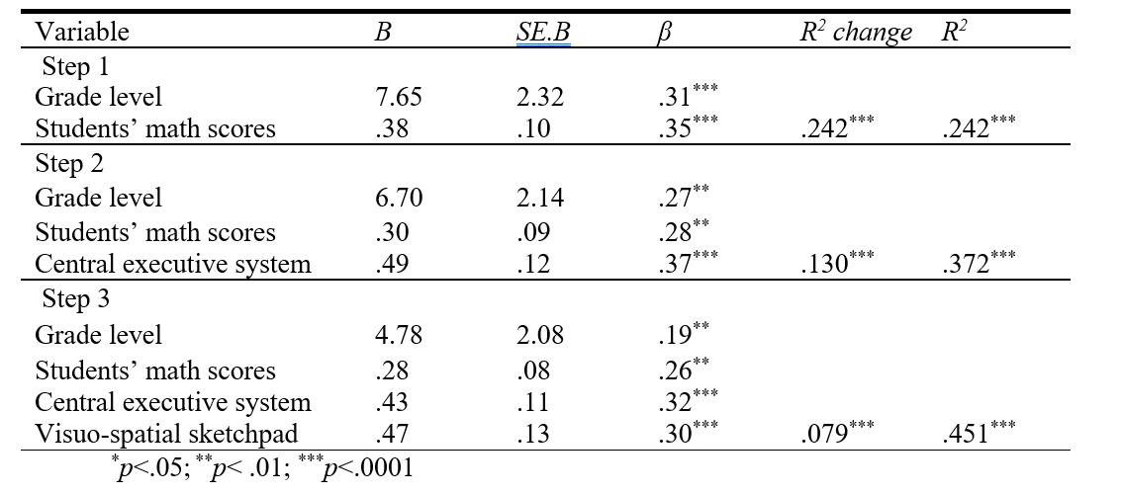
Regression Statistics for a Stepwise Regression of Predictors of Analytic
Geometry—Total Score

Table 6
Regression Statistics for a Stepwise Regression of Predictors on Analytic
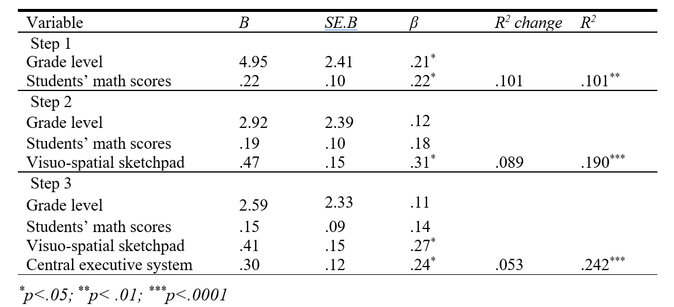
Geometry—Low Level

Table 7
Regression Statistics for a Stepwise Regression of Predictors on Analytic Geometry Intermediate-Level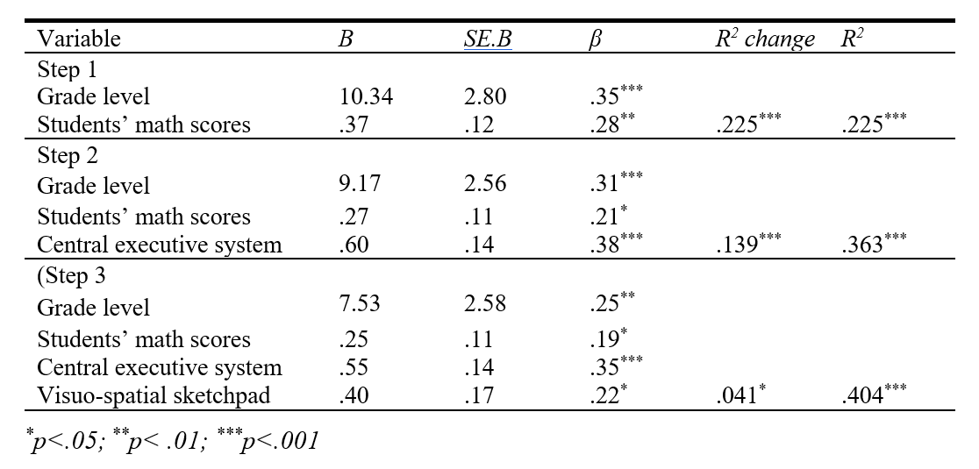
Table 8
Regression Statistics for a Stepwise Regression of Predictors on Analytic Geometry—High-Level
