Supplementary information

Table of Contents
Supplementary Note 1: The electronic structure of G/$α$-RuCl₃
Supplementary Note 2: Bias-dependent STM images of G/$α$-RuCl₃
Supplementary Note 3: Determination of lattice parameters of charge orderings
Supplementary Note 4: A commensurate relationship between the electron crystal and hole crystal
Supplementary Note 5: Bond-centred UHB charge ordering
Supplementary Note 6: Atomic defects in $α$-RuCl₃
Supplementary Note 7: The energy dependence of charge orderings in $α$-RuCl₃
Supplementary Note 8: The determination of charge transfer at the G/$α$-RuCl₃ interface
Supplementary Note 9: STM/STS results of gate-tunable G/$α$-RuCl₃/h-BN device

Figure S1. The electronic structure of G/$α$-RuCl₃ heterostructure.
Figure S2. Bias-dependent STM images.
Figure S3. The moiré superlattice of G/$α$-RuCl₃ at a twist angle $φ=30°$.
Figure S4. Uncovering the $α$-RuCl₃ lattice through the FT filtering process.
Figure S5. Simulated STM image.
Figure S6. A statistical analysis of lattice parameters of charge orderings.
Figure S7. A commensurate relationship between the electron crystal and hole crystal.
Figure S8. Identification of the bond-centered feature of UHB charge ordering.
Figure S9. Atomic defects in $α$-RuCl₃.
Figure S10. The energy dependence of charge orderings in $α$-RuCl₃.
Figure S11. Identify the non-dispersive nature of $q_{1}$ wave vector with improved k-space resolution.
Figure S12. The QPI in the graphene layer on top of the few-layer $α$-RuCl₃.
Figure S13. The calculated charge transfer at G/$α$-RuCl₃ interface.
Figure S14. The optical image, STM images, and STS results of G/$α$-RuCl₃/h-BN.
Figure S15. Charge orderings in G/$α$-RuCl₃ on the h-BN substrate.
Figure S16. Gate-dependent dI/dV spectra of G/h-BN near the assembled G/$α$-RuCl₃/h-BN heterostructure.
Figure S17. Gate-dependent dI/dV spectra of G/$α$-RuCl₃/h-BN.
Figure S18. Gate-dependent STM and STS results of G/$α$-RuCl₃/h-BN.
Figure S19. The absence of systematic distortion of atomic lattice.
Figure S20. Gate-induced transition of the UHB charge ordering in G/$α$-RuCl₃/h-BN.
Figure S21. Temperature-dependent STM and STS results of G/$α$-RuCl₃/h-BN.
1. The electronic structure of G/$α$-RuCl₃

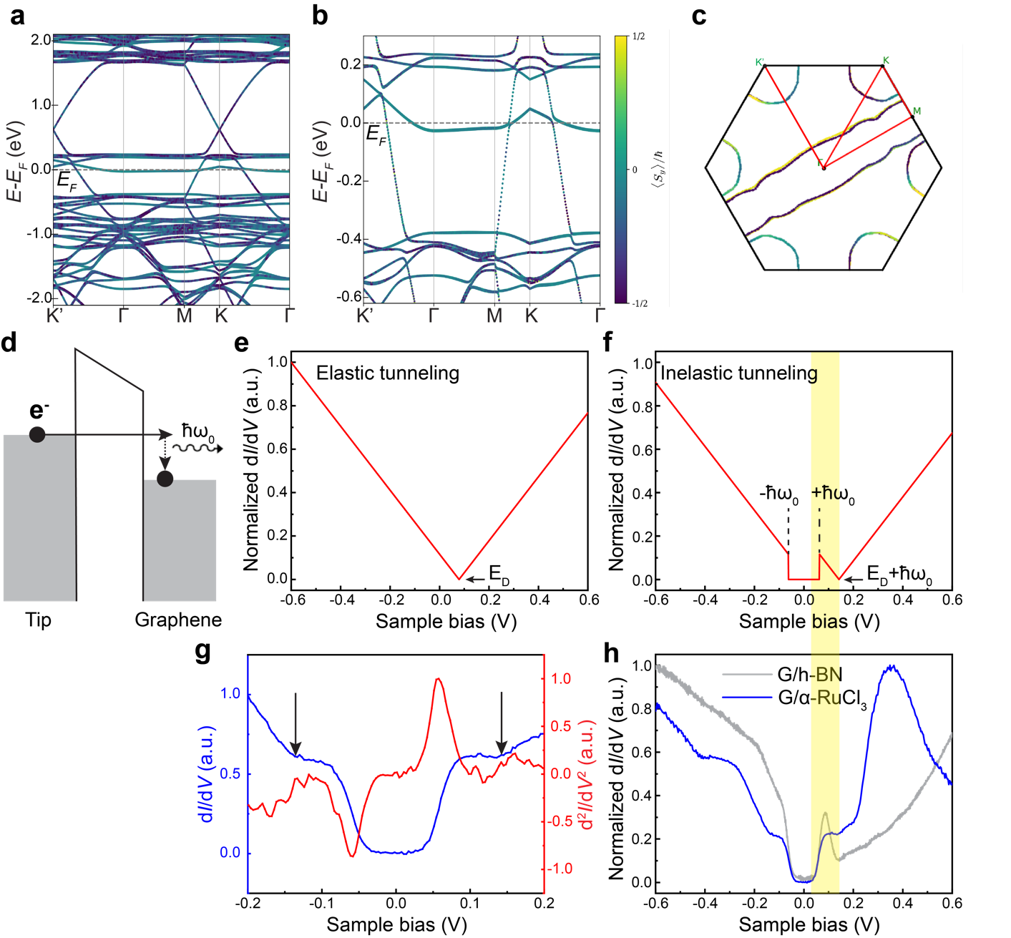

Figure S1. The electronic structure of G/$α$-RuCl₃ heterostructure. (a-b) Calculated band structure of $(5×5)$ graphene/$\left(2×2\right) α$-RuCl₃ in (a) wide and (b) narrow energy ranges along the $Κ^{'}$-$Γ$-$Μ$-$Κ$-$Γ$ path. The color coding in the Fermi surface contour indicates the expectation value of spin $<S_{y}>$. (c) The calculated Fermi surface of G/$α$-RuCl₃. It shows a quasi-1D open contour contributed by the UHB of $α$-RuCl₃ and closed contours around $Κ$ and $Κ^{'}$ points contributed by graphene, that is consistent with the previous calculation¹. The red line indicates the $Κ^{'}$-$Γ$-$Μ$-$Κ$-$Γ$ path in the Brillouin zone. (d) The illustration of inelastic tunneling process in graphene assisted by a particular phonon mode at the energy $ℏω_{0}=63 meV$ ². (e) The elastic tunneling spectrum of graphene, that is supposed to be proportional to the linear and V-shaped graphene DOS with E_{d} representing the Dirac point energy. (f) The phonon-assisted inelastic tunneling spectrum of graphene, resulting in a gap-like feature around E_{F} ². (g) The dI/dV spectrum (blue) and d²I/dV² spectrum (red) in a narrow $V_{s}$ range ($-0.2 V≤V_{s}≤0.2 V$). The band edges of $α$-RuCl₃ are assigned to the kinks indicated by black arrows. The symmetric peak and dip around the $E_{F}$ in the d²I/dV² spectrum is a fingerprint of phonon-assisted inelastic tunneling in graphene³. (h) dI/dV spectra acquired over G/$α$-RuCl₃/graphite (blue) and G/h-BN (grey) in a narrow $V_{s}$ range ($-0.6 V≤V_{s}≤0.6 V$).

The gap-like feature observed in both dI/dV spectra of G/h-BN and G/$α$-RuCl₃ is a result from the phonon-assisted inelastic tunneling process in graphene, that has been thoroughly studied in prior work³. Due to the large momentum mismatch between graphene states (located at the $Κ$ point of graphene Brillouin zone with the large in-plane momentum) and tunneling electrons (the majority have nearly zero momentum), the elastic tunneling into graphene states was significantly suppressed. However, when the energy of the tunneling electron exceeds a certain threshold, it can excite a specific phonon mode with an energy of $ℏω_{0}=63 meV$, compensating for the momentum mismatch. This introduces a new channel for inelastic tunneling, that significantly enhances the tunneling probability. The combined effect of strong suppression in elastic tunneling and the substantial increasement in inelastic tunneling gives rise to a signature gap-like feature in the graphene dI/dV spectrum (Figure S1d-g). Notably, the gap position and width remained unchanged despite the Dirac point of graphene is continuously tuned by gating (Figure S17b).

We note the STS of G/h-BN shows a peak-like feature when the Dirac point lies at the positive energies, that is qualitatively similar to the peak around $V_{s}=0.35 V$ in the dI/dV spectrum of G/$α$-RuCl₃ (Figure S1h). However, it is crucial to highlight that such a feature, stemming from the phonon-assisted inelastic tunneling in graphene, is always situated below $V_{s}=0.1 V$, which can be interpreted as the ‘shoulder’ of the gap. Ideally, the energy position of the peak-like feature should precisely align with the threshold energy determined by the phonon mode ($±ℏω_{0}=±63 meV$). The actual energy position is slightly larger than $ℏω_{0}=63 meV$ due to the presence of broadening effect in the dI/dV spectrum. Based on our observation and corroborating evidence from previous study³, it is important to note that the energy position of the peak-like feature in graphene never exceeds $V_{s}=0.1 V$, regardless of how the graphene spectrum is modified by doping (Figure S17b), that cannot account for the peak around $V_{s}=0.35 V$ observed in the dI/dV spectrum of G/$α$-RuCl₃.

A direct comparison between the dI/dV spectrum of G/$α$-RuCl₃ with the DFT+U calculation results reveal some discrepancies between experimental and theoretical results (Figure 2b-c). For example, the predicted gap of $0.38 eV$ is slightly larger than the determined band gap in the experiment. Such a discrepancy is attributed to the limitations of DFT calculation in the prediction of a many-body system. DFT, being a single-particle theory, falls short in accurately predicting the correlated gap of Mott system where strong correlation effects play a significant role. Another discrepancy is about the peak heights for the LHB and UHB. The dI/dV spectrum indicates the UHB peak is higher than LHB peak, that is inconsistent with the calculated DOS. The deviation can be attributed to the asymmetric influence of tunneling matrix element on LHB and UHB states⁴. Namely, the tunneling probability depends on the spatial overlap between electron wavefunctions in the tip and sample, that is described by the tunneling matrix element $M$. A more extensive decay of wavefunction into the vacuum results in a larger magnitude of tunneling matrix element, contributing more to the tunneling current. Consequently, the dI/dV signal are influenced by both DOS and spatial wavefunction of sample states, that can be evaluated by following equations ($ρ_{S}$ and $ρ_{T}$ represent DOS of sample and tip, respectively): ${(\frac{dI}{dV})}_{V=V_{s}}∝ρ_{S}(E_{F}+eV)ρ_{T}(E_{F}){\left|M(V_{s})\right|}^{2}$. It is plausible that LHB and UHB states have different spatial wavefunctions resulting in asymmetric influence of tunneling matrix element, leading to the subtle difference between peak heights in the dI/dV spectrum and DOS.
2. Bias-dependent STM images of G/$α$-RuCl₃

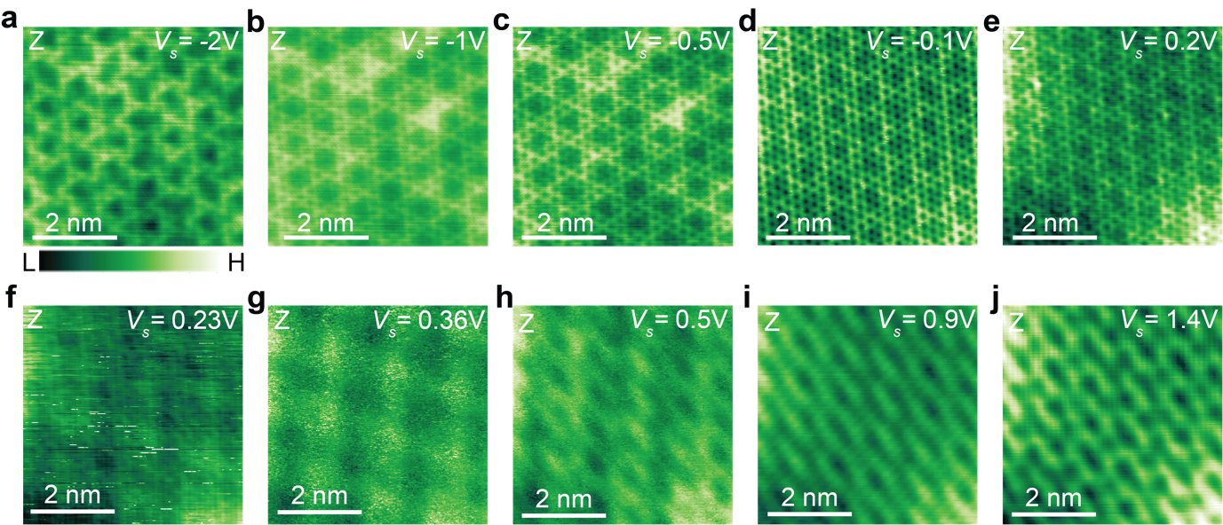

Figure S2. Bias-dependent STM images. Panels (a-c) are taken over one surface area, and panels (d-j) are taken over another. Notably, the long C₂ axis of UHB charge ordering in panel (g) aligns with the stripy pattern in panels (h-j). The setpoint $I_{t}$ for acquiring STM images ranges from 0.1 nA to 1 nA.

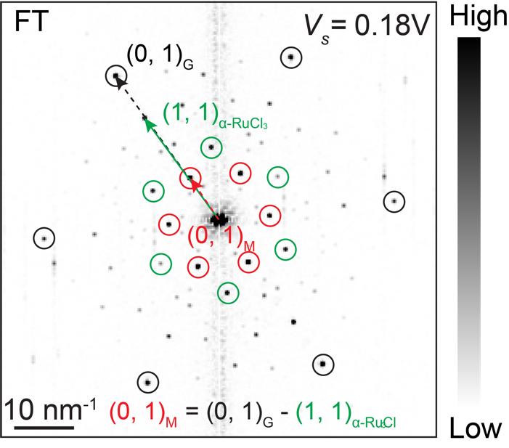

Figure S3. The moiré superlattice of G/$α$-RuCl₃ at a twist angle $φ=30°$. The Fourier transform (FT) pattern of the STM image at ($V_{s}=0.18 V$, $I_{t}=0.5 nA$). The corresponding STM image is shown in Figure 1b. The reciprocal lattices of graphene, $α$-RuCl₃, and moiré pattern are denoted by the black, green, and red circles, respectively. The reciprocal lattice vector of the moiré pattern ${(0, 1)}_{M}$ can be deduced by subtracting the vector of ${(1, 1)}_{α-RuCl_{3}}$ from the vector of ${(0, 1)}_{G}$.

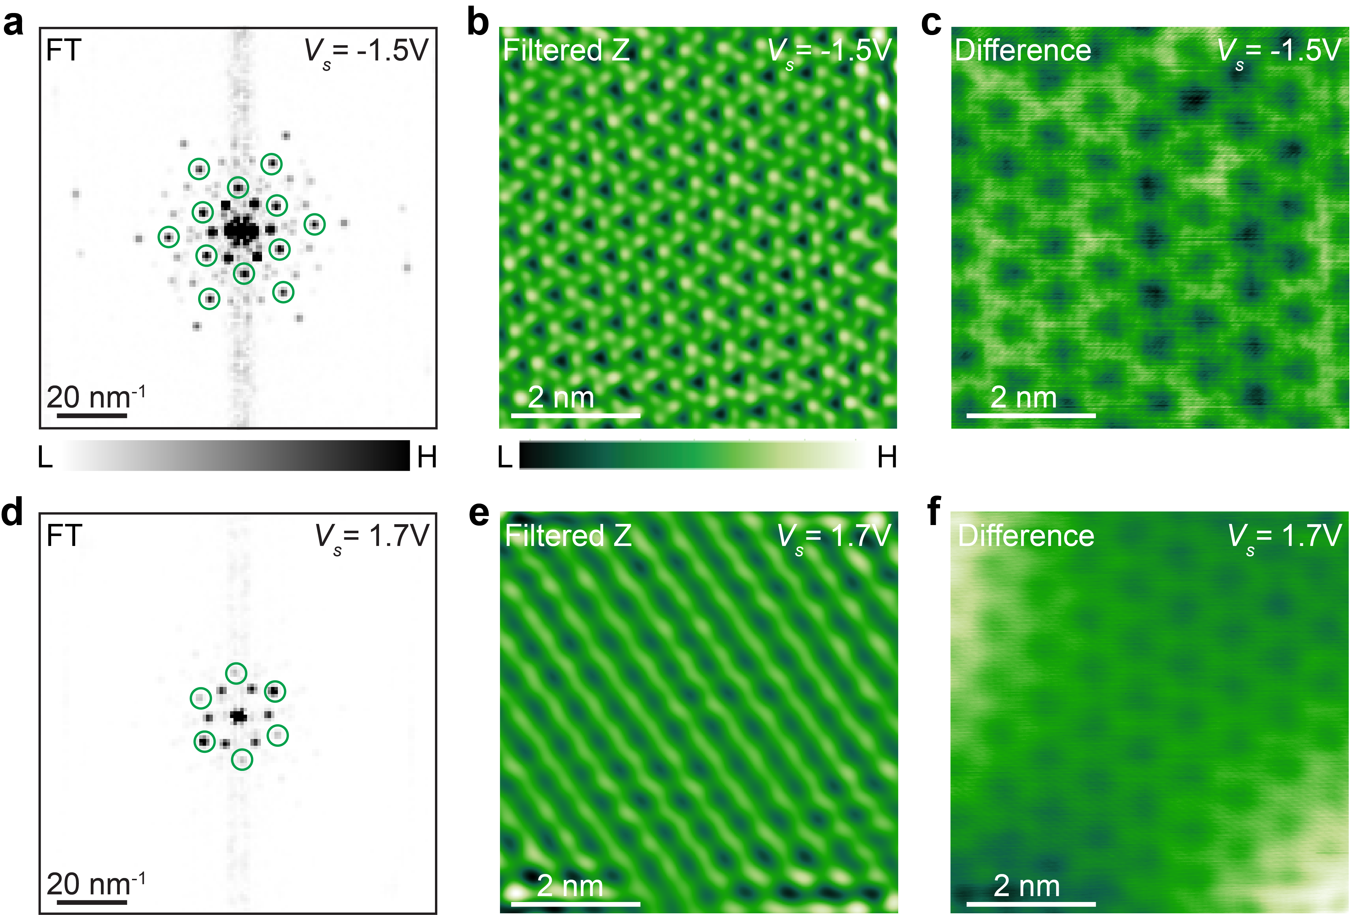
Figure S4. Uncovering the $α$-RuCl₃ lattice through the FT filtering process. (a) The FT pattern of the STM image acquired at ($V_{s}=-1.5 V$, $I_{t}=0.1 nA$). The corresponding STM image is shown in Figure 2d. The first- and second-order diffraction points associated with the $α$-RuCl₃ lattice is outlined by the green circles. (b) FT filtered $α$-RuCl₃ lattice acquired at $V_{s}=-1.5 V$. In the FT filtering process, only the Fourier components within green circles related to the $α$-RuCl₃ lattice are kept. It shows top-layer Cl atoms. (c) The difference between STM images ($V_{s}=-1.5 V$) before and after FT filtering, showing the moiré modulation. (d) The FT pattern of the STM image acquired at ($V_{s}=1.7 V$, $I_{t}=0.2 nA$). The corresponding STM image is shown in Figure 2f. The reciprocal lattice highlighted by the green circles are related to the $α$-RuCl₃ lattice. (e) FT filtered $α$-RuCl₃ lattice at $V_{s}=1.7 V$. It shows obvious anisotropy. However, this anisotropic pattern is absent in another sample of G/α-RuCl3 with a twist angle of ~17° (Figure S14). Since our study focuses primarily on the intrinsic properties of doped α-RuCl₃, the moiré dependent stripe pattern falls outside the scope of this work. (f) The difference between STM images ($V_{s}=1.7 V$) before and after FT filtering, showing the moiré modulation.

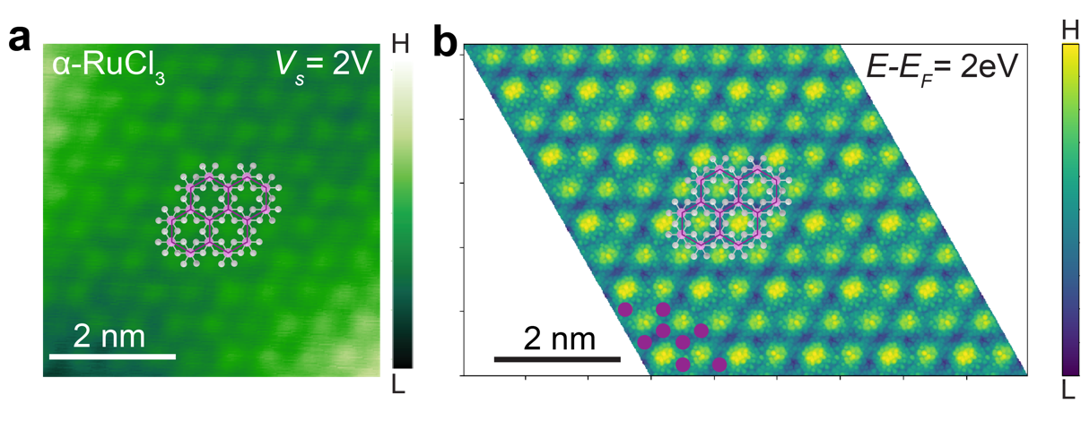
Figure S5. Simulated STM image. (a) The STM image of G/$α$-RuCl₃/graphite taken at ($V_{s}=2 V$, $I_{t}=0.2 nA$) with the superimposed atomic structure of $α$-RuCl₃. (b) Simulated STM image of G/$α$-RuCl₃ at ${E-E}_{F}=2 eV$ with the superimposed atomic structure of $α$-RuCl₃. Purple balls indicate the position of Ru atoms. It provides the evidence that the squared wavefunction of $α$-RuCl₃ states can be directly probed by tunneling electrons.

3. Determination of lattice parameters of charge orderings

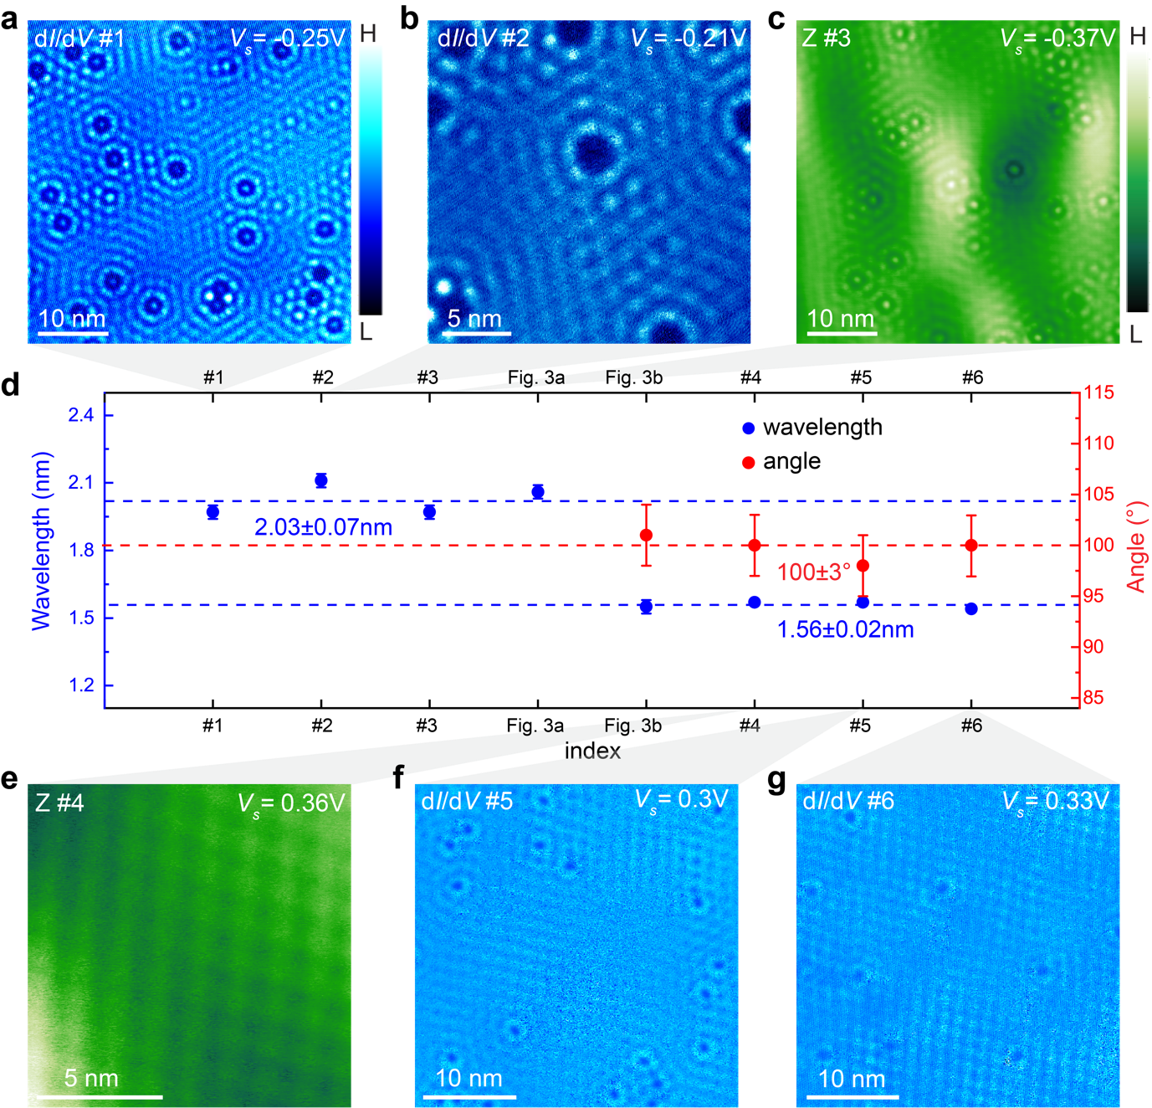

Figure S6. A statistical analysis of lattice parameters of charge orderings. (a-c) A series of STM images and dI/dV maps (#1-#3) taken in different regions at negative $V_{s}$ showing the LHB charge ordering. (d) A statistical analysis of lattice parameters of charge orderings. The lattice parameters are determined via the 2D power spectral density function (PSDF) of images shown in panels (a-c), Figure 3a-b, and panels (e-g). The lattice parameters are determined to be $λ_{1}=2.02±0.08$ nm for the LHB charge ordering and $λ_{2}=1.56±0.02$ nm with an angle of $θ_{2}=100±3°$ for the UHB charge ordering. Lattice parameters of charge orderings show slight differences that might reflect the variation in the local defect level. (e-g) A series of STM images and dI/dV maps (#4-#6) taken on different regions at positive $V_{s}$ showing the UHB charge ordering. The setpoint $I_{t}$ for taking STM images and dI/dV maps ranges from 0.2 nA to 0.5 nA.

4. A commensurate relationship between the electron crystal and hole crystal

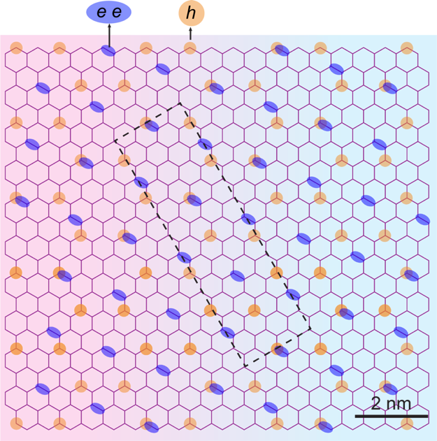
Figure S7. A commensurate relationship between the electron crystal and hole crystal. The unit cell of the coexisting $(2\sqrt{3}a_{0}×2\sqrt{3}a_{0}) R30°$ hole crystal and the $(\sqrt{7}a_{0}×\sqrt{7}a_{0}, θ=98°)$ electron crystal is outlined by the black dashed rectangular.

5. Bond-centred UHB charge ordering

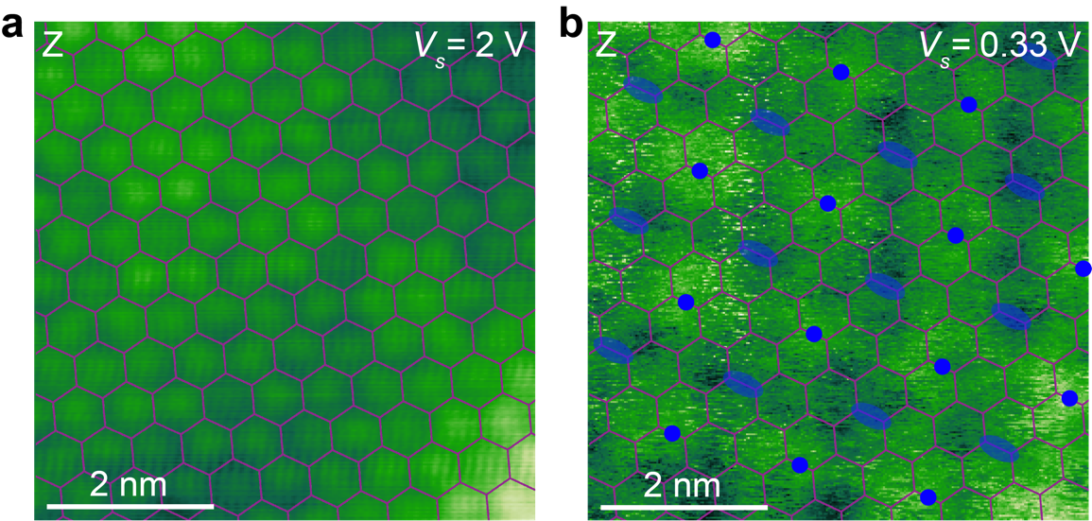

Figure S8. Identification of the bond-centered feature of UHB charge ordering. (a-b) Resolving $α$-RuCl₃ lattice at ($V_{s}=2 V$, $I_{t}=0.1 nA$) (a) and UHB charge ordering at ($V_{s}=0.33 V$, $I_{t}=0.1 nA$). (b) in the same region. The honeycomb Ru sublattice (purple) and a $(\sqrt{7}a_{0}×\sqrt{7}a_{0}, θ=98°)$ superlattice (blue dots and ellipses) are superimposed to the STM images. It reveals that the maxima (blue dots) and minima (blue ellipses) of UHB charge ordering are located in the center of the Ru-Ru bond. Such a unique bond-centered charge ordering has been observed experimentally and studied theoretically in strongly correlated quasi-one-dimensional system with the quarter-filled band, whose origin is attributed to the accumulation of paired electrons in bonds as a consequence of spontaneous bond dimerization induced by Peierls instability⁵. Considering electron pairs are typically involved in bonding between atoms, the bond-centered feature of UHB long-wavelength modulation implies the localization of electron pairs in bonds shared between atoms, providing evidence for the existence of a paired electron crystal.

6. Atomic defects in $α$-RuCl₃

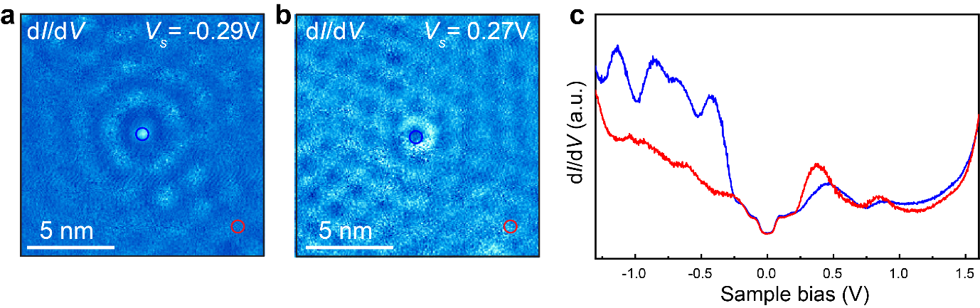
Figure S9. Atomic defects in $α$-RuCl₃. (a-b) dI/dV maps taken at (a) ($V_{s}=-0.29 V$, $I_{t}=0.5 nA$) and (b) ($V_{s}=0.27 V$,$I_{t}=0.5 nA$). (c) Comparing dI/dV spectra acquired on the defect (blue) and away from the defect (red). The tip position for obtaining the blue (red) dI/dV spectrum is indicated by the blue (red) circle in panel (a-b). Our STM/STS reveals that the presence of atomic defects strongly modifies the local electronic structure of $α$-RuCl₃. They can play the role of local potential traps that electron or hole prefer to stay, which disrupt the phase and lattice structure of charge crystals.

Real-space images show long-wavelength modulations are pinned and distorted by the local defects (Figure S9a-b), which can be attributed to the detrimental influence of electrically active defects on the crystalline order of charge. Specifically, spatially dependent STS reveals that defects exert a profound influence on the local electronic structure of α-RuCl₃, that induce an elevation in the LHB states while concurrently suppressing the UHB states (Figure S9). These electrically active defects will disrupt the phase and lattice structure of charge crystals, as electrons or holes tend to localize at the local minima of the disorder potential rather than the lattice sites. In this case, the disrupted crystalline order observed in the STM image and the diffusive arcs in FT pattern for the LHB long-wavelength modulation (Figure 3a-b) can be attributed to the phase destruction of hole crystals induced by the disorder potential of randomly distributed defects. Similar phenomena are widely observed for 2D Wigner crystals in semiconductor quantum wells. For instance, in real samples of semiconductor quantum wells, a Wigner crystal is typically pinned and distorted by defects, that shows the characteristic “pinning mode” observed in experiments⁶⁻⁸.

7. The energy dependence of charge orderings in $α$-RuCl₃

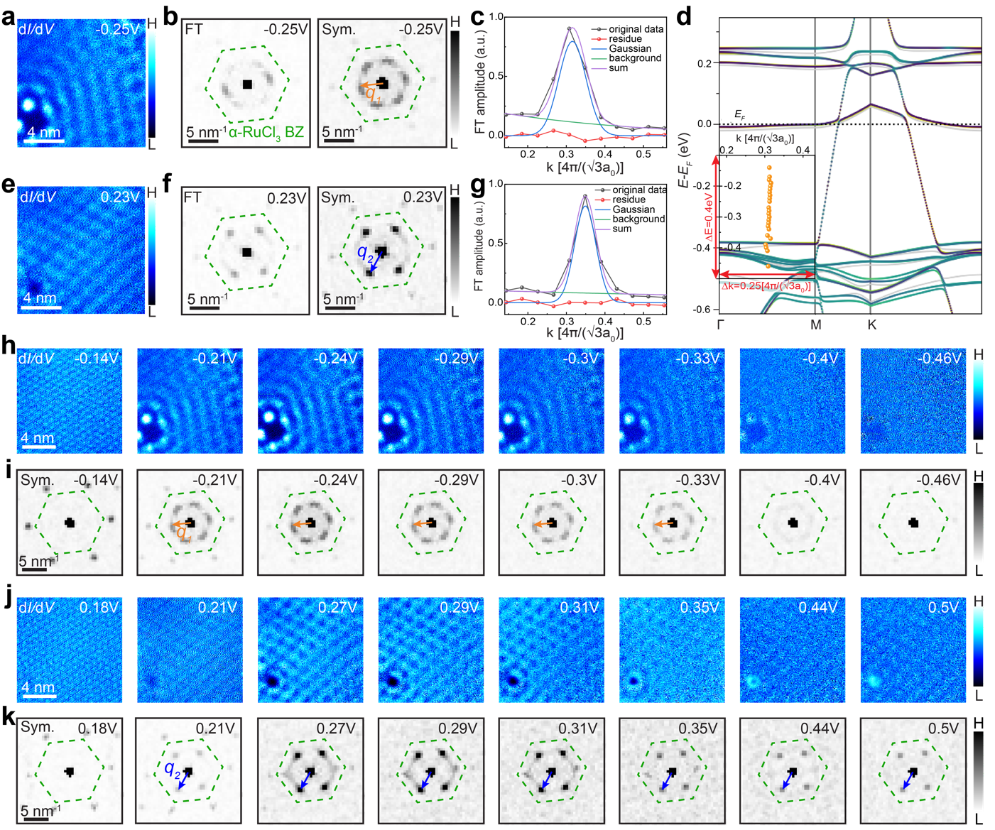
Figure S10. The energy dependence of charge orderings in $α$-RuCl₃. (a-b) The dI/dV map taken at ($V_{s}=-0.25 V$, $I_{t}=0.5 nA$) (a) with the corresponding FT pattern (b) showing the LHB charge ordering. The first Brillouin zone (BZ) of $α$-RuCl₃ is outlined by the green dashed line. The FT pattern is three fold symmetrized, respecting the three fold symmetry of LHB charge ordering. (c) The FT linecut along the direction of $q_{1}$ in the symmetrized FT pattern taken at $V_{s}=-0.25 V$ with fitted curves. The original data are represented by black dots connected by straight lines. The fitted curves include the Gaussian peak (blue line), the background (green line, using a single Gaussian function), the sum of Gaussian peak and background (purple line), and the residue (red line). (d) Direct comparison between the dispersion of $q_{1}$ (within ${-0.5 eV≤eV}_{s}≤-0.14 eV$) and the calculated band structure of $(5×5)$ graphene/$\left(2×2\right) α$-RuCl₃, illustrated on the same scale in energy and momentum (k). Notably, in the calculated band structure of $(5×5)$ graphene/$\left(2×2\right) α$-RuCl₃, the momentum separation between $Γ$ and $Μ$ points is $\left|ΓΜ\right|=0.25[4π/(\sqrt{3}a_{0})]$. (e-f) The dI/dV map taken at ($V_{s}=0.23 V$, $I_{t}=0.5 nA$) (e) with the corresponding FT pattern (f) showing the UHB charge ordering. The FT pattern is two fold symmetrized, respecting the two fold symmetry of UHB charge ordering. It is noteworthy that the long C₂ axis of UHB charge ordering is rotated by $120°$ in this region (compared with UHB charge ordering shown in Figure 3d) that can be attributed to the existence of different domains. (g) The FT linecut along the direction of $q_{2}$ in the symmetrized FT pattern taken at $V_{s}=0.23 V$, with fitted curves. (h-i) Bias-dependent dI/dV maps taken at the negative $V_{s}$ (h) with the corresponding FTs (i). (j-k) Bias-dependent dI/dV maps taken at the positive $V_{s}$ (j) with the corresponding FTs (k). The setpoint for acquiring dI/dV maps is $I_{t}=0.5 nA$.
The slight energy dependence observed in the magnitude of $q_{1}$ wave vector (Figure 3i) can be attributed to the fitting uncertainties primarily constrained by the k-space resolution. Notably, the resolution in k-space is inversely proportional to the lateral size of the real-space image. Consequently, a small real-space dI/dV map of LHB charge ordering with a lateral size of $L=12.6 nm$ (Figure S10a) results in a relatively poor k-space resolution of $k_{res}=\frac{2π}{L}=0.0410∙(\frac{4π}{\sqrt{3}a_{0}})$ in the corresponding FT pattern (Figure S10b). When the FT linecut is extracted from the symmetrized FT patterns along the direction of $q_{1}$ and subsequently fitted with a Gaussian peak and a background line (Figure S10c), there are merely five data points available for determining the Gaussian peak ( the peak center indicating the magnitude of $q_{1}$ wave vector). The insufficient data points, combined with the finite and fluctuating fitting residue, introduce inaccuracies and uncertainties in the peak determination. This leads to the confusing energy dependence of the determined magnitudes of $q_{1}$ wave vectors.

To unambiguously determine whether $q_{1}$ exhibits non-dispersive or weakly dispersing characteristics, one needs to enhance the k-space resolution in the FT pattern by enlarging the size of real-space image. In this context, we revisited the long-wavelength modulations at LHB energies in a new region with an increased lateral size of $L=35 nm$ (Figure S11a). It yields a finer k-space resolution of $k_{step}=\frac{2π}{L}=0.0147∙(\frac{4π}{\sqrt{3}a_{0}})$ in the corresponding FT pattern (Figure S11b-c) and provides more data points for fitting the peak in the FT linecut (Figure S11d). More dI/dV maps taken at negative $V_{s}$ across a window of ${-0.4 V≤V}_{s}≤-0.17 V$ together with corresponding symmetrized FT patterns, are presented in Figure S11e. Additionally, the bias-dependent FT linecuts with the fitted curves are displayed in Figure S11f. Each FT linecut was subjected to fitting for the precise determination of the magnitude of $q_{1}$ at different energies. The summarized results in Figure S11g unambiguously verifies that $q_{1}$ does not disperse across varying energies.

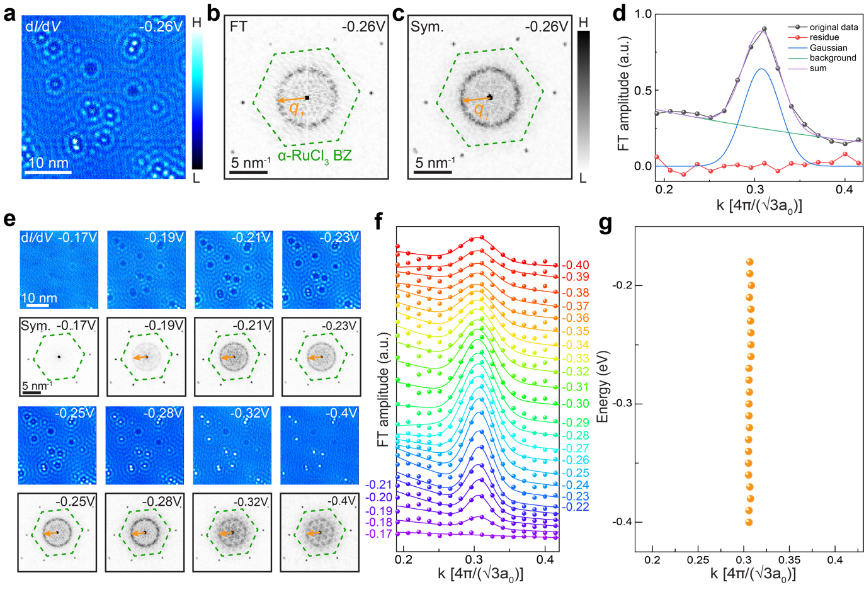
Figure S11. Identify the non-dispersive nature of $q_{1}$ wave vector with improved k-space resolution. (a) A large dI/dV map with a lateral size $L=35 nm$ taken at ($V_{s}=-0.26 V$, $I_{t}=1 nA$), showing the LHB long-wavelength modulation. (b) The corresponding FT pattern at $V_{s}=-0.26 V$ showing the wave vector $q_{1}$associated with the LHB long-wavelength modulation. The first Brillouin zone (BZ) of $α$-RuCl₃ is outlined by the green dashed line. (c) The symmetrized FT pattern at $V_{s}=-0.26 V$ respecting the three fold symmetry of LHB long-wavelength modulation. (d) The FT linecut along the direction of $q_{1}$ in the symmetrized FT pattern taken at $V_{s}=-0.26 V$ with fitted curves. The original data are represented by black dots connected by straight lines. The fitted curves include the Gaussian peak (blue line), background (green line, using a single Gaussian or Lorentzian function), the sum of Gaussian peak and the background (purple line), and the residue (red line). (e) Bias-dependent dI/dV maps taken at the negative $V_{s}$ with the corresponding symmetrized FTs. The setpoint for acquiring dI/dV maps is $I_{t}=1 nA$. (f) Bias-dependent FT linecuts along the direction of $q_{1}$ with fitted curves. The $V_{s}$ for taking each FT linecut is indicated by the adjacent number. (g) The magnitudes of $q_{1}$ (within ${-0.4 eV≤eV}_{s}≤-0.17 eV$) as a function of energy.
8. The determination of charge transfer at the G/$α$-RuCl₃ interface

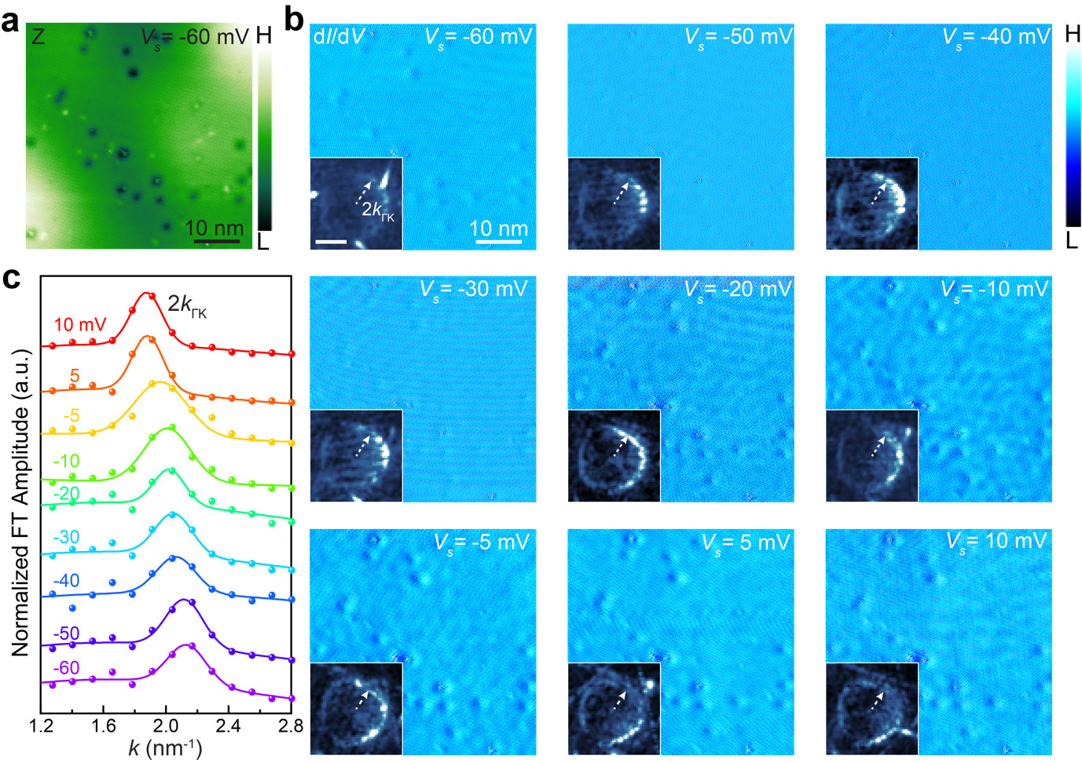
Figure S12. The QPI in the graphene layer on top of the few-layer $α$-RuCl₃. (a) Atomic defects in graphene, introduced via low-energy N⁺ ion sputtering, visualized as bright or dark spots in the STM image of G/$α$-RuCl₃ acquired at ($V_{s}=-60 mV$, $I_{t}=0.1 nA$) within the gap of $α$-RuCl₃. (b) Energy-dependent dI/dV maps with the corresponding magnified FT patterns showing intervalley scattering taken in an energy range $-0.06 eV≤{eV}_{s}≤0.01 eV$. Scale bar for all magnified FT patterns is $2 {nm}^{-1}$. The setpoint $I_{t}$ for acuquiring dI/dV maps ranges from 0.02 nA to 0.1 nA. The distance from the center of the triangular pattern to one of the sides corresponds to 2$k_{ΓΚ}$, which is indicated by the white dashed arrow. Here $k_{ΓΚ}$ is the radius in the contour of constant energy along $ΓΚ$ direction in graphene⁹. (c) Energy-dependent FT linecut along the direction of $k_{ΓΚ}$, measuring the distance from the center of the triangular pattern to the side, with fitted curves. The original data are represented by dots. The fitted curve is the sum of the fitted Gaussian peak and background line, where the Gaussian peak center corresponds to 2$\left|k_{ΓΚ}\right|$. The $V_{s}$ for taking each FT linecut is indicated by the adjacent number.
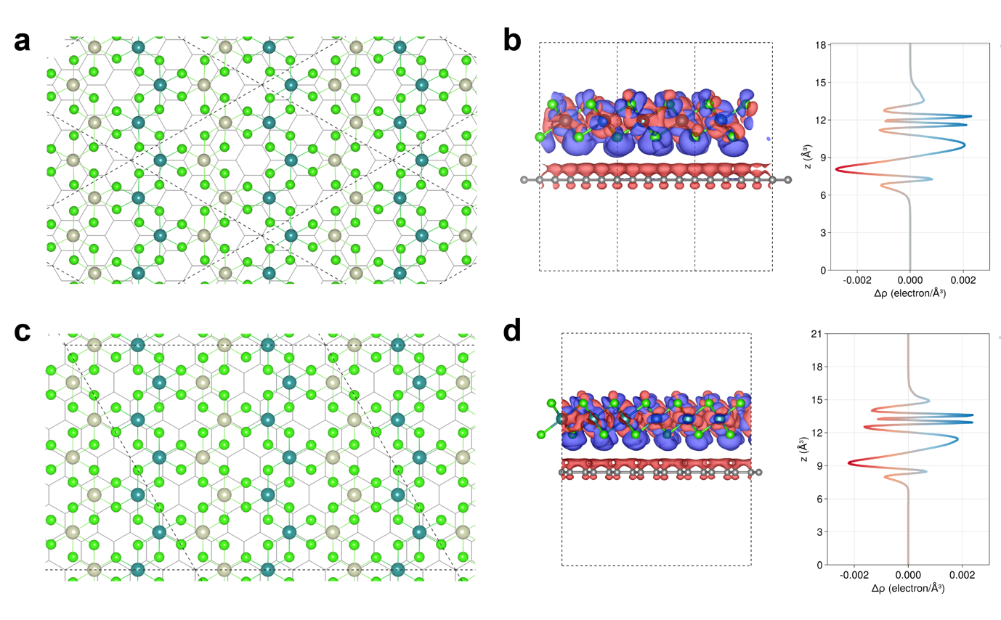
Figure S13. The calculated charge transfer at the G/$α$-RuCl₃ interface. (a) The supercell of $R0^{°}$ interface ($(5×5)$ graphene/$(2×2)R0^{°}α$-RuCl₃) with zigzag antiferromagnetic configuration. (b) The visualized charge density difference at $R0^{°}$ interface with in-plane averaged charge density difference, in which the purple and red colors denote the charge accumulation and depletion, respectively. The amount of charge transfer for $R0^{°}$ interface is estimated to be $3.1×{10}^{13} electron/{cm}^{2}$. (c) The supercell of $R{30}^{°}$ interface ($(8×8)$ graphene/$(2\sqrt{3}×2\sqrt{3})R{30}^{°}α$-RuCl₃) with zigzag antiferromagnetic configuration. (d) The visualized charge density difference at $R{30}^{°}$ interface with in-plane averaged charge density difference. The amount of charge transfer for $R{30}^{°}$ interface is estimated to be $2.3×{10}^{13} electron/{cm}^{2}$.

9. STM/STS results of gate-tunable G/$α$-RuCl₃/h-BN device

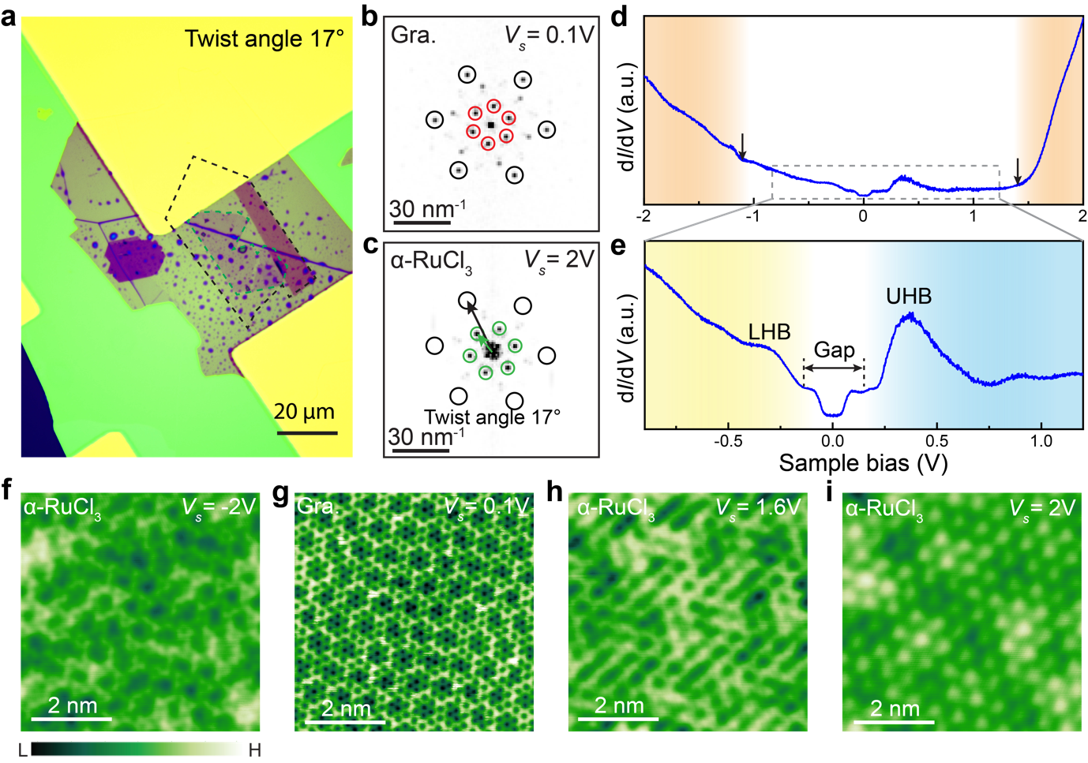

Figure S14. The optical image, STM images, and STS results of G/$α$-RuCl₃/h-BN. (a) The optical image of as-assembled G/α-RuCl₃/h-BN heterostructure. The top graphene layer is outlined by the black dashed line. The few-layer $α$-RuCl₃ is outlined by the green dashed line. The thickness of α-RuCl₃ is estimated to be 2-3 layers based on the optical contrast. (b) The FT pattern of the STM image taken at ($V_{s}=0.1 V$, $I_{t}=0.1 nA$) (panel g). The reciprocal lattices of graphene and moiré pattern are denoted by the black and red circles. (c) The FT pattern of the STM image taken at ($V_{s}=2 V$, $I_{t}=0.5 nA$) (panel i). The reciprocal lattices of graphene and $α$-RuCl₃ are denoted by the black and green circles, respectively. From the reciprocal lattice vectors, the twist angle between graphene and $α$-RuCl₃ is determined to be 17°. (d-e) The dI/dV spectra of G/$α$-RuCl₃ on the h-BN substrate almost identical to the dI/dV spectra of G/$α$-RuCl₃ on the graphite substrate. (f-i) Representative bias-dependent STM images of G/$α$-RuCl₃ on the h-BN substrate showing the atomic structure of G/$α$-RuCl₃. Interestingly, the anisotropic pattern, that is shown in Figure 2f, is absent in this sample. The setpoint $I_{t}$ for acuquiring STM images ranges from 0.1 nA to 0.5 nA.

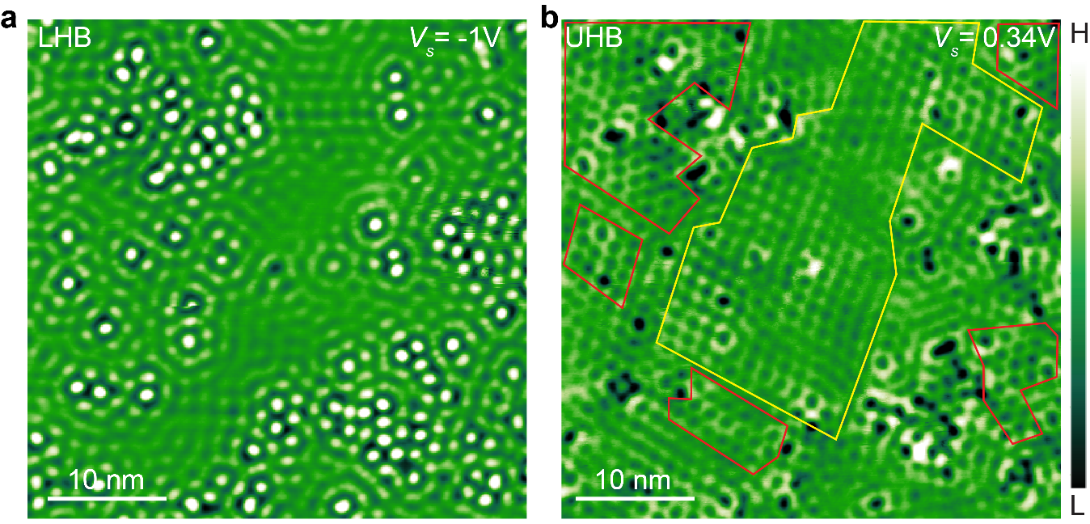

Figure S15. Charge orderings in G/$α$-RuCl₃ on the h-BN substrate. (a) The STM image taken at ($V_{s}=-1 V$, $I_{t}=0.5 nA$) showing the LHB charge ordering. (b) The STM image taken at ($V_{s}=0.34 V$, $I_{t}=0.8 nA$) showing the UHB charge ordering. It is noteworthy charge orderings are inevitably pinned and distorted by defects in $α$-RuCl₃, as exemplified in Figure S9. Due to defects with much larger densities, we observe separate phases of the UHB charge ordering in G/$α$-RuCl₃ on the h-BN substrate. One kind of UHB charge ordering shows two-fold symmetry, which is outlined by the yellow line. Another kind of UHB charge ordering, that is outlined by the red line, shows nearly six-fold symmetry, which is attributed to the strain or electronic modification due to a large number of defects.

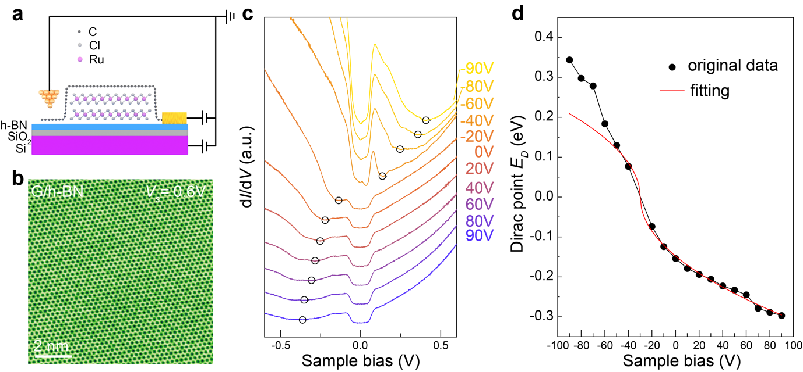

Figure S16. Gate-dependent dI/dV spectra of G/h-BN near the assembled G/$α$-RuCl₃/h-BN heterostructure. (a) The schematic illustration of G/α-RuCl₃ device structure. The STM tip approaches the G/h-BN region away from the $α$-RuCl₃ flake. (b) The Large-size STM topographic image of the clean surface of G/h-BN taken at ($V_{s}=0.6$V, $I_{t}=0.6 nA$). It shows graphene lattice and moiré modulation of G/h-BN without any signal contributed by $α$-RuCl₃. (c) Gate-dependent dI/dV spectra taken in a range of $-0.6 V≤V_{s}≤ 0.6 V$. The number indicates the corresponding gate voltage for taking each dI/dV spectrum. The local minimum ($V_{D}$) of the differential conductance in each spectrum is indicated by the black circle. The Dirac point position of graphene (E_{D}) at each gate voltage can be determined from $E_{D}=e|V_{D}|-hω_{0}$, where $hω_{0}=63$ meV is the energy of the phonon involved in the inelastic tunnelling³. (d) The gate-dependent Dirac point of graphene ($E_{D}$, the black dot). The red line is the fitting curve derived from the equation: $E_{D}=ℏν_{F}\sqrt{πα|V_{g}-V_{0}|}$, where $ν_{F}$ is the Fermi velocity of graphene around $1×{10}^{6}$ m/s, $α$ is a coefficient, and $V_{0}$ is associated with the initial doping of graphene (in terms of the gate voltage). Our results show that only part of the data can be well fitted (in the range of $-40 V≤V_{g}≤ 90 V$), which yields $α=4.4×{10}^{10}$ cm⁻² V⁻¹ and $V_{0}=-30$ V. The rest of the data are significantly deviated from the fitting curve, probably due to the gate-induced ionization of charged defect in h-BN.

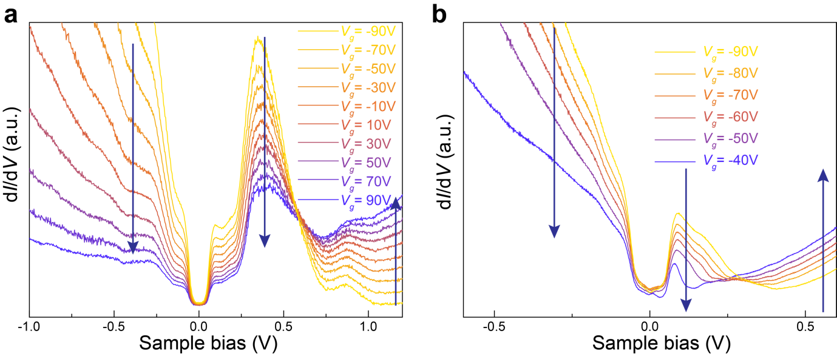

Figure S17. Gate-dependent dI/dV spectra of G/$α$-RuCl₃/h-BN. (a) The gate-dependent dI/dV spectra of G/$α$-RuCl₃/h-BN. (b) The gate-dependent dI/dV spectra of G/h-BN in the hole-doped regime. The similarity between two sets of dI/dV spectra suggests that the gate-dependent monotonic shift of spectral weights in LHB and UHB can be straightforwardly understood as the feature inherited from the covering gate-tunable graphene layer¹⁰.

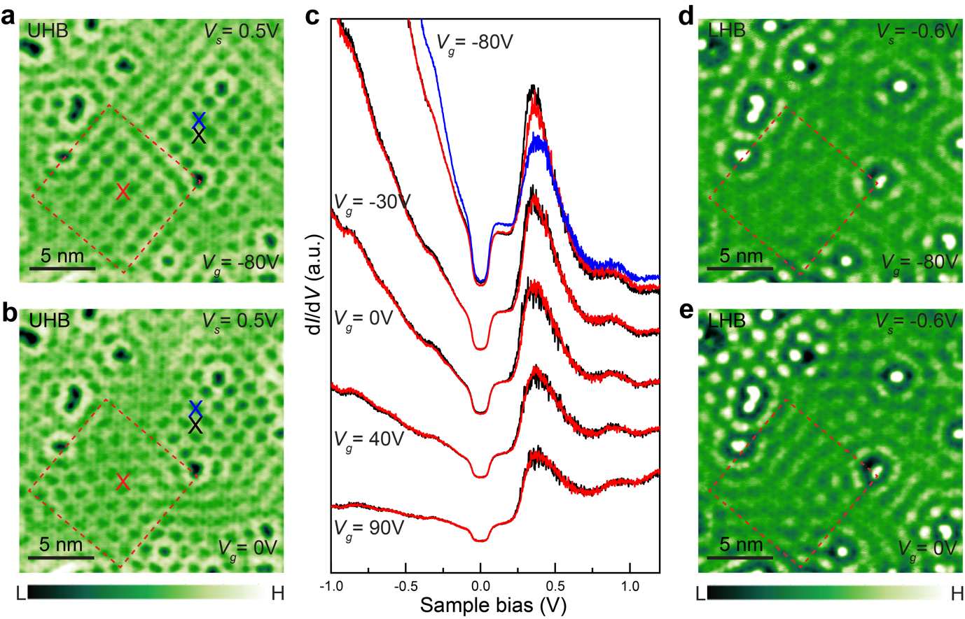

Figure S18. Gate-dependent STM and STS results of G/$α$-RuCl₃/h-BN. (a-b) Gate-dependent STM images taken at ($V_{s}=0.5 V$, $I_{t}=0.5 nA$) showing the UHB charge ordering. The symmetry of UHB charge ordering is changed from (a) the two-fold symmetry at $V_{g}=-80 V$ to (b) the nearly six-fold symmetry at $V_{g}=0 V$, in a local region indicated by the red dashed line. Notably, throughout the gate voltage sweep, the gate-induced phase transition is observed only in such a small local region, where the UHB charge ordering initially has a nearly six-fold symmetry at $V_{g}=0 V$. This suggests the UHB charge ordering in this small region is in close proximity to the phase transition, making it highly susceptible to the external tuning. The absence of global phase transition is attributed to the limited tuning capability of a solid-state gating. The formation of the nearly six-fold symmetric UHB charge ordering might be potentionally stabilized by the local strain or electronic modification induced by a significant number of defects, as we discussed in Figure S15. (c) The spatially dependent point dI/dV spectra at different gate voltages. The tip position for taking the black, red, and blue dI/dV spectrum is indicated by the black, red, and blue crosse in panels (a-b). The spatial dependence of dI/dV spectra is hardly discernible between two different UHB charge orderings. (d-e) Gate-dependent STM images taken at ($V_{s}=-0.6 V$, $I_{t}=0.1 nA$) in the same region showing the LHB charge ordering. The result shows if there is any disorder present, holes prefer to sit at the local minima of the disorder potential rather than at the lattice sites, that disrupts the phase and lattice structure of hole crystal at the LHB energy (refer to Figure S9 for more details).

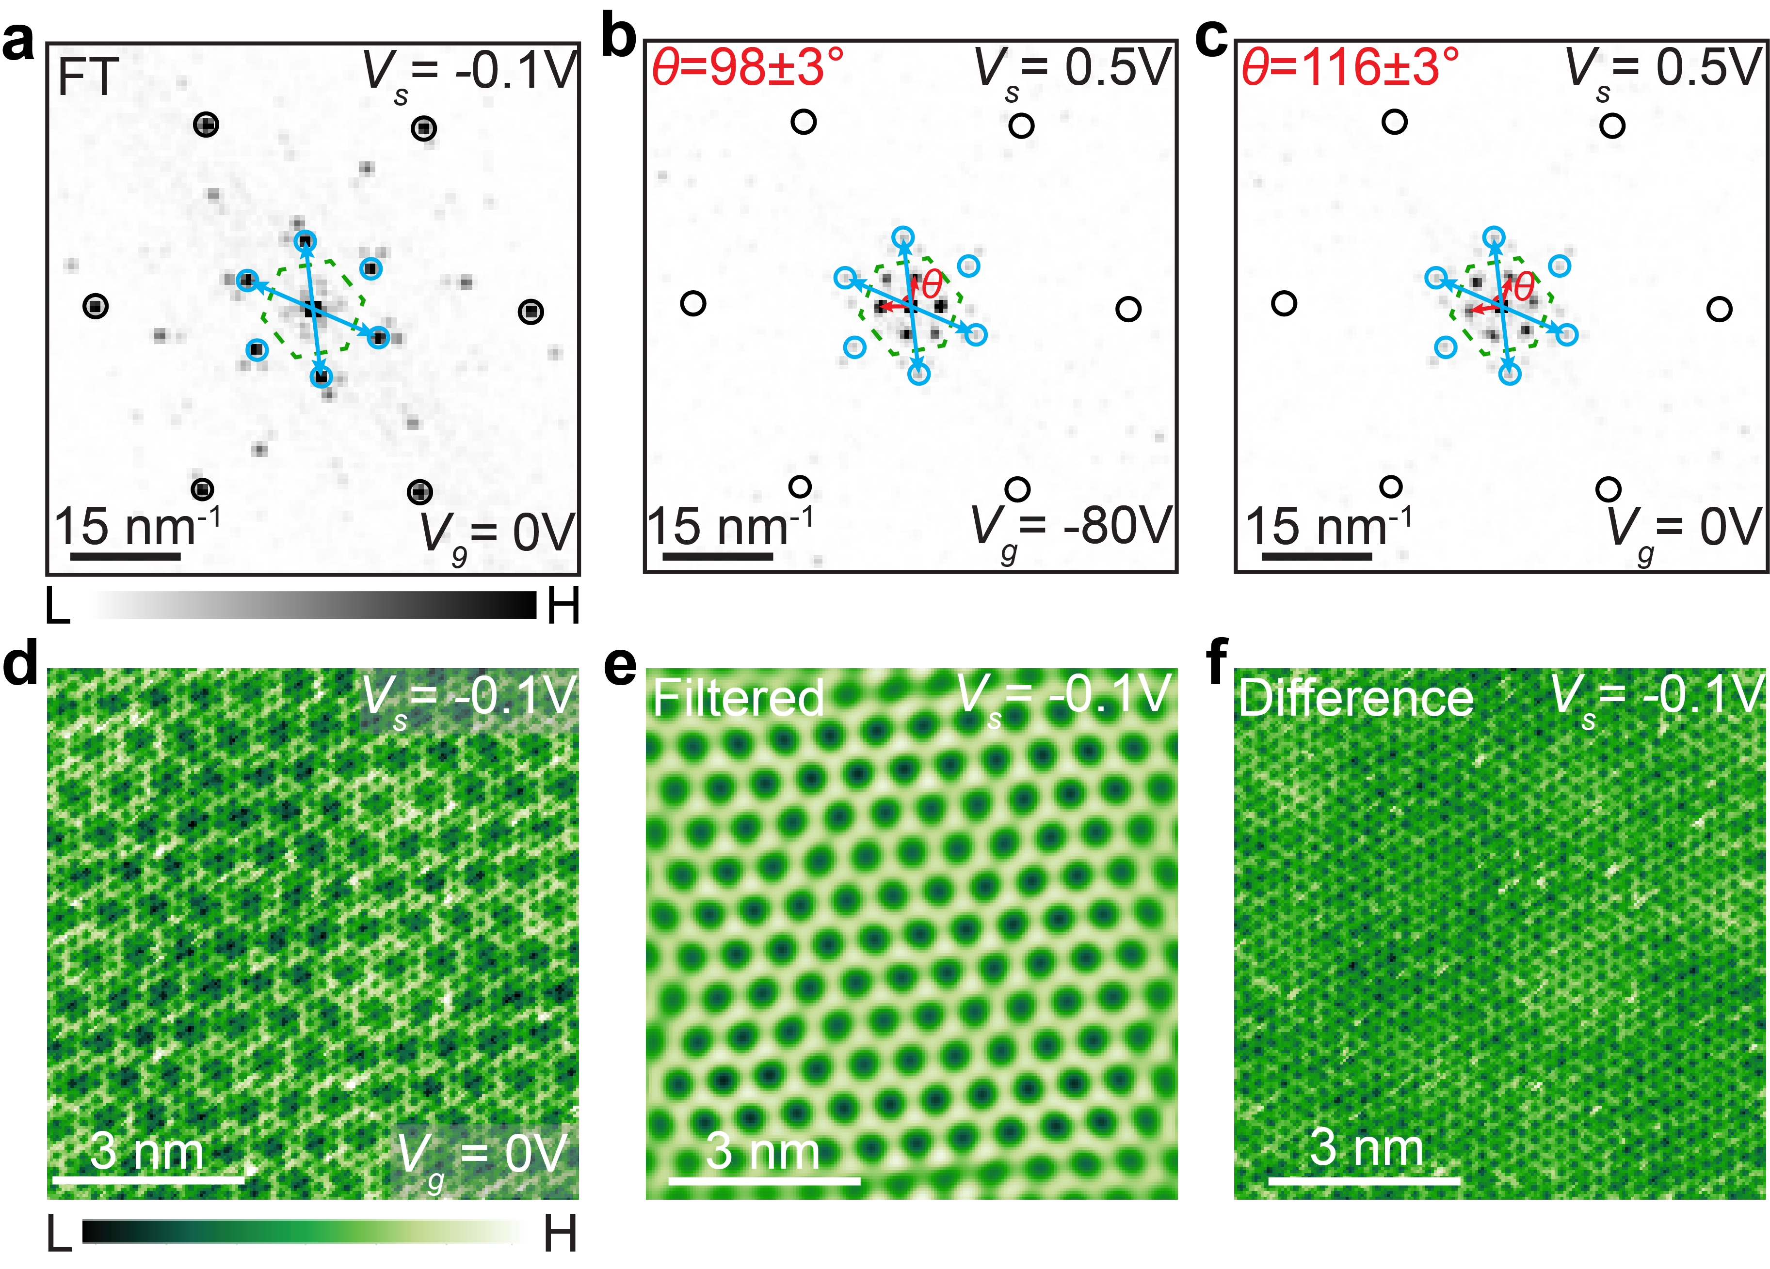
Figure S19. The absence of systematic distortion of atomic lattice. (a) The FT pattern of the STM image taken at ($V_{s}=-0.1 V$, $I_{t}=0.5 nA$) under $V_{g}=0 V$. The corresponding STM image is shown in panel (d). (b) The FT pattern of the STM image taken at ($V_{s}=0.5 V$, $I_{t}=0.5 nA$) under $V_{g}=-80 V$. The corresponding STM image is shown in Figure 4c. (c) The FT pattern of the STM image taken at ($V_{s}=0.5 V$, $I_{t}=0.5 nA$) under $V_{g}=0 V$. The corresponding STM image is shown in Figure 4d. For all FT patterns, the reciprocal lattices of graphene and moiré pattern are denoted by the black and blue circles. The first BZ of $α$-RuCl₃ is outlined by the green dashed line. Blue arrows indicate the reciprocal lattice vectors of moiré pattern with an angle of $120°$, while red arrows denote the reciprocal lattice vectors of UHB charge ordering, with an angle tunable by the gate. When the gate voltage is swept from $V_{g}=-80 V$ to $V_{g}=0 V$, the angle between the reciprocal lattice vectors of moiré structure remains same as $120°$, while the symmetry of UHB charge ordering undergo dramatic transformation. It demonstrates the gate-tunable transition of UHB charge ordering as an electronic phase transition in the absence of any systematic distortion of atomic lattice. (d) The STM image taken at ($V_{s}=-0.1 V$, $I_{t}=0.5 nA$) under $V_{g}=0 V$. It clearly shows the moiré and graphene lattice. (e) FT-filtered moiré pattern at $V_{s}=-0.1 V$. (f) The difference between STM images $V_{s}=-0.1 V$ before and after FT filtering, showing the graphene lattice.

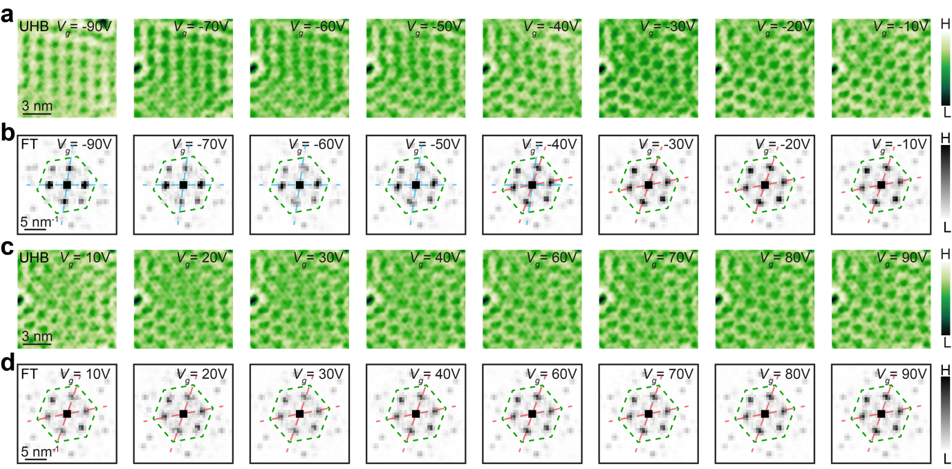

Figure S20. Gate-induced transition of the UHB charge ordering in G/$α$-RuCl₃/h-BN. (a-d) Gate-dependent STM images with the corresponding FTs. The first BZ of $α$-RuCl₃ is outlined by the green dashed line. The blue dashed line is the visual guide for an angle of $θ=98°$. And the red dashed line is the visual guide for an angle of $θ=120°$. The setpoint for acuquiring STM images is $I_{t}=0.5 nA$.

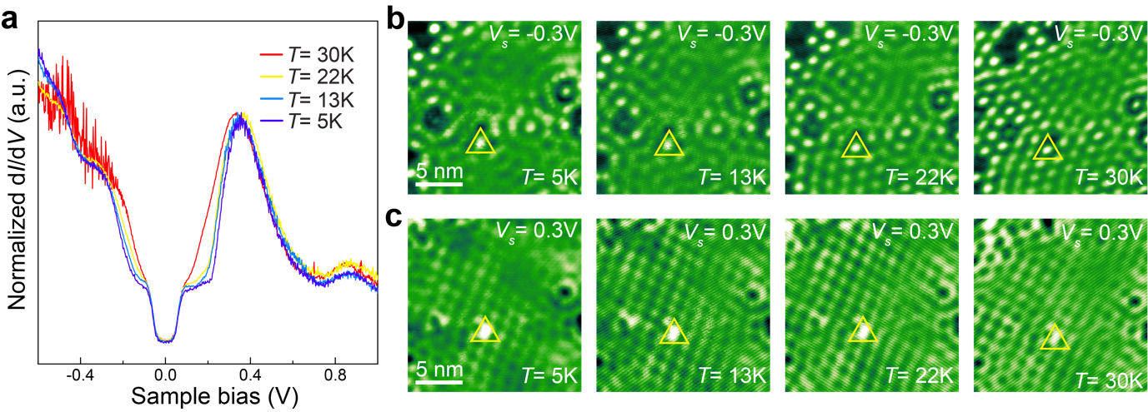
Figure S21. Temperature-dependent STM and STS results of G/$α$-RuCl₃/h-BN. (a) Temperature dependent point dI/dV spectra. It shows temperature dependent thermal broadening of LHB and UHB. (b-c) Temperature-dependent STM images showing persistent electron-hole crystals up to $T=30K$. The same point defect is outlined by the yellow triangle. The setpoint for acquiring STM images is $I_{t}=1 nA$.

References:

1 Mashhadi, S. et al. Spin-split band hybridization in graphene proximitized with α-RuCl₃ nanosheets. Nano Lett. 19, 4659-4665 (2019).
2 Brar, V. W. Scanning tunneling spectroscopy of graphene and magnetic nanostructures, UC Berkeley, (2010).
3 Zhang, Y. et al. Giant phonon-induced conductance in scanning tunnelling spectroscopy of gate-tunable graphene. Nat. Phys. 4, 627 (2008).
4 Chen, C. J. Introduction to scanning tunneling microscopy. Oxford University Press, New York, N. Y. (2008).
5 Clay, R., Mazumdar, S. & Campbell, D. Pattern of charge ordering in quasi-one-dimensional organic charge-transfer solids. Physical Review B 67, 115121 (2003).
6 Fertig, H. Electromagnetic response of a pinned Wigner crystal. Physical Review B 59, 2120 (1999).
7 Fogler, M. M. & Huse, D. A. Dynamical response of a pinned two-dimensional Wigner crystal. Physical Review B 62, 7553 (2000).
8 Chitra, R., Giamarchi, T. & Le Doussal, P. Pinned wigner crystals. Physical Review B 65, 035312 (2001).
9 Dombrowski, D. et al. Energy-dependent chirality effects in quasifree-standing graphene. Phys. Rev. Lett. 118, 116401 (2017).
10 Li, H. et al. Imaging two-dimensional generalized Wigner crystals. Nature 597, 650-654 (2021).

