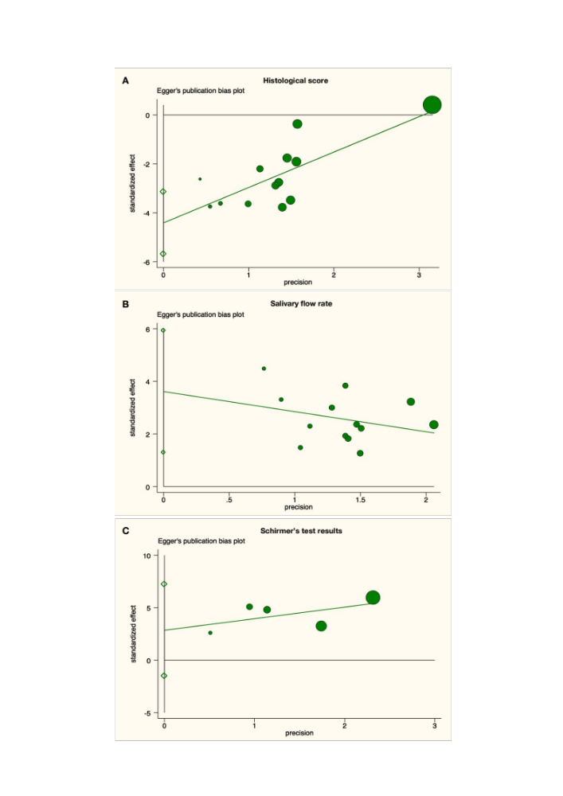
Supplemental Fig 3. The linear regression plot assessing publication bias.

