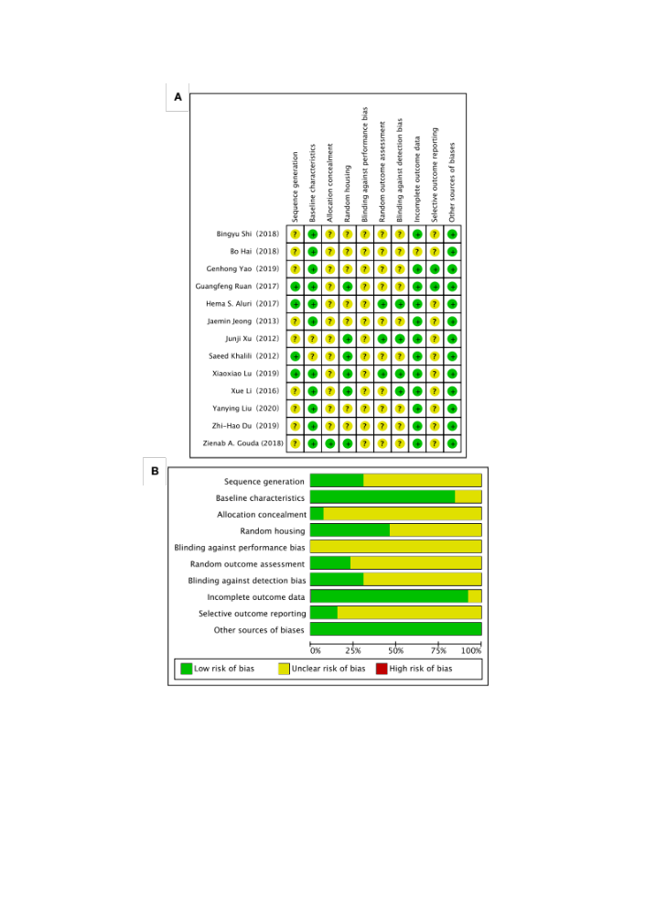
Supplemental Fig 1. Quality assessment of literature. A. Aggregate risks of bias graph for each experimental. B. Risks of bias summary. Green indicates “low risk”; yellow indicates “not clear risk”.

