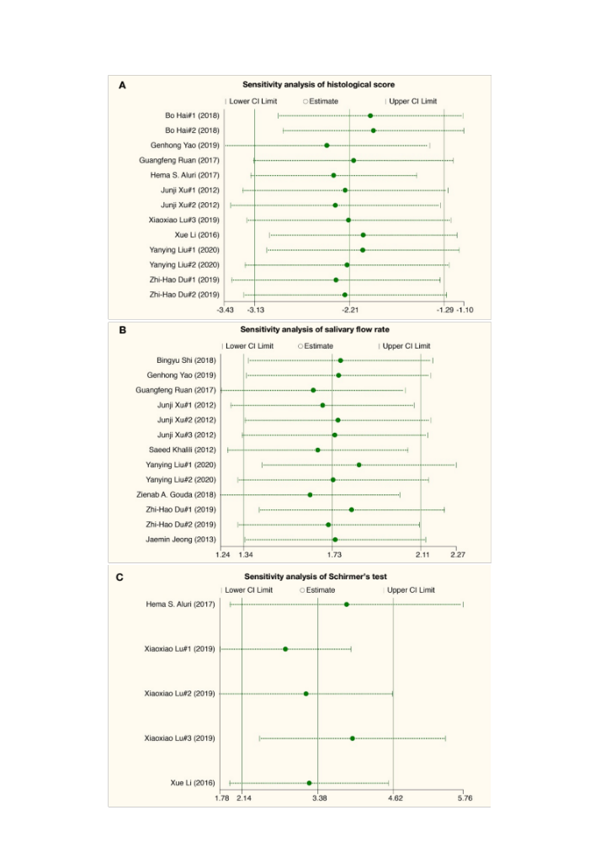
Supplemental Fig 2. The sensitivity analysis of main outcomes.

