Supporting Information

Fig. S1 Flow chart of study population.
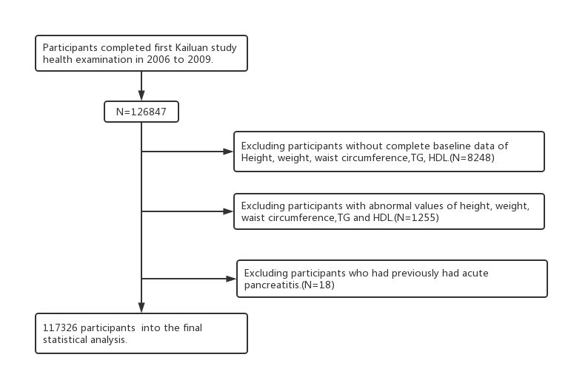

Figure S2. The cumulative incidence rates in the quartile groups of LAP level

Figure S3. The cumulative incidence rates in the quartile groups of WTI level

Figure S4. The cumulative incidence rates in different groups of BMI

Table S1.Baseline characteristics of participants according to quartiles of LAP
Characteristics | Quartiles of LAP |  |  |  | P Value
Characteristics | LAP1(≤16.49) | LAP2(16.49-28.77) | LAP3(28.77-50.38) | LAP4(≥50.38) | P Value
Number | 29495 | 29250 | 29293 | 29288
No. Of AP patient | 70 | 87 | 97 | 147
Age,year | 48.23±14.08 | 51.34±12.64 | 52.58±12.30 | 52.40±11.59 | <0.001
Men,n(%) | 23214 (78.70) | 23729 (81.12) | 23606 (80.59) | 23843 (81.41) | <0.001
BMI,kg/m2 | 22.37±2.70 | 24.49±2.74 | 25.89±2.95 | 27.27±3.27 | <0.001
WC,cm | 77.40±6.76 | 85.41±6.48 | 90.07±7.25 | 94.68±8.38 | <0.001
Ht,cm | 166.99±6.74 | 167.69±6.72 | 167.84±6.90 | 168.18±7.06 | <0.001
FBG,mmol/L | 5.18±1.29 | 5.35±1.43 | 5.54±1.66 | 5.91±2.14 | <0.001
TG,mmol/L | 0.80±0.35 | 1.11±0.37 | 1.54±0.51 | 3.15±1.73 | <0.001
TC,mmol/L | 4.67±0.95 | 4.91±0.96 | 5.07±1.10 | 5.11±1.46 | <0.001
HDL-C,mmol/L | 1.55±0.38 | 1.53±0.38 | 1.51±0.38 | 1.49±0.40 | <0.001
LDL-C,mmol/L | 2.36±0.88 | 2.45±0.93 | 2.46±0.94 | 2.35±1.07 | <0.001
Alcohol intake, n(%) | 12831 (43.50) | 11722 (40.08) | 12172 (41.55) | 12863 (43.92) | <0.001
Smoker,n(%) | 12411 (42.08) | 11496 (39.30) | 11956 (40.82) | 12781 (43.64) | <0.001
Physical activity,n(%) | 4889 (16.58) | 4682 (16.01) | 4887 (16.68) | 4611 (15.74) | <0.001
Hypertension, n (%) | 8034 (27.24) | 12062 (41.24) | 14512 (49.54) | 17056 (58.24) | <0.001
Diabetes, n(%) | 1190 (4.03) | 2002 (6.84) | 2956 (10.09) | 4634 (15.82) | <0.001
Cholelithiasis，n(%) | 721 (2.44) | 945 (3.23) | 1081 (3.69) | 1132 (3.87) | <0.001
Education≥9 years,n(%) | 8476 (28.74) | 5801 (19.83) | 5771 (19.70) | 5632 (19.23) | <0.001

Table S2.Baseline characteristics of participants according to quartiles of WTI
Characteristics | Quartiles of WTI |  |  |  | P Value
Characteristics | WTI 1(≤74.40) | WTI2(74.40-109.65) | WTI3(109.65-171.69) | LAP4(≥171.69) | P Value
Number | 29406 | 29280 | 29308 | 29332
No. Of AP patient | 70 | 79 | 97 | 155
Age,year | 49.10±13.87 | 51.37±12.91 | 52.46±12.47 | 51.60±11.62 | <0.001
Men,n(%) | 21555 (73.30) | 23608 (80.63) | 24114 (82.28) | 25115 (85.62) | <0.001
BMI,kg/m2 | 23.01±3.03 | 24.54±3.09 | 25.72±3.18 | 26.73±3.29 | <0.001
WC,cm | 80.82±8.82 | 85.53±8.47 | 89.13±8.62 | 92.03±8.92 | <0.001
Ht,cm | 166.83±6.91 | 167.61±6.80 | 167.90±6.86 | 168.35±6.82 | <0.001
FBG,mmol/L | 5.16±1.25 | 5.36±1.44 | 5.57±1.69 | 5.89±2.14 | <0.001
TG,mmol/L | 0.69±0.16 | 1.08±0.15 | 1.54±0.23 | 3.29±1.65 | <0.001
TC,mmol/L | 4.63±0.93 | 4.91±0.94 | 5.12±1.15 | 5.10±1.44 | <0.001
HDL-C,mmol/L | 1.55±0.39 | 1.54±0.38 | 1.51±0.38 | 1.49±0.40 | <0.001
LDL-C,mmol/L | 2.30±0.92 | 2.46±0.94 | 2.50±0.91 | 2.36±1.05 | <0.001
Alcohol intake, n(%) | 12084 (41.09) | 11512 (39.32) | 12350 (42.14) | 13642 (46.51) | <0.001
Smoker,n(%) | 11479 (39.04) | 11342 (38.74) | 12261 (41.83) | 13562 (46.24) | <0.001
Physical activity,n(%) | 4891 (16.63) | 4692 (16.02) | 4925 (16.80) | 4561 (15.55) | <0.001
Hypertension, n (%) | 8347 (28.39) | 12193 (41.64) | 14498 (49.47) | 16626 (56.68) | <0.001
Diabetes, n(%) | 1262 (4.29) | 2029 (6.93) | 3037 (10.36) | 4454 (15.18) | <0.001
Cholelithiasis，n(%) | 835 (2.84) | 929 (3.17) | 1116 (3.81) | 999 (3.41) | <0.001
Education≥9 years,n(%) | 8068 (27.44) | 5833 (19.92) | 5905 (20.15) | 5874 (20.03) | <0.001

Table S3.Baseline characteristics of participants according to different groups of BMI
Characteristics | BMI 1(<24) | BMI 2(24-28) | BMI 3(≥28) | P Value
Number | 46919 | 49026 | 21381
No. Of AP patient | 136 | 163 | 102
Age,year | 50.38±13.87 | 51.86±11.88 | 51.11±12.32 | <0.001
Men,n(%) | 35984 (76.69) | 40897 (83.42) | 17511 (81.90) | <0.001
WC,cm | 80.87±8.29 | 88.66±7.25 | 95.96±8.52 | <0.001
Ht,cm | 167.45±6.86 | 167.93±6.77 | 167.58±7.10 | <0.001
FBG,mmol/L | 5.30±1.58 | 5.58±1.73 | 5.73±1.76 | <0.001
TG,mmol/L | 1.32±1.07 | 1.77±1.36 | 2.08±1.45 | <0.001
TC,mmol/L | 4.83±1.07 | 5.00±1.19 | 5.04±1.21 | <0.001
HDL-C,mmol/L | 1.57±0.40 | 1.50±0.38 | 1.47±0.37 | <0.001
LDL-C,mmol/L | 2.33±1.01 | 2.45±0.92 | 2.47±0.93 | <0.001
Alcohol intake, n(%) | 19200 (40.92) | 21385 (43.62) | 9003 (42.11) | <0.001
Smoker,n(%) | 19134 (40.78) | 20789 (42.40) | 8721 (40.79) | <0.001
Physical activity,n(%) | 7332 (15.63) | 8174 (16.67) | 3563 (16.66) | <0.001
Hypertension, n (%) | 14864 (31.68) | 23650 (48.24) | 13150 (61.50) | <0.001
Diabetes, n(%) | 2823 (6.02) | 5120 (10.44) | 2839 (13.28) | <0.001
Cholelithiasis，n(%) | 1239 (2.64) | 1759 (3.59) | 881 (4.12) | <0.001
Education≥9 years,n(%) | 11299 (24.08) | 9939 (20.27) | 4442 (20.78) | <0.001

Abbreviations:CMI=Cardiometabolic Index;LAP=Lipid Accumulation Products;WTI=Waist Triglyceride Index ;BMI=body mass indes;WC=Waist circumference;Ht=Height;FBG=fasting blood glucose;TC=total cholesterol, TG=triglyceride, HDL=high-density lipoprotein, LDL=low-density lipoprotein.

