SUPPLEMENTARY MATERIAL

Viral Genome Sequencing to Decipher In-Hospital SARS-CoV-2 Transmission Events

Elisabeth Esser^{a,b,§}, Eva C. Schulte^{a,c,d,e,f,§}, Alexander Graf^{g}, Alexander Karollus^{b}, Nicholas H. Smith^{b}, Thomas Michler^{a,h}, Stefan Dvoretskii^{b}, Angel Angelov^{i}, Michael Sonnabend^{i}, Silke Peter^{i}, Christina Engesser^{i}, Aleksandar Radonic^{j}, Andrea Thürmer^{j}, Max von Kleist^{k,l}, Friedemann Gebhardt^{m}, Clarissa Prazeres da Costa^{m,n}, Dirk H. Busch^{m,n}, Maximilian Muenchhoff^{o,n}, Helmut Blum^{g}, Oliver T. Keppler^{o,n}, Julien Gagneur^{b,p,q,$*,} Ulrike Protzer^{a,n$*}

ª Institute of Virology, School of Medicine, Technical University of Munich/Helmholtz Munich, Munich, Germany
^{b} School of Computation, Information and Technology, Technical University of Munich, Garching, Germany
^{c} Department of Psychiatry, University Hospital, LMU Munich, Munich, Germany
^{d} Institute of Psychiatric Phenomics and Genomics, University Hospital, LMU Munich, Munich, Germany
^{e} Department of Psychiatry, University Hospital, Medical Faculty, University of Bonn, Bonn, Germany
^{f} Institute of Human Genetics, University Hospital, Medical Faculty, University of Bonn, Bonn, Germany
^{g} Laboratory for Functional Genome Analysis, Gene Center, LMU Munich, Munich, Germany
^{h} Current address: Institute of Laboratory Medicine, University Hospital, LMU Munich, Germany
^{i} NGS Competence Center, University of Tübingen, Tübingen, Germany
^{j} Method development, research infrastructure & IT (MFI), Robert-Koch Institute (RKI), Berlin, Germany
^{k} Department of Mathematics and Computer Science, Freie Universität (FU) Berlin, Berlin, Germany
^{l} Project groups, Robert-Koch Institute, (RKI), Berlin, Germany
^{m} Institute for Medical Microbiology, Immunology and Hygiene, School of Medicine, Technical University of Munich, Munich, Germany
^{n} German Center for Infection research (DZIF), Munich partner site, Munich, Germany
º Max von Pettenkofer Institute and Gene Center, Virology, National Reference Center for Retroviruses, Faculty of Medicine, LMU Munich, Munich, Germany
^{p} Institute of Human Genetics, School of Medicine, Technical University of Munich, Munich, Germany
^{q} Computational Health Center, Helmholtz Center Munich, Neuherberg, Germany
§ shared first authors
$shared last authors
*corresponding authors: Ulrike Protzer, protzer@tum.de; Tel.: +49-89-4140-6821
Julien Gagneur, gagneur@in.tum.de; Tel.: +49-89-289-19411

SUPPLEMENTARY METHODS

Viral whole genome sequences were obtained from residual diagnostic material (e.g. nasopharyngeal swabs, bronchoalveolar lavage fluid, material from throat flushes, sputum, stool, or tracheal secretions) testing positive for SARS-CoV-2 by PCR. Samples were collected at Klinikum rechts der Isar in Munich, Germany, across 12 months from February 3, 2020, to January 10, 2021 (“TUM samples”, Suppl Fig 1).
An additional dataset of local viral sequences from 16 hospitals and emergency departments across Munich other than the Klinikum rechts der Isar, collected by the Ludwig Maximilian University of Munich (LMU), served as negative controls. This dataset consisted of 1,156 samples collected from 1,030 individuals across a 11-month timespan from March 5, 2020, to January 10, 2021 (“LMU samples”).
Sequencing was performed on NextSeq, ISeq, or HiSeq platforms (Illumina, San Diego) for a total of 926 samples from 622 probands, including both patients (n=433; m=271, f=158, missing=4; age 2-99 yrs (mean ± SD: 63.8 ± 18.7 yrs)) and staff members (n=189; m=83, f=106; age 20-67 yrs (mean ± SD: 38.7 ± 12.3 yrs))
First wave samples were sequenced at the Robert Koch Institute (RKI) in Berlin, Germany. The RKI received samples covering the time period from February 3, 2020, to June 25, 2020 (n=390). For the samples sequenced at RKI, libraries were prepared using the CleanPlex protocol by Paragon Genomics [1]. Since only samples with CT-values < 33.0 yielded reliable sequencing results, samples sequenced at RKI were excluded from the analysis if they had CT-values $≥$ 33.0.
Second wave samples were sequenced at the NGS Competence Center Tübingen, Tübingen, Germany, and the Gene Center at the Ludwig Maximilian University of Munich (LMU), Munich, Germany. The NGS Competence Center Tübingen mainly sequenced samples collected between September 13, 2020, and January 10, 2021 (n=182) and the Gene Center mainly sequenced samples received for diagnostics from November 2, 2020 to January 10, 2021 (n=354). For the samples sequenced at the Gene Center of the LMU Munich and the samples sequenced at the NGS Competence Center Tübingen, the Artic library preparation protocol was used [2].
All sequences were aligned to the SARS-CoV-2 reference genome (NC 045512.2) using bwa-mem [3]. Genetic variants were called with freebayes [4].
The following quality control filters were implemented: A sample needed to reach a genome coverage over 80%, read depth at a variant position had to be higher than ten, and the number of alternate observations on the forward and the reverse strand each had to be greater than two. Applying these quality filters, 619 samples from 475 probands, containing both patients (n=320; m=207, f=112, missing=1; age 17-99 yrs (mean ± SD: 66.2 ± 17.1 yrs)) and staff members (n=155; m=66, f=89; age 20-67 yrs (mean ± SD: 38.2 ± 12.0 yrs)), were included in the final analysis.
The same quality filters were implemented for the additional dataset of local sequences, collected by the LMU, which served as negative controls. This resulted in the inclusion of 957 samples from 854 individuals (m= 285, f= 263, missing=306; age 0-102 yrs (mean ± SD: 64.8 ± 20.7 yrs), missing=18) in the analysis.
Clustering analysis was performed in RStudio (version 4.1.1) across the entire set of TUM samples to identify clusters of genetically related samples. The pairwise dissimilarities between the samples were computed using the pretty heatmaps package [5]. The resulting multiple levels of clusters were then visualised as phylogenetic trees, which were cut, to put similar samples into groups. The cutting height was determined by probands, which changed their virus strain over time. The samples of these probands were assigned different Next-Strain clades [6] as the virus strain changed. The right cutting height was defined as the height where those samples, from the same probands with different Next-Strain clades, were also put into different groups by cutting the tree. The resulting groups were filtered for high similarity (Jaccard distance between samples <0.2), time of sample collection (< 30 days apart), number of probands included (≥ three probands). Genetic variants were only included in the analysis if they occurred in at least one sample with an allele frequency higher than 50%.
As part of routine procedures, interview-based contact tracing was performed by a physician specialising in clinical hygiene whenever a transmission cluster was suspected clinically. Individuals were included in an interview-based transmission cluster when either a close contact was reported, defined as exposure to presumably high concentrations of aerosols without wearing an FFP2 mask or if the index or the contact were wearing no more than a surgical mask while conversing or being in close proximity for more than ten minutes (Fig 1B), or when a patient had shared a room with the index patient at some point, regardless of the duration or the use of personal protective equipment (Fig. 1B). In addition to either of the inclusion criteria above, the infections needed to have taken place within the potentially infectious period of the index patient (defined as two days before until 10 days after symptom onset; for asymptomatic cases, up to 10 days after the date of the first positive test). In cases of uncertain routes of infection (community-acquired vs. while working as a health care provider), professional exposure was assumed, and the individuals were always included in the clusters. A cluster was defined when at least three infections were connected as described above.
To validate the in-hospital transmissions, September 13, 2020, to January 10, 2021, was chosen as a time period with enough comparable data for both the TUM and the LMU datasets. For the last viral sequence of each individual in the TUM dataset (n=334) during this period, the number k_{i} of individuals with a closely related virus genotype (Jaccard distance <0.2) as well as the average (T_{k}) for the entire TUM dataset was computed. To compare our data to an out-of-hospital “negative” control, we proceeded with Monte Carlo simulations by randomly drawing n=334 viral genomes from the LMU dataset (n=681, only last samples from each individual), collected at other local hospitals and emergency departments during the same time period, repeating this process 1,000 times and every time computing the number k_{i}^{LMU} of closely related individuals for each sample of the TUM dataset. As before, the average T_{k}^{LMU} was computed each time.
A similar approach was used to confirm true transmission clusters ruling out multiple simultaneous introductions. For each viral genome cluster, the number of closely related samples from a random draw (n=343) of the LMU dataset (n=681) was computed and the process was repeated 1,000 times for each cluster. If this number was smaller than the number of samples in the cluster in 95% of the results, the cluster was deemed likely to be an in-hospital transmission cluster. The higher number of samples in the random draw compared to the previous simulation results from the fact that if multiple samples of a single individual were assigned to different clusters, all of these samples were included in the analysis.

SUPPLEMENTARY FIGURES

  - 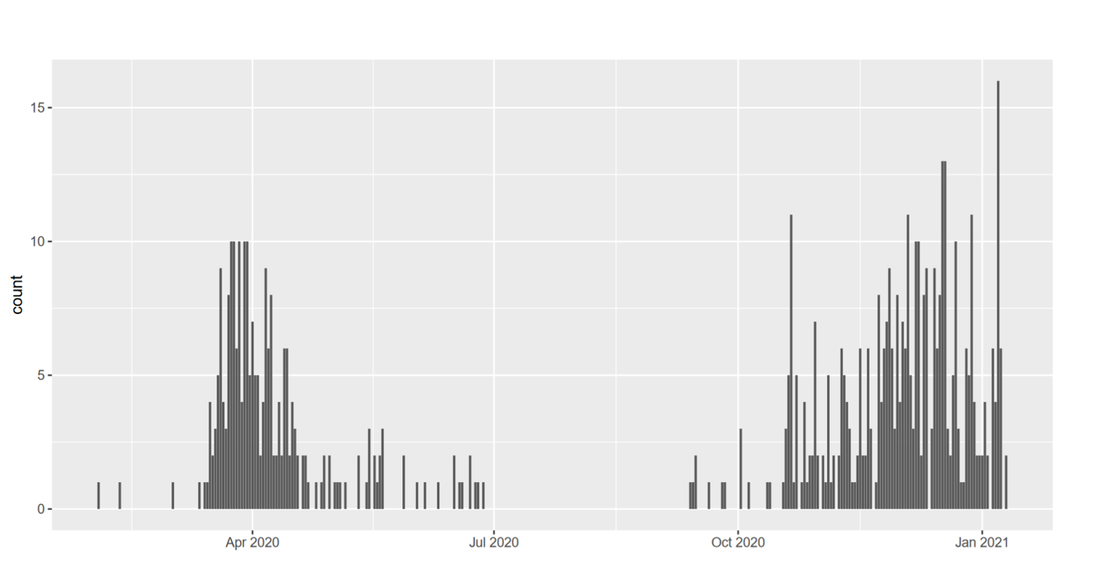Suppl. Fig.1: Distribution of samples over one year. Number of samples collected at Klinikum rechts der Isar in Munich, Germany, per day across a 12-month timespan from February 3, 2020, to January 10, 2021, which met the quality criteria and were included in the analysis.
  - 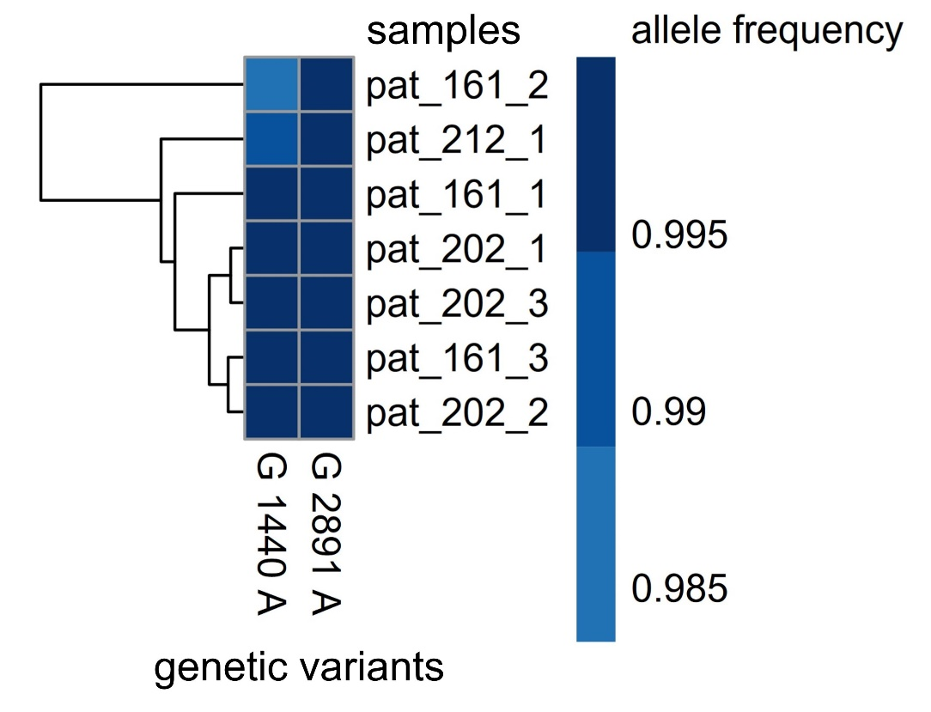
Suppl. Fig.2: Cluster A. This cluster includes seven samples from three patients. The color gradient depicts allele frequencies, grey coloring denotes that the base call did not pass the quality control filters for a given variant. X-axes display genetic variants with allele frequencies >50% in at least one sample when compared to the reference genome (NC 045512.2) Each row denotes one sample included in the cluster.
  - 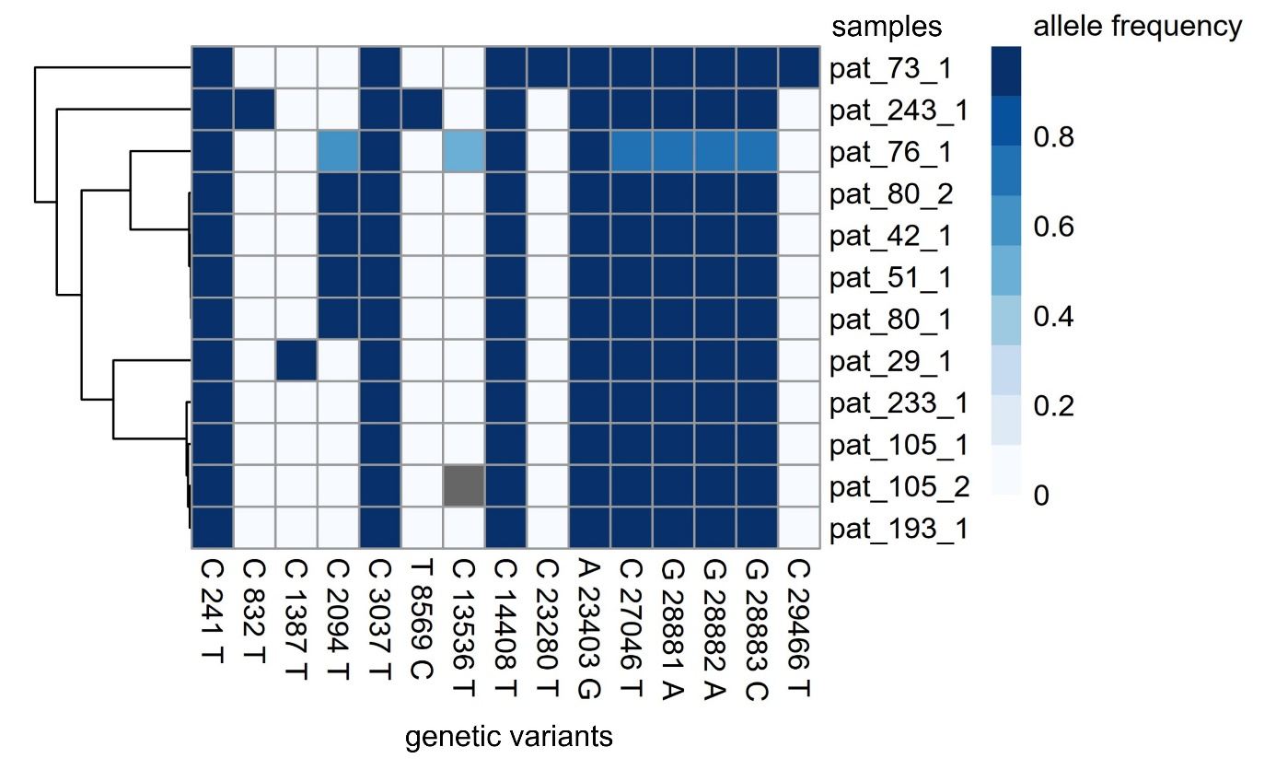
Suppl. Fig.3: Cluster B. This Cluster includes twelve samples from ten probands, five staff members and five patients. The color gradient depicts allele frequencies, grey coloring denotes that the base call did not pass the quality control filters for a given variant. X-axes display genetic variants with allele frequencies >50% in at least one sample when compared to the reference genome (NC 045512.2) Each row denotes one sample included in the cluster.
  - 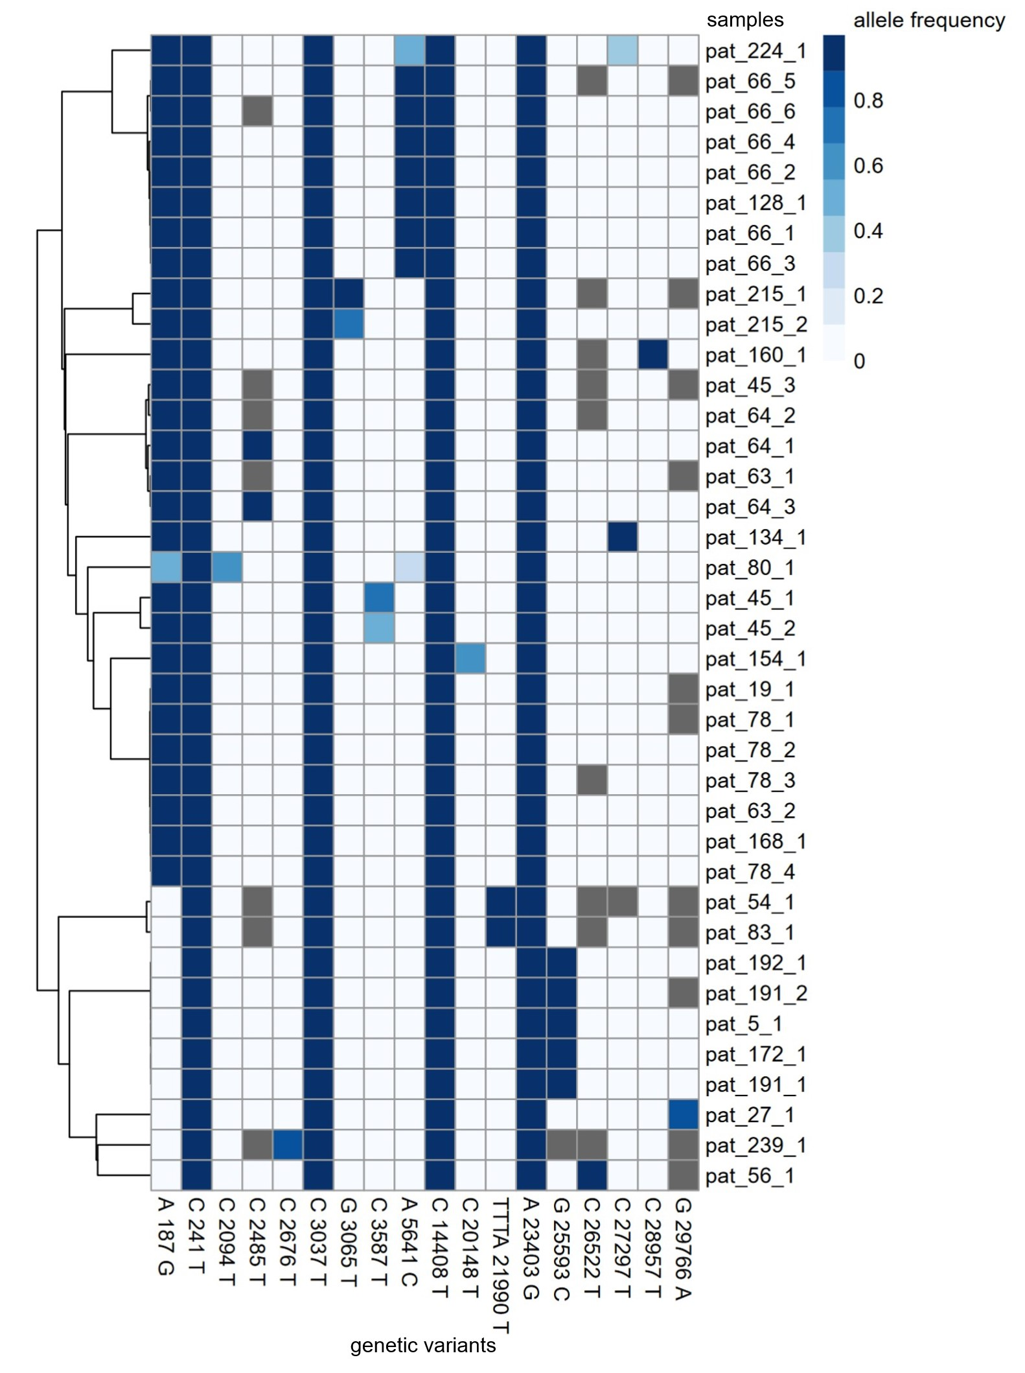
Suppl. Fig.4: Cluster C. This cluster includes 38 samples from 23 probands (two staff members and 21 patients). This cluster is bigger and more heterogenous because the defining genetic variants in this cluster (C 241 T, C 3037 T, C 14408 T, A 23403 G) are four variants common to most viruses circulating at the time. Since this makes it unlikely that all samples with those genetic variants originated from one big transmission event, there was an extra filter implemented for this cluster. The filter only includes samples in the cluster that have additional genetic variants to the four common ones. The color gradient depicts allele frequencies, grey coloring denotes that the base call did not pass the quality control filters for a given variant. X-axes display genetic variants with allele frequencies >50% in at least one sample when compared to the reference genome (NC 045512.2) Each row denotes one sample included in the cluster.
  - 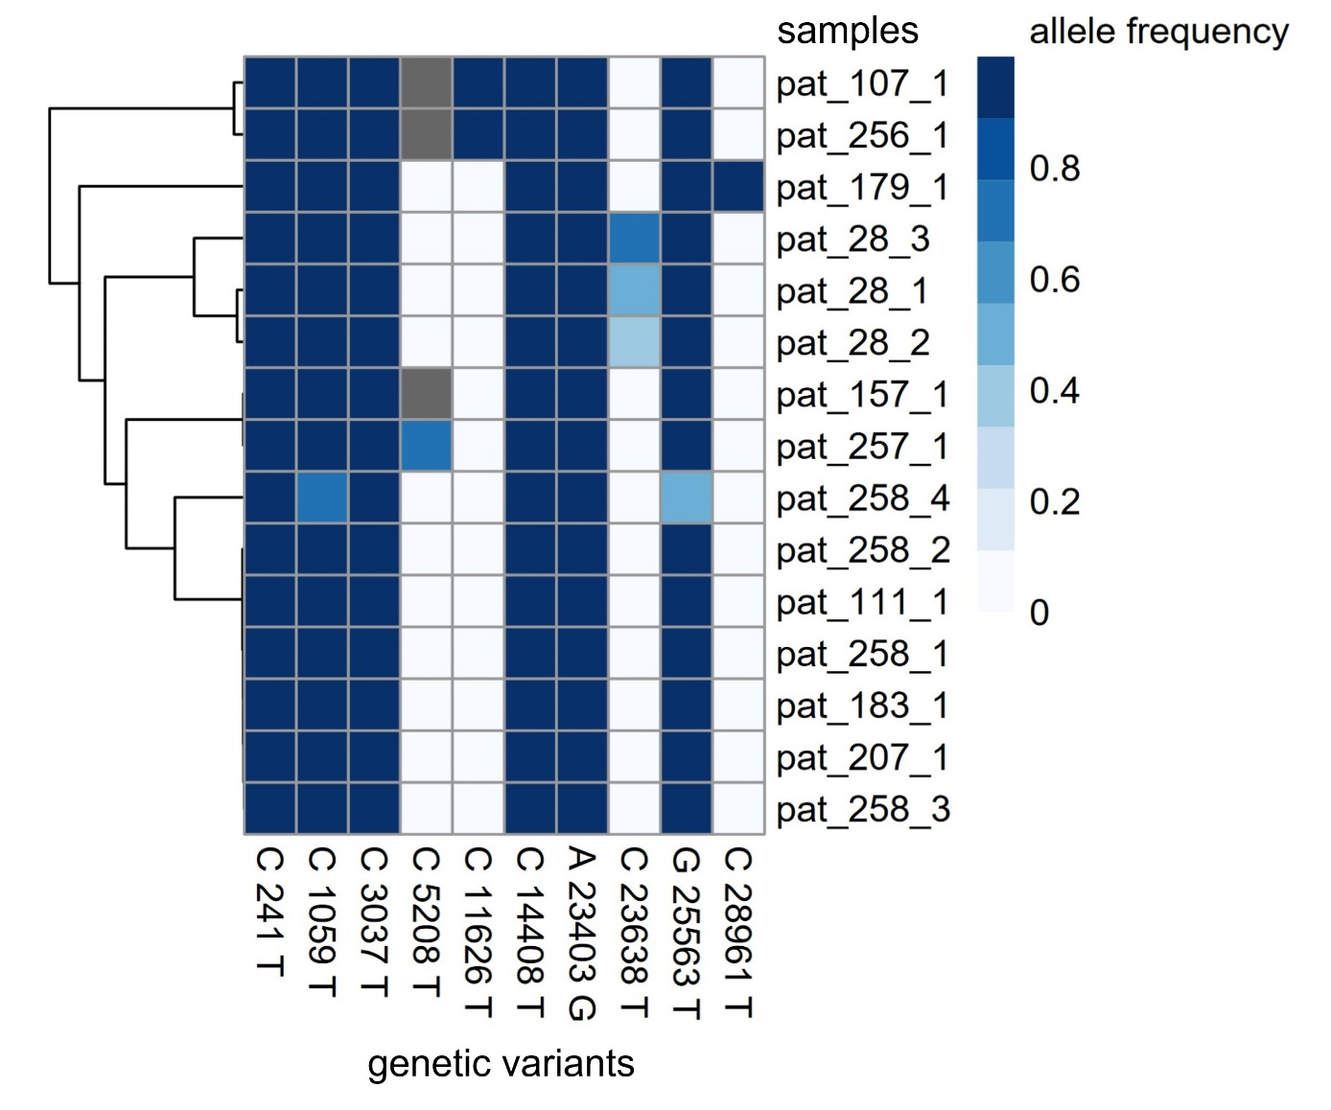
Suppl. Fig.5: Cluster D. This cluster includes 15 samples from ten probands (three staff members and seven patients). The color gradient depicts allele frequencies, grey coloring denotes that the base call did not pass the quality control filters for a given variant. X-axes display genetic variants with allele frequencies >50% in at least one sample when compared to the reference genome (NC 045512.2) Each row denotes one sample included in the cluster.
  - 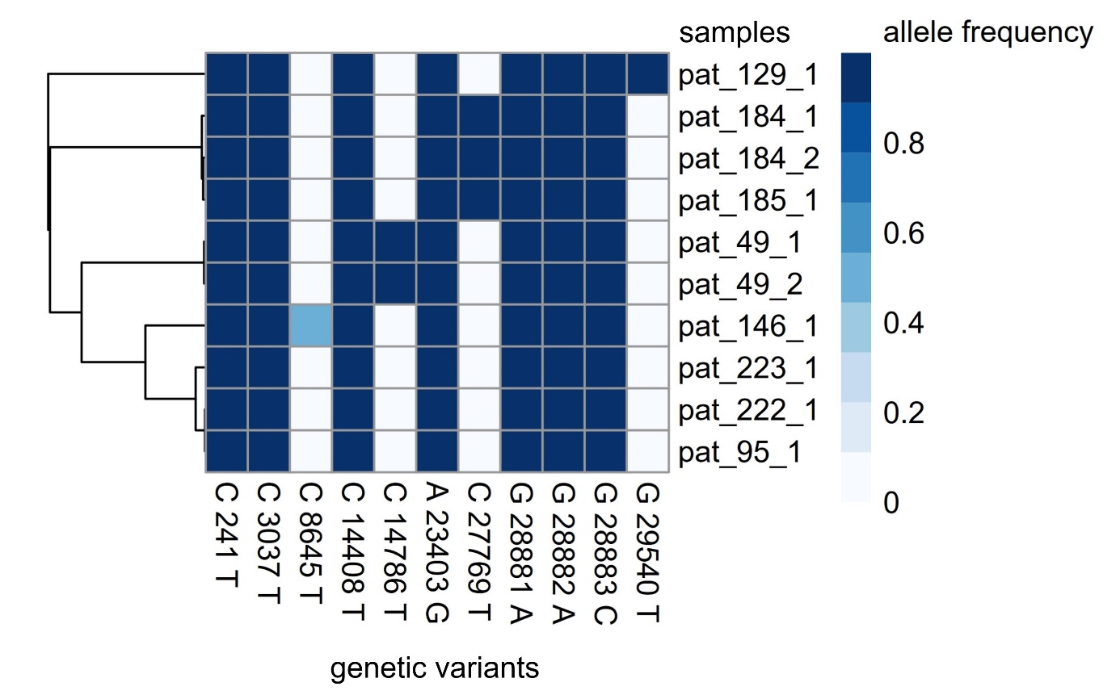
Suppl. Fig.6: Cluster E. This cluster includes ten samples from eight patients. The color gradient depicts allele frequencies, grey coloring denotes that the base call did not pass the quality control filters for a given variant. X-axes display genetic variants with allele frequencies >50% in at least one sample when compared to the reference genome (NC 045512.2) Each row denotes one sample included in the cluster.
  - 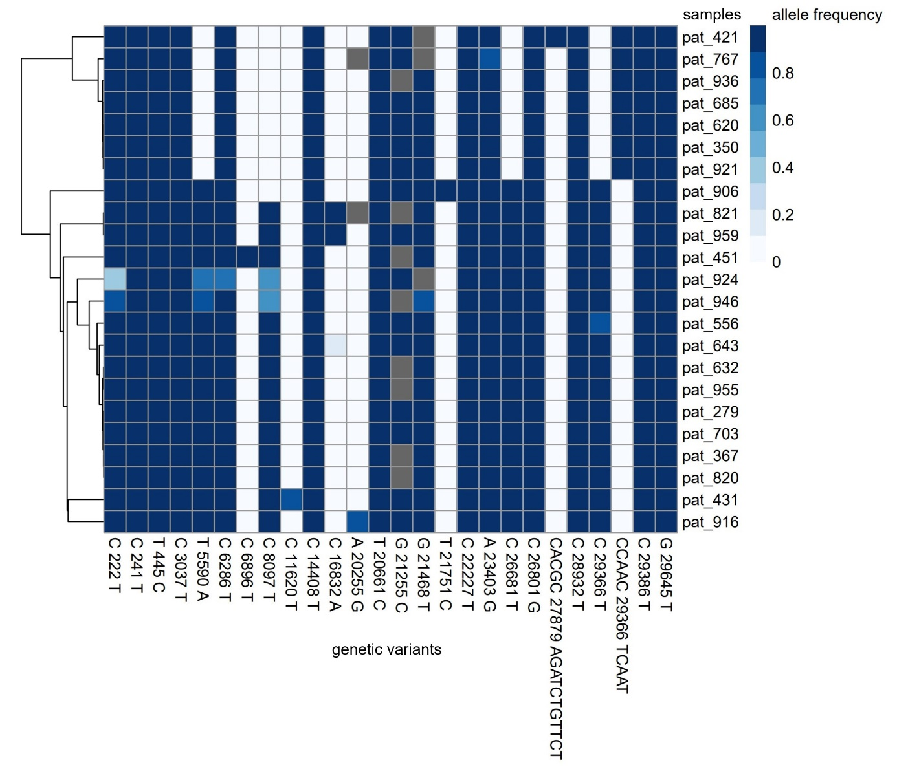
Suppl. Fig.7: Cluster F. This cluster includes 23 samples from 23 probands 8nine staff members and twelve patients). The color gradient depicts allele frequencies, grey coloring denotes that the base call did not pass the quality control filters for a given variant. X-axes display genetic variants with allele frequencies >50% in at least one sample when compared to the reference genome (NC 045512.2) Each row denotes one sample included in the cluster.
  - 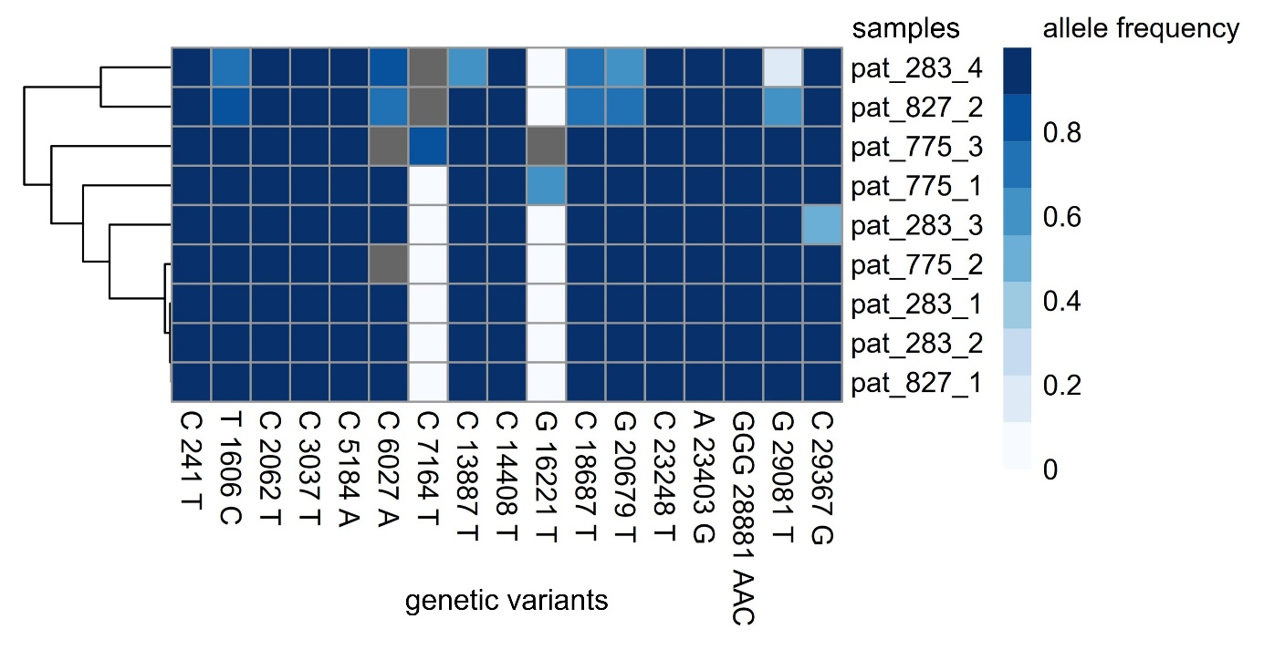
Suppl. Fig.8: Cluster G. This cluster includes nine samples from three patients. The color gradient depicts allele frequencies, grey coloring denotes that the base call did not pass the quality control filters for a given variant. X-axes display genetic variants with allele frequencies >50% in at least one sample when compared to the reference genome (NC 045512.2) Each row denotes one sample included in the cluster.
  - 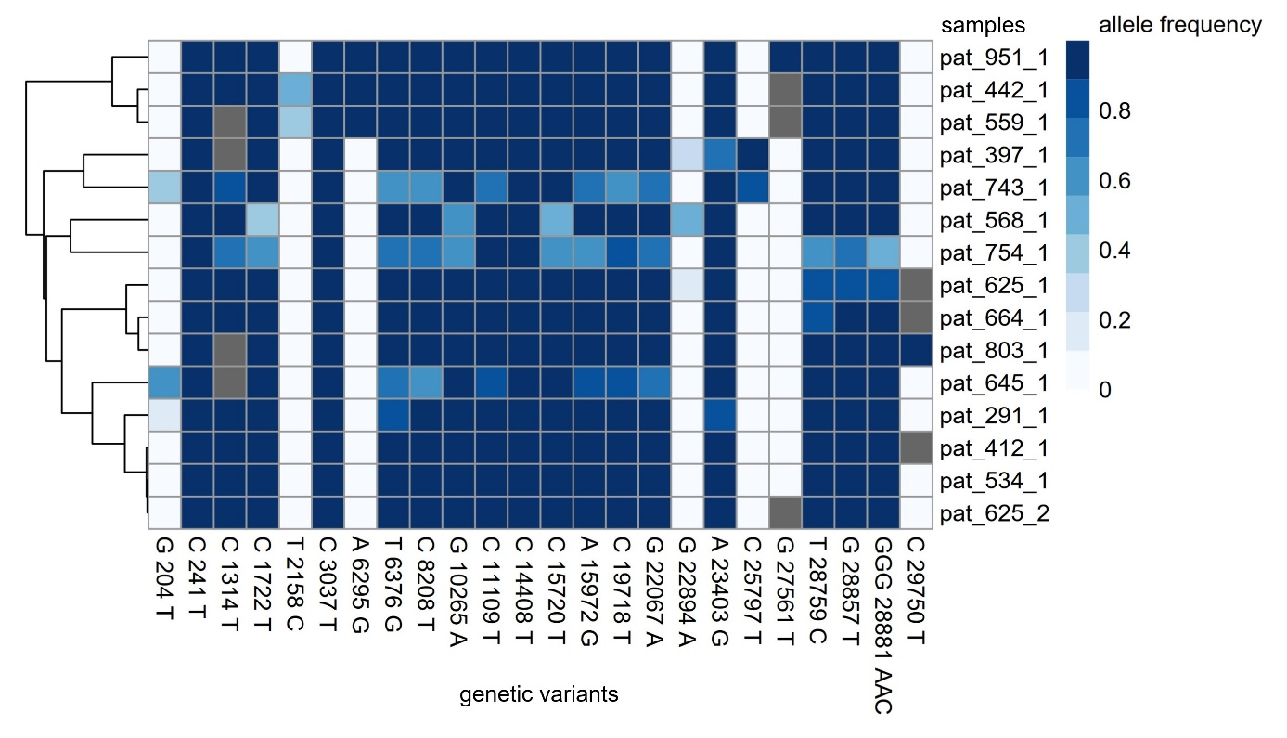
Suppl. Fig.9: Cluster I. This cluster includes 15 samples from 14 probands, three staff members and eleven patients. The color gradient depicts allele frequencies, grey coloring denotes that the base call did not pass the quality control filters for a given variant. X-axes display genetic variants with allele frequencies >50% in at least one sample when compared to the reference genome (NC 045512.2) Each row denotes one sample included in the cluster.
  - 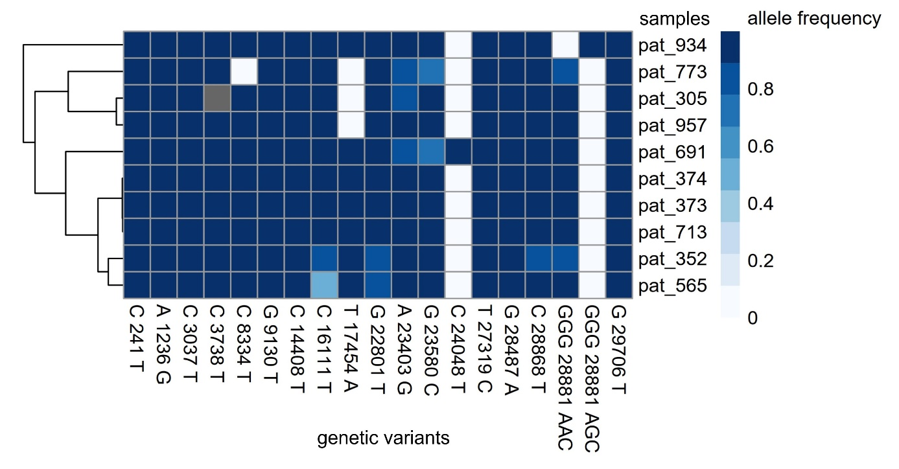
Suppl. Fig. 10: Cluster J. This cluster includes ten samples from ten probands, five staff members and five patients. The color gradient depicts allele frequencies, grey coloring denotes that the base call did not pass the quality control filters for a given variant. X-axes display genetic variants with allele frequencies >50% in at least one sample when compared to the reference genome (NC 045512.2) Each row denotes one sample included in the cluster.
  - 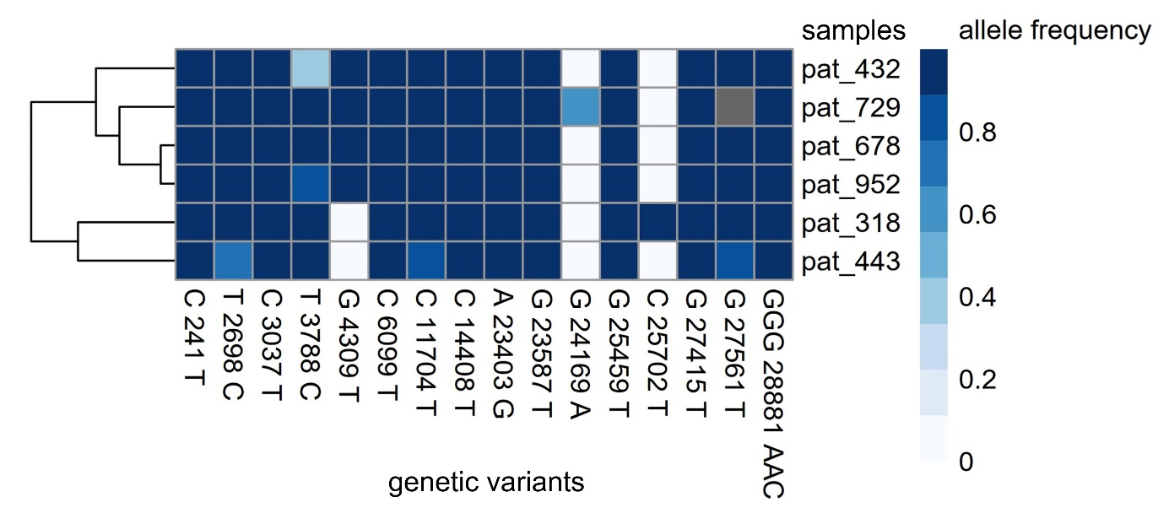
Suppl. Fig.11: Cluster K. This cluster includes six samples from six probands, two staff members and four patients. The color gradient depicts allele frequencies, grey coloring denotes that the base call did not pass the quality control filters for a given variant. X-axes display genetic variants with allele frequencies >50% in at least one sample when compared to the reference genome (NC 045512.2) Each row denotes one sample included in the cluster.
  - 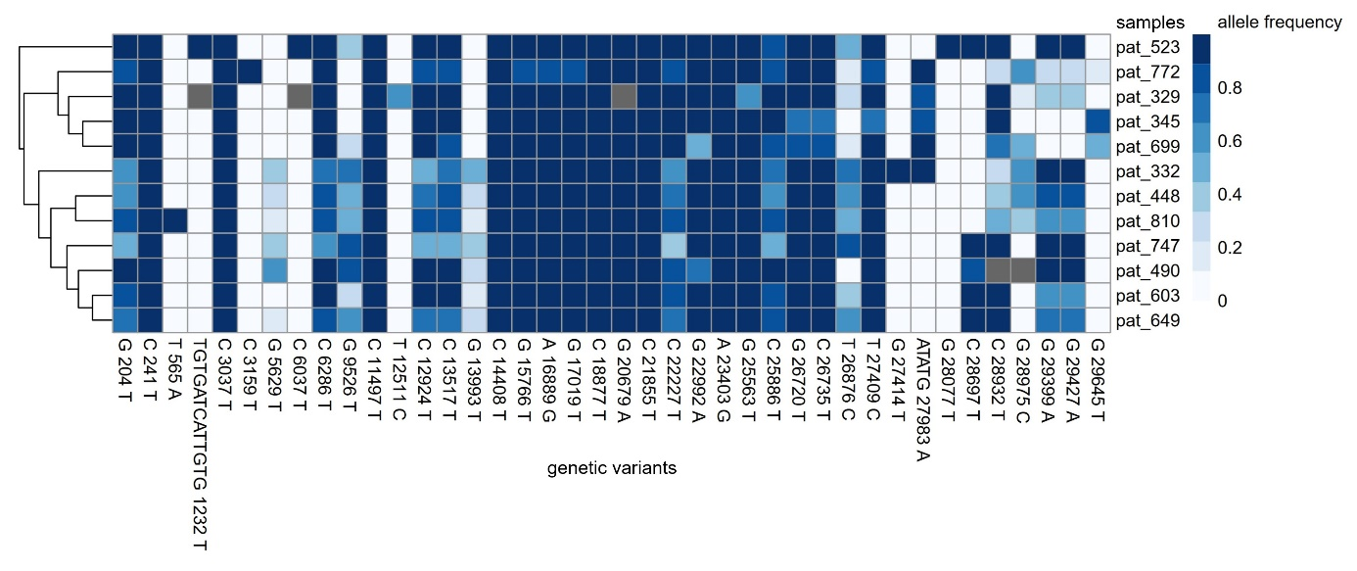
Suppl. Fig.12: Cluster L. This cluster includes twelve samples from twelve probands, seven staff members and five patients. The color gradient depicts allele frequencies, grey coloring denotes that the base call did not pass the quality control filters for a given variant. X-axes display genetic variants with allele frequencies >50% in at least one sample when compared to the reference genome (NC 045512.2) Each row denotes one sample included in the cluster.
  - 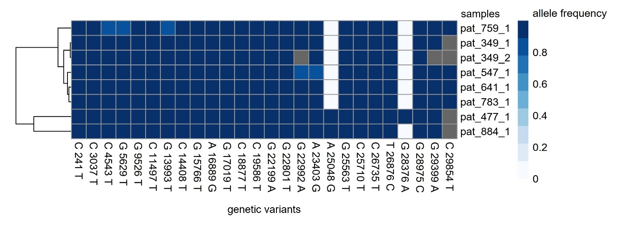
Suppl. Fig.13: Cluster N. This cluster includes eight samples from seven probands, three staff members and four patients. The color gradient depicts allele frequencies, grey coloring denotes that the base call did not pass the quality control filters for a given variant. X-axes display genetic variants with allele frequencies >50% in at least one sample when compared to the reference genome (NC 045512.2) Each row denotes one sample included in the cluster.
  - 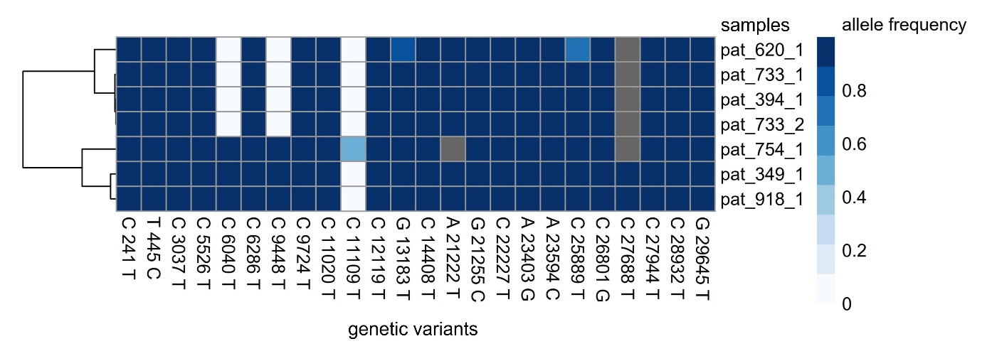
Suppl. Fig.14: Cluster O. This cluster includes seven samples from six probands, one staff member and five patients. The color gradient depicts allele frequencies, grey coloring denotes that the base call did not pass the quality control filters for a given variant. X-axes display genetic variants with allele frequencies >50% in at least one sample when compared to the reference genome (NC 045512.2) Each row denotes one sample included in the cluster.
  - 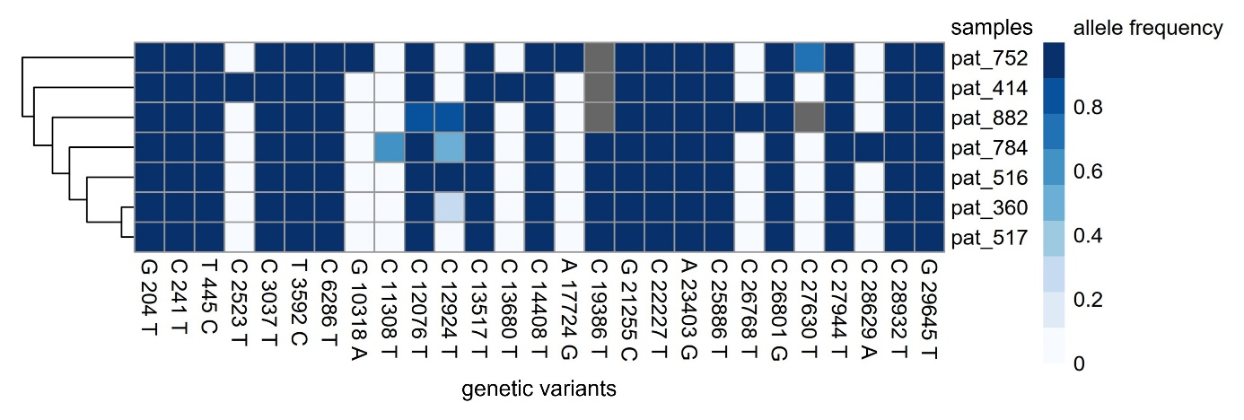
Suppl. Fig.15: Cluster P. This cluster includes seven samples from seven probands, three staff members and four patients. The color gradient depicts allele frequencies, grey coloring denotes that the base call did not pass the quality control filters for a given variant. X-axes display genetic variants with allele frequencies >50% in at least one sample when compared to the reference genome (NC 045512.2) Each row denotes one sample included in the cluster.
  - 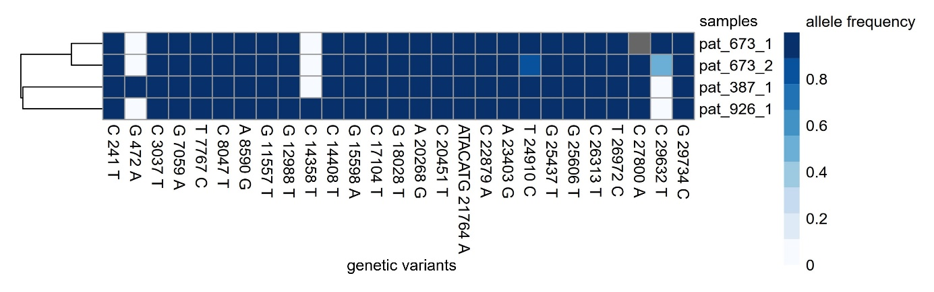
Suppl. Fig.16: Cluster Q. This cluster includes four samples from three probands, one staff members and one patient. The color gradient depicts allele frequencies, grey coloring denotes that the base call did not pass the quality control filters for a given variant. X-axes display genetic variants with allele frequencies >50% in at least one sample when compared to the reference genome (NC 045512.2) Each row denotes one sample included in the cluster.
  - 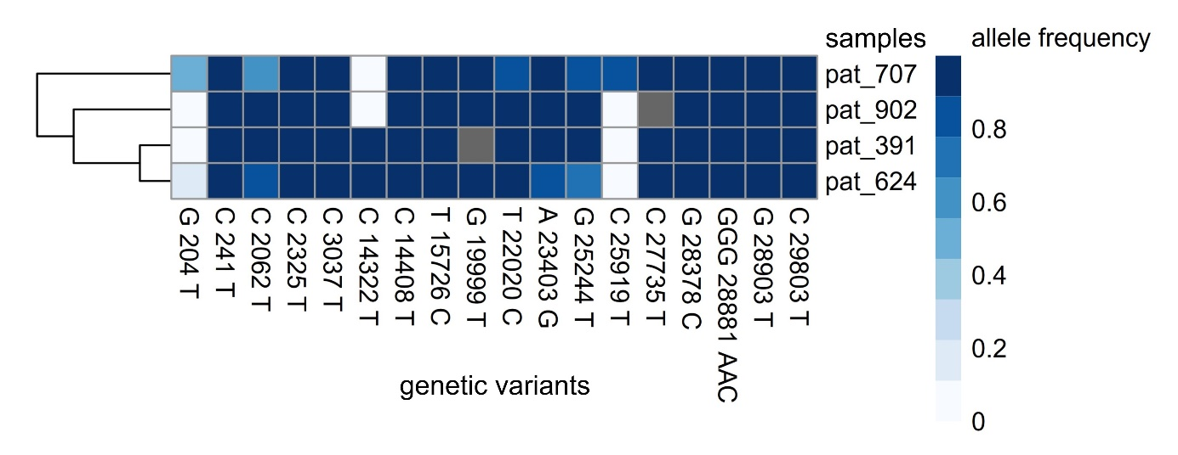
Suppl. Fig.17: Cluster R. This cluster includes four samples from four probands, two staff members and two patients. The color gradient depicts allele frequencies, grey coloring denotes that the base call did not pass the quality control filters for a given variant. X-axes display genetic variants with allele frequencies >50% in at least one sample when compared to the reference genome (NC 045512.2) Each row denotes one sample included in the cluster.

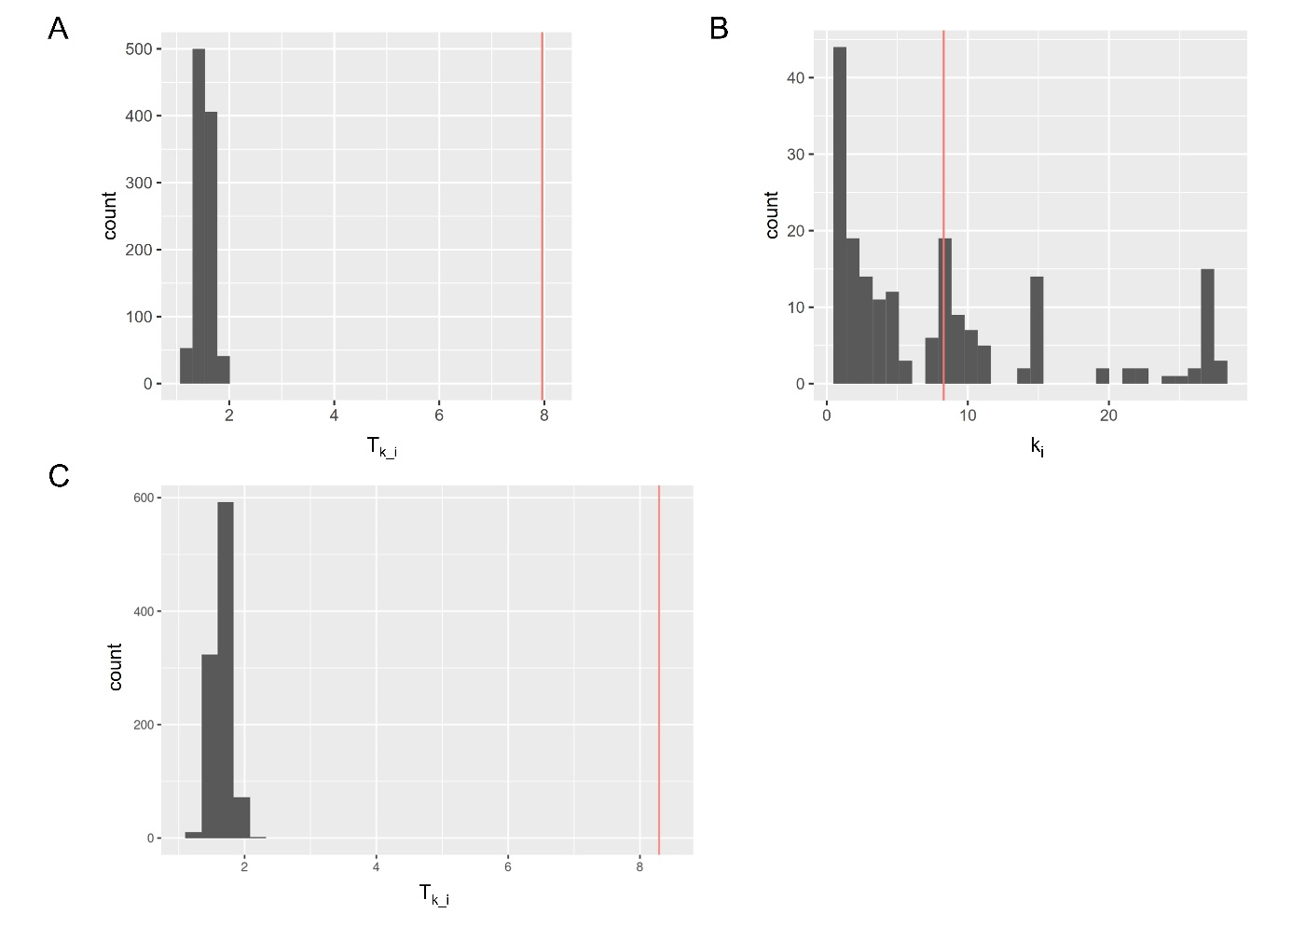
  - Suppl. Fig.18: Genetic relationship of TUM samples to LMU samples and each other
(A) Results of Monte Carlo Simulations with LMU samples using the last collected viral genome of an individual. X-axis displays the average number of viral genomes closely related to each TUM-individual (T_{k_i}). The red line represents the average number of closely related samples in the TUM dataset (T_{k_i}=7.96). TUM samples were significantly more closely related to each other than to the LMU samples (T_{k_iLMU}=1.09-2.00). (1000 simulations, p=0.001).
(B) Close genetic relationships in TUM dataset. X-axis displays the number of viral genomes closely related to each TUM-individual (k_{i}). The red line represents the average (T_{k_i}=7.96).
(C) Results of Monte Carlo Simulations with LMU samples using the first collected viral genome of an individual. X-axis displays the average number of viral genomes closely related to each TUM-individual (T_{k_i}). The red line represents the average number of closely related samples in the TUM dataset (T_{k_i}=8.29). TUM samples were significantly more closely related to each other than to the LMU samples (T_{k_iLMU}=1.19-2.08). (1000 simulations, p=0.001).

[1] ‘UG4001-04-CleanPlex-SARS-CoV-2-Panel-User-guide.pdf’. https://www.paragongenomics.com/wp-content/uploads/2021/02/UG4001-04-CleanPlex-SARS-CoV-2-Panel-User-guide.pdf (accessed Jun. 17, 2021).
[2] Lusajo Mwakibete et al., ‘ARTIC-NEB: SARS-CoV-2 Library PrepV.4’. protocols.io, Feb. 2021. [Online]. Available: https://www.protocols.io/view/artic-neb-sars-cov-2-library-prep-br77m9rn.pdf#page=1&zoom=auto,-23,848
[3] H. Li, ‘Aligning sequence reads, clone sequences and assembly contigs with BWA-MEM’, arXiv e-prints, p. arXiv:1303.3997, Mar. 2013.
[4] E. Garrison and G. Marth, ‘Haplotype-based variant detection from short-read sequencing’, arXiv e-prints, p. arXiv:1207.3907, Jul. 2012.
[5] R. Kolde, ‘pheatmap: Pretty Heatmaps’, 2019, [Online]. Available: https://CRAN.R-project.org/package=pheatmap
[6] J. Hadfield et al., ‘Nextstrain: real-time tracking of pathogen evolution’, Bioinformatics, vol. 34, no. 23, pp. 4121–4123, Dec. 2018, doi: 10.1093/bioinformatics/bty407.

