Supplementary Information
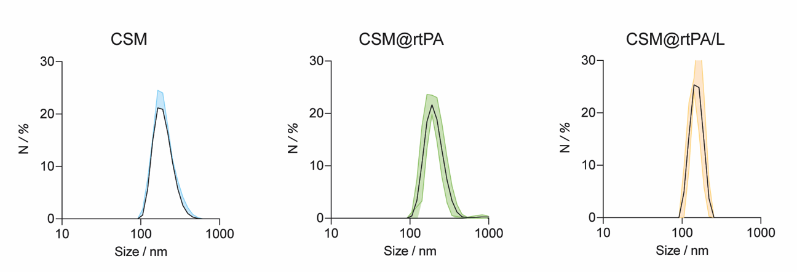
Figure S1. DLS size distribution of CSM, CSM@rtPA and lyophilized CSM@rtPA. Data are shown as mean ± S.D. (n = 3). DLS was used to characterize the colloidal properties of the CSMs and determine the hydrodynamic size of the samples.

Table S1. Size distribution analysis by DLS of CSM, CSM@rtPA and lyophilized CSM@rtPA. Mean hydrodynamic diameter derived from the DLS size distributions. ^{[1]} d_{H,I}, d_{H,N} refer to the mean average hydrodynamic diameter from the intensity, and number of DLS distributions, respectively. PDI refers to polydispersity index. Standard deviation values were calculated from five independent measurements of CSMs samples. Data are shown as mean ± SEM. (n = 3).
Sample | PDI | d_{H,I} (nm) ^{[1]} | d_{H,N} (nm) ^{[1]}
CSMs | 0.26 ± 0.055 | 206 ± 1.4 | 225 ± 2
CSM@rtPA | 0.325 ± 0.087 | 219.7 ± 14.9 | 234.5 ± 1
CSM@rtPA / L | 0.45 ± 0.099 | 258 ± 26.8 | 261.2 ± 28

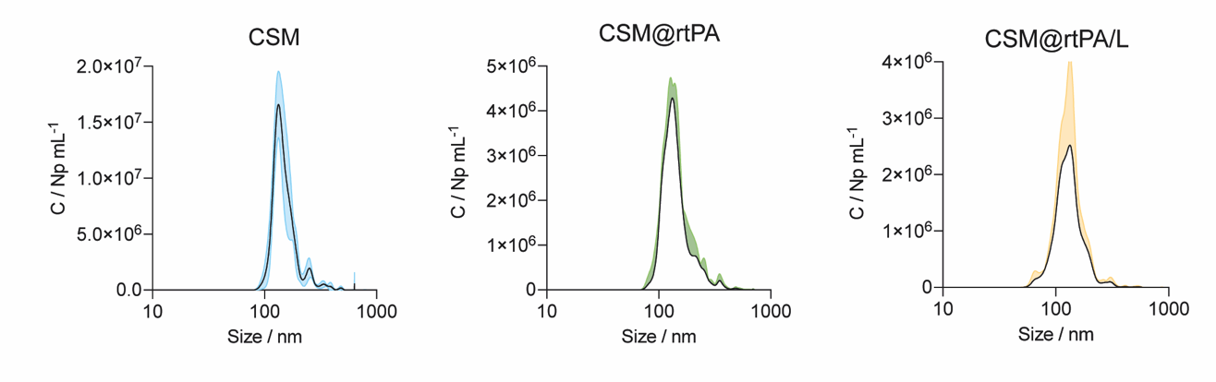
Figure S2. NTA size distribution of CSM, CSM@rtPA and lyophilized CSM@rtPA. Data are shown as mean ± S.D. (n = 3). NTA was used to characterize the colloidal properties of the CSMs and determine the CSMs concentration in solution.

Table S2. Raw data of the mean hydrodynamic diameter for the NTA distributions and concentration of three independent measurements of CSM, CSM@rtPA and lyophilized CSM@rtPA. Data are shown as mean ± S.D. (n = 3).
Sample | Size (nm) | Concentration  (CSM/mL)
CSMs | 182.8 ± 5.4 | (2.70 ± 2.2) ·10¹¹
CSM@rtPA | 184.4 ± 11.6 | (2.65 ± 1.1) ·10¹¹
CSM@rtPA / L | 187.3 ± 5.5 | (1.23 ± 0.2) ·10¹¹

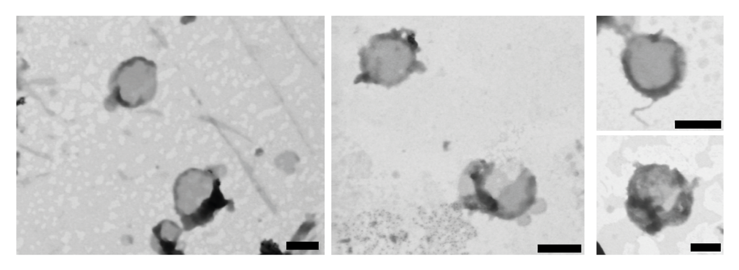
Figure S3. STEM micrographs of CSMs staining with uranyl acetate. Scale bars: 200 nm

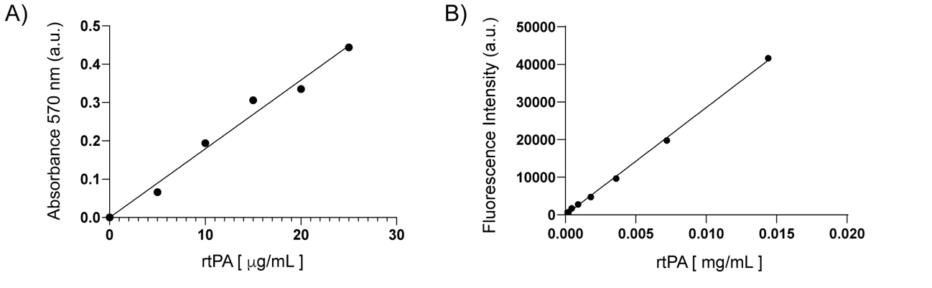
Figure S4. Calibration curves. A) Protein quantification by Bradford assay: absorbance at 570 nm versus protein concentration (y = 0.0187x – 0.0144, r²= 0.98). B) Fluorescence intensity of FTIC-rtPA versus rtPA concentration (y = 3•10⁶x – 150, r² = 0.99). The % of LE of rtPA encapsulated in CSM samples obtained was 21.5 ± 1 %.
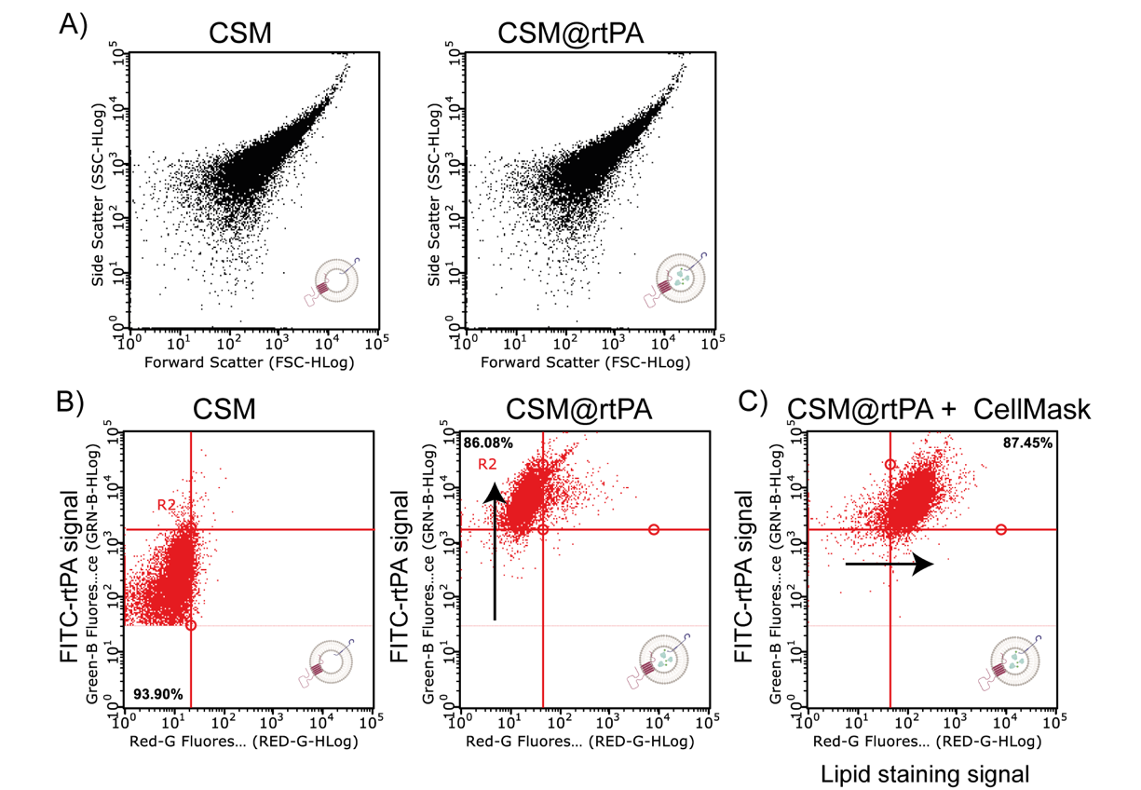
Figure S5. CSM dispersion analysis by flow cytometry. The variation of the flow cytometry side scattering signal and the fluorescence signals of CSM and CSM@rtPA samples are shown. A) Scatter density plots of side scattering (SSC) signal versus forward scattering (FSC) signal for CSM and CSM@rtPA samples. B) Scatter density plots of Green fluorescence signal (Green-B channel, rtPA channel) versus Red fluorescence signal (Red-R channel, CellMask DeepRed channel) for CSM and CSM@rtPA samples without any label. C) Scatter density plots of Green fluorescence signal (Green-B channel, rtPA channel) versus Red fluorescence signal (Red-R channel, CellMask DeepRed channel) for CSM@rtPA sample after labeling with CellMask Deep Red for lipid staining.

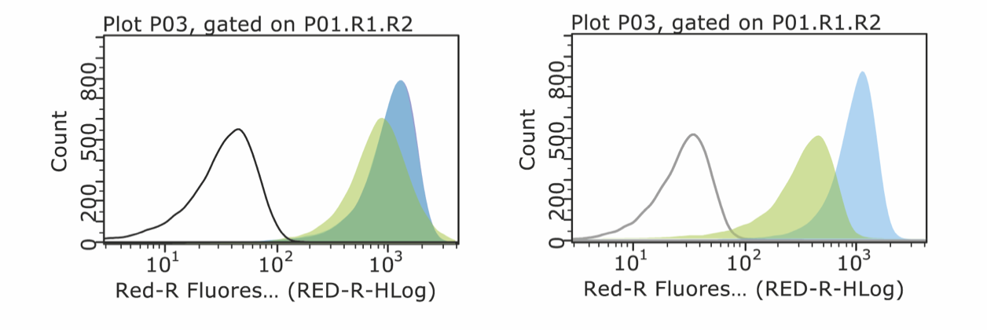
Figure S6. Surface characterization of CD42 and CD47 in platelet (left panel) and platelet-derived CSM by Flow cytometer (right panel). Histograms representation of mean fluorescence intensity of Red-R-channel of cells or CSM control and treated with APC-fluorescently labeled anti-hCD47 antibody (in blue), and APC-fluorescently labelled anti-hCD42b/GPlbα antibody (in green).
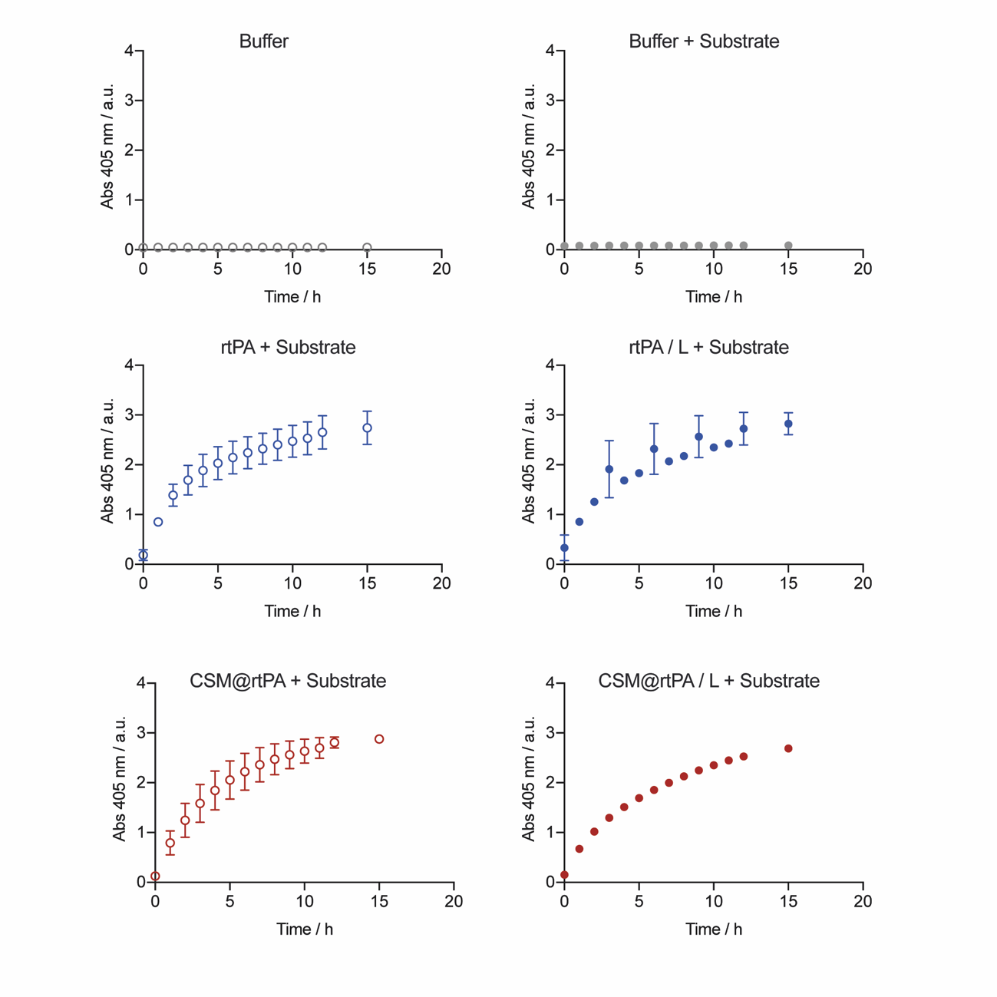
Figure S7. rtPA bioactivity studies. The proteolytic activity of free rtPA and encapsulated rtPA (CSM@rtPA), before and after lyophilization process, in presence of the chromogenic substrate is recorded by measuring the absorbance at 405 nm over time. These data represent mean ± S.D. (of three independent replicates).

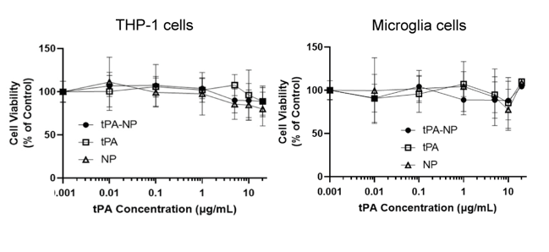
Figure S8. THP-1 macrophage and HMC3 microglia cells were treated for 24 hours with increasing concentrations of rtPA, CSM, CSM@rtPA. Cell nuclei were stained with Hoechst 33342 nucleic acid staining and counted using the Cell Counter plugin in FIJI (ImageJ). Cell counts normalized to the mean cell count of untreated cells. Data represents means ± S.D. from three independent experiments.

