Supporting Information

High solubility of cellulose in slow-cooling alkaline systems and interacting modes of alkali and urea at the molecular level

Shuo Ai*, Zhenhua Huang, Wanguo Yu, Chengdu Huang

College of Biological and Chemical Engineering, Guangxi University of Science and Technology, Liuzhou 545006, China

Corresponding author: 100001928@gxust.edu.cn (Shuo Ai)

Fig. S1 Determination of viscosity-average polymerization degree of MCC
Fig. S2 Dissolution situation of 10 wt% MCC in a solvent containing 7 wt% NaOH, 12 wt% urea and 81 wt% water in a freeze-thaw process from room temperature to −22 °C
Fig. S3 Viscous cellulose solution (7 wt%) in a Ubbelohde viscometer
Fig. S1 Determination of viscosity-average polymerization degree of MCC

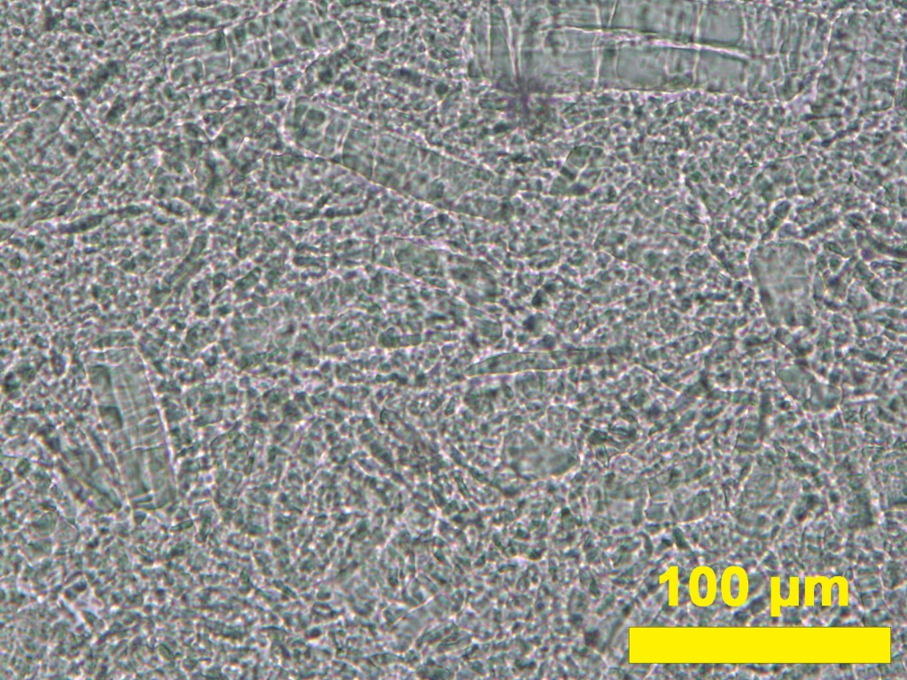
Fig. S2 Dissolution situation of 10 wt% MCC in a solvent containing 7 wt% NaOH, 12 wt% urea and 81 wt% water in a freeze-thaw process from room temperature to −22 °C. The freeze and thaw procedures took 1.5 and 0.5 h, respectively

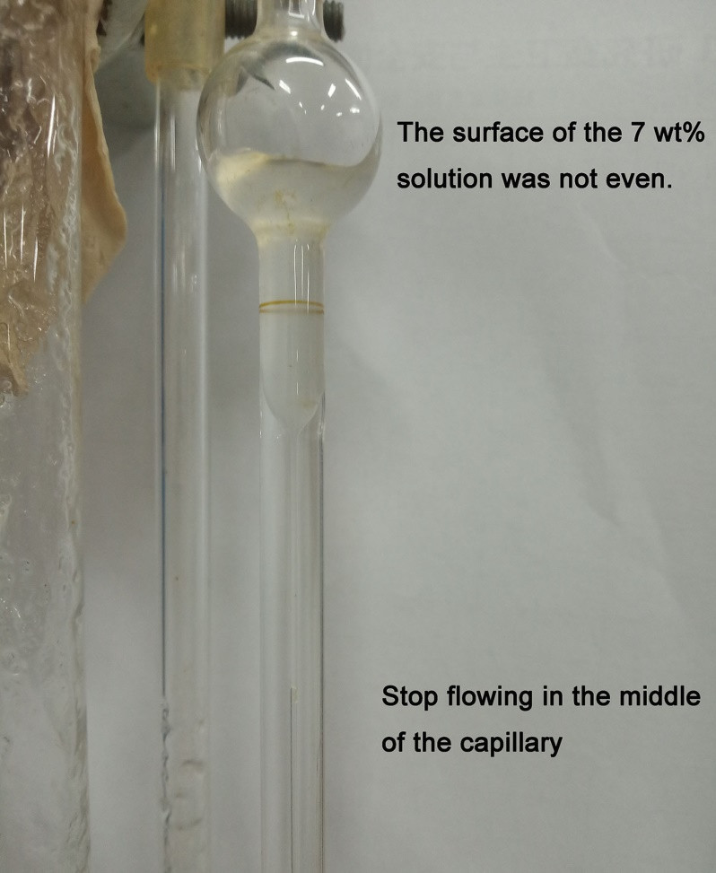
Fig. S3 Viscous cellulose solution (7 wt%) in a Ubbelohde viscometer. The solution was too viscous to be measured with the Ubbelohde viscometer.

