A mild and eco-friendly, one-pot synthesis of
2-hydroxy-N-arylacetamides from 2-chloro-N-arylacetamides

Vamshikrishna Y. Radhakrishna ¹, Gopal L. Khatik ², Bhuvaneshwari S. Vijaya ¹, Vipin A. Nair ¹ ✉

¹ Department of Chemistry, REVA University, Yelahanka, Bangalore 560064, Karnataka, India.

² Department of Medicinal Chemistry, National Institute of Pharmaceutical Education and Research, Raebareli 226002, Uttar Pradesh, India.

Contents | Page No
Experimental | 3
Figure S1: ¹H NMR of 2-hydroxy-N-phenylacetamide (3a) | 4
Figure S2: ¹³C NMR of 2-hydroxy-N-phenylacetamide (3a) | 5
Figure S3: HRMS of 2-hydroxy-N-phenylacetamide (3a) | 6
Figure S4: ¹H NMR of N-(2-chlorophenyl)-2-hydroxyacetamide (3b) | 7
Figure S5: ¹³C NMR of N-(2-chlorophenyl)-2-hydroxyacetamide (3b) | 8
Figure S6: HRMS of N-(2-chlorophenyl)-2-hydroxyacetamide (3b) | 9
Figure S7: ¹H NMR of N-(3-chlorophenyl)-2-hydroxyacetamide (3c) | 10
Figure S8: ¹³C NMR of N-(3-chlorophenyl)-2-hydroxyacetamide (3c) | 11
Figure S9: HRMS of N-(3-chlorophenyl)-2-hydroxyacetamide (3c) | 12
Figure S10: ¹H NMR of N-(4-fluorophenyl)-2-hydroxyacetamide (3d) | 13
Figure S11: ¹³C NMR of N-(4-fluorophenyl)-2-hydroxyacetamide (3d) | 14
Figure S12: HRMS of N-(4-fluorophenyl)-2-hydroxyacetamide (3d) | 15
Figure S13: ¹H NMR of N-(4-chlorophenyl)-2-hydroxyacetamide (3e) | 16
Figure S14: ¹³C NMR of N-(4-chlorophenyl)-2-hydroxyacetamide (3e) | 17
Figure S15: HRMS of N-(4-chlorophenyl)-2-hydroxyacetamide (3e) | 18
Figure S16: ¹H NMR of N-(4-bromophenyl)-2-hydroxyacetamide (3f) | 19
Figure S17: ¹³C NMR of N-(4-bromophenyl)-2-hydroxyacetamide (3f) | 20
Figure S18: HRMS of N-(4-bromophenyl)-2-hydroxyacetamide (3f) | 21
Figure S19: ¹H NMR of 2-hydroxy-N-(o-tolyl)acetamide (3g) | 22
Figure S20: ¹³C NMR of 2-hydroxy-N-(o-tolyl)acetamide (3g) | 23
Figure S21: HRMS of 2-hydroxy-N-(o-tolyl)acetamide (3g) | 24
Figure S22: ¹H NMR of 2-hydroxy-N-(m-tolyl)acetamide (3h) | 25
Figure S23: ¹³C NMR of 2-hydroxy-N-(m-tolyl)acetamide (3h) | 26
Figure S24: HRMS of 2-hydroxy-N-(m-tolyl)acetamide (3h) | 27
Figure S25: ¹H NMR of 2-hydroxy-N-(p-tolyl)acetamide (3i) | 28
Figure S26: ¹³C NMR of 2-hydroxy-N-(p-tolyl)acetamide (3i) | 29
Figure S27: HRMS of 2-hydroxy-N-(p-tolyl)acetamide (3i) | 30
Figure S28: ¹H NMR of 2-hydroxy-N-(4-methoxyphenyl)acetamide (3j) | 31
Figure S29: ¹³C NMR of 2-hydroxy-N-(4-methoxyphenyl)acetamide (3j) | 32
Figure S30: HRMS of 2-hydroxy-N-(4-methoxyphenyl)acetamide (3j) | 33
Figure S31: ¹H NMR of 2-hydroxy-N-(2-methoxyphenyl)acetamide (3k) | 34
Figure S32: ¹³C NMR of 2-hydroxy-N-(2-methoxyphenyl)acetamide (3k) | 35
Figure S33: HRMS of 2-hydroxy-N-(2-methoxyphenyl)acetamide (3k) | 36
Figure S34: ¹H NMR of N-(2,4-dimethylphenyl)-2-hydroxyacetamide (3l) | 37
Figure S35: ¹³C NMR of N-(2,4-dimethylphenyl)-2-hydroxyacetamide (3l) | 38
Figure S36: HRMS of N-(2,4-dimethylphenyl)-2-hydroxyacetamide (3l) | 39
Figure S37: ¹H NMR of N-(2,6-dimethylphenyl)-2-hydroxyacetamide (3m) | 40
Figure S38: ¹³C NMR of N-(2,6-dimethylphenyl)-2-hydroxyacetamide (3m) | 41
Figure S39: HRMS of N-(2,6-dimethylphenyl)-2-hydroxyacetamide (3m) | 42
Figure S40: ¹H NMR of N-(2,3-dichlorophenyl)-2-hydroxyacetamide (3n) | 43
Figure S41: ¹³C NMR of N-(2,3-dichlorophenyl)-2-hydroxyacetamide (3n) | 44
Figure S42: HRMS of N-(2,3-dichlorophenyl)-2-hydroxyacetamide (3n) | 45
Figure S43: ¹H NMR of N-(3,5-dichlorophenyl)-2-hydroxyacetamide (3o) | 46
Figure S44: ¹³C NMR of N-(3,5-dichlorophenyl)-2-hydroxyacetamide (3o) | 47
Figure S45: HRMS of N-(3,5-dichlorophenyl)-2-hydroxyacetamide (3o) | 48
Figure S46: ¹H NMR of N-(2-fluorophenyl)-2-hydroxyacetamide (3p) | 49
Figure S47: ¹³C NMR of N-(2-fluorophenyl)-2-hydroxyacetamide (3p) | 50
Figure S48: HRMS of N-(2-fluorophenyl)-2-hydroxyacetamide (3p) | 51
Figure S49: ¹H NMR of 2-oxo-2-(phenylamino)ethyl acetate (2a) | 52
Figure S50: ¹³H NMR of 2-oxo-2-(phenylamino)ethyl acetate (2a) | 53
Figure S51: HRMS of 2-oxo-2-(phenylamino)ethyl acetate (2a) | 54

Experimental

All the chemicals were purchased from commercial suppliers and used as received. The reactions were performed in oven-dried glassware under appropriate atmosphere. The reaction is monitored by thin-layer chromatography (TLC) on 0.25 mm Merck Silica gel 60 F254 plates using UV light for visualization. The column chromatography was performed with 100-200 mesh silica gel using hexane and ethyl acetate as eluents. NMR spectra were recorded on a Jeol ECZ 400R spectrometer (¹H at 400 MHz and ¹³C at 100 MHz) using CDCl₃ or DMSO-d₆ as the solvent with TMS as the internal standard. Chemical shifts ($δ$) are reported relative to residual solvent signals (CDCl₃, 7.25 ppm for ¹H NMR and triplet centered at 77.00 ppm for ¹³C NMR; DMSO-d₆, 2.5 ppm for ¹H NMR and 39.5 ppm for ¹³C NMR). High resolution mass spectrometric analysis was carried out in ESI quadrupole time of flight Agilent mass spectrometer.

General procedure for the preparation of 2-hydroxy-N-phenylacetamide

To a solution of 2-chloro-N-arylacetamide (1.0 mmol) in ethanol, diisopropyl ethyl amine (0.14g, 1.1 mmol) and Cu(OAc)₂.H₂O (0.22g, 1.1 mmol) were added and the resulting mixture was stirred in an oil bath at reflux temperature (80ºC) for 2 hours. After completion of the reaction as monitored by thin layer chromatography, KOH (0.06g, 1.1 mmol) was added to the reaction mixture and refluxed for another 10 minutes. The progress of the reaction was monitored by TLC and upon completion the reaction mixture was cooled to room temperature and filtered. The filtrate was diluted with CH₂Cl₂ (3x15 mL) and washed with water. The combined organic layer was dried over anhydrous Na₂SO₄, evaporated under vacuum, and purified by column chromatography on silica gel (60-120 mesh) with ethyl acetate-petroleum ether mixture (30:70) as the eluting solvent to obtain the desired product.

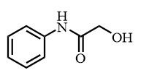
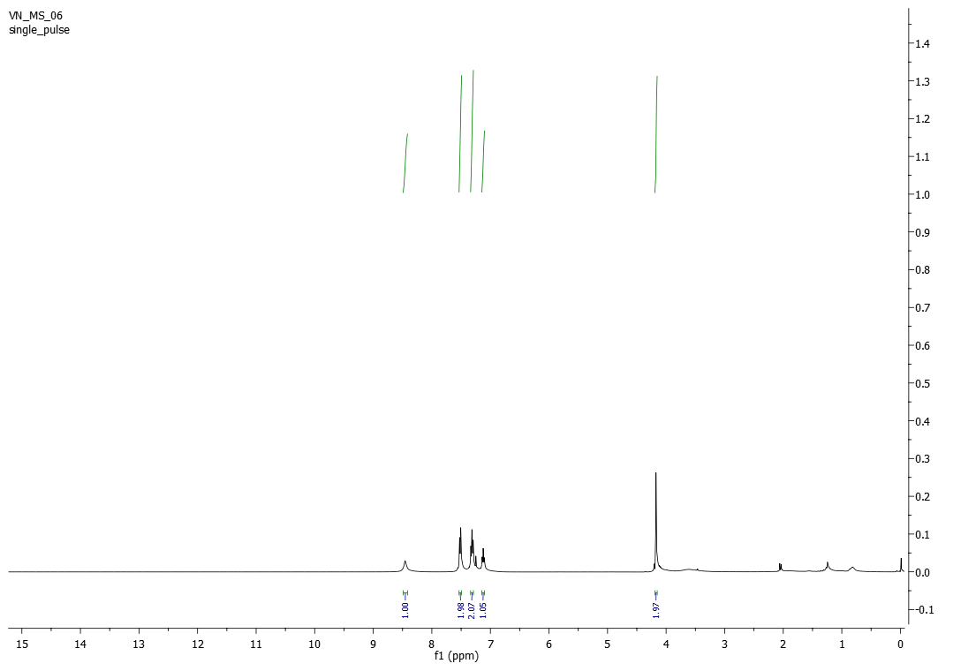

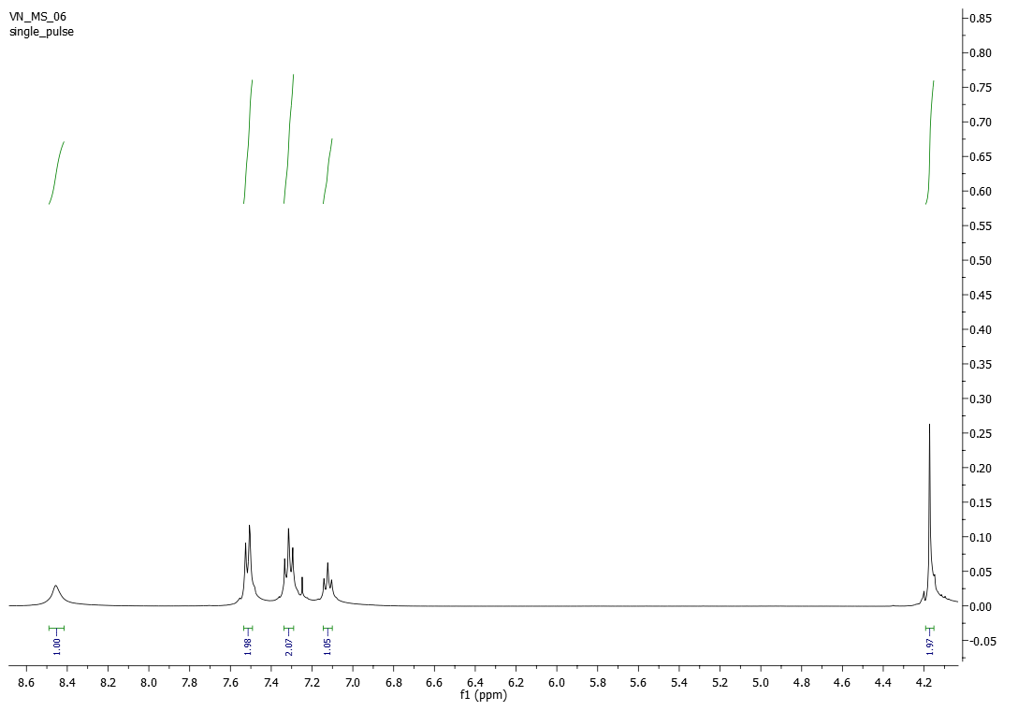
Figure S1: ¹H NMR of 2-hydroxy-N-phenylacetamide (3a)
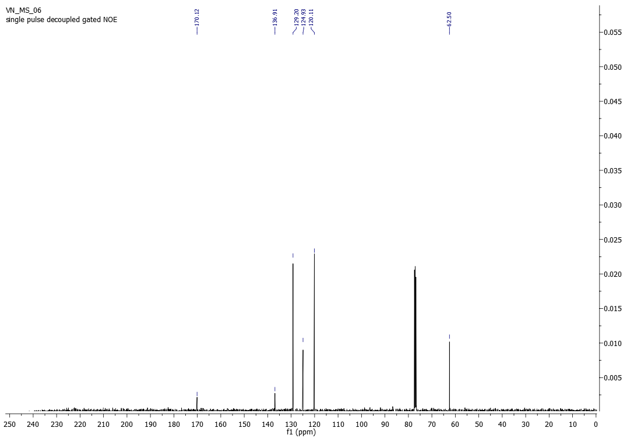
Figure S2: ¹³C NMR of 2-hydroxy-N-phenylacetamide (3a)

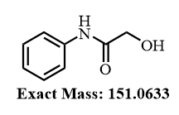
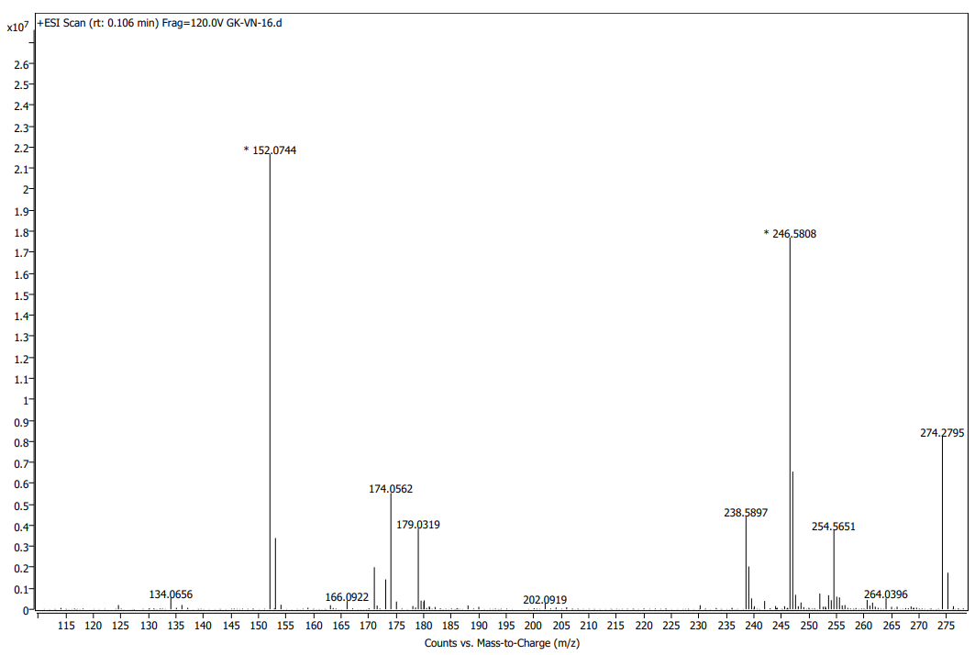
Figure S3: HRMS of 2-hydroxy-N-phenylacetamide (3a)

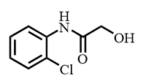
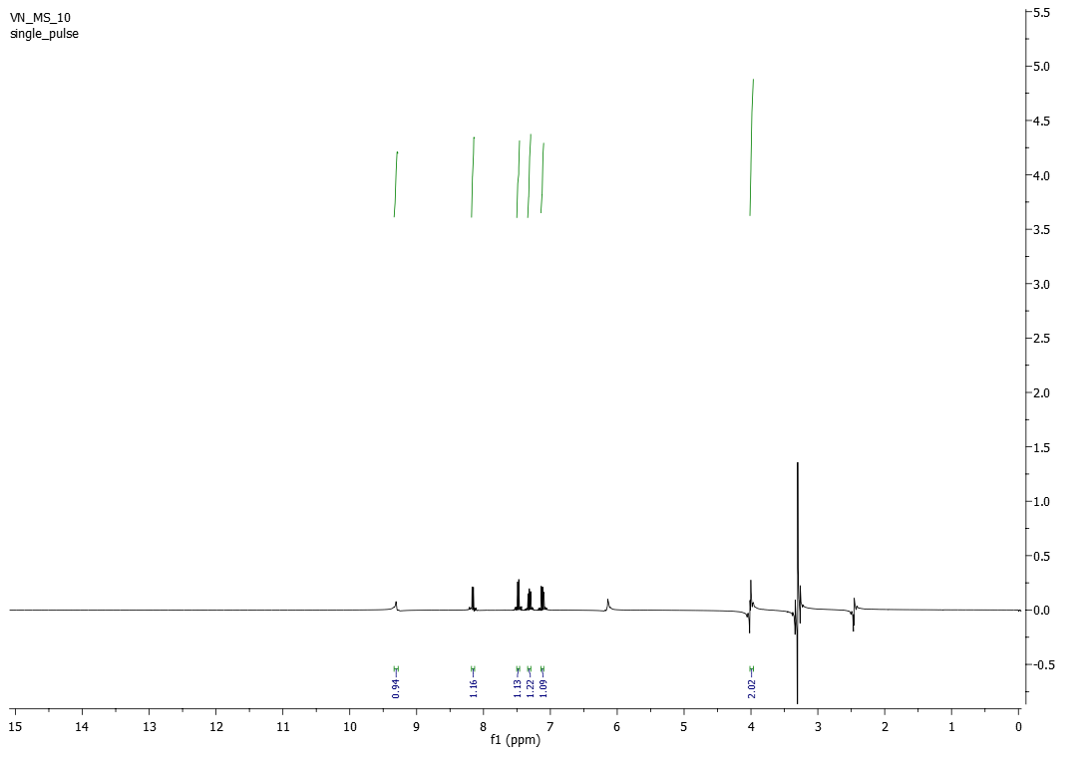

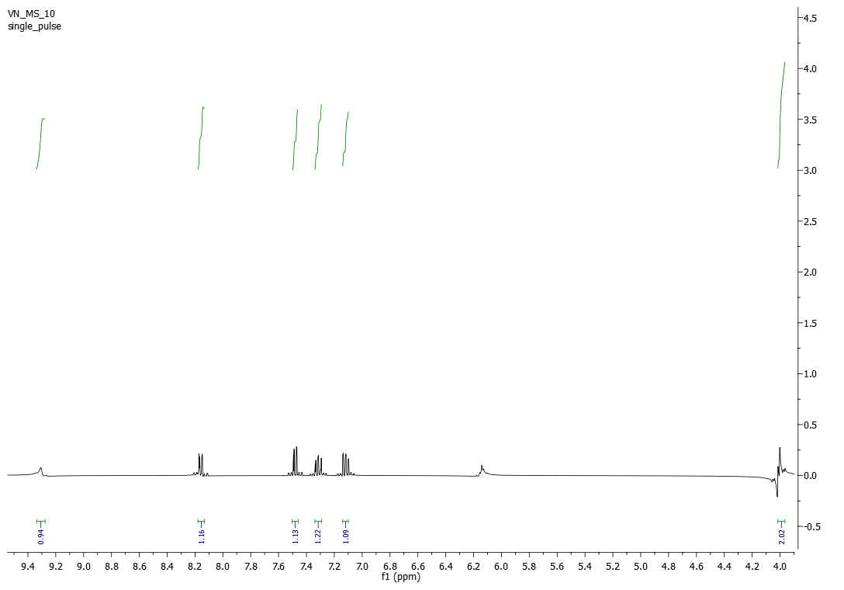
Figure S4: ¹H NMR of N-(2-chlorophenyl)-2-hydroxyacetamide (3b)

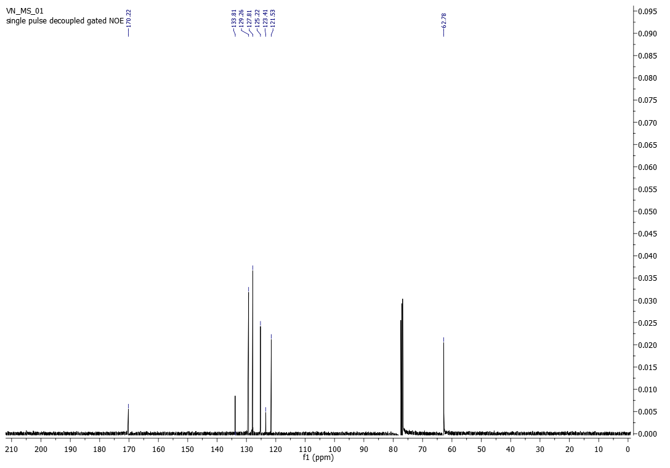
Figure S5: ¹³C NMR of N-(2-chlorophenyl)-2-hydroxyacetamide (3b)

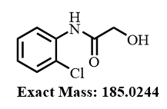
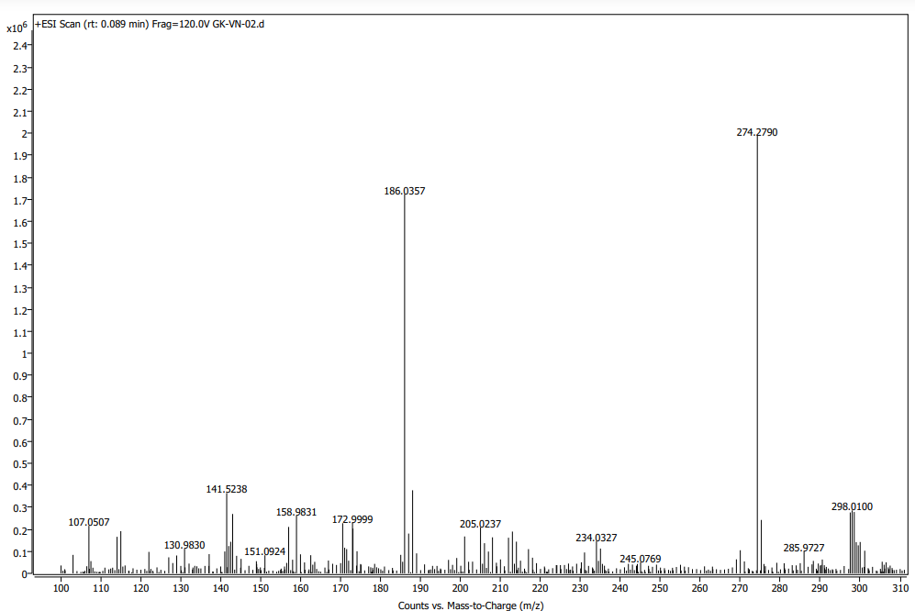
Figure S6: HRMS of N-(2-chlorophenyl)-2-hydroxyacetamide (3b)

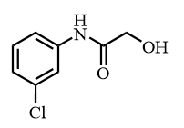
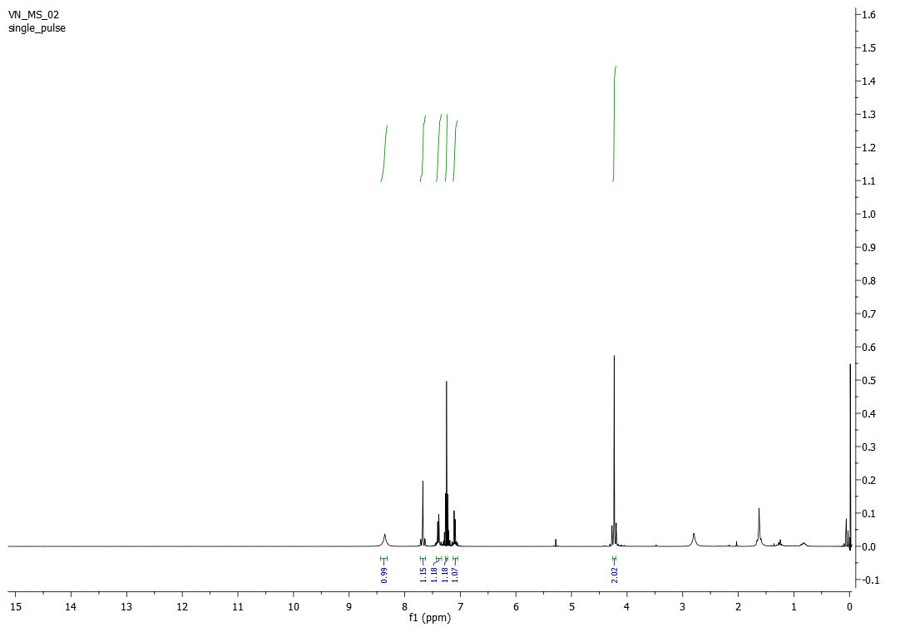

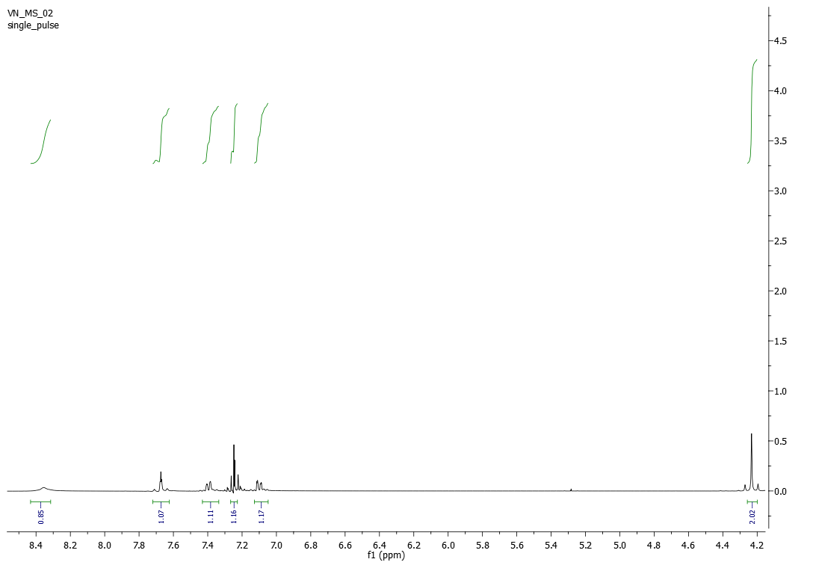
Figure S7: ¹H NMR of N-(3-chlorophenyl)-2-hydroxyacetamide (3c)

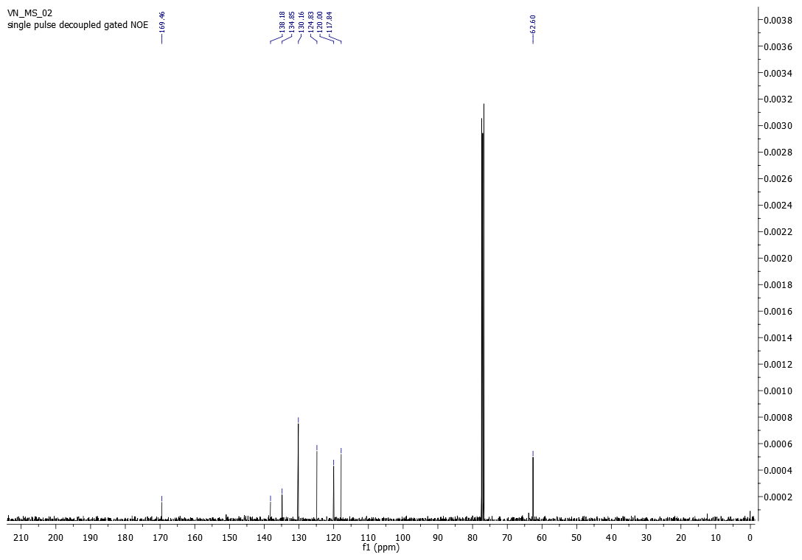
Figure S8: ¹³C NMR of N-(3-chlorophenyl)-2-hydroxyacetamide (3c)

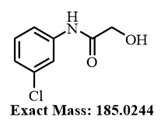
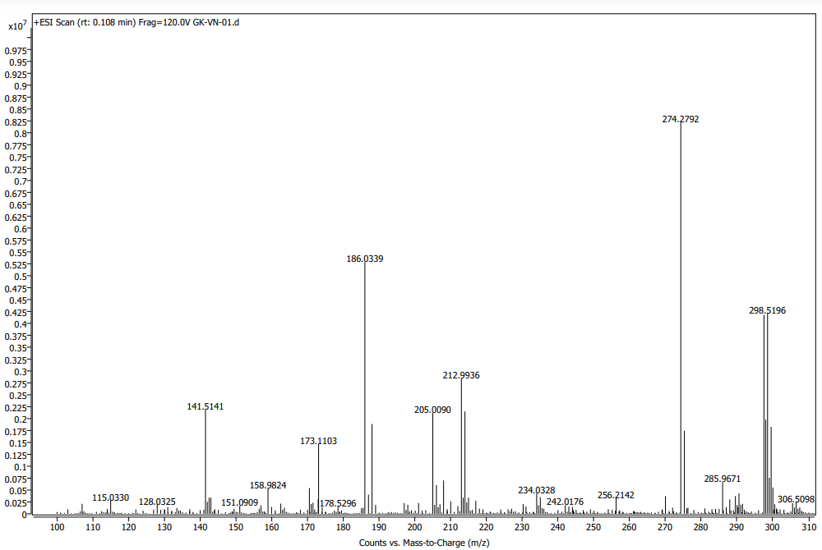
Figure S9: HRMS of N-(3-chlorophenyl)-2-hydroxyacetamide (3c)

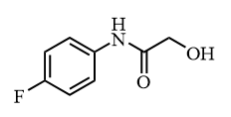
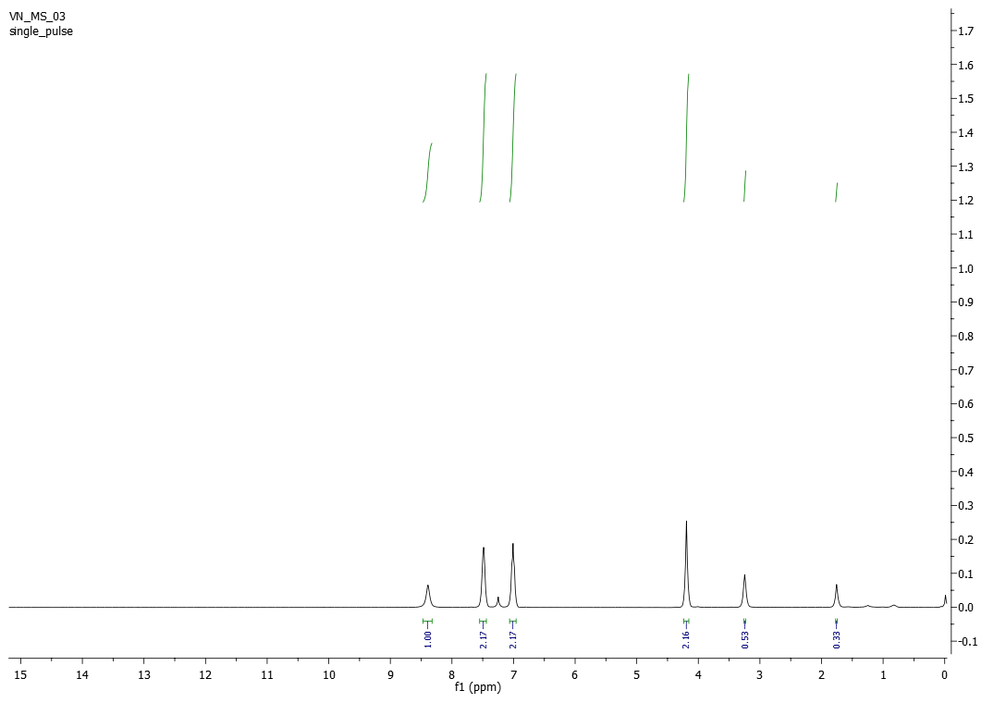

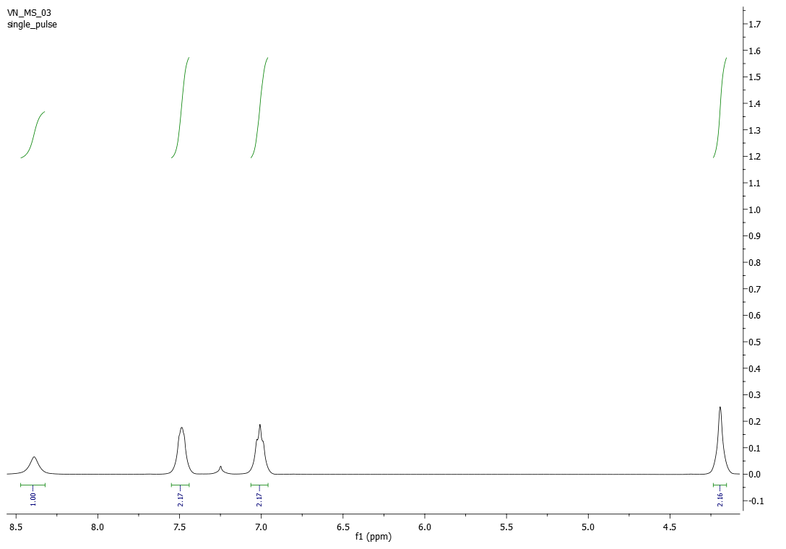
Figure S10: ¹H NMR of N-(4-fluorophenyl)-2-hydroxyacetamide (3d)

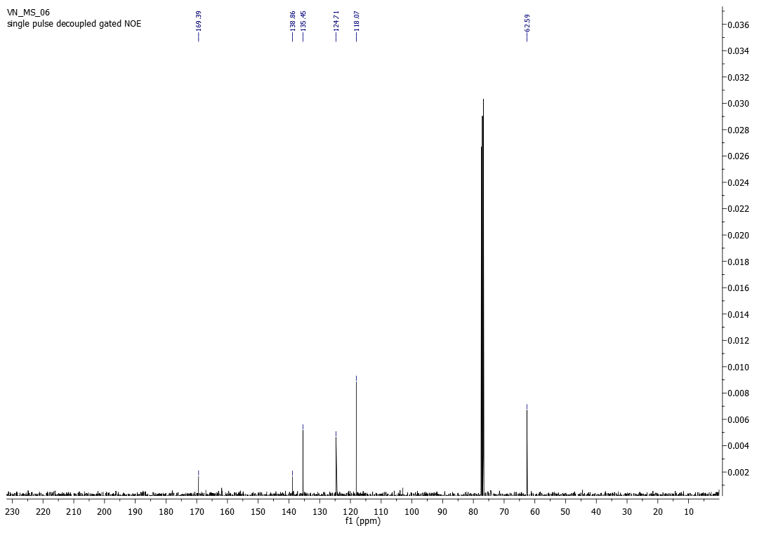
Figure S11: ¹³C NMR of N-(4-fluorophenyl)-2-hydroxyacetamide (3d)

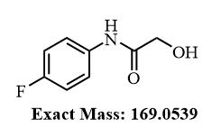
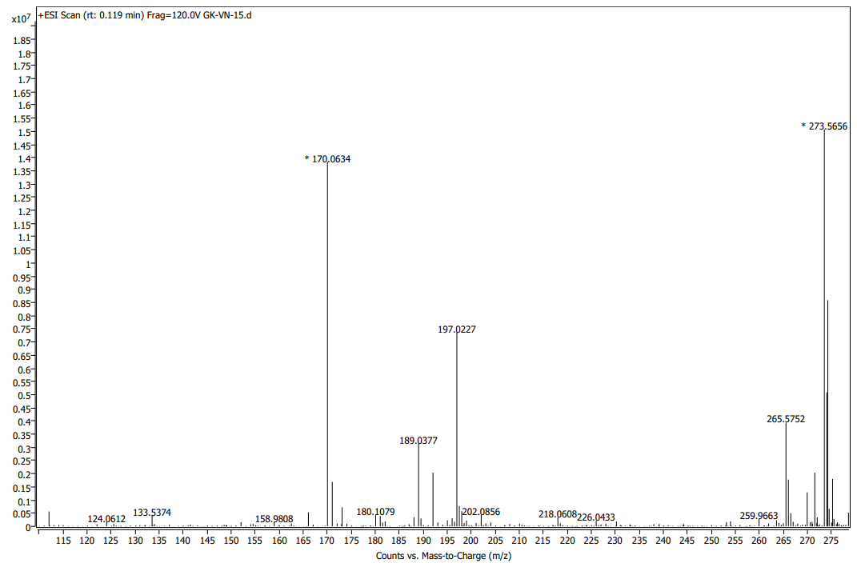
Figure S12: HRMS of N-(4-fluorophenyl)-2-hydroxyacetamide (3d)
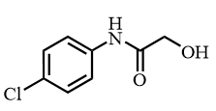
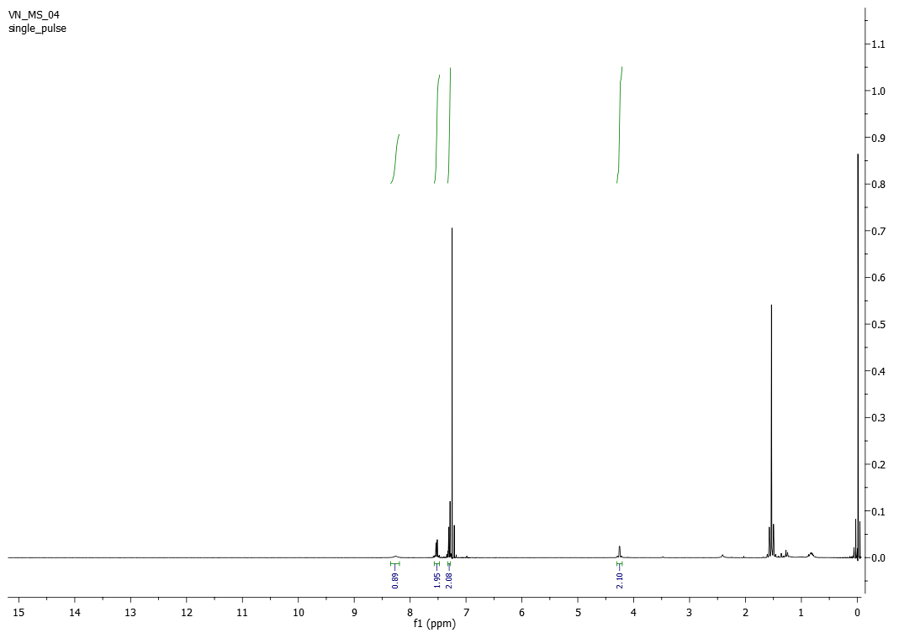

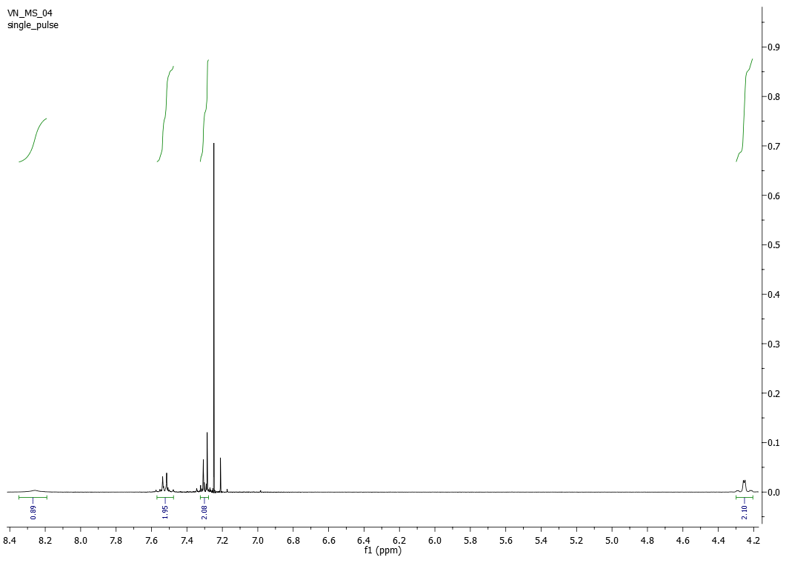
Figure S13: ¹H NMR of N-(4-chlorophenyl)-2-hydroxyacetamide (3e)

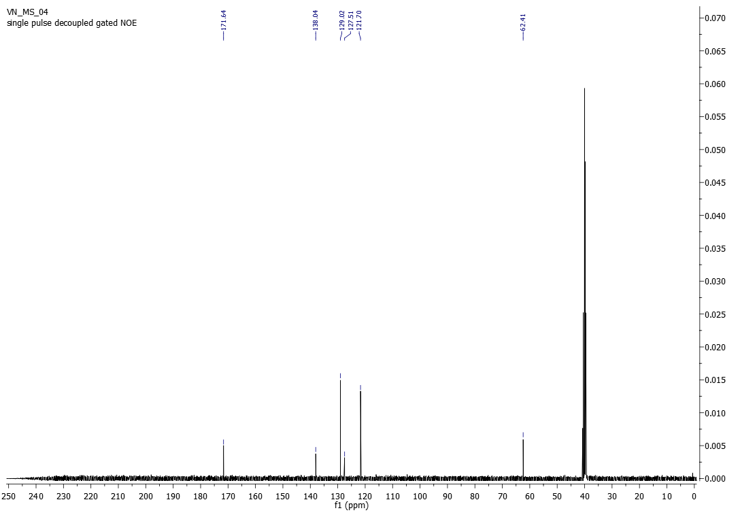
Figure S14: ¹³C NMR of N-(4-chlorophenyl)-2-hydroxyacetamide (3e)

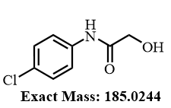
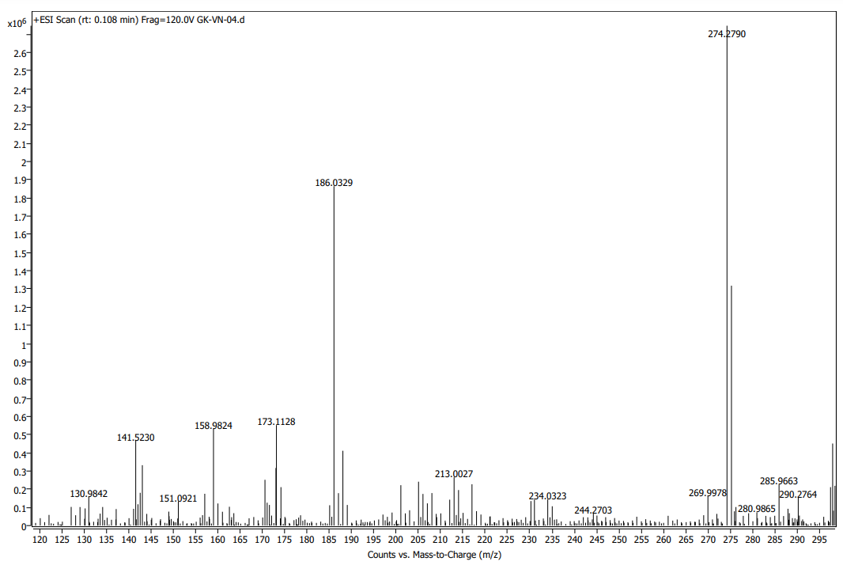
Figure S15: HRMS of N-(4-chlorophenyl)-2-hydroxyacetamide (3e)

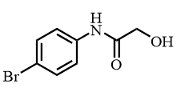
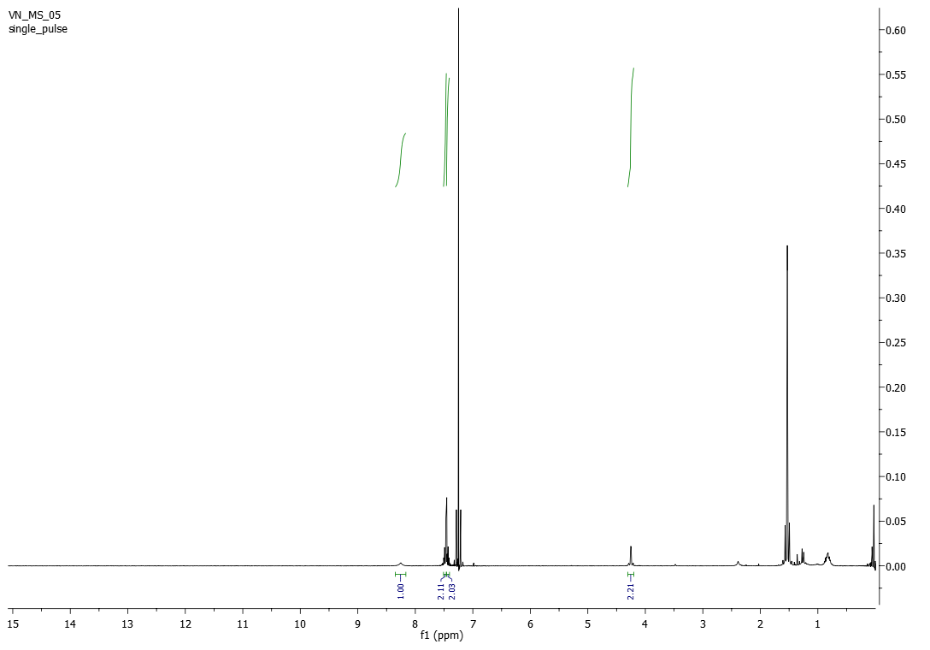

2
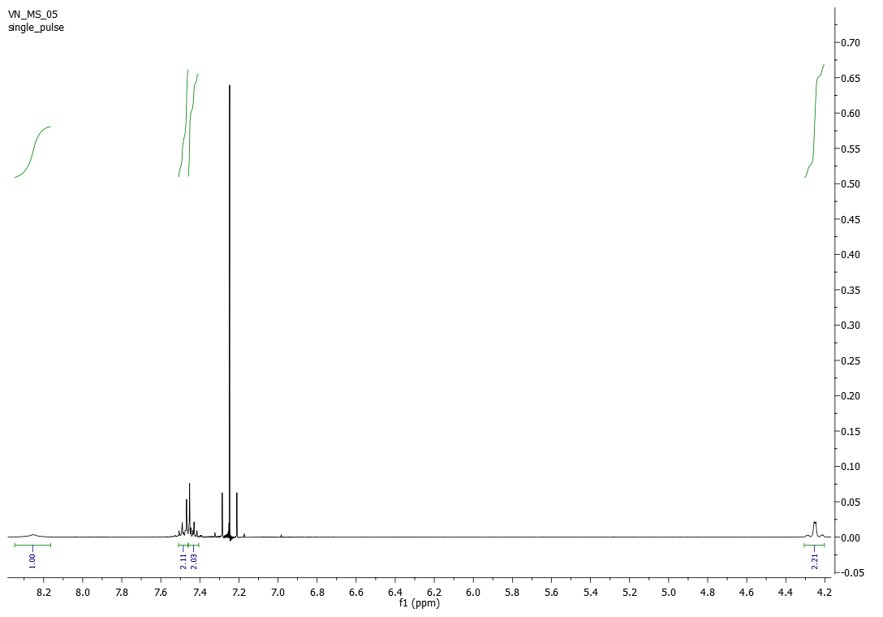2
Figure S16: ¹H NMR of N-(4-bromophenyl)-2-hydroxyacetamide (3f)

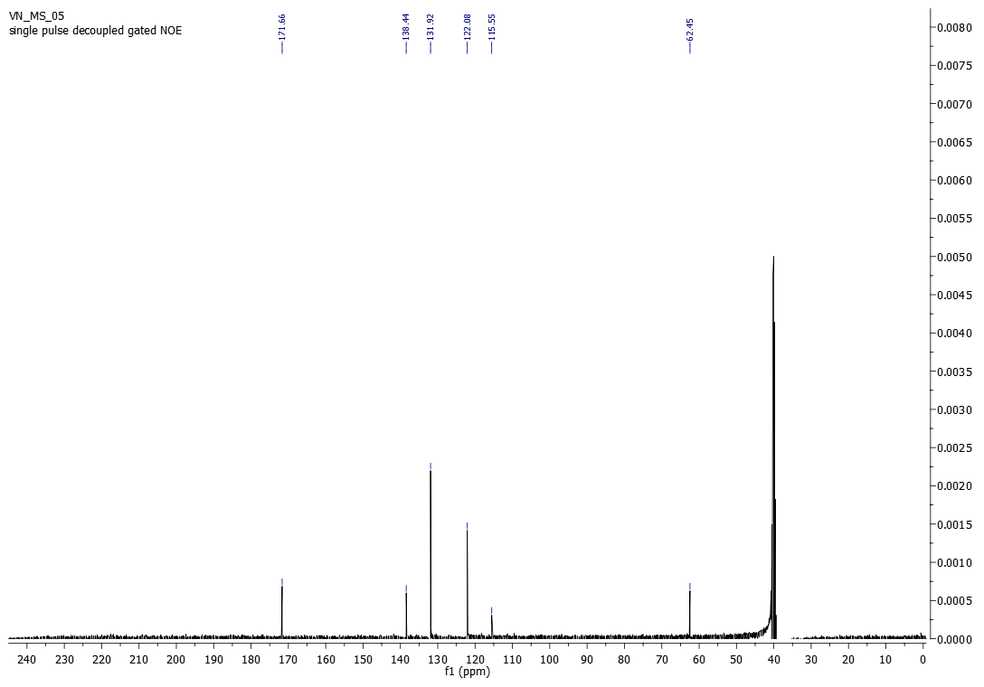
Figure S17: ¹³C NMR of N-(4-bromophenyl)-2-hydroxyacetamide (3f)

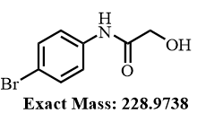
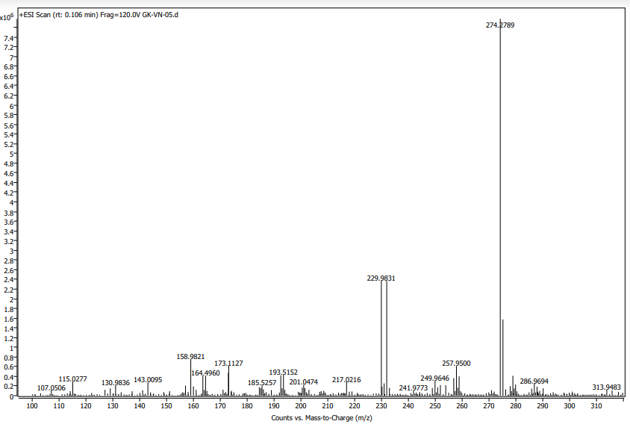
Figure S18: HRMS of N-(4-bromophenyl)-2-hydroxyacetamide (3f)
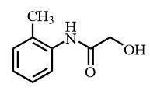
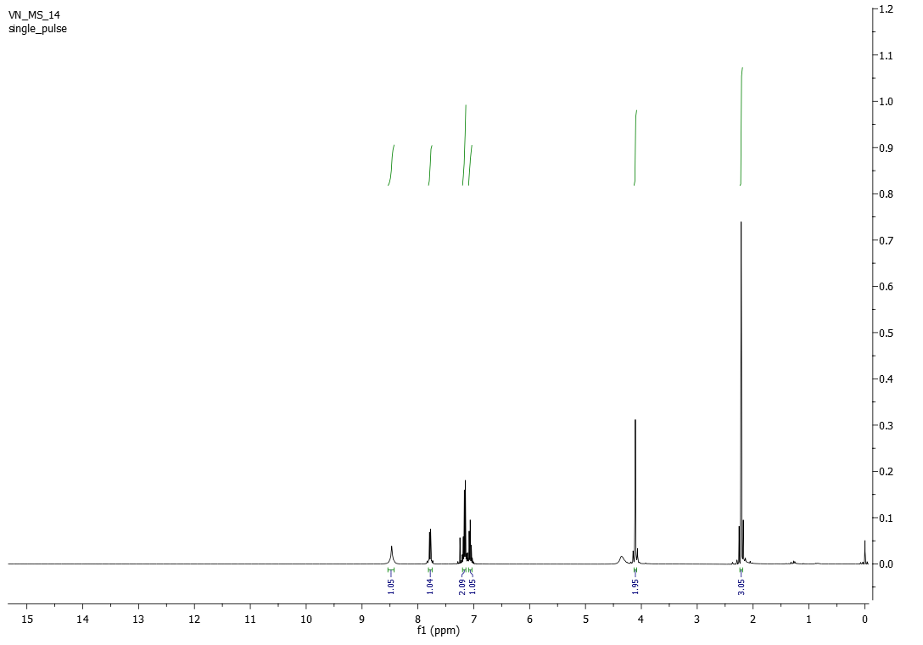

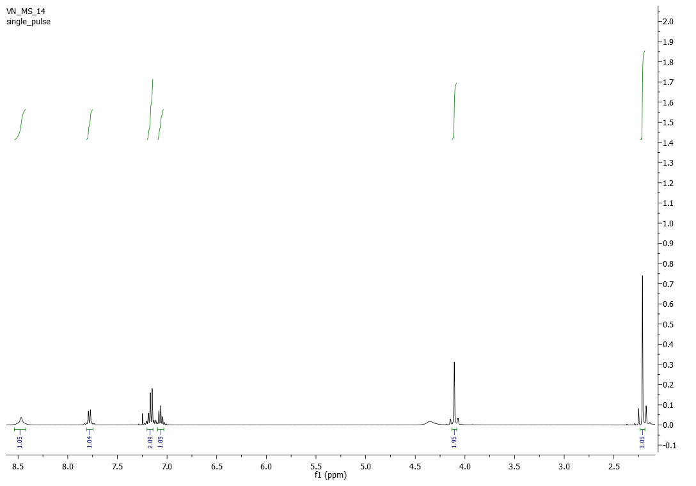
Figure S19: ¹H NMR of 2-hydroxy-N-(o-tolyl)acetamide (3g)

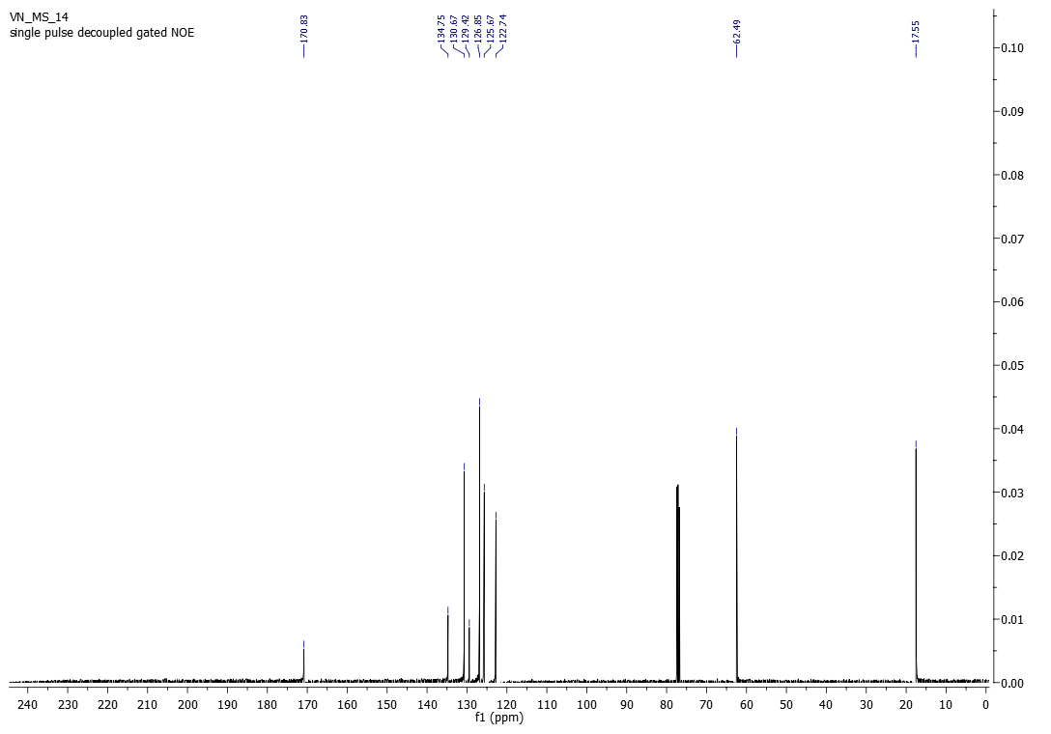
Figure S20: ¹³C NMR of 2-hydroxy-N-(o-tolyl)acetamide (3g)

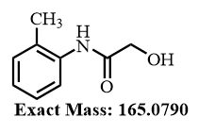
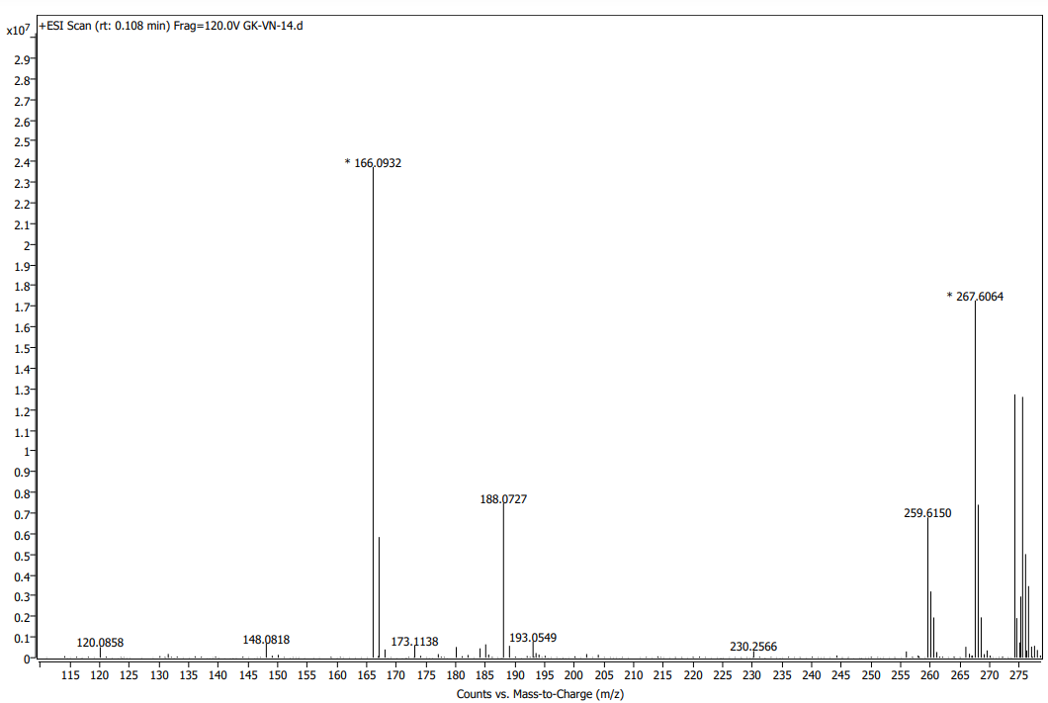
Figure S21: HRMS of 2-hydroxy-N-(o-tolyl)acetamide (3g)

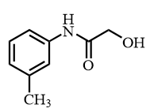
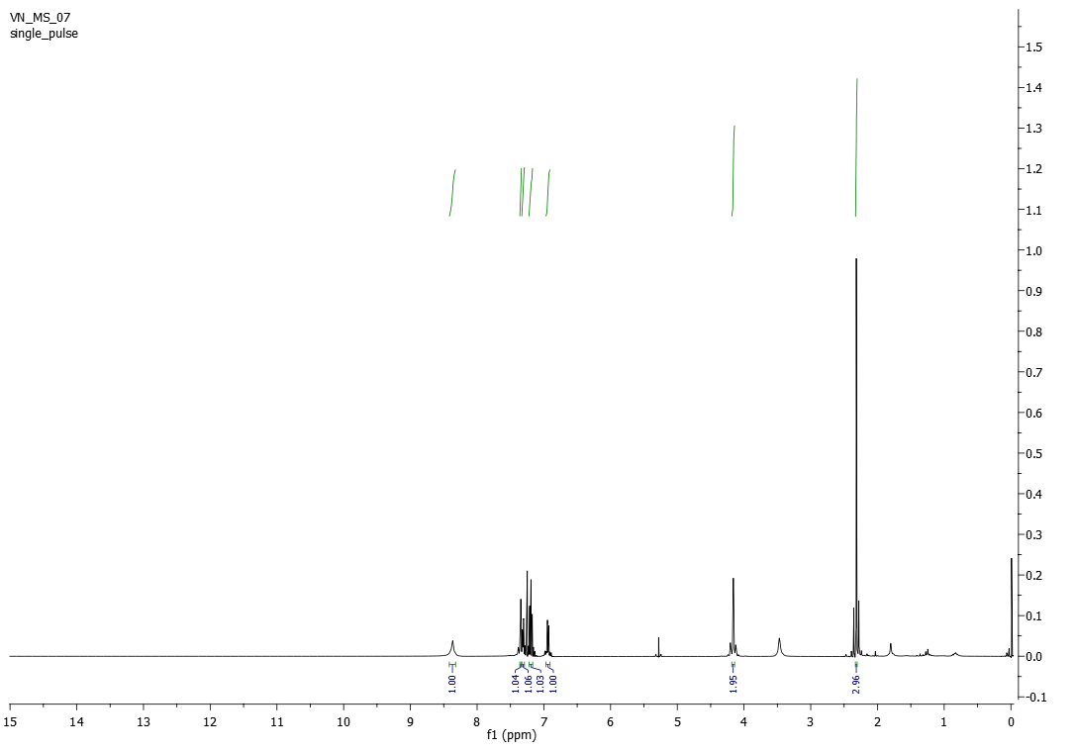

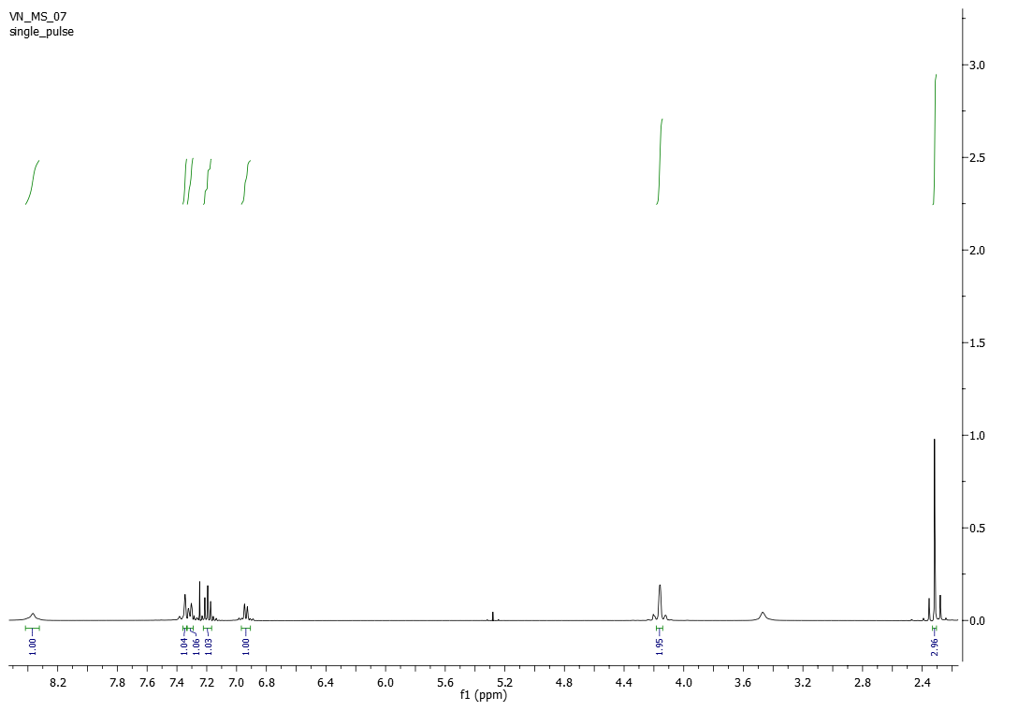
Figure S22: ¹H NMR of 2-hydroxy-N-(m-tolyl)acetamide (3h)
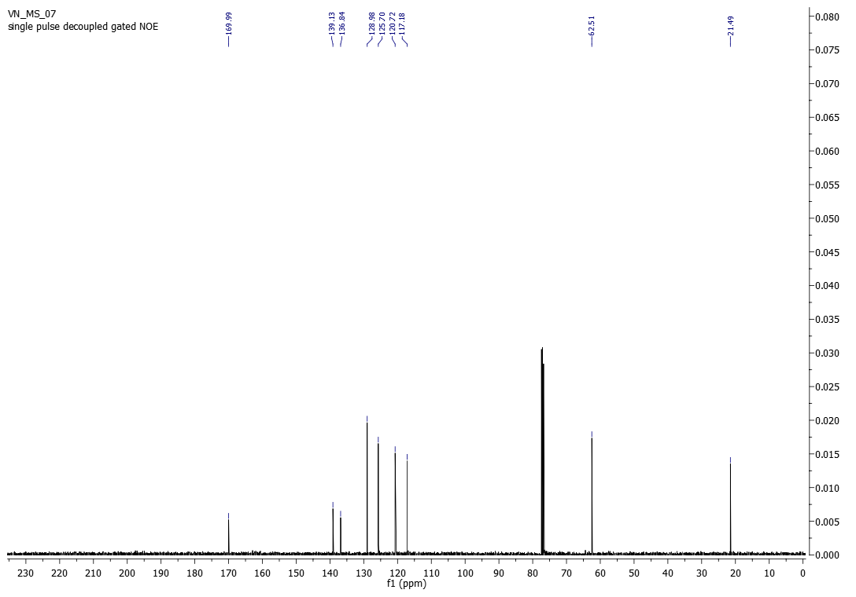
Figure S23: ¹³C NMR of 2-hydroxy-N-(m-tolyl)acetamide (3h)

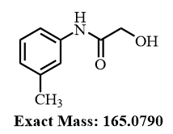
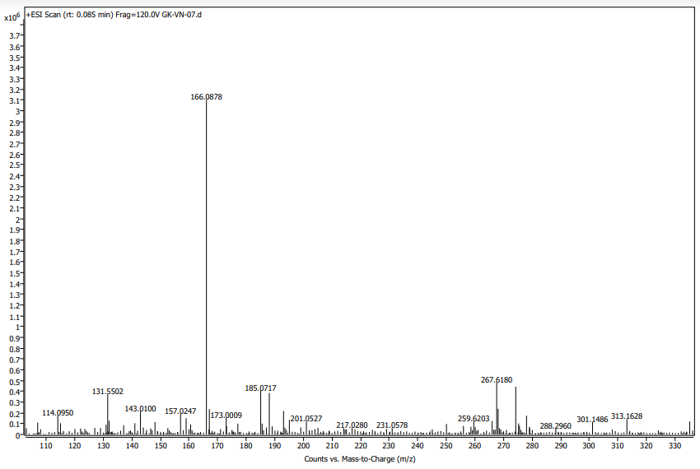
Figure S24: HRMS of 2-hydroxy-N-(m-tolyl)acetamide (3h)
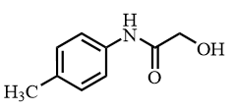
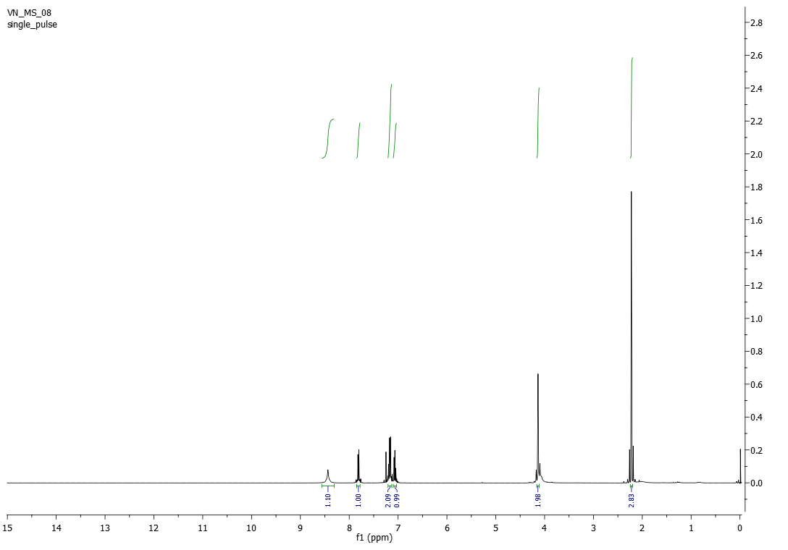

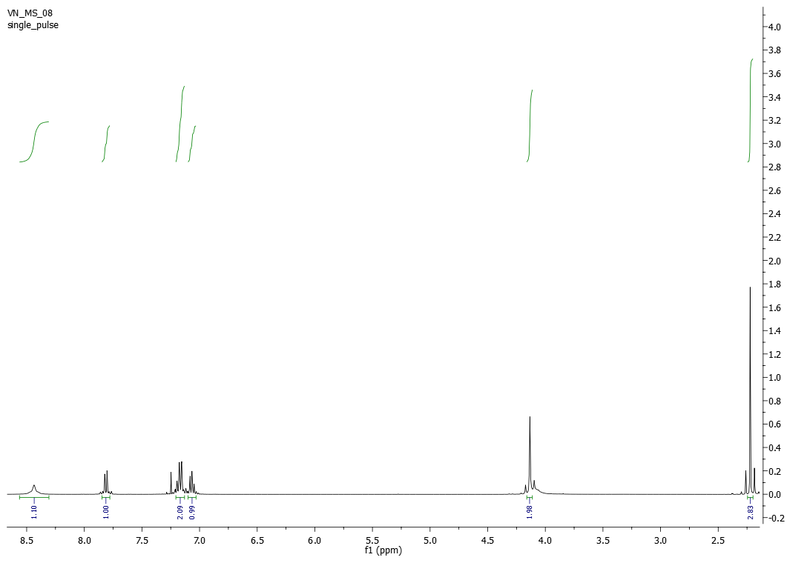
Figure S25: ¹H NMR of 2-hydroxy-N-(p-tolyl)acetamide (3i)

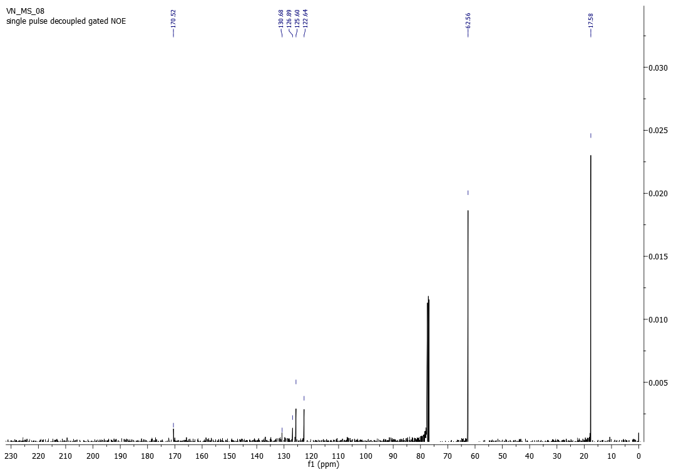
Figure S26: ¹³C NMR of 2-hydroxy-N-(p-tolyl)acetamide (3i)

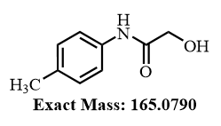
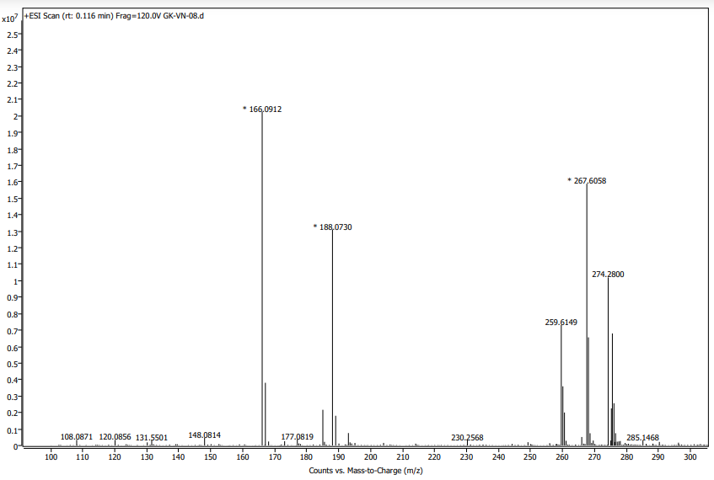
Figure S27: HRMS of 2-hydroxy-N-(p-tolyl)acetamide (3i)

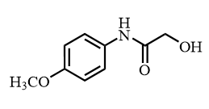
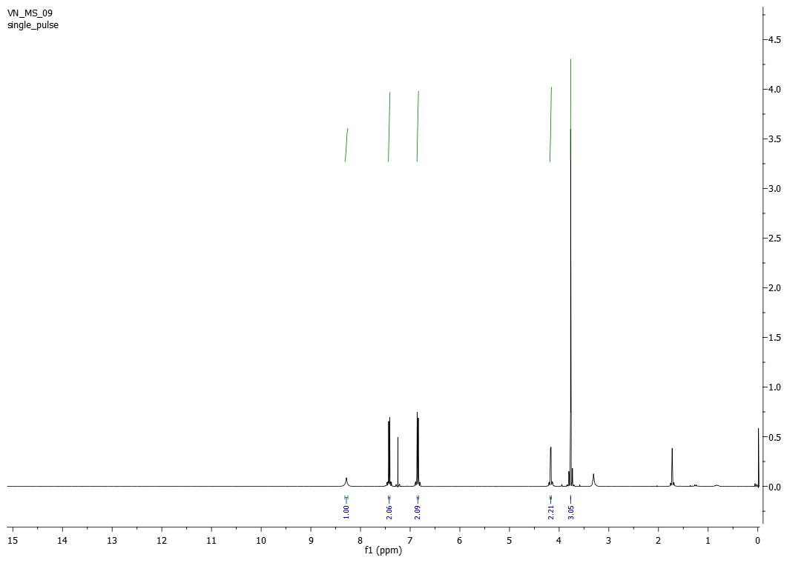

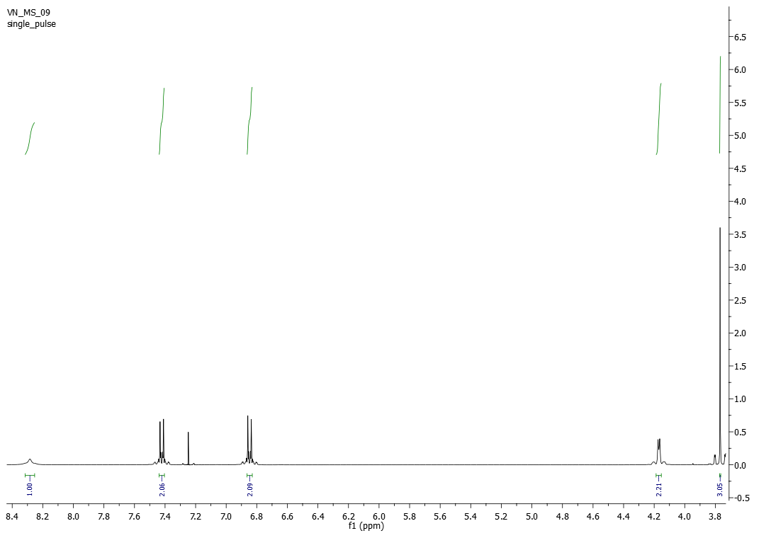
Figure S28: ¹H NMR of 2-hydroxy-N-(4-methoxyphenyl)acetamide (3j)

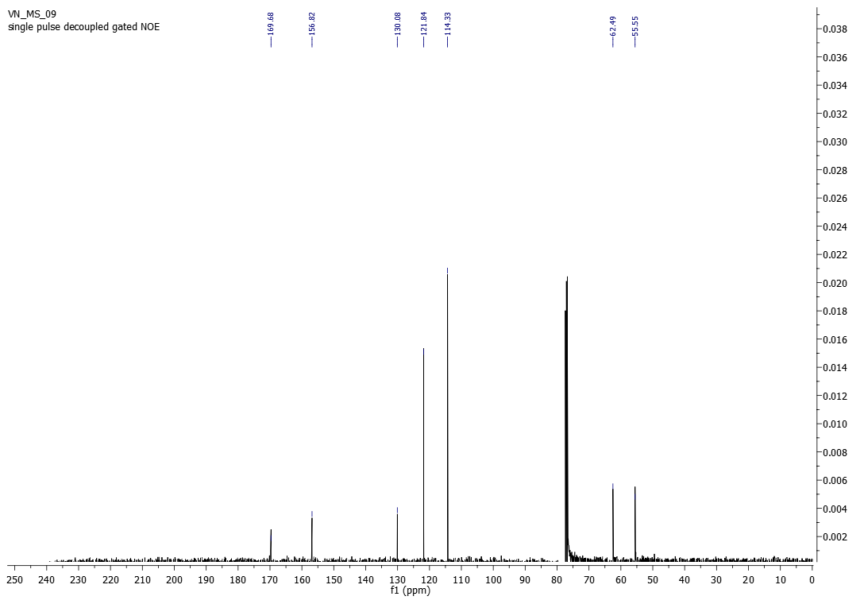
Figure S29: ¹³C NMR of 2-hydroxy-N-(4-methoxyphenyl)acetamide (3j)

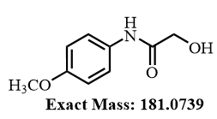
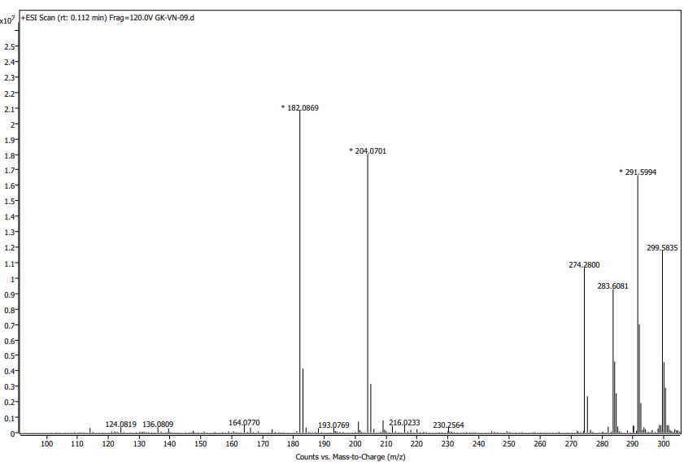
Figure S30: HRMS of 2-hydroxy-N-(4-methoxyphenyl)acetamide (3j)
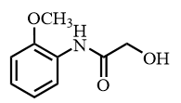
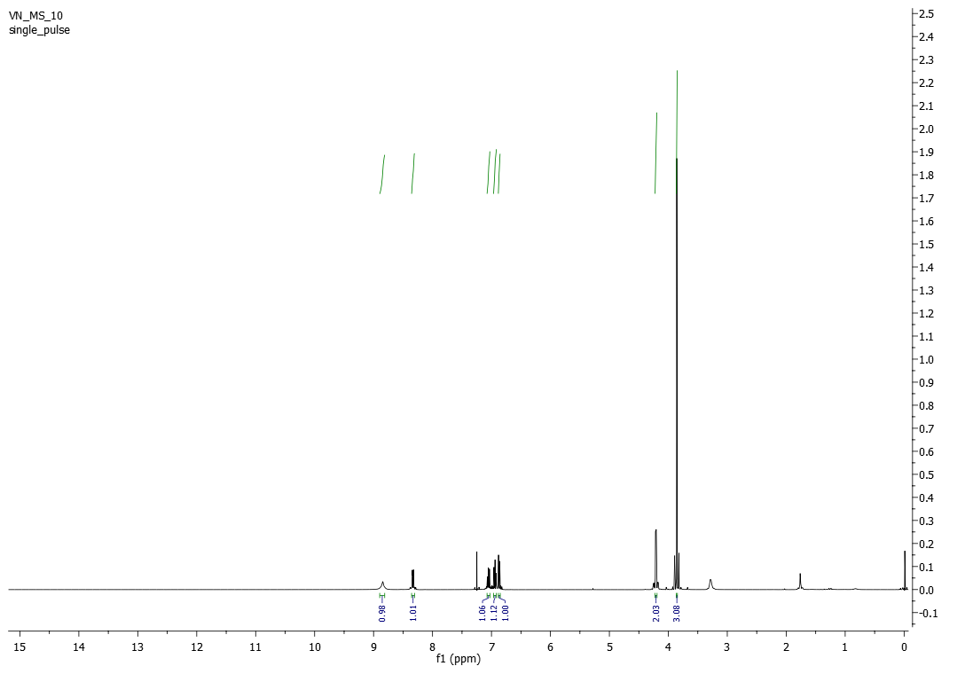

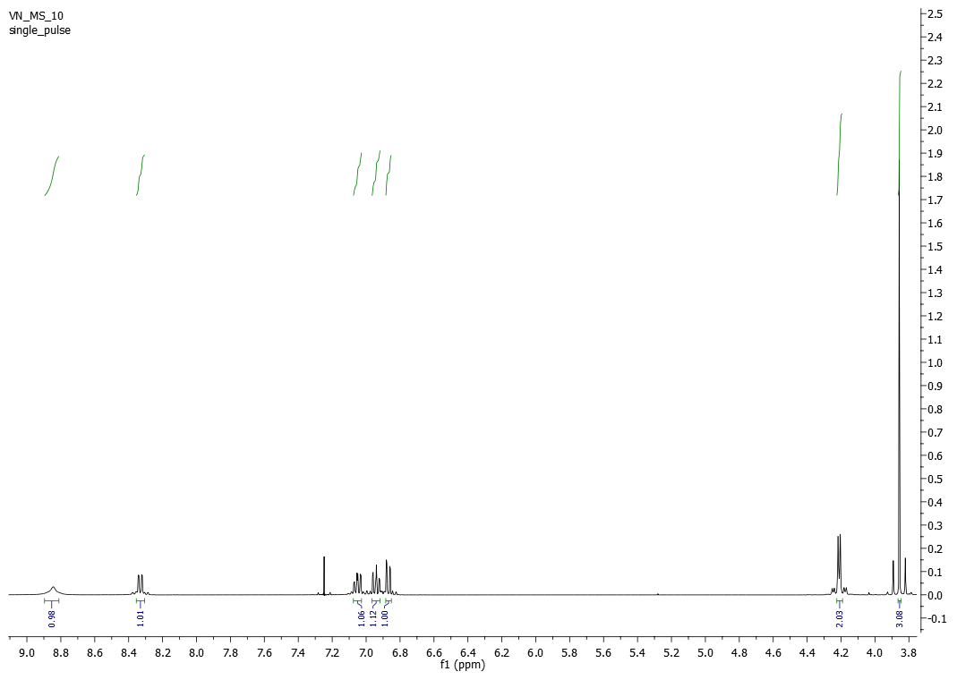
Figure S31: ¹H NMR of 2-hydroxy-N-(2-methoxyphenyl)acetamide (3k)
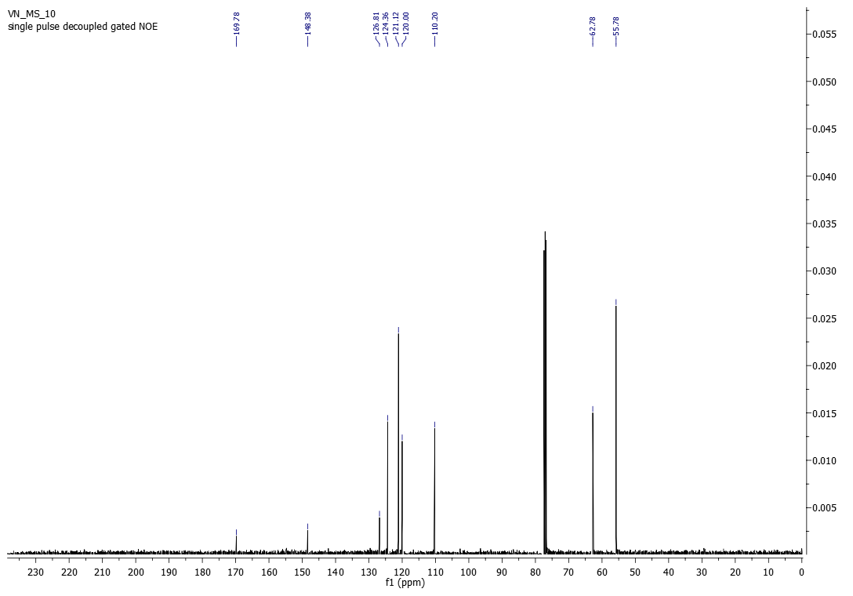
Figure S32: ¹³C NMR of 2-hydroxy-N-(2-methoxyphenyl)acetamide (3k)
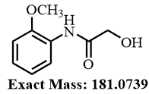
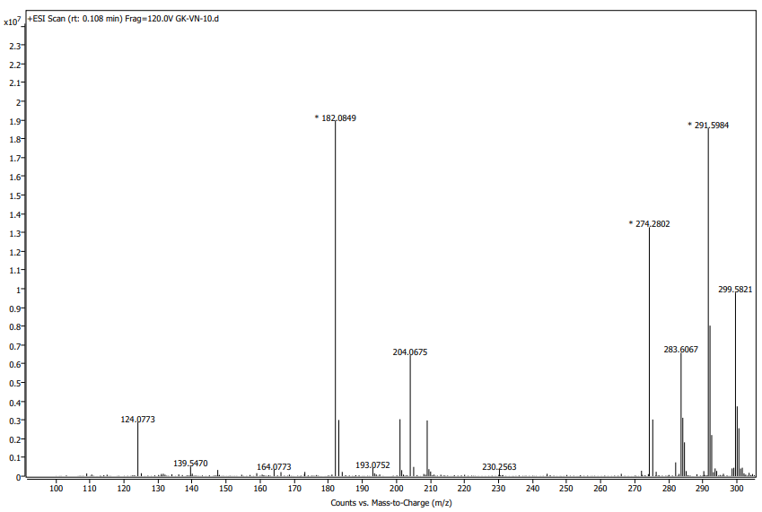
Figure S33: HRMS of 2-hydroxy-N-(2-methoxyphenyl)acetamide (3k)
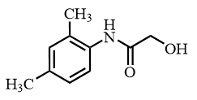
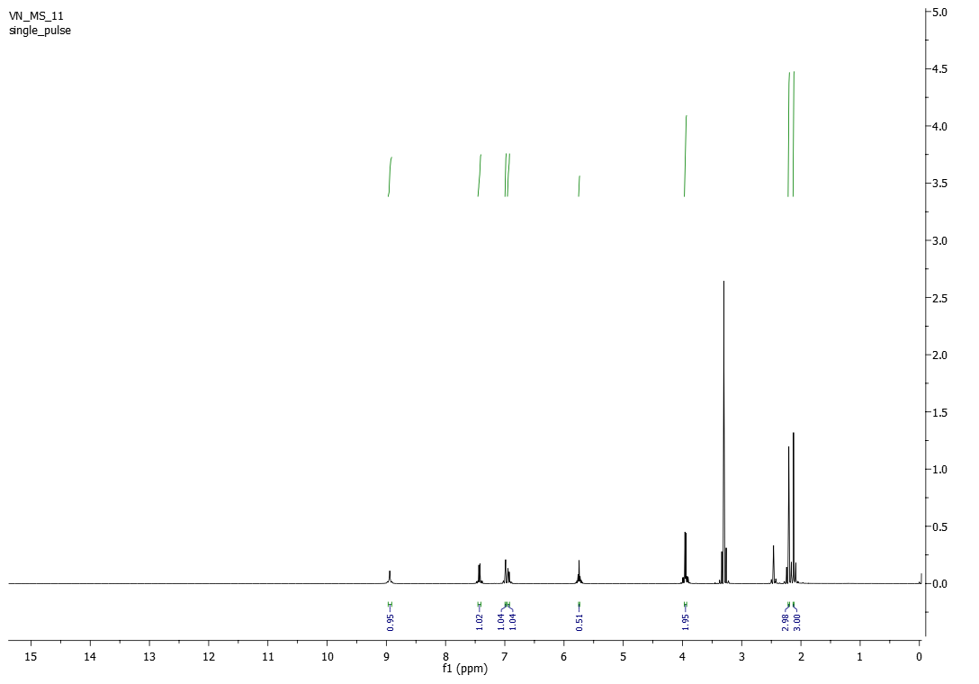

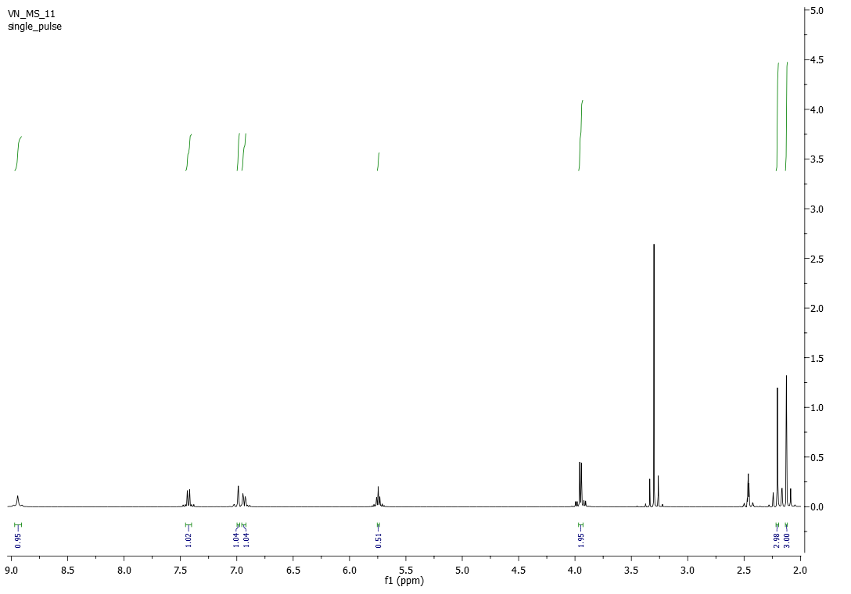
Figure S34: ¹H NMR of N-(2,4-dimethylphenyl)-2-hydroxyacetamide (3l)
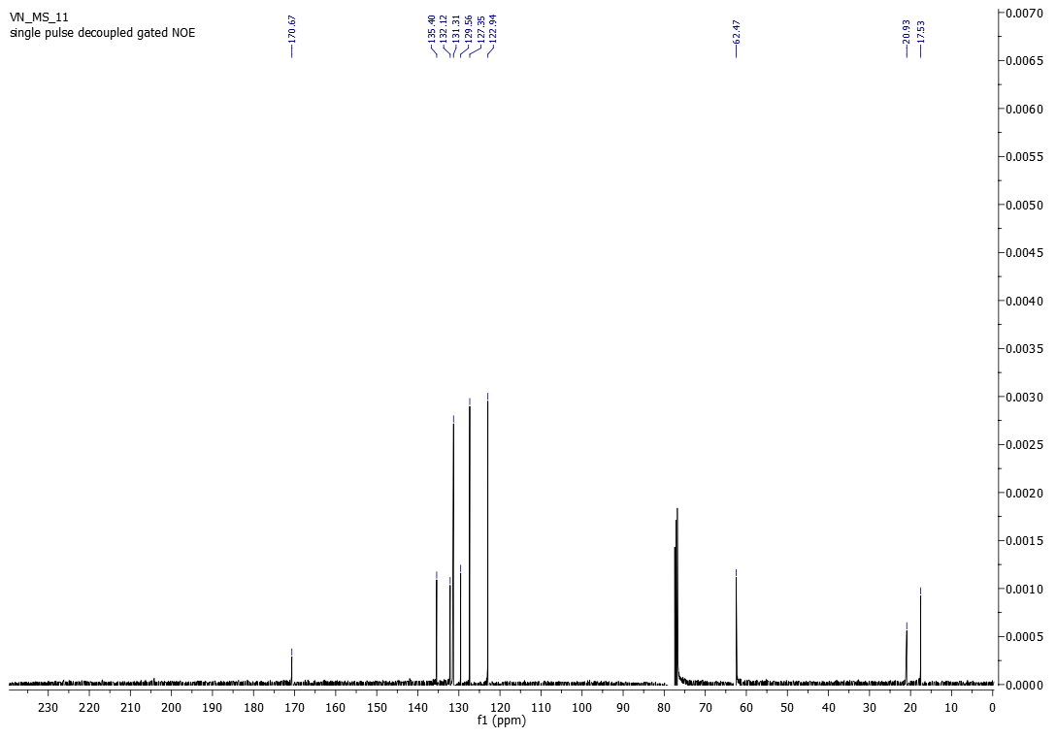
Figure S35: ¹³C NMR of N-(2,4-dimethylphenyl)-2-hydroxyacetamide (3l)
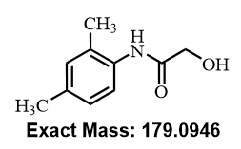
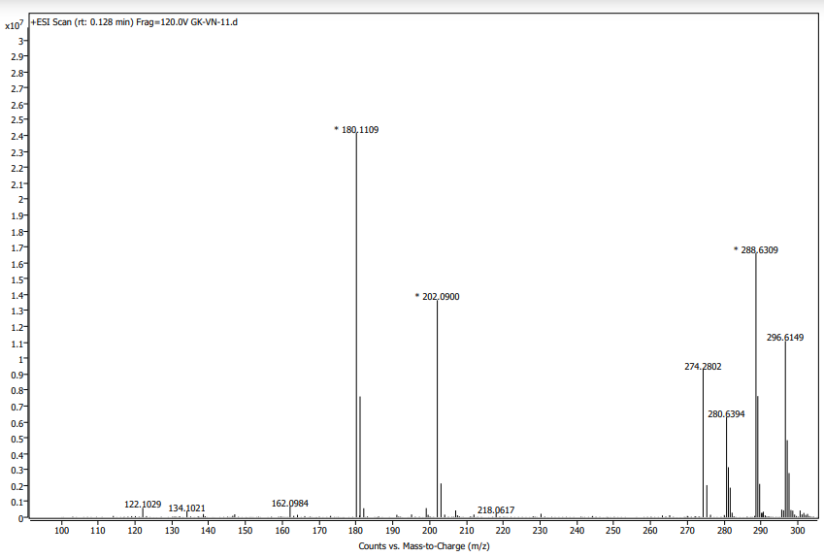
Figure S36: HRMS of N-(2,4-dimethylphenyl)-2-hydroxyacetamide (3l)
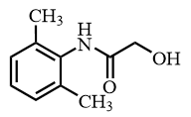
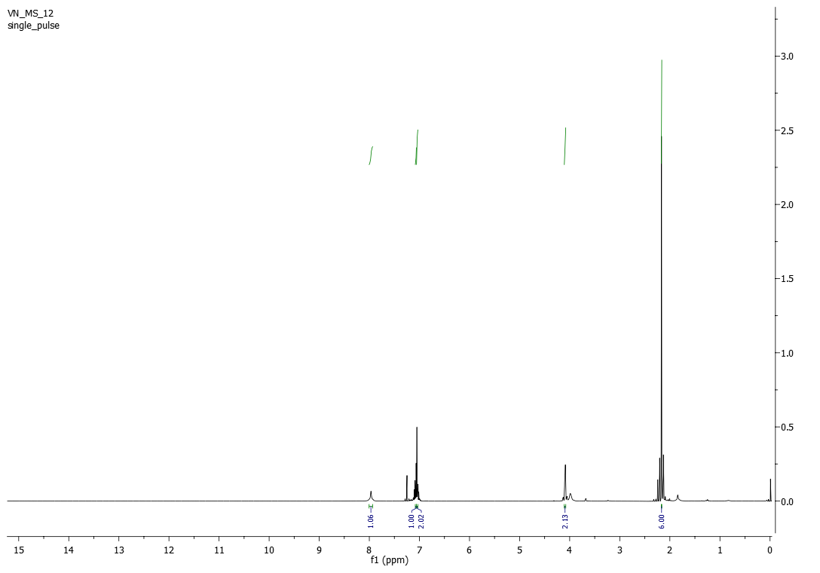

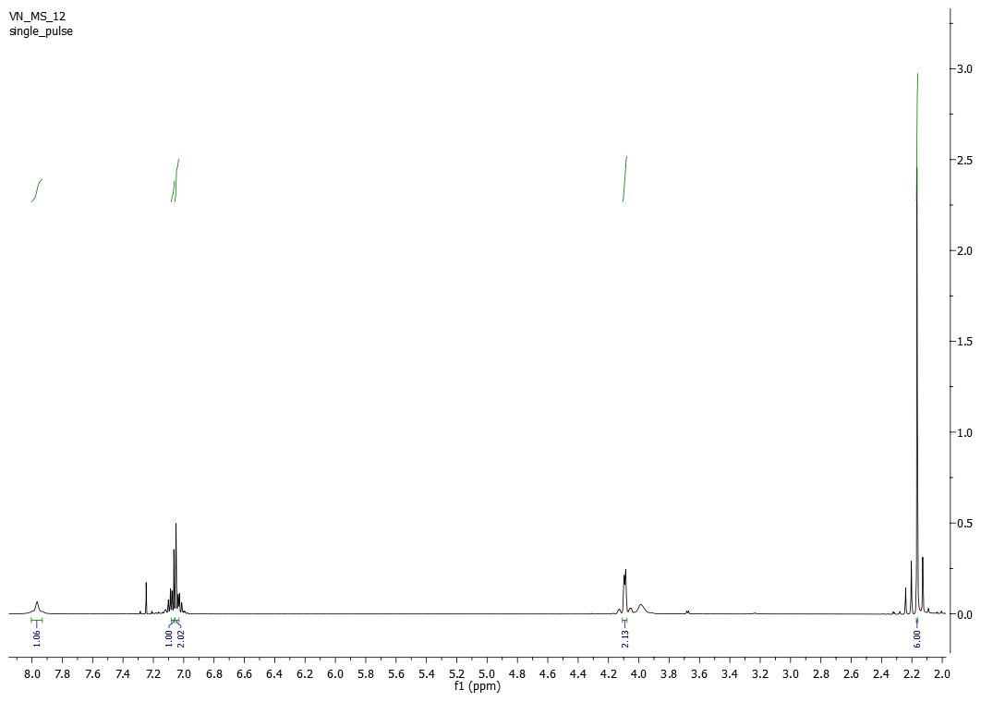
Figure S37: ¹H NMR of N-(2,6-dimethylphenyl)-2-hydroxyacetamide (3m)
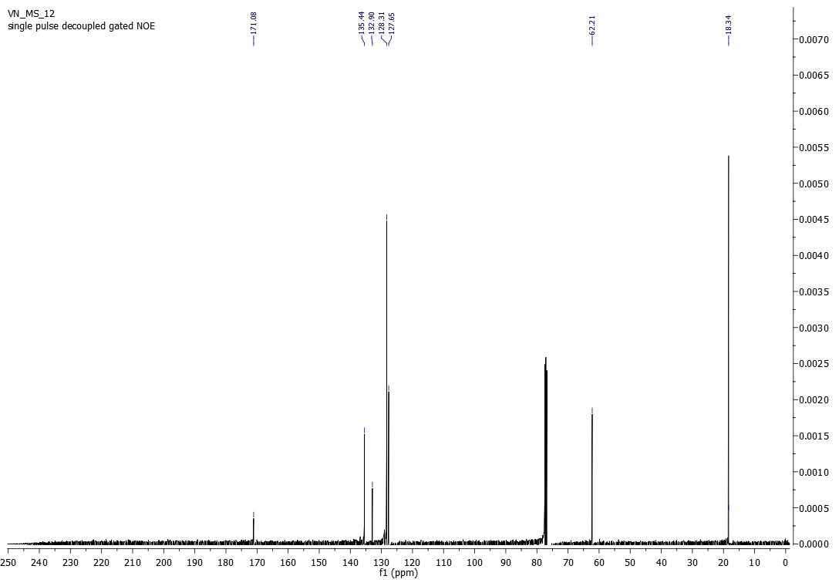
Figure S38: ¹³C NMR of N-(2,6-dimethylphenyl)-2-hydroxyacetamide (3m)
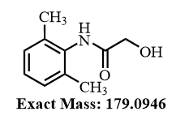
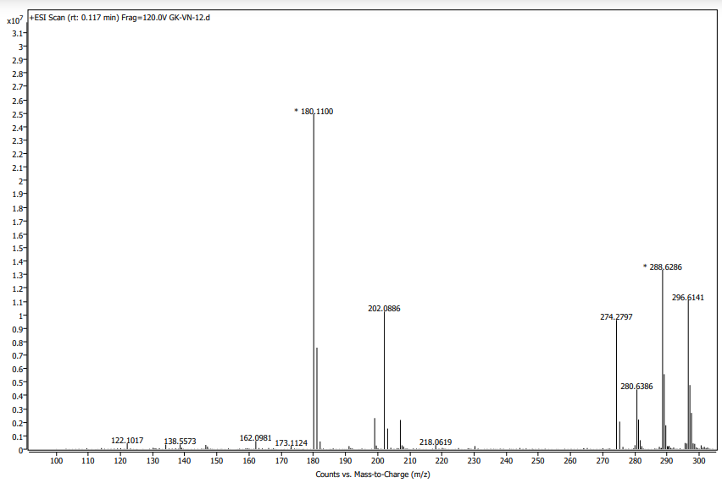
Figure S39: HRMS of N-(2,6-dimethylphenyl)-2-hydroxyacetamide (3m)

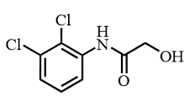
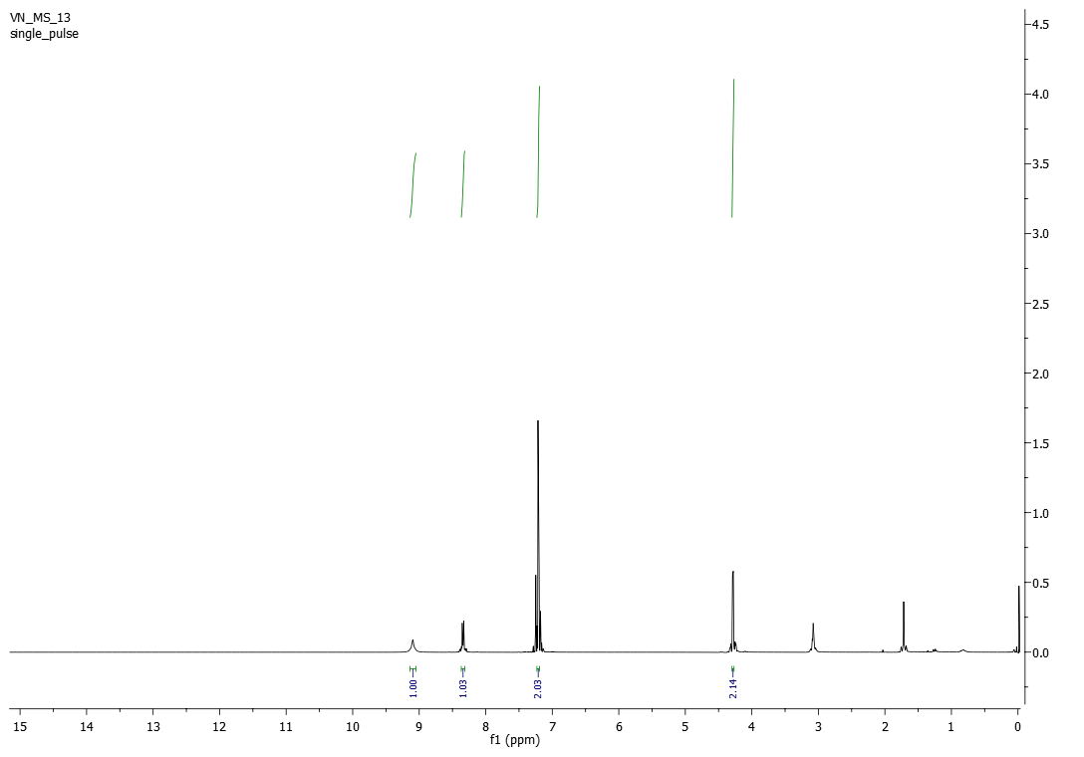

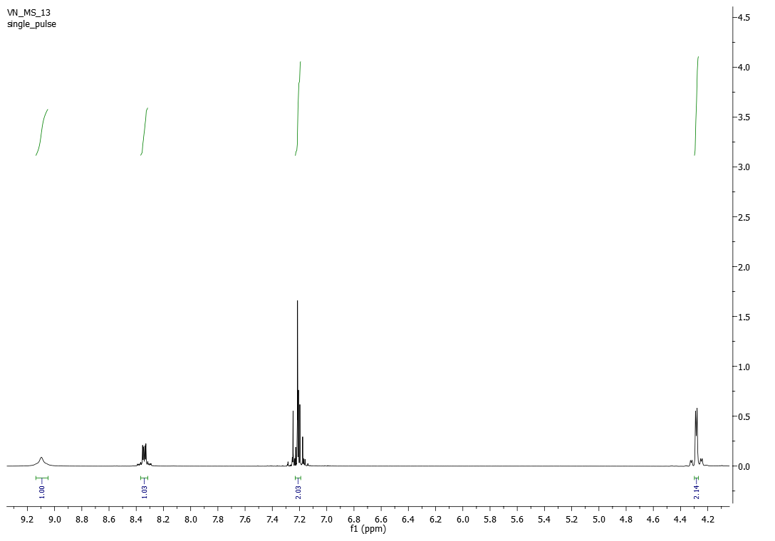
Figure S40: ¹H NMR of N-(2,3-dichlorophenyl)-2-hydroxyacetamide (3n)
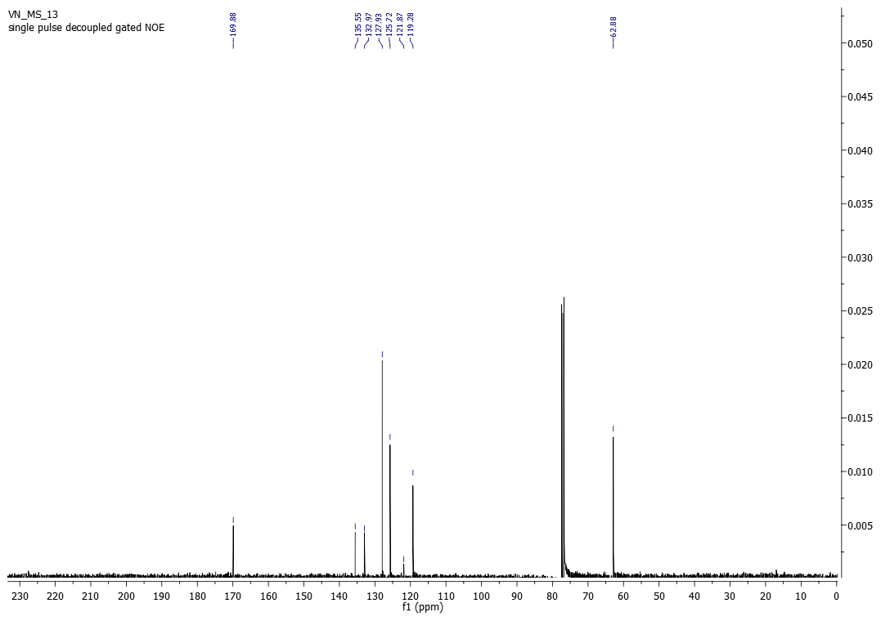
Figure S41: ¹³C NMR of N-(2,3-dichlorophenyl)-2-hydroxyacetamide (3n)
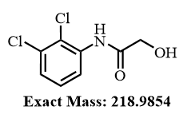
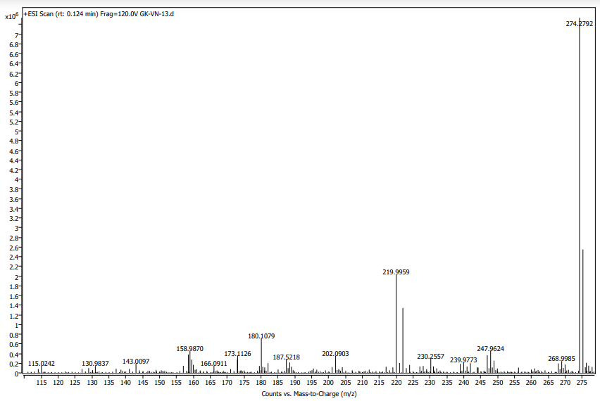
Figure S42: HRMS of N-(2,3-dichlorophenyl)-2-hydroxyacetamide (3n)
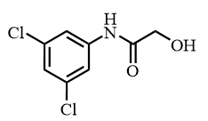
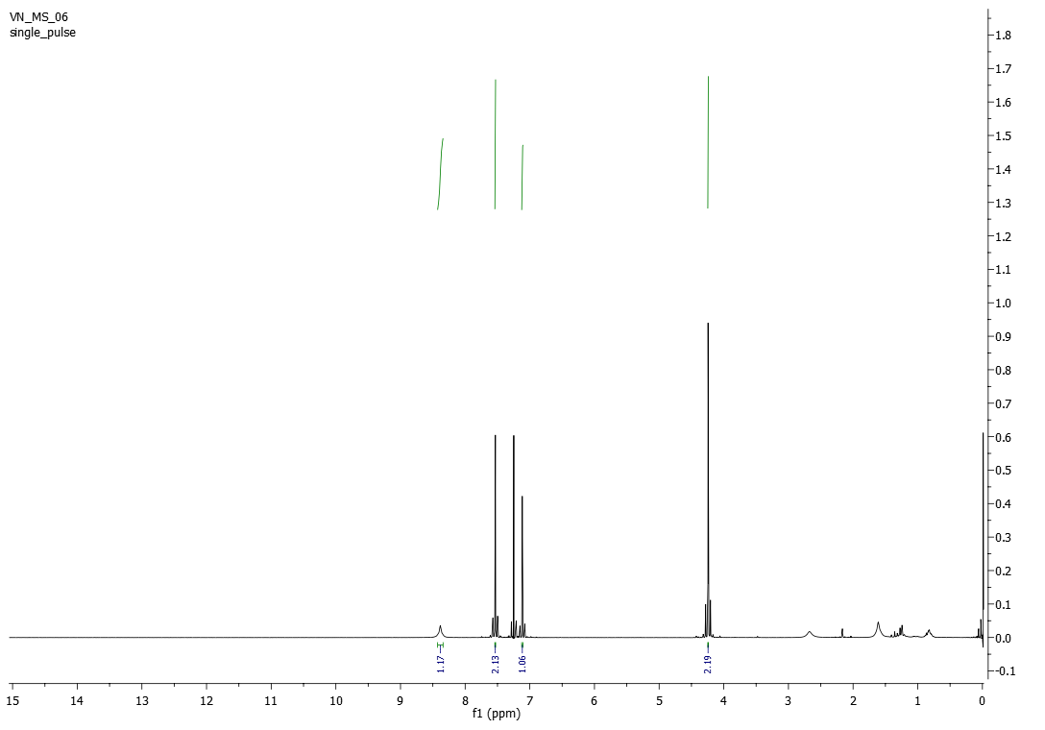

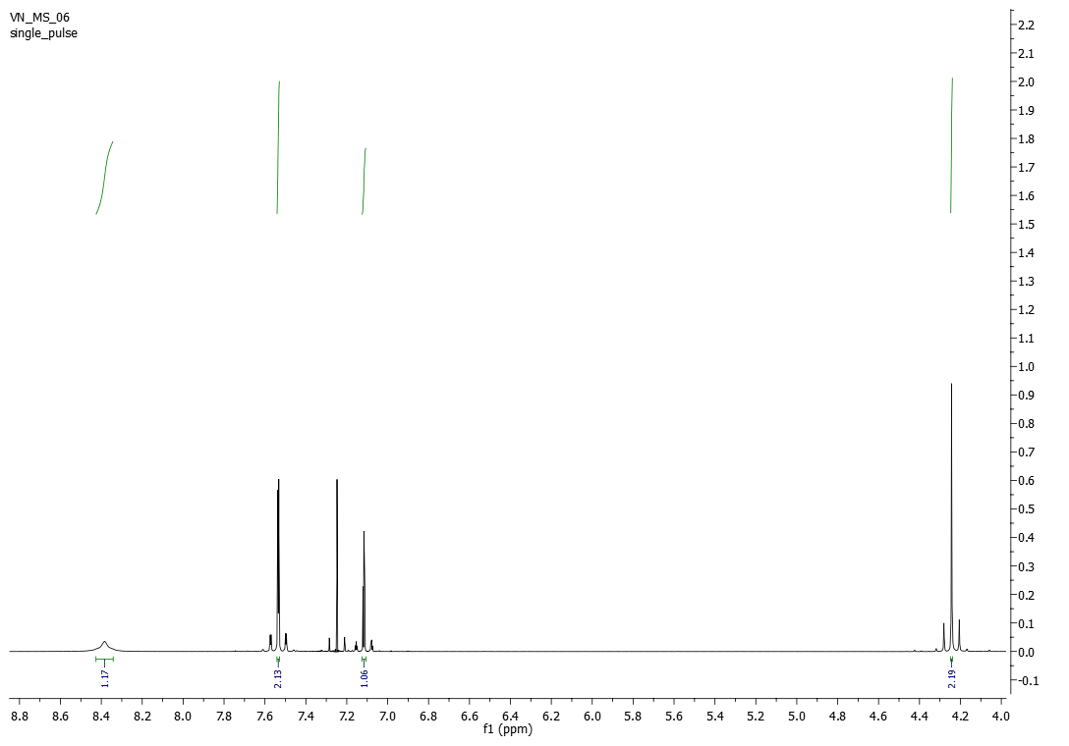
Figure S43: ¹H NMR of N-(3,5-dichlorophenyl)-2-hydroxyacetamide (3o)
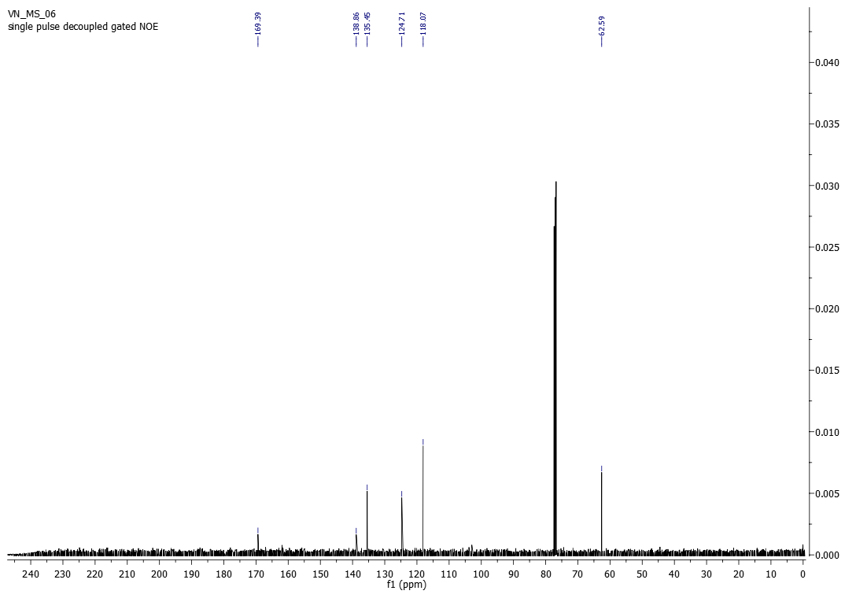
Figure S44: ¹³C NMR of N-(3,5-dichlorophenyl)-2-hydroxyacetamide (3o)
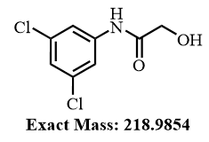
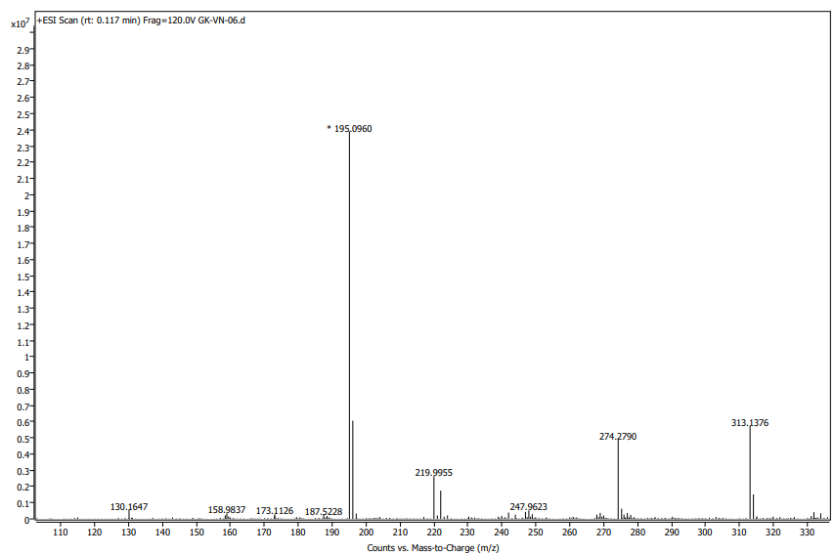
Figure S45: HRMS of N-(3,5-dichlorophenyl)-2-hydroxyacetamide (3o)
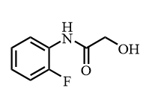
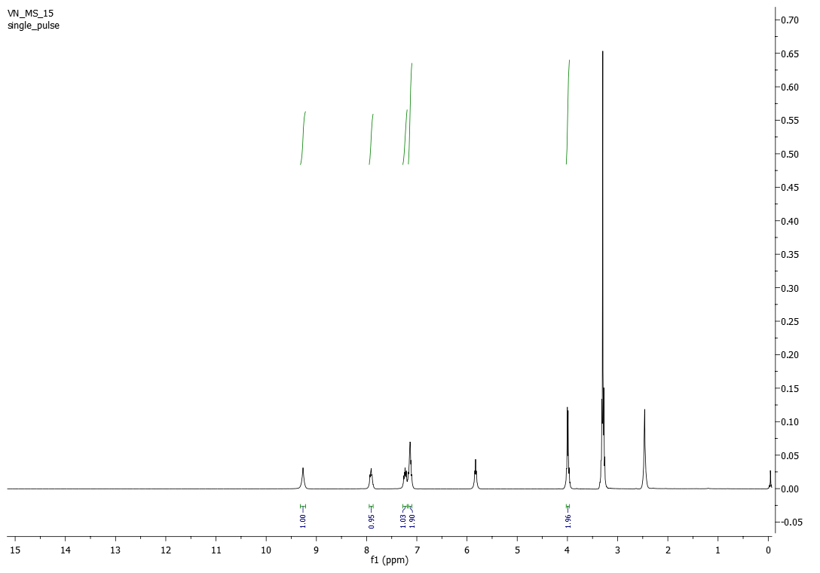

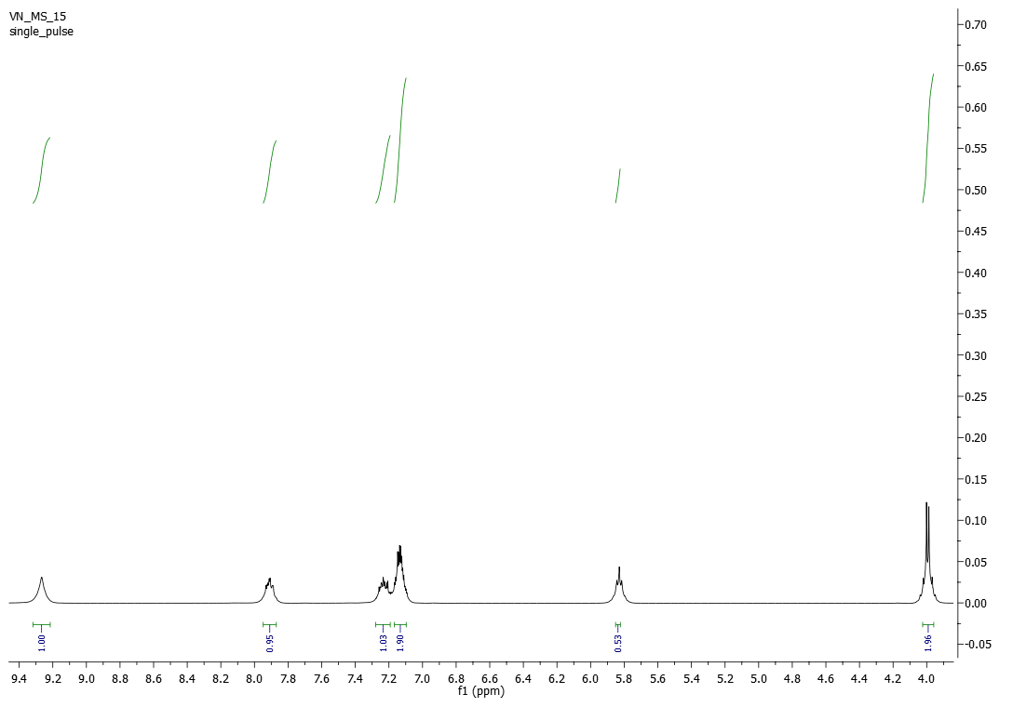
Figure S46: ¹H NMR of N-(2-fluorophenyl)-2-hydroxyacetamide (3p)
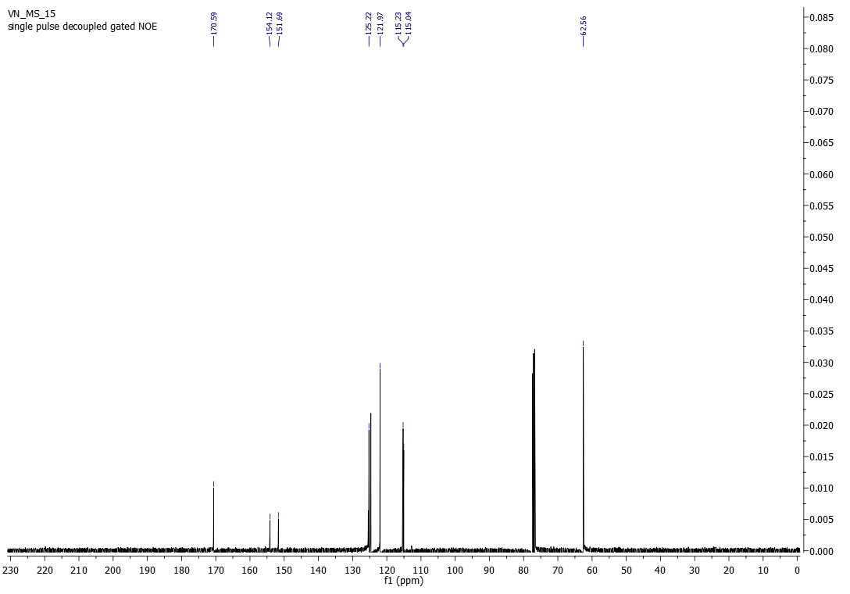
Figure S47: ¹³C NMR of N-(2-fluorophenyl)-2-hydroxyacetamide (3p)
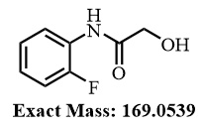
Figure S48: HRMS of N-(2-fluorophenyl)-2-hydroxyacetamide (3p)

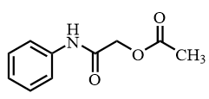
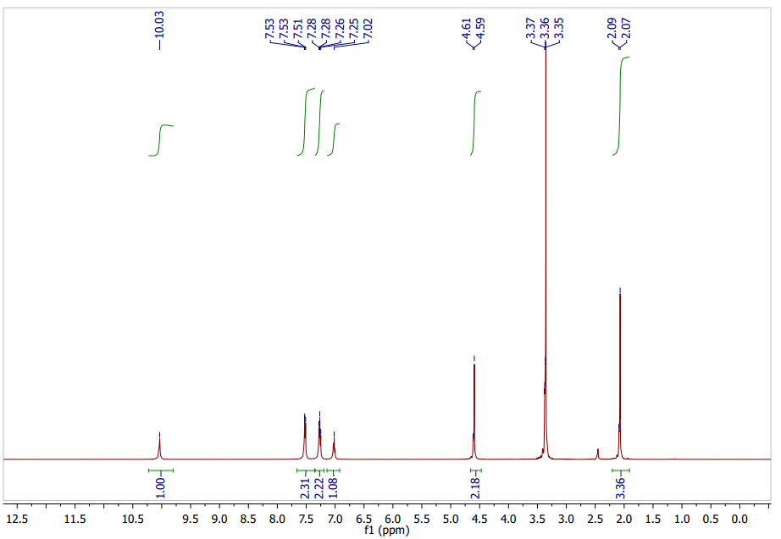
Figure S49: ¹H NMR of 2-oxo-2-(phenylamino)ethyl acetate (2a)
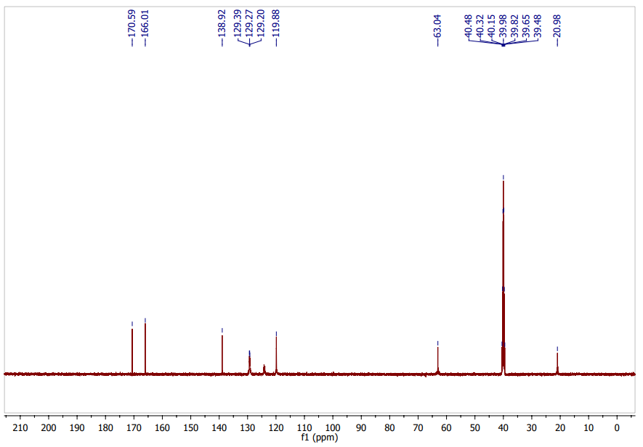
Figure S50: ¹³C NMR of 2-oxo-2-(phenylamino)ethyl acetate (2a)

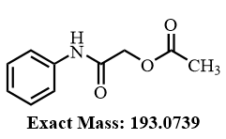
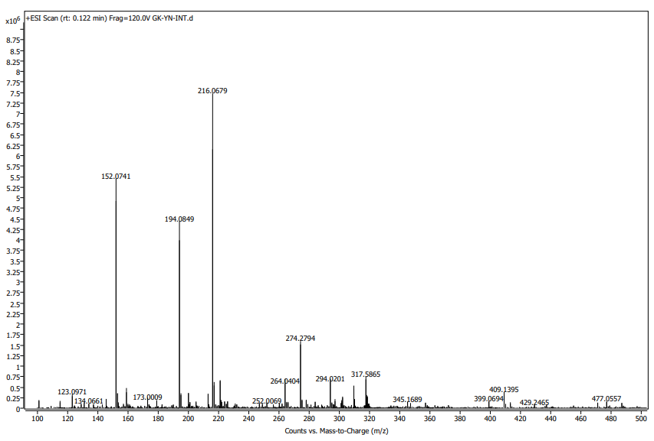
Figure S51: HRMS of 2-oxo-2-(phenylamino)ethyl acetate (2a)

