Table S1 Output from ANOVA analysis in OriginPro 2021; the pressure developed by N. cameroonii on different substrate loading of Enset fiber
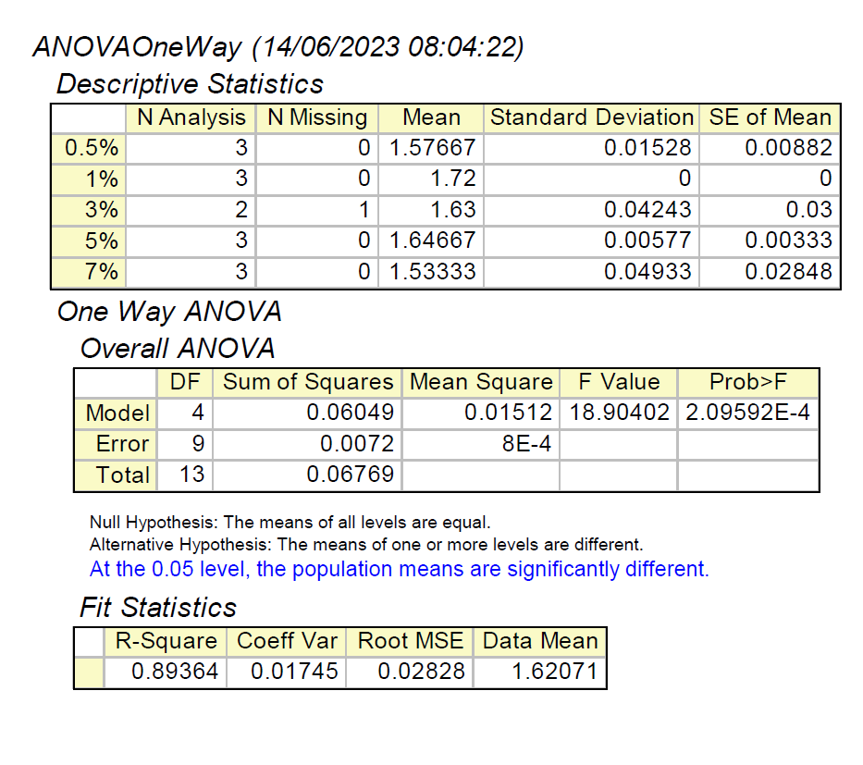
Table S2 Carbon balance for N. cameroonii growth on different substrate loading of Enset fiber
Compound | Carbon per compound (mmol)
Compound | 0.5 %(w/v) | 1 %(w/v) | 3 %(w/v) | 5 %(w/v) | 7 %(w/v)
Substrates
Enset fiber | 8.58 | 17.2 | 51.5 | 85.8 | 120.1
Ethanol* | 1.28 | 1.28 | 1.28 | 1.28 | 1.28
CO2 | 8.06 | 8.06 | 8.06 | 8.06 | 8.06
Products
Acetate | 2.81 | 3.79 | 4.88 | 4.91 | 6.36
Ethanol | 1.98 | 2.20 | 2.26 | 2.13 | 2.17
Succinate | 0.30 | 0.45 | 0.97 | 1.09 | 0.92
Lactate | 0.39 | 1.37 | 1.47 | 0.73 | 0.45
Formate | 1.43 | 1.82 | 1.88 | 1.60 | 0.90
CO2 | 10.8 | 11.1 | 10.9 | 11.2 | 10.6
Carbon recovery (%) | 98.8 | 78.3 | 36.7 | 22.7 | 16.5
*The amount of ethanol came from the hemin solution in the medium

