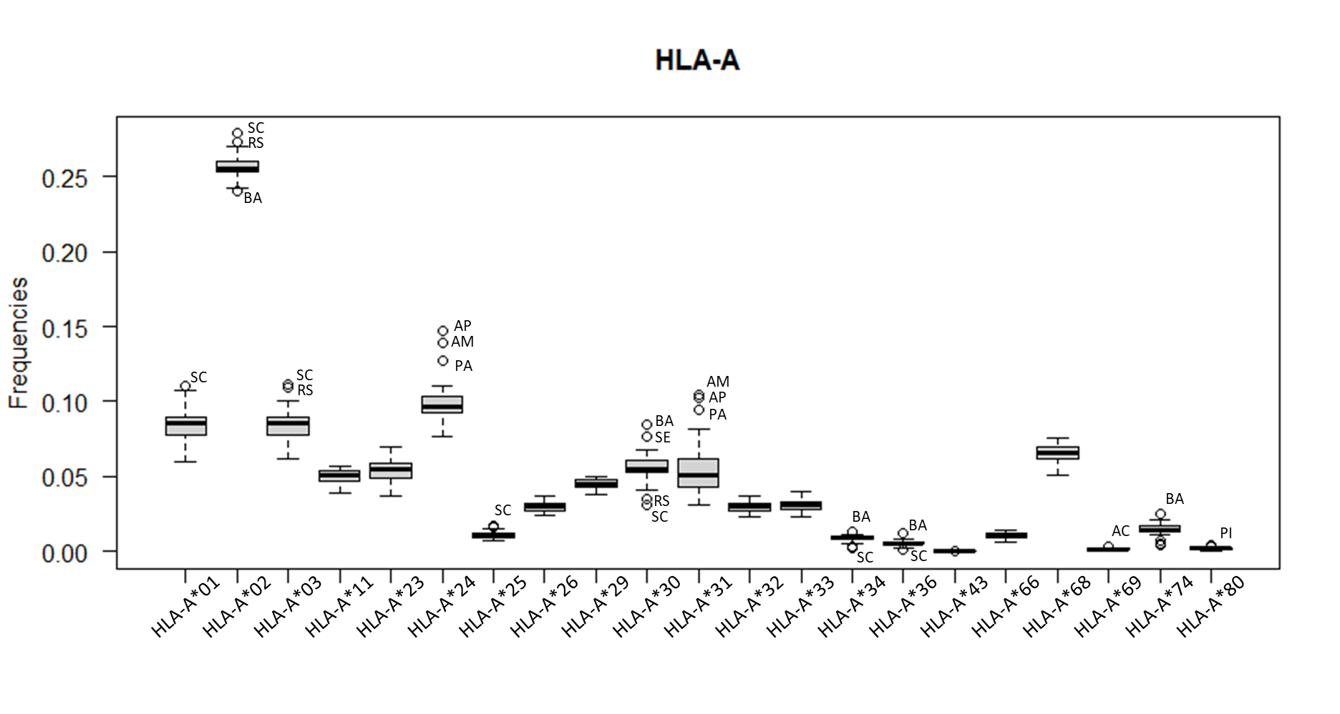
Supplementary Figure. Boxplot representing HLA-A allele frequencies observed in the Brazilian states. When an outlier was detected, it is indicated by the state’s abbreviation. RS: Rio Grande do Sul; SC: Santa Catarina; BA: Bahia; AP: Amapá; AM: Amazonas; PA: Pará; SE: Sergipe; AC: Acre; PI: Piauí.

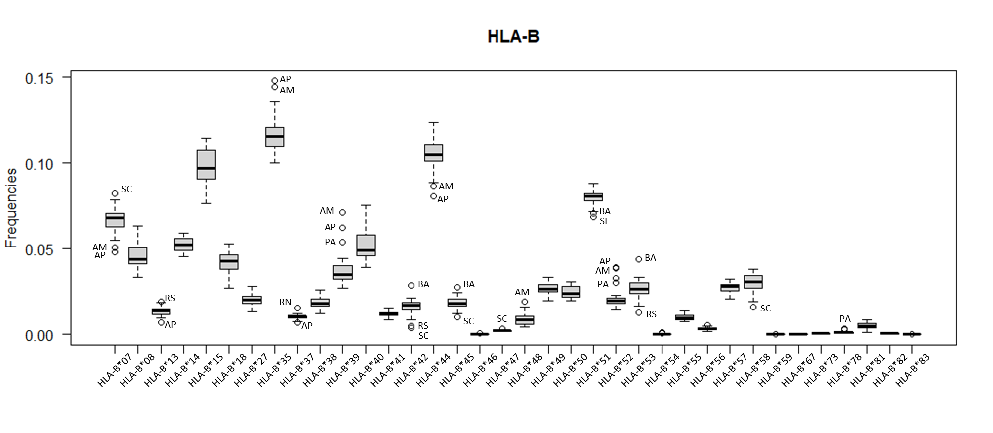
Supplementary Figure. Boxplot representing HLA-B allele frequencies observed in the Brazilian states. When an outlier was detected, it is indicated by the state’s abbreviation. RS: Rio Grande do Sul; SC: Santa Catarina; BA: Bahia; AP: Amapá; AM: Amazonas; RN: Rio Grande do Norte; PA: Pará; SE: Sergipe.

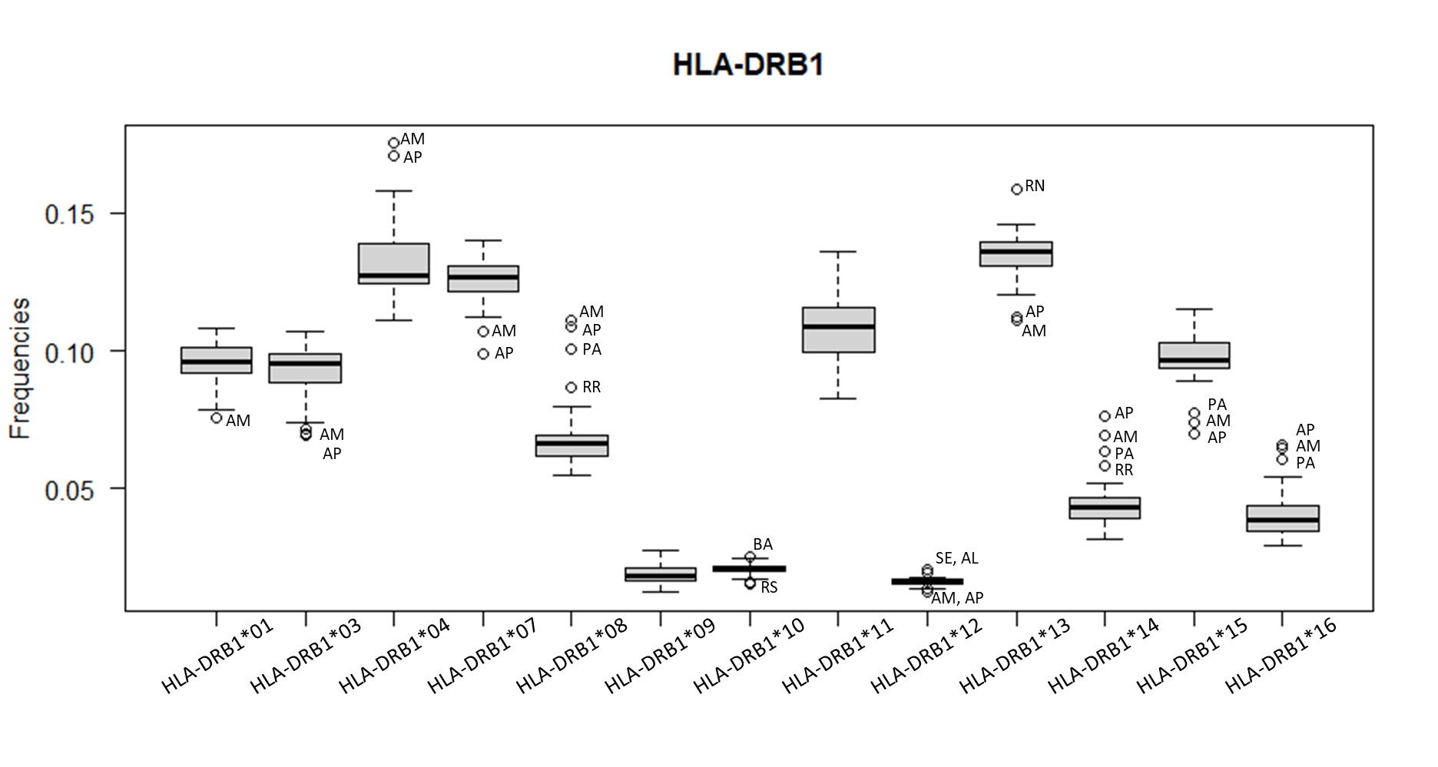
Supplementary Figure. Boxplot representing HLA-DRB1 allele frequencies observed in the Brazilian states. When an outlier was detected, it is indicated by the state’s abbreviation. RS: Rio Grande do Sul; BA: Bahia; AP: Amapá; AM: Amazonas; RR: Roraima; RN: Rio Grande do Norte; PA: Pará; SE: Sergipe; AL: Alagoas.

