Supporting Information
Fe₂GeS₄/Exfoliated Graphite Composite Anodes with Enhanced Performance for SIBs

Peng Wang, Xinxin Zhu, Yihong Ding*, Lixiong Shao, Huile Jin, Lichen Zhan, Xintong Wang, Tianbiao Zeng*

Key Laboratory of Carbon Materials of Zhejiang Province, Wenzhou Key Lab of Advanced Energy Storage and Conversion, Zhejiang Province Key Lab of Leather Engineering, College of Chemistry and Materials Engineering, Wenzhou University, Wenzhou Zhejiang 325035, P. R. China

*: Corresponding authors. Email: yhdd@wzu.edu.cn (Y. Ding), tianbiaoZeng@126.com (T. Zeng).

Supplementary Figures

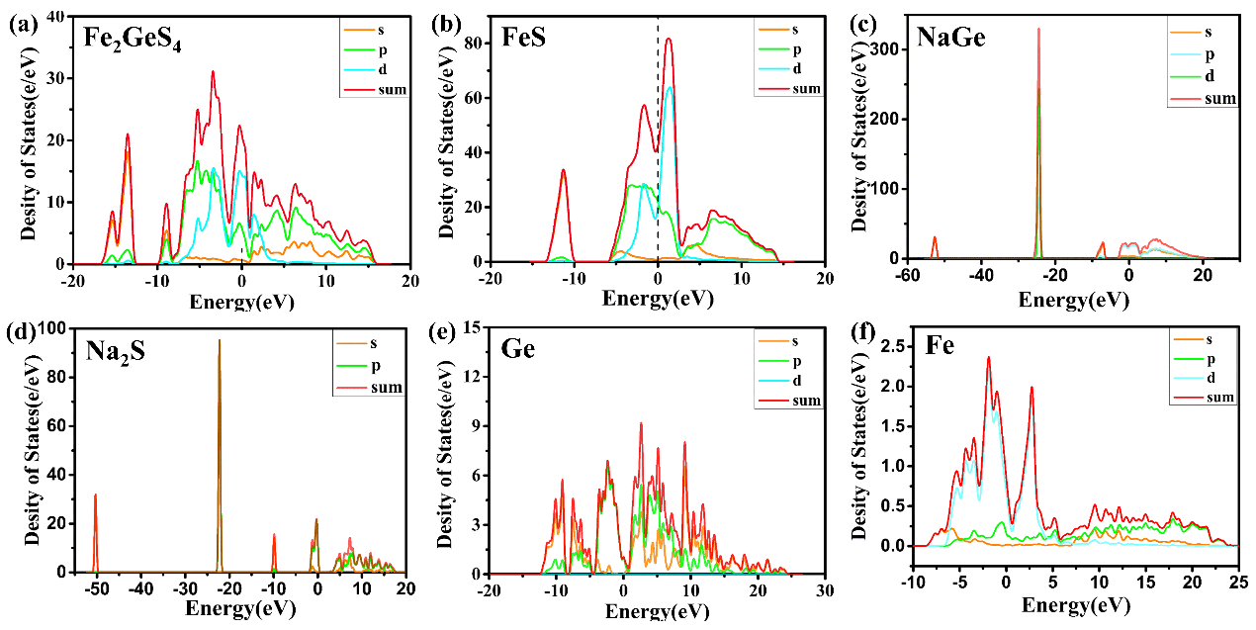
Figure S1 (a) density of the state of Fe₂GeS₄, (b) density of the state of FeS, (c) density of the state of NaGe, (d) density of the state of Na₂S (e) density of the state of Ge (f) density of the state of Fe

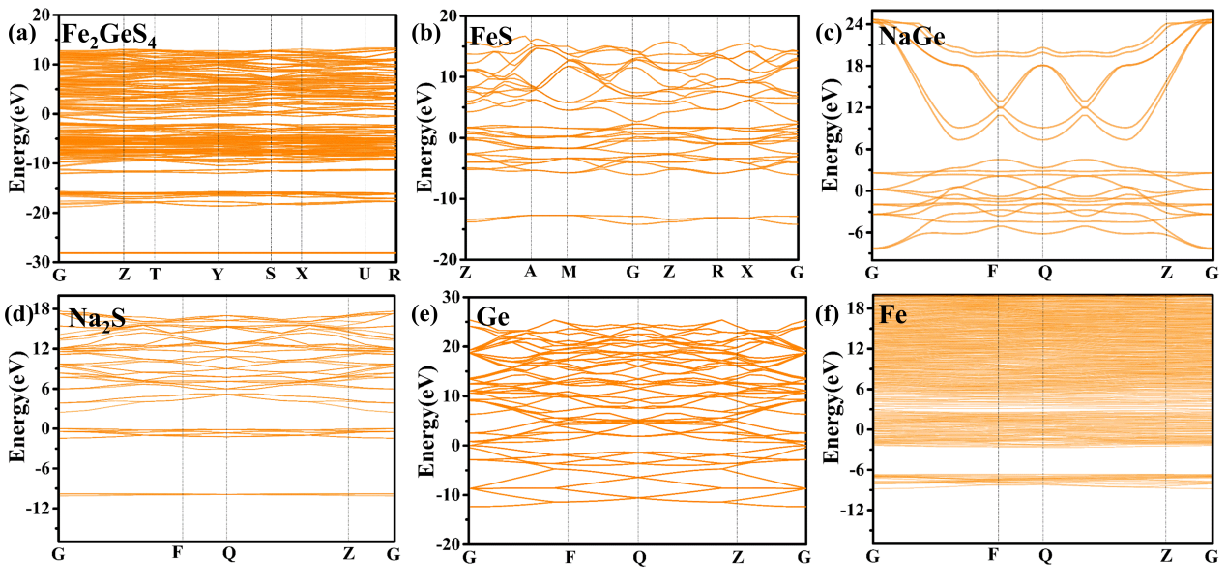
Figure S2 (a) band structure of Fe₂GeS₄, (b) band structure of FeS, (c) band structure of NaGe, (d) band structure of Na₂S, (e) band structure of Ge, (f) band structure of Fe.

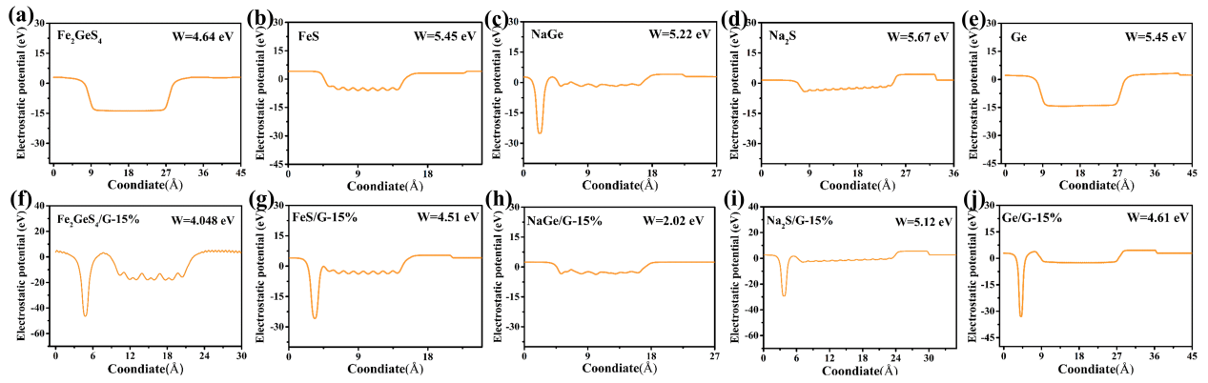
Figure S3 The electronic escape work functions of (a) Fe₂GeS₄, (b) FeS, (c) NaGe, (d) Na₂S, (e) Ge, (f) Fe₂GeS₄/G-15%, (g) FeS/G-15%, (h) NaGe/G-15%, (i) Na₂S/G-15%, (j) Ge/G-15%.

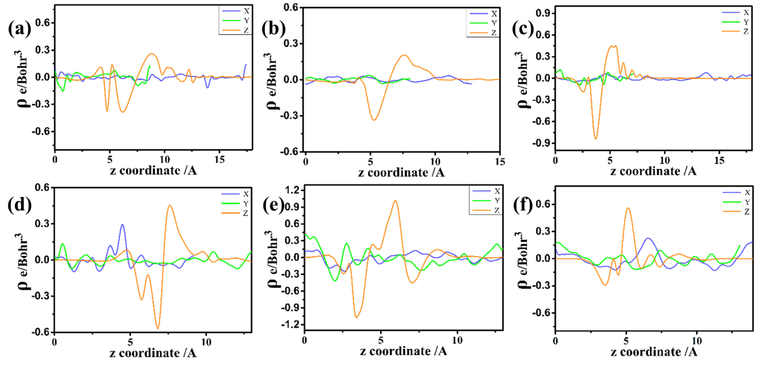
Fig. S4 Electron density evolution of Fe₂GeS₄/G-15% (a), Ge/G-15% (f), FeS/G-15% (g), S/G-15% (h), NaGe/G-15% (h), and Na₂S/G-15% (h).

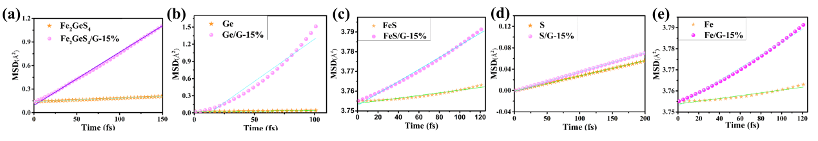
Figure S5 Mean square displacement against simulation time of the Na in Fe₂GeS₄ and Fe₂GeS₄/G-15% (a), Ge and Ge/G-15% (b), FeS and FeS/G-15% (c), S and S/G-15% (d), Fe and Fe/G-15% (e).

