Supporting Information for

Synergetic effect of potassium persulfate and iron oxalate on photodegradation of para-arsanilic acid

Yuliya E. Tyutereva^{a,b}, Petr S. Sherin^{b,c}, Evgeniya V. Polyakova^{b,d}, Vyacheslav P. Grivin,^{a,b} Victor F. Plyusnin^{a,b}, Olga V. Shuvaeva^{b,d}, Jing Xu^{e}, Feng Wu^{f} and Ivan P. Pozdnyakov^{a,b}*
ªV.V. Voevodsky Institute of Chemical Kinetics and Combustion, 3 Institutskaya str., 630090 Novosibirsk, Russian Federation
^{b}Novosibirsk State University, 2 Pirogova St., 630090 Novosibirsk, Russian Federation
^{c}International Tomography Center, 3a Institutskaya str., 630090 Novosibirsk, Russian Federation
^{d} Nikolaev Institute of Inorganic Chemistry, 3 Acad. Lavrentiev Ave., 630090 Novosibirsk, Russian Federation
^{e}State Key Laboratory of Water Resources and Hydropower Engineering Science, Wuhan University, 430072 Wuhan, P.R. China
^{f}Hubei Key Lab of Biomass Resource Chemistry and Environmental Biotechnology, School of Resources and Environmental Science, Wuhan University, 430079, P. R. China

*Corresponding author:
Ivan P. Pozdnyakov, Ph.D., Voevodsky Institute of Chemical Kinetics and Combustion, SB RAS, Institutskaya str. 3, 630090 Novosibirsk, Russian Federation, E-mail: ipozdnyak@kinetics.nsc.ru

Modelling of kinetic curves at 490 nm
Kinetic curves of intermediate absorption decay at 490 nm were processed by the 4th order Runge-Kutta method (RUNGE program, developed by Yu. I. Ivanov) according to the kinetic scheme (1-3):
${{SO}_{4}}^{-֩}+ RNH_{2} \underset{→}{k_{1}} RNH_{2}^{+} +{SO}_{4}^{2-}$ (1)
${{SO}_{4}}^{-֩}+ {{SO}_{4}}^{-֩} \underset{→}{k_{2}} {S_{2}O}_{8}^{2-}$ (2)
$RNH_{2}^{+} \underset{→}{k_{3}}P$ (3)

Fixed parameters of fitting, 2k₅ = 2.9*10⁹ М⁻¹с⁻¹ и ε(SO₄^{2-•}) = 1000 М⁻¹см⁻¹, were taken from the article [1].

[1] Ivanov K.L., Glebov E.M., Plyusnin V.F., Ivanov Yu.V., Grivin V.P., Bazhin N.M., Laser flash photolysis of sodium persulfate in aqueous solution with additions of dimethylformamide, J. Photochem. Photobiol. A: Chem. 133 (2000) 99–104 DOI: 10.1016/S1010-6030(00)00218-5

Table S1. Results of the best fit of experimental kinetic curves at 490 nm in the scheme (1-3) with varying the initial concentration of p-ASA. The initial concentration of the sulfate radical gradually decreased with an increase in the initial concentration of p-ASA due to competition for quanta of 266 nm of light between these reagents.

[pASA], µM | 22 | 41 | 57 | 82 | 98 | 120 | 150 | 180 | 210 | 210 | Mean value
[SO₄^{2-•}], µM | 25.8 | 23 | 22 | 18 | 18 | 14 | 13.3 | 12 | 11.4 | 11.6 | -
10⁻⁹×k₄,  M⁻¹s⁻¹ | 2.6 | 2.2 | 2.6 | 2.5 | 2.2 | 2.45 | 2.8 | 2.8 | 2.0 | 1.7 | 2.40 ± 0.40
10⁻³×k₆,  s⁻¹ | 6 | 6 | 6 | 6 | 7 | 6.5 | 3 | 3 | 7 | 6 | 5.7 ± 1.5
ε(RNH₂^{+•}) | 190 | 310 | 280 | 340 | 380 | 385 | 410 | 400 | 330 | 260 | 340 ± 50

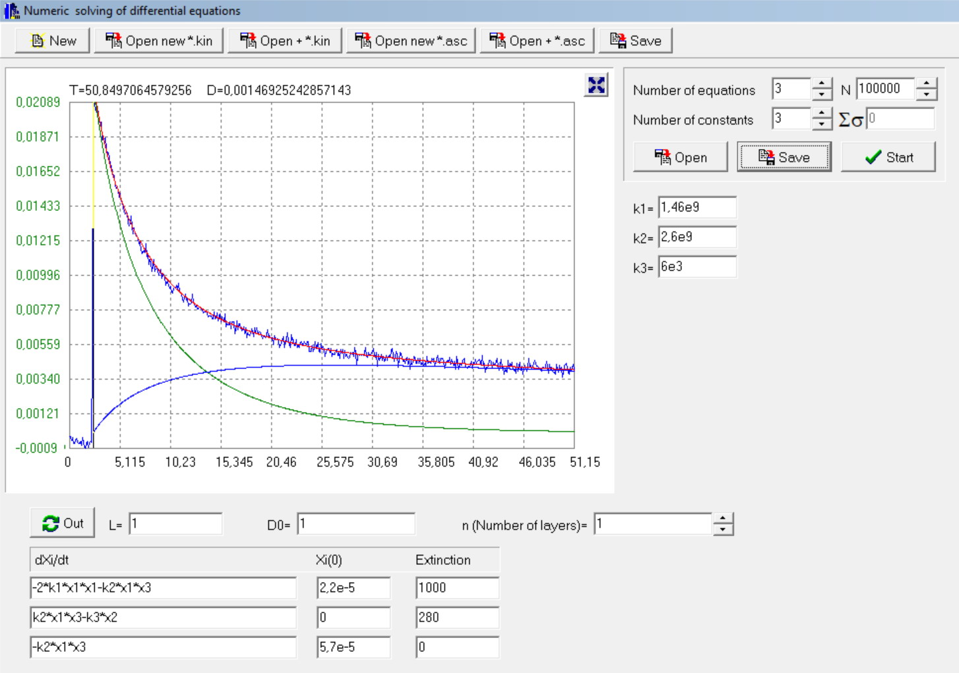
Fig. S1 Example of modelling of a kinetic curve at 490 nm at an initial p-ASA concentration of 57 μM. Smooth curves are calculation of the change in the absorption of the persulfate radical (green curve), the p-ASA cation radical (blue curve), and the total absorption of both radicals (red curve) with the parameters shown in the Table S1.
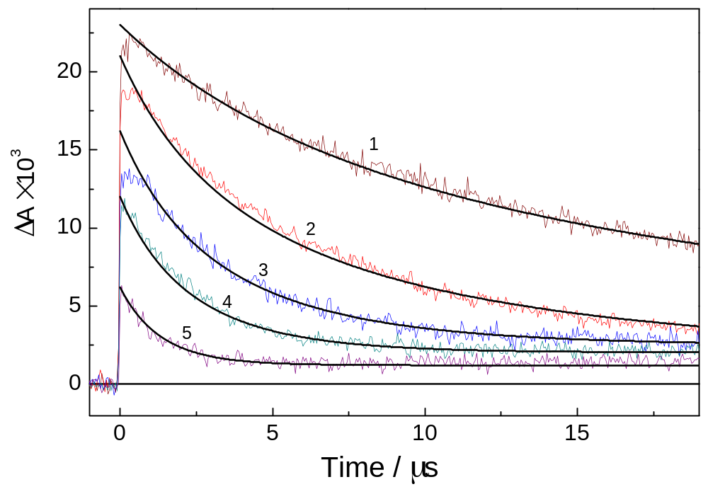
Fig. S2. Laser flash photolysis (at 266 nm) of PS (0.045 M) in the presence of p-ASA. Kinetic curves (490 nm) at the concentrations of p-ASA: 0 М (1), 2.2×10⁻⁵ М (2), 4.1×10⁻⁵ М (3), 5.7×10⁻⁵ М (4) и 9.8×10⁻⁵ М (5), respectively. Smooth curves are results of numerical simulation by the 4th order Runge-Kutta method according to the kinetic scheme (1-3). рН = 2.9.
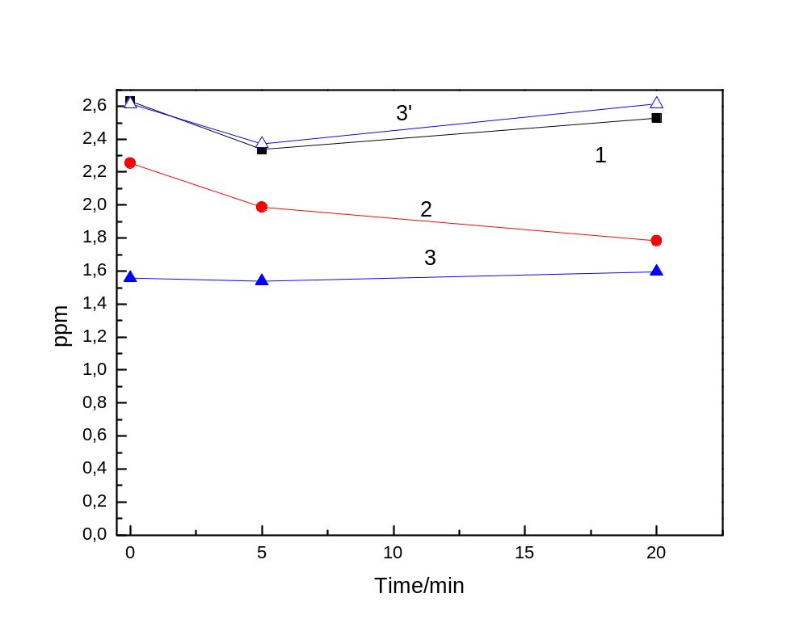
Fig. S3. Measurement of total arsenic concentration by ICP-AES in the day of irradiation (1), five days after irradiation (2) and eight days after (3) without shaking. (3’) - measurement of total arsenic concentration eight days after irradiation and with prelimenary shaking.

