Supplementary Table 1. Descriptive Statistics on Categorical Variables (Total 2679, N (%))
Variable | Yes | No
Male | 1815 (67.7) | 864 (32.3)
Hypertension | 1142 (42.6) | 1537 (57.4)
Diabetes Mellitus | 721 (26.9) | 1958 (73.1)
Dyslipidemia | 163 (6.1) | 2516 (93.9)
Family History of Cardiac Arrest |  | 1407 (52.5)
Parent | 20 (0.7)
Sibling | 14 (0.5)
Unknown | 1238 (46.2)
Family History of ACS |  | 1372 (51.2)
Parent | 41 (1.5)
Sibling | 20 (0.7)
Unknown | 1246 (46.6)
Family History of CVA |  | 1375 (51.4)
Parent | 54 (2)
Sibling | 11 (0.4)
Unknown | 1239 (46.2)
Family History of Arrhythmia |  | 1406 (52.5)
Parent | 8 (0.3)
Sibling | 3 (0.1)
Unknown | 1262 (47.1)
Witnessed Arrest | 1912 (71.4) | 767 (28.6)
Arrest Location
Home/Residence | 1453 (54.2)
Street/Highway | 317 (11.8)
Public Building | 143 (5.3)
Industrial/Workplace | 143 (5.3)
Sports/Recreation Event | 122 (4.6)
Other | 96 (3.6)
Unknown | 417 (15.6)
Bystander CPR | 1299 (48.5) | 1380 (51.5)
Bystander AED | 44 (1.6) | 2635 (98.4)
First Monitored Rhythm (Community)
VF/Pulseless VT | 762 (28.4)
PEA | 658 (24.6)
Asystole | 1017 (38)
Unknown | 242 (9)
First Monitored Rhythm (EMS)
VF/Pulseless VT | 784 (29.3)
PEA | 1034 (38.6)
Asystole | 675 (25.2)
Unknown | 186 (6.9)
Pre-hospital ROSC before ER Arrival | 810 (30.2) | 1869 (69.8)
ROSC by EMS Provider | 512 (19.1) | 2167 (80.9)
Defibrillation by EMS Provider | 677 (25.3) | 2002 (74.7)
Drug Use by EMS Provider | 318 (11.9) | 2311 (86.3)
Unknown | 50 (1.9)
Epinephrine Use by EMS Provider | 314 (11.7) | 2365 (88.3)
Airway Management by EMS Provider | 2100 (78.4) | 579 (21.6)
Intubation by EMS Provider | 195 (7.3) | 2484 (92.7)
Supraglottic Airway by EMS Provider | 1243 (46.4) | 1436 (53.6)
Mechanical CPR | 299 (11.2) | 2380 (88.8)
In-hospital Electrocardiogram on Arrival at ER
Non-Arrest Rhythm after ROSC | 655 (24.4)
Cardiac Arrest Rhythm | 2024 (75.6)
ECMO Apply | 123 (4.6) | 2546 (95)
Transfer after ECMO Apply | 10 (0.4)
ECMO Activation Success | 55 (2.1) | 867 (32.4)
Unknown | 1757 (65.5)
Reperfusion Attempted | 554 (20.7) | 2125 (79.3)
CAG | 736 (27.5) | 1943 (72.5)
Early CAG (within 24 hours) | 659 (24.6) | 2020 (75.4)
Inotropics Use after ROSC | 1763 (65.8) | 916 (34.2)
ECMO Apply after ROSC | 81 (3) | 2598 (97)
TTM after ROSC | 525 (19.6) | 2154 (80.4)
Thrombolytic Agent after ROSC | 233 (8.7) | 2446 (91.3)
PCI after ROSC | 269 (10) | 2410 (90)
ICD after ROSC | 61 (2.3) | 2618 (97.7)
TCP | 21 (0.8) | 2658 (99.2)
Pacemaker | 46 (1.7) | 2633 (98.3)
Intra-Aortic Balloon Pump | 11 (0.4) | 2668 (99.6)
CABG | 33 (1.2) | 2646 (98.8)
CPC 1-2 | 524 (19.6) | 2155 (80.4)
Abbreviations: ACS, acute coronary syndrome; AED, automated external defibrillator; CABG, coronary artery bypass graft; CAG, coronary angiography; CPC, cerebral performance category; CPR, cardiopulmonary resuscitation; CVA, cerebrovascular accident; ECMO, extracorporeal membrane oxygenation; EMS, emergency medical services; ICD, intracardiac defibrillator; PCI, percutaneous coronary intervention; PEA, pulseless electrical activity; ROSC, return of spontaneous circulation; TCP, transcutaneous pacing; TTM, targeted temperature management; VF, ventricular fibrillation; VT, ventricular tachycardia.

Supplementary Table 2. Descriptive Statistics on Continuous Variables
Variables | Mean | Median (IQR)
Age | 64.48 ± 15.4 | 65 (54-76)
Witness to ER Arrival (min) | 36.91 ± 67.68 | 30 (23-37)
Call to Scene (min) | 7.9 ± 4.53 | 7 (5-9)
Scene Arrival to Scene Departure (min) | 11.97 ± 5.44 | 12 (10-12)
Scene Departure to ER Arrival (min) | 10.15 ± 5.56 | 9 (8-11)
Scene Arrival to CPR Stop (min) | 37.61 ± 21.95 | 32 (24-43)
In-hospital CPR Duration | 14.79 ± 19.01 | 8 (2-18)
ER Arrival to Sustained ROSC (min) | 14.48 ± 15.97 | 11 (9-12)
Down Time | 55.82 ± 62.62 | 54 (37-54)
Epinephrine Dose until Sustained ROSC | 2.56 ± 3.13 | 1 (1-3)
Epinephrine Dose, Total | 4.82 ± 4.48 | 4 (2-6)
Hb | 12.05 ± 2.28 | 12.1 (11.6-12.9)
PLT | 184.47 ± 64.85 | 173 (173-198)
aPTT | 52.85 ± 27.66 | 49.6 (41.4-49.6)
CK-MB | 8.99 ± 31.05 | 4 (2.15-5.62)
Glucose | 264.86 ± 112.54 | 250 (239-275)
K | 5.16 ± 1.27 | 5.4 (4.3-5.4)
Calcium | 8.59 ± 2.33 | 8.6 (8.5-8.6)
Initial pH | 6.99 ±0.167 | 6.94 (6.94-7.05)
Post-ROSC pH | 7.037 ± 0.19 | 7.022 (6.94-7.14)
Post-ROSC Lactate | 13.86 ± 19.53 | 11 (9.1-12.6)
Abbreviations: CPR, cardiopulmonary resuscitation; ER, emergency room; ROSC, return of spontaneous circulation

Supplementary Table 3. Accuracy, Precision and AUC in Each Subgroup
Subgroup | Accuracy | Precision | AUC
1 | 0.8857 | 0.98 | 0.88
2 | 0.9275 | 0.93 | 0.50
3 | 0.9696 | 0.98 | 0.51
4 | 0.6693 | 0.60 | 0.62
5 | 0.5938 | 0.75 | 0.57
6 | 0.8276 | 0.96 | 0.72
Median | 0.8567 | 0.94 | 0.60
Abbreviations: AUC Area Under the Receiver-Operating-Characteristic Curve
Subgroup 1, 2, 3 No Prehospital ROSC, First Monitored Rhythm of VF/PVT, PEA, Asystole
Subgroup 4, 5, 6 Prehospital ROSC, First Monitored Rhythm of VF/PVT, PEA, Asystole

Figure S1. Decision Support System for Group 1 - No Prehospital ROSC and the First Monitored Rhythm of VF/Pulseless VT
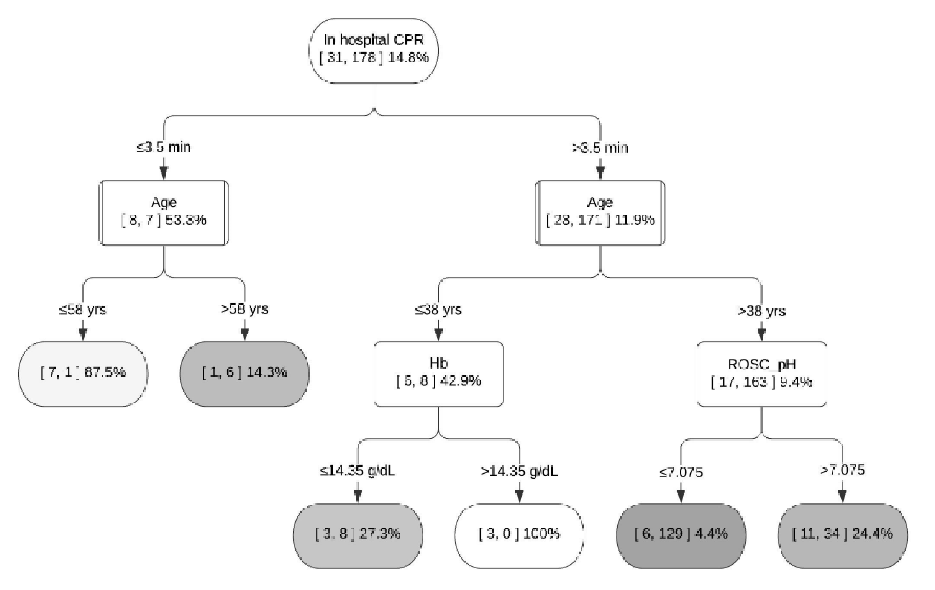

Figure S2. Decision Support System for Group 2 - No Prehospital ROSC and the First Monitored Rhythm of PEA
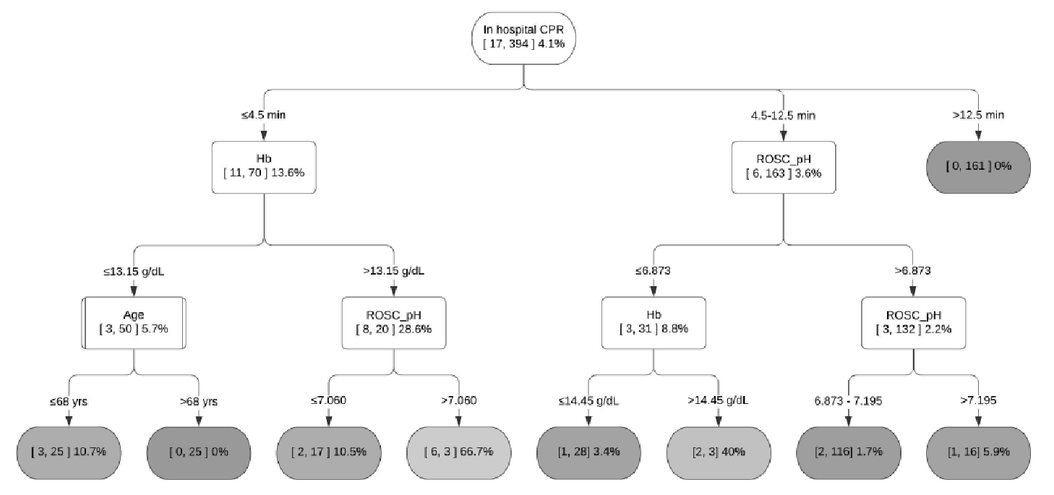

Figure S3. Decision Support System for Group 5 - Prehospital ROSC and the First Monitored Rhythm of PEA
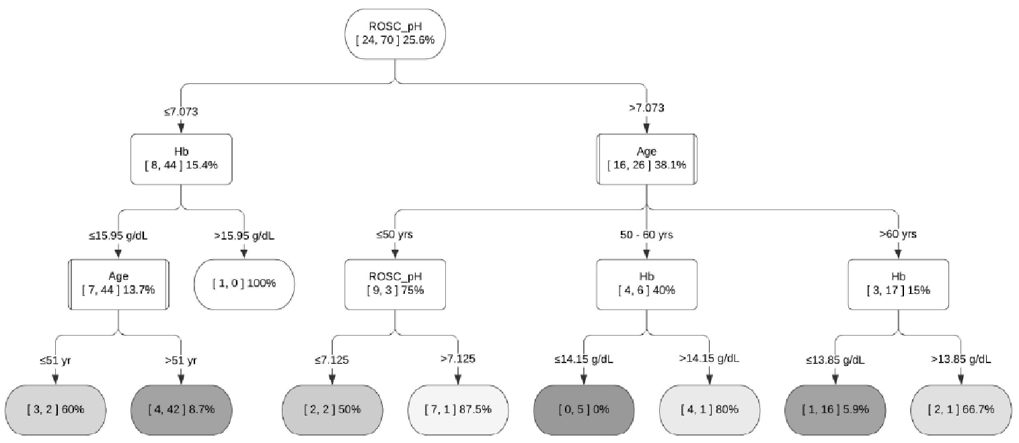

Figure S4. Decision Support System for Group 6 - Prehospital ROSC and the First Monitored Rhythm of Asystole
