Supporting Information

Development of high-performance zero-gap carbon dioxide electrolysis cells using a hydrophilic porous membrane

Yasuhiro Kiyota, ª Yusuke Kofuji, ª Yuki Kudo, ª Maki Yonetsu, ª Akihiko Ono, ª Satoshi Mikoshiba ª and Ryota Kitagawa ª
ª Corporate Research & Development Center, Toshiba Corporation, Kawasaki, Kanagawa 212-8582, Japan

Experimental setup for evaluation of CO₂ electrolysis cells
A scheme of experimental setup for evaluation of CO₂ electrolysis cells was shown in Figure S1. 99.995% pure CO₂ gas was supplied to the cathode inlet with constant flow rate controlled by a mass flow controller. The supplied gas was humidified through a water tank as needed. The cathode outlet gas passed a back pressure valve and liquid component (e.g. humidified water) was removed in the cathode tank. Gas components of the cathode outlet gas was diluted by 99.99% pure Ar gas and flow rate was measured by a flow meter. The gas components were quantified by gas chromatography (INFICON, Micro GC Fusion) periodically. 0.1 M potassium hydrogen carbonate (KHCO₃) aqueous solution (electrolyte) stored in the electrolyte tank was supplied to the anode inlet of the CO₂ electrolysis cell with constant flow rate controlled by a liquid pump. An Ag/AgCl electrode with saturated potassium chloride (KCl) solution was set in front of the anode inlet as the reference electrode. These chemicals purchased from Fujifilm Wako Pure Chemicals Co were used with no further purification. The electrolyte with anode generated gases passed a back pressure valve and returned to the electrolyte tank. The anode generated gases vented from the electrolyte tank. Pressure, temperature and dew point were controlled and monitored on each tubing. The cathode and anode inlet were pressurized when porous membranes were used. The current correctors of the CO₂ electrolysis cell were connected to a power source and AC resistance meter (CHINO, FC-100R). For measurements with the 16-cm² cell, the power source was a potentiostat (Bio-Logic Science Instruments, VMP-3e with booster). For measurements with the cell stack, the current source was a DC power supply (KIKUSUI, PWR801L).

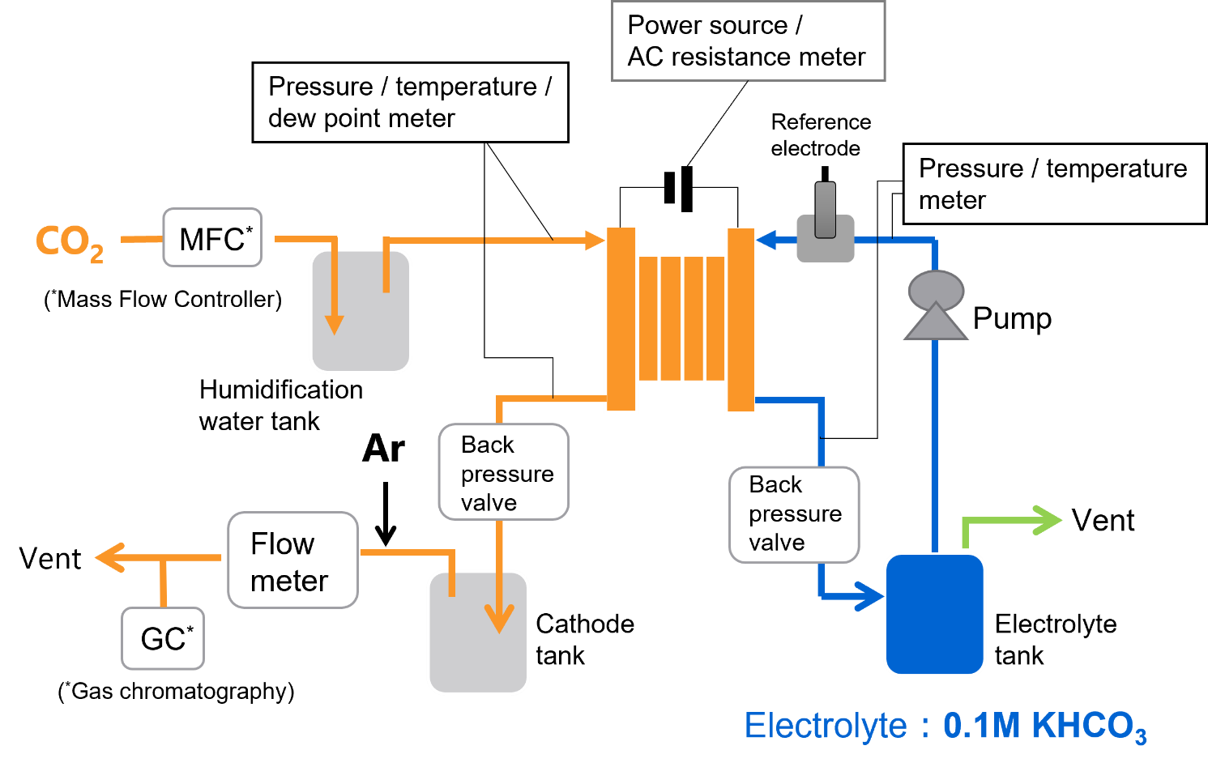
Figure S1. Experimental setup for evaluation of the CO₂ electrolysis cell.

Structure of the 10 × 100 cm² CO₂ electrolysis cell stack
Structure of the 10 × 100 cm² CO₂ electrolysis cell stack was displayed in Figure S2. The MEA which contained the cathode, diaphragm and anode was placed between the cathode flow unit and anode side of the bipolar flow unit, as well as between the cathode side of the bipolar flow unit and anode flow unit. The coolant channel was placed beside the two cell (cathode flow unit–bipolar flow unit–anode flow unit) structure and this component was a repeating unit. Five repeating units were held by a current collector, an inlet/outlet plate, an insulating plate and an outer plate from both sides. Both outer plates were tightened with a defined torque. Provide gas and electrolyte were introduced in inlet/outlet plates and provided to each flow units in parallel (orange and blue line in Figure S2). The product gases of each cell were collectively obtained from the inlet/outlet plate, therefore, total amount of CO generation rate was only obtained. Coolant water was circulated into the coolant channels by using a chiller to adjust the optimal temperature for each cell. Temperatures and voltages for each cell could be monitored.

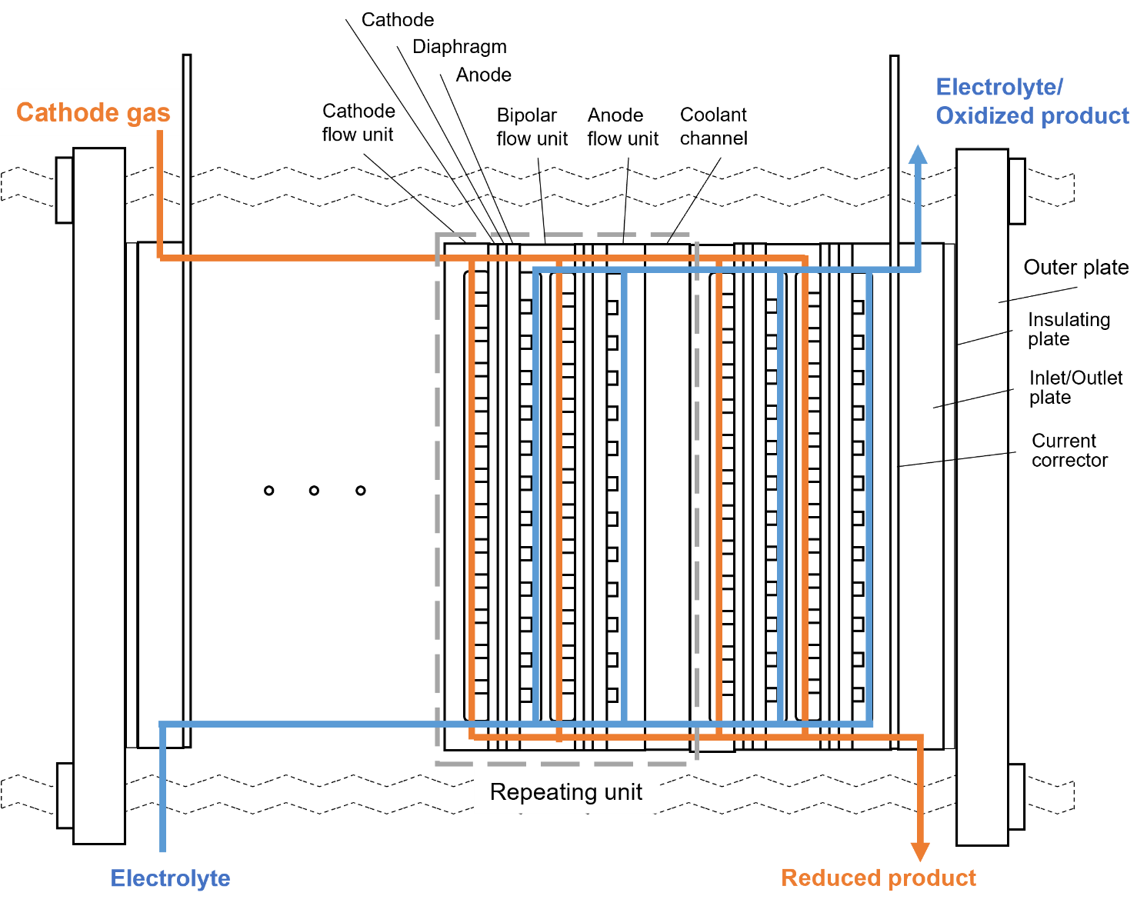
Figure S2. Detail of the 10 × 100 cm² CO₂ electrolysis cell stack.

Impurity gas measurement compared with the experiment using pure CO₂ gas
Durability test with pure CO₂ gas for comparison with the impurity gas measurement was displayed in Figure S3. The CO₂ electrolysis cell using the HPM didn’t show a large change of FE_{CO} and FE_{H2} despite existence of impurity components (NO₂ and SO₂). V_{cell} slightly decreased when using pure CO₂ gas, but CO₂ electrolysis cells using the HPM were hardly affected by the impurity gas.
Contrarily, the CO₂ electrolysis cell using the AEM showed decrease of FE_{CO} and increase of FE_{H2} under existence of the impurity gas, although the cell didn’t show a large change of FE_{CO} and FE_{H2} in the case of pure CO₂ gas. V_{cell} also increased with corresponding to the decrease of FE_{CO}, but there is no large increase in case of pure CO₂ gas. In contrast to CO₂ electrolysis cells using the HPM, CO₂ electrolysis cells using the AEM was considered to be affected by impurity gas.

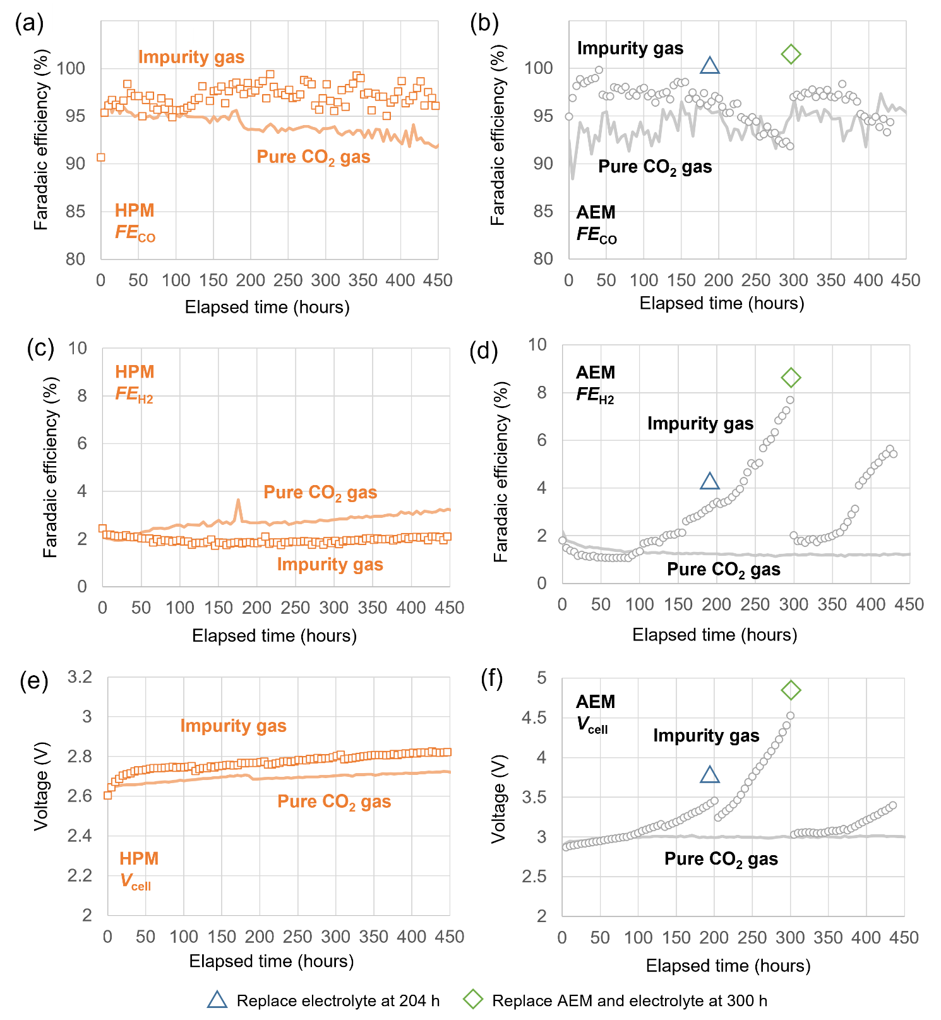
Figure S3. Durability tests at 200 mA/cm² with inlet gas contains NO₂ and SO₂. Comparison with pure CO₂ tests were displayed as solid line. Faradaic efficiency of COER for the cells using (a) HPM and (b) AEM, Faradaic efficiency of HER for the cells using (c) HPM and (d) AEM and cell voltage for the cells using (e) HPM and (f) AEM over time. In the case of the test using the AEM, electrolyte was replaced at 204 h (blue triangle) and both AEM and electrolyte were replaced at 300 h (green diamond).

Effect of the electrolyte concentration for CO₂ electrolysis cells
Effect of the electrolyte concentration was confirmed though cell evaluations using 10, 100 and 1000 mM KHCO₃ as shown in Figure S4. Measurements conditions were same as current density dependence measurement upon 1000 mA/cm² (See Method section of the manuscript). The CO₂ electrolysis cells using the HPM indicate similar value of FE_{CO} upon 700 mA/cm² but decline of FE_{CO} was observed from 800 mA/cm² when using 1000 mM KHCO₃ electrolyte. V_{cell} decreased with increasing the electrolyte concentration whole current density. The cells using the HPM was operated regardless of the electrolyte concentration. Although FE_{CO} of the CO₂ electrolysis cells using the AEM showed comparable values until 200 mA/cm², the operation was interrupted at 300 mA/cm² for 10 mM and 500 mA/cm² for 1000 mM electrolyte due to voltage limit over 10 V. V_{cell} showed same trend as the cells using the HPM. The dilute electrolyte increased solution resistance and decreased the absolute amount of potassium ions needed for the reaction, making operation unstable. Whereas concentrated electrolyte accelerated the salt precipitation and degraded the CO₂ electrolytic cell. We concluded that the electrolyte concentration of 100 mM was suitable and HPM was a more tolerant membrane to the electrolyte concentration changes than the AEM.

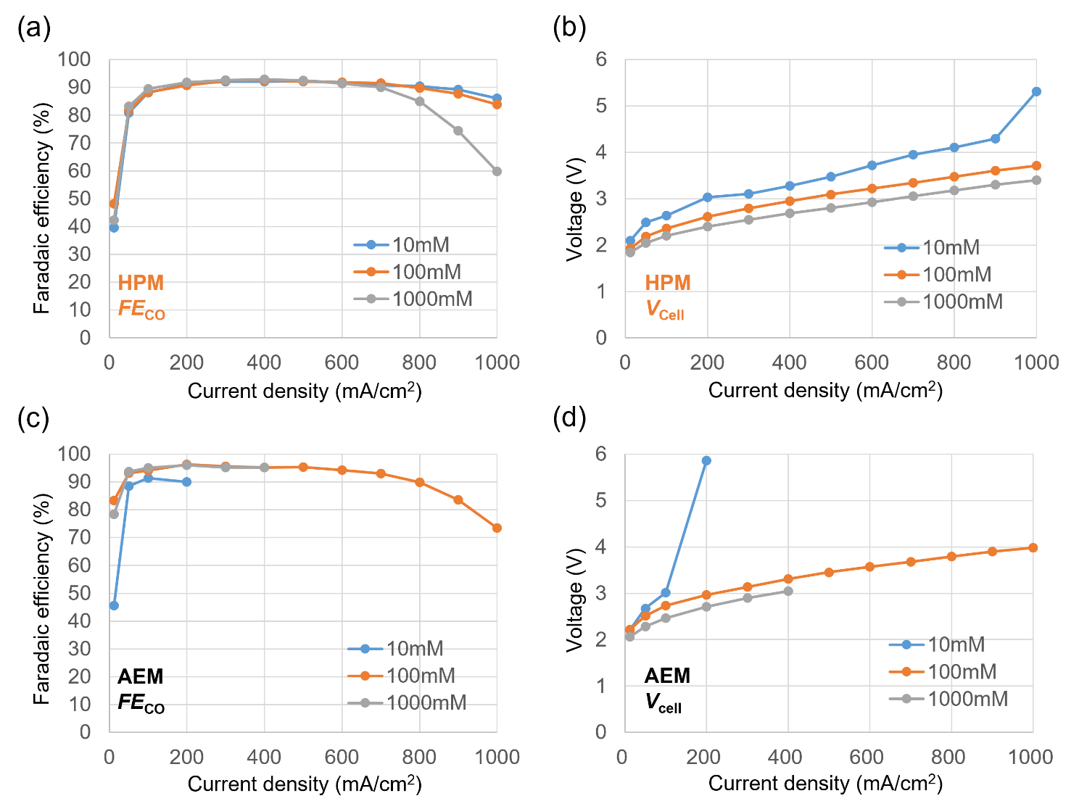
Figure S4. Measurements for CO₂ electrolysis cells with various electrolyte concentration. (a) Faradaic efficiency of COER and (b) V_{cell} for the cells using the HPM. (c) Faradaic efficiency of COER and (d) V_{cell} for the cells using the AEM.

Measurement of ion exchange capacity (IEC)
Ion Exchange Capacity (IEC) was measured for AEMs both before and after the durability test for 300 h with impurity gases. Procedure of IEC measurement was as follows. Samples were immersed in 40 mL of 1% Br⁻ solution at room temperature for 24 h to exchange Br⁻ ion into samples. The Br⁻ exchanged samples were immersed in 1 M potassium hydroxide (KOH) at room temperature for 1 h to exchange Br⁻ ion into KOH solution. Amount of Br⁻ in the KOH solution was quantified by ion chromatography. The amount of ions was normalized by the dry weight of samples which was measured after the ion chromatography measurement. The IEC of AEMs before and after measurement were 1.40 and 1.10 meq/g. The IEC was decreased after impurity gas operation.

Nuclear magnetic resonance (NMR) analysis
Solid Nuclear Magnetic Resonance (NMR) for ¹³C was measured for AEMs both before and after the durability test for 300 h with impurity gases. Figure S5 showed NMR spectroscopy using dipole decoupling method. The peak around 112 ppm was assigned to CF₃ originated from poly(aryl piperidinium) polymer and CF₂ originated from PTFE. The clear increase of 112 ppm peak after the measurement suggested that decrease in the ratio of poly(aryl piperidinium) polymer to PTFE. This implied that the HPM’s weight or even thickness, was reduced after the reaction.

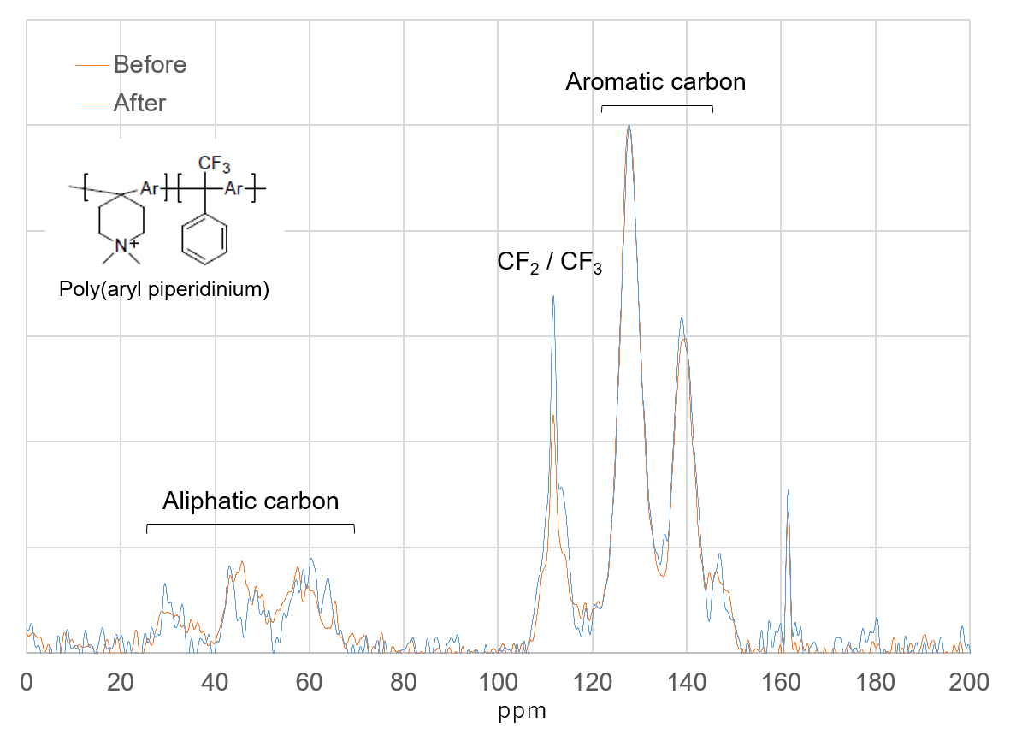
Figure S5. Solid NMR spectroscopy using dipole decoupling method for the AEM before and after the impurity gas measurement.

Potassium ion concentration during the cell stack operation
To reveal the cause of increasing voltage during the cell stack operation shown in Figure 6(f), we measured the potassium ion concentration in the electrolyte. Figure S6 displayed the voltage and potassium ion concentration side-by-side. During the first 120 h from the beginning, salt precipitation might occur due to insufficient humidification temperature, resulting in HER (Figure 6(e)). Then the potassium ion concentration didn’t decrease and the stack voltage slightly increased. After the dew temperature changed from 50°C to 60°C, the precipitated salts were eliminated and FE_{CO} was recovered. However, the excess humidified water migrated from the cathode to anode, and it diluted the electrolyte. Then the potassium ion concentration decreased and the stack voltage rapidly increased. With referring to Figure S3, it could be concluded that the decrease of potassium ion concentration in the electrolyte was the cause of the voltage increase.

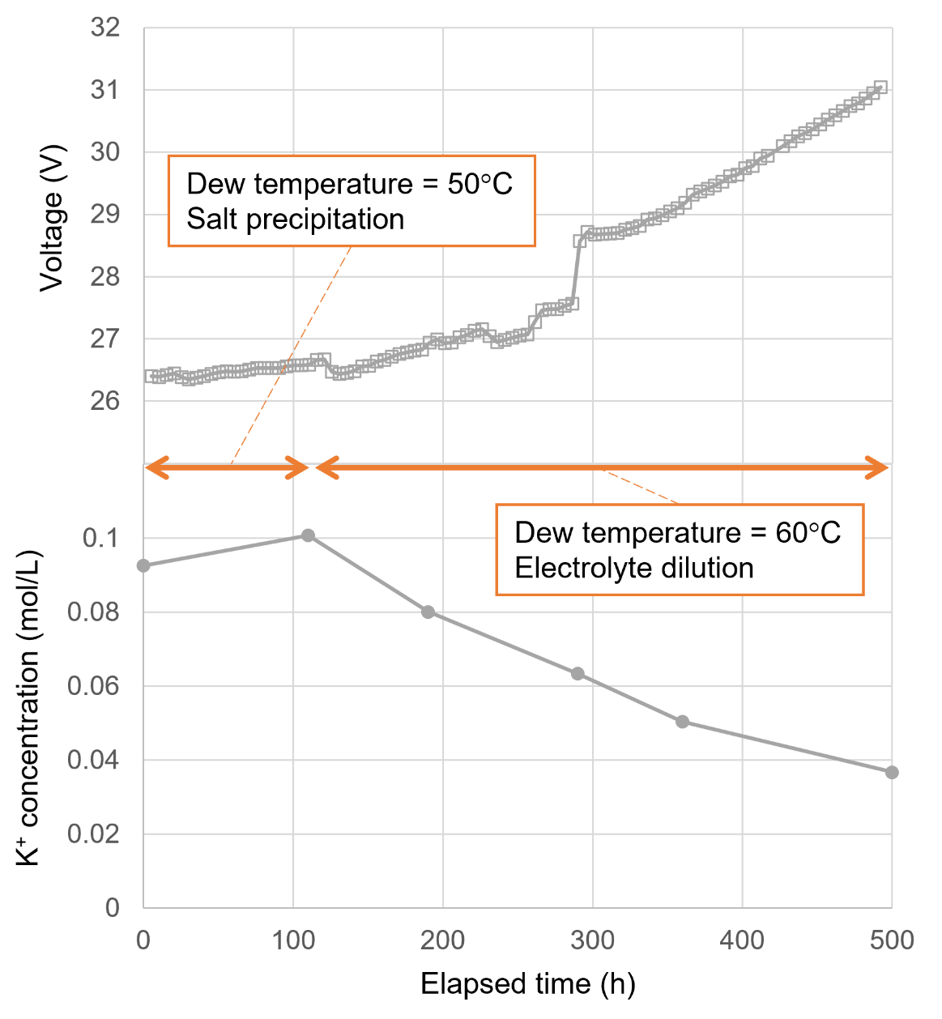
Figure S6. Stack voltage and potassium ion concentration during the 500 h operation.

