Bio-based pH‐responsive nanofibrous membranes for controlled release of tetracycline hydrochloride

Miaomiao Zhu, Wenxuan Xu, Duo Wu, Zhuangcheng Liu, Yuanyuan Song, Aying Zhou, Ranhua Xiong, Chaobo Huang*

M. Zhu, W. Xu, D. Wu, Z. Liu, Y. Song, A. Zhou, R. Xiong and C. Huang
Jiangsu Co-Innovation Center of Efficient Processing and Utilization of Forest Resources, College of Chemical Engineering, Nanjing Forestry University, Nanjing 210037, China.
M. Zhu, R. Xiong and C. Huang
Jiangsu provincial key lab for the chemistry and utilization of agro-forest biomass, Nanjing Forestry University, Nanjing 210037, China.
Email: chaobo.huang@njfu.edu.cn

Table S1. Different proportions of PLA, CAP and TH.
 | m_{PLA} (g) | m_{CAP} (g) | m_{TH} (mg)
PLA NFM | 1.2 | 0 | 0
PLA/CAP NFM | 0.8 | 0.4 | 0
PCT NFM-1 | 1 | 0.2 | 120
PCT NFM-2 | 0.9 | 0.3 | 120
PCT NFM-3 | 0.8 | 0.4 | 120

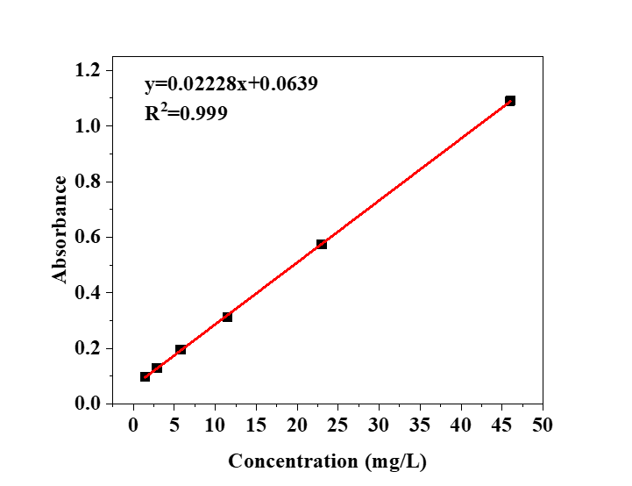
Fig. S1 (a) The standard curve of TH at 360 nm.

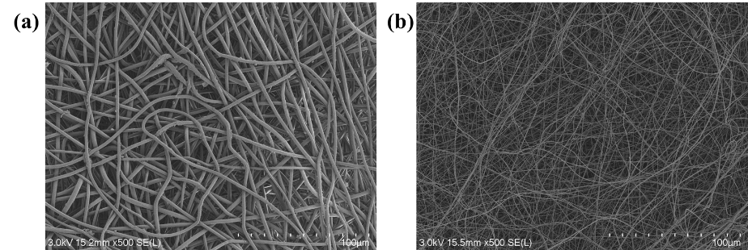
Fig. S2 (a-b) SEM images of the fabricated PLA and PLA/CAP NFMs, respectively.

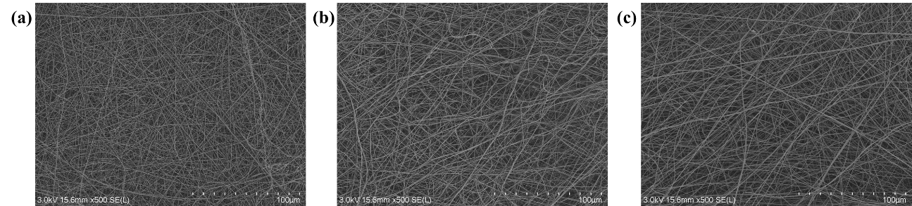
Fig. S3 (a-c) SEM images of the fabricated PLA/CAP/TH NFM-1, PLA/CAP/TH NFM-2 and PLA/CAP/TH NFM-3 at low magnification, respectively.

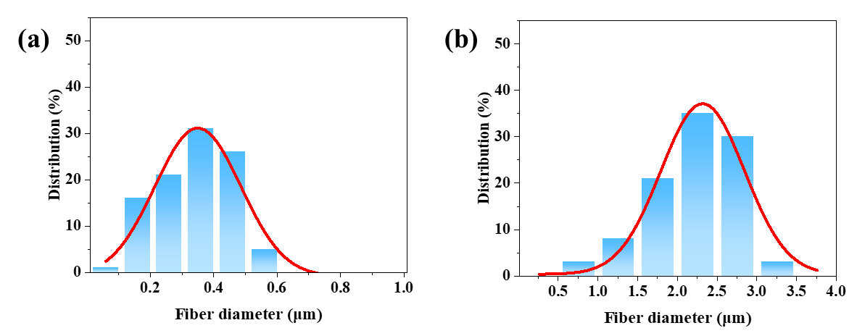
Fig. S4 (a-b) Diameter distribution of the fabricated PLA and PLA/CAP NFMs, respectively.

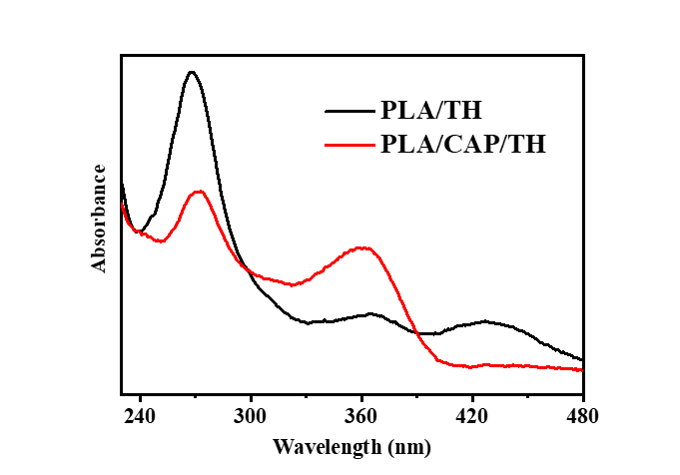
Fig. S5 The UV-Vis absorption spectra of tetracycline hydrochloride released from PLA/TH and PLA/CAP/TH NFMs.

