Front screen

Note: The redacted areas would include details of the specific study
Study information screen
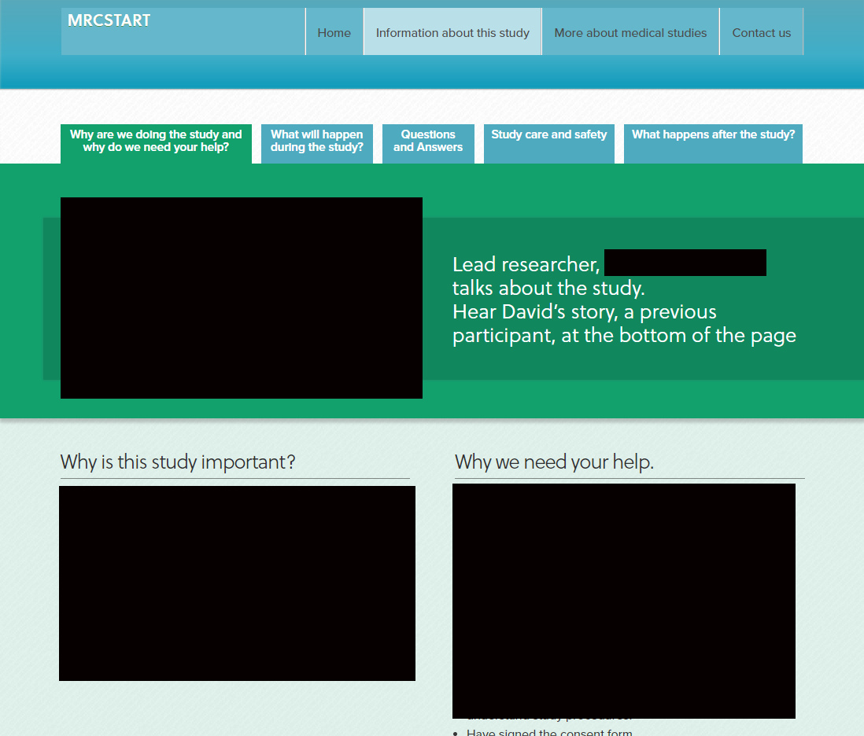
Note: The redacted areas would include details of the specific study, including a video clip from the principal investigator
Information about medical studies
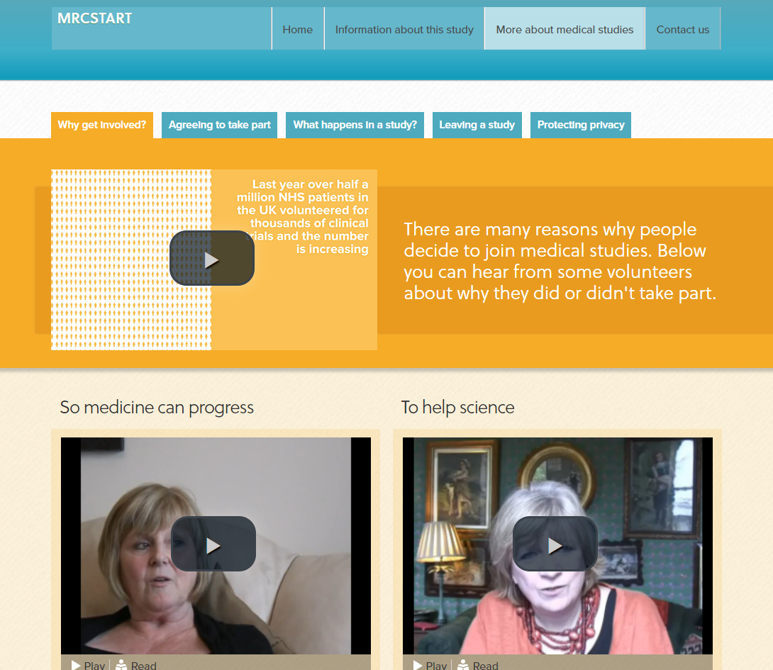
Note: The videos are from http://www.healthtalk.org/ and are used with permission

